

|  |
| --- |
| Business Template  **BICYCLE SALES** |
|  |



Contents

1 Business Description 3

1.1 Business background 3

1.2 Problems because of poor data management 3

1.3 Benefits from implementing a Data Warehouse 3

2 Dimensions of a Business 3

3 Logical Scheme 3

4 Data Flow 3

5 Fact Table Partitioning Strategy 3

6 Strategy of Parallel Load 3

7 Report Layouts 3

# 

# Business Description

## Business background

 Bicycles are fun ecological vehicles that can travel at high speeds and withstand even demanding conditions. To do their best, they need to be constructed of high-quality materials, assembled by competent and trained bicycle mechanics, and properly adjusted to fit you right. Cycling can help to protect you from serious diseases such as stroke, heart attack, some cancers, depression, diabetes, obesity and arthritis. Riding a bike is healthy, fun and a low-impact form of exercise for all ages. Cycling is easy to fit into your daily routine by riding to the shops, park, school or work.

But this business is competitive enough so if a company wants to succeed, it should know the product market well. This study can be done by collecting product sales information and analyzing it by means of special tools.

## Problems because of poor data management

Data analysis is impossible without good data management. In sales, where there is a lot of competition and seasonality, it is necessary to analyze the data well. If you don’t use tools that can provide you with information for analysis and can help you to come up with a business strategy, you will not be competitive.

Due to the fact, that the company's offices are located in different countries, it is difficult to combine information about the company's sales.

## Benefits from implementing a Data Warehouse

Using data warehouse can help the company to solve the problems described above. Implementing a data warehouse can provide the company with answers to the following questions:

* What product/brands are most popular?
* Which product/brands have the highest demand?
* What is the correlation between age and demand, gender and demand?
* Which geographical area has the most successful sales?
* Is there a typical (normal) price distribution across brands or within specific brands?

Further data processing would also let the company:

* Correlate specific product features with changes in price.
* Analyze sales according to geographical position
* And many other.

# Dimensions of THE Business

The description of the 4-step dimensional design process:

1. Definition of the business process.

Stores sell bicycles of different types to customers (buyers). Buyers can use different payments types and find store through different channels. Shops handling shipping (delivery) of purchases to buyers.

2. Declaring the grain.

The grain is a single sale of a certain product at certain price at certain date in a certain shop by a certain employee to a certain buyer who paid a specific amount of money (total cost) using a certain payment type shipped to certain address.

3. Identifying the dimensions.

The dimensions are Dates, Products, Customers, Channels, Employees, Delivery addresses, Payment types.

The Employee dimension is planned to be a slowly changing dimension of type 2.

The Products, Customers, and Delivery addresses dimensions contain hierarchies.

4. Identifying the facts.

Payments per sale (“revenue”) will be represented in the Sales table.

Below is the relational star schema of the DWH:

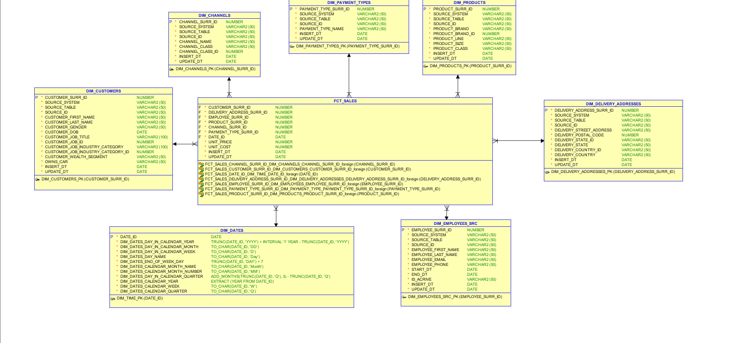

Below is the 3NF layer of the data warehouse:

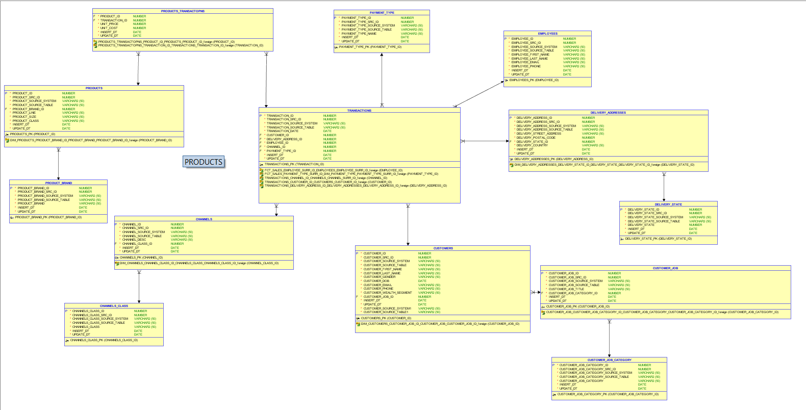

# Logical Scheme

**Logical model of bicycle sales DWH load**

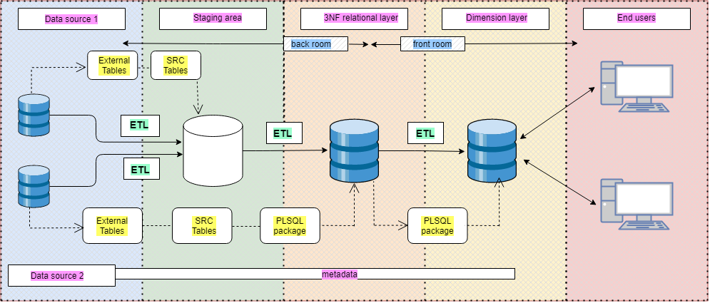

# Data Flow

1. Data flow dim_delivery_address

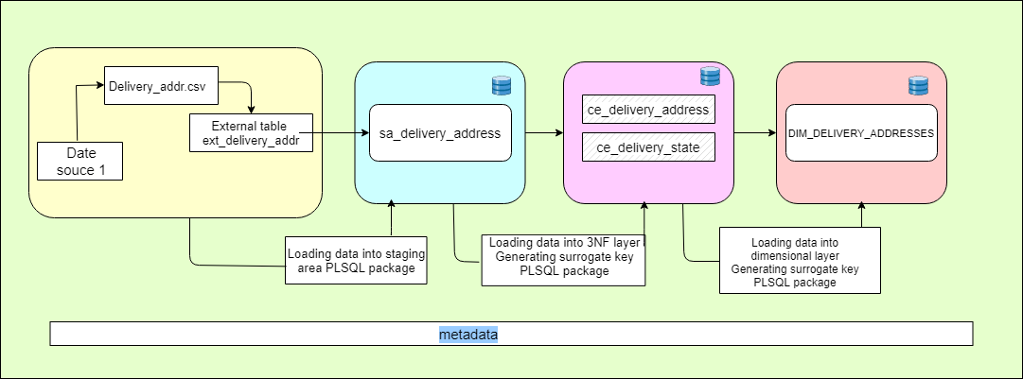

2. Data flow dim_products

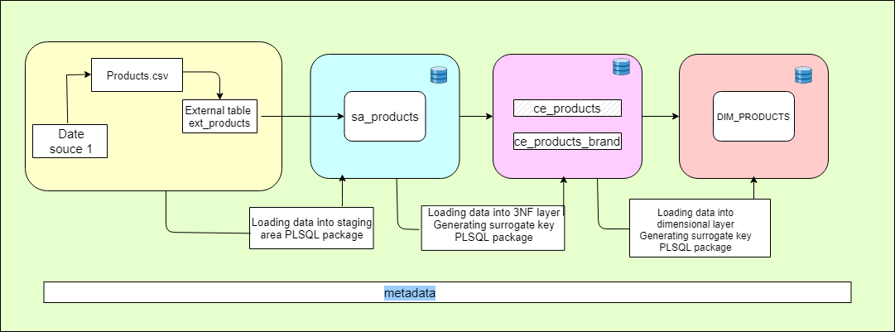

3. Data flow for dim_employees

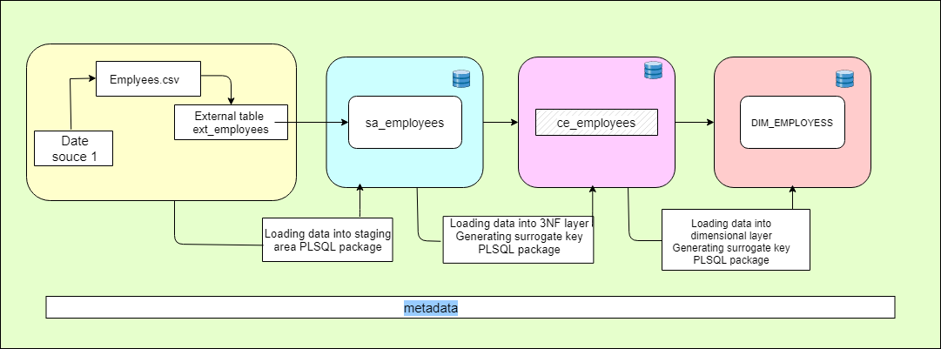

4. Data flow for dim_payment_types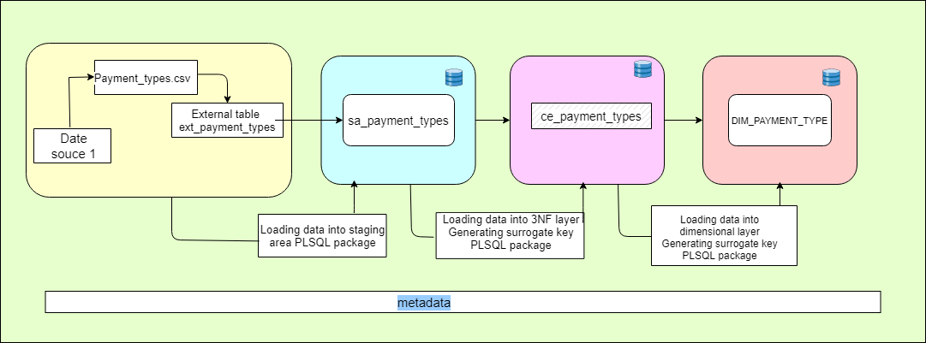

5. Data flow for dim_channels

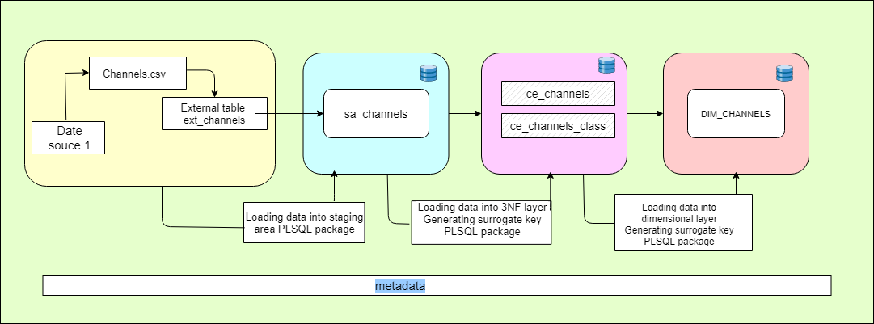

6. Data flow for dim_customers

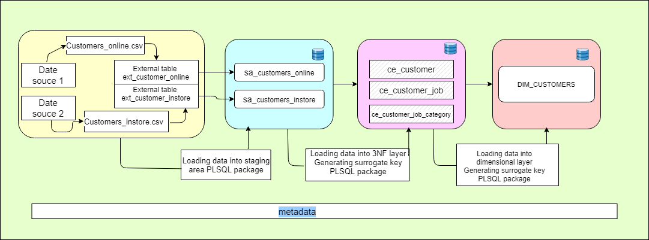

# Fact Table Partitioning Strategy

Partitioning of the table will be carried out by date, since most reports will be built on some period of time. Since we are loading into PEREODIC SNAPSHOT by month it would be better to use RANGE.

***For BL_3NF:***

PARTITION BY RANGE (TRANSACTION_DATE) interval – 1 month

***For BL_DM:***

PARTITION BY RANGE ((DATE_ID)) interval – 1 month