 

|  |
| --- |
| EPAM Systems, RD Dep., RD Dep.  **POWER BI** |
| Project Design Essentials |

**Legal Notice:** This document contains privileged and/or confidential information and may not be

disclosed, distributed or reproduced without the prior written permission of EPAM®.

Confidential

# BUILDING A SIMPLE POWER BI REPORT

## WORKING WITH POWER BI MODEL

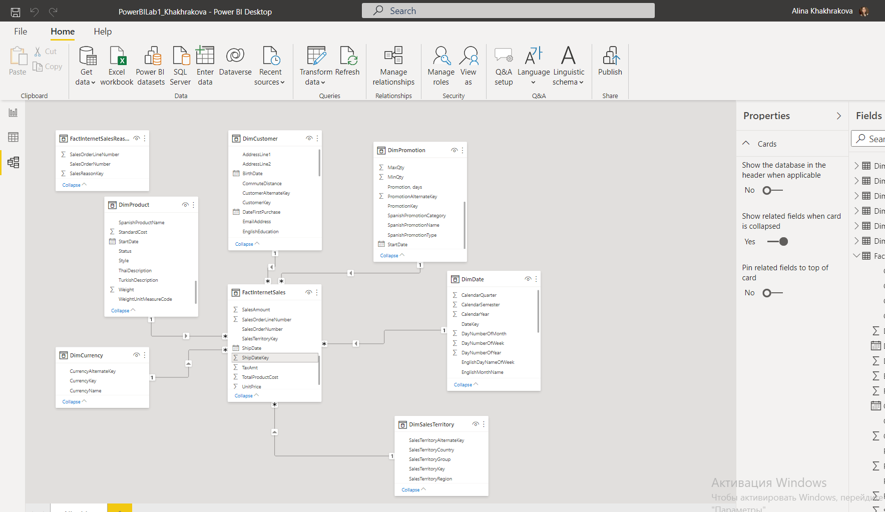

## WORKING WITH POWER BI REPORT

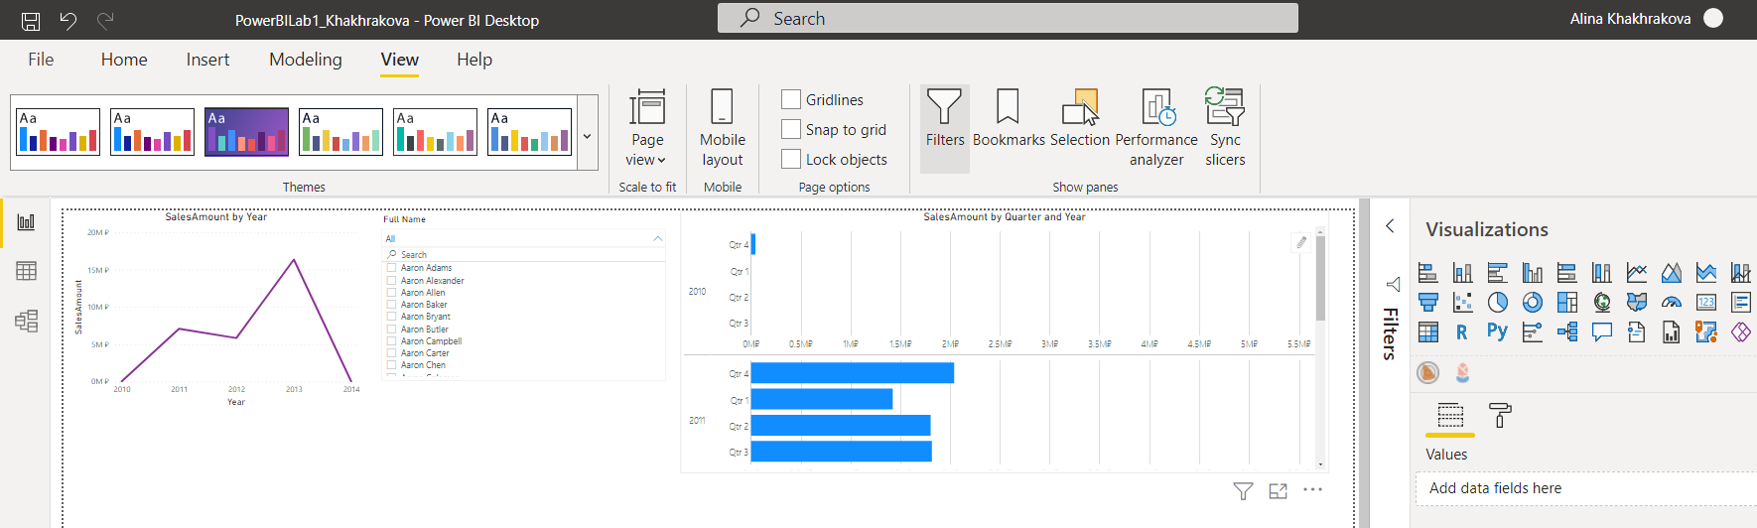

# CREATE LAB REPORT

# 2.1 Logo and header

“Sales enablement” sales in 2010-2014



# 2.2 Filters

# Drop-down slicer

# 

# List box slicer

# 

# Date filter

# 

# 2.3 Visuals

Standard visuals

# 

# 

# 

# 

# 

Custom visuals

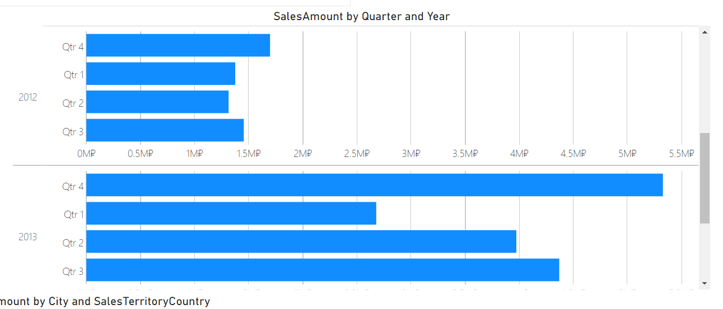

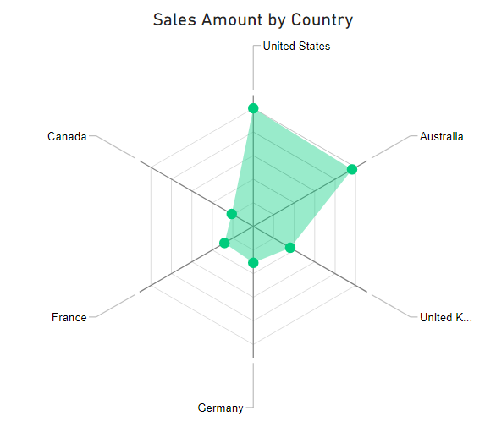

# 2.5 Map visual

# 

# 2.6 Power BI Service Portal

# 

# 

# 

# 2.7Personal Gateway

Installing

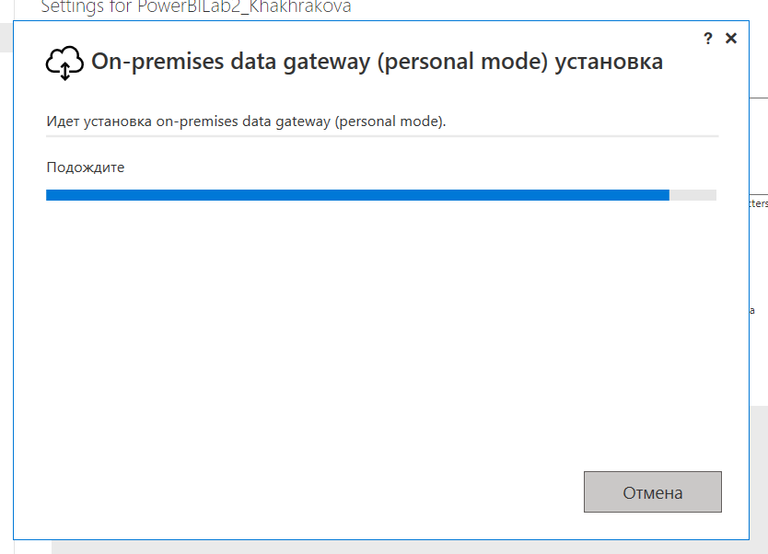

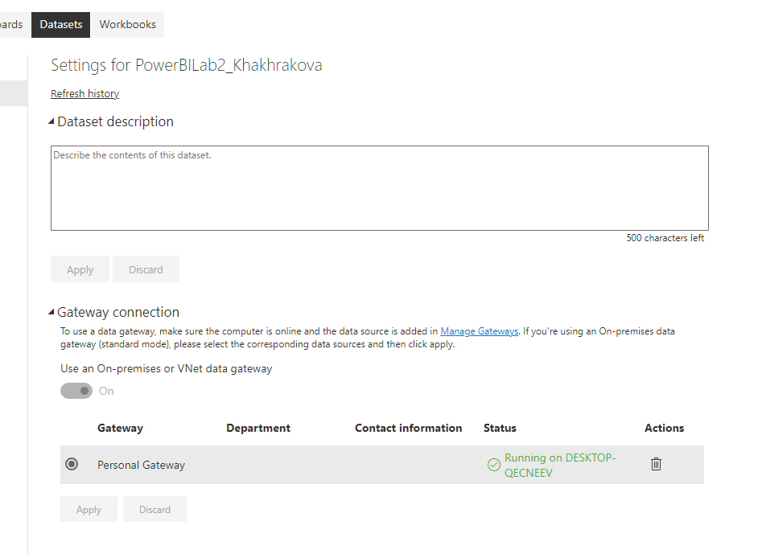

Editing source credentials

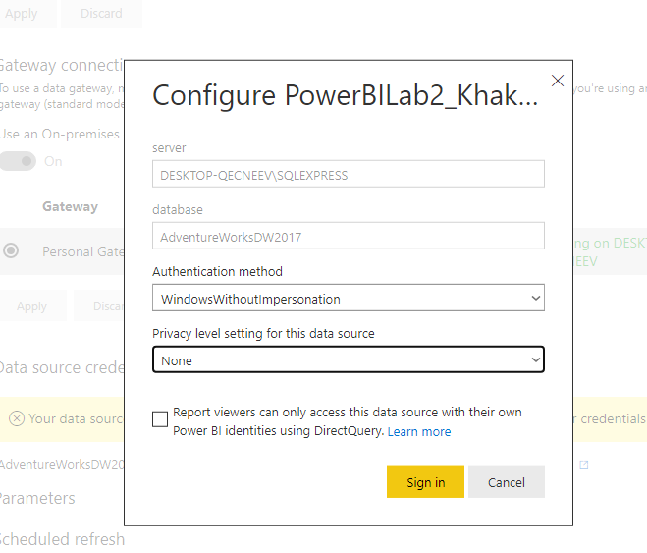

Set scheduled refresh time to 20:00 every day

