 

|  |
| --- |
| EPAM Systems, RD Dep., RD Dep.  **POWER BI** |
| DAX Basics |

**Legal Notice:** This document contains privileged and/or confidential information and may not be

disclosed, distributed or reproduced without the prior written permission of EPAM®.

Confidential

# CREATING SIMPLE DAX EXPRESSIONS

## CALCULATED COLUMN

1. The column show the year and first 3 letter of month.

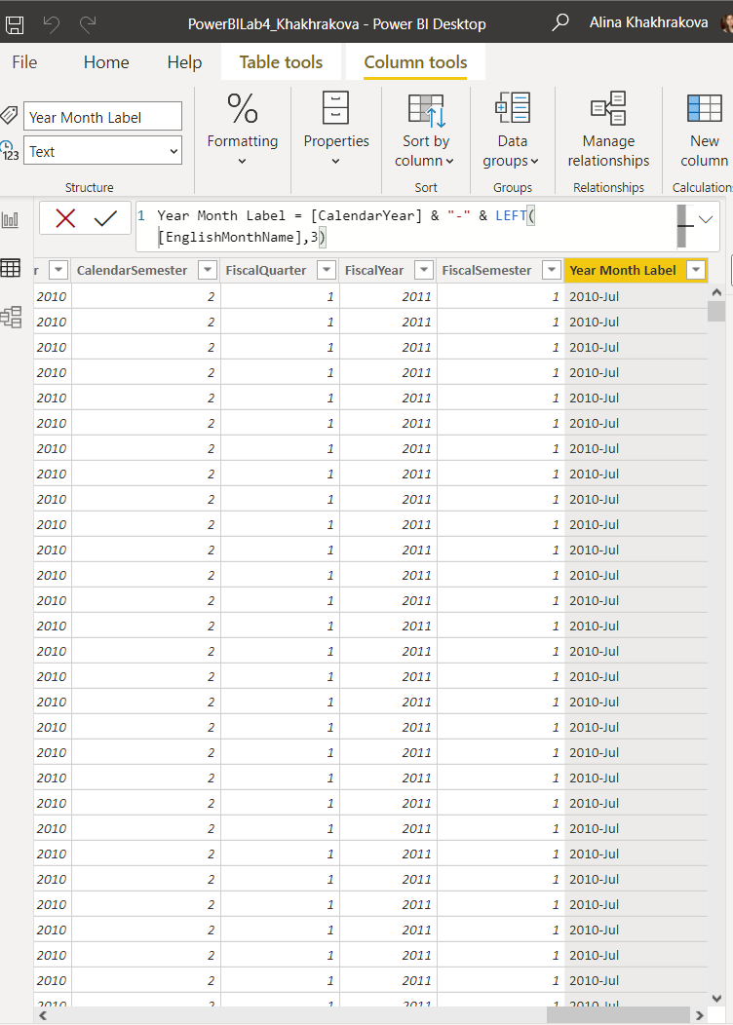

Line graph that displays Sales by the column ‘Year Month Label’ with month in alphabetic order

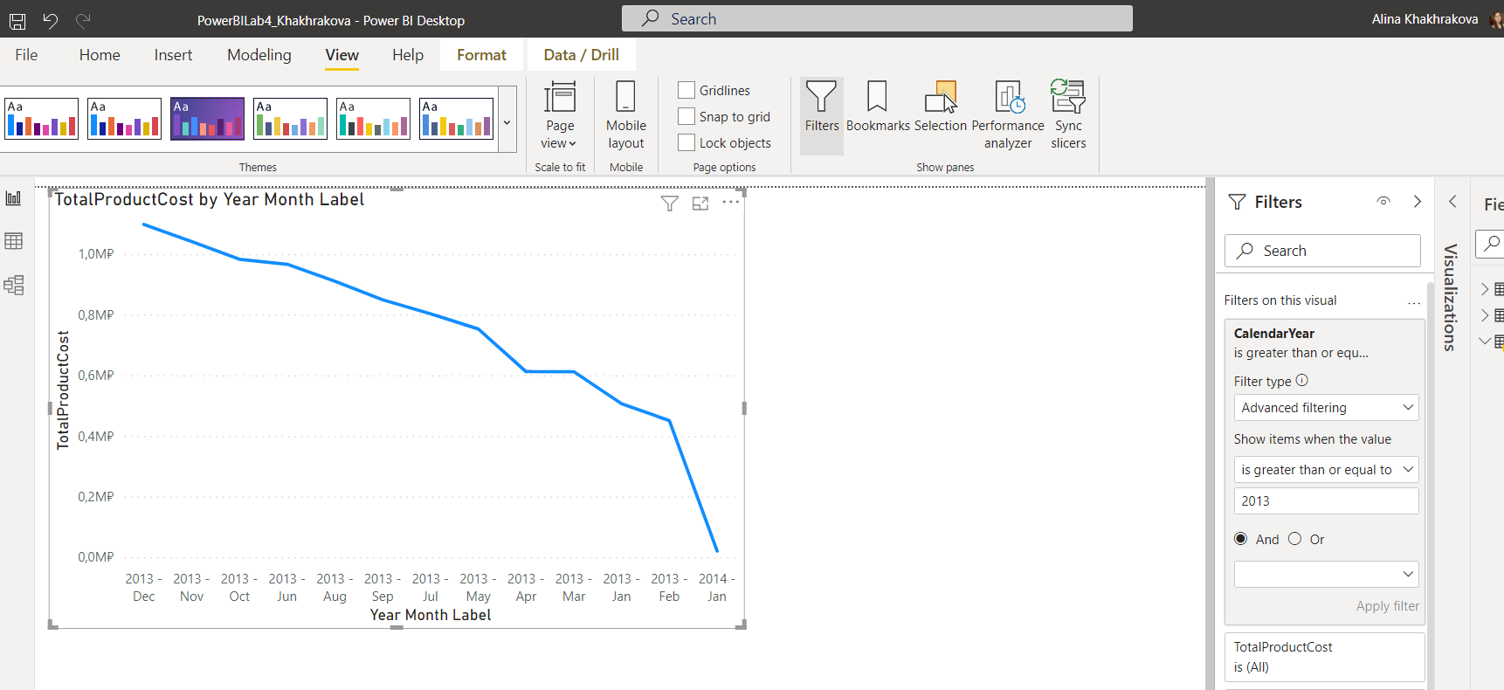

1. Add a new column ‘Year Month Int’

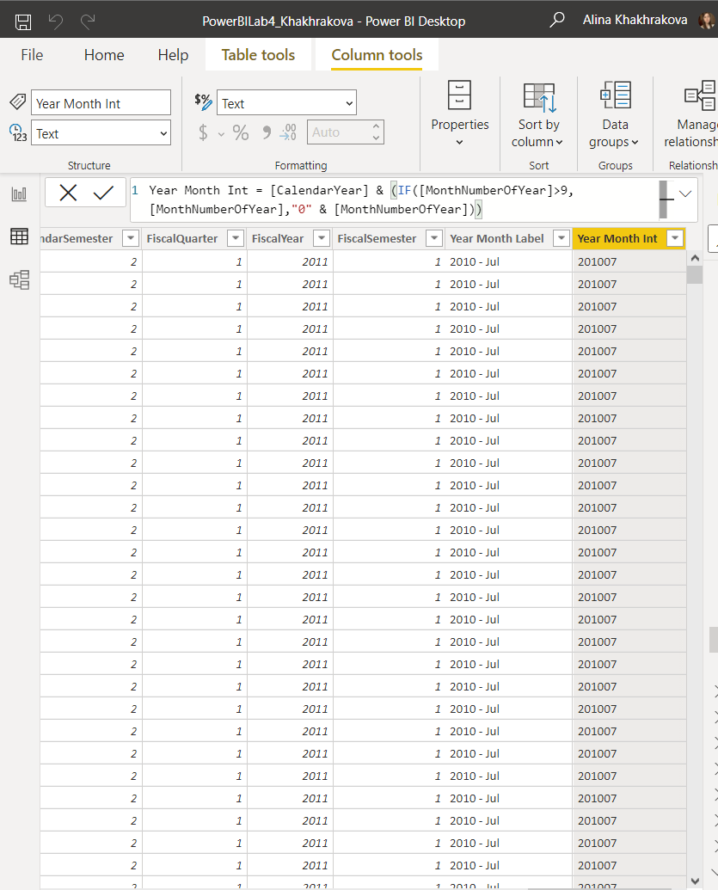

After sorting by a ‘Year Month Int’ all data is in a right order.

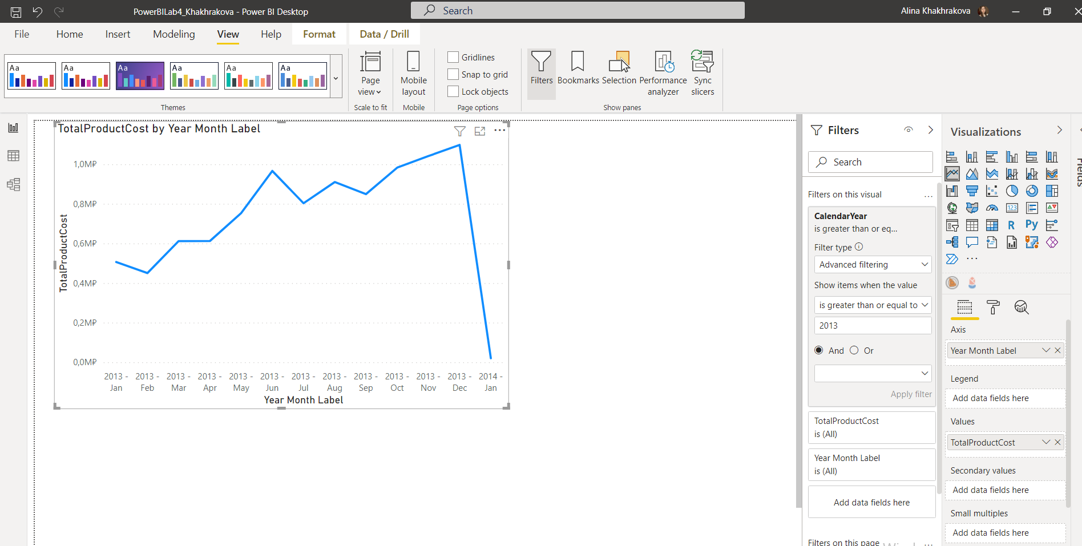

## MEASURE

1. Add a new measure to ‘DimCurrency’ table and display it on the card visualization.

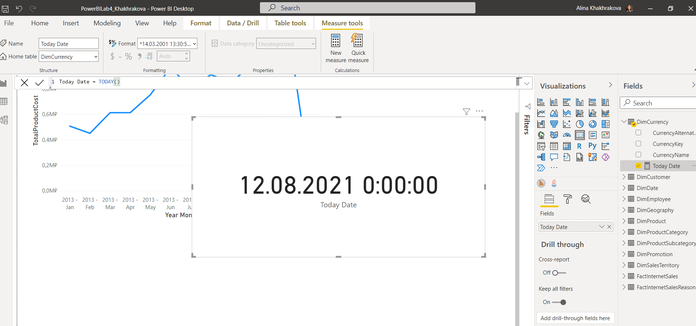

1. Changed date format .

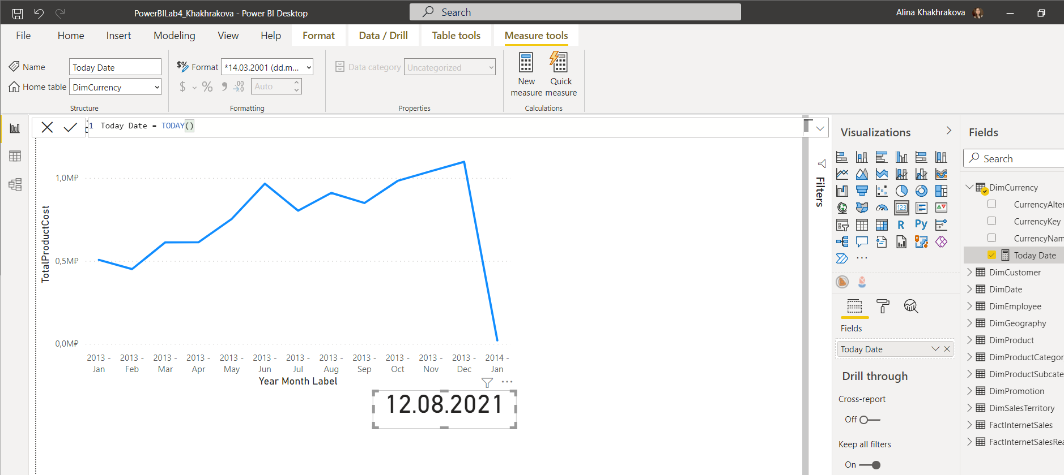

1. Sum of order quantity calculation with visualisation.

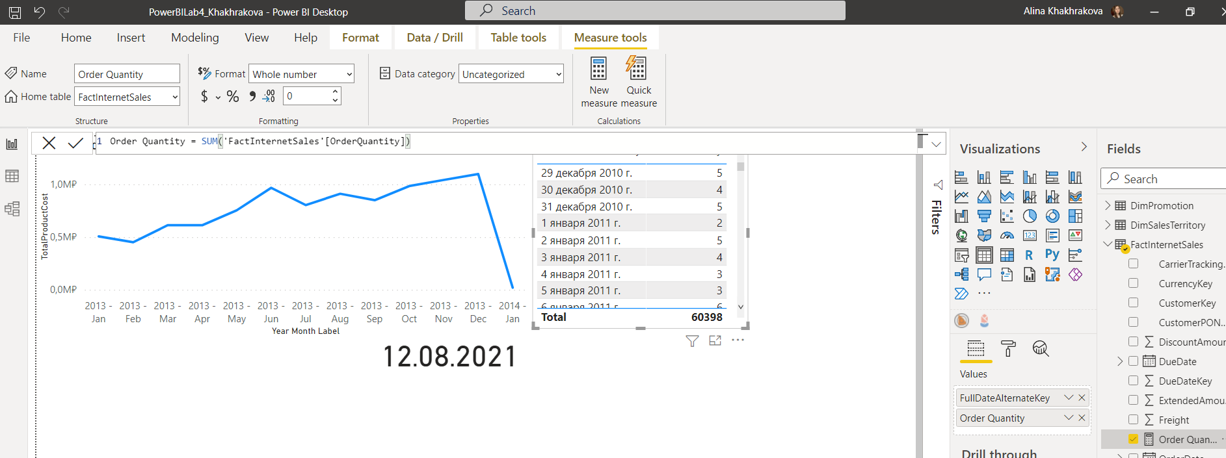

1. New calculation ‘Order Quantity YTD’

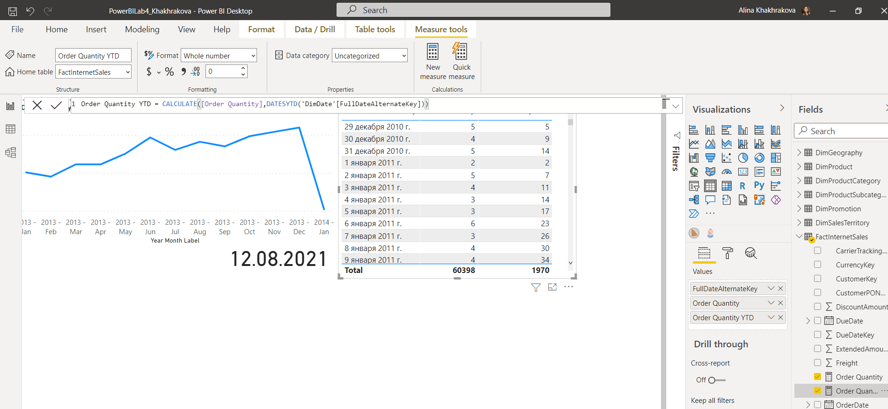

# CREATE LAB REPORT

* 1. Add a line chart the displays Order Quantity YTD line and Order Quantity YTD for Previous Year (*). Create measures for these calculations using DAX.

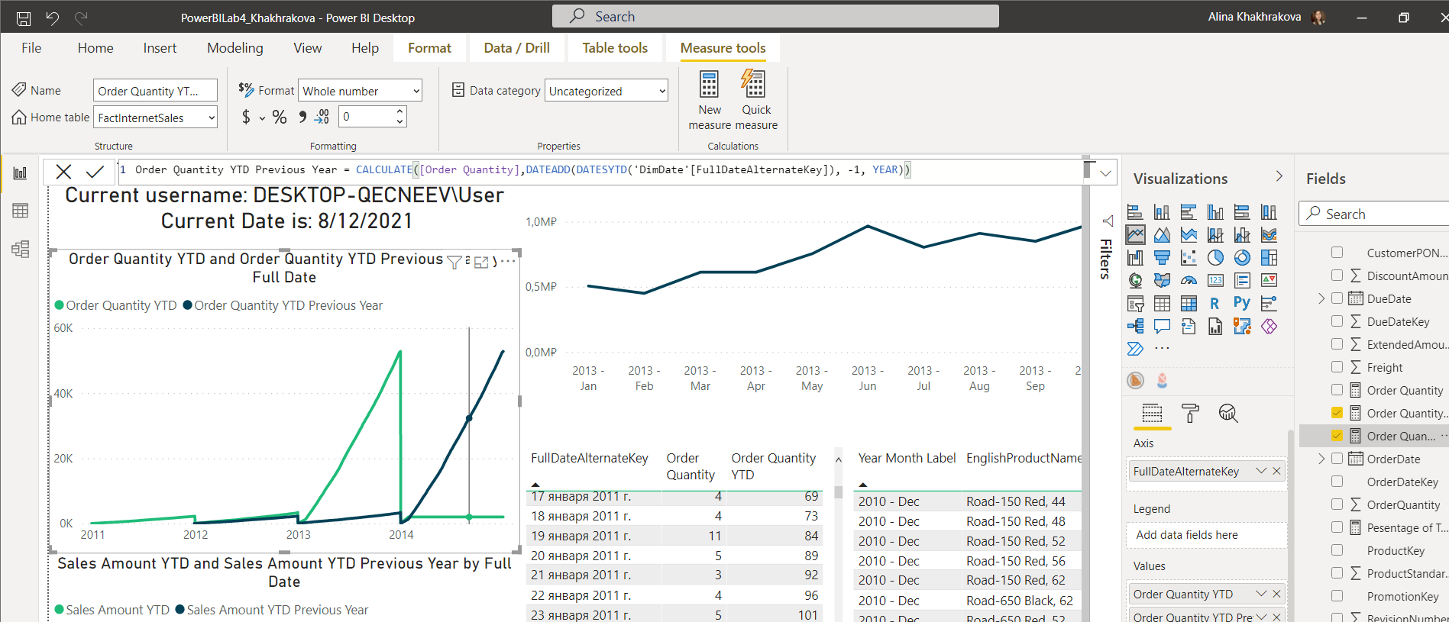

* 1. Add the same chart for Sales Amount

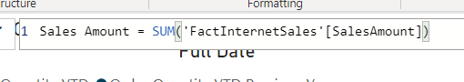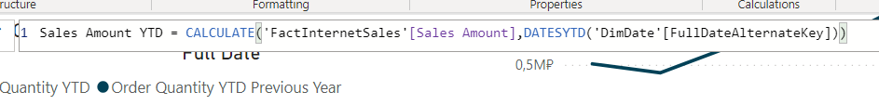

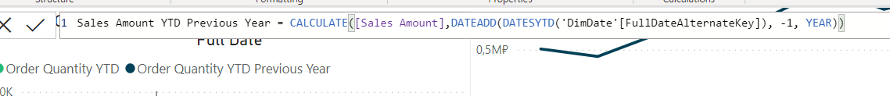

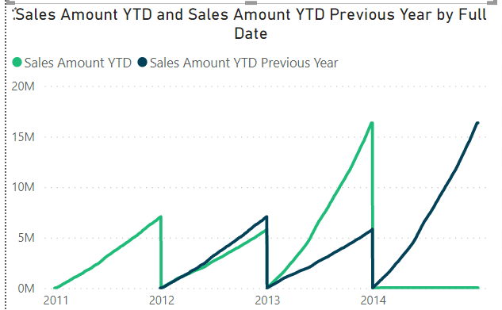

* 1. On top of the report display current username and current date in the format:

*Welcome, [Current User] Current Date is: [Current Date]*

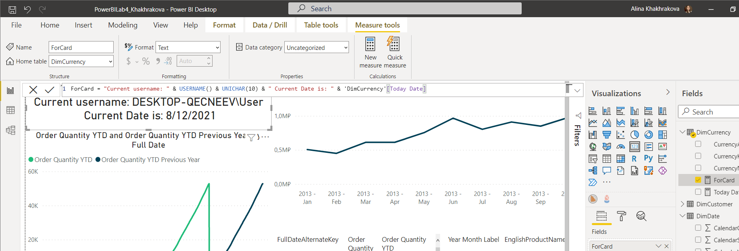

* 1. Add a table that shows Year-Month label that was created during lab work, 2-3 Categories (Like Product Name, Color), Order Quantity and % of total Order quantity for the Dimensions Selected (e.g. table of 4 columns like on the picture below and % of total by Year Month Label and Color):



