 

|  |
| --- |
| EPAM Systems, RD Dep., RD Dep.  **POWER BI** |
| Advanced Reporting Concepts |

**Legal Notice:** This document contains privileged and/or confidential information and may not be

disclosed, distributed or reproduced without the prior written permission of EPAM®.

Confidential

# ROW LEVEL SECURITY

# I chose dynamic RLS. First, I created “RLS” table with columns: ID, FULL NAME and EMAIL and connected it with one-to-many relationship to FCT_SALES using employee_surr_id.

# 

# Then I created a role “Employee” in Power BI Desktop and published the report to Power BI Portal, where I configured the role for users.

# 

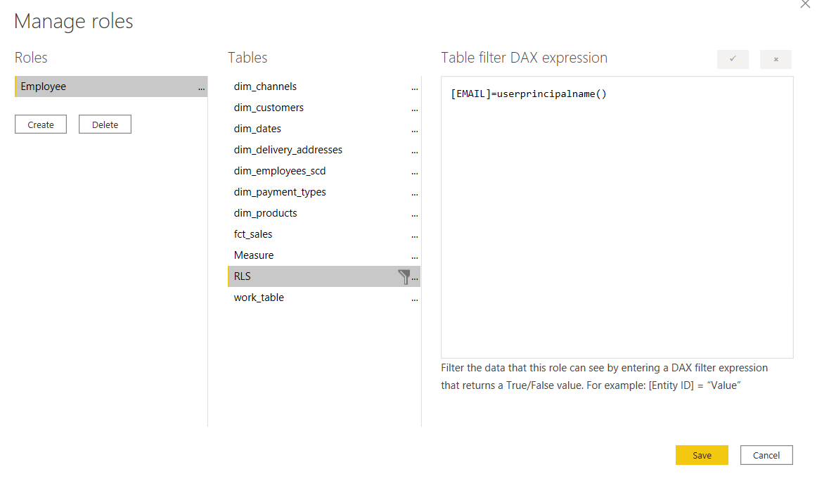

# 

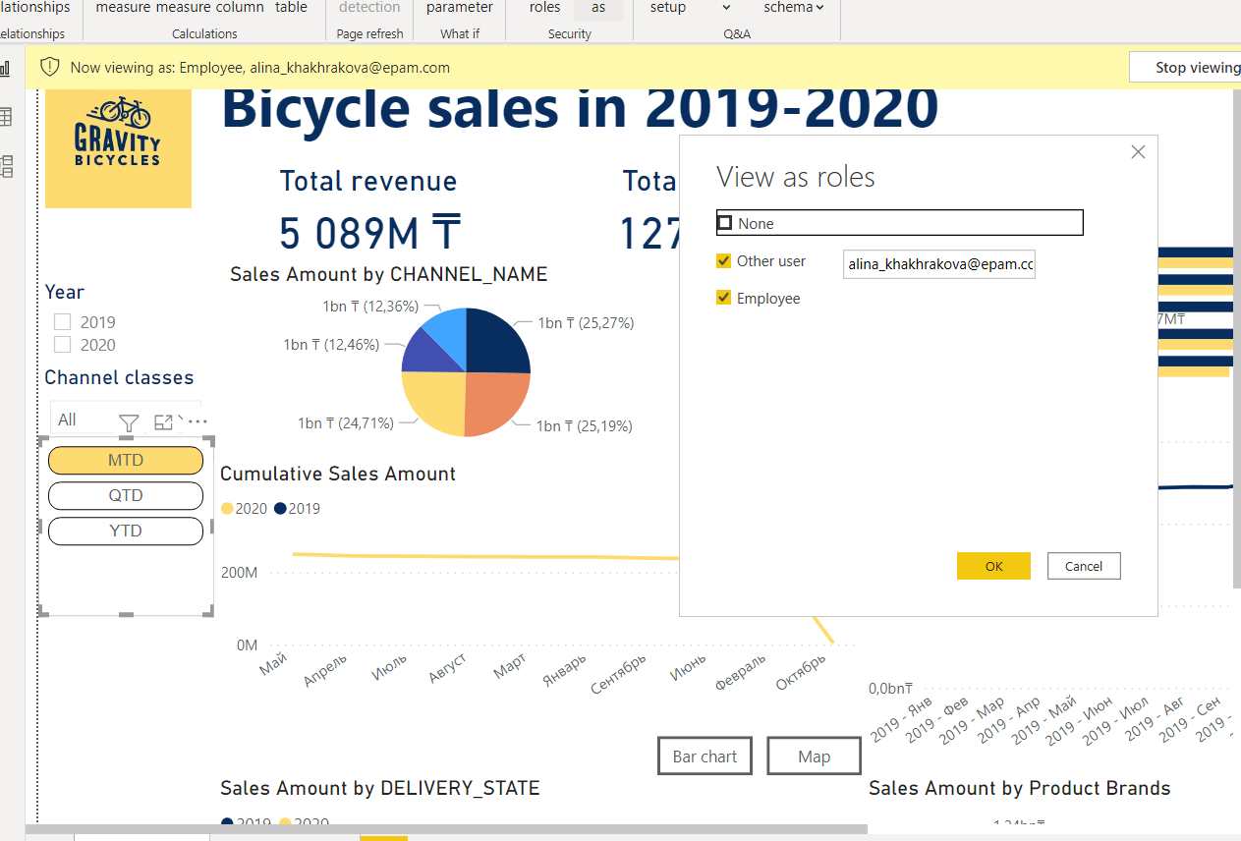

So, when I tested the report under employee_id 3221, I could see only its sales.

# USING BOOKMARKS AND BUTTONS

I created two bookmarks: “Map visual” and “Bar Chart visual”.

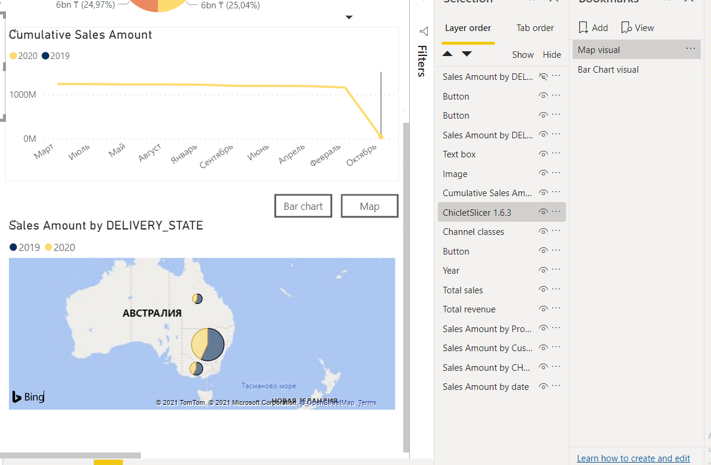

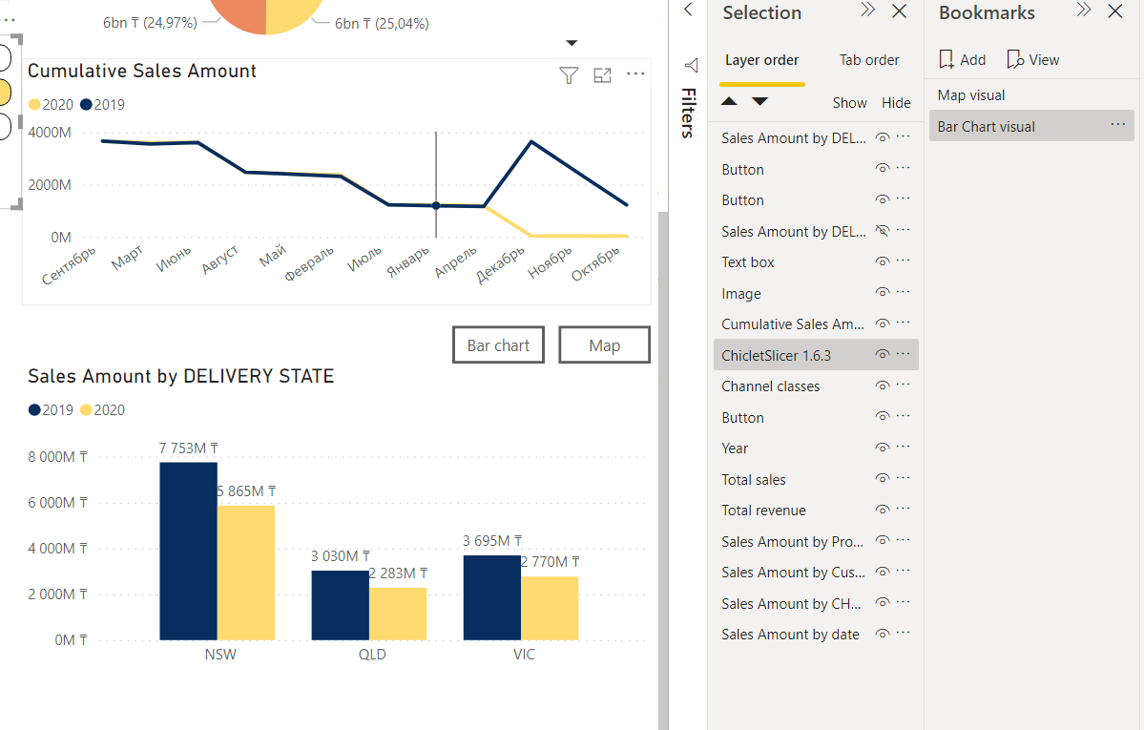

Then I created two buttons to switch between bookmarks

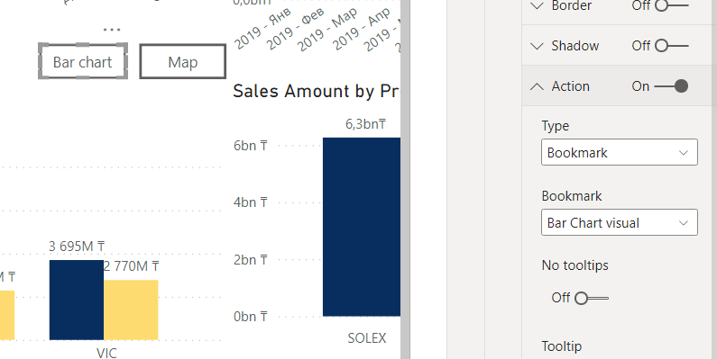

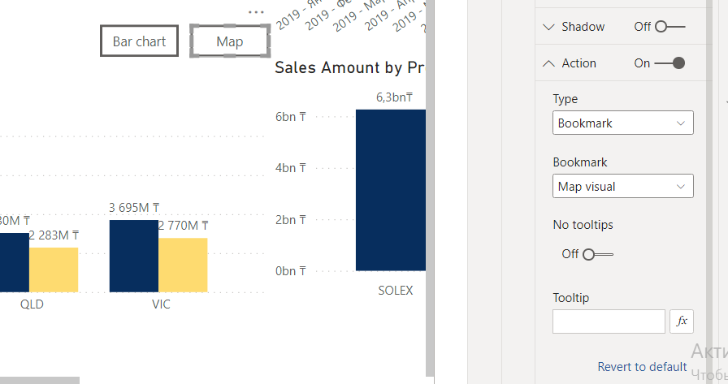

# Chiclet Slicer

At the first step, I added new work table which contain next column YTD, MTD, QTD.

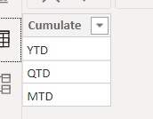

Then, at the second step, I created measures : Sales Amount YTD, Sales Amount QTD , Sales Amount MTD and YTD QTD MTD.

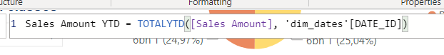

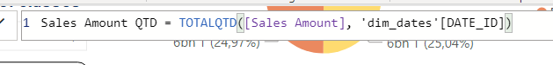

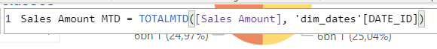

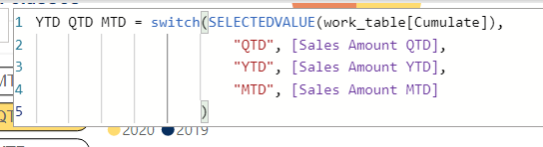

And for the previous year:







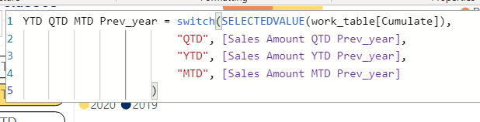

At the third step, I created a Chiclet Slicer.

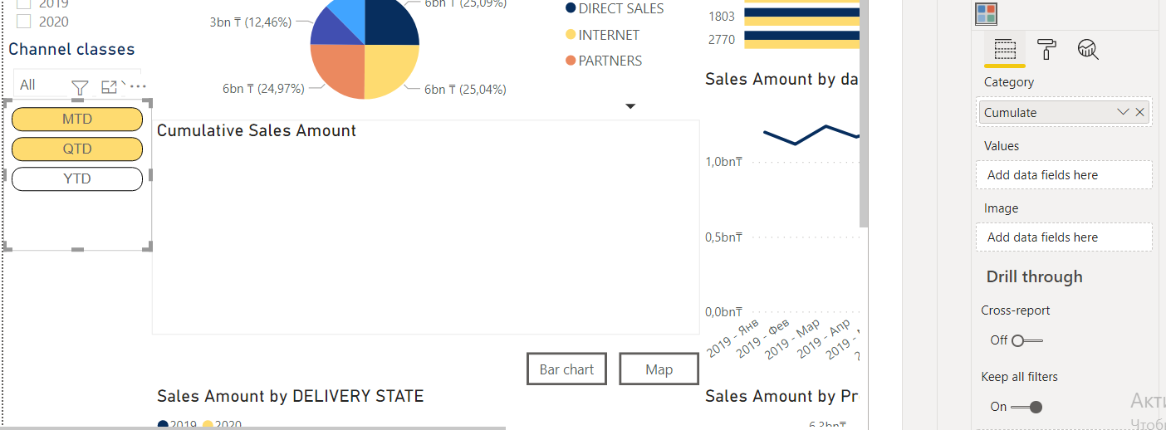

The way as it works you can see on the line chart

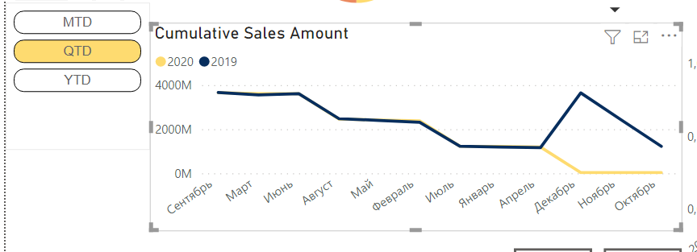

# CREATING TOOLTIPS BASED ON REPORT PAGE

# Tooltip page .

# 

# How tooltip page works.

