PROJECT READINESS REPORT
Bariatric Digital Care Platform
A digital care pathway for a bariatric and general surgery clinic
Prepared for Ali — Product Owner · Medical Reviewer · Technical Operator
Prepared by Claude Code
Date 16 September 2026
Status Pre-approval draft — no code written, nothing approved
Repository bariatric-care/ · branch claude/bariatric-platform-readiness-d9rp2o

Two markers are used throughout, and both mean “not settled”.
[MEDICAL REVIEW REQUIRED] Clinical content or a clinical rule. Not approved until the Medical Reviewer approves it in writing. Nothing clinical in this report was invented.
[DECISION REQUIRED] A product, legal or infrastructure decision that cannot be derived from engineering reasoning alone.
This platform is not an emergency service, not a monitoring service, and not a diagnostic device. No component autonomously diagnoses, recommends treatment, changes medication, or reassures a patient that a symptom is benign.

Contents
If the entries below appear empty, select them and press F9 in Word to build the table of contents.

ملخص تنفيذي
منصة الرعاية الرقمية لجراحة السمنة — تقرير الجاهزية
أُعدّ لـ: علي — Product Owner و Medical Reviewer و Technical Operator
الحالة: ما قبل الاعتماد. لم يُكتب أي كود. لا شيء في هذا التقرير معتمد.

ما هذا المستند
استجابة لطلبك بعدم البدء بالبرمجة قبل تقييم القدرات والمعمارية. يحتوي التقرير كل ما طلبته: الفهم، الافتراضات، القرارات الناقصة، مصفوفة القدرات، سجل المخاطر، مقارنة الـStack، المعمارية، نقد الـMVP، خارطة الطريق، نقاط التدخل البشري، محركات الكلفة، والأسئلة.
كل ما فيه محفوظ داخل الـrepository وليس في ذاكرة محادثة — تنفيذاً لقاعدتك التي تقول إن القرارات المهمة لا تعيش في الـchat.
المنهجية: لم أكتب هذا من فراغ. مساحة العمل هذه تحتوي student-os — نظاماً بحجم مشابه بنيته أنت بنفس الـAI workforce، وفيه ADRs وCI حقيقي وطبقة صلاحيات مختبرة وسكربتات نسخ احتياطي واسترجاع ومستندات جاهزية App Store. قرأته كاملاً. كل ادعاء بالقدرة هنا مسنود بدليل من هناك — بما في ذلك فشلاه الموثّقان.

الخلاصة في ثلاث جمل
المنتج ليس تطبيق متابعة تستخدمه عيادة، بل نظام workflow سريري له سطح لجمع بيانات المريض. وحدة القيمة ليست «وزناً مسجّلاً» بل متابعة تم إنقاذها. وأخطر ما في المشروع ليس الكود، بل أن يعمل النظام بشكل صحيح تماماً فيوهم المريض بوجود مراقبة طبية غير موجودة.

القدرة الحقيقية — رقمان لا رقم واحد
المقياس | النسبة
من الـartifacts التقنية (كود، اختبارات، CI، توثيق) | 75–85%
من المشروع ككل | 40–50%

الفجوة بينهما هي الجواب الصادق. نصف هذا المشروع ليس artifacts أصلاً: محتوى طبي، قرارات منتج، تشغيل، validation سريري، بناء ثقة مع طاقم العيادة، موقف قانوني، وإطلاق. أنا قوي جداً في النصف الأول، وعاجز بنيوياً عن النصف الثاني.

ثلاثة مواقف أحاجج عنها، وهي التي تستحق أن تخالفني فيها
الأول — الـDashboard هو المنتج، والتطبيق sensor. النظام يجب أن ينتج قيمة عند صفر تبنٍّ من المرضى: إذا استطاعت الممرضة إدخال الوزن وبقيت قائمة المتابعات المتأخرة تعمل، فالعيادة تستفيد من اليوم الأول. لذلك أوصي ببناء وإطلاق الـDashboard قبل تطبيق المريض. هذا يزيل المجهول الأكبر (سلوك المريض) من المسار الحرج، ويُخرج App Store منه أيضاً.
الثاني — الـMVP المقترح أكبر بـ40% تقريباً، وتنقصه خمسة أشياء تمنع الإطلاق. أربعة بنود في قائمتك ليست features بل أنظمة كاملة. والناقص: تدفّق تسجيل المريض (أكثر شيء يُنسى، وإذا كانت الإجابة «نرسل له رابطاً» فالتبنّي سينهار)، وإدخال العيادة نيابة عن المريض، وحذف الحساب، وشاشات الموافقة والتنبيه الطبي، وإدارة حسابات الطاقم.
الثالث — الـAPI يعمل كـcontainer طويل العمر لا كـserverless. هذا ليس رأياً عاماً: student-os دفع ثمنه فعلاً — شُحنت الـfunction بدون ثلاث من dependencies فأعطى production خطأ 502 على كل request بينما كل فحوصات CI خضراء، لأن لا شيء كان يختبر ما يُنشر فعلاً.

أكبر خمسة أشياء قد تقتل المشروع
1. انهيار تفاعل المرضى — الاحتمال الأعلى بفارق كبير، ومشكلة product لا يحلّها أي كود.
2. عدم اكتمال المحتوى الطبي — أنت المصدر الوحيد لكل بروتوكول ونص، وأنت جرّاح ممارس. أقتل شيء للجدول الزمني.
3. خلل في صلاحيات الوصول يكشف بيانات مرضى — قابل للنجاة تقنياً، وغير قابل للنجاة سمعةً لطبيب معروف بالاسم في مجتمع محلي.
4. نظام الإنذار ينشئ واجب رعاية لا أحد مُخصَّص للوفاء به.
5. أنت كنقطة فشل وحيدة — قبل الإطلاق يوقف المشروع، وبعده يوقف رعاية مرضى.
ملاحظة على شكل سجل المخاطر: المخاطر التي سـتقتل هذا المشروع ليست هندسية. الطبقة الأولى كلها product وناس وانضباط. والمجهود يذهب طبيعياً إلى الطبقة الهندسية، وهي الأقل أهمية.

هل يستطيع شخص واحد + Claude + Codex إطلاق MVP احترافي؟
نعم — بشروط، ولنطاق ضيّق عمداً. والدليل عندك: student-os بُني بهذه الطريقة ووصل إلى حالة production حقيقية. لكن مستندات تدقيقه نفسها تسجّل ما يخطئ فيه هذا النموذج: ملف CI في المجلد الخطأ جعل المراحل صفر حتى خمسة كلها تُدمج بلا أي فحص يعمل، وانقطاع production لم تلتقطه أي علامة خضراء. الفشلان هما نفس الفشل: الفحوصات لم تكن تختبر ما يُنشر فعلاً.
أربعة شروط إن أُسقط أيٌّ منها لتوفير الوقت، يصبح جوابي: لا.
1. لا اختصارات في طبقة الصلاحيات أبداً.
2. استرجاع نسخة احتياطية مُختبَر فعلياً قبل وجود بيانات مرضى حقيقية.
3. لا محتوى طبي من AI إطلاقاً.
4. مراجعة أمنية بشرية ومراجعة إصدار قبل المرضى الحقيقيين.

أرخص فريق واقعي
أنت متفرغاً · Claude Code للتنفيذ · Codex للمراجعة والاختبارات · مهندس senior بدوام جزئي 4–8 ساعات أسبوعياً · مراجعة أمنية واختبار اختراق (3–5 أيام، مرة) · مراجعة قانونية (2–3 أيام) · مهندس إصدار iOS (5–10 أيام) · المنسّق واختصاصي التغذية من طاقم العيادة الحالي.
كل بند لا أتنازل عنه في هذه القائمة هو إنسان. والبند الأرجح أن يُشطب هو المهندس الجزئي، وهو الذي أدافع عنه بأشدّ ما أستطيع: قيمته ليست الكود، بل أن شخصاً غير منحاز لصحة الكود ينظر إليه، وأن يوجد شخص غيرك يمكن الوصول إليه حين ينكسر production.

ما المطلوب منك الآن
أولاً — أجب الأسئلة الاثني عشر. كل سؤال معه توصيتي، فيكفي أن تكتب «موافق» حيث توافق. أهمها: طريقة دخول المريض، وهل واتساب قناة رسمية، ومكان استضافة البيانات، ومن المسؤول القانوني عن البيانات.
ثانياً — ابدأ المحتوى الطبي اليوم. الأقسام CC-1 (العمليات) و CC-2 (مراحل ما بعد العملية) و CC-8 (حقول تسجيل المريض) تحديداً. كل حقل تركته فارغاً عمداً — لن أخترع أي بروتوكول طبي، لأن بروتوكولاً مخترعاً سيبدو صحيحاً وهذا أخطر ما يمكن أن يحدث في هذا المشروع. المحتوى الطبي هو أطول بند زمنياً في المشروع كله وهو على المسار الحرج.
ثالثاً — ابدأ تسجيل حساب Apple Developer الآن. مدته أسابيع وهو على المسار الحرج أيضاً، وبدؤه لا يكلّف شيئاً.
المسار الحرج ليس هندسياً: المحتوى الطبي ← قرار القناة ← المراجعة القانونية ← حساب Apple. ولا واحد منها كود.

لن أبدأ البرمجة
حتى تكتب حرفياً: ARCHITECTURE APPROVED — START MILESTONE 1

PART I

Project Readiness Report
Project: Bariatric Digital Care Platform Prepared for: Ali — Product Owner, Medical Reviewer, Technical Operator Status: Pre-approval. No code written. Nothing in this report is approved. Date: 2026-09-16

PART 1 — Understanding

1.1 What is actually being built
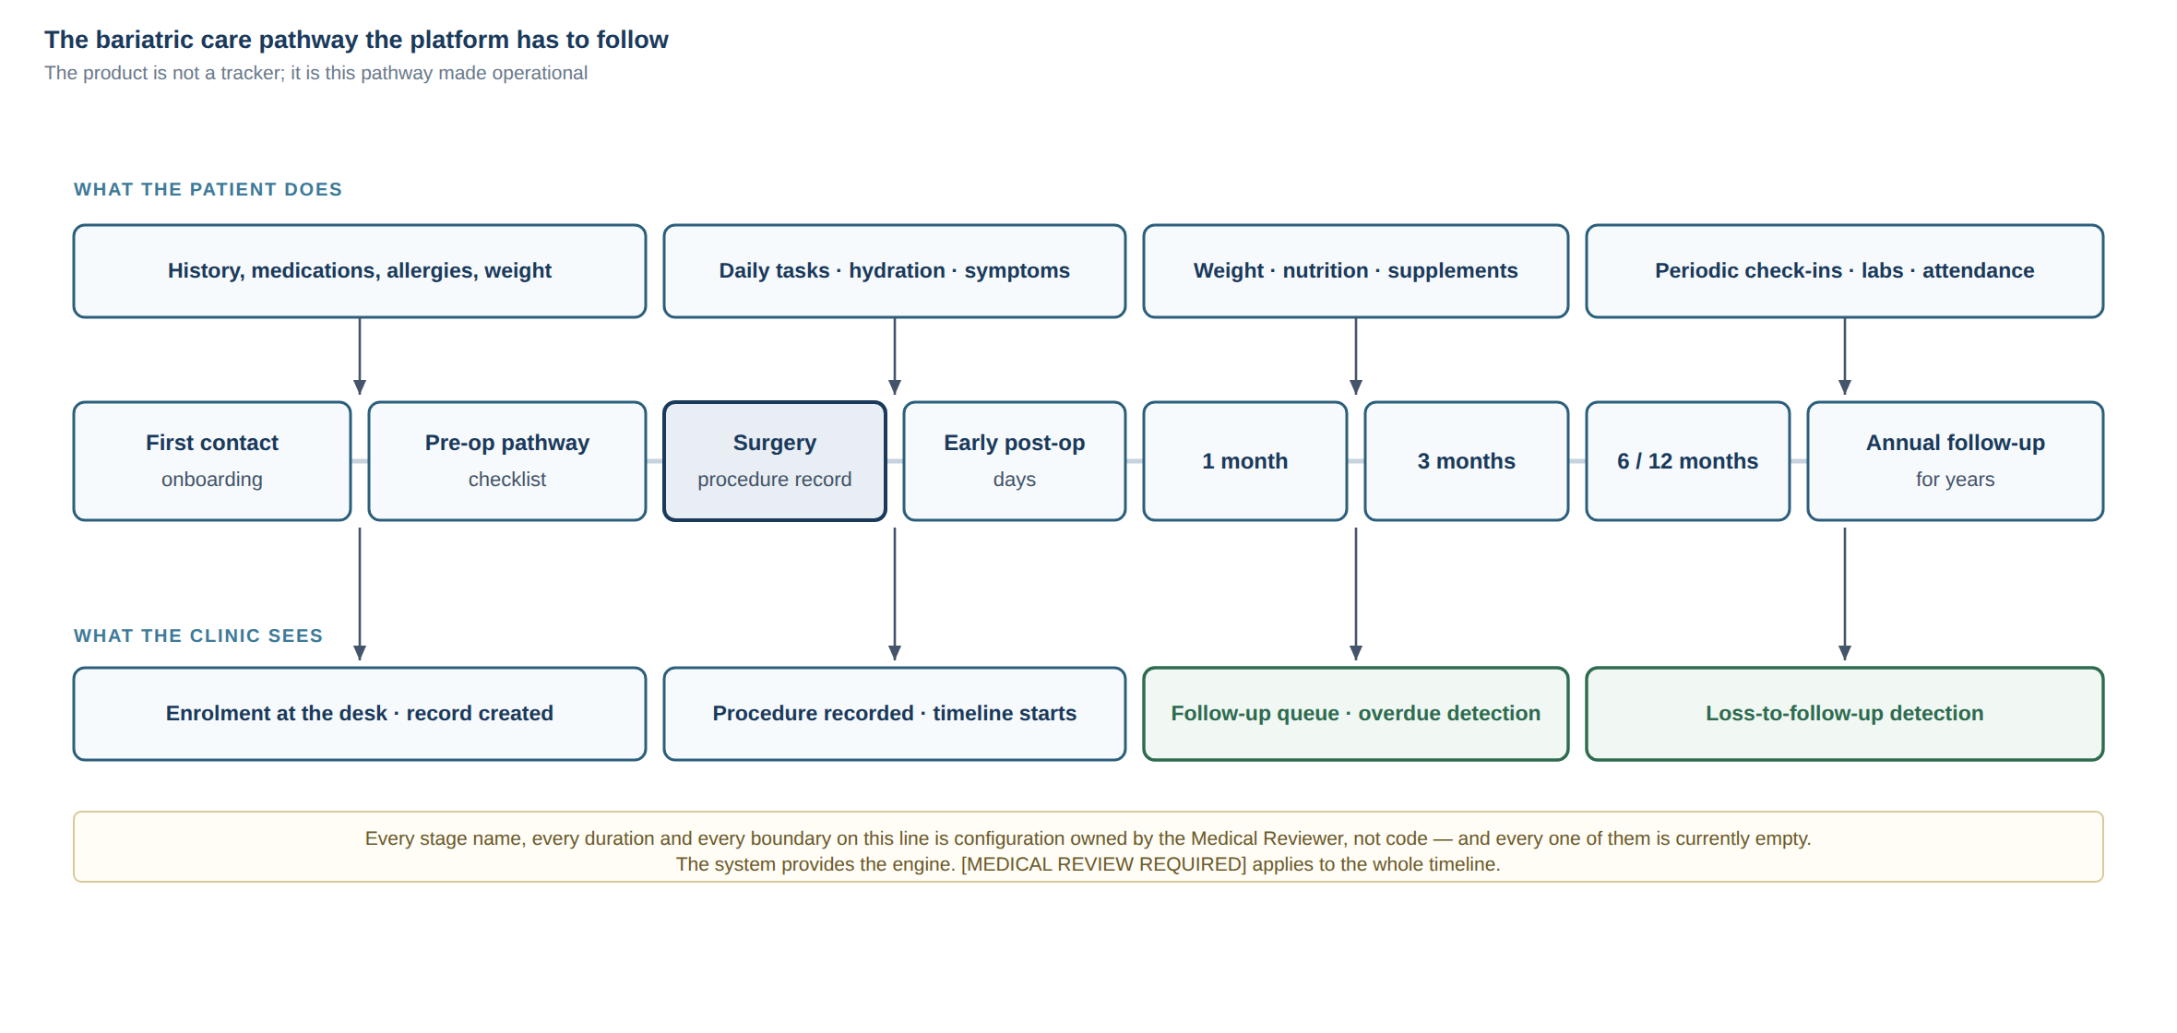
The bariatric care pathway the platform has to follow, and what the clinic sees at each stage.
A Digital Bariatric Care Pathway: a system that follows one patient from first consultation through years of post-operative follow-up, for a clinic seeing 200–500 patients a month.
The distinction that matters most, and that shapes every architectural decision below:
This is not a tracking app that happens to be used by a clinic. It is a clinical workflow system that happens to have a patient-facing data-collection surface.
A weight tracker's unit of value is a logged weight. This product's unit of value is a resolved follow-up — a patient who was drifting out of care, was detected, was contacted, and came back. Everything else (weight, hydration, protein, supplements, symptoms) is instrumentation that feeds that outcome.
If that framing is accepted, three consequences follow immediately:
1. The dashboard is the product; the app is a sensor. The commercial value lives in the surgeon's screen — the ranked, filtered, actionable list of who needs attention today. The patient app exists to keep that list accurate.
2. Patient engagement is the single biggest product risk, not a nice-to-have metric. Every downstream feature's value multiplies by the engagement rate. At 20% engagement, a beautifully engineered nutrition module is worth almost nothing.
3. The system must produce value at zero patient app adoption. If a nurse can enter a weight and the dashboard still surfaces overdue follow-ups, the clinic gets value on day one, and patient adoption becomes upside rather than a precondition. This is the most important design constraint I would add to the brief, and it is not in it.

1.2 The three hard problems
Most of this system is ordinary CRUD. Three parts are genuinely hard and deserve disproportionate design attention, review and testing:
(a) The pathway/protocol engine. Clinical content must be data, not code — so the surgeon can change the protocol without a developer. The hard part is not running the engine; it is versioning. When the doctor changes the week-2 diet phase in March, a patient who completed week 2 in January must still be interpretable under the protocol that was actually in force for them. Get this wrong and the historical dataset becomes scientifically and legally worthless. This is why protocol definitions must be immutable-and-versioned, and every patient must be pinned to a protocol version.
(b) Authorization. Not "is the user logged in" but "may this actor see this patient's row". Every list query, every file, every export, every AI retrieval call. One missed check is a patient-data breach. The correct shape is a single policy layer of pure functions used by every path with no privileged bypass — the pattern already proven in ../student-os (ADR-0003).
(c) The alert engine. This is the highest-risk component in the entire product, for clinical, legal and reputational reasons simultaneously. The engineering is easy. The danger is that a working alert engine creates a false impression of monitoring. A patient who submits a symptom at 2 a.m. and receives a calm confirmation screen may reasonably infer someone is watching. Nobody is. That gap — between what the software implies and what the clinic actually staffs — is how this project hurts someone.

1.3 Safety position I am designing to
Derived from the handoff (§17, §32, §96, §97, §98) and stated here as engineering constraints, not aspirations:
- No autonomous diagnosis, treatment recommendation, medication change, or surgical advice. Not by rules, not by AI.
- Absence of an alert is never reassurance. The app must never state or imply that a patient is fine. There is no "all clear" screen. This is a copy constraint enforced in design review.
- Every symptom intake states, at the moment of submission, the expected response window and the emergency instruction. "Reviewed during clinic hours. For severe symptoms, go to the nearest emergency department / call X." Anything less overpromises.
- Alerts route to a human queue. The rule decides routing, never meaning.
- Clinical content is authored by the Medical Reviewer, versioned, and approved before it can be served. No clinical string ships from a developer's keyboard.

1.4 What the clinic actually gets
Stated plainly, so we can test whether we delivered it:
- The surgeon opens one screen and sees who needs attention today, ranked, with a reason.
- Nobody disappears silently. A patient who misses a 6-month follow-up becomes visible.
- The doctor's protocol is configuration the doctor controls, not code a developer owns.
- Every clinically meaningful action has an auditable record of who did what, when.
- The patient has a simple, Arabic-first app that tells them what to do today.

PART 2 — Assumptions
These are assumptions, not facts. Each one that is wrong changes the design. Correct any that are wrong before approval.

Users and context
# | Assumption | If wrong, what changes
A1 | Patients are predominantly in Iraq, Arabic-speaking, with mixed digital literacy. Arabic is the primary language, English secondary. | UX, content pipeline, RTL priority
A2 | Android dominates the patient base; iOS is a meaningful minority that still must be supported. | Release order, test-device matrix
A3 | Phone number — not email — is the natural patient identifier. Many patients have no email address they check. | Authentication design (major)
A4 | Some patients share a phone, or have a family member operate the app for them. | Account model, consent, future caregiver role
A5 | Mobile data is intermittent; patients are often on 3G/weak LTE. | Client caching, retry, offline tolerance
A6 | WhatsApp is the dominant communication channel culturally; the clinic already uses it informally. | Notification channel strategy (major)
A7 | Clinic staff = surgeon + 1–3 people (coordinator/nurse, dietitian, admin). Not a large team. | RBAC realism, workflow design
A8 | The clinic is not staffed 24/7 and will not become a monitoring service. | All alert/symptom copy and SLAs

Product and clinical
# | Assumption | If wrong, what changes
A9 | Greenfield. No existing EMR to integrate with; current records are paper or ad-hoc digital. | Migration scope, integration scope
A10 | No HL7/FHIR interoperability requirement at MVP, but the data model should not preclude it later. | Data model conventions
A11 | All clinical content (diet phases, red flags, lab schedules, supplement protocols, patient copy) is supplied and approved by the Medical Reviewer. Nothing clinical is invented by AI. | Non-negotiable
A12 | Version 1 serves one clinic and one surgeon, but must not foreclose multi-clinic SaaS. | Tenancy strategy
A13 | Payments, billing and subscriptions are out of scope for MVP and Phase 2. | Scope
A14 | The platform is not a regulated medical device in its launch jurisdiction under its launch feature set. This is an assumption, not a legal finding. | Everything. Needs legal review.

Engineering and operations
# | Assumption | If wrong, what changes
A15 | Ali operates cloud, deployments and service accounts, and is technical enough to run a CLI, read logs, and manage secrets. | Ops model, runbook depth
A16 | Budget is bootstrapped, not funded. Infrastructure choices are cost-sensitive. | Stack, hosting
A17 | Timeline is months, not weeks. A rushed MVP is more dangerous here than a late one. | Roadmap
A18 | No hard legal requirement (yet known) forcing data residency inside Iraq. Assumption. Needs legal review. | Hosting region, provider
A19 | ../student-os in this workspace is a valid capability reference: the same Product Owner and the same AI workforce already shipped a modular-monolith TypeScript system with CI, integration tests, E2E journeys, RTL/a11y audits, backup-restore drills and App Store readiness documentation. | Confidence levels throughout this report
A20 | Two AI agents (Claude Code, Codex) plus Ali form the working team, with a part-time human engineer available. | Ways of working
A21 | Patient-facing content and notifications must never expose clinical detail on a lock screen. | Notification payload design

Assumptions I explicitly refuse to make
- That HIPAA, GDPR or any specific framework applies. Iraqi law governs; I do not know it. I will apply equivalent engineering practice as a baseline, and will not claim compliance with anything.
- That patients will engage because the app is good. They mostly will not, unless the clinic actively enrolls them face-to-face.
- That any clinical threshold, formula (%TWL, %EWL), phase duration, or symptom list is correct. All are [MEDICAL REVIEW REQUIRED].

PART 3 — Missing Decisions
Decisions I cannot make from engineering reasoning. Grouped by what they block. The blocking ones are restated as direct questions in 06-OPEN-DECISIONS.md.

Blocks architecture (needed before Milestone 1)
1. Patient authentication method. Phone+OTP is the natural fit for A3, but OTP in Iraq has real cost and deliverability problems. This decision has a cost tail and changes the identity module fundamentally.
2. Is WhatsApp a supported channel? It changes the entire notification architecture, adds a business verification process, and may be the difference between 30% and 80% reminder reach. This is the highest-leverage open decision in the project.
3. Hosting provider and region, which follows from the data-residency answer.
4. Legal data controller identity — the doctor personally, a clinic entity, or a company. This determines who signs provider contracts and owns the data.
5. Tenancy posture for v1 — I have a recommendation (clinic_id present from day one, single-tenant deployment) but it needs confirmation because it has a small ongoing cost.

Blocks scope (needed before Milestone 1 planning)
6. Dashboard-first or app-first? I recommend dashboard-first (see §1.1 and 05-MVP-AND-ROADMAP.md). This reverses the natural instinct and needs an explicit decision.
7. Is in-app messaging in MVP? The handoff leaves it open. I recommend no.
8. Is there an existing patient database to migrate? Changes Milestone 2 entirely.
9. Pilot size and date. How many patients, when, and who selects them.

Blocks clinical work (needed before Milestone 6+, but start now — long lead time)
10. All items in 09-CLINICAL-CONTENT-REQUESTS.md. These have the longest lead time of anything in the project and are the most likely critical-path bottleneck.

Blocks launch (needed before Milestone 11, decide early anyway)
11. Apple Developer account type — individual vs. organization. Medical/health apps submitted under an individual account draw more scrutiny and the entity name appears publicly. Changing later is painful.
12. Who is the legal reviewer, and when they are engaged.
13. Branding — clinic name, logo, colours, app name, domain.

PART 4 — Capability Matrix
See 01-CAPABILITY-ASSESSMENT.md for sections A–D and the full matrix.

PART 5 — Risk Register
See 02-RISK-REGISTER.md.

PART 6 — Recommended Stack
See 03-STACK-EVALUATION.md.

PART 7 — Architecture
See 04-ARCHITECTURE-DRAFT.md.

PART 8 — MVP Recommendation · PART 9 — Roadmap
See 05-MVP-AND-ROADMAP.md.

PART 10 — Human Intervention Points
See 08-WAYS-OF-WORKING.md.

PART 11 — Cost Drivers
See 07-COST-DRIVERS.md.

PART 12 — Questions for Ali
See 06-OPEN-DECISIONS.md.

The ten direct answers

1. What proportion of this project can Claude Code actually execute?
Two numbers, because one number would be misleading.
Of the code and technical artifacts: 75–85%. Of the project as a whole: 40–50%.
The gap between them is the honest answer. A software project of this type is roughly half engineering artifacts and half things that are not artifacts at all: clinical content, decisions, operations, validation, trust-building with staff, legal posture, and launch. Claude Code is very strong at the first half and structurally incapable of the second.
Dimension | Claude Code share
Backend code, API, data model, migrations | 90%
Authorization logic and its tests | 85% (the 15% is adversarial human review)
Dashboard web app | 85%
Patient mobile app code | 80% (build/signing/store is not code)
Tests (unit, integration, authorization, E2E) | 90%
CI/CD configuration | 90%
Documentation, ADRs, runbooks | 95%
Infrastructure-as-code | 75% (writing it, not owning the accounts)
Clinical content | 0%
Product decisions and prioritisation | 0%
Legal, privacy, regulatory posture | 0%
Production operation and incident response | 20% (writes the runbook, cannot be paged)
Store submission and release | 10%
Clinical validation and pilot | 0%

Treat the headline as ~80% of the typing and ~45% of the project.

2. What can Codex help with or review?
Codex is most valuable where an independent second opinion beats a larger volume of first-opinion output. Concretely:
- Adversarial review of authorization, as a different model reading the policy layer cold and trying to find a path where patient_id is not constrained.
- Test generation from contracts — given the API contract and the policy functions, write the negative tests, not the happy path.
- Security review of specific surfaces: authentication, file access and signed URLs, file upload handling, rate limiting, input validation.
- Medical rule test cases — given an approved rule with a version and a threshold, enumerate boundary and off-by-one cases (at the threshold, one below, missing data, stale data, duplicate submissions).
- Second opinion on data model before migrations are written, when changing is cheap.
- Dependency and license review.
- Reviewing my code when I wrote it, and vice versa — with the rule that neither agent's output is accepted because the other agent approved it. Ali accepts.
Where Codex is not useful: as a parallel feature factory on the same surface. Two agents implementing adjacent features in the same module produces merge chaos and inconsistent conventions. One owner per feature, one reviewer per feature.

3. What must Ali do personally?
Nothing on this list can be delegated to any AI:
- All clinical content and its approval. Diet phases, durations, red-flag criteria, symptom lists, lab schedules, supplement protocols, medication rules, alert thresholds, and the exact Arabic wording of anything a patient reads that touches their health.
- Product decisions: scope, priority, what ships, what waits, what gets cut.
- Acceptance. Final accept/reject on every feature. Neither agent accepts its own or the other's work.
- Cloud accounts, billing, secrets, service accounts, production credentials.
- Production deployment authorisation, and the decision to put real patients on it.
- The pilot: selecting patients, enrolling them face-to-face, gathering feedback.
- Clinic staff buy-in. The coordinator and dietitian have to want to use this. That is a human relationship, and it is a genuine project risk if neglected.
- Engaging the legal reviewer, the security reviewer, and the human developer.
- Being the escalation point when an alert fires and someone must act.

4. What needs a human developer?
- Apple Developer Program enrolment, certificates, provisioning profiles, signing.
- App Store and Google Play submission, review responses, rejection appeals.
- Final device testing on real hardware — a range of actual Android phones including old and low-end ones, and real iPhones. Emulators do not surface the failures that matter (fonts, Arabic shaping, notification behaviour, background restrictions on Chinese-OEM Android skins, battery optimisation killing reminders).
- Native module work if it becomes necessary (health platform integrations, background tasks, push edge cases).
- A release engineering pass before first production launch — someone experienced looking at the whole deploy path and saying "yes" or "no".
- Being on call. An AI cannot be paged at 3 a.m.
- Independent architecture review at Milestone 0 and Milestone 9. Ideally 4–8 hours of a senior engineer's time, twice, from someone with no stake in the code being right.

5. What needs a security, legal or medical specialist?
Security specialist (one-off engagements, not full time):
- Penetration test before production launch, focused on broken access control and IDOR — the failure mode most likely here and the one automated tooling finds worst.
- Review of the authentication and session design before it is built, not after.
- Review of the file access and signed-URL design.
- Infrastructure review: network exposure, database reachability, secrets handling.
Legal / privacy reviewer (local to the launch jurisdiction):
- What law actually governs patient health data here, and what it requires.
- Whether this product is a regulated medical device under its launch feature set.
- Data controller identity, retention obligations, deletion rights, consent wording.
- Privacy policy, terms of service, medical disclaimer.
- Cross-border data transfer position if hosting is outside the country.
- Liability posture for the alert feature specifically.
Medical specialist — this is Ali, plus:
- A dietitian to validate the nutrition module against real practice.
- The clinic nurse/coordinator to validate that the follow-up workflow matches reality. Not optional: a dashboard that does not match how the clinic actually works will be abandoned regardless of code quality.
- Ideally a second bariatric surgeon reviewing the red-flag rules, because a single reviewer is a single point of clinical failure.

6. The five things most likely to kill this project
1. Patient engagement collapses, and the data dries up. Patients install, use it for two weeks, and stop. The dashboard empties. The clinic concludes it does not work. This is the most likely failure mode by a wide margin, and it is a product problem that no amount of engineering fixes. Treatment: design for value at zero patient adoption (staff-entered data), enroll patients face-to-face at the clinic rather than by sending a link, keep the patient app brutally small, and measure engagement from the first pilot patient.
2. Clinical content never gets finished. Ali is the sole source of every diet phase, red flag, threshold and patient-facing sentence, while also being the Product Owner, the Technical Operator, and a practising surgeon. The engine gets built and sits empty. This is the most likely schedule killer. Treatment: start clinical content now, in parallel with Milestone 0; treat it as the critical path; ship with a deliberately small approved content set rather than waiting for completeness.
3. An access-control defect exposes patient data. One missing scope check in one list query. It is survivable technically and possibly not survivable reputationally for a named surgeon in a local community. Treatment: single policy layer, authorization tests as a first-class suite that runs on every commit, adversarial review by the second agent, and a human penetration test before launch. No exceptions for MVP speed.
4. The alert system creates a duty of care nobody is staffed to meet. A patient reports a symptom, the app confirms receipt, and nobody looks until Sunday. Treatment: explicit response-window copy at submission, no "all clear" state ever, a named human owner for the queue with a defined review cadence, and a hard product rule that a channel the clinic cannot staff does not ship.
5. Single point of failure: Ali. Product owner, medical reviewer, technical operator, deployer, secret holder, escalation point. Illness, travel, or a busy operating month stops the project entirely — and after launch, stops patient care workflows. Treatment: everything in the repository (§63), runbooks written for a stranger, a second person with break-glass production access, and a part-time human engineer who already has context before they are needed.

7. Can one person plus Claude Code and Codex launch a production-grade MVP?
Yes — with conditions, and only for a deliberately narrow MVP.
Precedent matters here: ../student-os in this workspace was built this way and reached a genuinely production-shaped state — real CI with integration and E2E gates, an authorization layer with unit tests, backup and restore drills, a documented security posture, App Store readiness audits. That is evidence, not optimism.
But that project's own audit documents also record what this model gets wrong: a CI workflow that sat in the wrong directory so phases 0 through 5 all merged with no CI running at all, and a production outage from a packaging failure that every green check had missed. Both are the same failure: the checks were not testing the thing that actually ships. That is the characteristic failure mode of AI-led development, and it is worth more than any general warning about AI code quality.
The conditions I would not compromise on:
1. Authorization is never shortcut for speed. It is the one thing that cannot be fixed after a breach.
2. CI is real, runs on every commit, and is verified to actually be running. A green check that tests nothing is worse than no check.
3. The pipeline tests the deployed artifact, not the source tree.
4. A tested restore, before real patient data exists. A backup that has never been restored is a file, not a backup.
5. No clinical content invented by AI. Ever. Every clinical string traceable to an approved, versioned source.
6. One feature at a time, through the full gate: acceptance criteria → plan → implementation → tests → review by the other agent → demo → Ali approves.
7. A human security review and a human release review before real patients. Two one-off engagements. This is the cheapest insurance in the project.
8. Staging is real and patients are never the test environment.
9. A pilot of 10–20 patients before the full panel, with the explicit expectation of finding workflow problems, not bugs.
10. Scope discipline. The realistic failure is not bad code, it is a half-finished product with thirty features at 70%.
If any of 1, 4, 5 or 7 is dropped to save time, my answer changes to no.

8. Where is 100% reliance on AI dangerous?
- Clinical content and rules. An AI producing a plausible-sounding post-op diet progression is the single most dangerous thing that could happen in this project, precisely because it would look right.
- Authorization. I will write correct-looking policy code and correct-looking tests for it. Tests written by the same author as the code share the author's blind spots.
- Anything where "it compiles and the tests pass" is mistaken for "it works." See the CI and packaging failures cited above.
- Production operations and incident response. I cannot be paged, cannot notice a gradual degradation, cannot judge whether to roll back at 2 a.m.
- Legal and regulatory judgement. I will produce confident, fluent, and possibly wrong statements about Iraqi law. Treat any such statement from me as unreliable.
- Knowing whether the clinic will actually use it. I cannot observe the clinic.
- Patient-facing tone in Arabic. I can write fluent Arabic; I cannot judge whether a sentence lands correctly for a 55-year-old patient in Baghdad. That needs a human ear.
- Judging clinical significance. I can tell you a weight dropped 12%. I cannot tell you whether that matters.

9. Where does AI give the biggest speed and cost advantage?
- Schema, migrations, contracts and API layer. Mechanical, high-volume, rule-driven.
- Test suites, especially the tedious authorization matrix (every role × every resource × every operation) that a human team writes badly because it is boring.
- Two client surfaces from one contract — dashboard and mobile staying in sync.
- Arabic/English bilingual UI with RTL, done from the start instead of retrofitted.
- Documentation, ADRs, runbooks — normally the first thing a small team drops, and the thing this project most needs (§63).
- CI/CD configuration and infrastructure-as-code.
- Refactoring under test. Large mechanical changes that a human team avoids.
- Exploring a design in prose before building it — which is exactly what this document is, and it cost hours instead of a week of meetings.
Realistically this is the difference between a 4–6 person team and a 1 person + 2 agents + part-time specialist team, for the construction phase. It does not compress the clinical content phase, the pilot, or the launch.

10. The cheapest realistic team that can still launch professionally
Role | Who | Commitment | Non-negotiable?
Product Owner + Medical Reviewer | Ali | Significant and sustained | Yes
Technical Operator (cloud, secrets, deploys) | Ali | Ongoing | Yes
Primary implementer | Claude Code | Per milestone | —
Independent reviewer / test author | Codex | Per milestone | Yes (some second reviewer)
Senior engineer, retained | Human, part-time | ~4–8 hrs/week, plus 2 deep reviews at M0 and M9 | Yes
Security review + penetration test | Human, one-off | ~3–5 days before launch | Yes
Legal / privacy review | Human, one-off + annual | ~2–3 days | Yes
iOS release engineer | Human, one-off | ~5–10 days at launch | Yes
Clinic coordinator / nurse | Existing clinic staff | A few hours/week as pilot user and workflow validator | Yes
Dietitian | Existing clinic staff | A few hours for nutrition module validation | Yes
Arabic UX / copy review | Human, one-off | 2–3 days | Recommended
Second bariatric surgeon (rule review) | Human, one-off | 1–2 days | Recommended

That is one full-time person, two AI agents, one part-time engineer, and roughly four short specialist engagements. It is genuinely much cheaper than the 5–7 person team this scope would normally imply — but note that every entry marked non-negotiable is a human, and three of them are humans doing things no AI can do at any budget.
The retained part-time senior engineer is the line item most likely to be cut and the one I would argue hardest to keep. Their value is not code. It is that somebody who is not invested in the code being right looks at it, and that somebody other than Ali can be reached when production breaks.

PART II

Capability Assessment
Sections A–D of the Readiness Report, plus the capability matrix (PART 4).
Capability claims here are calibrated against ../../student-os in this workspace — a system of comparable complexity built by the same Product Owner with the same AI workforce. Where I claim "I can do this", that repository generally contains evidence. Where it does not, the claim is marked as untested.

A. What I can build independently
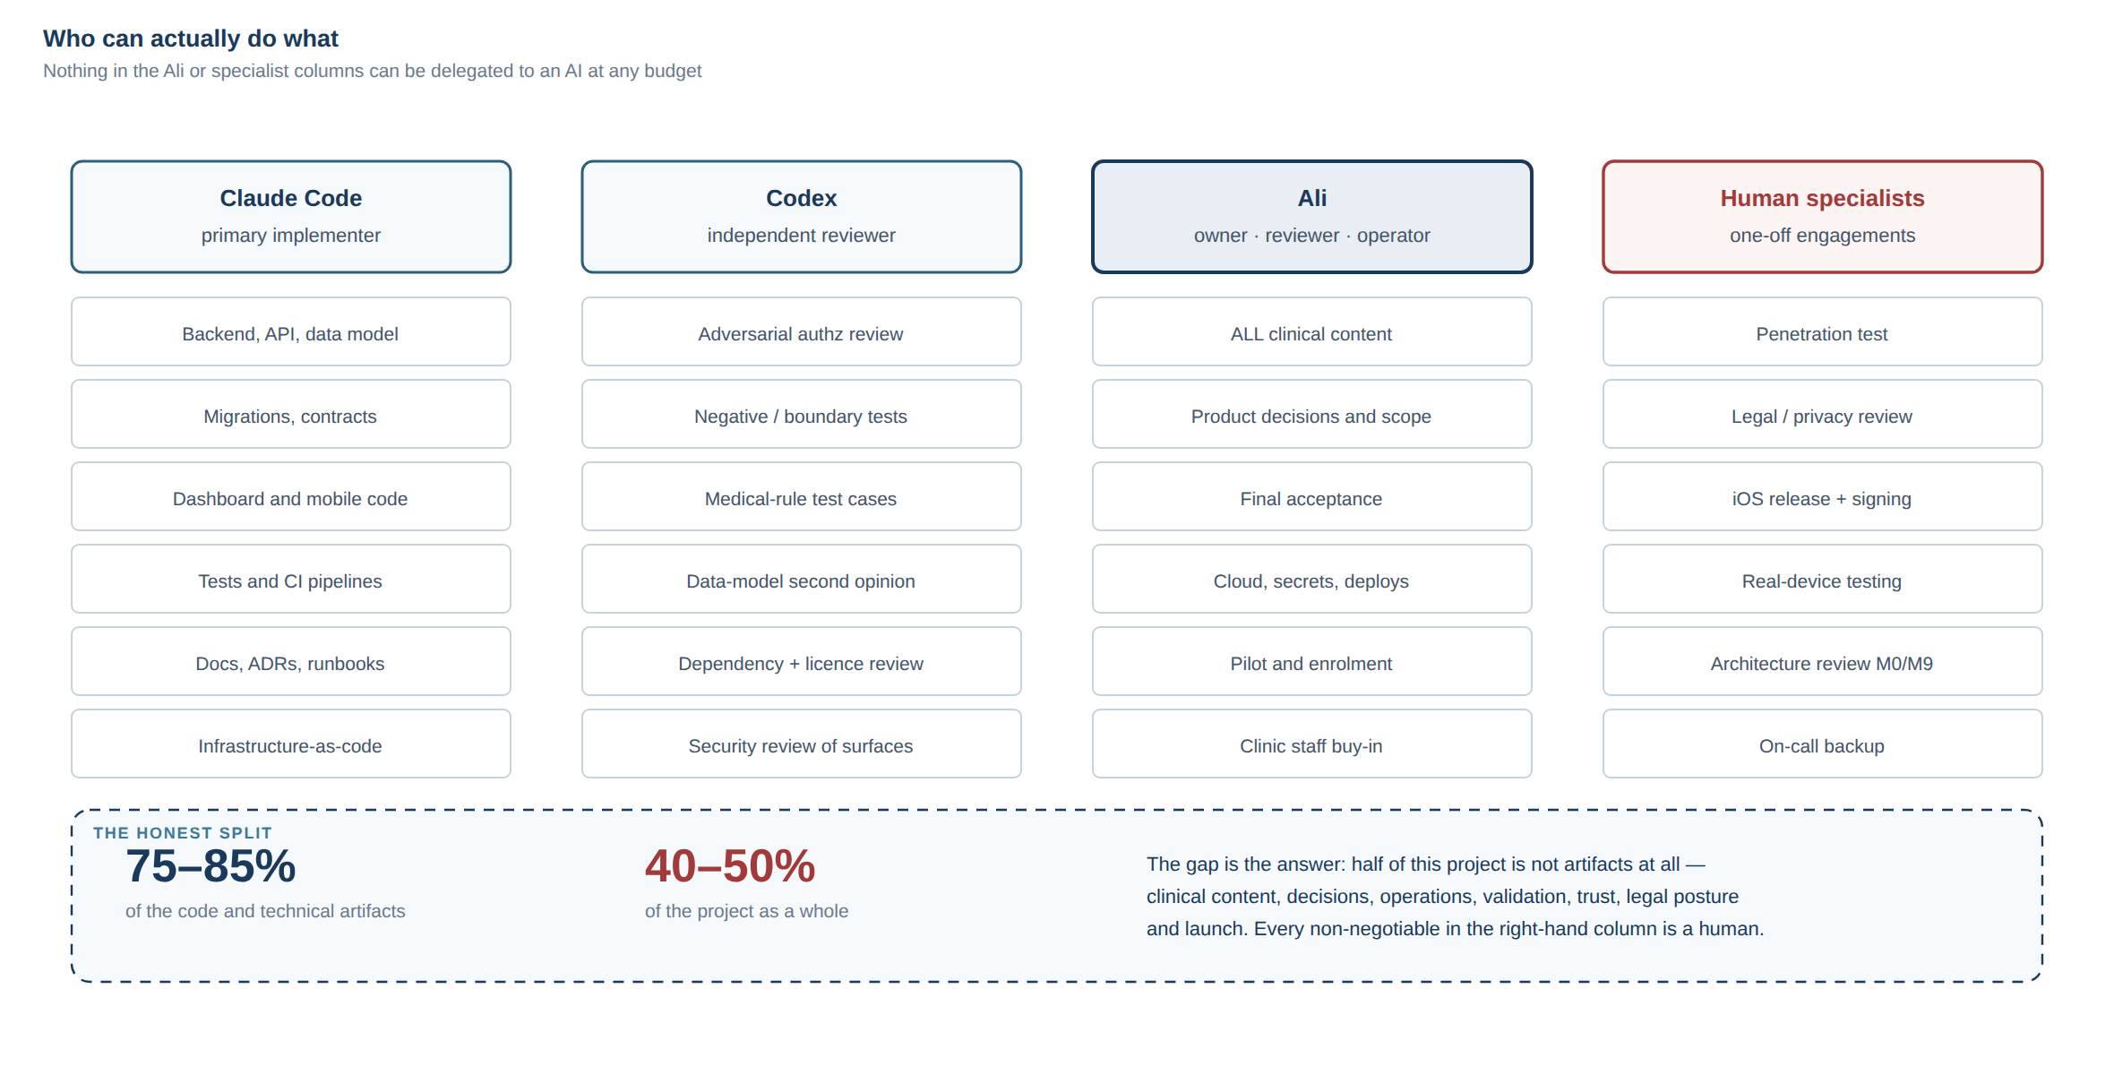
Who owns what — and the gap between 75–85% of the artifacts and 40–50% of the project.
"Independently" means: I can produce it, test it, and hand it over without needing a decision or a credential from anyone. It does not mean nobody should review it.

A1 — Backend API and domain logic
What: A modular monolith exposing a versioned REST API — patient records, surgery records, measurements, appointments, tasks, nutrition entries, supplements, medications, labs, symptoms, alerts, documents, content, notifications, audit, admin configuration.
Technology: TypeScript on Node, Fastify, Zod schemas shared between server and clients as a contracts package, PostgreSQL accessed through parameterised SQL with file-based migrations.
To what level: Production. Request validation on every endpoint, a consistent error envelope, structured logging with redaction, health/readiness endpoints, rate limiting on credential paths, graceful shutdown, transactional writes with a domain-event outbox.
How I test it: Unit tests over pure domain functions; integration tests against a real PostgreSQL in CI (not a mock, not SQLite); a migrations-from-empty assertion that fails the build if the schema cannot be rebuilt from nothing; a smoke suite driving every module over real HTTP.
Risks: I write plausible code faster than anyone can review it. The specific danger is not a syntax error, it is a subtly wrong domain rule that passes tests I also wrote. Mitigation: acceptance criteria written and approved before implementation, and review by the second agent against the criteria rather than against the code.

A2 — Database design and migrations
What: Normalised relational schema, foreign keys, check constraints, indexes, forward-only numbered SQL migrations, seed and demo-data scripts.
To what level: Production, with these properties designed in from the first migration: clinic_id on every tenant-scoped table; created_at/updated_at as timestamptz; soft-delete where clinical retention requires it; append-only history for clinically significant records; data-source attribution on every measurement; protocol version pinning on every pathway assignment.
How I test it: Migrations applied from an empty database in CI with an assertion that every file on disk corresponds to an applied row; integration tests exercising the constraints; explicit tests that a query cannot cross a clinic_id boundary.
Risks: Schema mistakes are the most expensive to correct once real patient data exists. This is why I want a second opinion on the data model before migrations are written — the cheapest possible moment.

A3 — Authorization layer
What: Roles and permissions as data; a single policy module of pure, synchronous functions over a fully resolved actor; scope-pushing into SQL WHERE clauses for list queries rather than fetch-then-filter.
To what level: Production, and this is the component I would build most carefully in the whole system. The pattern is proven in student-os ADR-0003.
How I test it: An exhaustive authorization matrix — every role × every resource × every operation × (own / same clinic / other clinic) — as fast unit tests over pure functions, plus integration tests asserting that a cross-patient request returns the same response shape as a not-found, leaking nothing.
Risks: Highest-consequence component in the system. My tests share my blind spots. This needs adversarial review by the second agent and a human penetration test. I would not accept my own authorization work as sufficient.

A4 — Authentication and session handling
What: Credential handling with a standard memory-hard hash (Argon2id or scrypt — not invented, not rolled by hand), short-lived access tokens with rotating refresh tokens, token revocation, rate limiting and lockout on credential and OTP paths, secure storage on the device, password/OTP reset flows with single-use, expiring, hashed tokens.
To what level: Production for the mechanism. The method (OTP vs password vs magic link) is a decision I cannot make alone — see section B.
How I test it: Integration tests for the full lifecycle including expiry, reuse, revocation and rate limiting; explicit tests that tokens are invalidated on password change and on logout; tests that error responses do not distinguish "no such user" from "wrong password".
Risks: I can implement the mechanism correctly and still have the design be wrong for this user base. And OTP is a cost and deliverability problem before it is a code problem. Design review before implementation, by a human.

A5 — Clinical dashboard (web)
What: Role-aware dashboard — the actionable work queue, patient search with server-side pagination, patient profile with longitudinal timeline, data entry on behalf of patients, alert queue with acknowledgement, appointment management, protocol configuration screens, admin/user management.
Technology: Next.js (App Router) with TypeScript, server-side data fetching, a mature accessible component library rather than hand-rolled widgets, charting for weight and lab trends.
To what level: Production, including loading and error states, empty states, RTL and Arabic/English, keyboard navigation, and server-side pagination everywhere.
How I test it: Component tests for logic-bearing pieces; E2E browser journeys for the critical paths (find patient → view timeline → record weight → acknowledge alert); an RTL/layout audit in both languages at multiple viewports; an accessibility audit. All of these patterns exist and run in student-os CI today.
Risks: I cannot judge whether the dashboard matches how the clinic actually works. That requires the coordinator using it on real cases and telling us it is wrong.

A6 — Patient mobile app
What: Expo/React Native app — onboarding, home screen with today's tasks, weight entry, hydration and nutrition logging, supplement and medication reminders, symptom check-in, appointments, educational content, notification preferences, account deletion.
To what level: Production-quality code, Arabic-first with RTL, large touch targets, low-literacy-friendly flows, tolerant of weak connectivity (optimistic local writes with retry and clear pending state), running on both platforms.
How I test it: Unit tests for client logic; the web export driven in a real browser through Playwright for the full journey in both languages; an accessibility audit; screenshot artifacts kept for visual review. student-os runs exactly this shape of suite, including a preview build with an in-memory transport so UI gates cannot go red because a server was slow.
Risks and honest limits: I cannot run the app on a real iPhone or a real low-end Android phone. Browser-driven testing of a React Native Web export is a genuine proxy for layout and flow, and a poor proxy for push notifications, background behaviour, OEM battery optimisation, font shaping on old Android, and camera/photo permissions. Real device testing is a human task (section C).

A7 — Protocol / pathway engine
What: The engine that resolves (patient, procedure, days since surgery, protocol version) → current stage → tasks, content, required check-ins. Definitions stored as versioned data; patients pinned to the version in force when they were enrolled.
To what level: Production for the mechanism. Zero for the content — every stage name, duration, task and instruction comes from the Medical Reviewer.
How I test it: Table-driven unit tests over the resolver, including boundaries (day 0, day before transition, day of transition, far future), missing surgery date, revised surgery date, protocol version changes mid-journey, and patients enrolled retrospectively.
Risks: The temptation to hard-code "reasonable" defaults so the engine can be demonstrated. I will not do that. Empty is the correct state until content is approved.

A8 — Alert rule engine (mechanism only)
What: Declarative, versioned rules evaluated on domain events and on scheduled sweeps, producing alerts with full provenance: rule id, rule version, triggering data snapshot, triggered_at, severity, assigned queue, acknowledged_by, acknowledged_at, action_taken, closed_at.
To what level: Production for the mechanism. Rules themselves are [MEDICAL REVIEW REQUIRED] without exception.
How I test it: Every approved rule ships with its own test-case table supplied alongside the rule (at threshold, below, above, missing data, stale data, duplicate submission, patient out of scope). A rule without test cases does not ship.
Risks: This is the component whose correct operation can still cause harm, by implying monitoring that is not staffed. The engineering controls are in the product copy and queue-ownership design, not in the engine.

A9 — Notifications
What: A notification service with per-user, per-category preferences, quiet hours, templated bilingual content, delivery attempt records, and a generic-payload rule so no clinical detail appears on a lock screen.
To what level: Production for push (Expo push / FCM / APNs) and email. SMS and WhatsApp are integrations I can write but cannot provision (section C).
How I test it: Unit tests over scheduling and preference resolution; integration tests over the outbox and delivery records; a test asserting no notification payload contains clinical terms.
Risks: Push delivery is best-effort and silently unreliable on some Android OEMs. The system must never treat "notification sent" as "patient informed" — so delivery state is recorded, and a missed task is detected by the absence of the action, not the absence of a notification failure.

A10 — File and document handling
What: Object storage with authorization checked before any URL is minted, short-lived signed URLs with constant-time signature comparison, content-type and magic-byte validation, size limits, image metadata stripping, non-sequential storage keys, and an audit record on every document access.
To what level: Production. This pattern exists and is documented in student-os.
Risks: Malware scanning of uploads needs an external service (section C). Without it, the mitigation is to never serve an uploaded file back as a renderable document to another user without validation — a design constraint, not a code fix.

A11 — Audit logging
What: An append-only audit event stream — actor, action, resource type, resource id, timestamp, request correlation id, outcome — covering login, patient record viewed, data edited, medication updated, alert acknowledged, document opened, clinical note modified, export performed, permission changed.
To what level: Production, with the deliberate constraint that audit records carry identifiers rather than clinical values, so the audit trail does not itself become a second copy of the medical record.

A12 — Testing, CI/CD, observability, documentation
What: Full pipeline — lint, typecheck, unit, integration against real PostgreSQL, authorization suite, migrations-from-empty, build, E2E journeys, RTL and accessibility audits, dependency audit, secret scanning, and a deployment-contract gate that exercises the packaged artifact rather than the source tree. Structured logging with redaction, error tracking integration, uptime checks, health endpoints. Backup, restore, and a restore drill script. All docs and ADRs.
Evidence: Nearly all of this exists in student-os today.
Risks: I can write a pipeline that does not actually run. student-os merged phases 0 through 5 with a workflow in the wrong directory and zero checks executing. The mitigation is explicit: after CI is configured, verify a deliberately failing commit is rejected.

B. What I can build, but need input from Ali
Technically straightforward; blocked on a decision or on content.
# | What | What I need from you | Why I cannot decide it
B1 | Diet phase definitions and the phase engine's content | Phase names, order, durations by procedure, what is allowed/avoided, transition criteria | [MEDICAL REVIEW REQUIRED] — inventing a post-op diet progression is the single most dangerous thing I could do
B2 | Red-flag rules | Which findings route to which queue, at what threshold, with what urgency | [MEDICAL REVIEW REQUIRED]
B3 | Symptom list and intake wording | The symptoms you want captured, their answer scales, exact Arabic wording | [MEDICAL REVIEW REQUIRED]
B4 | Alert severity levels and routing | Level names, definitions, which role owns each queue, expected response window | Clinical + staffing reality
B5 | Follow-up schedule | Intervals by procedure, what "overdue" means, when a patient is "lost" | [MEDICAL REVIEW REQUIRED]
B6 | Pre-op checklist template | Investigations, labs, imaging, consultations, education, consent steps | [MEDICAL REVIEW REQUIRED]
B7 | Lab panels and schedules | Which tests, at which intervals, units, reference ranges | [MEDICAL REVIEW REQUIRED]
B8 | Supplement protocol | Which supplements, doses, schedules, by procedure and phase | [MEDICAL REVIEW REQUIRED]
B9 | Nutrition targets | Protein/fluid targets by phase and patient factors; whether calories are tracked at all | [MEDICAL REVIEW REQUIRED]
B10 | Weight-loss metrics | Whether %TWL / %EWL are used, which formula, which ideal-weight basis | [MEDICAL REVIEW REQUIRED] — competing formulas exist and the choice is clinical
B11 | Procedure list | Which procedures the clinic performs, with any protocol differences | Clinical
B12 | Intake fields | Which history, comorbidity and lifestyle fields are captured, and which are required | [MEDICAL REVIEW REQUIRED]
B13 | All patient-facing copy | Every sentence a patient reads about their health, in Arabic | Clinical + tone
B14 | Notification wording and timing | Message text, send times, frequency ceilings, quiet hours | Product + clinical
B15 | Authentication method | OTP / password / hybrid, and acceptance of the cost | Cost and user-behaviour judgement
B16 | Channel strategy | Whether WhatsApp/SMS are in scope | Cost, business verification, biggest single lever on reach
B17 | Role definitions | What each role may actually see and do in your clinic | Organisational
B18 | Dashboard priorities | Which queues appear first on the surgeon's screen | Product
B19 | Retention and deletion policy | How long data is kept; what deletion means for clinical records | Legal + clinical
B20 | Branding | Name, logo, colours, domain, app name | Business
B21 | Educational content | Articles, videos, instructions, FAQs | [MEDICAL REVIEW REQUIRED]
B22 | Medication rules | What the module may and may not do; provider-only boundaries | [MEDICAL REVIEW REQUIRED]

The pattern: I build the engine; you supply the medicine. Every row above is an engine I can build this month and content only you can approve.

C. What I cannot safely complete alone
Stated without hedging. These are not "harder for me" — they are outside what I can do.

C1 — Things requiring a human being
Item | Why
Testing on real devices | I have no phone. Push behaviour, background restrictions, OEM battery killers, Arabic font shaping on old Android, camera permissions — none are observable from a browser
App Store / Play submission | Requires an account holder, agreements, signing identity, and responses to human reviewers
Certificates, provisioning, signing | Requires account access and a person legally accepting terms
Production incident response | I cannot be paged, cannot watch a gradient, cannot decide to roll back at 2 a.m.
Penetration testing | Automated checks find a fraction of broken access control. A human adversary is a different activity
Clinical validation | Requires clinical judgement and responsibility for patients
Pilot and user research | Requires observing real people using it
Staff training and adoption | A human relationship
Being legally responsible for anything | I cannot hold responsibility

C2 — Things requiring accounts and credentials I must never hold
Apple Developer Program; Google Play Console; cloud provider account and billing; production database credentials; domain registration and DNS; SMS gateway contracts; WhatsApp Business API approval; push notification credentials (APNs keys, FCM); error-tracking and monitoring accounts; email sending domain verification; any payment processing.
I can write every line of configuration and every runbook step for all of these. I must not hold the credentials, and I should not be given them.

C3 — Things requiring professional judgement I cannot provide
Legal review of Iraqi health-data law; the determination of whether this is a regulated medical device; privacy policy and terms with legal standing; liability posture for the alert feature; any compliance claim; clinical sign-off on any rule or content; the decision to put real patients on the system.

C4 — Things I can do but should not do unreviewed
Authorization logic (needs adversarial review + pen test); authentication design (needs human design review before implementation); anything touching file access; the alert engine's routing behaviour; the first production deployment; any migration that rewrites existing patient data.

C5 — My honest self-assessment as a worker
Failure modes to plan around rather than hope against:
1. I am fluent when I am wrong. My confident tone does not vary with my accuracy. This is most dangerous on legal and clinical questions.
2. I test what I built, for what I thought of. My tests inherit my blind spots.
3. I mistake "checks are green" for "it works." The student-os history in this workspace has two documented instances: a CI workflow that never ran for six phases, and a production 502 that every green check missed because nothing tested the packaged artifact.
4. I do not know what I was not told. If the clinic has a workflow nobody described to me, I will build something that does not fit and it will look finished.
5. Context is finite. On a long project I will forget decisions unless they are in the repository. This is exactly why §63 of the handoff is correct and non-negotiable.
6. I will drift toward more code. Left unchecked I will produce more surface area than one person can maintain. Scope discipline has to come from you.

D. External dependencies
Item | Can Claude do it? | Needs Ali? | Needs human specialist? | Why
Backend API, services, domain logic | ✅ Yes | Acceptance | Review | Ordinary engineering
Database schema and migrations | ✅ Yes | Acceptance | Second opinion pre-migration | Expensive to change later
Authorization layer | ✅ Build | Acceptance | ✅ Pen test + review | Highest-consequence component
Authentication implementation | ✅ Build | ✅ Method decision | ✅ Design review | Cost and behaviour judgement
Clinical dashboard | ✅ Yes | ✅ Priorities | Clinic staff validation | Must match real workflow
Patient mobile app (code) | ✅ Yes | ✅ Copy + scope | ✅ Device testing | No physical device
Mobile build, signing, release | ⚠️ Config only | ✅ Accounts | ✅ Yes | Legal identity + accounts
App Store / Play submission | ❌ No | ✅ Yes | ✅ Yes | Human reviewers, agreements
Protocol engine (mechanism) | ✅ Yes | Acceptance | — | Pure engineering
Protocol content | ❌ Never | ✅ Yes | Dietitian / 2nd surgeon | [MEDICAL REVIEW REQUIRED]
Red-flag rules (mechanism) | ✅ Yes | Acceptance | — | Pure engineering
Red-flag rules (content) | ❌ Never | ✅ Yes | ✅ 2nd surgeon | [MEDICAL REVIEW REQUIRED]
Push notifications (code) | ✅ Yes | ✅ Credentials | — | Needs APNs/FCM accounts
SMS / OTP delivery | ⚠️ Integration only | ✅ Contract + billing | Possibly | Local gateway, cost, deliverability
WhatsApp Business API | ⚠️ Integration only | ✅ Business verification | Possibly | Meta approval process
Email delivery | ⚠️ Integration only | ✅ Domain + DNS | — | Needs domain control
Object storage | ✅ Yes | ✅ Account | — | Needs cloud account
Malware scanning of uploads | ⚠️ Integration only | ✅ Service account | — | External service
Infrastructure-as-code | ✅ Write | ✅ Apply | Review at M0/M9 | Cannot hold credentials
Hosting provisioning | ⚠️ Scripted | ✅ Yes | — | Account + billing
CI/CD pipeline | ✅ Yes | ✅ Repo secrets | — | Secrets are yours
Backup scripts and restore drill | ✅ Yes | ✅ Run in production | — | Must be run for real
Monitoring / error tracking | ✅ Integrate | ✅ Account | — | Account + PHI scrubbing config
Test suites | ✅ Yes | — | Codex adversarial review | Shared blind spots
Penetration test | ❌ No | ✅ Engage | ✅ Yes | Different activity entirely
Documentation and ADRs | ✅ Yes | Approval | — | —
Privacy policy / terms | ⚠️ Draft only | ✅ Yes | ✅ Yes | Needs legal standing
Legal / regulatory determination | ❌ No | ✅ Engage | ✅ Yes | I will be confidently wrong
Data residency decision | ❌ No | ✅ Yes | ✅ Legal input | Legal question
Arabic patient-facing copy | ⚠️ Draft | ✅ Approve | Native UX reviewer | Tone and clinical safety
Clinical validation / pilot | ❌ No | ✅ Yes | ✅ Clinic staff | Requires real patients
Staff training and adoption | ❌ No | ✅ Yes | — | Human relationship
Production deploy authorisation | ❌ No | ✅ Yes | Release review at launch | Responsibility
On-call / incident response | ❌ No | ✅ Yes | ✅ Yes | Cannot be paged

Legend: ✅ can/must · ⚠️ partial — can write it, cannot provision or own it · ❌ cannot

PART III

Risk Register
Probability and impact are assessed for this project — one clinic, one surgeon, a one-person team with AI agents, patients in Iraq — not for software projects generally.
Impact scale: Low · Medium · High · Critical (project-ending or patient-harming)
Risks are ordered by expected damage, not by category.

Tier 1 — Most likely to actually kill the project
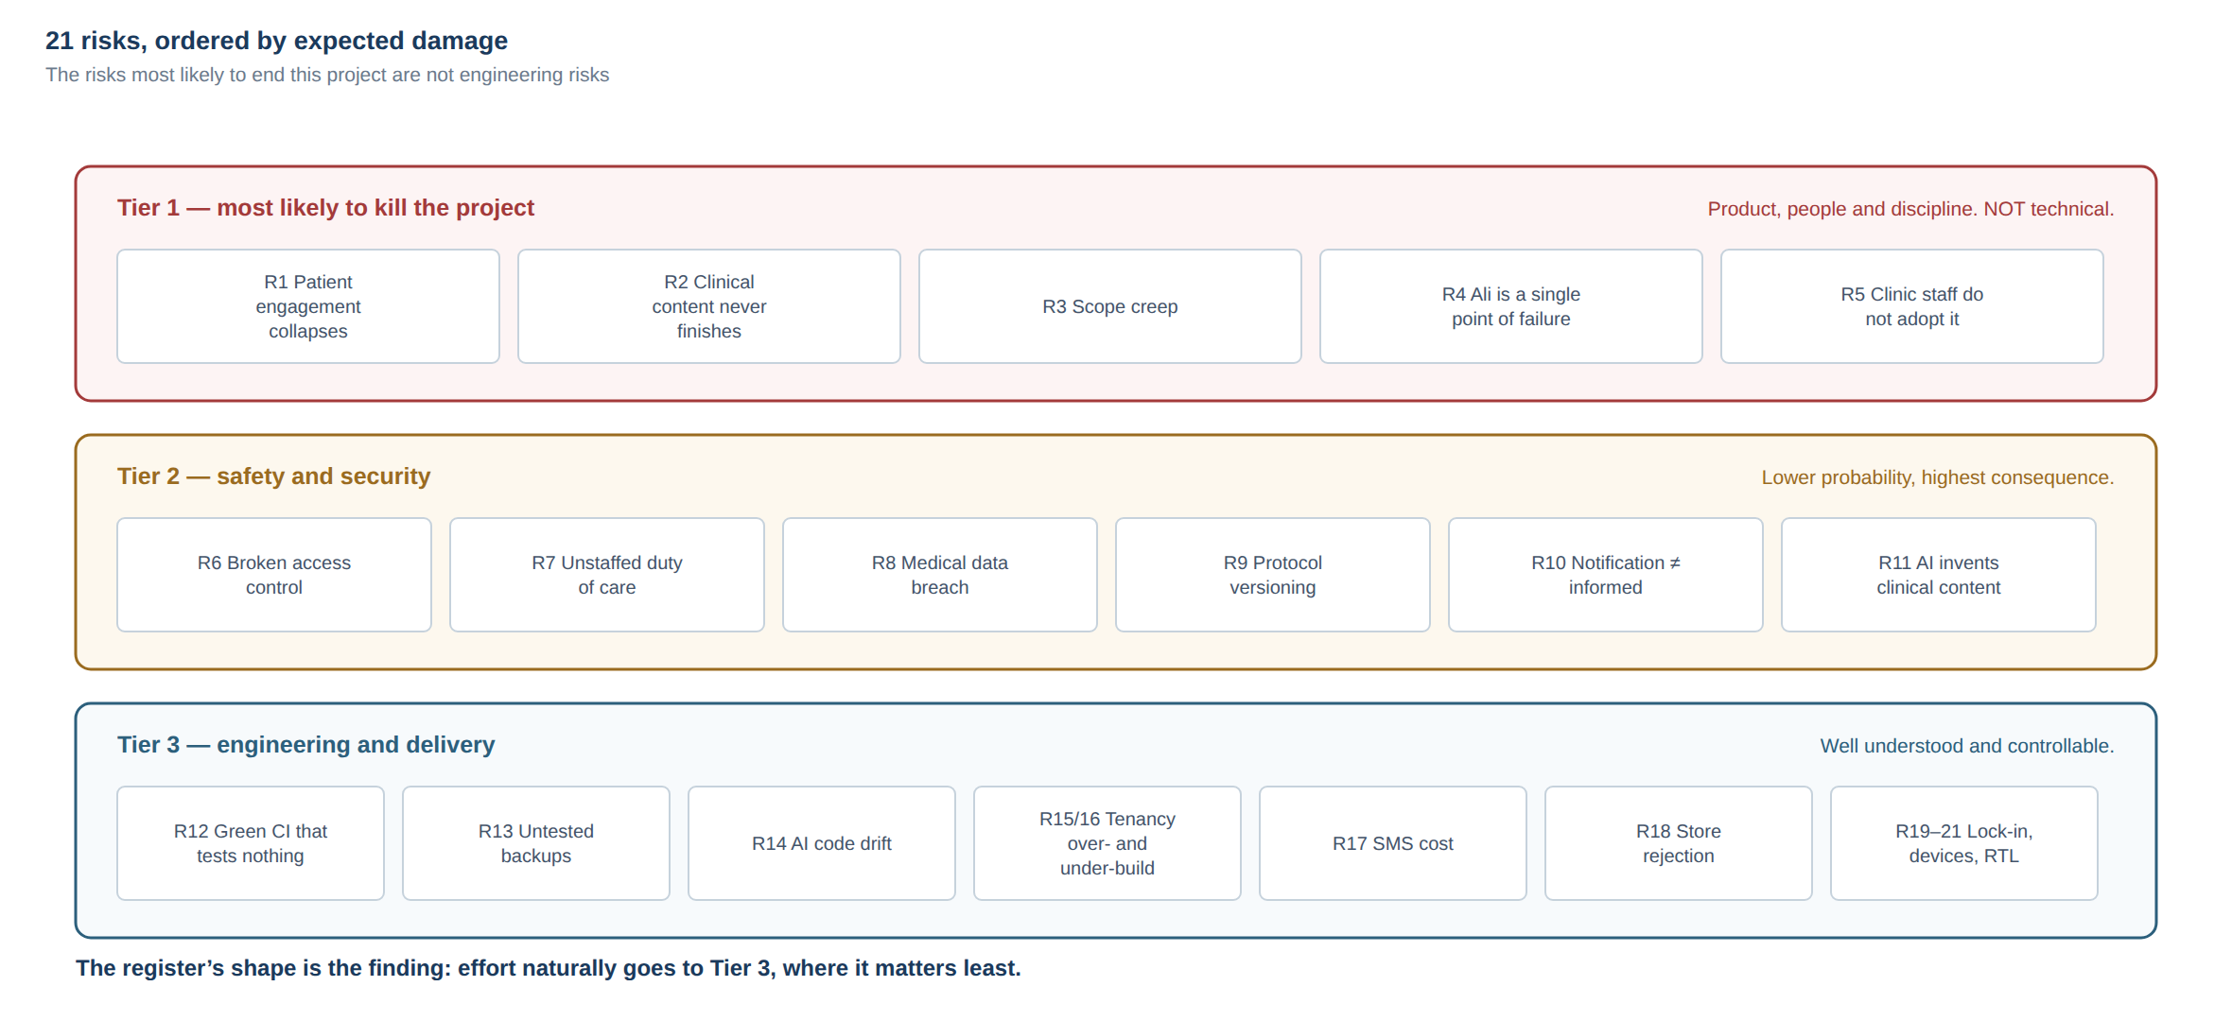
The register's shape: the risks most likely to end this project are not engineering risks.

R1 — Patient engagement collapses
Probability: High · Impact: High
Patients install, use it for 1–3 weeks, and stop. The dashboard empties, the clinic concludes it does not work, and every downstream feature's value goes to zero. This is the default outcome for patient-facing health apps, not the exception.
Mitigation: Design for value at zero patient adoption — the nurse can enter any data the patient can, with source attribution, so the follow-up queue works regardless. Enroll patients face-to-face at the clinic desk, never by sending a link. Keep the patient app brutally small at launch. Instrument engagement from patient #1 and treat a falling curve as a P0 product bug, not a metric. Consider whether the reminder channel should be WhatsApp, where the patient already is.

R2 — Clinical content is never finished
Probability: High · Impact: High
Ali is the sole source of every diet phase, red flag, threshold, lab schedule and patient-facing sentence — while also being Product Owner, Technical Operator, and a practising surgeon. The engine ships empty and stays empty.
Mitigation: Start clinical content now, in parallel with Milestone 0, using 09-CLINICAL-CONTENT-REQUESTS.md. Treat it as the critical path in the plan, not a dependency of it. Ship with a deliberately minimal approved content set — one procedure, one pathway — rather than waiting for completeness. Timebox each content request; an empty module is better than a delayed launch, and far better than invented content.

R3 — Scope creep
Probability: High · Impact: Medium-High
The handoff describes a platform that would occupy a 6-person team for 18 months. The realistic failure is not bad code: it is thirty features at 70% completion and nothing shippable.
Mitigation: §66 of the handoff — every new request gets classified (MVP / Phase 2 / Phase 3) before it is touched, never implemented on arrival. One feature through the full gate at a time. A written MVP scope that requires an explicit decision to change.

R4 — Single point of failure: Ali
Probability: Medium · Impact: Critical
Product owner, medical reviewer, technical operator, deployer, secret holder, escalation point, and the only person who understands both the clinic and the system. A busy operating month stalls the project; after launch it stalls patient care workflows.
Mitigation: §63 — everything in the repository, written for a stranger. A second person with break-glass production access and documented recovery steps. The retained part-time engineer kept warm with context before they are needed, not summoned during an incident. Runbooks tested by someone other than their author.

R5 — Clinic staff do not adopt the dashboard
Probability: Medium · Impact: High
The coordinator keeps using WhatsApp and a notebook because the dashboard does not match how the clinic actually runs. The system becomes the surgeon's private toy.
Mitigation: The coordinator is a named participant from Milestone 2, not a recipient at launch. Watch them use it on real cases before building more. Measure adoption by staff actions per day, not by feature count. Accept workflow feedback as requirements.

Tier 2 — Safety and security

R6 — Broken access control exposes patient data
Probability: Medium · Impact: Critical
One missing scope check in one list query, or one endpoint taking an id from the client without an ownership check. For a named surgeon in a local community this is a reputational event first and a technical one second.
Mitigation: Single policy layer with no privileged path; scope pushed into SQL rather than filtering after fetch; an exhaustive role × resource × operation test suite on every commit; adversarial review by the second agent; human penetration test before launch focused specifically on IDOR. Never traded away for MVP speed.

R7 — The alert system creates a duty of care nobody is staffed to meet
Probability: Medium · Impact: Critical
A patient reports a symptom at 2 a.m., receives a calm confirmation, and reasonably infers someone is watching. Nobody is until Sunday. The harm is caused by the system working exactly as built.
Mitigation: Response window and emergency instruction shown at the moment of submission, every time. No "all clear" state anywhere in the product. A named human owner per queue with a defined review cadence. A hard product rule: a channel the clinic cannot staff does not ship. Legal review of the alert feature specifically.

R8 — Medical data breach
Probability: Low · Impact: Critical
Bariatric patients' weight, comorbidities and surgical history are among the more sensitive categories of personal data, in a context where social consequences are real.
Mitigation: Encryption in transit everywhere; managed database not publicly reachable; secrets in a secret manager and never in git; least-privilege service accounts; audit logging; dependency and secret scanning in CI; penetration test; no PHI in third-party analytics or crash reporting; a written incident response plan before launch, not after.

R9 — Protocol versioning not handled, historical data becomes uninterpretable
Probability: Medium · Impact: High
The doctor revises the diet protocol in month 8. Every previously recorded adherence entry now refers to a stage that no longer means what it meant. The dataset loses its scientific and legal value silently — nothing breaks, nothing alerts.
Mitigation: Protocol definitions immutable once activated; new versions instead of edits; every patient pinned to the version in force at enrolment; every derived record carrying the version used. Designed in at the first migration, because it cannot be retrofitted.

R10 — Notification failure treated as patient informed
Probability: Medium · Impact: High
Push is silently unreliable on several Android OEMs. The system records "sent", the patient never saw it, and a follow-up is missed while the dashboard shows the reminder went out.
Mitigation: Record delivery attempts and outcomes as first-class data. Detect missed tasks by the absence of the action, never by the absence of a delivery failure. Escalate to a human queue on repeated non-response. Never display "reminded" as if it meant "informed".

R11 — AI invents clinical content
Probability: Low (with controls) · Impact: Critical
An agent produces a plausible post-op diet progression or a threshold, it looks right, and it ships. This is the single most dangerous possible event in the project.
Mitigation: Absolute rule — no clinical string originates from an agent. Content lives in an approved, versioned store with an approver and a timestamp. A CI check that fails if clinical content appears in source code rather than in the content store. Every clinical item traceable to an approval record.

Tier 3 — Engineering and delivery

R12 — Green CI that tests nothing
Probability: Medium · Impact: High
Documented twice in this workspace's own history: a workflow in the wrong directory meant six phases merged with zero checks; and a packaging defect took production to 502 while every check was green, because nothing tested the artifact that actually ships.
Mitigation: After configuring CI, push a deliberately failing commit and confirm it is rejected. Include a deployment-contract gate that runs the packaged artifact in an environment where the repository's dependencies are unreachable. Re-verify after any pipeline change.

R13 — Untested backups
Probability: Low-Medium · Impact: Critical
Backups run for six months, the restore has never been attempted, and it fails on the day it is needed. Clinical data exists nowhere else.
Mitigation: A restore drill script that backs up, restores into a scratch database, compares row counts of irreplaceable tables, and exits non-zero on disagreement. Run on a schedule and before any data-rewriting migration. student-os/ops/ already contains a working implementation of exactly this pattern.

R14 — AI-generated code drifts in quality and convention
Probability: Medium · Impact: High
Two agents over many months produce inconsistent patterns, duplicated logic, and unreviewable volume. Nobody can hold the system in their head.
Mitigation: One owner and one reviewer per feature. Conventions written down and enforced by lint where possible. ADRs for every structural decision. A hard rule that volume is not progress — a feature is not done because code exists (see Definition of Done in 08-WAYS-OF-WORKING.md).

R15 — Over-engineering multi-tenancy too early
Probability: Medium · Impact: Medium
Tenant isolation, clinic configuration portals and white-labelling built for customers who do not exist, tripling MVP complexity.
Mitigation: clinic_id on every row from day one — cheap, and impossible to retrofit. Everything else deferred: one deployment, one clinic, config in one table. Multi-tenant operations are a Phase 3 problem.

R16 — Under-engineering multi-tenancy, so it cannot be sold
Probability: Medium · Impact: High
The inverse. Clinic-specific assumptions leak into schema, URLs, branding and content, and surgeon #2 requires a fork.
Mitigation: The same clinic_id discipline, plus: no hard-coded clinic name in code, branding as configuration, content scoped to a clinic, and a periodic check that no query can return rows across clinics.

R17 — SMS / OTP cost and deliverability in Iraq
Probability: High · Impact: High
OTP delivery in Iraq is expensive, inconsistent across carriers, and slow enough that patients abandon signup. At 200–500 patients/month plus reminders, per-message cost becomes the largest recurring line item.
Mitigation: Decide the channel strategy before building authentication. Evaluate WhatsApp as the primary channel. Design the identity module so the delivery channel is pluggable. Consider clinic-assisted enrolment, where the patient is verified at the desk by a staff member instead of by an OTP.

R18 — App Store rejection
Probability: Medium · Impact: High
Health apps draw scrutiny: medical claims, privacy disclosure accuracy, account deletion requirements, permissions justification, and the reviewer needing a working demo account.
Mitigation: Design against the guidelines from the start rather than auditing at the end. No claim the product cannot support. Account deletion in MVP, not later. Accurate data-use disclosure. A reviewer demo account with seeded data. Human iOS developer engaged before submission. student-os/docs/app-store/ contains a usable template for this work.

R19 — Vendor lock-in
Probability: Medium · Impact: Medium
Deep coupling to one provider's proprietary primitives makes migration expensive when pricing, policy or residency requirements change.
Mitigation: Standard PostgreSQL, S3-compatible storage, containerised application, no proprietary primitive in domain code. Data export capability built in Phase 2 (§75). Serverless-specific runtimes avoided for the API — see 03-STACK-EVALUATION.md.

R20 — Low-end Android and weak connectivity make the app unusable
Probability: Medium · Impact: Medium
Older devices, 2GB RAM, aggressive battery optimisation, intermittent 3G. The app works on the developer's machine and not on the patient's phone.
Mitigation: Small bundle, few dependencies, optimistic local writes with visible pending state and retry, no assumption of a live socket, real-device testing on deliberately old hardware before launch.

R21 — Arabic/RTL retrofit debt
*Probability: Low (if handled early) · Impact: Medium
Layout, date formatting, number formatting, text truncation and bidirectional text break in Arabic when RTL is treated as a late translation pass.
Mitigation: §71 — RTL from the first screen. Automated RTL audit in both languages at multiple viewports, in CI. student-os runs this suite today.

Summary
Tier | Risks | Character
1 | R1–R5 | Product, people and discipline — not technical
2 | R6–R11 | Safety and security — lower probability, highest consequence
3 | R12–R21 | Engineering and delivery — well-understood, controllable

The register's shape is the finding: the risks most likely to end this project are not engineering risks. Tier 3 is where the effort naturally goes and where it matters least.

PART IV

Stack Evaluation
Three realistic options, evaluated against the handoff's stated criteria (§34): development speed, maintainability, AI coding compatibility, mobile deployment, scalability, cost, ecosystem, security, developer availability.
A preference for TypeScript is stated in the handoff because the agents work well in it. That is a legitimate input — the team is two AI agents and one person — but it is not sufficient on its own, so each option is assessed on its own merits and the recommendation is justified independently.

Option A — TypeScript monorepo: Fastify + PostgreSQL + Expo + Next.js
One repository, one language, three deployables.
packages/contracts Zod schemas shared by API, dashboard and app
packages/core Pure domain logic: policy, pathway resolution, rules, formulas
apps/api Fastify modular monolith → container
apps/dashboard Next.js → container or static+SSR host
apps/mobile Expo / React Native → App Store + Play
Deployed as long-running containers with managed PostgreSQL and S3-compatible object storage.
Criterion | Assessment
Development speed | High. One language, shared contracts, no serialisation boundary between teams that do not exist
Maintainability | High, if module boundaries are enforced. Medium if they are not
AI coding compatibility | Highest of the three. Strong typing gives agents a real feedback loop; one language means no context switching
Mobile deployment | Good. Expo manages the native build pipeline; one codebase for both platforms
Scalability | More than sufficient. PostgreSQL and a stateless API handle tens of thousands of patients on modest hardware
Cost | Low. Roughly $25–70/month at pilot scale
Ecosystem | Excellent
Security | Good. Mature, audited libraries for every primitive needed
Developer availability | Very good. TypeScript/React developers are the easiest to hire, including locally

Evidence: ../../student-os is this stack, at comparable complexity, with real CI, integration tests, E2E journeys, RTL and accessibility audits, and documented ops. The team has already executed this architecture once.
Weaknesses. Background work — reminder scheduling, the outbox relay, follow-up sweeps — needs a worker process, which is an extra deployable. React Native's native surface is where the unknowns live, and the team has no native expertise. Expo SDK upgrades are periodic real work.

Option B — Next.js full-stack + Supabase + Expo
Next.js (App Router, server actions) as both dashboard and API. Supabase for PostgreSQL, auth, storage and row-level security. Expo for mobile against the Supabase client or a thin API.
Criterion | Assessment
Development speed | Highest initially. Auth, storage and a database on day one
Maintainability | Medium. Business logic tends to scatter across server actions, route handlers and RLS policies
AI coding compatibility | High, but see the authorization note below
Mobile deployment | Same as A
Scalability | Good. Same PostgreSQL underneath
Cost | Low initially; rises with usage, and egress/storage pricing can surprise
Ecosystem | Very good
Security | The decisive concern. See below
Developer availability | Very good

The authorization problem. Supabase's model encourages pushing authorization into row-level security policies. For this product that is the wrong place, for three reasons:
1. Testability. RLS policies are tested by running queries against a database. The authorization matrix here — every role × every resource × every operation × ownership — is hundreds of cases. As pure functions those are millisecond unit tests that run on every commit. As database policies they are slow integration tests that, in practice, get run less often and therefore protect less.
2. Clinical authorization is not row-shaped. "A dietitian may see nutrition entries but not surgical notes, for patients in their clinic, who are assigned to them, unless the patient has withdrawn consent" is awkward as a policy expression and clear as a function.
3. A second path will appear. Some feature — export, AI retrieval, an admin screen — will need the service role key, and at that moment there are two authorization implementations, one of which bypasses the other. The handoff (§42, §43) asks for centralised policy; RLS makes the centre the database while the application still needs its own answers.
Where B is genuinely attractive: Supabase as managed PostgreSQL plus storage plus an auth primitive, with authorization still in an application policy layer, is a reasonable hybrid. That is a hosting decision inside Option A, not a different architecture — and it is worth considering on cost and operational-simplicity grounds.
Other weaknesses. Serverless plus PostgreSQL requires connection pooling discipline. Background jobs need a separate mechanism. Vendor coupling is deeper than it first appears.

Option C — Python/FastAPI backend + Flutter mobile + React dashboard
Criterion | Assessment
Development speed | Medium. Three languages, no shared contracts, hand-maintained parity
Maintainability | Good per-component; worse across the system
AI coding compatibility | Good per language, worse overall — agents lose the cross-boundary type feedback that catches contract drift
Mobile deployment | Good. Flutter is excellent, with strong RTL support
Scalability | Excellent
Cost | Comparable
Ecosystem | Excellent — and the strongest data/analytics/ML ecosystem of the three
Security | Good
Developer availability | Good, but "Python backend + Flutter + React" is three hiring pools

Where C wins. If serious clinical research, cohort analysis or ML were a near-term goal, Python's data ecosystem would be a real argument. If the team already had Flutter expertise, that would be another. Neither applies here.
Precedent in this workspace: ../../medmind is Python/FastAPI and works. But it is a bot-and-pipeline backend with no rich client surface, so it does not carry the three-language coordination cost that this product would.
Weaknesses for this project. Three languages for a one-person team. No shared contracts, so API drift is found at runtime instead of at compile time — the single largest source of avoidable bugs in multi-surface products. Dart is a fourth context for the agents.

Scoring
Weighted for this project: a one-person team with AI agents, a multi-year clinical system, bootstrapped budget, Arabic-first, two client surfaces.
Criterion | Weight | A | B | C
Maintainability by a tiny team | 5 | 5 | 3 | 3
AI coding compatibility | 5 | 5 | 4 | 3
Security controllability | 5 | 5 | 3 | 4
Development speed | 4 | 4 | 5 | 3
Mobile deployment | 4 | 4 | 4 | 5
Cost | 3 | 5 | 4 | 4
Scalability | 3 | 4 | 4 | 5
Ecosystem | 2 | 5 | 5 | 5
Developer availability | 2 | 5 | 5 | 4
Weighted total |  | 147 | 127 | 126

The scoring is a summary of the reasoning above, not a substitute for it. The decisive factors are the top three rows.

Recommendation
Option A, with three specific decisions inside it.

1. The API runs as a long-lived container, not as serverless functions
This is the most important sub-decision and it comes directly from evidence in this workspace. student-os ships its API as a Netlify function, and its own documentation records the result: a production outage where the packaged function shipped without three of its dependencies and threw before a line of it ran, while every CI check was green. The team then had to build a bespoke packaging-verification gate to prevent a recurrence.
That cost is avoidable. This system additionally needs things serverless makes awkward: persistent database connections, scheduled sweeps for overdue follow-ups, an outbox relay, and reminder delivery. A single container on a managed host (Fly.io, Render, Railway, or a Hetzner VPS with Docker) plus a managed PostgreSQL is simpler, cheaper at this scale, easier to reason about, and easier to move.
ADR-0002 will record this.

2. Dashboard in Next.js, not React Native Web
Sharing one Expo codebase across mobile and dashboard is tempting and wrong here. The dashboard's core is dense tables, filters, multi-column layouts, keyboard navigation and charts — all of which are native to the web platform and all of which are fought for in React Native Web. The patient app and the dashboard also have genuinely different users, different information density, and different release cadences. They share the contracts package and the domain package; that is the sharing that pays.

3. Authorization in application code, whatever the hosting choice
Whether the database is self-managed PostgreSQL, Neon, or Supabase, the policy layer is pure TypeScript functions in packages/core/policy, used identically by the API, the dashboard, exports and any future AI retrieval path. Database-level RLS may be added as defence in depth; it is never the primary mechanism.

Proposed stack
Layer | Choice | Note
Language | TypeScript | Everywhere
API | Fastify, modular monolith | Container
Validation | Zod, shared contracts package | One source of truth for API shapes
Database | PostgreSQL 16+, managed | Plain SQL, file-based migrations
Migrations | Numbered forward-only SQL | Proven in student-os
Auth | Own implementation, Argon2id, JWT access + rotating refresh | Method [DECISION REQUIRED]
Object storage | S3-compatible | Signed URLs, auth checked before minting
Background work | Worker process in the same codebase | Scheduler + outbox relay
Dashboard | Next.js + TypeScript + accessible component library | RTL from day one
Mobile | Expo / React Native | One codebase, both platforms
Testing | Vitest + Playwright | Unit, integration, authorization, E2E, RTL, a11y
CI | GitHub Actions | Including a deployed-artifact gate
Hosting | Container host + managed PostgreSQL | [DECISION REQUIRED] — follows residency
Errors | Self-hosted or PHI-scrubbed error tracking | Never raw request bodies

What would change my recommendation
- Data residency inside Iraq is legally required → hosting changes; the stack does not. Containerisation is what makes that cheap, which is another argument for it.
- Near-term research/ML is a real goal → Option C's data ecosystem becomes a genuine argument, and a hybrid (TypeScript API + Python analytics service reading a replica) becomes attractive.
- Existing Flutter expertise is available → Option C's mobile story improves materially.
- Launch pressure is extreme and scope is halved → Option B's hybrid form is the fastest path to something real, accepting the maintainability cost knowingly.

PART V

Architecture (Draft)
High-level architecture proposal. Assumes Option A from 03-STACK-EVALUATION.md. Nothing here is settled; this is the shape I would defend in review.

1. System context
┌──────────────┐ ┌──────────────────┐ ┌──────────────────┐
│ Patient app │ │ Clinical │ │ Admin / config │
│ Expo (iOS + │ │ dashboard │ │ (same dashboard, │
│ Android) │ │ Next.js │ │ gated by role) │
└──────┬───────┘ └────────┬─────────┘ └────────┬─────────┘
│ │ │
└──────────── HTTPS / REST + Zod ───────────┘
│
┌──────────▼───────────┐
│ API (Fastify) │
│ modular monolith │
└──────────┬───────────┘
│
┌────────────────────┼────────────────────┐
│ │ │
┌──────▼──────┐ ┌─────────▼────────┐ ┌────────▼────────┐
│ PostgreSQL │ │ Object storage │ │ Worker process │
│ (managed) │ │ (S3-compatible) │ │ scheduler + │
└─────────────┘ └──────────────────┘ │ outbox relay │
└────────┬────────┘
│
┌─────────────────────────┼──────────────┐
│ │ │
┌──────▼──────┐ ┌───────▼─────┐ ┌─────▼──────┐
│ Push │ │ SMS / What- │ │ Email │
│ (APNs/FCM) │ │ sApp [TBD] │ │ │
└─────────────┘ └─────────────┘ └────────────┘
Both clients speak to the same API. Neither touches the database. No client holds a privileged credential.

2. Layering inside the API
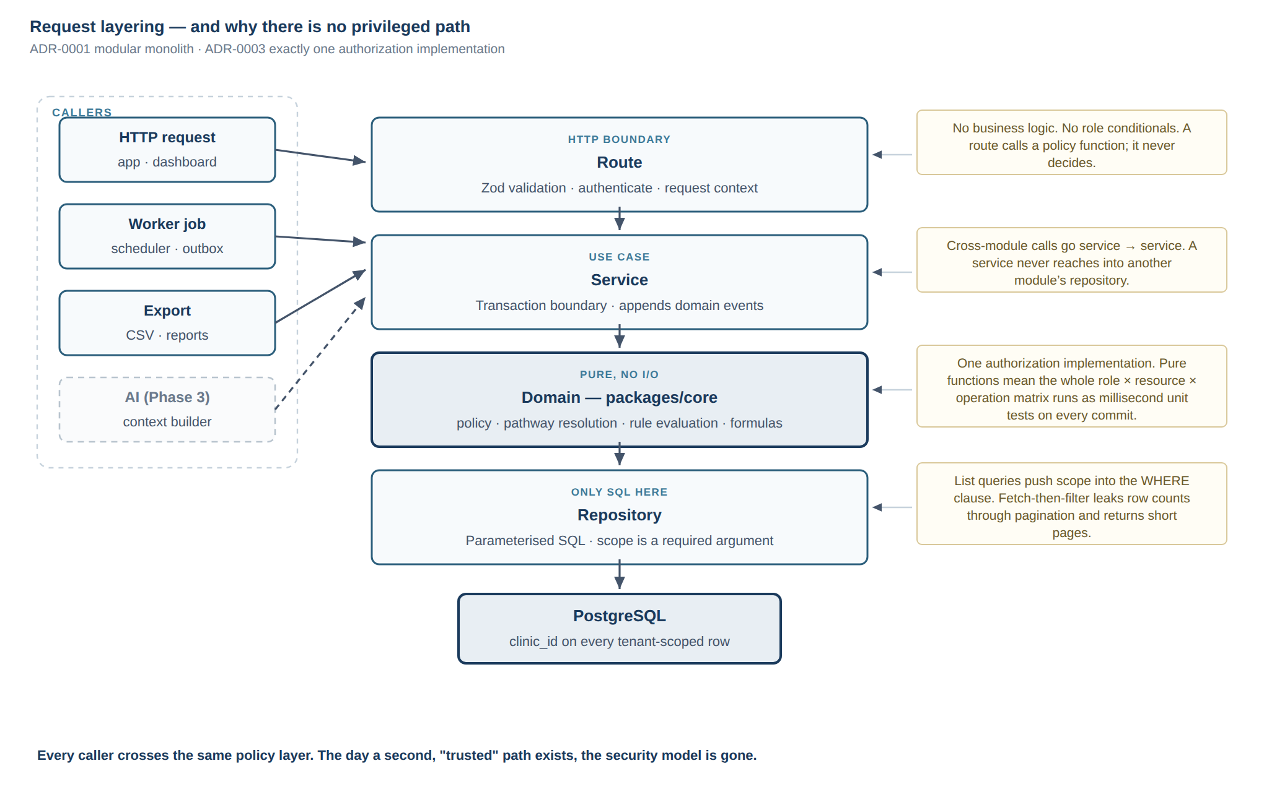
Request layering, and why no caller gets a privileged path to the data.
HTTP route validation (Zod), auth, request context — no business logic
↓
Service use case, transaction boundary, emits domain events
↓
Domain (core) pure functions: policy, pathway resolution, rule evaluation, formulas
↓
Repository parameterised SQL. Only layer that touches the database
Rules that make this hold rather than decay:
- Cross-module calls go through services, never another module's repository.
- Domain logic is pure and dependency-free, so it is testable in milliseconds and reusable by API, worker, exports and any future AI path.
- Routes contain no conditionals about roles — they call policy functions.
- A repository never calls a service.

3. Modules
Module | Responsibility
identity | Accounts, credentials, sessions, tokens, device registration
authz | Roles, permissions, actor resolution (policy itself lives in core)
clinic | Clinic record, staff, branding config, feature flags, settings
patients | Demographics, medical history, comorbidities, allergies, enrolment
surgery | Procedure records, dates, surgeon, facility, operative notes
pathway | Protocol definitions, versions, stages, assignment, resolution
tasks | Task instances generated from pathway stages, completion
measurements | Weight, BMI, body measurements, source attribution
nutrition | Meals, protein, fluids, supplements, adherence
medications | Medication list, schedules, adherence
labs | Panels, results, units, reference ranges, trends
symptoms | Structured check-ins, submissions
alerts | Rule engine, alert lifecycle, queues, acknowledgement, audit
appointments | Scheduling, status, reminders, overdue detection
followup | Loss-to-follow-up detection, the work queues
documents | Uploads, signed URLs, access audit
content | Educational content, versioning, targeting by procedure/stage
notifications | Preferences, templates, dispatch, delivery records
audit | Append-only audit event stream
analytics | Descriptive aggregates for the clinic
admin | Configuration surfaces, user management

Each module: routes / service / repository / <module>.policy usage / tests.

4. Authorization
The single most important design in the system.
// packages/core/policy — pure, synchronous, dependency-free
canViewPatient(actor, patient): boolean
canEditMeasurement(actor, measurement): boolean
patientScopesFor(actor): Scope // pushed into SQL WHERE, never post-filtered
- The Actor is resolved once per request: user, roles, clinic, assignments, and — for a patient — their own patient id.
- List queries push scope into SQL. Fetch-then-filter leaks row counts through pagination and returns short pages.
- There is no privileged path. Exports, analytics, notifications and any future AI retrieval call the same functions. The day a second "trusted" path exists, the security model is gone.
- Roles and permissions are data, not if (role === 'doctor') scattered through the codebase (§43).
Proposed roles: patient, surgeon, dietitian, nurse_coordinator, clinic_admin, super_admin. Permissions are granular and assigned to roles, so a new role is configuration rather than a code change. [DECISION REQUIRED] — the exact permission set per role is an organisational decision (B17).

5. Tenancy
- clinic_id on every tenant-scoped table from the first migration. Cheap now, effectively impossible to retrofit later.
- Every query constrained by the actor's clinic, enforced in the policy layer.
- One deployment, one clinic, for v1. No tenant routing, no per-tenant provisioning, no clinic configuration portal. Those are Phase 3.
- A recurring test asserts no query returns rows across clinics.
This is the balance §39 asks for: the expensive-to-retrofit part now, the operationally complex part later.

6. The pathway engine
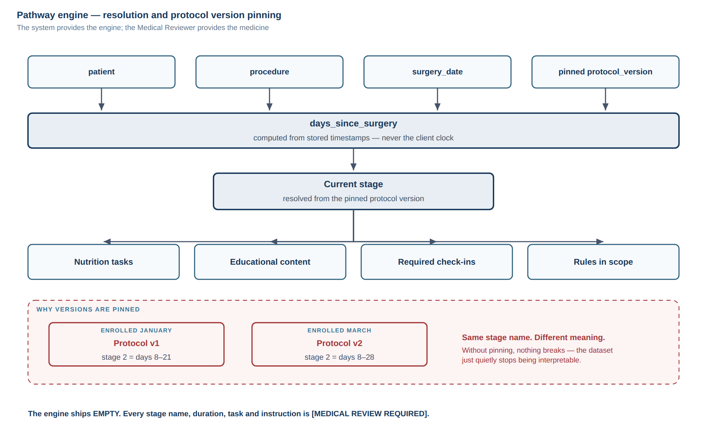
Pathway resolution, and why every patient is pinned to a protocol version.
patient + procedure + surgery_date + protocol_version
↓
days_since_surgery (computed from stored timestamps, never client clock)
↓
current stage (from the pinned protocol version)
↓
┌────────────┬───────────────┬──────────────┬───────────────┐
│ tasks │ content │ check-ins │ rules in scope│
└────────────┴───────────────┴──────────────┴───────────────┘
Design constraints:
- Protocol definitions are immutable once activated. Changes create a new version.
- Every patient is pinned to the version in force at enrolment, and migrating a patient to a newer version is an explicit, audited clinical action.
- Every generated task and every adherence record carries the protocol version used.
- The engine ships empty. No default stages, no default durations, no placeholder content. [MEDICAL REVIEW REQUIRED] for every value.

7. Alert rule engine
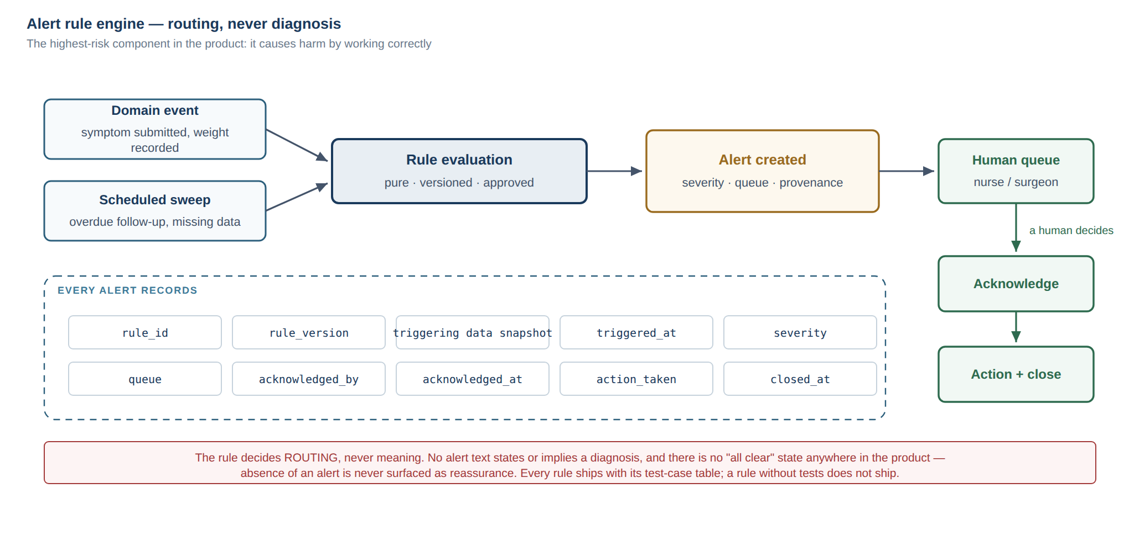
The alert engine routes to a human queue; it never assigns meaning.
domain event ──┐
├──▶ rule evaluation (pure) ──▶ alert ──▶ queue ──▶ human
scheduled sweep ┘ (versioned) decides
Every alert records: rule_id, rule_version, triggering data snapshot, triggered_at, severity, queue, acknowledged_by, acknowledged_at, action_taken, closed_at (§19).
Non-negotiable properties:
- Rules decide routing, never meaning. No alert text states or implies a diagnosis.
- Every rule ships with its test-case table. A rule without tests does not ship (§57).
- Rule definitions are versioned data with an approver and an approval timestamp.
- There is no "no alert" message. Absence of an alert is never surfaced as reassurance.

8. Domain events and the outbox
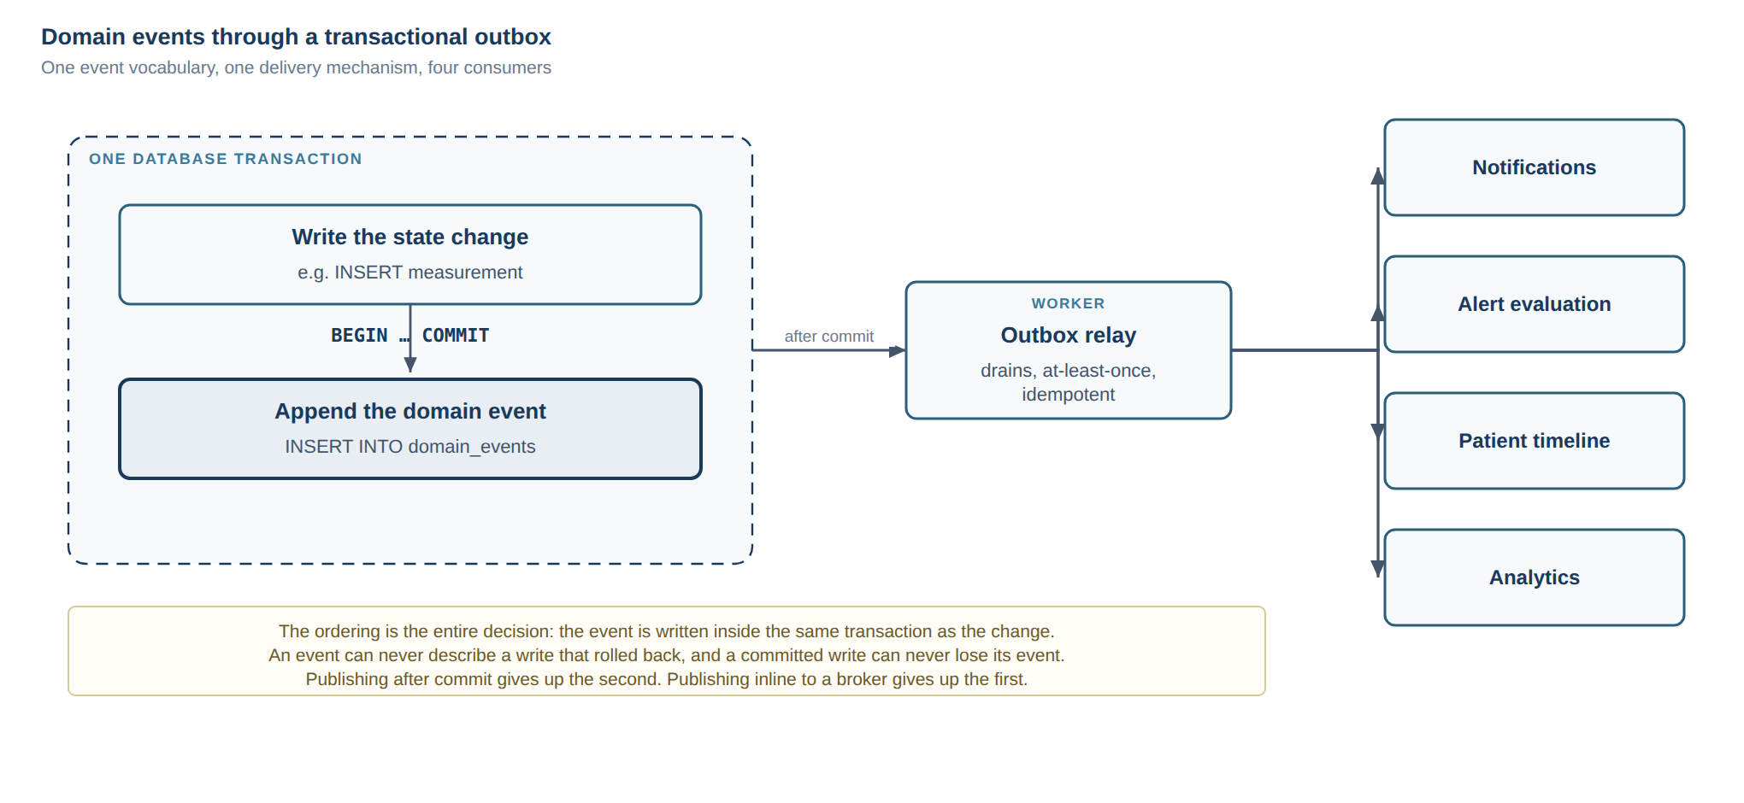
The event is written inside the same transaction as the change it describes.
State changes append an event inside the same transaction as the change. A relay in the worker process drains it afterwards.
That ordering is the entire point: an event can never describe a write that rolled back, and a committed write can never lose its event. Publishing after commit loses the second; publishing inline to a broker loses the first. Consumers: notifications, alert evaluation, the patient timeline, and analytics.
This is ADR-0010 in student-os, and the reasoning transfers unchanged.

9. The patient timeline
A read model projected from domain events, not a table anyone writes to directly. Consultations, pre-op evaluation, surgery, post-op events, weights, appointments, labs, alerts, nutrition milestones, clinical notes — one chronological, filterable view (§24).
Because it is derived, it cannot drift from the record it describes.

10. Data classification
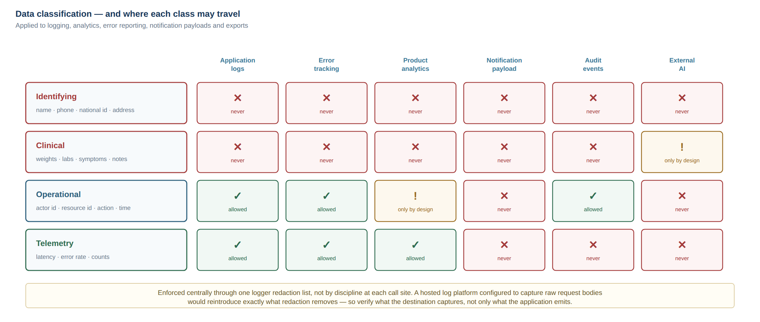
Four data classes, and the destinations each one may and may not reach.
Applied to logging, analytics, error reporting, notification payloads and exports (§47, §48, §94).
Class | Examples | Rule
Identifying | Name, phone, national id, address | Never in logs, analytics, or notification payloads
Clinical | Weight, labs, symptoms, notes, procedures | Never leaves the platform without explicit design and approval
Operational | Actor id, resource id, action, timestamp | Fine in audit and logs
Telemetry | Latency, error rates, counts | Fine externally, aggregate only

Enforced centrally through a logger redaction list, not by discipline at each call site.

11. Cross-cutting decisions
- Time. All timestamps timestamptz, stored UTC, generated server-side. Client clocks are never trusted for anything clinical (§89). Display in the clinic's timezone.
- History. Clinically significant records are append-only or versioned; an edit never erases what was there (§90, §91).
- Source attribution. Every measurement records who entered it, when, and through which channel — patient, clinic staff, device import (§9, §31).
- Errors. One error taxonomy, one envelope, correlation id on every response. No try/catch + console.log (§55).
- Pagination. Server-side everywhere, cursor-based on large collections (§88).
- Deletion. Soft delete with a retention policy; no ad-hoc hard deletes (§77).
- Feature flags. Configuration-driven, per clinic, from the start (§93).
- i18n. Arabic and English, RTL from the first screen, audited in CI (§71).
- Branding. Clinic name, logo and colours are configuration, never literals (§70).

12. Environments
Environment | Data | Purpose
Development | Synthetic seed | Local
Staging | Synthetic, production-shaped | Every change before production
Production | Real patients | Never used for testing (§80)

No real patient data outside production. Ever. Staging seeds are generated, not copied.

13. Deliberately out of scope for now
Microservices; an event bus or message broker; Kubernetes; CQRS beyond the timeline read model; GraphQL; a separate analytics store; multi-region; real-time collaboration.
Each would be justifiable at a scale this product does not have, and each would cost more than it returns today. Modular monolith first; the service boundary is already a function signature that can become an HTTP call when there is a reason.

PART VI

MVP Recommendation and Roadmap

PART 8 — MVP critique
The handoff (§67) asks me to criticise the proposed MVP before it is accepted. Here it is.

8.1 The proposed scope
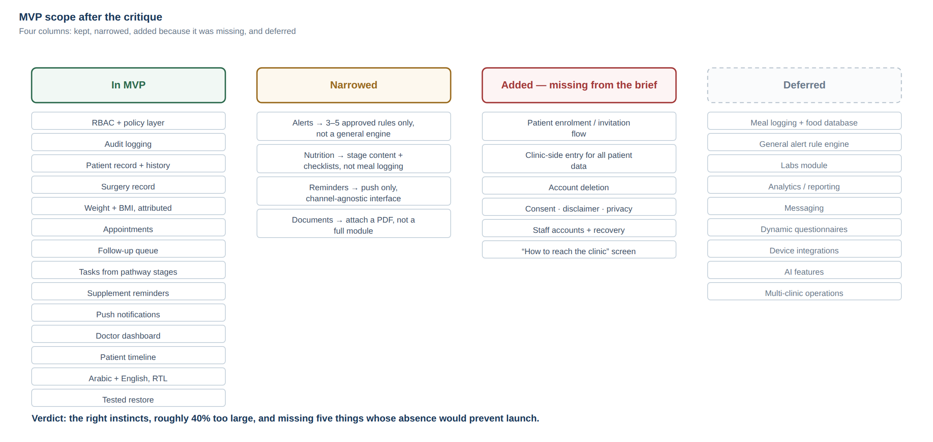
MVP scope after the critique: kept, narrowed, added, and deferred.
Patient authentication · Patient profile · Surgery info · Weight tracking · Appointments · Reminders · Nutrition pathway · Supplements reminder · Basic patient tasks · Doctor dashboard · Patient timeline · Basic alerts · Basic reporting · RBAC · Audit logging
Verdict: the right instincts, roughly 40% too large, and missing five things whose absence would prevent launch.
It is a good list. Nothing on it is frivolous. The problem is that four items — "nutrition pathway", "basic alerts", "basic reporting", and "reminders" — are each a system rather than a feature, and together they are more work than everything else combined.

8.2 What should be cut or narrowed

Cut: "Basic reporting"
Analytics before there is data to analyse. At launch the clinic has zero historical patients in the system; a reporting module reports on nothing. It is also the easiest thing to add later, because it is read-only. → Phase 2. Replace with: the follow-up queue counts, which are operationally necessary rather than analytical.

Narrow sharply: "Basic alerts"
A general rule engine is the highest-risk component in the product, and building it before the clinical rules exist means building it against imagined requirements. → MVP ships a structured symptom check-in that routes to a human queue, with a very small set of approved, versioned rules — I would argue for three to five, not thirty. The general engine is Phase 2, designed after the clinic has run the narrow version for two months and knows what it actually needs. This is both safer and cheaper.

Narrow: "Nutrition pathway"
A full protocol engine with meal logging, protein and calorie tracking, and adherence scoring is several months of work and the part most likely to be redesigned after real use. → MVP ships stage-based content and checklists driven by configuration: what phase the patient is in, what they should be doing, and a simple daily confirmation. Protein and fluid targets as simple numeric goals, if approved. Meal logging, food databases and adherence scoring are Phase 2.

Narrow: "Reminders"
A full notification engine with multi-channel delivery, preferences, quiet hours and delivery tracking is substantial. → MVP ships push only, with per-category preferences, generic payloads, and delivery records. SMS/WhatsApp is a channel decision (see 06-OPEN-DECISIONS.md) and, if chosen, is a Phase 2 addition on an interface designed for it now.

Defer: patient-initiated free-text anything
Free text from patients creates an expectation of a reply. Not in MVP.

8.3 What is missing and must be added
These are not enhancements. Without them the product cannot launch.

1. Patient enrolment flow — the most commonly overlooked thing in this class of product
How does a patient actually get into the system? If the answer is "we send them a link", adoption will be very low. The realistic answer is that the coordinator enrols them at the desk, on their phone, before they leave — a clinic-generated invitation code or QR, scanned in the app, tied to an already-created patient record. This single flow has more influence on the project's success than any other MVP feature.

2. Clinic-side data entry on behalf of the patient
Already argued in 00-READINESS-REPORT.md §1.1. Every patient-enterable datum must also be enterable by staff, with source attribution. This is what makes the product work at 20% patient adoption, and it is what makes the pilot possible before the app is even in the stores.

3. Account deletion
An App Store requirement for any app with account creation, and a reasonable expectation regardless. It interacts with clinical retention — deleting an account must not silently destroy a medical record — so it needs designing, not bolting on.

4. Consent, disclaimer, privacy policy screens
Needed for the stores, needed legally, and needed to set the expectation that this is not an emergency service. Cheap to build, impossible to launch without.

5. Staff account management and credential recovery
Someone forgets a password on a Tuesday. If the answer is "Ali runs a SQL statement", the product is not launchable.

And one more: "how to reach the clinic"
Messaging is correctly excluded from MVP, but patients will try to message. A single screen with the clinic's phone/WhatsApp and a clear statement of hours and of what to do in an emergency prevents patients from using the symptom form as a chat window.

8.4 Recommended MVP scope
Area | In MVP | Notes
Identity & auth (staff) | ✅ | Password + recovery
Identity & auth (patient) | ✅ | Method [DECISION REQUIRED]
RBAC & policy layer | ✅ | Non-negotiable, built first
Audit logging | ✅ | Non-negotiable, built early
Clinic config & branding | ✅ | Minimal; one clinic
Patient record & medical history | ✅ | Fields [MEDICAL REVIEW REQUIRED]
Patient enrolment / invitation | ✅ | Added
Surgery record | ✅ | Procedures configurable
Weight & BMI, with source attribution | ✅ | Formulas [MEDICAL REVIEW REQUIRED]
Clinic-side entry for all patient data | ✅ | Added
Appointments + overdue detection | ✅ | The core business value
Follow-up queue | ✅ | The product's reason to exist
Patient tasks from pathway stages | ✅ | Content from Medical Reviewer
Supplement reminders | ✅ | Schedule from Medical Reviewer
Push notifications + delivery records | ✅ | Push only
Symptom check-in → human queue | ✅ | 3–5 approved rules only
Doctor dashboard (queues, search, filters) | ✅ | The primary screen
Patient timeline | ✅ | Read model
Patient app: home, weight, tasks, appointments, content | ✅ | Deliberately small
Account deletion | ✅ | Added
Consent / disclaimer / privacy | ✅ | Added
Staff account management + recovery | ✅ | Added
"How to reach the clinic" screen | ✅ | Added
Arabic + English, RTL | ✅ | From day one
Backups + tested restore | ✅ | Before any real patient data
Nutrition: meal logging, food DB, adherence scoring | ❌ | Phase 2
General alert rule engine | ❌ | Phase 2
Labs module | ❌ | Phase 2 — staff can attach a document in MVP
Documents/uploads | ⚠️ | Minimal: attach a PDF to a patient. Full module Phase 2
Analytics / reporting | ❌ | Phase 2
Messaging | ❌ | Phase 2, if at all
Dynamic questionnaires | ❌ | Phase 2
Device integrations | ❌ | Phase 3
AI features | ❌ | Phase 3
Multi-clinic operations | ❌ | Phase 3 (clinic_id exists from day one)

8.5 The sequencing recommendation — dashboard first
I recommend building and launching the clinical dashboard before the patient app.
This inverts the natural instinct, so the reasoning matters:
1. The clinic gets value with zero patient installs. Staff enter data, the follow-up queue works, overdue patients surface. That is already a product worth having.
2. It de-risks the largest unknown. Whether patients will engage is unknown and unknowable from here. Whether the clinic will use a good dashboard is much more predictable. Build the predictable value first.
3. It removes the store from the critical path. App review, certificates and Apple accounts cannot delay a web dashboard.
4. It produces real data for the app to display. A patient app launching against a populated record is a far better first impression than an empty one.
5. Workflow mistakes get found early, when they cost a week instead of a quarter.
The patient app follows immediately, into a system that already works.
This is a recommendation, not a decision. If there is a reason the patient app must come first — a commitment made, a launch event, a competitive concern — say so and I will plan for it. But I would argue this one.

PART 9 — Roadmap
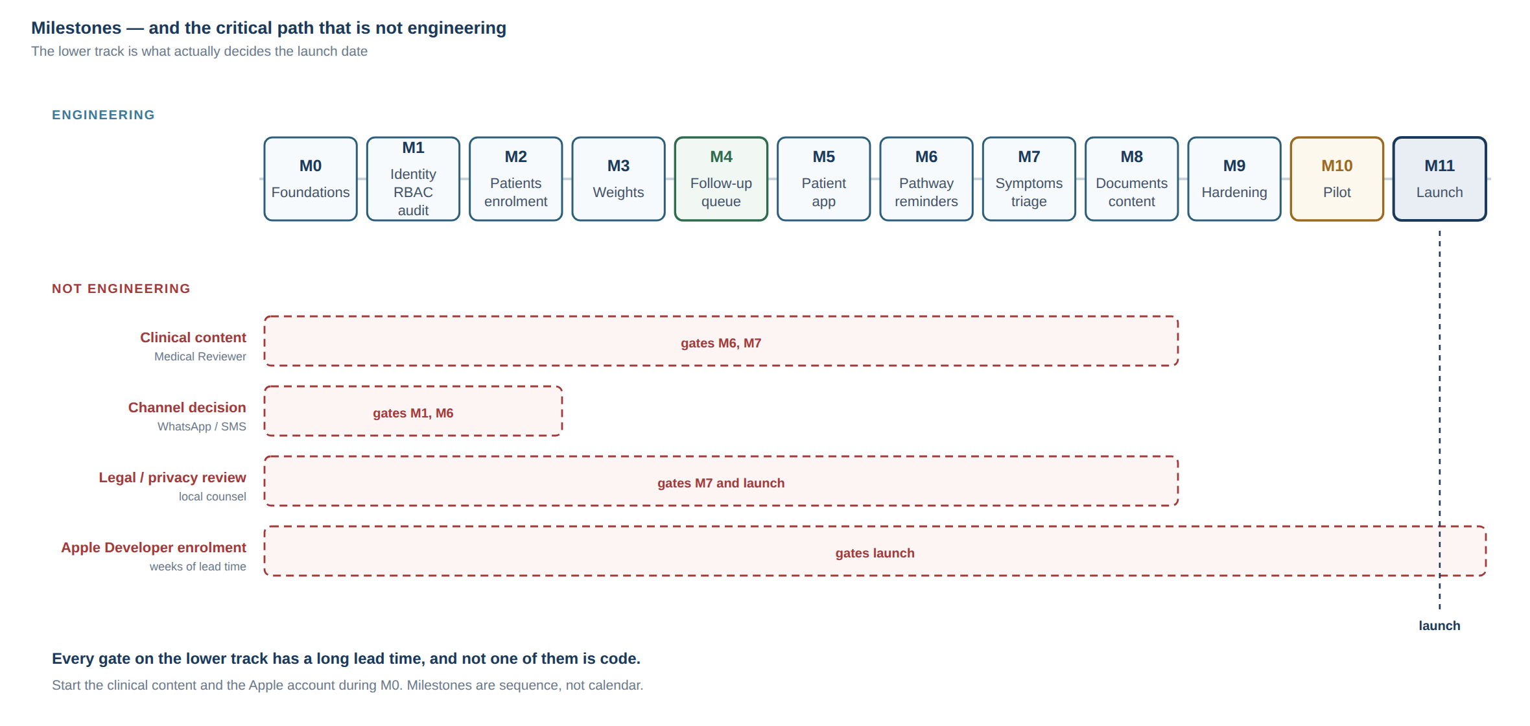
Milestones against the non-engineering gates that actually decide the launch date.
Milestones, not dates. Each is a coherent, demonstrable increment, and each ends with your approval before the next begins (per the handoff's operating rules). Sizes are relative effort, not calendar time.

Milestone 0 — Foundations and decisions · no product code
Blocking decisions answered (06-OPEN-DECISIONS.md). Repository, monorepo skeleton, environments, CI with a deliberately-failing-commit verification, ADRs for every decision made, domain model and entity-relationship design reviewed by the second agent before migrations exist, API contract conventions, error taxonomy, i18n/RTL foundation, security baseline document. Human architecture review at the end. Exit: the design is written down and reviewed, and nothing about it depends on my memory.

Milestone 1 — Identity, RBAC, audit
Staff accounts, sessions, tokens, recovery. Roles and permissions as data. The policy layer with its full authorization matrix under test. Audit event stream. Clinic record and configuration. Exit: the authorization suite is green and a human has reviewed the auth design. Nothing else is built until this is right.

Milestone 2 — Patients, enrolment, surgery records, timeline skeleton
Patient records, medical history (fields per Medical Reviewer), search with server-side pagination, enrolment/invitation flow, surgery records, procedure configuration, timeline read model. Exit: the coordinator can register a real patient and find them again. They try it.

Milestone 3 — Measurements and clinic-side entry
Weight, BMI, optional body measurements, source attribution, trends, staff entry on behalf of patients, edit history. Exit: a weight recorded by staff appears on the trend and in the timeline.

Milestone 4 — Appointments and the follow-up queue · the commercial core
Scheduling, statuses, completed/cancelled/missed, overdue detection, loss-to-follow-up rules, the ranked work queue, dashboard filters. Exit: the dashboard correctly identifies overdue patients from real clinic data. This is the milestone that proves the product's premise.

Milestone 5 — Patient mobile app, first release
Auth, onboarding, consent and disclaimer, home with today's tasks, weight entry, appointments, account deletion, the contact screen. Arabic-first, RTL. Exit: a real patient completes onboarding and records a weight, on their own phone.

Milestone 6 — Pathway stages, tasks, supplements, notifications
Protocol definitions and versioning, stage resolution, task generation, supplement schedules, push notifications with preferences and delivery records. Exit: a patient receives the right task on the right post-operative day, under an approved protocol version.

Milestone 7 — Symptom check-in and triage
Structured check-in, 3–5 approved versioned rules with their test tables, the human queue, acknowledgement and closure with full audit, response-window and emergency copy. Exit: a submitted symptom appears in the nurse queue and is closed with a recorded action. Legal review of this feature's copy has happened.

Milestone 8 — Documents and education content
Minimal document attachment with signed URLs and access audit; educational content targeted by procedure and stage. Exit: staff attach a lab report; the patient sees stage-appropriate content.

Milestone 9 — Hardening · no new features
Penetration test and remediation. Dependency and secret scanning. Load check at realistic scale. Backup and restore drill executed for real. Incident response plan. Full RTL and accessibility audit. Real-device testing on old Android and real iPhones. Error tracking with PHI scrubbing verified. Runbooks tested by someone who did not write them. Exit: a human security reviewer and a human engineer both say yes.

Milestone 10 — Pilot
10–20 patients, selected by the clinic, enrolled face-to-face. Two to four weeks. The explicit goal is finding workflow problems, not bugs. Engagement measured from patient #1. Exit: the clinic wants to continue, and we know the real engagement rate.

Milestone 11 — Store submission and launch
Human iOS developer engaged. Certificates, signing, builds. Store metadata, privacy answers, age rating, reviewer demo account. Submission and review responses. Staged rollout to the full panel. Exit: live, with real patients, and a plan for what happens when it breaks.

Phase 2 (post-launch, prioritised by what the pilot taught)
Full nutrition module · general alert rule engine · labs · dynamic questionnaires · messaging · analytics · data export (§75) · caregiver accounts · SMS/WhatsApp channel.

Phase 3
Multi-clinic SaaS · clinic configuration portal · white-labelling · billing · device/health-platform integrations · clinician AI copilot · research exports.

Critical path
The critical path is not engineering. It is:
clinical content (Medical Reviewer) ──▶ M6, M7 ──▶ launch
channel decision (WhatsApp/SMS) ──▶ M1, M6
legal review ──▶ M7, M11
Apple account + iOS developer ──▶ M11
Every one of these has a long lead time and none of them is code. Start the clinical content and the Apple account now, during Milestone 0.

PART VII

Open Decisions — Questions for Ali
Only the questions that genuinely block an architecture or scope decision. Anything I could reasonably derive from engineering judgement is not here.
Each question carries my recommendation. If you agree, answer "agreed" and we move. Write a different answer only where you disagree or know something I do not.
أسئلة تمنعني فعلاً من اتخاذ قرار معماري أو قرار Scope. لكل سؤال توصيتي — إذا كنت موافقاً اكتب "موافق" ونكمل.

Blocking Milestone 0–1 (architecture)

Q1 — Patient authentication method · طريقة دخول المريض
EN: Phone+OTP fits Iraqi patient behaviour but has real per-message cost and deliverability problems across carriers. Password-only is cheap but a recovery nightmare for low-digital-literacy users with no email.
AR: ما طريقة دخول المريض؟ رقم الهاتف مع OTP هو الأنسب لسلوك المريض العراقي، لكن كلفة الرسائل وموثوقية وصولها عبر الشبكات مشكلة حقيقية. الباسوورد رخيص لكن استرجاعه صعب جداً لمريض كبير بالعمر بدون إيميل.
My recommendation: Clinic-assisted enrolment as the primary path — the coordinator verifies the patient's identity at the desk and issues a one-time invitation code; the patient sets a PIN/password in the app on the spot. OTP is used only for device re-binding and recovery, which is a fraction of the message volume. This removes OTP from the critical signup path, cuts cost dramatically, and matches how the clinic already works.
Blocks: identity module design (M1), cost model.

Q2 — Is WhatsApp a supported channel? · هل واتساب قناة رسمية؟
EN: Probably the highest-leverage decision in the project. Iraqi patients live on WhatsApp; push notifications on old Android are unreliable. WhatsApp Business API requires business verification, has per-conversation cost, and constrains message templates.
AR: أهم قرار تقريباً. المريض العراقي موجود على واتساب، والإشعارات push غير موثوقة على أندرويد القديم. لكن WhatsApp Business API يحتاج توثيق تجاري وله كلفة وقوالب رسائل محددة.
My recommendation: Push-only in MVP, with the notification layer designed channel-agnostic from day one so WhatsApp can be added in Phase 2 without rework. Start the business verification process now, in parallel — it has a long lead time. Do not build the integration until the pilot tells us push reach is genuinely inadequate.
Blocks: notification architecture (M6), cost model.

Q3 — Hosting region and data residency · مكان استضافة البيانات
EN: Does any law, contract, or hospital policy require patient data to remain inside Iraq? I do not know Iraqi law and will not guess.
AR: هل يوجد قانون أو عقد أو سياسة تفرض بقاء بيانات المرضى داخل العراق؟ أنا لا أعرف القانون العراقي ولن أخمّن.
My recommendation: Ask the legal reviewer this specific question early. Until answered, I will design so the answer is cheap to honour: containerised application, standard PostgreSQL, S3-compatible storage, no proprietary primitives in domain code. Default assumption if no requirement exists: a European region (Frankfurt) for latency and provider maturity.
Blocks: hosting provider choice (M0), privacy policy.

Q4 — Who is the legal data controller? · من هو المسؤول القانوني عن البيانات؟
EN: The surgeon personally, a registered clinic entity, or a company? This determines who signs provider contracts, who owns the data, whose name appears in the privacy policy and on the App Store listing.
AR: الطبيب شخصياً، أم كيان العيادة المسجل، أم شركة؟ هذا يحدد من يوقّع عقود الخدمات، ومن يملك البيانات، واسم من يظهر في سياسة الخصوصية وفي App Store.
My recommendation: A registered entity rather than an individual, if one exists or can be created. It separates personal and professional liability, is required for an organisation-type Apple account, and is necessary for any future SaaS sale.
Blocks: privacy policy, store account type, provider contracts.

Q5 — Tenancy posture for v1 · بنية تعدد العيادات
EN: My proposal: clinic_id on every row from the first migration (cheap now, impossible to retrofit), but a single deployment, one clinic, no tenant routing, no configuration portal.
AR: اقتراحي: clinic_id في كل جدول من أول migration — رخيص الآن ومستحيل إضافته لاحقاً — لكن مع deployment واحد وعيادة واحدة، بدون تعقيد multi-tenant.
My recommendation: As stated. Confirm.
Blocks: data model (M0).

Blocking scope

Q6 — Dashboard first, or patient app first? · نبدأ بالـDashboard أم بتطبيق المريض؟
EN: I recommend dashboard-first, argued in 05-MVP-AND-ROADMAP.md §8.5: the clinic gets value at zero patient adoption, the largest unknown is de-risked, and the App Store leaves the critical path.
AR: أوصي بالبدء بالـDashboard. السبب في المستند أعلاه: العيادة تستفيد حتى لو لم يستخدم أي مريض التطبيق، ونتجنب أن يكون App Store على المسار الحرج.
My recommendation: Dashboard first. Tell me if a commitment or launch event makes this impossible.
Blocks: milestone order.

Q7 — Is messaging in MVP? · هل المراسلة ضمن الـMVP؟
EN: Messaging creates an expectation of a reply and an implied duty of care the clinic is not staffed for.
AR: المراسلة تخلق توقعاً بالرد ومسؤولية ضمنية لا تستطيع العيادة تغطيتها الآن.
My recommendation: No. Instead ship a "how to reach the clinic" screen with phone / WhatsApp, clinic hours, and a clear emergency instruction. Revisit in Phase 2 with a defined response SLA and a named owner.
Blocks: MVP scope.

Q8 — Is there an existing patient database to migrate? · هل توجد قاعدة بيانات مرضى حالية؟
EN: Paper records, Excel, an existing system? Rough volume? This changes Milestone 2 substantially and may add a whole migration workstream.
AR: سجلات ورقية، Excel، أم نظام موجود؟ كم العدد تقريباً؟ يغيّر Milestone 2 كثيراً.
My recommendation: If the answer is "thousands of historical records", do not migrate them for MVP. Start with new patients and import history later, selectively. A migration at the start doubles the risk of the riskiest phase.
Blocks: M2 scope.

Q9 — Pilot size, timing and who selects the patients · حجم وتوقيت التجربة الأولية
EN: How many patients, when, and who chooses them?
AR: كم مريض، متى، ومن يختارهم؟
My recommendation: 10–20 patients, chosen by you for engagement likelihood rather than clinical complexity, after Milestone 9, for 2–4 weeks. The goal is finding workflow problems, not bugs.
Blocks: M10 planning.

Blocking launch (decide early — long lead times)

Q10 — Apple Developer account · حساب Apple Developer
EN: Do you have one? Individual or organisation? Health apps under an individual account draw more review scrutiny, and the account holder's name appears publicly. Enrolment can take weeks.
AR: هل لديك حساب؟ فردي أم شركة؟ التطبيقات الصحية تحت حساب فردي تخضع لتدقيق أكثر، واسم صاحب الحساب يظهر للعامة. التسجيل قد يستغرق أسابيع.
My recommendation: Organisation account, tied to the entity from Q4. Start enrolment during Milestone 0 — it is on the critical path and costs nothing to start early.
Blocks: M11.

Q11 — Monthly infrastructure budget ceiling · سقف الكلفة الشهرية
EN: Not for pricing the clinic — for choosing infrastructure. A $30/month ceiling and a $300/month ceiling lead to different, both-defensible architectures.
AR: ليس لتسعير العيادة، بل لاختيار البنية التحتية. سقف 30 دولار وسقف 300 دولار يعطيان معمارية مختلفة، وكلاهما صحيح.
My recommendation: Tell me the ceiling and I will design to it. See 07-COST-DRIVERS.md for what actually drives cost. The variable that dominates everything else is per-message cost if SMS/WhatsApp is chosen.
Blocks: hosting choice (M0).

Q12 — Clinic identity and branding · هوية العيادة
EN: Clinic name, app name, logo, colours, domain. Also: is the product named after the surgeon? That is a reasonable choice for v1 and a problem for a multi-clinic SaaS later.
AR: اسم العيادة، اسم التطبيق، الشعار، الألوان، الدومين. وأيضاً: هل المنتج باسم الطبيب؟ قرار منطقي للنسخة الأولى لكنه يصبح مشكلة عند التحول إلى SaaS.
My recommendation: A product name distinct from the surgeon's name, with the clinic's identity applied as configuration (logo, colours, clinic name). Costs nothing now and preserves the Phase 3 option entirely.
Blocks: branding config, store listing, domain.

Also needed, but not blocking architecture
Start these in parallel — they have long lead times and do not block Milestone 0:
- All clinical content — see 09-CLINICAL-CONTENT-REQUESTS.md
- Who the legal reviewer will be, and when they are engaged
- Who the retained part-time engineer will be
- Names and roles of the actual clinic staff who will use the dashboard
- Whether there is a hard launch date, and what is driving it

Answer log
Record answers here as they are decided, with the date. This becomes the source of truth (§65) and each architectural answer becomes an ADR.
# | Decision | Answer | Date | ADR
Q1 | Patient auth method | _pending_
Q2 | WhatsApp channel | _pending_
Q3 | Hosting / residency | _pending_
Q4 | Legal data controller | _pending_
Q5 | Tenancy posture | _pending_
Q6 | Dashboard-first | _pending_
Q7 | Messaging in MVP | _pending_
Q8 | Existing data migration | _pending_
Q9 | Pilot plan | _pending_
Q10 | Apple account | _pending_
Q11 | Budget ceiling | _pending_
Q12 | Branding | _pending_

PART VIII

Technical Cost Drivers
What drives cost, and which variables actually matter. No client pricing here.
Magnitudes are order-of-magnitude bands for planning, at the stated scale, as of writing. Verify against live provider pricing before committing — I am not a reliable source for current prices.
Scale assumed: 200–500 new patients/month, an active panel growing toward a few thousand, one clinic, a handful of staff.

1. The cost structure in one sentence
Everything except messaging is nearly free at this scale; messaging can cost more than everything else combined.
Hosting, database, storage, push, monitoring and CI for a system this size land in the tens of dollars per month. A per-message channel at a few thousand messages per month lands in the same range or well above it, and it scales linearly with patient count while everything else does not.
That is the entire cost story, and it is why Q2 in 06-OPEN-DECISIONS.md is the decision with the largest financial tail.

2. Recurring — infrastructure
Driver | Scales with | Magnitude at pilot | Notes
Application hosting | Deployables, not users | $10–40/mo | One API container + one worker. A single small VPS also works
Managed PostgreSQL | Storage + connections | $10–50/mo | The main state. Clinical text and numbers are small; this stays cheap for years
Object storage | GB stored | $1–10/mo | Lab PDFs and photos. Small unless patients upload images heavily
Storage egress | GB served | Low, watch it | Can surprise if documents are served repeatedly without caching
Staging environment | Fixed | $10–25/mo | Non-negotiable (§80). Can be smaller than production
Backups | GB + retention | $1–10/mo | Cheap. The cost is in testing restores, which is time
Domain + TLS | Fixed | ~$15/yr | TLS free via the platform or Let's Encrypt
CI minutes | Commits × suite duration | $0–20/mo | Free tier usually sufficient; E2E suites consume the most

Subtotal: roughly $30–150/month for development plus a modest production, depending on provider and whether staging is always-on.

3. Recurring — messaging and notifications · the variable that matters
Driver | Scales with | Cost character | Notes
Push (APNs / FCM) | — | Free | Only engineering cost. Unreliable on some Android OEMs
SMS / OTP in Iraq | Messages sent | Per message, high | Varies by carrier and route; international A2P to Iraq is not cheap. The dominant cost risk
WhatsApp Business API | Conversations, not messages | Per conversation | Often cheaper than SMS per useful interaction; requires business verification
Email | Messages | Very low | Free tiers cover this scale. Low value for this user base

Worked illustration. 400 new patients/month, each needing one OTP at signup, plus two reminders per active patient per week across a panel of 2,000:
- OTP only: ~400 messages/month — modest.
- OTP + SMS reminders: ~16,400 messages/month — two orders of magnitude higher, and growing linearly with the panel forever.
This is why the recommendation in Q1 is to keep OTP off the signup critical path (clinic-assisted enrolment) and why reminder channel choice is a strategic decision rather than a technical one.

4. Recurring — observability and tooling
Driver | Scales with | Magnitude | Notes
Error tracking | Events/month | $0–30/mo | Free tiers usually sufficient. Must be PHI-scrubbed (§94)
Log retention | Volume × days | $0–30/mo | Retention is a privacy decision, not only a cost one
Uptime monitoring | Checks | $0–10/mo | Free tiers sufficient
Product analytics | Events | $0–?? | Only if privacy-reviewed. Self-hosted is the safer default here

A real constraint, not just a cost: a hosted log platform that captures raw request bodies would reintroduce exactly the PHI the application's redaction removes. Verify what the destination captures, not only what the app emits.

5. Recurring — AI (Phase 3)
Driver | Scales with | Notes
LLM tokens | Requests × context size | Zero in MVP. AI is Phase 3
Summarisation of patient history | Patients × frequency × history length | Grows with data volume per patient — the one AI cost that compounds

The larger issue is not cost. Sending patient data to an external model is a privacy and legal decision (§47) that must be made deliberately, with a reviewed data-processing posture, before it is made incidentally by an engineer adding a feature.

6. One-off and annual
Driver | Cost character | Notes
Apple Developer Program | ~$99/year | Required. Long enrolment lead time for organisations
Google Play Console | ~$25 one-time | —
Penetration test | Significant one-off | The largest single one-off. Non-negotiable before real patients
Legal / privacy review | Significant one-off + periodic | Local counsel. Non-negotiable
iOS release engineer | One-off, ~5–10 days | Certificates, signing, submission, device testing
Retained part-time engineer | Ongoing | Likely the largest recurring line item overall, and the one I would protect
Arabic UX / copy review | One-off, 2–3 days | Recommended
Real test devices | One-off | Two or three deliberately cheap, old Android phones. Genuinely worth it

7. Hidden cost drivers
Things that cost real money or time and do not appear on any invoice:
- Ali's time. By far the largest cost in the project, and the scarcest resource.
- Clinical content authoring. Weeks of expert time, on the critical path, unavoidable.
- Staff training and change management. Recurring, underestimated, and the difference between adoption and abandonment.
- The support burden after launch. Patients will call the clinic about the app. That is a real, permanent operational cost the clinic absorbs.
- App Store review cycles. Each rejection is days of calendar time.
- Expo/React Native SDK upgrades. Periodic, mandatory, non-trivial.
- Dependency maintenance and security patching. Small and continuous.

8. What I would optimise, and what I would not
Optimise hard:
- Per-message costs. The only line that scales linearly with patients forever.
- Storage egress, by caching documents correctly rather than re-serving them.
- CI duration, because slow pipelines get bypassed, and a bypassed pipeline is the expensive failure.
Do not optimise:
- Database tier. Going cheap on the store of record is a false economy; correctness and recoverability matter more than $20/month.
- Staging. Removing it puts patients in the test environment.
- The security review or the legal review. These are the cheapest insurance in the project relative to what they prevent.
- The retained engineer. See 00-READINESS-REPORT.md answer 10.
The genuine cost lever is scope, not infrastructure. Every feature deferred from MVP saves more than every infrastructure optimisation combined.

PART IX

Ways of Working
Human intervention points (PART 10), the two-agent working model (§59–§60), Definition of Done (§85), scope control (§66) and git workflow (§83–§84).

PART 10 — Human intervention points
Where each human must engage, and what happens if they do not.

Ali — Product Owner, Medical Reviewer, Technical Operator
When | What | If skipped
Before M0 | Answer the blocking decisions in 06-OPEN-DECISIONS.md | Architecture is guesswork
Before M0 ends | Approve the architecture. Write `ARCHITECTURE APPROVED — START MILESTONE 1` | No code is written
Continuously from M0 | Author and approve clinical content | The critical path stalls. Start now
Every milestone | Approve acceptance criteria before implementation | We build the wrong thing efficiently
Every milestone | Accept or reject the demo | Neither agent may accept its own or the other's work
M0–M1 | Provision cloud accounts, secrets, environments | Nothing deploys
M2, M4 | Bring the coordinator in to use it on real cases | R5: staff never adopt it
M7 | Approve every alert rule, threshold, and patient-facing sentence | Nothing clinical ships
M9 | Engage the security reviewer; run the restore drill in production | R8, R13
M10 | Select and enrol pilot patients face-to-face | R1: engagement collapses
M11 | Authorise production launch with real patients | Nobody else can take this responsibility
Ongoing | Scope control — classify every new request before it is touched | R3: scope creep

Medical Reviewer (Ali, plus specialists)
When | What
From M0 | Author all content in 09-CLINICAL-CONTENT-REQUESTS.md
Before M6 | Approve protocol definitions, stages, durations, tasks
Before M7 | Approve every red-flag rule with its test cases (§57)
Before M7 | Approve response-window and emergency wording
Before M5 | Approve every patient-facing Arabic sentence
Recommended | A second bariatric surgeon reviews the red-flag rules — a single clinical reviewer is a single point of clinical failure
Recommended | A dietitian validates the nutrition module against real practice

Human developer (part-time, retained)
When | What | Effort
End of M0 | Independent architecture review before any code exists | 4–8 hrs
End of M1 | Review the authentication and authorization design | 4–8 hrs
Ongoing | Spot-review AI-generated code; be the person who is not invested in it being right | ~4 hrs/week
M9 | Release-readiness review of the whole deploy path | 1–2 days
M11 | Certificates, signing, store submission, real-device testing | 5–10 days
Post-launch | On-call backup. An AI cannot be paged | Retainer

Security specialist
When | What
Before M1 implementation | Review the authentication and session design — cheaper before than after
M9 | Penetration test, focused on broken access control and IDOR
M9 | Infrastructure review: network exposure, database reachability, secrets
Annually | Re-test

Legal / privacy reviewer
When | What
M0 | What law governs patient health data here; is this a regulated medical device; is in-country residency required
Before M5 | Privacy policy, terms, medical disclaimer, consent wording
Before M7 | Liability posture for the alert feature specifically
Before M11 | Store privacy disclosures; retention and deletion policy

Clinic staff
When | What | Why
M2, M4 | Coordinator uses the dashboard on real cases | The dashboard must match how the clinic runs, not how we imagine it does
M6 | Dietitian validates the nutrition module | Same
M7 | Whoever owns the alert queue confirms the workflow is actually workable | R7
M10 | Everyone, during the pilot | Adoption is a human process

The two-agent working model

Ownership
One owner and one reviewer per feature. Never two implementers on the same surface.
Two agents writing adjacent features in one module produces merge conflicts, inconsistent conventions, and duplicated logic — and neither agent can see the other's reasoning.
Work | Owner | Reviewer
Architecture and ADRs | Claude Code | Codex + human, at M0
Data model and migrations | Claude Code | Codex, before migrations are written
Domain logic and services | Claude Code | Codex
Authorization | Claude Code | Codex, adversarially + human pen test
Authentication | Claude Code | Codex + human design review
Dashboard | Claude Code | Codex
Mobile app | Claude Code | Codex
Negative and authorization tests | Codex | Claude Code
Medical rule test cases | Codex, from approved rules | Claude Code + Medical Reviewer
Security review of a surface | Codex | Claude Code
Dependency and license review | Codex | Claude Code
Documentation | Claude Code | Ali

Codex owns test authorship on the highest-risk surfaces deliberately: tests written by the author of the code inherit the author's blind spots. A different model reading the policy layer cold and trying to break it is worth more than the same model writing more tests.

Rules
1. Neither agent accepts its own work. Ali accepts (§60).
2. Neither agent accepts the other's work because the other approved it. A second AI approving is evidence, not authority.
3. Review against acceptance criteria, not against the code. "Does this do what was agreed?" not "is this code plausible?"
4. Object to bad engineering. If either agent — or Ali — proposes something structurally wrong, say so, explain why, and propose an alternative (§SPECIAL RULE: AI CODING). Silence is not agreement.
5. Say "this requires a decision" rather than inventing a requirement.
6. Mark `[MEDICAL REVIEW REQUIRED]` on anything clinical, and treat it as unapproved until approved in writing.

Per-feature cycle
Acceptance criteria → approved by Ali BEFORE implementation
↓
Implementation plan → what changes, what could break, what gets tested
↓
Code → one feature, one branch
↓
Tests → unit, integration, authorization, E2E as applicable
↓
Self-review → read the diff adversarially before asking anyone
↓
Cross-agent review → the other agent, against the criteria
↓
Demo → Ali sees it work
↓
Approval → Ali accepts, or sends it back
↓
Next feature
No skipping to the next feature because the current one is "basically done".

Definition of Done (§85)
A feature is not done when the UI renders. It is done when all of these hold:
☐ The agreed requirement is satisfied — not an adjacent one
☐ Backend complete, with validation on every input (frontend is never trusted)
☐ Authorization correct and covered by tests, including negative cases
☐ Frontend complete: loading states, error states, empty states
☐ Tests pass — unit, integration, authorization, and E2E where the journey is critical
☐ Arabic and English both checked, RTL verified
☐ Accessible: labels, contrast, touch targets
☐ Responsive at real device widths, including small phones
☐ Audit events emitted where the action is clinically or administratively significant
☐ No secret, credential or PHI in logs, analytics, or notification payloads
☐ Documentation updated; an ADR written if a structural decision was made
☐ Reviewed by the other agent against the acceptance criteria
☐ Demonstrated to Ali and accepted
Additionally, for anything clinical:
☐ Content traceable to an approved, versioned source with an approver and a date
☐ Rules carry a rule id, a version, and their test cases
☐ No sentence states or implies a diagnosis, or reassures a patient

Scope control (§66)
When a new feature is requested mid-implementation, it is not implemented on arrival. It gets classified, in writing:
Question | Answer required
Is it MVP, Phase 2, or Phase 3? | —
What does it depend on? | —
Estimated complexity | S / M / L / XL
What risk does it add? | Especially clinical, security, or privacy risk
What would it displace? | Something always gets displaced

Then Ali decides. The default answer for anything not already in the MVP scope is Phase 2, and the burden is on the request to argue otherwise.

Git workflow (§83)
- Never commit directly to main.
- One branch per feature: feat/<area>-<short-description>.
- Every branch runs the full CI pipeline before merge.
- PR-style review, even when both author and reviewer are agents.
- Squash or merge per repository convention, consistently.

Commits (§84)
Conventional commits, with a scope, describing the change:
feat(patient): add weight tracking API with source attribution
fix(auth): prevent cross-patient record access in list endpoint
test(authz): cover dietitian access to surgical notes
docs(adr): record decision to run the API as a container
Not fix stuff, update, wip.

AI-generated code policy (§58)
No code is accepted because it compiles. Every change passes:
1. Static review — lint, formatting, conventions
2. Type checking — including the deployment configuration, not just the source tree
3. Tests — unit, integration, authorization, E2E where applicable
4. Security review — mandatory for authentication, authorization, patient data, file handling, clinical rules, and anything touching AI
5. Dependency review — is it maintained, secure, licensed acceptably, and worth the coupling (§95)
6. Architecture review — does it belong where it was put
And one gate learned from this workspace's own history: verify that CI actually runs. After configuring or changing the pipeline, push a deliberately failing commit and confirm it is rejected. A green check that tests nothing is worse than no check, because it is trusted.

PART X

Clinical Content Requests
Every item on this page is `[MEDICAL REVIEW REQUIRED]` and is currently EMPTY.
Nothing here has been filled in with a plausible-looking value, and nothing will be. An invented post-operative diet progression or symptom threshold would look correct and could cause harm — it is the single most dangerous thing that could happen in this project.
كل عنصر في هذه الصفحة فارغ عمداً. لن أخترع أي بروتوكول طبي. أنت المسؤول عن اعتماد كل محتوى طبي، وأنا أبني المحرّك فقط.

How to use this document
1. Fill in a section. Partial is fine — one procedure, one pathway is enough to start.
2. Sign it: approver name and date. That becomes the approval record the system stores.
3. It becomes versioned data in the content store — never a string in source code.
4. Changing it later creates a new version. Patients stay pinned to the version in force when they were enrolled, so historical records remain interpretable.
Priority order. CC-1, CC-2 and CC-8 block the most milestones. Start there. A small, approved set beats a complete, unapproved one.

CC-1 — Procedures · العمليات
Blocks: M2 · Priority: High
Which procedures does the clinic perform, and do any have different post-operative pathways?
Procedure name (EN) | Name (AR) | Different pathway? | Notes
_(empty)_

Examples appeared in the handoff (Sleeve Gastrectomy, RYGB, OAGB/MGB) but the handoff states explicitly that the list is not final. The system treats procedures as configuration; it will not assume any list.

CC-2 — Post-operative pathway and diet phases · المراحل بعد العملية
Blocks: M6 · Priority: High — longest lead time in the project
For each procedure:
Stage # | Name (EN) | Name (AR) | Starts (day) | Ends (day) | Allowed | Avoid | Transition criteria
_(empty)_

Also required per stage:
- Patient tasks for this stage
- Educational content shown
- Required check-ins and their frequency
- Which rules (CC-5) are active during this stage
Do the stage boundaries depend on anything other than days since surgery — tolerance, clinical assessment, a clinician's manual advance? This changes the engine's design, so it is needed before M6 is planned.

CC-3 — Follow-up schedule · جدول المتابعة
Blocks: M4 · Priority: High
Visit | Timing after surgery | Window (± days) | Required? | What happens at this visit
_(empty)_

And the definitions the follow-up queue depends on:
- At what point is a follow-up overdue?
- At what point is a patient considered lost to follow-up?
- At what point is a patient inactive?
- Do these differ by procedure or by time since surgery?

CC-4 — Symptoms and check-ins · الأعراض
Blocks: M7 · Priority: High
Symptom (EN) | Symptom (AR) | Answer type | Scale / options | Which stages
_(empty)_

Plus:
- The exact Arabic wording of the question as the patient reads it
- Whether free text is allowed (I recommend not, in MVP — see Q7)

CC-5 — Red-flag rules · قواعد الإنذار
Blocks: M7 · Priority: High · Highest risk item in the project
Recommendation: three to five rules for MVP, not thirty. Each must be unambiguous, and each must ship with its test cases (§57).
For each rule:
Field | Value
Rule ID | _(empty)_
Version | _(empty)_
Condition (precise, testable) | _(empty)_
Applies to which procedures / stages | _(empty)_
Severity level | _(empty)_
Routes to which queue | _(empty)_
Expected response window | _(empty)_
Message the patient sees | _(empty)_
Message the clinician sees | _(empty)_
Approved by / date | _(empty)_

Test cases (required — a rule without these does not ship):
Case | Input | Expected
At threshold
Just below threshold
Just above threshold
Missing data
Stale data
Duplicate submission

Constraints the engine enforces regardless of content: no rule message states or implies a diagnosis; no rule produces an "all clear"; every rule routes to a human.

CC-6 — Alert levels · مستويات الإنذار
Blocks: M7
Level | Name (EN) | Name (AR) | Definition | Owning role | Response window
_(empty)_

The handoff suggested informational / attention required / high priority, and also said classification must be configurable. Both are respected: these are data, not code.

CC-7 — Response windows and emergency wording · أوقات الاستجابة وحالات الطوارئ
Blocks: M7 · Priority: High — safety-critical
This is what prevents the product from implying monitoring it does not provide.
- Clinic working hours: _(empty)_
- Expected review time for a submitted symptom during hours: _(empty)_
- Expected review time outside hours: _(empty)_
- Exact Arabic sentence shown to the patient at submission (must state the window honestly): _(empty)_
- Exact Arabic emergency instruction — where to go, who to call: _(empty)_

CC-8 — Patient intake fields · بيانات المريض عند التسجيل
Blocks: M2 · Priority: High
Field | Required? | Type | Options | Who may see it
_(empty)_

Areas named in the handoff, none assumed: medical history, surgical history, medications, allergies, comorbidities, height, weight, previous weight-loss attempts, smoking, lifestyle. Which of these are actually captured, and which are required, is a clinical decision.

CC-9 — Weight-loss metrics · مقاييس فقدان الوزن
Blocks: M3
- Is %TWL used? Which formula exactly?
- Is %EWL used? Which formula, and on which ideal-body-weight basis?
- Which BMI classification is displayed, if any?
- What is shown to the patient versus to the clinician?
Competing formulas exist and the choice is clinical, not arithmetic. I will implement whichever is approved, with the formula recorded and versioned, and I will not pick one.

CC-10 — Nutrition targets · أهداف التغذية
Blocks: M6 (Phase 2 for the full module)
Stage | Protein target | Fluid target | Calories tracked? | Other
_(empty)_

- Do targets vary by patient (weight, sex, procedure)? By what rule?
- Is calorie tracking used at all, or deliberately avoided?

CC-11 — Supplements · المكملات
Blocks: M6
Supplement | Dose | Frequency | Starts | Duration | Which procedures
_(empty)_

CC-12 — Medications · الأدوية
Blocks: M6 (Phase 2 for the full module)
The system is not a prescribing engine. Required:
- What may the patient see, and what may they edit (I expect: nothing clinical)?
- Who may change a medication record?
- What does the patient see if their provider changes something?

CC-13 — Labs · التحاليل
Blocks: M8 (Phase 2 for the full module)
Test | Unit | Reference low | Reference high | Schedule after surgery
_(empty)_

The system will not interpret results autonomously. Clinician-facing abnormal-value highlighting is possible in a later phase, only within approved rules.

CC-14 — Pre-operative checklist · قائمة ما قبل العملية
Blocks: Phase 2
Item | Category | Required? | Which procedures | Order
_(empty)_

CC-15 — Patient-facing copy · النصوص التي يقرأها المريض
Blocks: M5 · Priority: High
Every sentence a patient reads about their health, in Arabic, approved by you.
Screen / context | Arabic text | Approved
Welcome / onboarding | _(empty)_ | ☐
Consent | _(empty)_ | ☐
Medical disclaimer | _(empty)_ | ☐
Symptom submission confirmation | _(empty)_ | ☐
Emergency instruction | _(empty)_ | ☐
How to reach the clinic | _(empty)_ | ☐
Task reminders | _(empty)_ | ☐
Missed-task follow-up | _(empty)_ | ☐

I can draft Arabic text for you to edit. Drafting is not approving, and I cannot judge whether a sentence lands correctly for a 55-year-old patient in Baghdad. That needs your ear, and ideally a native UX reviewer's.

CC-16 — Notification content · نصوص الإشعارات
Blocks: M6
Notification | Arabic text | Send time | Max frequency | Category
_(empty)_

Constraint enforced by the system regardless of content (§79): no notification payload may contain clinical detail, because it appears on a lock screen. Generic wording that prompts the patient to open the app.

CC-17 — Educational content · المحتوى التثقيفي
Blocks: M8
Title | Type | Procedure | Stage | Language | Source
_(empty)_

Copyright matters: content must be authored by the clinic or properly licensed.

CC-18 — Role permissions · صلاحيات الأدوار
Blocks: M1 · Priority: High
What may each role actually see and do in your clinic? Organisational, not technical.
Capability | Patient | Surgeon | Dietitian | Nurse / Coordinator | Clinic Admin
View own record | ☐
View any patient in clinic |  | ☐ | ☐ | ☐ | ☐
View surgical notes |  | ☐ | ☐ | ☐ | ☐
View nutrition data | ☐ | ☐ | ☐ | ☐ | ☐
View labs | ☐ | ☐ | ☐ | ☐ | ☐
Enter measurements | ☐ | ☐ | ☐ | ☐ | ☐
Edit medications |  | ☐ | ☐ | ☐ | ☐
Acknowledge alerts |  | ☐ | ☐ | ☐ | ☐
Edit protocol config |  | ☐ | ☐ | ☐ | ☐
Manage users |  | ☐ | ☐ | ☐ | ☐
Export data |  | ☐ | ☐ | ☐ | ☐

Tick what each role may do. Where you are unsure, the safe default is no, and it can be widened later — the reverse is a breach.

Approval log
Section | Approved by | Date | Version | Notes
_(none yet)_

PART XI

Final Architecture Decision Addendum
Scope: two open questions only — the hosting/deployment decision, and whether to adopt "One Public Clinical Data Gateway" as a binding rule. Baseline: documents 00–10 and ADR-0001…0003 stand. Nothing here rewrites them. Status: proposed. Not in force until the Product Owner writes HOSTING AND DATA ARCHITECTURE APPROVED. Research date: 2026-09-16.

0. How this was researched, and what that is worth
Provider facts below were re-verified against current sources on the research date rather than recalled. That mattered more than expected: three findings invalidate advice that was correct six months ago, and one of them is the kind of thing that decides a project.
Two honesty notes carried through the whole document:
- Several vendor pricing pages could not be fetched directly from this environment, so some figures come from search-index summaries rather than a primary page read end to end. Every such figure is marked. Re-verify prices against the vendor's own page before committing spend.
- No latency figure here is a measurement. Every RTT is an estimate from network topology. The measurement task is named in §5.

PART 1 — The hosting decision

1.1 Gate 0: can Ali actually buy it?
Before any feature comparison, one question outranks all of them, and it is the question architecture reviews routinely skip:
Which of these providers will accept a signup and a payment from Iraq?
This is not hypothetical. Google Cloud does not list Iraq as a signup country at all — it is absent from the billing-country dropdown, confirmed by community reports current to within days of this research. That single fact eliminates GCP entirely, regardless of how Cloud Run and Cloud SQL score on every other axis.
For the rest, the honest answer is: not determinable from public sources. Iraq is not comprehensively sanctioned the way Iran, Syria, Cuba and North Korea are, so most providers should work. But "should" is not a deployment plan. The practical barriers are signup country lists, card acceptance, and automated compliance screening — none of which publish their rules.
Therefore: Gate 0 is an empirical test, executed before the hosting decision is ratified. For each shortlisted provider, in order: create an account with Iraqi billing details, add the intended payment instrument, provision one trivial paid resource, and confirm the charge settles. A provider that fails Gate 0 is eliminated no matter how well it scores below. Budget a week; expect at least one failure.
[LEGAL REVIEW REQUIRED] Iraq's current status under OFAC and EU sanctions as it affects cloud service provisioning. This is a legal question and nothing in this document should be read as advice on it.
This also produces a design requirement, not just a task: the architecture must survive a failed Gate 0. Everything recommended below is a plain container, plain PostgreSQL and a plain S3 API precisely so that a provider rejection costs a redeploy rather than a rewrite.

1.2 What changed in 2026, and why it settles three options
Finding | Verified | Consequence for this project
AWS Middle East regions hit by drone strikes, March 2026. me-central-1 (UAE) lost AZ mec1-az2 to physical strikes — 109 services affected. me-south-1 (Bahrain) went fully dark for ~7h23m on 14 March and is reported still unavailable due to the ongoing regional conflict. | Yes | The "host in the Gulf for lower latency to Iraq" argument is dead. The nearest regions to Iraq are the ones with a live physical-conflict risk. This is not an availability abstraction; it is the same regional instability the clinic itself operates in. Europe is now the correct region on resilience grounds, not merely convenience.
AWS App Runner closed to new customers on 30 April 2026, moved to maintenance. ECS Express Mode is the named successor. | Yes | The simplest realistic AWS path no longer exists for a new account. ECS Express Mode is real and costs nothing extra, but it deploys pre-built images only, has no scale-to-zero, and still sits on VPC + IAM + ALB.
Google Cloud does not accept Iraq as a billing country. | Yes | GCP eliminated at Gate 0.

1.3 Provider assessment
Scored for this project: one operator, no ops team, bootstrapped, real medical data, hundreds of patients a month growing into tens of thousands of records, Iraq.
Provider | Verdict | Deciding reason
Railway | Selected | Managed PostgreSQL on pgBackRest with a ~4-week PITR window (4 rolling full backups, restore to any second). Restore provisions a new service and never touches the source — which is what makes the mandated restore drill safe to automate. First-party S3-compatible buckets on the private network with free egress. Private networking between API, worker and DB. Sealed variables that cannot be read back.
Render | Second best | Genuinely close. Managed PostgreSQL with PITR, Frankfurt, background workers as first-class, render.yaml as infrastructure-as-code. Loses on two narrow points: a shorter PITR window (7 days on paid tiers; 3 days on Hobby, which is disqualifying) and no first-party object storage, so documents need a third vendor and paid egress.
Fly.io | Viable third | Machines + Managed Postgres in fra, good private networking. Managed Postgres is the newer offering and its backup retention is the weakest of the three; mixed reliability record. Choose if Railway and Render both fail Gate 0.
Hetzner | Rejected as primary; adopted for one job | Cheapest compute by a wide margin and sells no managed PostgreSQL. Self-managing PITR, failover, patching and monitoring for clinical data, by a solo operator who has never completed a restore drill, is the single worst risk/benefit trade available here. Adopted only as an off-provider backup target.
AWS | Rejected as primary; adopted for one job | App Runner closed; ME regions compromised; the surviving build (ECS Fargate + ALB + NAT + RDS) is ~$130–195/month for production alone (figure from research, unverified against AWS's calculator) and adds VPC, IAM and a hand-rolled deploy pipeline. That is precisely the class of accidental complexity that put student-os into a production 502. Retained as a candidate for immutable off-provider backup (S3 + Object Lock).
Google Cloud | Eliminated | Gate 0. Iraq is not a supported billing country.
Azure | Escape hatch only | Has UAE North / Qatar Central, but those carry the same regional exposure as AWS's ME regions, and Azure's operational surface is the largest of any option here.
Supabase | Rejected as a platform; rejected as plain Postgres | As a platform it is a second authorization implementation (RLS), a second public origin, and a service_role key whose leakage is unbounded — see §3 and ADR-0004. As merely managed Postgres it costs multiples of Neon for this size, largely on a PITR add-on.
Neon | Viable DB-only | Good serverless Postgres with branching, eu-central-1. A reasonable substitute if Railway's DB specifically disappoints; adds a vendor.
DigitalOcean | Peer of Render | App Platform + Managed PostgreSQL + Spaces in FRA1. A legitimate Gate 0 fallback, not a superior option.
Cloudflare | Selected, for the edge only | See §1.4.

1.4 Cloudflare: selectively, and the reason is Iraq
The right question is not "can the backend run on Cloudflare" — it cannot, comfortably. Fastify is a Node HTTP server, the worker is a long-lived process, and PostgreSQL wants persistent connections; Workers is a V8-isolate runtime that fights all three, and D1 is SQLite, not PostgreSQL. Adopting D1 would also destroy the only backup and restore tooling this team has, in service of a non-negotiable (a tested restore before real patient data) that has never actually been completed.
But Cloudflare earns its place at the edge on a project-specific fact. Cloudflare operates points of presence inside Iraq — Baghdad, Basra, Erbil, Najaf, Nasiriyah and Sulaymaniyah — the widest in-country footprint of any CDN. With the origin in Frankfurt, TLS termination in-country removes the handshake round trips from the slowest part of the path, which is the part that actually hurts a patient on Zain or Asiacell.
Use | Decision
DNS, TLS termination, CDN, DDoS protection | Adopt
WAF + edge rate limiting (Pro zone, ~$20/mo unverified) | Adopt
Turnstile on enrolment, login and OTP-request endpoints | Adopt
Bot protection | Adopt at the zone default
Origin lockdown | Adopt — see §2.3; without it the WAF is decorative
R2 object storage | Not adopted. Railway's buckets are on the private network with free egress, which is what makes byte-proxying affordable (§3.6)
Workers / Workers Containers as app runtime | Reject
D1 | Reject — not PostgreSQL
Hyperdrive, Queues | Reject — solving problems this topology does not have
Cloudflare Access on the clinical hostname | Deferred, not rejected — see §3.4

One caveat that must be configured, not assumed: an authenticated JSON API behind a misconfigured "Cache Everything" rule will serve one patient's response to another patient. The zone must carry an explicit rule that /api/* is never cached, and that rule is a test, not a note.
[LEGAL REVIEW REQUIRED] No Cloudflare product offers an Iraq or Middle East data residency boundary. If Iraqi law requires in-country residency, this entire recommendation fails and the decision reopens with a much worse option set.

PART 2 — The production topology

2.1 Component placement
Component | Runs on | Exposure
DNS | Cloudflare | Public
TLS termination (edge) | Cloudflare | Public
CDN, DDoS, WAF, bot, Turnstile, edge rate limits | Cloudflare | Public
Fastify API (serves /api/* and the dashboard's static bundle) | Railway container, EU region | Public via Cloudflare only
Worker (scheduler + outbox relay) | Railway container, same image, ROLE=worker | No inbound. Internal only
Dashboard (Vite + React static bundle) | Built in CI, baked into the API image, served by Fastify at / | Public assets; no data path of its own
Patient mobile app | Expo, App Store / Play | Client
PostgreSQL | Railway managed Postgres, same project/private network | Private. No public endpoint
Object storage | Railway Buckets, private network | Private. No public endpoint, no presigned URLs
Backups (primary) | Railway pgBackRest, ~4-week PITR | Provider-internal
Backups (off-provider) | Nightly age-encrypted pg_dump + object mirror to Backblaze B2 or AWS S3 with Object Lock | Write-only credential from the worker
Secrets | Railway sealed variables (runtime); GitHub Actions secrets (CI) | Never in the repo, never in a client bundle
Error tracking | Sentry, PII disabled, no request bodies | Egress only
Logs | Structured pino to stdout → platform sink, central redaction list | Egress only
Audit events | A PostgreSQL table, not logs — see §2.4 | Internal
Uptime check | External monitor on /health/ready | Public probe of a PHI-free endpoint
CI/CD | GitHub Actions → image build → Railway deploy | —

2.2 Zones
PUBLIC (reachable from the internet)
Cloudflare edge — DNS, TLS, WAF, CDN, rate limits, Turnstile
Fastify API — one origin, ONLY via Cloudflare
Dashboard static assets — served by the same origin, carry no data

PRIVATE (reachable only from inside the provider's project network)
PostgreSQL — no public endpoint
Object storage — no public endpoint, no presigned URL code path

INTERNAL-ONLY (no inbound listener at all)
Worker — outbound to DB, storage, and providers

EGRESS-ONLY (we call them; they never call us)
APNs / FCM · email · SMS / WhatsApp · Sentry · off-provider backup
There are no inbound provider webhooks in v1. The worker polls delivery status outbound. A second inbound public path that nobody specified is not accepted by default; if a provider later forces one, it lands on a single path with HMAC verification plus an IP allowlist at the WAF, and its handler never resolves an Actor and never touches PHI.

2.3 Origin lockdown — the control that makes the edge real
A WAF in front of an origin that is still directly reachable by IP or platform hostname is decoration. Railway assigns a world-reachable *.up.railway.app hostname, so:
1. Cloudflare injects a secret header on every proxied request.
2. The first Fastify hook — before routing, before auth, before logging — compares it with timingSafeEqual and returns a bare 404 on mismatch.
3. The secret is a sealed variable, rotated on any suspicion.
This is a bypass-prevention control, not authentication, and the document says so because the failure mode is a developer later treating the header's presence as trust. Cloudflare Tunnel is the stronger version — the origin then has no inbound listener at all — and becomes the right answer the day the origin is a VM rather than a managed container. On a PaaS with no OS access it costs a sidecar daemon whose failure is a total outage with a confusing cause, which is a poor trade at this size.

2.4 Two things that are deliberately not where you would expect
The audit trail is a database table, not a log stream. Logs are ephemeral, live with a vendor, and have a retention window someone else chooses. An audit trail that cannot answer "who opened this patient's file, and when" a year later is not an audit trail. Putting it in PostgreSQL means it is backed up, restorable and queryable by the same mechanisms as everything else. Application logs remain separate, redacted and disposable.
The dashboard has no server. It is a static bundle served by the API process at the same origin. This removes a deployable, a second credential holder, a second place that could resolve an Actor, CORS entirely, and an entire framework's server-side auth semantics. For an authenticated internal tool used by a handful of clinicians, with no SEO requirement and no anonymous traffic, a Next.js server is pure cost. This overturns the Next.js choice in document 03, and it is the only baseline decision this addendum revisits.

2.5 Diagram
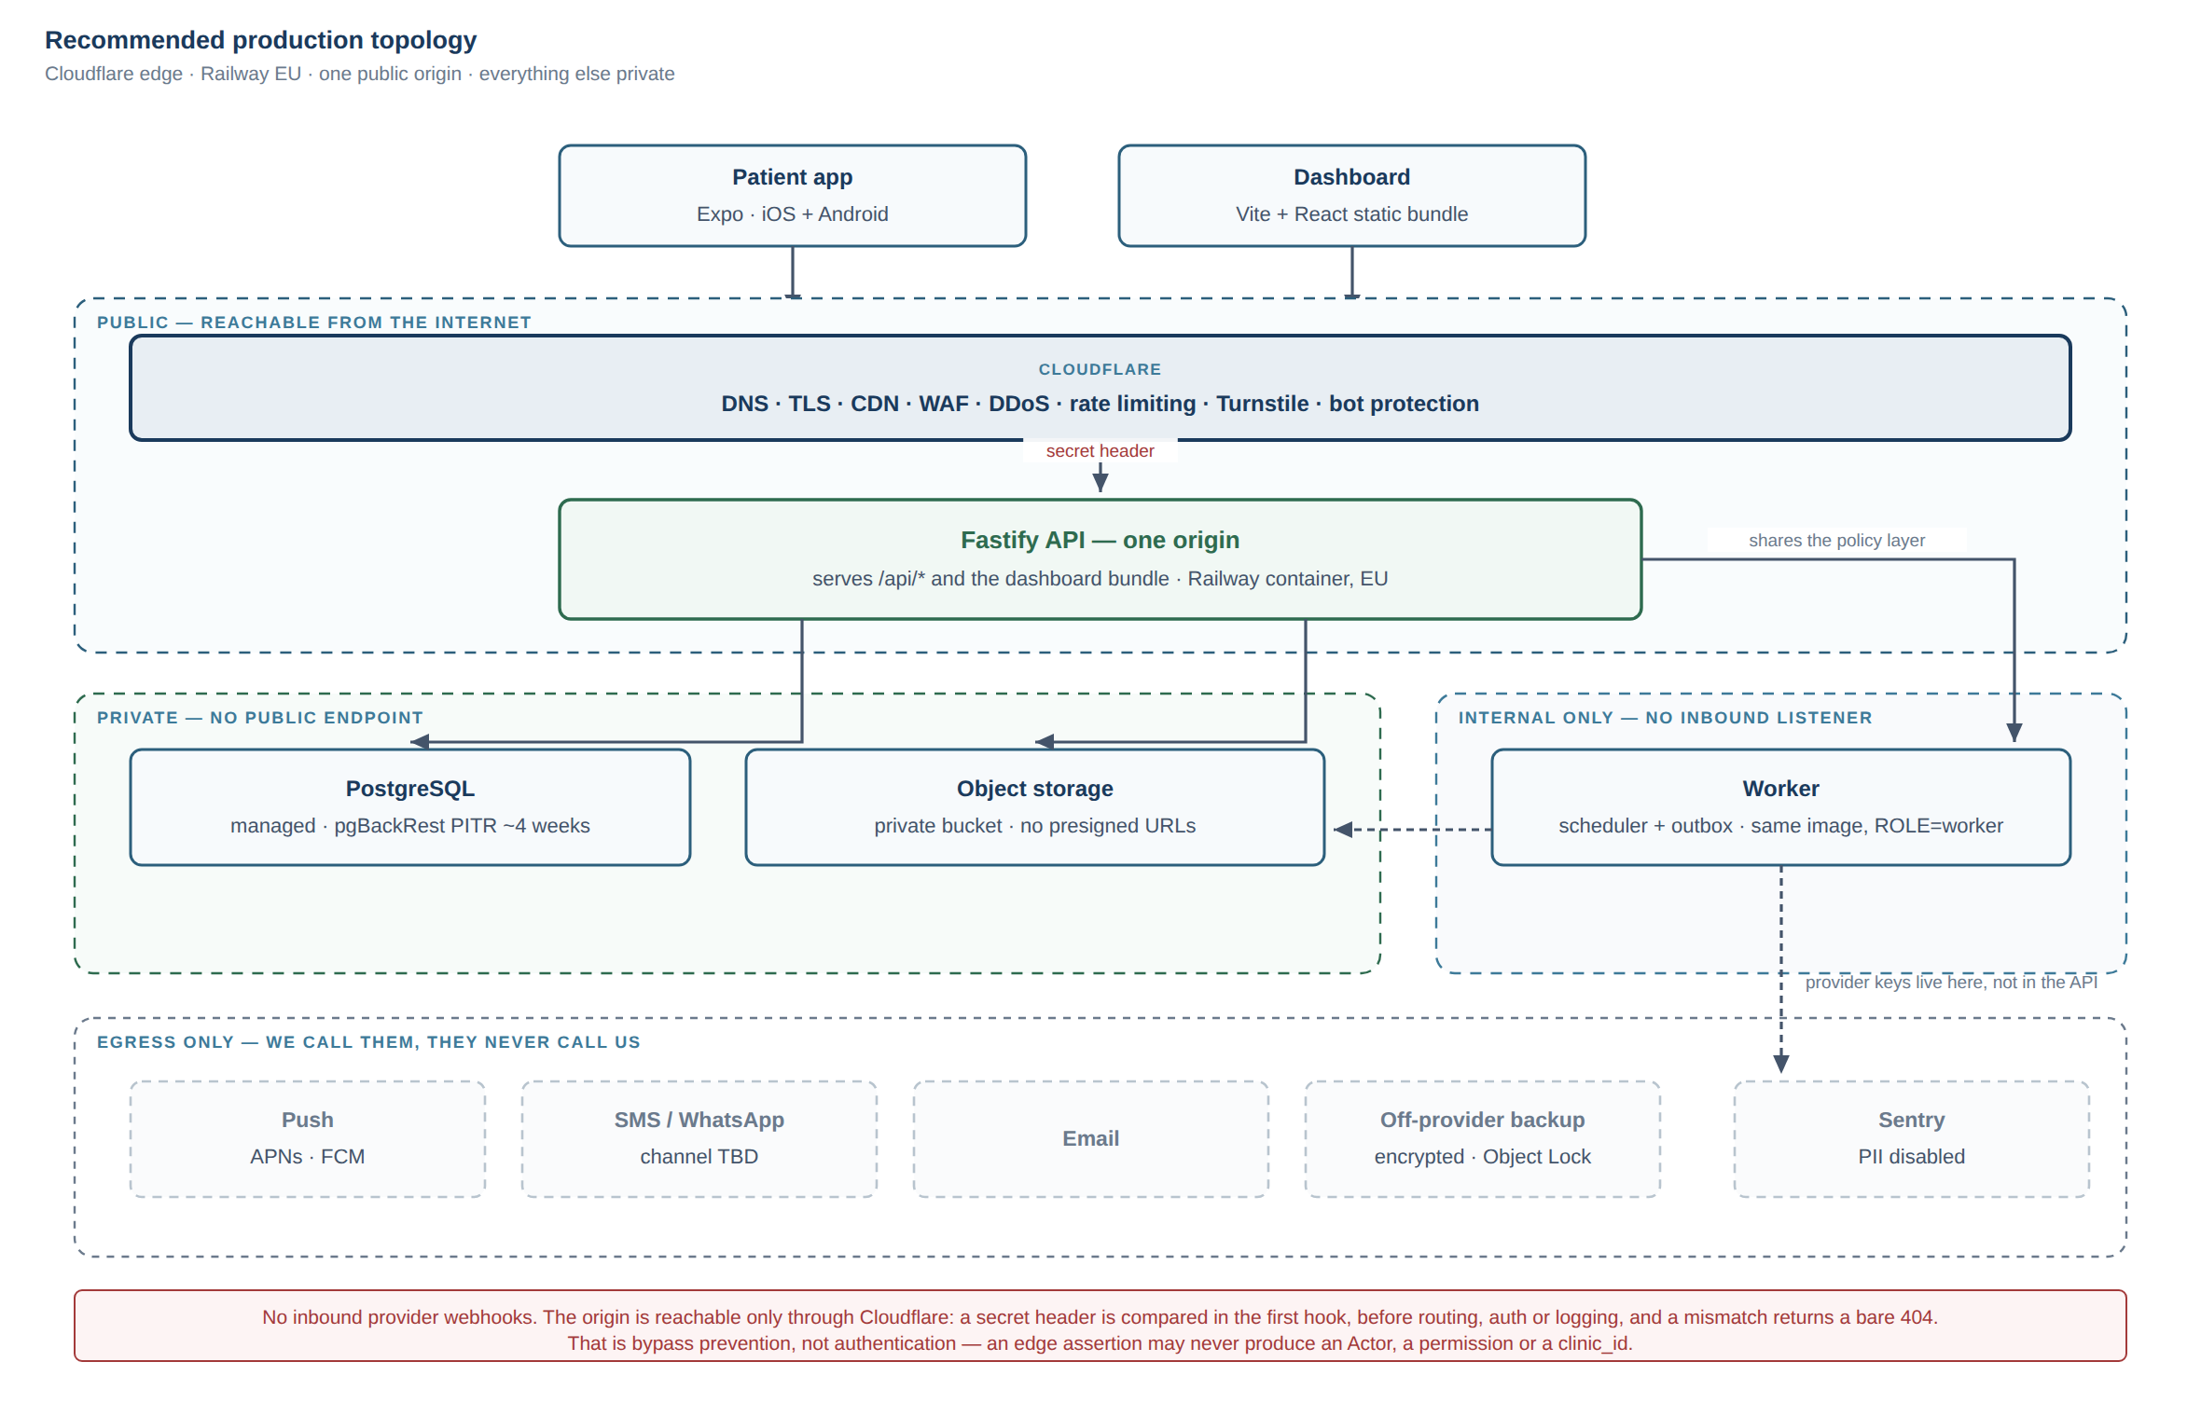
Recommended production topology, with public, private and internal-only zones marked.

PART 3 — "One Public Clinical Data Gateway", attacked before it is adopted

3.1 First, fix the statement
The proposed wording says "ONE authoritative application gateway" and then correctly notes this does not mean one server, process or container. That nuance is right but it is doing too much work in a footnote, and a rule that needs a footnote gets misread.
The rule is about authorization, not about exposure. Sharpened:
Every read or write of clinical data, from any client, service, job or tool, resolves an Actor and passes the same policy implementation before any repository call.
That formulation survives the attacks below; "one public entry point" does not. The two are routinely conflated and they are different claims: one is about how many rulebooks exist, the other about how many front doors exist. Only the first is non-negotiable.

3.2 The attacks
"It is a bottleneck." At the stated scale, no. A few thousand requests a day against a policy layer of pure synchronous functions over a pre-resolved Actor is not a measurable cost. The honest version of this objection is about document bytes, not policy — proxying large files through the API does consume a connection for the duration. §3.6 addresses it directly. Objection does not survive at this scale; the trigger to revisit is named.
"It is a single point of failure." This confuses the policy boundary with the process. One rulebook does not imply one replica. The API can run N replicas behind the edge and remain one gateway, because the gateway is the code path, not the container. What is genuinely single is PostgreSQL, and that is true in every architecture considered here, including the Supabase one. Objection does not survive.
"It harms scalability." The scaling limits here are PostgreSQL connections and document bandwidth. Neither is caused by centralised authorization. A direct-to-database client architecture does not scale better; it scales the same and audits worse. Objection does not survive.
"It complicates the worker." This is the strongest version of the objection and it deserves a real answer, in §3.3. Partially survives — and changes the rule's wording.
"AI will need broad data access." It will not, and this is exactly where the rule earns its keep. An AI context builder is a caller, like any other: it resolves an Actor, calls the same policy functions, and receives only what that Actor could have read through the API. What it must never receive is a credential that reads more. Objection does not survive; see ADR-0004.
"Analytics needs unrestricted SQL." Partly true, and the rule must say what is allowed rather than pretend the need does not exist. §3.5. Partially survives.
"Multi-clinic will force a second path." The opposite. Multi-tenancy is the case where a single scope-resolution point is worth most, because clinic_id leakage is the failure that ends the business. Objection does not survive.

3.3 The worker: reuse the layer, do not call the API
The question "should internal services call the API over HTTP, or reuse the policy and domain layer in-process?" has a clear answer here: reuse the layer.
An internal HTTP hop between two processes inside the same trust boundary buys nothing — the same code, the same database, the same deployment — and costs a network failure mode, a serialisation boundary, and a service credential that becomes a bearer token for everything. That credential is precisely the "second privileged path" the rule exists to prevent.
So the worker imports packages/core/policy and the repositories, exactly as the API does, and runs under an explicit system Actor that is a real value with a real scope, not a bypass. The rule's wording is therefore one policy implementation, not one process — and the auditability requirement is met by the system Actor writing audit events that name the job and rule that caused the action, so an automated write is never indistinguishable from a human one.

3.4 One rulebook, but how many front doors?
A serious counter-proposal argued for two hostnames with deliberately different exposure: the patient API open to the world (patients arrive from arbitrary mobile IPs), and the clinical surface behind Cloudflare Access, so the highest-value surface — see every patient, export everything — is not reachable by anonymous internet traffic at all. Both terminate in the same process and the same policy module.
This is a good argument and it is compatible with the rule as sharpened in §3.1. It is deferred rather than adopted for v1 on two practical grounds: it introduces an identity provider dependency for a three-person clinic, and if Access is misconfigured or unavailable the clinic cannot work at all — an availability risk traded for a real but secondary exposure reduction.
What is adopted now instead, at no operational cost: the same process serves both surfaces, and every route declares its surface tag derived from its policy. Staff-only routes are tagged clinical automatically. That makes the later split a configuration change rather than a redesign, and in the meantime the WAF applies different rate limits and bot posture per path prefix.
Revisit when: the clinic adopts any SSO identity provider, or staff count exceeds ~10, or a credentialed-insider incident occurs.

3.5 Exports and analytics
Both are real needs and both are where centralised authorization is most often quietly abandoned. The allowed shapes:
- Exports run through the same scope resolution as a list query. An export is a privileged read, not a different kind of access: same patientScopesFor(actor), pushed into the same WHERE. Every export writes an audit event recording the actor, the filter and the row count, and exports are rate-limited and alerted on — because a compromised staff account quietly exporting the panel is the most likely real breach in a clinic, and no authorization rule can stop it. Only detection can.
- Analytics runs against a restored backup or a read replica, never against production with an unrestricted role, and against data with direct identifiers removed. If a question genuinely needs identifiers, it is a report and it goes through the API.

3.6 Documents: proxy the bytes
Decision: no presigned URL code path exists in v1. Every document byte is streamed through the API so the policy call runs and an audit row is written.
This reverses the usual instinct, so the reasoning matters:
1. A presigned URL is a bearer token inside a URL. In this user population it will land in screenshots, WhatsApp forwards and the Android share sheet. That is a realistic leak vector, not a theoretical one.
2. You cannot audit a read that never reaches your API. Minting a URL records authorization; it does not record delivery. For clinical documents that distinction is the whole point of the audit trail.
3. The cost objection is gone. Railway's buckets sit on the private network with free egress, so the bandwidth argument that normally makes proxying unattractive does not apply. This is a concrete example of the hosting choice and the security design being decided together rather than in sequence.
Named trigger to revisit, stated now so it cannot be smuggled in later: sustained document reads roughly two orders of magnitude above pilot, or single objects above ~100 MB. If adopted then, TTL ≤ 60 seconds, single-use nonce recorded in the database, and a written acknowledgement that the audit row records authorization, not delivery.

3.7 Verdict
Adopt, with the sharpened wording. The principle survived every attack except two, and both of those changed the wording rather than the decision: the worker reuses the policy layer instead of calling an API, and "one gateway" governs authorization rather than exposure. See adr/0004-one-public-clinical-data-gateway.md.
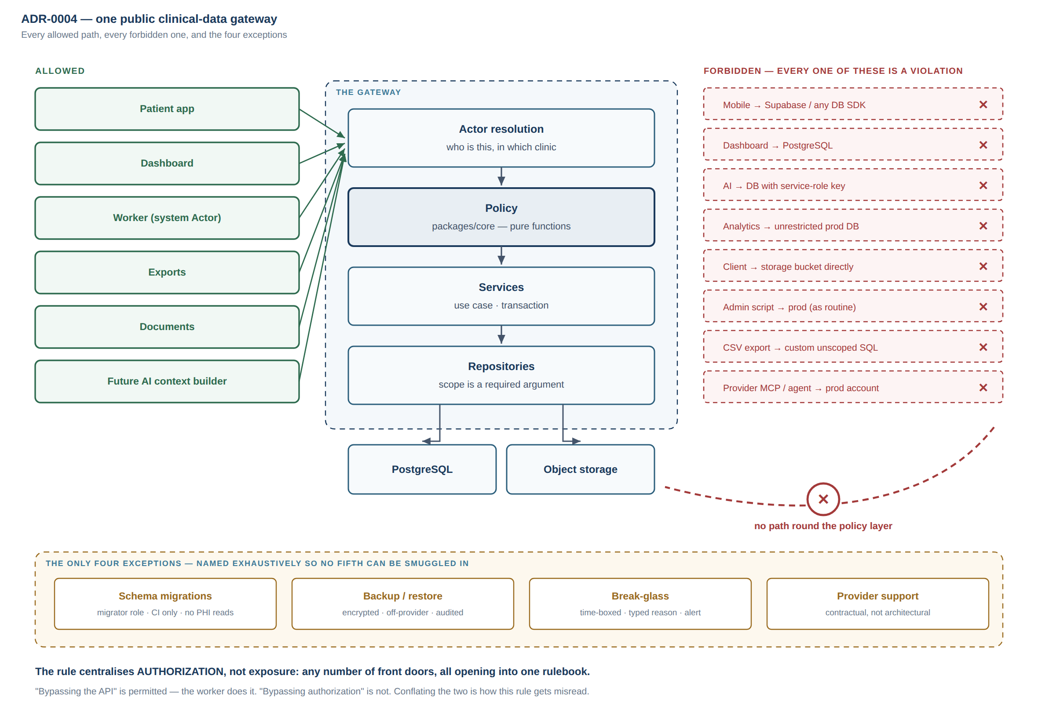
The one-gateway boundary: every allowed path, and the eight ways past it that are forbidden.

PART 4 — The ADR
Written as adr/0004-one-public-clinical-data-gateway.md, including the violation table the brief asked for.

PART 5 — Hostile security review
Note on scope: the brief's Part 5 was truncated mid-sentence after "service-role abuse". This section covers the attack classes that were listed plus the ones that follow from this topology. Tell me what was cut and I will extend it.

5.1 The finding I would escalate first
An AI agent session connected to the production hosting account is a second privileged data path, and it is the most likely one to appear on this project.
This is not hypothetical. The session writing this document has tools available named mcp__Render__query_render_postgres and mcp__Render__update_environment_variables. Any provider MCP integration of that shape, connected to a production workspace, can read the clinical database and rewrite secrets without traversing the API, the policy layer, or the audit trail — which is the precise definition of a gateway violation in ADR-0004.
On a project whose stated working model is "Claude Code + Codex do most of the implementation", this is the highest-probability bypass in the entire system, and it arrives through a convenience feature rather than an attack.
Control: production provider accounts are never connected to an AI agent session. Agent tooling is restricted to development and staging workspaces. This belongs in the ADR's forbidden list, in the operator runbook, and in the onboarding of any future contributor.

5.2 IDOR / BOLA and broken object-level authorization
The dominant risk in this system. The defences, in order of strength:
1. Make the mistake impossible to express. Repository functions take a Scope value that only the policy layer can construct. findMeasurements(scope, …) cannot be called with a raw patientId from a request body, because the type does not permit it. Forgetting becomes a compile error rather than a code-review hope — this is the single highest-leverage control and it costs almost nothing in TypeScript.
2. Fail at boot, not at review. Every route schema carries a required policy property; the process exits at startup if any registered route lacks one. This directly repairs ADR-0003's own stated weakness, that nothing fails when someone skips the policy layer.
3. A route-inventory test. Every registered route must appear in the authorization test matrix; CI fails when a new route is added without one. This is what makes the guarantee hold under AI-generated code, where volume outpaces review.
4. Never fetch-then-filter. Scope goes into the WHERE clause. Filtering after the fetch leaks row counts through pagination and returns short pages.
5. Identical responses for "not found" and "not yours." Otherwise the 403/404 difference is a patient-existence oracle.

5.3 Cross-patient and cross-clinic leakage
Cross-patient leakage is IDOR and is handled above. Cross-clinic is different in consequence: it is the failure that ends the business when clinic #2 exists.
Recommendation — and it differs from both proposals I reviewed. Do not enable PostgreSQL row-level security in v1, and do not defer its plumbing:
- From the first migration, all database access goes through one `withActor()` transaction helper that sets app.clinic_id as a transaction-local setting. A lint rule forbids importing the connection pool anywhere else.
- RLS policies are added at the multi-clinic milestone, as a migration only, with a hard constraint: a policy may encode clinic_id = current_setting('app.clinic_id') and nothing else. Any policy referencing a role, permission or patient assignment is forbidden.
The reasoning: with one clinic, RLS protects against nothing today, so paying its debugging cost now is waste. But retrofitting it later normally means auditing every query path again — unless the GUC plumbing already exists, in which case enabling it is a migration. The constraint to clinic_id only is what prevents RLS becoming the second rulebook ADR-0003 warns about: it expresses an invariant, not a policy.

5.4 Service-role abuse
The canonical second path, and the strongest argument against the Supabase platform model: a service_role key bypasses RLS entirely and, once it exists, migrates toward whatever code is most convenient. This topology has no such credential by construction — there is no key that reads more than an Actor may read.
The credentials that do exist are separated by deployment: the API container holds database and storage credentials; the worker holds the provider keys (FCM, SMS, WhatsApp) that the API never needs. A compromise of the public-facing process therefore does not yield the messaging credentials. This is the main reason the worker stays a separate container from the same image rather than an in-process loop, despite the event volume being low enough to justify merging them.

5.5 Other paths a developer could take by accident
Path | Why it happens | Control
A repository query written without scope | Fastest way to make a feature work | Branded Scope type; lint rule; route-inventory test
Storage SDK imported into the dashboard or app | Copy-paste from a tutorial | no-restricted-imports on client packages; CI check on the built bundle
A secret committed | Routine | gitleaks in CI; sealed variables; a leak probe that boots the built image and asserts no secret appears in any response
A migration that reads PHI | Convenience during a data fix | Migrations run under a migrator role whose credential is absent from the API container
An admin script against production | A genuine emergency | Break-glass only: separate credential, time-boxed, typed reason, out-of-band alert — never routine
Debug logging of a request body | Debugging a real incident | Central pino redaction keyed to the data classification; a test asserting no clinical field name appears in log output
Clinical detail in a push payload | Making the notification useful | Generic payloads enforced by test; the app fetches detail after authentication

5.6 The attack that no authorization design prevents
A credentialed clinician reading 300 patient records at 02:00 is indistinguishable, to the policy layer, from a clinician doing their job. Authorization cannot stop it; only detection can, and this is the most likely real breach in a small clinic.
Therefore, as a v1 requirement rather than a later enhancement: bulk-access anomaly detection over the audit table — reads per actor per hour, exports per actor per day, access to patients outside an actor's assignment — with a real-time alert and a monthly review. Break-glass access to an unassigned patient is allowed, because refusing it would get the control worked around, but it requires a typed reason and fires an alert.

Summary of decisions
# | Decision
1 | Gate 0 first: empirically verify Iraqi signup and payment per provider before ratifying anything.
2 | Edge: Cloudflare — DNS, TLS, CDN, WAF, DDoS, rate limiting, Turnstile, bot. Not the app runtime. Not R2.
3 | App + DB + storage: Railway, EU region. Render second, Fly third.
4 | Off-provider encrypted immutable backup to a third vendor, drilled monthly in CI.
5 | Origin locked to Cloudflare by a secret header checked before anything else.
6 | Dashboard becomes a static SPA served by the API process. Next.js removed. (Overturns doc 03.)
7 | Worker stays a separate container from the same image, for credential separation.
8 | Adopt ADR-0004, with authorization — not exposure — as the thing centralised.
9 | No presigned URLs for PHI in v1. Proxy every byte.
10 | RLS plumbing from day one; RLS policies at multi-clinic, constrained to clinic_id.
11 | No production provider account is ever connected to an AI agent session.
12 | Bulk-access anomaly detection is v1 scope, not a later enhancement.

What remains open
Ali decides: Gate 0 results; whether to accept the Next.js removal; whether the two-hostname split is wanted earlier than §3.4 proposes; the off-provider backup vendor.
Requires Iraqi legal review: whether in-country data residency is required (if yes, this entire recommendation fails); Iraq's sanctions status as it affects provisioning; whether storing Iraqi patients' records in Germany under a German or US processor is permitted.
Requires human security review: the authorization matrix and the branded-Scope mechanism; the origin-lockdown configuration; the break-glass procedure; and a penetration test focused on object-level authorization before real patients.
Must be measured, not estimated: RTT from Zain, Asiacell, Korek and a fixed line to Frankfurt, and whether Iraqi ISPs peer with Cloudflare's in-country PoPs or backhaul via Europe. The second determines whether the edge argument in §1.4 holds at all.

Sources
Verified 2026-09-16: AWS Middle East outage and drone strikes — Data Center Knowledge, Cybersecurity News, AWS re:Post. App Runner closure — AWS documentation. ECS Express Mode — AWS migration guide. Google Cloud billing countries — Google Cloud community. Railway PITR — Railway docs. Cloudflare Iraq PoPs — Cloudflare network, CDN Planet.

APPENDIX A

Architecture Decision Records
One short record per significant decision, so that in twelve months anyone — including a developer who has never met us — can find out why something is the way it is, not just what it is (§64).

Status values
Status | Meaning
Proposed | Written, argued, not approved. Everything here is Proposed until the Product Owner approves the architecture
Accepted | Approved and in force
Superseded by NNNN | Replaced. The record stays — the history is the point
Rejected | Considered and declined. Kept, so it is not re-proposed from scratch

When to write one
Write an ADR when a decision is expensive to reverse or when someone will later ask "why on earth is it done this way?":
- Choosing a language, framework, database, or hosting model
- Where a cross-cutting concern lives (authorization, errors, i18n, events)
- A data-model decision with migration cost
- Anything clinical-safety-related in the system's design
- Deliberately not doing something obvious
Do not write one for ordinary implementation choices. An ADR every week is a healthy project; an ADR every day means the format is being misused.

Rules
- Numbered sequentially, never renumbered.
- Never edited after acceptance except to change status. A decision that changes gets a new ADR that supersedes the old one.
- Short. One page. If it needs five pages, it is a design document with an ADR pointing at it.
- Records the context and the consequences, including the bad ones. An ADR listing only advantages is marketing, not a record.

Index
# | Title | Status
0001 | Modular monolith in TypeScript | Proposed
0002 | The API runs as a long-lived container | Proposed
0003 | Exactly one authorization implementation | Proposed
0004 | One public clinical-data gateway | Proposed

ADR-0001 — Modular monolith in TypeScript
Status: Proposed — awaiting Product Owner approval Date: 2026-09-16 Milestone: M0

Context
The product spans a dozen domains: identity, patients, pathway, measurements, nutrition, medications, labs, symptoms, alerts, appointments, follow-up, documents, content, notifications, audit. That breadth invites a service-per-domain split.
The team is one person plus two AI agents plus a part-time engineer. There is no operations team, no platform team, and nobody to be paged.
Three stack options were evaluated in ../03-STACK-EVALUATION.md.

Decision
One deployable TypeScript application, organised as modules under apps/api/src/modules/<domain>/, each with routes / service / repository / tests, plus one worker process from the same codebase for scheduled work and the outbox relay.
Cross-module calls go through services, never another module's repository. Pure domain logic lives in packages/core with no dependencies, so it is shared unchanged by the API, the worker, exports, and any future AI path.
TypeScript across API, dashboard and mobile, with Zod contracts shared between them.

Consequences
Good. One deploy, one database, real foreign keys across domains, and atomic transactions spanning domains — a symptom submission that also writes a domain event and creates an alert is one transaction, not a distributed saga. Shared contracts mean API drift is a compile error rather than a runtime bug. One language keeps the AI agents in one context, which measurably improves their output. A team this size can hold the whole system in their heads.
Bad. No independent scaling and no independent deploys. Module boundaries are enforced by convention and review, not by the network — they will erode without discipline. A single runtime fault can take down every domain at once. TypeScript is a weaker choice than Python if clinical research and analytics become a priority.
If this becomes a problem. The boundary is already a service interface — a function signature that can become an HTTP call. Extraction is mechanical when there is a genuine reason. Microservices at this scale would buy distributed transactions, network failure modes, and a deploy pipeline per service: all of the cost of scale with none of the scale.

ADR-0002 — The API runs as a long-lived container, not as serverless functions
Status: Proposed — awaiting Product Owner approval Date: 2026-09-16 Milestone: M0

Context
The obvious modern default is to deploy the API as serverless functions on a platform with a generous free tier. The sibling project ../../../student-os in this workspace does exactly that.
Its own documentation records what that cost. The packaged function shipped without three of its dependencies and threw Cannot find package 'zod' before a line of it ran — production returned 502 to every request while every CI check was green, because nothing in the pipeline tested the artifact that actually ships. A failed boot also leaked a filesystem path, a stack frame and a connection string to the public before that was fixed. The team then had to build a bespoke packaging-verification gate to stop it recurring.
This system additionally needs things serverless makes awkward:
- Persistent database connections. Serverless plus PostgreSQL means a pooler and connection-limit discipline as permanent overhead.
- Scheduled work. Overdue-follow-up sweeps and reminder dispatch are not request-triggered.
- An outbox relay draining domain events continuously.
- Predictable latency. Cold starts on a clinical dashboard are a daily irritation for staff who use it all day.

Decision
The API runs as a long-lived container on a managed container host, alongside a worker container from the same image for scheduled work and the outbox relay, with managed PostgreSQL and S3-compatible object storage.
CI still includes a deployment-contract gate that exercises the built artifact rather than the source tree. The lesson from the incident is not "serverless is bad" — it is "test what ships".

Consequences
Good. No packaging-shape failure class. Connection pooling is ordinary. Scheduled work and the relay are a process, not an architecture. No cold starts. The application is portable — if data residency requires moving to a provider inside Iraq, a container moves and functions do not. Local development matches production closely.
Bad. A small fixed monthly cost instead of a free tier. We manage a process: restarts, health checks, graceful shutdown, memory limits. Scaling is manual until it is configured. Two deployables instead of one.
If this becomes a problem. At this scale it will not be load. If the fixed cost is genuinely prohibitive, the same container runs on a single small VPS for less than the managed host. The application code does not change either way — which is the point.

ADR-0003 — Exactly one authorization implementation
Status: Proposed — awaiting Product Owner approval Date: 2026-09-16 Milestone: M1

Context
This system holds the medical records of a named surgeon's patients in a community where the social consequences of exposure are real. Broken access control is the failure mode most likely to occur and the one with the worst consequences (../02-RISK-REGISTER.md R6).
The handoff requires centralised authorization policy (§42, §43) rather than role checks scattered through the codebase.
Systems normally fail this in one specific way: they grow a second, "trusted" path. Some feature — a CSV export, an analytics job, an admin screen, an AI retrieval pipeline — needs data across users, so it is given a privileged database role and bypasses the policy layer. From that moment the security model is whatever the weakest path allows.

Decision
Authorization lives in packages/core/policy as pure, synchronous functions over a fully resolved Actor. Two mechanisms:
1. canViewPatient(actor, patient) and siblings, for single-object decisions.
2. patientScopesFor(actor), whose result is pushed into the SQL WHERE clause for list queries.
The REST API, the dashboard, the worker, exports, and any future AI retrieval path call the same functions. There is no privileged path. List endpoints must not fetch-then- filter: that leaks row counts through pagination and returns short pages.
Roles and permissions are data. There is no if (role === 'doctor') anywhere outside the policy module.
Database-level row security may be added later as defence in depth. It is never the primary mechanism — see ../03-STACK-EVALUATION.md for why.

Consequences
Good. The security surface is covered by fast unit tests over pure functions, so the full role × resource × operation matrix runs on every commit rather than nightly. The Actor is resolved once per request, which makes "what can this user reach?" a single auditable question. Adding a role is configuration. Cross-clinic leakage becomes provable rather than hoped for.
Bad. Every request loads the actor's full membership and assignment set, even when it needs one field. Discipline is required forever: the day someone adds a repository call that skips the policy layer, this ADR is violated silently and nothing fails.
If this becomes expensive. Cache the resolved Actor per request batch. Do not make the policy layer lazy or optional — laziness is exactly how the second path gets born.
Verification. A test asserts that no query returns rows across clinic_id boundaries. A human penetration test before launch targets this specifically, because tests written by the author of the code inherit the author's blind spots.

ADR-0004 — One public clinical-data gateway
Status: Proposed — awaiting HOSTING AND DATA ARCHITECTURE APPROVED Date: 2026-09-16 Milestone: M1 Analysis: ../11-ARCHITECTURE-DECISION-ADDENDUM.md §3 and §5. This record is longer than this directory's own one-page rule allows, because it has to carry an enforceable violation list; the reasoning lives in document 11.

Context
This system holds the medical records of a named surgeon's patients in a community where the social consequences of exposure are real. Broken access control is both the most likely failure and the worst one (risk R6).
Systems fail this in one characteristic way: they grow a second, privileged path. Some feature — an export, an analytics job, an admin screen, an AI retrieval pipeline, a convenient platform integration — needs data across users, so it is given a credential that reads more than any user may read. From that moment the security model is whatever the weakest path allows, and the first path's careful policy layer is decoration.
ADR-0003 already established one authorization implementation inside the application. It does not say anything about paths that never enter the application at all, and those are the ones that actually cause breaches.
The principle was attacked before adoption (document 11 §3.2). Two objections changed the wording; none defeated the decision.

Decision
Every read or write of clinical data — from any client, service, job, script or tool — resolves an Actor and passes the same policy implementation before any repository call.
The thing centralised is authorization, not exposure. This is deliberate and it is the correction the original phrasing needed:
- One policy implementation. Non-negotiable.
- One public origin. Not required. Multiple hostnames with different edge exposure are permitted, provided they terminate in the same policy implementation.
- One process. Not required. The worker reuses the policy and repository layer in-process under an explicit system Actor. It does not call the API over HTTP: an internal HTTP hop inside one trust boundary buys nothing and costs a service credential that becomes exactly the second privileged path this ADR exists to prevent.

Security boundary
The boundary is the policy layer, not the network edge:
any caller → Actor resolution → policy functions → services → repositories → data
A caller is inside the boundary when it has traversed policy with a resolved Actor. Network position grants nothing. A Cloudflare Access assertion, a private-network origin, a platform console session and a CI runner are all outside the boundary, and none of them may produce an Actor, a permission or a clinic_id.

Trust boundaries
Zone | Contains | Trusted to
Untrusted | Patient app, dashboard bundle, the internet | Nothing. Every input is validated server-side
Edge | Cloudflare | Filter volume and shape. Never to assert identity
Application | Fastify API, worker | Resolve Actors and enforce policy
Data | PostgreSQL, object storage | Nothing — they enforce no policy of their own in v1
Operator | Provider console, CI, break-glass | Audited, exceptional, never routine

Allowed access paths
1. Patient app → edge → API → policy → services → repositories → PostgreSQL / storage.
2. Dashboard → same, from the same origin that serves its bundle.
3. Worker → the same policy and repository layer, in-process, under a system Actor whose scope is explicit and whose audit events name the job and rule that caused the action.
4. Exports → the same patientScopesFor(actor) pushed into the same WHERE, plus an audit event recording actor, filter and row count.
5. Documents → bytes streamed through the API after the policy call. No presigned URL code path exists in v1.
6. Future AI → an approved context builder that is an ordinary caller: it resolves an Actor, calls the same policy functions, and receives only what that Actor could have read.

Forbidden access paths — the violation list
A violation is any read or write of clinical data that reaches the database or object storage without resolving an Actor and passing the policy layer. Network location, convenience and good intentions are irrelevant.
Path | Verdict | Why
Mobile app → Supabase (or any DB SDK) directly | Violation | A second authorization implementation with different semantics and a weaker test story. The client also becomes a place a privileged key can leak.
Dashboard → PostgreSQL directly | Violation | Requires database credentials in a browser. Catastrophic and unrecoverable — the credential is public the moment it ships.
AI service → database with service-role credentials | Violation | The canonical second path. An AI component must never hold a credential that reads more than the user it is acting for.
Analytics job → unrestricted production database | Violation as stated. Allowed shape: a read-only role against a restored backup or replica, with direct identifiers removed. If a question genuinely needs identifiers it is a report and goes through the API. | Unrestricted production SQL is indistinguishable from a breach in the audit trail.
Worker → database bypassing authorization | Depends — and this is the distinction that matters. Reusing the policy and repository layer under a system Actor is allowed and is the design. Ad-hoc SQL from the worker that skips policy is a violation. | "Bypassing the API" is fine. "Bypassing authorization" is not. They are different things and conflating them is how this rule gets misread.
Client → private storage bucket directly | Violation in v1. No presigned URL path exists. | A presigned URL is a bearer token inside a URL; in this population it lands in screenshots and WhatsApp forwards. And you cannot audit a read that never reaches your API.
Admin script → production database | Violation as routine practice. Allowed as break-glass under §Exceptions. | Routine console SQL is how every control erodes.
CSV export → custom unrestricted SQL | Violation | An export is a privileged read, not a different kind of access. Same scopes, same WHERE, plus an audit event.
Provider MCP / AI agent integration connected to the production account | Violation | The highest-probability bypass on this project. Integrations of this shape expose tools that query the production database and rewrite environment variables without touching the API, the policy layer or the audit trail. Agent tooling is restricted to development and staging.

Exceptions
Four, named exhaustively so that nothing else can be smuggled in as "also an exception":
1. Schema migrations. Run under a migrator role whose credential is absent from the API container, in CI, and must not read PHI.
2. Backup and restore. Operates on the whole dataset by definition. Compensating controls: encryption at rest with a key held separately, an off-provider immutable copy, and an audit record of every restore.
3. Break-glass operator access. A separate, time-boxed credential; a typed reason required; an out-of-band alert fired; reviewed monthly. Allowed because refusing it entirely guarantees it is worked around during a real emergency.
4. Provider platform support access. Outside our control; governed by contract, not architecture. Recorded here so it is not mistaken for a path we designed.
Every exception is logged where the application cannot suppress it.

Enforcement mechanisms
A rule nothing enforces is decoration. In descending order of strength:
Mechanism | Enforces
Branded `Scope` type that only the policy layer can construct; repositories require it | Makes an unscoped query a compile error
Boot-time route assertion — every route schema carries a required policy property; the process exits at startup if any route lacks one | Repairs ADR-0003's own stated weakness: that nothing failed when someone skipped the policy layer
Route-inventory test — every registered route must appear in the authorization matrix | CI fails when a route is added without an authorization test. The control that holds under AI-generated volume
no-restricted-imports — DB and storage clients importable only in packages/db and *.repository.ts; never in apps/dashboard or apps/mobile | Client-side leakage
Single withActor() transaction helper; lint rule forbids importing the pool elsewhere | One place sets the transaction scope
Built-bundle CI check for storage/DB SDK symbols and secret patterns | What actually ships
gitleaks + dependency audit in CI | Committed credentials
Production provider accounts never connected to agent tooling | The MCP violation above

Testing strategy
- Authorization matrix: every role × resource × operation × (own / same clinic / other clinic), as fast unit tests over pure functions, run on every commit.
- Cross-clinic assertion: a test that no query returns rows across a clinic_id boundary.
- Negative tests authored by the second agent, not by the author of the code — tests written by the implementer inherit the implementer's blind spots.
- 404/403 indistinguishability: "not found" and "not yours" must be byte-identical, or the difference is a patient-existence oracle.
- Route-inventory test as above.
- Human penetration test focused on object-level authorization before real patients.

Consequences
Advantages. One place to answer "who can read this patient's weight series?", and one tired person can find it by grep. The full authorization matrix runs as millisecond unit tests rather than slow integration tests, so it is actually run. Every clinical access is auditable because every clinical access traverses code we control. No credential exists that reads more than an Actor may read, so there is no single catastrophic key to leak. Adding a role is configuration. Multi-clinic isolation has exactly one enforcement point.
Disadvantages. Document bytes flow through the API, which consumes a connection for the duration (trigger to revisit named in document 11 §3.6). Every caller loads the Actor's full membership set even when it needs one field. Analytics is less convenient by design. And the rule requires permanent discipline: the day someone adds a repository call that skips the policy layer, the enforcement mechanisms above are what fail the build — which is why they, not this document, are the actual control.
Failure modes.
Failure | Effect | Mitigation
API unavailable | All clinical access stops | Accepted. Health checks, fast restart, and the mobile app remaining readable from its local cache
Policy bug grants too much | Silent over-exposure | Authorization matrix; adversarial review by the second agent; penetration test
Policy bug grants too little | Visible, non-damaging | Preferred direction of failure. Fail closed
Credentialed insider reads 300 records at 02:00 | Indistinguishable from legitimate work | No authorization design prevents this. Bulk-access anomaly detection over the audit table is v1 scope for exactly this reason
Someone adds a second path anyway | Model silently defeated | Boot assertion, lint rules, route-inventory test, quarterly review of every production credential and integration

Implications
Future AI. An AI feature is a caller, never a principal. It resolves an Actor, passes the same policy layer, and receives a minimised, field-allowlisted context. It never holds a database credential and never has a tool that can issue arbitrary queries. Sending patient data to an external model is additionally a legal decision before it is an engineering one [LEGAL REVIEW REQUIRED].
Future analytics. Against a restored backup or replica, identifiers removed. The moment analytics needs a production credential, this ADR is being violated and the requirement should be re-examined instead.
Multi-clinic. This is where the rule pays for itself: clinic_id scope resolution happens in one place. Additionally, at the multi-clinic milestone, PostgreSQL row-level security is enabled as defence in depth — constrained to clinic_id = current_setting('app.clinic_id') and nothing else, so that it expresses an invariant rather than becoming a second rulebook. The withActor() plumbing that sets the setting exists from day one, so enabling it is a migration rather than an audit of every query path.
Migration. Nothing here binds the system to a provider. Policy is application code; the data layer is plain PostgreSQL and a plain S3 API. Moving providers does not move the security boundary — which is itself an argument for the boundary being in application code rather than in a vendor's row-level security engine.

Revisit this ADR when
- Document reads sustain roughly 100× pilot volume, or single objects exceed ~100 MB (reopens presigned URLs, under the constraints in document 11 §3.6).
- A third party needs programmatic access — a partner clinic, a lab integration, a research export. The answer is expected to be a scoped surface behind the same policy layer, but it deserves a fresh look rather than an assumption.
- The clinic adopts an SSO identity provider, or staff exceed ~10 (reopens the two-hostname exposure split).
- A credentialed-insider incident occurs.
- Any regulatory finding requires an access path this ADR forbids.
Until then: one rulebook. Any number of front doors, all opening into it.

