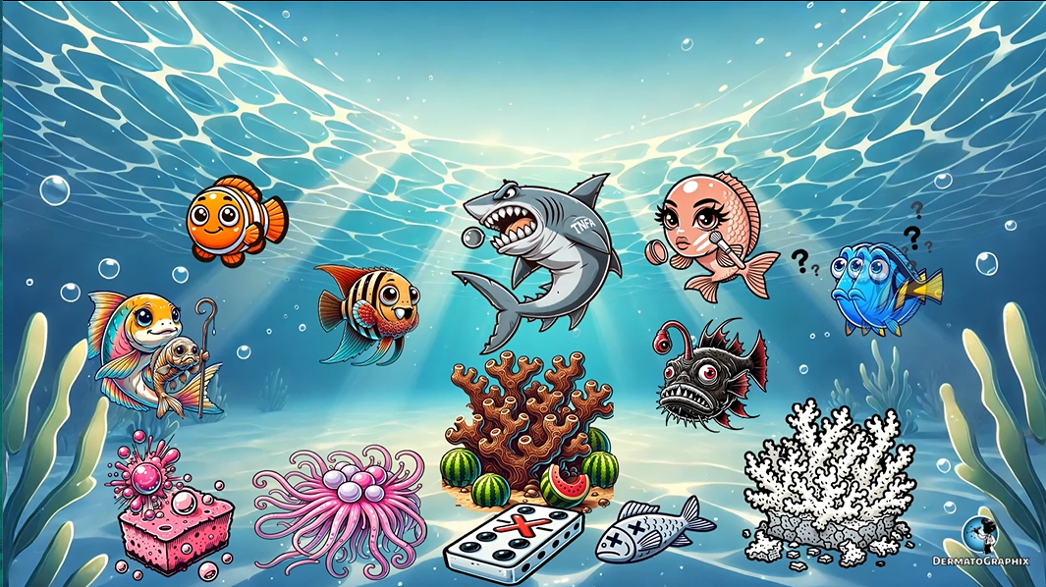

TRANSCRIPT: Biotinidase & Multiple Carboxylase Deficiency
============================================================

Welcome to the biodegradable tin can recycling factory, where we will learn about biotinidase deficiency as well as multiple carboxylase deficiency, hence the biodegradable tin cans and the torn cardboard box. Biotin is required for the function of four carboxylase enzymes. Biotinidase deficiency typically presents in childhood and is autosomal recessive, as shown by the child holding a recessive recessed chocolate. Hollow carboxylase synthetase deficiency, or HLCS deficiency, is also autosomal recessive, but typically presents in early infancy, shown by this infant inside the hollow cardboard box. Careful kiddo, that box is dangerous. The skull and crossbones represents that this deficiency is often more severe and fatal if untreated. In biotinidase deficiency and multiple carboxylase deficiency, loss of function of these enzymes results in disruption of fatty acid oxidation and accumulation of toxic metabolites. Their metallologic manifestations include perioral and generalized dermatitis, as shown by the red spots all over this baby. The baby is also bald, representing the finding of alopecia in this condition. See how this next baby has sunken eyes that almost have an atrophy appearance to them? This represents the extracutaneous manifestations like optic atrophy in biotinidase deficiency. These cans really are biodegradable. This IV growing around the tin can represents IV biotin replacement, which is used for treatment. Okay, let's recap the symbols. In this biodegradable tin can factory, we learned about biotinidase deficiency as well as multiple carboxylase synthetase deficiency. The child holding a recessive recess reminds us that these conditions are autosomal recessive. Biotinidase deficiency typically presents in childhood, hence the older child on the left, on the right side we spot an infant inside the hollow cardboard box, representing the hollow carboxylase deficiency typically presents an infancy. Watch out, that box is dangerous. The skull and crossbones warns us that hollow carboxylase synthetase deficiency is often fatal if untreated. The bald baby covered in red spots illustrates the dermatologic manifestations of perioral and generalized dermatitis as well as alopecia. The baby with sunken, atrophied eyes symbolizes extracutaneous manifestations like optic atrophy in biotinidase deficiency. Finally, we see an IV growing around the tin can representing the life saving IV biotin replacement treatment. That's all for now. Remember to reuse, reduce, and recycle.

Biotinidase & Multiple Carboxylase Deficiency (Biotinidase_Multiple_Carboxylase_Deficiency_transcript.txt)
Topic | Details
Inheritance | Autosomal recessive
Mechanism | Biotin is cofactor for 4 carboxylases → deficiency → impaired fatty acid oxidation, accumulation of toxic metabolites
Biotinidase deficiency | Presents in childhood
Holocarboxylase synthetase (HLCS) deficiency | Presents in early infancy; more severe; often fatal if untreated
Skin | Perioral & generalised dermatitis, alopecia
Eyes | Optic atrophy (in biotinidase deficiency)
Treatment | IV biotin replacement

