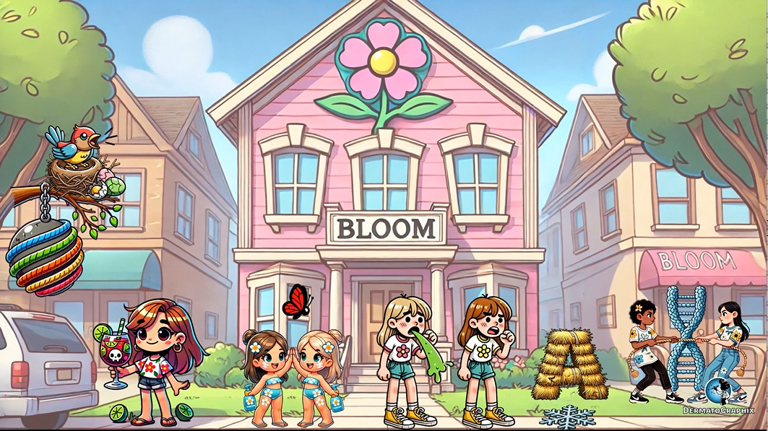

TRANSCRIPT: Bloom Syndrome
============================================================
Welcome to the Bloom Sisters sorority where we'll cover Bloom Syndrome. This is also known as congenital telangiectatic erythema. Bloom Syndrome is an autosomal recessive disorder due to a mutation in the BLM or RECQL-3 gene. You can remember BLM because they are the Bloom Sisters. Guess they are big Miley Cyrus fans too. This wrecking ball on a tree represents RECQL-3, which encodes a DNA helicase, hence the helical ribbons. Bloom Syndrome presents early in life with prenatal and postnatal growth impairment, leading to a short stature, hence the super short sisters. They are giving each other high fives to represent that patients do not exceed five feet in height. These sisters know how to protect their skin. They're applying sunscreen to represent the cutaneous manifestations of photosensitivity and telangiectatic erythema in a mallar distribution. Hence the red erythematous mallar-shaped butterfly. This high-pitched chirping bird with a beak represents the characteristic narrow face with prominent ears and bird-like nose as well as a high-pitched voice. These shriveled eggs represent primary hypogonidism. Effected men are sterile while women have decreased fertility. Patients can also have decreased immunity with decreased IgA and IgM levels, as represented by the IgA-Hey and IgM-shaped snowflake on the ground. This represents the pentamer that IgM typically forms, which kind of looks like a snowflake. This can lead to respiratory and GI infections, as shown by the sisters coughing and vomiting. Maybe they had a bit too much to drink? And what's a party without limes in the sangria? These limes represent increased risk of lymphoma, and the sangria represents increased risk of leukemia. Looks like the first hazing activity's already started. This tug of war game, with the rope in front of the chromosome-shaped bush, represents a characteristic pattern of chromosomal breakage and rearrangement that may be seen on chromosomal instability testing. Think of it like this rope about to break in front of the chromosome bush, representing chromosomal breakage and instability. There is also increased rates of sister chromatid exchange, hence the Bloom-Sister's sorority to symbolize sister chromatid exchange. While some of the cutaneous and immunologic findings improved with age, an increased risk of mortality from malignancy still remains and is the number one cause of death. This is especially the case with leukemia, hence the death skull on the leukemia sangria. Warning, it's so strong that it might cause death.
On that note, let's recap this graphic. The Bloom-Sister's sorority represents Bloom syndrome, also known as congenital telangiotatic erythema. This autosomal recessive disorder stems from a mutation in the BLM or the RECQL3 gene, symbolized by the wrecking ball tied to a tree representing the number three because tree rhymes with three. Bloom syndrome presents early in life with prenatal and postnatal growth impairment, leading to short stature shown by the short sisters. They're high-fiving to represent the fact that affected individuals don't exceed five feet in height. These sisters apply sunscreen representing the photosensitivity. The telangiotatic erythema seen in a malar butterfly-shaped distribution is shown by the red butterfly. This high-pitched bird with a sharp beak represents the characteristic narrow face, bird-like nose, prominent ears, and high-pitched voice. This is the first time the Shriveled Eggs symbolize primary hypogonodism. Men with Bloom syndrome are sterile, while women have reduced fertility. On the ground, we see hay-shaped like an A for IgA and a snowflake representing IgM, highlighting decreased immunity, which can lead to respiratory and gastrointestinal infections, like the coughing and vomiting sisters at the party. And what's a party without limes in the sangria? The limes represent an increased risk of lymphoma while the sangria symbolizes leukemia. The chromosomal tug of war game with a chromosome-shaped rope illustrates the chromosomal breakage and rearrangement pattern seen in chromosomal instability testing. While some of the cutaneous and immunologic features improve with age, the increased risk of malignancies, especially leukemia, remains the number one cause of death represented by the skull on the sangria glass. I think that's my cue to head out. Remember, chromosomes may break, but sisterhood is forever.

Bloom Syndrome (Bloom_Syndrome_transcript.txt)
Topic | Details
Inheritance | Autosomal recessive
Gene | BLM (RECQL3) → encodes a DNA helicase
Aka | Congenital telangiectatic erythema
Growth | Pre- and postnatal growth retardation; height does not exceed 5 feet
Skin | Photosensitivity, telangiectatic erythema in malar (butterfly) distribution
Facies | Narrow face, prominent ears, bird-like nose, high-pitched voice
Endocrine | Primary hypogonadism — males sterile, females have ↓ fertility
Immunology | ↓ IgA and IgM → respiratory and GI infections
Cytogenetics | Chromosomal breakage & rearrangement; ↑ sister chromatid exchange
Cancer risk | ↑ Risk of lymphoma and leukaemia (#1 cause of death)

