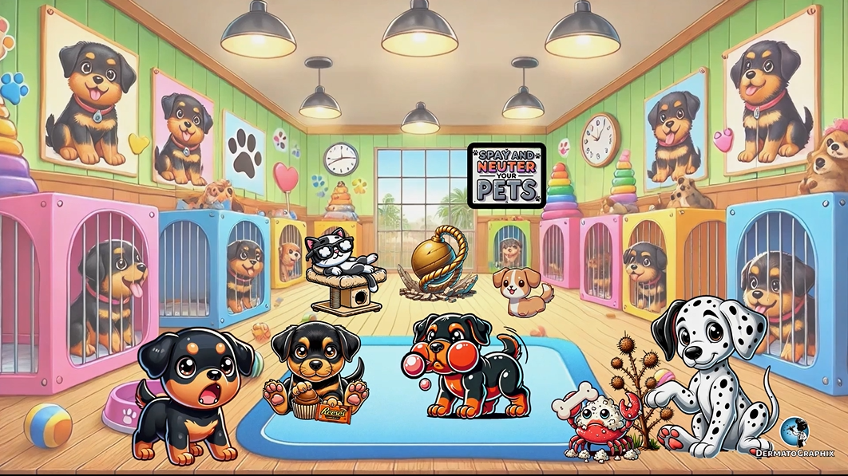

TRANSCRIPT: Cockayne Syndrome
============================================================
We're in the land of cockatooes, where we'll learn about cockane syndrome, which is an autosomal recessive disorder, hence the recessive Reese's chocolate. It is due to defective transcription coupled nucleotide excision repair, as shown by the wildlife expert transcribing notes and excising a piece of paper from her notebook. This results in an inability to resume RNA synthesis after UV radiation exposure. This is different from xero-derma pigmentosom, which has defective global genomic nucleotide excision repair. In cockane syndrome, an identical phenotype can occur due to a mutation in one of two genes. These are CSA and CSB, which you can remember as cockane syndrome A and cockane syndrome B.
CSA results in a mutation in excision repair and cross-complimenting group 8. The acronym for this is ERCC-8. We will use our number rhyming system to show this 8-gate with the A on it to remind you that ERCC-8 is linked to CSA. On the other side, CSB has a mutation in ERCC-6, as shown by this stack of six sticks with a bumblebee on it to remind you of CSB. Cutaneous manifestations of cockane syndrome include photosensitivity, hence the cockatoo breaking open this bottle of sunscreen. The landjectatic erythema can also be present, hence the red color of the cockatoo. Unlike XP, there is no increased risk of skin cancer, so recall this sign that says no crabs allowed. Can't let those pesky crabs invade this enchanted forest. Patients also lack pigmentary changes, so remember that all of the cockatoo in this graphic are one smooth color with no pigmentary changes. Patients will have a typical pinched narrow bird-like face with a beak nose. It goes without saying to reference the faces of all of these cockatoo as the hook to remember this. Notably, affected patients can have progressive deterioration and demyelination of the central and peripheral nervous systems. This is shown by the cockatoo eating this sausage link that resembles the appearance of a myelin sheath. Notice how it is also dizzy representing ataxia as well. These sausage links are dangerous. The skull on the sausages represents that most patients die by the fourth decade due to complications from progressive neurological disease. Patients will also have a short stature with a cachectic and thin body, known as cachectic dwarfism. This is shown by the short and skinny baby bird that looks like a cachectic dwarf itself. Finally, patients can have salt and pepper retinopathy and other ophthalmologic manifestations. This is shown by the cockatoo putting salt and pepper into his eyes, yikes.
Let's review this graphic one more time. In the enchanted land of cockatoo's, we explore cocaine syndrome, an autosomal recessive disorder represented by the recessive Reese's chocolate. The wildlife expert transcribing notes and excising a piece of paper from her notebook symbolizes defective transcription-coupled nucleotide excision repair. This flaw leaves patients unable to resume RNA synthesis after UV radiation exposure, contrasting with xero derma pigmentosum, which affects global genomic nucleotide excision repair. Cocaine syndrome can result from mutations in either the CSA or CSB genes. The 8-shaped gate with an A on it represents CSA, which is caused by a mutation in excision repair cross-complimenting group 8 or ERCC8, hence the 8-gate. The bumblebee on a stack of 6-shaped sticks represents CSB, caused by a mutation in ERCC6, hence the 6-sticks. The cutaneous manifestations include photosensitivity, symbolized by the cockatoo breaking open a bottle of sunscreen, while its red feathers represent talangelectatic erythema. Unlike XP, patients with cockane syndrome do not have an increased risk of skin cancer, as highlighted by the no-crab's allowed sign. Additionally, these cockatoo's have smooth, uniform coloring to remind you that pigmentary changes are absent. The characteristic pinched narrow bird-like face with beak-shaped noses are represented by the cockatoo's faces. Progressive neurological decline, including central and peripheral nervous system demyelination, is shown by a cockatoo eating sausage links resembling a myelin sheath. Its dizziness represents ataxia and neurological impairment, and the skull on the sausages reminds us that most patients die by the fourth decade due to neurological complications. Patients also develop short stature with cachectic thin bodies, shown by the baby cockatoo, with a frail, cachectic dwarf-like appearance. Ophthalmologic issues like salt and pepper retinopathy are depicted by a cockatoo putting salt and pepper into its eyes. On that note, let's make our way out of the forest. See you on the next graphic.

Cockayne Syndrome (Cockayne_Syndrome_transcript.txt)
Topic | Details
Inheritance | Autosomal recessive
Defect | Defective transcription-coupled nucleotide excision repair (vs. XP = global genomic NER)
Genes | CSA → ERCC8; CSB → ERCC6
Skin | Photosensitivity, telangiectatic erythema
No skin cancer risk (key difference from XP); no pigmentary changes
Facies | Pinched, narrow, bird-like face with beak nose
Neuro | Progressive demyelination of CNS & PNS, ataxia
Growth | Cachectic dwarfism — short stature, thin body
Eyes | Salt and pepper retinopathy
Prognosis | Most patients die by 4th decade from neurological complications

