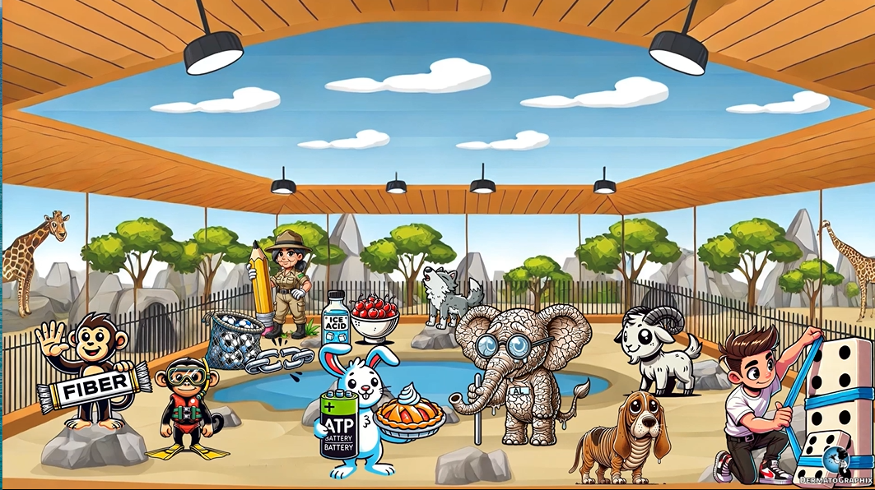

TRANSCRIPT: Cutis Laxa
============================================================
Welcome to the petting zoo. Here we'll learn about cutus laxia, aka generalized elastolysis, a condition where patients have an aged facial appearance and hound dog facies because of the lax skin. This is shown by the hound dog at the zoo. There are multiple forms based on inheritance. This young adult holding an autosomal dominant domino represents the autosomal dominant form which is less common and typically presents an early adulthood, hence the young adult. This is due to a mutation in the elastin or ELN gene, which is why he's wrapping an elastic band around the domino. This results in a dysregulation of the elastic fiber network mainly in the skin, while internal involvement can occur it's uncommon. The most common form is the autosomal recessive form of cutus laxia and there are three types of autosomal recessive cutus laxia that will show in the middle.
Type I is usually due to a mutation in the FBLN5 gene which encodes fibulin. This is symbolized by the monkey eating a fiber 5 bar for fibulin or 5-bulin 5. See how this other monkey is wearing a little lung vest? This symbolizes the hypoplastic lungs and emphysema associated with type I cutus laxia. Notice how that monkey is also a diver to symbolize GI and GU diverticula that can form in this type. The monkey also has on red diapers as an additional reminder of the GI and GU region.
Type II cutus laxia has two types of its own, type IIA and type IIB. Type IIA will be represented by this energizer bunny holding an ATP battery to represent the mutation in ATP6VOA. type IIB is due to a mutation in the PYRC1 gene which will be shown by this pi for PYRC.
The third type of autosomal recessive cutus laxia is also known as debarsi syndrome. This form also has a type A and type B. Type IIIA is represented by the elephant holding a bar for debarsi and notice that his name is AL and he's super dehydrated. Putting this all together, type IIIA is due to a mutation in AL-dehyde dehydrogenase 1-8A1 or the AL-dehyde 18A1 gene. That's AL, the elephant whose dehydrated symbolizing amutation in AL-dehyde dehydrogenase. Type IIIB is also due to a mutation in PYRC1 which is the same mutation as that of type IIB cutus laxia. So we place the bar right next to the pi to show that type IIIB debarsi syndrome can also have a mutation in PYRC1. Take a look at the fogged up glasses on the elephant. These show that type III autosomal recessive cutus laxia is often associated with corneal clouding and cataracts.
The last form of inherited cutus laxia is the excellent recessive type which is now termed occipital horn syndrome and what better way to show this than a goat with occipital horns. These horns represent the wedge-shaped occipital calcifications that are seen in affected patients.
We just covered the types of inherited cutus laxia but cutus laxia can also be acquired. This primarily occurs in adults and presents with sagging of skin hence the zookeeper's saggy skin on her cheeks. Cutenius involvement is usually acral hence the zookeeper wearing gloves but generalized involvement can also occur typically affecting the face and neck hence the sagging skin on her face and neck. The acquired form can occur in association with drugs most commonly penicillamine as shown by the pencil or isoniazid as shown by the bottle of acid with ice inside for isoniazid or icy acid as I like to think of it. Certain cutaneous disorders like sweet syndrome like eruption can also be associated with acquired cutus laxia. This is shown by the bowl of sweet juicy cherries. Systemic diseases like rheumatoid arthritis, sarcoidosis or lupus can also be associated. And arthritis is represented by this broken chain joint representing damaged joints. Sarcoidosis is represented by these sarcoid soccer balls and lupus as usual is depicted by the wool.
Ok, let's sum up this sketch. First we encountered the hound dog symbolizing the aged facial appearance and hound dog faceys characteristic of cutus laxia. The young adult by the autosomal dominant domino showed us the less common autosomal dominant form caused by mutations in the elastin gene hence the elastic band. Next we moved to the other side where we saw the most common form of cutus laxia, autosomal recessive cutus laxia. The monkey munching on a fiber 5 bar introduced us to type 1 cutus laxia which is due to a mutation in the fibulin 1 gene or the fibulin 1 gene as I like to think of it. Moving on, he brought along his buddy with a tiny lung vest for hypoplastic lungs to remind us of hypoplastic lungs and emphysema associated with this type. The diver suit, complete with red diapers, reminded us of the GI and GU diverticula that can also form in this condition. For type 2A, the energizer bunny with an ATP battery represented the ATP6VOA2 mutation while the pi symbolized the PYRC mutation associated with type 2B cutus laxia. Moving on, we met AL the dehydrated elephant to represent AL-dihyde dehydrogenase mutations in type 3A and type 3B cutus laxia. He's holding a bar because this is also known as debarsi syndrome and his fogged up glasses illustrate the corneal clouding and cataracts often seen in type 3A. The bar is also next to the pi to remind us that type 3B can also be due to a mutation in the PYRC1 gene. Next, the goat with occipital horns represented X-linked recessive form of cutus laxia, which is now known as occipital horn syndrome, characterized by wedge-shaped occipital calcifications. Our zookeeper with a sagging face, neck, and gloves represented the acquired form of cutus laxia, which is typically seen in adults and has involvement that's predominantly acral and facial. The pencil and acid bottle with ice inside symbolized penicillamine and isoniazid, which are drugs that are associated with the acquired form of cutus laxia. Finally, we had a taste of a bowl of sweet, juicy cherries linking the acquired form of cutus laxia to sweet syndrome-like eruptions, along with the broken chain link for rheumatoid arthritis and the sarcoid soccer balls for sarcoidosis. Finally, the lupus wolf represented lupus, which is also associated with the acquired form of cutus laxia. That's all for cutus laxia. We'll see you in the next Dermatographics.

Cutis Laxa (Cutis_Laxa_transcript.txt)
Topic | Details
Aka | Generalised elastolysis — aged facial appearance, "hound dog" facies due to lax skin
Autosomal Dominant | ELN gene mutation; less common, presents in early adulthood, mainly skin involvement
Autosomal Recessive Type I | FBLN5 (fibulin-5); hypoplastic lungs/emphysema, GI & GU diverticula
AR Type IIA | ATP6V0A2 mutation
AR Type IIB | PYCR1 mutation
AR Type III (De Barsy syndrome) IIIA | ALDH18A1 mutation; corneal clouding, cataracts
AR Type IIIB | PYCR1 mutation
X-linked recessive | Now called Occipital Horn Syndrome — wedge-shaped occipital calcifications
Acquired form | Adults; sagging skin (acral or face/neck); drugs (penicillamine, isoniazid); associated with Sweet syndrome–like eruption, RA, sarcoidosis, lupus

