Ichtyosis1:
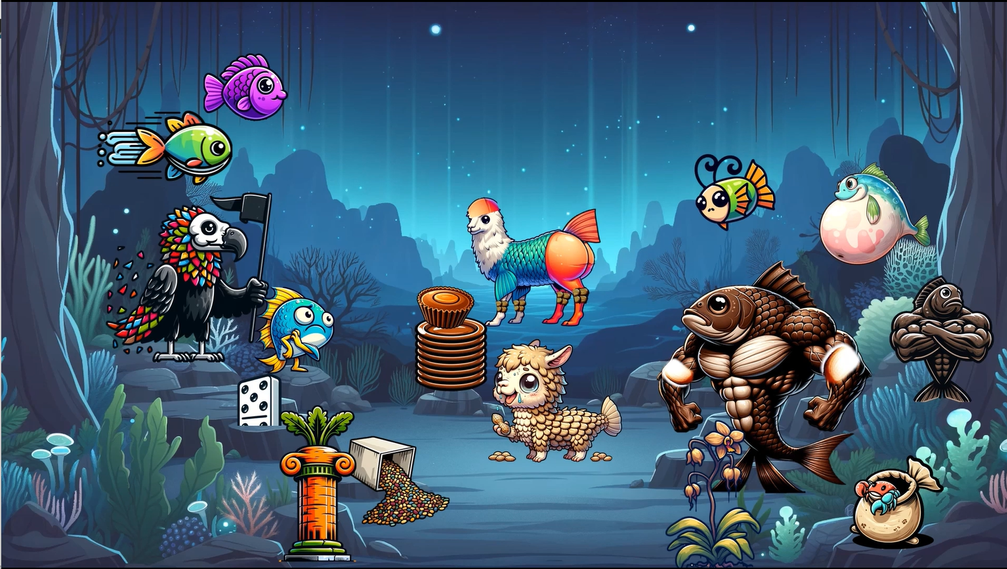
Welcome to the deep dark abyss of Ichthyosis. The term Ichthyosis is derived from the Greek word Ichthys, which means fish. That's because this group of disease has a fish scale-like appearance of the skin. So it only makes sense that we're diving under the sea to meet the different gangs, um, schools of fish that each represent a different form of Ichthyosis. These schools of fish are fighting to win over the Queen fish.
First off, the vulture-shaped fish represents Ichthyosis vulgaris. That's vulture for vulgaris. The fine adherent scales on the vulture fish mirror the fine scales found on the extremities and trunk, typically sparing the flexures in Ichthyosis vulgaris. The vulture fish is repping its turf with this flag, which represents a mutation in the filaggrin gene. Ichthyosis vulgaris is an autosomal semi-dominant condition, shown by the half-buried domino. Hyperlinear palms and soles are common in this condition and are shown by the next fish zooming by with a hyperlinear trail of water behind it. Slow down there, buddy. Associated clinical conditions include keratosis pilaris, shown by a carrot-shaped pillar, and an atopic diathesis, shown by an itchy fish.
Next up, we have the histological findings. A box of grains spilling on the sea floor, signifying the diminished or absent stratum granulosum. And the thick purple top fin of this fish, symbolizing overlying ortho hyperkeratosis.
Good luck trying to win over the queen when you got to face this roid rage beast. This roid rage fish represents steroid sulfatase deficiency. The brown spots on its biceps show the dark brown adherent scales found across the body, which typically spare the flexures. This is shown here as its flexural areas without any of the brown spots.
The fish with a comma-shaped antenna represents corneal comma-shaped opacities, while the shriveled orchid denotes cryptorchidism. What's that? The crab crawling from a sack indicates the increased risk of testicular cancer. That's a sack for testicles. All right, TMI, TMI. This condition is an X-linked recessive disorder, represented by the backup roid fish making an X by crossing his arms. As a side note, this condition is also often referred to as X-linked Ichthyosis. Female carriers of this condition might experience prolonged labor if the child is also affected due to placental sulfatase deficiency. We'll show this here with a pregnant female fish who's clearly been pregnant for a prolonged time.
Last up, we have lamellar Ichthyosis, depicted by a llama fish. He's got shaved glutes to highlight the mutation in the transglutaminase 1 gene (TGM1). A stack of brown plates represents the generalized thick plate-like brown scales with significant involvement even in the flexures. Hence the llama getting chocolate all over his flexures. Wait, where'd the chocolate come from? Wow, looks like he's a fan of Reese's. The Reese's represents that lamellar Ichthyosis is an autosomal recessive condition.
Finally, the llama fish is bald, reminding us of scarring alopecia, which is also an associated condition. Lamellar Ichthyosis is also associated with heat intolerance. This is shown by the overheated dehydrated baby llama fish eating salty peanuts, symbolizing the potential hypernatremic dehydration.
I guess even down in the abyss it gets really hot. It's about time we wrap up this graphic. We started with the vulture-shaped fish representing Ichthyosis vulgaris. This fish has fine adherent scales that represent the scales typically seen in this condition. He's waving a flag to represent that the filaggrin gene is mutated. He also brought along a half-buried domino to denote that it is autosomal semi-dominant in inheritance. The fish with a trail of hyperlinear water hinted at the hyperlinear palms and soles that are common in Ichthyosis vulgaris. Accompanying features include a carrot-shaped pillar for keratosis pilaris, and an itchy fish symbolizing atopic diathesis. The histological aspects are shown by a box of grains spilling on the floor to show a diminished stratum granulosum, and a thick purple fin for ortho hyperkeratosis.
Next, we meet the roid rage fish, representing steroid sulfatase deficiency. His muscles are covered in dark brown scales with the flexural areas remaining spot-free, indicating the sparing of flexural folds. The comma-shaped antenna fish reminds us of the corneal comma-shaped opacities, and a shriveled orchid signifies cryptorchidism. The increased risk of testicular cancer is depicted by a cancer crab crawling out of a sack. And the crossed arms of the backup roid rage fish illustrate that this condition is X-linked recessive. A pregnant fish enduring a prolonged labor represents placental sulfatase deficiency in female carriers that can lead to prolonged labor. Finally, lamellar Ichthyosis was portrayed by a llama fish with shaved glutes pointing to a mutation in the transglutaminase 1 gene, also known as TGM1. A stack of brown plates represents the thick plate-like scales characteristic of this condition, accompanied by the chocolate on his flexures, as this condition often involves the flexural folds, unlike steroid sulfatase deficiency. The llama fish's bald head indicates scarring alopecia as another associated feature. The dehydrated and overheated baby llama fish with salty peanuts brings attention to the potential hypernatremic dehydration due to heat intolerance.
All right, kids, this should serve as a reminder to stay in gangs and don't join schools. I mean, stay in schools and don't join, you know what I mean. In the next graphic, we'll learn about some more Ichthyosis. Let's head over to the Kingdom of the Deep Sea. Time to meet the queen.

Ichthyosis2:
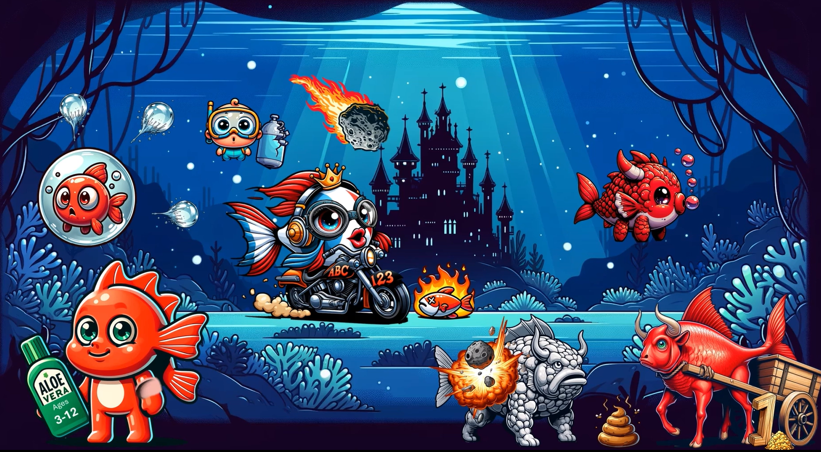

[Speaker A]
We've made it to the kingdom. Before we get to meet the queen, we'll have to get through her bodyguards first. Shh. This guy, a bodyguard?
This sunburned red baby fish represents congenital ichthyosiform erythroderma (CIE). He's rubbing aloe on the sunburn to show that the genes affected are ALOXE3 and ALOX12B. The aloe bottle is safe for ages three to 12 to reinforce the numbers associated with these genes, which again are ALOXE3 and ALOX12B.
Oh no, this fish is trapped in a colloidal bubble. This symbolizes how patients often present with a collodion membrane at birth. As the membrane resolves, it gives way to fine white scales across the body, depicted as fine white popped bubbles around the fish. The elbow pad on the first fish reminds us that the flexures are commonly involved in CIE.
Okay, now that is a bodyguard. This bullfish illustrates bullous CIE, also known as epidermolytic ichthyosis. This bullfish is pulling a cart to remind us that it's caused by KRT mutations — again, that's cart for KRT. Specifically, KRT1 or KRT10 can be affected. KRT1 mutations are associated with palmoplantar keratosis, while KRT10 is usually not. We show this with a one-shaped rod dragging on the sea floor, creating bumps in the sand. The fact that it creates bumps in the sand reminds us of the bumpy palmoplantar keratosis that KRT1 is associated with. This is in contrast to the smooth ride of the back wheel, shaped like a zero, representing KRT10 — which is not associated with palmoplantar keratosis.
Aw, it's a baby bullfish. The baby bullfish is red and is blowing bubbles to indicate the initial presentation of bullous CIE at birth with erythroderma, hence the redness, and blistering, hence the bubbles. This adult bullfish has a cobblestone pattern, representing the hallmark cobblestone-like keratosis, which is seen later in life in patients affected with bullous CIE. The retinoid asteroid is destroying the cobblestones, illustrating how retinoids may exacerbate skin fragility. Lastly, these patients are prone to frequent skin infections, which can lead to malodor.

[Speaker B]
The time has come to meet the queen. Here she comes riding in the Harley. She's a Harley queen, representing harlequin ichthyosis. The queen's half red, half blue appearance is a subtle note to Harley Quinn from Batman, who was Joker's henchwoman.
There's so much wind resistance that it's blowing up her lips, showing us that eclabium is usually present in affected patients. Safety first — she's got on her goggles to represent the extreme ectropion that's also seen in harlequin ichthyosis. She's jamming out in those headphones, symbolizing the association with ear deformities.
And finally, she makes it look easy riding around on that Harley. We might even say it's as easy as ABC 123. The ABC 123 design on the Harley represents the ABCA12 mutation that's associated with harlequin ichthyosis. The retinoid asteroid is lighting up the path in front of her, symbolizing the life-saving potential of early systemic retinoids and specialized NICU care.
Unfortunately, this condition's severity can often lead to neonatal death, usually secondary to sepsis, as depicted by a dead fish on fire — it's on fire to represent the systemic inflammation seen in sepsis. In addition to sepsis, another cause of death is respiratory insufficiency, shown by the baby diver with a broken oxygen tank.

[Recap — Speaker B]
All right, let's recap the journey through this kingdom. First, we met the sunburned red baby fish, symbolizing congenital ichthyosiform erythroderma (CIE). The aloe marked for ages 3 to 12 points to the ALOX3 and ALOX12B mutations. Trapped in a collodion bubble, the fish shows the collodion membrane present at birth, which resolves into fine white scales. The elbow pads represent flexural involvement.
Next, we encountered the bullfish, embodying bullous CIE (epidermolytic ichthyosis). The bumpy ride of KRT1 is linked to palmoplantar keratosis, and the smooth ride of KRT10 indicates absent palmoplantar keratosis. The baby bullfish blowing red bubbles highlights the initial erythroderma and blistering, whereas the adult bullfish's cobblestone pattern depicts cobblestone-like hyperkeratosis in later stages. The retinoid asteroid destroying the cobblestones reminds us that retinoids can increase skin fragility. The malodour is from frequent bacterial infections.
Our final encounter is with the Harley Queen, representing harlequin ichthyosis. The windblown lips point to eclabium. The goggles represent severe ectropion, while the headphones remind us of ear deformities. Her motorcycle's ABC 123 insignia symbolizes the ABCA12 mutation, while the retinoid asteroid illuminates her path as a life-saving treatment. Harlequin ichthyosis can lead to tragic neonatal death — depicted by a dead fish on fire for sepsis, and a baby diver with a broken oxygen tank for respiratory insufficiency.
Well, that was dark. Let's head closer to the surface to lighten things up. See you there.

Ichthyosis3:
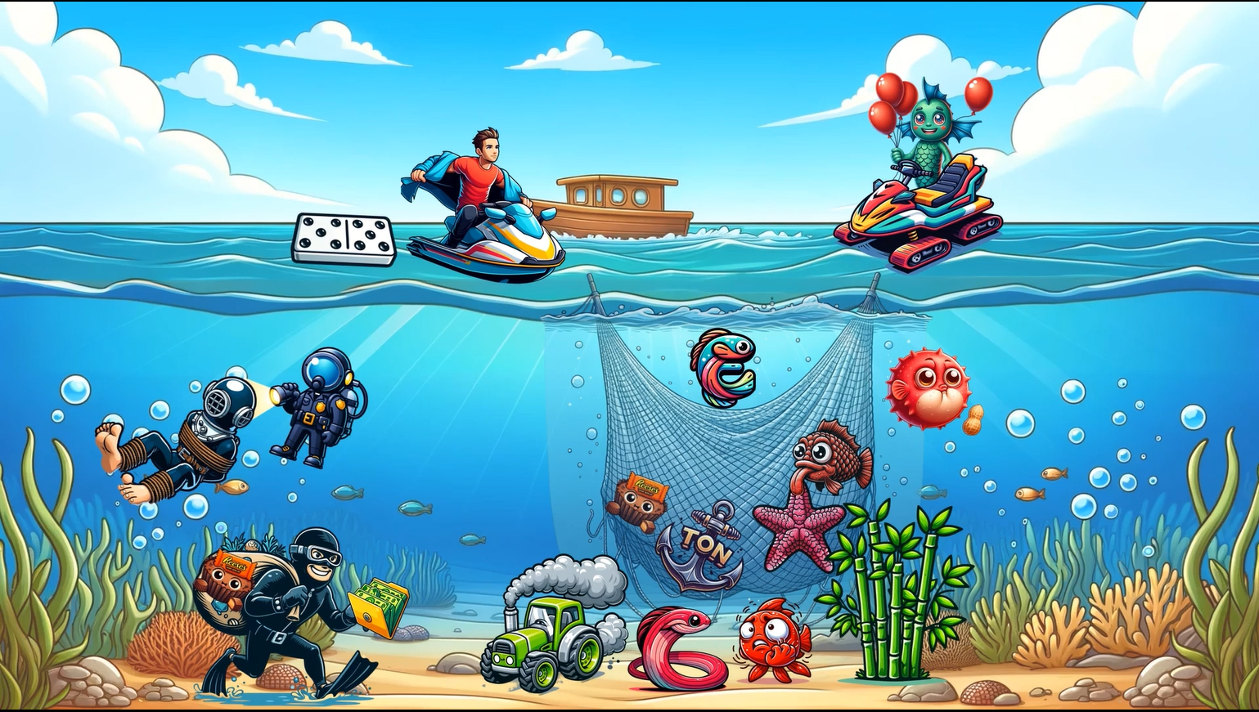Welcome back to our exploration of ichthyosis. We've gotten out of the abyss and moved a little bit closer to land. In this graphic, we start off with a boat at the superficial surface, which represents superficial epidermolytic ichthyosis — a condition characterized by blistering and scaling of the skin.
A seaman holding up balloons symbolizes its other name, which is ichthyosis bullosa of Siemens. The balloons also represent blistering, and their red color symbolizes erythroderma, because both blistering and erythroderma are present in superficial epidermolytic ichthyosis. There are two water carts, indicating a mutation in the KRT2 gene — or as I like to call it, cart two. A domino floating superficially helps us remember that this condition is autosomal dominant. Lastly, a man removing his coat illustrates the moulting of skin, where the skin peels away, kind of like removing a coat. This typically spares the palms and soles, which you can also remember by the coat, which does not cover the palms or soles.

Next up is Netherton syndrome, symbolized by a net catching a one-ton anchor. That's net and ton for Netherton. This disorder is due to a mutation in the SPINK5 gene, which is shown by a pink five-armed starfish. SPINK5 encodes the LEKT1 protein, which is a serine protease inhibitor. LEKT1 is represented by this fish licking the starfish. This fish is also red and scaly, symbolizing erythroderma and scaling that is typically seen at birth in affected patients. Netherton syndrome is autosomal recessive, which is why the net also reeled in a recess.
There are two principal phenotypes for Netherton syndrome:
- Ichthyosis linearis circumflexa — shown by a double-edged eel, representing the serpiginous annular double-edged plaques
- A phenotype resembling congenital ichthyosiform erythroderma (CIE) — shown by an itchy red fish, symbolizing CIE-like disease with pruritus and eczematous plaques
A tractor releasing toxic fumes cautions us about tacrolimus and other topical calcineurin inhibitors, which can lead to increased systemic absorption and toxicity. Another clinical feature is trichorrhexis invaginata, also known as bamboo hair — shown with a bamboo plant. An E-shaped fish elevated above the net indicates elevated IgE levels. Finally, a swollen fish with a peanut allergy highlights associated food allergies and an increased risk of anaphylaxis.

Lastly, the grand Larson thief depicts Sjögren-Larsson syndrome. A thief stealing a folder full of money illustrates that the mutation is in the FALDH gene — that's folder for FALD. Sjögren-Larsson syndrome is autosomal recessive, again represented by the recess in his bag. Another clinical feature is progressive spastic di- and tetraplegia, shown by his tied-up victim that can't move. The thief's white glasses indicate perifoveal glistening white dots affecting the eyes. And finally, the victim hiding from the cop's flashlight under a thick helmet reminds us that photophobia is also a component of Sjögren-Larsson syndrome.

Recap:
All right, let's recap. We first navigated to the superficial surface with a boat, symbolizing superficial epidermolytic ichthyosis. The seaman introduces the alternative name, ichthyosis bullosa of Siemens. We highlighted blistering and erythroderma via the red balloons. The two water carts represent the KRT2 mutation, while the floating domino symbolized autosomal dominant inheritance. A man shedding his coat depicts skin molting, sparing the palms and soles.
The fisherman's net introduced Netherton syndrome. The pink five-armed starfish represents the SPINK5 mutation, and the fish licking it symbolizes the LEKT1 protein. A double-edged eel for ichthyosis linearis circumflexa, and an itchy red scaly fish for CIE-like Netherton syndrome. The bamboo plant represents bamboo hair (trichorrhexis invaginata). An E-shaped fish above the net represents elevated IgE. The swollen fish with a peanut allergy represents food allergies and increased anaphylaxis risk. The tractor warns of tacrolimus/calcineurin inhibitor toxicity.
Lastly, the grand Larson thief symbolized Sjögren-Larsson syndrome. The stolen folder = FALDH gene mutation. The restrained victim = progressive spasticity with di- or tetraplegia. The white glasses = perifoveal glistening white dots. The victim hiding from the flashlight = photophobia. And don't forget — autosomal recessive, represented by the stolen chocolate.
We've made it far in our series of ichthyosis, but we've still got a ways to go. In the next sketch, we'll head over to the ocean games, where our ichthyotic athletes will compete against each other in the underwater Olympics. See you there.

Ichthyosis4:
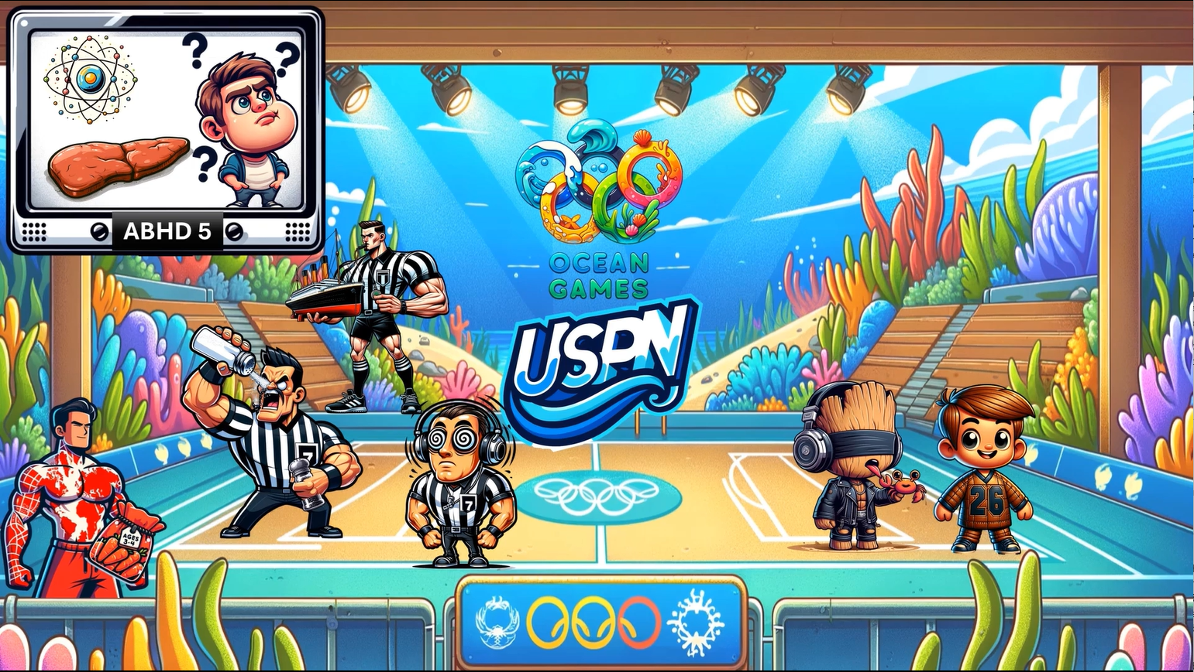The following program is brought to you by Dermato Graphics.
Welcome back to USPN, the underwater sports programming network. We're broadcasting live from the Ocean Games, the ultimate underwater arena where we cover some more ichthyosis. We've got quite the athletic lineup today. Let's check it out.

Check out the jumbotron where we spot a dwarf man with a large chin, symbolizing Chanarin-Dorfman syndrome, also known as neutral lipid storage disease with ichthyosis. Here at the Ocean Games, we provide our viewers with super high definition viewing. The jumbotron is high definition ABHD to remind us that this condition stems from an ABHD5 mutation. The limelight seems to have thrown our competitor off his game. Looks like someone forgot the rules — he's confused to symbolize that Chanarin-Dorfman syndrome is associated with developmental delays.
I think he's here to wrestle. The large liver-shaped wrestling mat reminds us that patients with Chanarin-Dorfman syndrome may also have hepatomegaly. Oh wait, he's actually here for a science competition. Wow, he truly is confused. We see globes of electrons behind him, representing electron-lucent inclusions seen in the epidermis of affected patients.

Let's turn our attention to the referees of tonight's matches. This ref boasts large pecs, symbolizing a mutation in the PEX7 gene — his pocket has the number seven on it to remember PEX7. His dizzy eyes symbolize cerebellar ataxia that's also seen in Refsum disease. I guess these games can be hypnotizing. Decked out in headphones, he highlights the deafness associated with the condition.
And don't miss that other ref shaking salt and pepper straight into his eyes. This depicts the salt and pepper pigment of atypical retinitis pigmentosa seen in Refsum disease. This one just dug up the Titanic, indicating the increased plasma phytanic acid levels in patients affected by Refsum disease.

Our kid competitors on the underwater field represent KID syndrome, where KID stands for Keratitis, Ichthyosis, and Deafness. There are two kids affected, representing that GJB2 (gap junction binding 2 protein) is affected. One of these junior athletes is sporting the number 26 on his jersey, representing connexin 26, the protein encoded by GJB2. They are wearing coarse leather jackets to remind us of the coarse-grained leather appearance of skin seen in KID syndrome. And one of them even has a Groot-like face, reminiscent of the hyperkeratotic plaques often seen in affected patients. The young player is also equipped with headphones to represent the associated deafness, and he's wearing a blindfold to represent the keratitis, which can eventually lead to blindness. Patients with KID syndrome are particularly at risk for oral and cutaneous squamous cell carcinoma — that's why the cancer crab is grabbing his tongue.

Okay, let's wrap up today's coverage with the last contender. He's gearing up with some pre-workout, munching on a bag of red carrots, illustrating erythrokeratodermia variabilis. He's a worldwide fan favorite — just look at those tattoos. His tattoo of a map with geographic borders accentuates the transient erythematous patches and geographic hyperkeratotic plaques that are typical of this condition. The bag of carrots has ages 3 to 4 written on it to represent that GJB3 and GJB4 mutations are associated with this condition.
Folks, if you're starting to get tired of our underwater series, then I have some good news for you. We are almost done. We have one more graphic to wrap up the ichthyosis series and we promise it's a good one. See you there.

📝 Summary of the Audio Content
The audio is another Dermatographics episode covering Ichthyosis Part 4, using an underwater sports theme. Topics covered:
Condition | Key Points
Chanarin-Dorfman Syndrome | ABHD5 mutation, neutral lipid storage disease, developmental delays, hepatomegaly, electron-lucent inclusions in epidermis
Refsum Disease | PHYH/PEX7 mutation, cerebellar ataxia, deafness, retinitis pigmentosa (salt & pepper), elevated plasma phytanic acid
KID Syndrome | GJB2 mutation (Connexin 26), Keratitis + Ichthyosis + Deafness, coarse leather-like skin, risk of SCC (oral & cutaneous)
Erythrokeratodermia Variabilis | GJB3/GJB4 mutations, transient erythematous patches, geographic hyperkeratotic plaques

That's four files transcribed! You now have coverage of:
- File 1 — Ichthyosis vulgaris, steroid sulfatase deficiency, lamellar ichthyosis
- File 2 — CIE, bullous CIE (epidermolytic ichthyosis), harlequin ichthyosis
- File 3 — Superficial epidermolytic ichthyosis, Netherton syndrome, Sjögren-Larsson syndrome
- File 4 — Chanarin-Dorfman syndrome, Refsum disease, KID syndrome, erythrokeratodermia variabilis

Ichthyosis5:
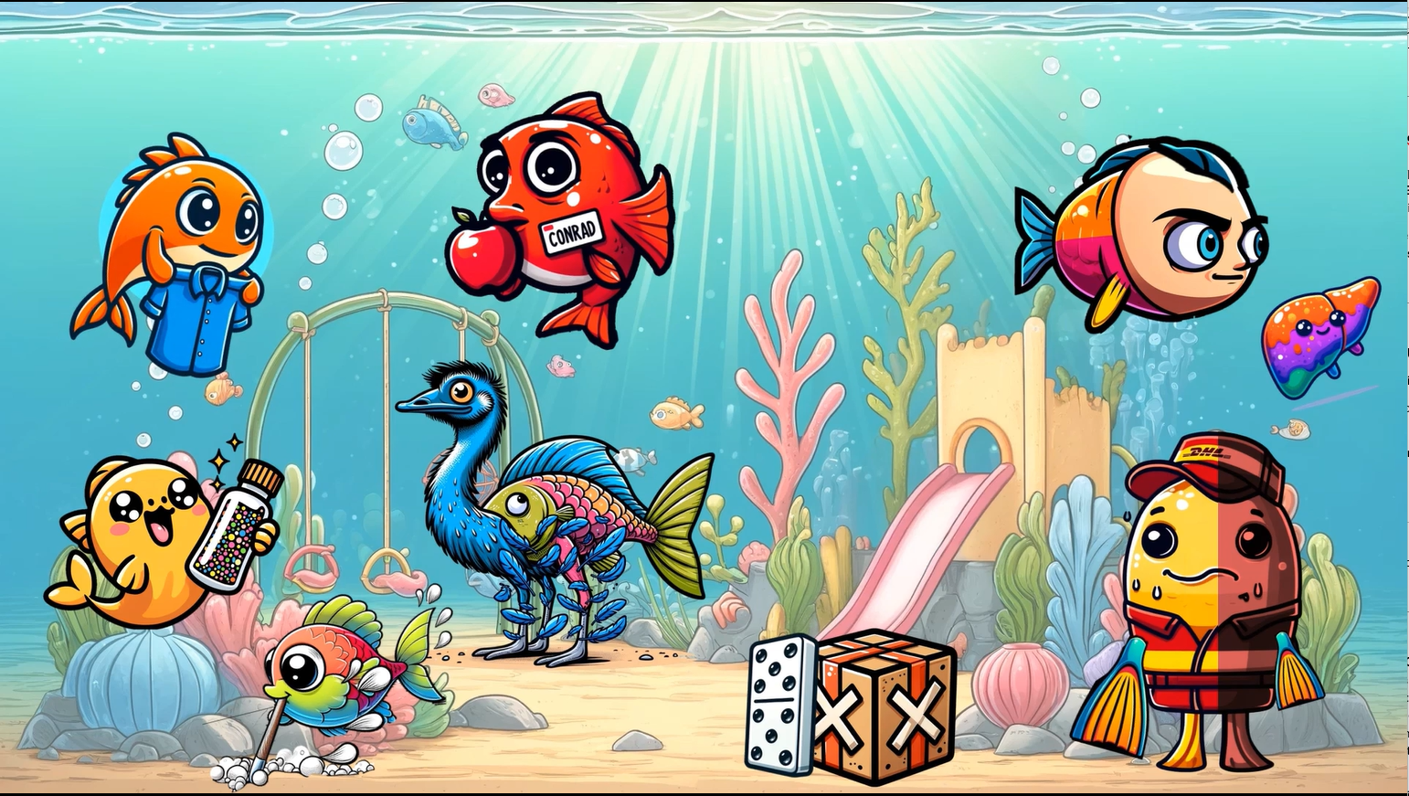We've made it to the last graphic in the ichthyosis series, where we'll cover CHILD syndrome and Conradi-Hünermann-Happle syndrome.

CHILD Syndrome
We're at the CHILD playground for CHILD syndrome, which stands for Congenital Hemidysplasia with Ichthyosiform erythroderma and Limb Defects. The DHL worker symbolizes that CHILD syndrome is associated with the NSDHL mutation, a gene crucial for cholesterol biosynthesis. The DHL worker is dehydrated, since NSDHL encodes a 3-beta hydroxysteroid dehydrogenase. He made a delivery of a box with X-shaped tape and a domino leaning against it — putting it all together, these symbols represent that CHILD syndrome is X-linked dominant.
This delivery fish is half yellow, half red, illustrating the initial presentation of CHILD syndrome at birth, characterized by unilateral erythema and waxy yellowish scale, affecting only one half of the body. A small fin on the affected red side represents ipsilateral skeletal hemidysplasia with hypoplastic limbs. His small liver-shaped fish friend symbolizes ipsilateral organ hypoplasia, emphasizing the asymmetry in organ development seen in CHILD syndrome. The half-shaved head on this fish indicates ipsilateral alopecia is also present.

Conradi-Hünermann-Happle Syndrome
This fish named Conrad is eating an apple, portraying Conradi-Hünermann-Happle syndrome. He's a fully red fish, symbolizing generalized ichthyosiform erythroderma at birth. Conrad is right above the X-shaped tape, since this condition is also X-linked dominant. An emu signifies a mutation in EBP (emopamil binding protein) — that's emu for emopamil. The feathers falling off of the emu depict the unique feathery adherent scale along Blaschko's lines, a distinctive dermatologic sign of this syndrome.
The mama fish brought Conrad a change of clothes so he can stop being so red. This symbolizes that the erythema resolves within the first few months of life, unlike CHILD syndrome. The fish digging a line of sand on the floor symbolizes the progression to follicular atrophoderma along Blaschko's lines — the holes represent the atrophoderma. He's getting sand on the back of his fins to remind us that the dorsal hands and forearms are the most commonly affected sites. Finally, the fish shaking glitter represents stippled epiphyses (chondrodysplasia punctata), a common X-ray finding that looks like the stippled appearance of a glitter bottle.

Recap
- CHILD syndrome: NSDHL mutation → cholesterol biosynthesis defect; X-linked dominant; unilateral erythema + waxy yellow scale; ipsilateral skeletal hemidysplasia, organ hypoplasia, and alopecia
- Conradi-Hünermann-Happle: EBP mutation; X-linked dominant; generalized erythroderma at birth that resolves in first few months; feathery scale along Blaschko's lines; follicular atrophoderma (dorsal hands/forearms); chondrodysplasia punctata on X-ray
That does it for our ichthyosis series. Give yourself a pat on the back because that was a lot of information. Time to slide on out of here. Get it? Slide? Because we're at a playground.

DermNemonics
All the fish in the sea part1
Congenital-ichtyosis part2
Sometime around 360 bc the Greek philosopher Plato described a miraculous civilization inhabit3ed by the demigods. They wielded naval power, the likes of which was unknown to the world at that time. It was thought that this city was lost to time, but our explorers here at Dermnemonics have found the once great city of Atlantis.
Welcome back, in this sketch titled "The rest of the fish in the sea”, we’ll continue our review of congenital ichthyoses. Namely, ichthyosis vulgaris, KID syndrome, Ichthyosis bullosa of siemens, lamellar ichthyosis, steroidal sulfatase deficiency, and Netherton syndrome. Let’s get started with ichthyosis vulgaris which is due to AD mutation in filaggrin. This disorder displays variable penetrance which accounts for the wide variability in clinical severity. Does that jelly fish seem vulgar to anyone else? This vulgar jellyfish on the Atlantean flag should serve to remind you of ichthyosis vulgaris due to Filaggrin mutations. Just my opinion, but that doesn’t seem to be the ideal way to advertise a city, but I’m not judging their ancient culture and traditions. Now, mutations in filaggrin are also associated with KP, so we’ll also include this Greek style pillar that’s fallen just behind out flag which should remind you that these 2 conditions may be seen together.
Atlantis seems like a bit of a dump… I bet it’s because some hooligans trashed the place - yeah, I’m looking at you KID! This KID serves as our next hook which is for KID syndrome, aka keratitis, ichthyosis, and deafness syndrome which is due to mutations in gap junction protein 2. If you recall from our other sketch covering inherited PPKs, we depict gap junctions with a bridge like this one that “bridges the gap”. You might also recall that GJP 2 encodes connexin 26 – the same gene responsible for Vohwinkle PPK with deafness. To remind you that it’s specifically GJB2 or connexin 26, we’ve added our recurring 2-duck of the sea – an eel – here by the bridge, but we’ll also add another 2 eel to the left of the kid and have the KID holding a 6 golf club to remind you of connexin 26. 2 eel, 6 golf club, connexin 26. Like the name implies, KID syndrome is characterized by deafness as shown by the over ear headphones, keratitis shown by the ocular red glasses, and ichthyosis as shown by the title of the sketch. It’s also worth noting that these patients are at an increased risk of oral and cutaneous SCCs, so let’s give this big baby a crab pacifier to remind you of this fact.
Who’s this kid waving at? It’s a sea-man… Get it? Well, this sea-man in a yellow submarine with a blister bubble-esc submarine covered in sea-weed is to remind you of superficial epidermolytic ichthyosis aka ichthyosis bullosa of seimens which is due to mutations in keratitn 2 – shown by another 2 eel.
- I do apologize for any confusion it may cause by putting the sub close to the bridge, but I have faith in you that you can remember that this is due to KERATIN 2.
Like the ridiculously long name implies, superficial epidermolytic ichthyosis bullosa of seimens presents at birth with superficial blistering often described as molting of the skin, but often spares the palms and soles. To remind you of this, we’ve shown the sea-mans hands pressed against the glass to represent sparing of the hands and we’ve places the sub next to “molt”en lava. For his sake, I’m just praying someone other than this kid comes along to help the poor sea-man.
Like my grand pappy once said, “Be careful what ya wish for, or some naked sword wielding fish-man might just show up.” Yeah, pappy was a little crazy, but by the beard of Zeus he was right! This naked fish man who’s riding what I can only describe as a sea lama should serve to remind you of lamellar ichthyosis which is due to transglutaminase 1 – or TGM 1 for short. I want you to remember this by recalling that our tiny green man is wielding a 1 sword – TGM 1. Like many of the ichthyoses from the first sketch, lamellar ichthyosis can present at birth with a collodion baby, so we’ll bring back the collodion diver back as a reminder and have him reaching towards the tiny green man. In addition to collodion membrane at birth, lamellar ichthyosis at birth, lamellar ichthyosis should also be included on the differential for ichthyoses with significant flexural involvement. Ooooh, check out those intimidating red fins on the TGMs flexural regions and the divers matching red patches. The scales in lamellar ichthyosis are often described as being thick, brown, and platelike – much like the thick plate-like coral reef growing nearby. It may be worth remembering, though not exclusively included in the sketch, that lamellar ichthyosis may be associated with hypernatremic dehydration and heat intolerance in addition to scarring alopecial. I suppose you can try to remember that they’re in hypernatremic water?
Now, if you’re wondering why this TGM takes his job so seriously, it’s because he’s been tasked with protecting the crypts of Atlantis. You may notice the entrance to the crypts in the background with a broken starfish statue adorning the mantle. The star fish is to remind you of steroidal, or as I like to say, “star-oidal”, sulfatase deficiency – AKA x-linked recessive ichthyosis – hence why we’ve depicted it as broken to resemble an X. This form of ichthyosis presents with fine-to-large dark brown adherent scales over the trunk and extremities, but it spares the flexural regions. So notice how the star fish has dark brown barnacles over the body and extremities, but NOT in the flexural areas. For the boards and COREs, you should be able to identify the classic finding of “comma shaped opacities” in the eye, and we’ve included this comma shaped arch above the starfish to help you with that.
- As a side note, the most common Kodachrome you’ll encounter is of a young boy with thick brown scales over the lateral neck which we colloquially term the “Dirty neck”. This isn’t shown explicitly, but once you see the Kodachrome, you can’t miss it!
These patients are also at increased risk of testicular cancer, cryptorchidism, and hypogonadism as shown by the cancer crab statues and hypogonadism trash sack lying on the ground in front of the crypts.
Last, but certainly not least, we’ll cover Netherton syndrome. I’ll be the first to admit that the hook for Netherton’s may not be the best, but the hook is memorable and this condition is so heavily emphasized in didactics, that I have no doubt that it’ll stick for life. We’ll depict Netherton’s with this giant sphinx statue with the nether-regions covered up.
- For having such a vulgar flag, it seems a little excessive to cover THAT up doesn’t it?
We chose a sphinx because Netherton’s is due to a mutation in spink 5 which encodes a gene called LEKTI. I think spink would be enough to get you the answer, but we’ll include an anchor that looks like the number 5 as an added bonus. One of the reasons Netherton’s is a board favorite is due to the array of pathognomonic findings. One of these is ichthyosis linearis circumflexa which is characterized by annular to serpiginous plaques with a double-edged scale. Once you see a picture of this, it’s hard to forget, but we’ll also put an old timey double-sided scale to remind you of this unique feature. Another unique finding is seen on trichoscopy and called trichorrhexis invaginata which (to me at least) looks like bamboo. So remember these bamboo-esc kelp growing from around the sphinx. While it may seem like board fodder, it’s worth knowing that these patient’s have an increased risk of shellfish allergies, so we’ve added some shellfish as a hook. Furthermore, because of the impaired skin barrier function, these patients are at risk for high systemic absorption of topical calcineurin inhibitors such as pimecrolimus or tacrolimus, and these medications should be avoided. Recall this sea-pickle by the sphinx for pimecrolimus (and as a general reminder that all topical calcineurin inhibitors should be avoided).
Whew! That was a lot of information, so let’s sum it up. In the front we have our vulgar flag to represent ichthyosis vulgaris due to AD filaggrin mutations – the flag represents filaggrin which is also responsible for keratosis pilaris hence the pilar nearby. The KID represents keratitis ichthyosis and deafness syndrome which is due to mutations in GJP 2 – shown by the bridge over the gap and the 2 eel. Recall that GJB 2 encodes connexin 26 thus we’ve also included the 2 eel and 6 golfclub. The name literally describes the presentation – keratitis which can lead to blindness, ichthyosis, and deafness. So recall the red ocular glasses, the name of the sketch, and the over-ear headphones. Lastly, remember that these patients are predisposed to oral and cutaneous SCCs with the crab pacifier.
Superficial epidermolytic ichthyosis of siemens is shown by the sea-man in the yellow bubble submarine. This is due to mutations in keratin 2 – the 2 eel – and manifests with superficial blistering often described as molting but spares the palms and soles. So remember that his palms are against the glass. One of the more heavily tested ichthyoses is lamellar ichthyosis with is shown by the tiny green man riding a sea lama. Remember that tiny green man holding a 1 sword represents TGM1 which in real life stands for transglutaminase 1. Clinically it presents with thick, brown, plate-like scales with severe flexural involvement. We’ve shown this with the thick plate-like coral reef by him and the red flexural fins. Also remember that it can be a cause of collodion baby, which is shown with the collodion diver looking at him.
Steroidal sulfatase deficiency, AKA x-linked recessive ichthyosis, is shown in the back with the broken starfish that looks like an x. The comma shaped adornment is to remind you of the comma shaped corneal opacities, while the brown barnacles over the trunk and extremities, but sparing the flexures, should help you to recall the classic characteristic of the scale. Recall that they’re also at increased risk of testicular carcinomas, cryptorchidism, and hypogonadism – the crab statues, hypogonadism sack, and the fact that these are crypts.
Lastly, Netherton’s syndrome due to spink 5 mutations, is shown by our sphinx wearing a bra covering her Nether-regions. Burn the image of ichthyosis linearis circumflexa into your brain because the image of an annular double edged scale can show up frequently on tests. We’ve included this old-timey double edge scale as the hook. Furthermore, recall that the classic finding on trichoscopy is trichorrhexis invaginata, which looks like bamboo – depicted by the bamboo-like kelp growing by the sphinx. It may be tested that the best place to take a hair from is the eyebrow, so try to remember that the sphinx has a lisa-mona-esc smile and little to no eyebrows. These patients are at an increased risk of food allergies, specifically shellfish, and they should avoid calcineurin inhibitors like pimecrolimus or tacrolimus, so remember the shellfish and the sea pickle.

