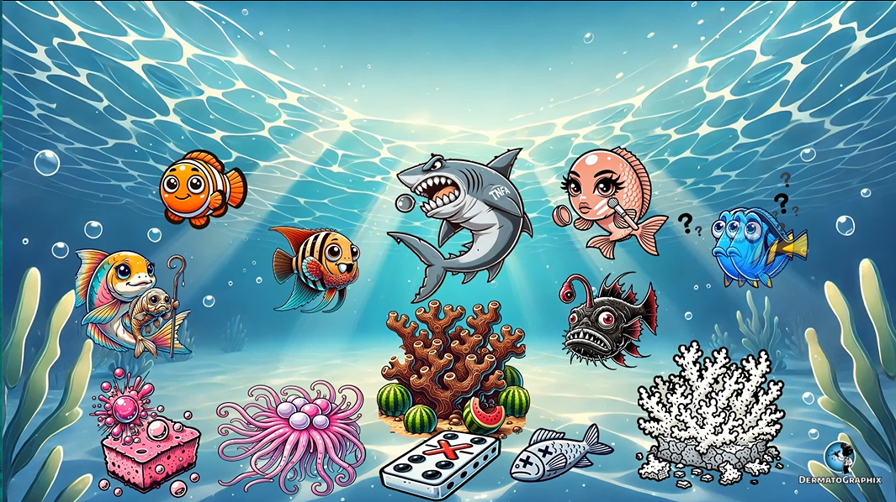
TRANSCRIPT: Incontinentia Pigmenti
============================================================
We're in the ocean learning about incontinentia pigmenti. Why the ocean? Because this condition results from a mutation in an essential modulator called Nimo, hence our favorite clown fish. This occurs in an excellent dominant pattern as represented by the domino with an X on it. The loss of function mutation in Nimo prevents activation of NFKAPA-B, which is a regulator of cell proliferation, inflammation, and TNF alpha induced apoptosis. As symbolized by this shark, or as I like to think of it, the teen alpha fish for TNF alpha, he ate no beta fish, and he is about to pop this bubble to represent apoptosis, which is mediated by TNF alpha. This mutation is lethal in males, symbolized by the dead male fish on the seafloor. Because of this, it is primarily seen in women and possibly client-feltor XXY males. Functional mosaicism from lionization and affected females results in a blaschcoid pattern of cutaneous involvement. So take a look at this female fish applying blush in streaks and whorls to represent blaschcoid distribution, which occurs in streaks and whorls on the skin. As an additional reminder, remember that most of these fish have streaks or stripes on their gills. Incontinentia pigmentae is a neuro-ectodermal disorder affecting the skin, teeth, central nervous system, and eyes. Scarring alopecia can occur in about 10 to 20% of patients, which is why the female fish is bald. See how this next fish has a scaly red barnacle stuck to its skin? This represents subungual tumors that can resemble squamous cell carcinomas, which can also be seen in up to 10% of patients. Pagged teeth, conical teeth, and anodontia occurs in about half of patients. This is shown by the fish with cone-shaped teeth, some of which are missing for anodontia. Keep in mind that dental manifestations are actually the most common extracutaneous feature seen in this condition. There are four distinct morphological stages of incontinentia pigmentae. Note that patients may not develop all four of these, and there can also be some overlap of the stages. Each stage varies by histological findings. The first stage is the vesicular stage, as shown by the vesicular bubbles on a sponge. The bubbles represent the vesicular stage, which has eosinophilic spongiosis, which is why we made this sponge pink, just like eosinophils. Notice how some of the bubbles are popped to represent the additional finding of apoptotic carotinocytes in the epidermis. The second stage is the verucus stage, symbolized by the anemone, the finger-like branches of the anemone represent acanthosis of the epidermis. The pink pearls represent the formation of squamous eddies in this stage. The third stage is represented by this dark hyperpigmented coral, representing the hyperpigmented stage. This stage has marked pigment incontinence, hence the dark colors, as well as numerous melanophages in the dermis, represented by the melons around the reef. Finally, the last stage is represented by the bleached hyperpigmented coral, representing the hyperpigmented stage. Notice how this coral is more frail representing epidermal atrophy and loss of melanin in the basal layer, hence the white color and absent melons. The severely affected patients can also develop seizures, as well as developmental delays and intellectual impairment, as represented by no other than Dory, who is a little bit mentally impaired, and has the developmental delay confusion question marks around her. Notice how she is also very hyperactive and shaking back and forth representing seizures. The highly affected patients can also have decreased visual acuity and even blindness in some cases. As a result of retinal vascular changes in optic atrophy, this is shown by the shrunken atrophyed eyes on this angler fish. Notice how they are attached to these red vessel-like antennas that symbolize retinal vascular changes. Females with a misense mutation in Nemo have a milder phenotype of incontinence pigmenti, as shown by the smiling female fish. They can bear children that are usually male with hypohydronic ectodermal dysplasia with immunodeficiency, as shown by this male fish with hypohydronic dried out skin. Notice his immunodeficiency cane. Alright, let's swim through the symbols one more time. Incontinentia pigmenti is a condition caused by a mutation in the Nemo gene, symbolized by Nemo the clown fish. It's excellent dominant as represented by the domino with an X on it. TNF-elfas role in epoptosis is shown by the shark, or as we like to think of it the teen alpha fish, popping the bubble, indicating TNF-mediated apoptosis. The condition is lethal in males, shown by the dead male fish, but females, and possibly client-felter males, exhibit mosaicism due to lionization, as shown by a female fish. The fish is also applying blush and streaks and whorls to represent the characteristic blaschcoid distribution. Incontinentia pigmenti is a neuro-ectodermal disorder, and we see its effects on various systems. The female fish is bald for sycutricial alopecia. This other fish with a scaly barnacle symbolizes sub-ungual tumors resembling squamous cell carcinomas. The conical, pegged, and missing teeth highlights the dental manifestations. This condition progresses through four distinct morphological stages, each represented by symbols on the seafloor. The vesicular stage is symbolized by vesicular bubbles on a pink sponge, signifying eosinophilic spongiosis and apoptotic keratinocytes, hence the popped bubbles. The vericose stage is symbolized by the anemone, whose finger-like branches illustrate a canthosis of the epidermis, while the pink pearls represent squamous eddies. Next, the dark hyperpigmented coral symbolizes the hyperpigmented stage, with melons representing melanophages, and the bleached fragile coral reflects the final stage of hypopigmentation, with epidermal atrophy and loss of melanin, hence the fragility of the reef. Severely affected patients may experience seizures and developmental delays, symbolized by hyperactive dory, with confusion question marks. Decreased visual acuity, including blindness, are symbolized by the fish with shrunken eyes and red vessel-like antennas, representing retinal vascular changes and optic atrophy. Females with a mis-sense nemomutation have a milder phenotype represented by a smiling fish, but they may bear male children with hypohydrotic ectodermal dysplasia with immunodeficiency, as shown by this male fish with hypohydrotic dried out skin, with an immunodeficiency cane. If you'll excuse me, I have to head off to P-Sharven 42 Wallaby Way.

Incontinentia Pigmenti (Incontinentia_Pigmenti_transcript.txt)
Topic | Details
Gene | NEMO (IKBKG) — loss of function → prevents NF-κB activation → ↓ TNF-α mediated apoptosis
Inheritance | X-linked dominant; lethal in males (except Klinefelter XXY)
Pattern | Functional mosaicism via lyonisation → Blaschkoid distribution (streaks & whorls)
System | Neuro-ectodermal disorder (skin, teeth, CNS, eyes)
Skin | Scarring alopecia (10–20%); subungual tumours resembling SCC (10%)
Teeth | Pegged, conical teeth, anodontia (~50%) — most common extracutaneous feature
4 Morphological Stages | 1. Vesicular (eosinophilic spongiosis, apoptotic keratinocytes) → 2. Verrucous (acanthosis, squamous eddies) → 3. Hyperpigmented (pigment incontinence, melanophages) → 4. Hypopigmented (epidermal atrophy, melanin loss)
CNS | Seizures, developmental delays, intellectual impairment
Eyes | ↓ Visual acuity / blindness; retinal vascular changes, optic atrophy
Missense NEMO mutation | Milder phenotype in females; male offspring → hypohidrotic ectodermal dysplasia with immunodeficiency

