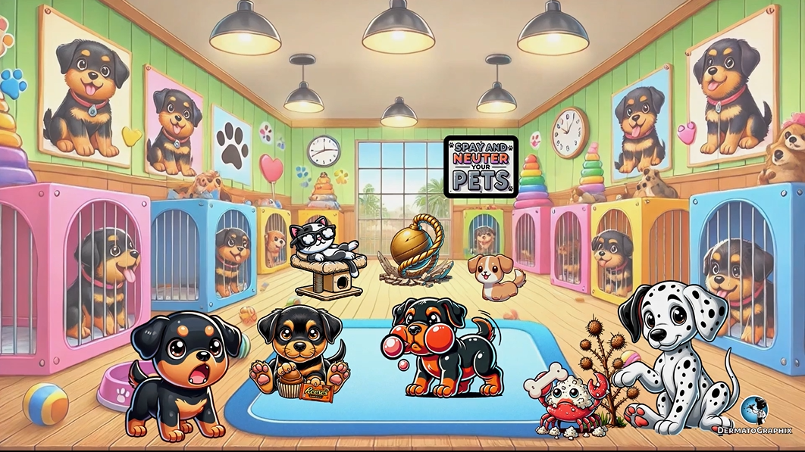
TRANSCRIPT: Rothmund-Thomson Syndrome
============================================================
We are at the Rotweiler shelter to learn about Rothman Thompson syndrome. This is an autosomal recessive disorder shown by this dog eating a recessive Reese's chocolate. Looks like they're doing a little bit of demolition here. This wrecking ball on the floor represents RQL4, which is the affected gene. We show it on the floor since floor rhymes with four. This encodes a DNA helicase that facilitates DNA replication and repair of UV damage. The fact that it's a helicase is represented by the helical ribbon on the wrecking ball. This dog with swollen red cheeks represents Catanus manifestations, including erythema and edema that begin on the cheeks. This blistering bubble represents that blisters may also be present. This later progresses to involve the extensor surfaces of the extremities and buttocks. They have more than just rotwilers here. There are also Dalmatians. This Dalmatian with multiple hypo and hyper pigmented spots represents Poikiloderma. Patients can also have acral verrucous keratosis shown by this verrucous bush near the dog's paw. Notice the little crab peeking out of the bush, symbolizing that acral verrucous keratosis may result in squamous cell carcinoma. Patients can also have a short stature and skeletal dysplasia, shown by the short dog with stubbed legs representing the absence or hypoplasia of thumbs, radius and ulna. Juvenile cataracts can also be present, shown by this cataracts cat with cloudy eyes. This sign reminding you to have your pet spade and neutered symbolizes that patients can also have hypogonadism. In affected patients, malignancy may lead to premature death. This includes osteosarcoma, as shown by the osteobone in the crab's claw. Premature death can also be due to non-melanoma skin cancer, especially squamous cell carcinoma, shown by the crab's scaly erythematous-crusted shell, resembling the appearance of SCCs.
Alright, let's review the symbols one more time. We're at the rotwiler shelter for Rothman Thompson syndrome. This autosomal recessive disorder is shown by the dog eating a recessive Reese's chocolate. Demolition seems to be underway as the wrecking ball on the floor represents a mutation in the RQL4 gene, which encodes a DNA hila case, visualized by the helical ribbon. This gene plays a critical role in DNA replication and UV damage repair. The dog with swollen red cheeks shows the characteristic erythema and edema that begin on the cheeks, with a blistering bubble nearby representing the potential for blistering. Over time, the skin involvement progresses to the extensor surfaces of the extremities and buttocks. A Dalmatian also makes an appearance with hypo and hyperpigmented spots, which represent pokiloderma seen in this condition. Next to the dog's paw is a varicose bush, symbolizing acral varicose keratosis, while a crab peaking out reminds us of the increased risk of squamous cell carcinoma. Skeletal dysplasia, including absent or underdeveloped thumbs, radius and ulna, is depicted by the short dog with stubby legs. Juvenile cataracts are represented by the cat with cloudy eyes and the reminder to spay or neuter your pets points to hypogonadism in affected patients. Unfortunately, malignancy may lead to premature death, as shown by the osteobone symbolizing osteosarcoma. Another crab with scaly, erythematous crust represents the high risk of non-melanoma skin cancers, particularly squamous cell carcinoma. That about does it for Rothman Thompson syndrome. See you in the next graphic.

Rothmund-Thomson Syndrome (Rothmund_Thomson_Syndrome_transcript.txt)
- Inheritance: Autosomal recessive
- Gene: RECQL4 (encodes a DNA helicase for replication & UV repair)
- Skin: Erythema/edema → blistering on cheeks → poikiloderma; acral verrucous keratoses
- Skeletal: Short stature, absent/hypoplastic thumbs, radius, ulna
- Other: Juvenile cataracts, hypogonadism
- Cancer risk: Osteosarcoma & SCC (premature death)

