TRANSCRIPT: Atopic Dermatitis
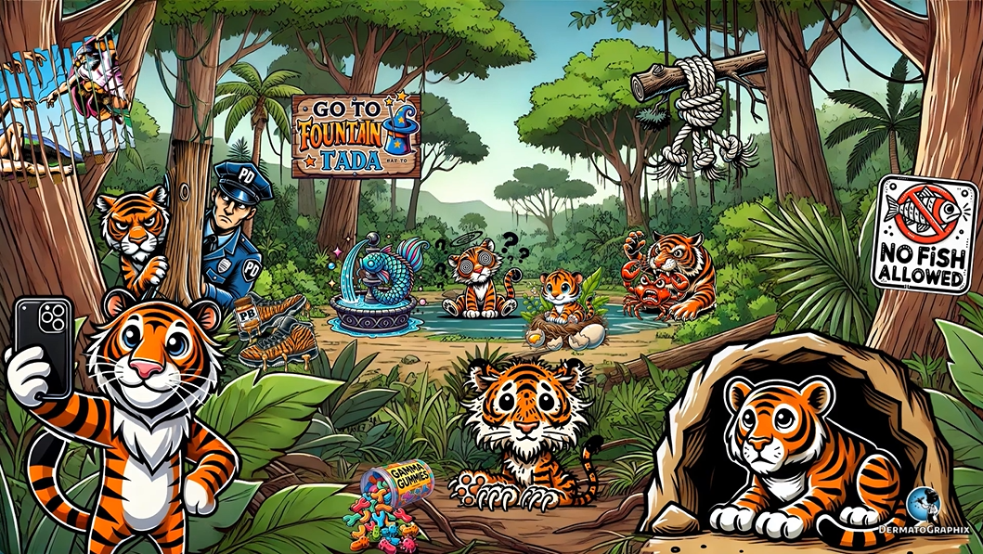
TRANSCRIPT: Trichothiodystrophy (TTD)
============================================================

We're in the forest with tigers to learn about tricothyodystrophy, which is also known as Tay syndrome or Pibid syndrome. This is an autosomal recessive group of diseases that present with brittle hair and nails, resulting from decreased content of cysteine-rich proteins. To remind you of this, check out this shredded poster of the cysteine chapel, symbolizing decreased cysteine, as well as the tiger's brittle hair and claws, representing the brittle hair and nails. You may be wondering why we are among tigers. The brittle hair in this condition usually has alternating light and dark bands on polarizing light microscopy, resulting in a tiger tail appearance.
Tricothiodystrophy, or TTD for short, is classified as either photosensitive or non-photosensitive, which we will represent on two different sides, with the photogenic tiger for photosensitive and the tiger hiding away from the cameras for non-photosensitive.
TTD with photosensitivity is caused by mutations in three genes. These are ERCC2, ERCC3, and GTF2H5. ERCC is represented by this tiger lurking behind a tree for ERCC3. This is because lurk rhymes with ERC. This gene encodes the protein XPD, shown by the police department also behind the tree, and notice the pair of two shoes and the bushes for ERCC2. This gene encodes the protein XPB, shown by the PB, or peanut butter, stuck on the shoe. This sign that reads, go to fountain represents the third gene, which is GTF2H5. That's go to fountain for GTF. Rumor has it that the fountain is magical. It's so magical that there is a sign that says TADA, which represents the protein TTDA encoded by the GTF2H5 gene. See that ichthyotic fish in the fountain? This represents the presence of ichthyosis in TTD with photosensitivity.
Non-photosensitive TTD usually lacks ichthyosis, so check out this sign that shows no fish allowed near the tiger hiding out away from the camera and light. These beasts are hungry. This crab being hunted by a tiger represents that unlike XeroDerma pigmentosum, Pricothiodistrophy does not have an increased skin cancer risk, hence the crab about to be gone. This frayed rope with knots represents that in the hair, tricoscisis and tricorexis nodosa may also be seen. These tigers are confused. Must have gotten lost looking for this magical fountain. The confusion question marks in dizzy tiger represent intellectual impairment and a taxia that can also be present. This tiger nest with broken eggs symbolizes decreased fertility and hypogonodism. Wait, do tigers even lay eggs? Anyways, this short baby tiger symbolizes short stature. Shout out to all the short tiger kings out there. Finally, this spilled bottle of gamma gummies that are kind of shaped like immunoglobulins and infectious germs represents hypogamoglobulinemia with recurrent infections.
Let's review this graphic one more time. In the tiger forest, we explore tricothiodistrophy or TTD, also known as Tay syndrome or Pibid syndrome. This group of autosomal recessive diseases presents with brittle hair and nails due to decreased cysteine-rich proteins. A shredded poster of the cysteine chapel and the tiger's brittle hair and claws symbolize this. The characteristic tiger tail appearance comes from the alternating light and dark bands seen in the hair under polarizing light microscopy, which is why we're learning about this condition among tigers. TTD can be classified as photosensitive or non-photosensitive.
The photogenic tiger represents the photosensitive type, while the camera shy tiger hiding away represents the non-photosensitive form. Photosensitive TTD is caused by mutations in three genes, ERCC2, ERCC3, and GTF2H5. The tiger lurking behind a tree symbolizes ERCC3 while the police department nearby represents XPD. A pair of two shoes stuck in the bushes symbolizes ERCC2, which encodes XPB. The sign that says go to fountain symbolizes GTF2H5 and the TADA sign nearby represents the TTDA protein it encodes. The ICHTheotic fish in the fountain highlights the presence of ICHTheosis in photosensitive TTD.
For the non-photosensitive type, the no-fish allowed sign near the hiding tiger represents the lack of ICHTheosis. A tiger hunting and destroying a cancer crab symbolizes that unlike XeroDerma pigmentosum, TTD does not increase the risk of skin cancer. The frayed rope with knots represents trichoschesis and trichorexis nodosa, which are common hair findings in this condition. The confused, dizzy tiger with question marks represents intellectual impairment and ataxia, while a tiger's nest with broken eggs points to decreased fertility and hypogonodism. The short baby tiger symbolizes short stature and a spilled bottle of gamma gummies, shaped like immunoglobulins and germs, symbolizes hypogamaglopulinemia and recurrent infections.
That's all for TTD. Before we head out, I'd like to give one more shout out to all the short tiger kings out there. Stand tall, my friends.

Trichothiodystrophy / TTD (Trichothiodystrophy_transcript.txt)
- Inheritance: Autosomal recessive (aka Tay or PIBIDS syndrome)
- Hair: Brittle, low cysteine content; "tiger tail" appearance on polarising microscopy
- Two forms:
  - Photosensitive — ERCC2 (XPB), ERCC3 (XPD), GTF2H5 (TTDA); has ichthyosis
  - Non-photosensitive — no ichthyosis
- Key feature: Unlike XP, no increased skin cancer risk
- Other: Intellectual impairment, ataxia, hypogonadism, short stature, hypogammaglobulinaemia

