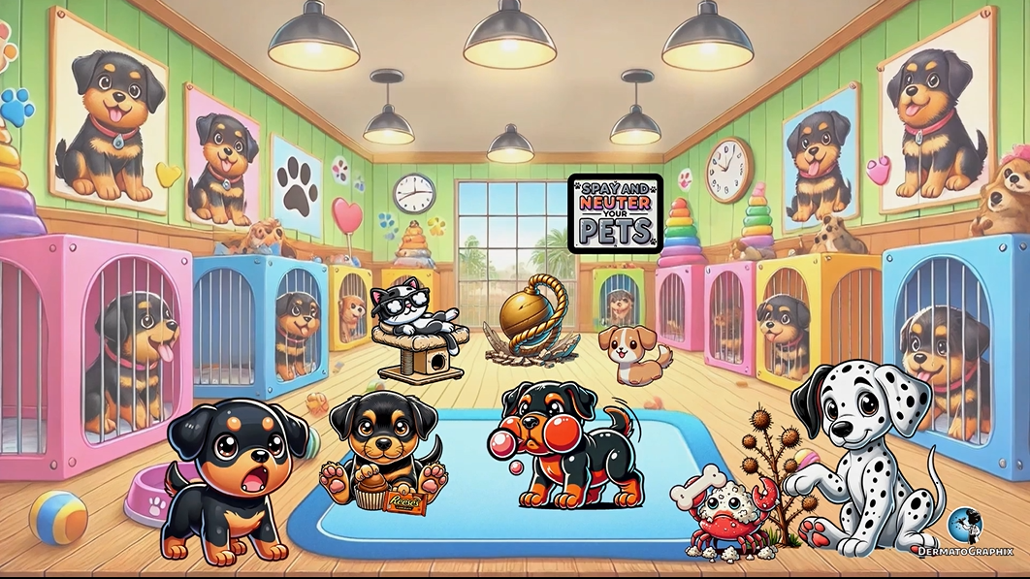

TRANSCRIPT: Tuberous Sclerosis
============================================================

Welcome to the Water Sports Tubing Complex, where we will learn about tuberous sclerosis complex, which is an autosomal dominant disorder caused by a mutation in one of two genes. The first is represented by the hammer team, representing a mutation in hammerton. Watch out because this team is rated number one. The number one foam finger represents that hammerton is encoded by the TSC1 gene. Take a look at this next team with pool tubes. The tubes represent a mutation in tuberin. This team is ranked second place, which is why they have silver medals. They are number two, because tuberin is encoded by TSC2. TSC2 is most common and is contiguous with polycystic kidney disease, as symbolized by the cystic kidney flask held by the tube team. These proteins form a complex that inhibits signal transduction of downstream factors of MTOR, which stands for the mammalian target of rapamycin. MTOR is represented by this MTOR's boat. When these proteins are not working as they should, it can lead to abnormal regulation of cellular differentiation, proliferation and migration of affected cell types, leading to the formation of multiple hammer tomas. Check out these bushes on the side with burnt ash leaves. This symbolizes the ash leaf macules that typically have a confetti pattern, and are present on the pre-tibial shins. So notice the racer getting some of the leaves on his shins. See that green tube the man is floating on? This represents shagreen patches in tuberous sclerosis, which are collagen connective tissue nearby. The man is a sea bum with spots on his face, representing adenoma sebaceum, or facial angiophibromas. These can be treated with topical rapamycin, so notice his candy in a wrapper. Looks like a pine cone fell on his toenails. This cone represents cone entomers, which are peri-ungul fibromas, hence the cone being on the nail. Caffeole macules may also be present. He should have known better than him to bring a cup of coffee onto the water tube. It's going to spill. The man is really getting out of control. He's resting his head on a sack of tubers, symbolizing the neurological findings of cortical tubers. Affected patients can also have infantile spasms and seizures as shown by the baby shaking from spasms. The death skull on the baby's water suit represents that the number one cause of mortality in patients with tuberous sclerosis is complications related to seizures. Check out this plain flying overhead. It has some calcium milk coming from the vent. This symbolizes that peri-ventricular calcification can also be present. That's one way to hydrate the contenders. Back down on the ground, this bush oddly shaped like a kidney, with vessel-like red vines on it, represents renal findings of angiomile lapomas and renal cysts, as shown by the cyst-like berries on the bush. See some of those berries burst? This represents complications of renal disease, including catastrophic hemorrhage within a renal angiomile lapoma. Patients can also have renal failure and renal hypertension. Renal complications are the second most common cause of premature death in affected patients. Safety first. This retinal facoma safety floaty represents ocular findings like retinal facomas, which are hammer tomas. All this commotion is disturbing the wildlife. This rabid white wolf is eating a heart, symbolizing cardiac Arabdo-myomas and wolf Parkinson white arrhythmias, hence the white wolf. So where do the racers' dock when they are finished? This tooth-shaped dock with holes represents pits in the enamel. The referee on the dock, blowing ginger-vill gum, represents ginger-vill fibromas that can also present in this condition. Finally, this lion out of breath represents pulmonary lymph angiolai-omyomatosis and pulmonary cysts that can lead to complications like pneumothorax, chylothorax, hemoptosis, and pulmonary insufficiency. No wonder he's out of breath. That's it for the high-yield points. Remember, that definitive diagnosis of tuberous sclerosis complex requires either the presence of a pathogenic mutation in either TSC1 or TSC2, or the presence of two major criteria or one major and two minor criteria. Keep in mind that cutaneous features are seen in 90% of affected patients and can often be the first presenting sign, so it is imperative that we identify these cases early as dermatologists. Alright, let's wrap up this graphic. This graphic for tuberous sclerosis complex takes place in the water tube race, where the race begins with two water tubing teams. The hammer team, ranked number one, represents a mutation in Hummarton encoded by TSC1, while the number two ranked tube team symbolizes a mutation in tubrin encoded by TSC2. The cystic kidney flask connects TSC2 with polycystic kidney disease. These two proteins form a complex that inhibits M-tore signaling, represented by the M-tore's boat. When this system malfunctions, it leads to multiple hammer tomas. On the sidelines, burnt ashy leaves remind us of ashleaf macules on the shins, while the man on a green tube points to shag green patches. As a sea bum, with facial spots, signifying adenoma subacium or facial angiophybromas, treated with topical rapamycin, shown by the candy and a wrapper. The pine cone on his nail signals piri-ungual fibromas known as cone end tumors, and the spilled coffee highlights cafeo-lay macules. He's resting his noggin on a sack of tubers to remind us of cortical tubers. On the sideline, the spasming baby represents infantile spasms, tied to a worse prognosis. The death skull reminds us that seizures are the leading cause of death in these patients. Overhead, a plain emitting calcium from its vent symbolizes paravan-tricular calcifications, while the kidney-shaped bush with cyst-like berries reflects renal angiomial lopomas and cysts. The bursted berries emphasize the potential for catastrophic renal hemorrhage, which are the second most common cause of death. A retinal facoma floaty signifies ocular hammer tomas, and a rabid white wolf eating a heart symbolizes cardiac rabdomiomas and wolf Parkinson white arrhythmias. The racers dock at a tooth-shaped pier with holes representing enamel pits while a referee blowing gingival gum signals gingival fibromas. Finally, a breathless lion reminds us of pulmonary lymphangioleomyomatosis with complications like pneumothorax and pulmonary insufficiency. That's the scoop on tuberous sclerosis. We'll see you in the next dermatographics. In the meantime, please try not to spill your coffee.

Tuberous Sclerosis Complex (Tuberous_Sclerosis_transcript.txt)
- Inheritance: Autosomal dominant
- Genes: TSC1 (hamartin) or TSC2 (tuberin) → mTOR pathway
- Skin: Ash-leaf macules, shagreen patches, facial angiofibromas (treat with topical rapamycin), periungual fibromas (Koenen tumours), café-au-lait macules
- Neurological: Cortical tubers, infantile spasms, seizures (#1 cause of mortality), periventricular calcifications
- Renal: Angiomyolipomas + cysts (#2 cause of mortality, risk of catastrophic haemorrhage)
- Other: Retinal phacomas, cardiac rhabdomyomas, WPW arrhythmias, dental enamel pits, gingival fibromas, pulmonary LAM

