Lecture 1: Skin Structure & Basic Terminology

1. Introduction & Functions of the Skin

Summary
- The skin is the largest organ of the body, composed of three main layers: Epidermis, Dermis, and Subcutaneous fat (Hypodermis)
- Functions of the skin:
- Protection — barrier against physical, chemical, and biological threats
- Secretion — sebum production via sebaceous glands
- Excretion / Vitamin D synthesis — produces Vitamin D3 via UV exposure
- Sensation — pain, temperature, and pressure (via nerve endings)
- Heat regulation — via sweating and vasodilation/vasoconstriction
- Absorption — transdermal absorption of substances
- Immunity — innate and adaptive immune functions
- Flexibility, moisture retention, heat insulation, communication
- Clinical correlation focus: Understanding skin structure is the foundation for understanding ALL dermatological diseases

Translated & Tidied Audio Transcript
Dr. Eman: Welcome everyone. I hope you are all well. We will begin our first lecture in this course today, and I hope it will be a pleasant, light, and beneficial course for all of you. If there is any sound issue, please let me know immediately.
Dr. Eman: Today we start with the most important foundation of the entire course — skin basics and terminology. I am Dr. Eman Gomaa, Consultant Dermatologist at Al-Houd Al-Marsoud Hospital. This lecture will be different — we will understand the fundamentals of skin structure and their clinical correlations. It is not just about memorising "Epidermis" and "Dermis" — I want you to understand that every concept we discuss links directly to a specific disease.
Dr. Eman: Think of today's lecture as a brainstorming session that maps all of dermatology. Beginners should not be scared — we are starting from absolute basics. Those who already have some dermatology background will find this a useful refresher.
Dr. Eman: Let us start with the functions of the skin. Who can tell me — what does the skin secrete?
Student: Sebum? From the sebaceous glands?
Dr. Eman: Yes, sebum. And sweating?
Student: I think sweating is an excretory function.
Dr. Eman: Correct — excretion. And what else does the skin produce — something we all know?
Student: Vitamin D?
Dr. Eman: Exactly — Vitamin D3, produced through sun exposure. So the functions are: Protection, Secretion, Sensation (pain, temperature, pressure), Heat regulation via sweating, Excretion/Vitamin D synthesis, and Absorption. These are the core functions — memorise them but know they have limited direct clinical correlation for our purposes.

2. Overview of Skin Layers & Histological Structure

Summary
- The skin is divided into three layers (deep to superficial):
- Subcutaneous fat (Hypodermis) — fatty tissue; lobular panniculitis affects fat lobules; septal panniculitis affects fibrous septa between lobules
- Dermis — contains collagen, elastin, ground substance, blood vessels, nerves, and skin appendages; divided into:
- - Papillary dermis (superficial, looser collagen)
- - Reticular dermis (deeper, denser collagen bundles)
- Epidermis — outermost, avascular, cellular layer
- Skin appendages (located in the dermis):
- - Hair follicle + Sebaceous gland + Apocrine gland = Pilosebaceous unit
- - Eccrine sweat glands — main sweat glands, present throughout the body
- - Apocrine glands — limited to axillae, groin, areola

Translated & Tidied Audio Transcript
Dr. Eman: The basic structure of the skin consists of three layers: Epidermis, Dermis, and Subcutaneous fat. The Epidermis is made up of layers of cells. The Dermis contains Collagen, Elastin, Ground substance, and the skin appendages — the Hair follicle, Sebaceous gland, Apocrine sweat gland, and Eccrine sweat gland. Beneath all of this is the Subcutaneous fat.
Dr. Eman: An important histological point: if inflammation occurs in the fat lobules themselves, we call it lobular panniculitis. If inflammation is in the fibrous septa between the fat lobules, we call it septal panniculitis. These are important terms you will encounter throughout the course.

3. The Epidermis — Layers & Characteristics

Summary
- The epidermis is a self-renewing tissue — undergoes complete renewal every 28 days (epidermal transit time)
- Basic cell: The Keratinocyte
- Four layers of the epidermis (from deepest to most superficial):
Layer | Key Features | Clinical Correlation
Stratum Basale (Germinativum) | Single layer of mitotically active columnar keratinocytes; contains stem cells and melanocytes (1 per 8–10 keratinocytes) | Epidermolysis bullosa simplex (K5/K14 defect)
Stratum Spinosum | Larger, polyhedral cells with spine-like desmosomes; immediately above basale | Pemphigus (desmosome defects)
Stratum Granulosum | Contains keratohyalin granules (Filaggrin) and Odland bodies (lipids) | Missing in psoriasis (rapid turnover); thickened in lichen planus
Stratum Corneum | Dead, anucleate, flattened corneocytes packed with keratin; Brick and mortar structure | Ichthyosis, Atopic dermatitis (barrier defects)

- Key clinical pearls:
- - Stratum corneum is thicker on palms and soles
- - Dermatophytes are found in the stratum corneum → examined by KOH preparation
- - Stratum granulosum is MISSING in psoriasis due to accelerated differentiation (turnover reduced from 28 days → ~3 days)
- - Stratum granulosum is THICKENED in lichen planus (hypergranulosis)

Translated & Tidied Audio Transcript
Dr. Eman: Who can tell me about the structure of the skin? The Epidermis is a self-renewing tissue — it renews itself every 28 days. When we say "we shed our skin," we literally do! If there is a problem with this renewal cycle, disease appears. If the process speeds up, one disease appears; if it slows down, another appears.
Dr. Eman: The basic cell of the epidermis is the Keratinocyte. The epidermis consists of four discrete layers: Stratum corneum, Stratum granulosum, Stratum spinosum, and Stratum basalis. What is the difference between these layers?
Student (Dr. Doaa): The basalis is the precursor of all cells — it contains the melanocytes, produces keratinocytes, and forms the strong barrier against the dermis.
Dr. Eman: Exactly. The basal cell layer is where everything starts. As cells move upward, a process called Differentiation occurs — not proliferation. The cell's properties change as it migrates upward. The stratum corneum is composed of dead cells — just protein bonded together with a lipid layer. This is the Skin Barrier. What disease occurs when the skin barrier is defective?
Student: Atopic dermatitis.
Dr. Eman: Exactly — atopic dermatitis is the most important one. Also Ichthyosis — a disorder of differentiation causing scales. The stratum corneum is thicker on the palms and soles. Dermatophytes live in this layer — that's why we do a KOH examination of scrapings from this layer to find the fungus.
Dr. Eman: Now — why is the stratum granulosum absent in psoriasis? Because in psoriasis, the fundamental problem is the speed of differentiation — the skin turns over in 3 days instead of 28. The cells don't have time to pass through the granular layer, so they go straight from the basal layer to the stratum corneum. That is why the granular layer is absent in psoriasis histopathology. Does everyone understand? This is one of the most important histopathological features of psoriasis.

4. The Stratum Basale (Basal Cell Layer) in Detail

Summary
- Single layer of mitotically active, columnar-shaped keratinocytes
- Contains two functional cell populations:
- Stem cells → undergo Proliferation → remain in the basal layer to maintain cell supply
- Transient amplifying cells → undergo Differentiation → migrate upward to form the skin barrier
- Keratin expressed: K5 (basic/type II) and K14 (acidic/type I) — the basal pair
- Melanocytes are interspersed: 1 melanocyte per 8–10 keratinocytes (anatomical ratio); each melanocyte functionally supplies 36 keratinocytes (the Epidermal Melanin Unit)
- Cells are attached to each other by Desmosomes
- Contains melanosomes transferred from melanocytes by phagocytosis

Clinical Correlations of the Basal Layer
Defect | Disease
K5 / K14 defect | Epidermolysis bullosa simplex (EBS)
Desmoglein 1 autoantibody | Pemphigus foliaceus
Desmoglein 3 + 1 autoantibody | Pemphigus vulgaris
Desmocollin autoantibody (IgA) | IgA Pemphigus

Translated & Tidied Audio Transcript
Dr. Eman: The basal cell layer contains two types of cells: stem cells that proliferate and stay at the bottom, and cells that differentiate and migrate upward to eventually become the stratum corneum. So the two functions of the basal cell layer are: Proliferation (to maintain cell numbers) and Differentiation (to produce the skin barrier).
Dr. Eman: Between the keratinocytes in the basal layer are the Melanocytes — approximately 1 melanocyte for every 8 to 10 keratinocytes. These are responsible for producing melanin that gives the skin its colour.
Student: Is it one melanocyte for every 36 keratinocytes?
Dr. Eman: That is the functional ratio — each melanocyte supplies 36 keratinocytes through its dendrites. But anatomically there is 1 per 8 to 10. This is called the Epidermal Melanin Unit.
Dr. Eman: Now, what holds the cells together? Desmosomes. These are junctions that bind adjacent keratinocytes. The desmosome consists of: Desmoglein, Desmocollin, Desmoplakin, Plakophilin, and Plakoglobin. If Desmoglein 1 is attacked by autoantibodies — what disease results?
Student: Pemphigus foliaceus.
Dr. Eman: Correct. And Desmoglein 3 + 1?
Student: Pemphigus vulgaris.
Dr. Eman: Exactly. And an IgA autoantibody against Desmocollin gives us IgA Pemphigus. Now you understand the desmosome — when you study Pemphigus later, you will already understand the mechanism, not just memorise a name.

5. The Stratum Granulosum & Stratum Corneum — The Skin Barrier

Summary

Stratum Granulosum
- Contains two key organelles that build the skin barrier:
- Keratohyalin granules — contain Profilaggrin (precursor to Filaggrin)
- - Filaggrin acts as a glue that cross-links keratin intermediate filaments into dense macrofibrils
- Odland bodies (Lamellar bodies / Keratinosomes) — contain lipids (ceramide, cholesterol, free fatty acids)
- - Secreted into the intercellular space to form the Lipid lamellae (the "mortar" in the brick and mortar)

Stratum Corneum — The "Brick and Mortar"
- Largest cells of the epidermis; non-viable, anucleate
- Cells = Corneocytes (formerly keratinocytes) — the "bricks"
- Contents: Keratin macrofibrils (K1/K10) cross-linked by Filaggrin inside a thickened Cornified envelope
- Between cells: Lipid lamellae (ceramide + cholesterol + free fatty acids) — the "mortar"
- Cornified envelope = thickened cell wall formed by deposition of Loricrin and Involucrin cross-linked by Transglutaminase 1
- Desquamation: Upper stratum corneum desmosomes become discontinuous → Filaggrin degrades to Natural Moisturising Factor (NMF) → corneocytes shed

Key Proteins Summary
Protein | Location | Function | Disease if Defective
Filaggrin | Keratohyalin granules → Corneum | Cross-links keratin filaments; degrades to NMF | Atopic dermatitis, Ichthyosis vulgaris
Loricrin + Involucrin | Cornified envelope | Structural proteins of the cornified envelope | Vohwinkel syndrome, Ichthyosis
Transglutaminase 1 | Granular–corneum junction | Cross-links envelope proteins | Lamellar ichthyosis
Odland bodies (Lipid lamellae) | Between corneocytes | Water barrier (mortar) | Lamellar ichthyosis; Atopic dermatitis
Ceramide | Lipid lamellae | Main lipid component of mortar | Barrier dysfunction

🔑 Clinical Pearl — Exam MCQ: Which is responsible for maintaining the barrier to water loss in the stratum corneum?
Answer: E — Odland bodies (Lamellar bodies)
The lipid lamellae (mortar) between cells — not the keratin proteins inside cells — is what prevents water loss. A defect in the mortar (lipid) causes leaking; the bricks (keratin) provide structure, not the water barrier.

Translated & Tidied Audio Transcript
Dr. Eman: The stratum granulosum — why is it named "granulosum"?
Student (Dr. Moataz): Because it contains granules.
Dr. Eman: Correct — two types of granules. First, Keratohyalin granules — these contain Filaggrin, the glue that sticks keratin filaments together. Second, Odland bodies — these are the lipid-containing organelles. These lipids are secreted between the cells to form the Lipid lamellae. We call this structure Brick and Mortar — the cells are the bricks, the lipids between them are the mortar.
Dr. Eman: The stratum corneum is the final product. The cell is no longer called a keratinocyte — it is now called a Corneocyte. It has no nucleus, no mitochondria, no organelles. It is packed with keratin macrofibrils glued together by Filaggrin. The cell wall is now thick — it is called the Cornified envelope, made of Loricrin and Involucrin proteins cross-linked by Transglutaminase 1.
Dr. Eman: If there is a defect in Filaggrin — what diseases result?
Student: Atopic dermatitis and Ichthyosis vulgaris.
Dr. Eman: Exactly. When I tell you "Ichthyosis vulgaris," you won't just memorise it — you'll understand the mechanism. The Filaggrin is the glue that holds everything together. If it breaks down, the barrier cracks — you get dry, scaly skin. If Transglutaminase 1 is defective, you get Lamellar ichthyosis.
Dr. Eman: And the final step — desquamation. In the upper stratum corneum, desmosomes break down, Filaggrin degrades to Natural Moisturising Factor (NMF) — look at how beautifully God designed this — the very glue that built the barrier now converts into moisturising factors as the cells shed. This is the three-step cycle: Proliferation → Differentiation → Desquamation.
Student: So the corneocytes are the bricks, the lipid lamellae is the mortar, and Filaggrin holds the keratin inside?
Dr. Eman: Exactly. And the Keratin inside is organised into bundles — Keratin intermediate filaments — held together by Filaggrin. The wall of the cell — the Cornified envelope — is made thick by Loricrin and Involucrin. And the mortar between cells — Lipid lamellae — is made of Ceramide, Cholesterol, and free fatty acids. That is why moisturisers today contain Ceramide — because it is the core component of the mortar that prevents water loss.

6. Non-Keratinocyte Cells of the Epidermis

Summary

Melanocytes
- Origin: Neural crest cells — migrate to the basal layer during embryogenesis
- Location: Basal layer (1 per 8–10 keratinocytes anatomically; 1 per 36 functionally)
- Function: Produce Melanin via Melanogenesis (Tyrosine → DOPA → Dopaquinone → Melanin)
- Key enzyme: Tyrosinase
- Melanin is packaged into Melanosomes → transferred to surrounding keratinocytes by phagocytosis → degraded by lysosomal enzymes → pigment distributed throughout basal layer

Melanocyte Clinical Correlations
Defect/Event | Disease
Tyrosinase gene defect (enzyme absent) | Albinism (Oculocutaneous)
Autoantibodies destroy melanocytes | Vitiligo
Defective melanosome transport to keratinocytes | Griscelli syndrome (3 types — silver-blonde hair, bronze skin)
Melanocyte migration failure during embryogenesis (KIT mutation) | Piebaldism (white patches present from birth)
Increased melanin production | Melasma (Chloasma)
Proliferation of melanocytes (benign) | Melanocytic nevus (nevus cell = modified melanocyte)

Merkel Cells
- Type I mechanoreceptors (tactile sensitivity)
- Found in: Digits, lips, oral cavity, outer root sheath of hair follicle
- Tumour: Merkel cell carcinoma (aggressive skin cancer)

Langerhans Cells
- Dendritic, bone-marrow derived cells
- Function: Antigen-presenting cells (APCs) — capture antigens in the skin → migrate to lymph nodes → activate T-cells
- Part of the adaptive immune system of the skin
- Marker: CD1a, CD11c
- Depleted by phototherapy (NB-UVB) → one mechanism by which phototherapy reduces inflammation

Translated & Tidied Audio Transcript
Dr. Eman: Are there other cells in the epidermis besides keratinocytes? Yes — Melanocytes, Merkel cells, and Langerhans cells.
Dr. Eman: The Melanocyte produces melanin inside itself via an enzyme called Tyrosinase. If there is a genetic defect in Tyrosinase — what disease?
Student: Albinism.
Dr. Eman: Correct — Albinism. The enzyme is absent so no melanin is produced. What if autoantibodies attack and destroy the melanocytes?
Student: Vitiligo.
Dr. Eman: Exactly — Vitiligo is an immunological disease, not a genetic one. Antibodies attack the melanocytes and destroy them. What if the melanosomes cannot be transferred to the keratinocytes?
Student: Griscelli syndrome.
Dr. Eman: Yes — Griscelli syndrome — the child has silvery-blonde hair and a bronzed face. The melanocytes are present and making melanin, but the melanosomes cannot reach the keratinocytes. And Piebaldism — a KIT gene mutation — the melanocytes failed to migrate to certain areas during embryogenesis, so those areas are permanently white from birth.
Dr. Eman: The Merkel cell is a mechanoreceptor — found in areas of high tactile sensitivity: fingertips, lips, oral cavity, and the outer root sheath of hair follicles. Its malignant tumour is Merkel cell carcinoma.
Dr. Eman: The Langerhans cell is a dendritic, bone-marrow derived antigen-presenting cell. When an antigen enters the skin, the Langerhans cell captures it and migrates to the lymph node to activate T-cells. We will discuss this more in the next lecture on immunology.

7. The Dermo-Epidermal Junction (DEJ) / Basement Membrane Zone (BMZ)

Summary

Definition
- The BMZ is the basement membrane zone that forms the interface between the epidermis and dermis
- Functions:
- Attachment of epidermis to dermis
- Support the epidermis
- Enables epidermal cell adhesion, migration, and differentiation
- Site of epidermal morphogenesis, proliferation, and apoptosis

Components (from superficial to deep)
Zone | Components | Clinical Correlation
Basal plasma membrane | Keratin 5/14 → Hemidesmosome | Anchoring point
Lamina lucida | Anchoring filaments (Plectin, BPAG1/Collagen XVII, BPAG2, Integrin α6β4) | Weakest zone — splits in junctional EB and bullous pemphigoid
Lamina densa | Collagen IV, Laminin | Electron-dense; acts as a molecular filter/barrier
Sublamina densa | Anchoring fibrils (Collagen VII), Fibronectin, Fibrillin | Deepest zone; splits in dystrophic EB

Key Proteins of the Lamina Lucida
Protein | Disease if Defective (Genetic) | Disease if Autoantibody
BPAG2 (Collagen XVII) | Junctional EB | Bullous pemphigoid, Pemphigoid gestationis
BPAG1 | Junctional EB | Paraneoplastic pemphigus
Plectin | EB with muscular dystrophy | Cicatricial pemphigoid
Integrin α6β4 | Junctional EB with pyloric atresia | —

Key Proteins of the Sublamina Densa
Protein | Disease if Defective (Genetic) | Disease if Autoantibody
Collagen VII | Dystrophic EB (most severe) | Epidermolysis bullosa acquisita (EBA)

Clinical Pearl — Pemphigus vs. Pemphigoid
Feature | Pemphigus | Pemphigoid
Site of split | Within epidermis (above basal layer — intraepidermal) | Below epidermis (subepidermal — at BMZ)
Blister character | Flaccid — ruptures quickly, often just erosions seen | Tense — thick-roofed, intact
Why? | Superficial split → thin roof → ruptures easily | Deep split → thick roof (full epidermis above) → tense
Target | Desmoglein (desmosome) | BPAG2 / Lamina lucida proteins

🔑 Key concept: Epidermolysis bullosa (EB) types correspond to the level of split:
- EB Simplex — intraepidermal (K5/K14 defect)
- Junctional EB — lamina lucida split (BPAG2, Integrin α6β4)
- Dystrophic EB — sublamina densa (Collagen VII defect) — most severe, causes digit fusion/mutilation

Translated & Tidied Audio Transcript
Dr. Eman: Now let us cover the Dermo-Epidermal Junction. This is the basement membrane zone between the epidermis and dermis.
Dr. Eman: A patient presents with a bullous skin disease. The defect in BPAG2 (Bullous pemphigoid antigen 2) — is it genetic or immunological?
Student: Immunological.
Dr. Eman: Correct — when autoantibodies attack BPAG2, the result is Bullous pemphigoid. BPAG2 is also called Collagen XVII — remember this name so you are not confused later.
Dr. Eman: What is the clinical difference between Pemphigus and Pemphigoid?
Student: Pemphigus gives flaccid bullae, Pemphigoid gives tense bullae.
Dr. Eman: Excellent. Why?
Student: Because of the depth of the defect — superficial versus deep.
Dr. Eman: Exactly. In Pemphigus, the split is within the epidermis — the blister has a very thin roof so it ruptures immediately. You often see only erosions, not intact blisters. In Pemphigoid, the split is below the epidermis — the entire epidermis forms the roof of the blister, making it thick and tense.
Dr. Eman: For Epidermolysis bullosa — genetic defects at different levels give different types:
- Defect at the top (K5/K14) → EB Simplex (least severe)
- Defect in the middle (Lamina lucida) → Junctional EB
- Defect at the bottom (Collagen VII) → Dystrophic EB (most severe — the digits and limbs can become mutilated over time)
Dr. Eman: The Lamina lucida is the weakest zone of the DEJ — it is electron-lucent. The Lamina densa is strong, electron-dense — it acts as a molecular filter preventing passage of large molecules from dermis to epidermis.
Student: Doctor, what is Cicatricial pemphigoid?
Dr. Eman: It is another type of pemphigoid where the autoantibody targets Plectin or other lamina lucida proteins — it predominantly affects mucous membranes. We will cover it in detail in the bullous diseases chapter.

8. The Dermis — Structure & Components

Summary

Structure of the Dermis
The dermis is divided into Matrix and Non-matrix components:
Matrix:
- Fibrous network:
- - Collagen (types I, III, V in dermis) — provides tensile strength and elasticity; 75% of skin dry weight
- - Special stains: Verhoeff stain or Orcein stain → red or yellow
- - Synthesised by Fibroblasts
- - Note: Collagen IV = Lamina densa; Collagen VII = Anchoring fibrils; Collagen XVII = BPAG2 — do NOT confuse with dermal collagens
- - Elastic fibres — three types (superficial to deep):
- Oxytalan fibres — upper papillary dermis; bundles of microfibrils only
- Elaunin fibres — lower papillary dermis; microfibrils + some amorphous elastin
- Elastic fibres (amorphous elastin) — deep reticular dermis; predominantly amorphous elastin
- Non-fibrous (Ground substance / Mucin):
- - Hyaluronic acid (main component of mucin) — highly hydrophilic, responsible for skin hydration
- - Also contains proteoglycans and glycosaminoglycans
Cells of the Dermis:
- Fibroblasts — synthesis AND degradation of fibrous and non-fibrous matrix
- Macrophages — primary phagocytic cells (non-Langerhans histiocytes)
- Dendrocytes — dermal dendritic cells
- Mast cells — proliferation → Mastocytosis (Urticaria pigmentosa)

Clinical Correlations of the Dermis
Defect | Disease | Key Feature
Collagen defect (COL1A1, COL3A1, etc.) | Ehlers-Danlos syndrome | Hyperextensible fragile skin + joint hypermobility
Elastin defect (degradation/absence) | Cutis laxa | Loose sagging skin, aged facial appearance
Elastin calcification | Pseudoxanthoma elasticum (PXE) | Plucked chicken skin (neck), Angioid streaks (eye), cardiovascular calcification
Elastin/fibrillin defect | Marfan syndrome | Tall stature, arachnodactyly, lens dislocation, aortic aneurysm
Mucin excess | Mucinosis / Scleromyxedema | Leonine facies; associated with IgA monoclonal gammopathy (lymphoproliferative disorder)
Mucin degradation defect | Mucopolysaccharidoses | Lysosomal storage disorders
Mast cell proliferation | Mastocytosis (Urticaria pigmentosa) | Brown macules that urticulate on stroking (Darier's sign)

Translated & Tidied Audio Transcript
Dr. Eman: Now let us discuss the dermis. The dermis consists of matrix and non-matrix components. The matrix has two parts: the fibrous network (Collagen and Elastin) and the non-fibrous component (Ground substance / Mucin).
Dr. Eman: Collagen is the major component of the dermis — 75% of the dry skin weight. For those who work in aesthetics, everything we do is to stimulate collagen production! Collagen provides tensile strength and elasticity. It is synthesised by fibroblasts. The main types in the dermis are Collagen I, III, and V. What disease results from a collagen defect?
Student: Ehlers-Danlos syndrome.
Dr. Eman: Exactly — Ehlers-Danlos syndrome. You see these patients on TV shows doing incredible contortions — they actually have a disease. Hyperextensible fragile skin and joint hypermobility.
Dr. Eman: The Elastic fibres form a mesh network between collagen bundles and provide elasticity. Three types: Oxytalan at the top, Elaunin in the middle, and pure Elastic fibres at the bottom. A defect in elastin causes what disease?
Student (Dr. Basem): Cutis laxa.
Dr. Eman: Cutis laxa — loose, sagging skin. Children look elderly because their skin hangs. And Pseudoxanthoma elasticum — here calcium is deposited in the elastin. On the skin you see "plucked chicken skin" appearance on the neck. But the real danger is systemic — calcium deposits in the elastic tissue of blood vessels, the heart, and the eye (causing Angioid streaks by breaking Bruch's membrane). This is why the disease affects the skin, heart, and eyes together — all because elastin is present in all of these tissues and they all undergo calcification.
Dr. Eman: The Ground substance (non-fibrous matrix) is the homogenous material in which collagen and elastin float. The most important component is Hyaluronic acid — the substance we inject in aesthetics! It is extremely water-absorbing, which is why it provides skin hydration. Excess mucin causes Mucinosis. Look at this patient — leonine facies, thickened skin — this is Scleromyxedema. Where do I refer this patient?
Student: Oncology / cancer institute.
Dr. Eman: Exactly — because Scleromyxedema is associated with IgA monoclonal gammopathy and lymphoproliferative disorders. You must screen for malignancy.
Dr. Eman: Now, the cells of the dermis: Fibroblasts produce collagen. Macrophages are the primary phagocytic cells. Mast cells — if they proliferate abnormally, what disease?
Student: Urticaria pigmentosa.
Dr. Eman: Yes — Mastocytosis, the clinical form of which is Urticaria pigmentosa. We will discuss this in detail later.

9. Keratin — Structure, Types & Clinical Correlations

Summary

What Is Keratin?
- Keratin = a multigene family of proteins forming the intermediate filament cytoskeleton of epithelial cells
- Function: Gives the keratinocyte its shape (cytoskeleton) and mechanical strength
- Produced by keratinocytes (hence the name)

Two Subfamilies (must always pair — one from each):
Type | Keratin Numbers | Properties
Type I (Acidic) | K10–K20 | Acidic
Type II (Basic/Neutral) | K1–K9 | Basic/Neutral

Most Important Keratin Pairs
Keratin Pair | Location | Function | Disease if Defective
K5 / K14 | Basal cell layer | Proliferation / structural support of basal cells | Epidermolysis bullosa simplex (EBS)
K1 / K10 | Suprabasal layers (spinosum, granulosum, corneum) | Differentiation / cornification | Epidermolytic ichthyosis
K16 / K17 | Palmoplantar, nail, hair | Stress response | Pachyonychia congenita

🔑 Exam point: K5 and K14 are the basal pair (proliferation); K1 and K10 are the suprabasal pair (differentiation). In the spinous layer, keratin switches from K5/K14 → K1/K10 — this switch marks the beginning of terminal differentiation.
🔑 BPAG2 = Collagen XVII — Bullous pemphigoid antigen 2 is the same protein as Collagen XVII. This is a common source of exam confusion.

Translated & Tidied Audio Transcript
Dr. Eman: What is keratin? It is the cytoskeleton of the keratinocyte. If we were a person without bones, we would collapse — just a bag of organs. The same applies to the cell. Without its cytoskeleton, the cell has no shape. The cytoskeleton in epithelial cells is keratin.
Dr. Eman: Keratin is a family of proteins. There are two types: Type I (acidic, numbers 10–20) and Type II (basic, numbers 1–9). They always work in pairs — one Type I with one Type II.
Dr. Eman: The most important pairs to know: K5 and K14 — these are in the basal cell layer, responsible for proliferation. K1 and K10 — these are in the suprabasal layers, responsible for differentiation.
Dr. Eman: So what disease results from a K5/K14 defect?
Student: Epidermolysis bullosa simplex.
Dr. Eman: Correct. And K1/K10 defect?
Student: Epidermolytic ichthyosis.
Dr. Eman: Exactly. When the keratinocyte enters the spinous layer, keratin synthesis switches from K5/K14 to K1/K10. This switch marks the beginning of differentiation. The K1/K10 proteins then aggregate to form Keratin Intermediate Filaments (KIF) — bundles — which are cross-linked by Filaggrin in the cornified cell.

10. The Keratinization Process — Step by Step

Summary
The complete journey from a basal keratinocyte to a shed corneocyte:

Step 1 — Basal Layer (Stratum Basale)
- Stem cells divide → transient amplifying cells begin upward migration
- Keratin: K5 / K14

Step 2 — Spinous Layer (Stratum Spinosum)
- Keratin switch: K5/K14 → K1/K10 (marks entry into differentiation)
- Keratin proteins aggregate into Keratin Intermediate Filaments (KIF)
- Desmosomes appear prominent as "spines"

Step 3 — Granular Layer (Stratum Granulosum)
- Keratohyalin granules appear → contain Profilaggrin
- Cell envelope proteins appear: Involucrin and Loricrin
- Odland bodies appear → lipid-containing; will become lipid lamellae
- Nucleus begins to degenerate

Step 4 — Transitional Zone (Granulosum → Corneum)
- Profilaggrin → Filaggrin (by dephosphorylation)
- Filaggrin acts as glue → packs KIF into dense macrofibrils
- Organelles lost (nucleus, mitochondria — nucleophagy, mitophagy)
- Increased calcium permeability → activates Transglutaminase 1
- Transglutaminase 1 cross-links Involucrin and Loricrin → forms the Cornified Envelope
- Odland bodies secrete lipids into extracellular space → Lipid lamellae (mortar)

Step 5 — Stratum Corneum
- Dead corneocytes: 20 layers stacked = BRICK AND MORTAR
- Bricks = corneocytes (packed with keratin macrofibrils, surrounded by cornified envelope)
- Mortar = lipid lamellae (ceramide + cholesterol + free fatty acids)

Step 6 — Desquamation (Upper Stratum Corneum)
- Desmosomes become discontinuous → cells detach
- Filaggrin degrades → Natural Moisturising Factor (NMF) — hygroscopic molecules that moisturise the skin surface
- Corneocytes shed naturally

Disorders of Keratinization
- Ichthyosis (multiple types — defect in differentiation/barrier proteins)
- Palmoplantar keratoderma (PPK)
- Erythrokeratoderma
- Confluent and reticulated papillomatosis (CARP)
- Porokeratosis

Translated & Tidied Audio Transcript
Dr. Eman: Let us now go through the Keratinization process step by step — I want you to understand this as a flowing narrative.
Dr. Eman: The cell enters the spinous layer — keratin switches from K5/K14 to K1/K10. Keratin proteins begin aggregating into filaments. Then in the granular layer, Keratohyalin granules appear — these contain Profilaggrin — and Odland bodies appear — containing lipids. The cell envelope proteins Involucrin and Loricrin also appear.
Dr. Eman: At the transition zone between the granular and corneum layers: Profilaggrin converts to Filaggrin, which acts as glue packing the keratin filaments into macrofibrils. The organelles die. Calcium permeability increases, activating Transglutaminase 1, which cross-links the envelope proteins to form the Cornified envelope. The Odland bodies secrete lipids — forming the Lipid lamellae between cells. Result: Brick and Mortar.
Dr. Eman: Then in the upper corneum, desmosomes break down, Filaggrin degrades to Natural Moisturising Factor — look at the beauty of this design — the same glue that built the barrier now dissolves into moisture factors as the cells are shed. This is desquamation.
Dr. Eman: If there is a defect in any step of this process, you get a specific disease. Defect in Filaggrin → Atopic dermatitis or Ichthyosis vulgaris. Defect in K1/K10 → Epidermolytic ichthyosis. Defect in Transglutaminase 1 → Lamellar ichthyosis. Defect in Lipid lamellae → Lamellar ichthyosis or barrier dysfunction (atopy). These are not random facts to memorise — they follow logically from understanding the process.
Student: This is really making sense — once you understand the structure, the diseases just follow.
Dr. Eman: Exactly. Dermatology is beautiful when you understand it from first principles. If you just memorise, nothing sticks. But if you understand the Filaggrin as the glue, you will never forget what happens when it is defective.

11. Exam Practice Questions (from Lecture)

Summary
These MCQs were discussed live during the lecture and are representative of SCE/EBDV-style questions.

Q1. Which of the following is responsible for maintaining a barrier to water loss in the stratum corneum?
- A. Involucrin
- B. Filaggrin
- C. Loricrin
- D. Transglutaminase 1
- E. Odland bodies ✅
Explanation: The lipid lamellae (mortar) between corneocytes — produced by Odland bodies — is the water barrier. Keratin proteins provide structural strength, not the water barrier. A crack in the mortar (lipid) allows water through much faster than a crack in the bricks (keratin).

Q2. Which of the following is TRUE regarding BPAg1?
- A. It is pathogenic in cicatricial pemphigoid
- B. It is a member of the Plakin family ✅
- C. It is pathogenic in pemphigoid gestationis
- D. It is not pathogenic in paraneoplastic pemphigus
- E. It coprecipitates with plakoglobin
Explanation: BPAg1 is a member of the Plakin family (includes envoplakin, periplakin, desmoplakin, plectin, BPAg1). BPAg2 (Collagen XVII) is pathogenic in bullous pemphigoid and pemphigoid gestationis. BPAg1 IS pathogenic in paraneoplastic pemphigus.

Q3. Regarding the Stratum germinativum (basale), which is TRUE?
- A. Intermediate filaments insert into hemidesmosomes only
- B. Keratins 1 and 10 are expressed
- C. Not all basal cells have the potential to divide ✅
- D. Microfilaments assist in downward movement of cells
- E. Plectins regulate adhesion and initiation of differentiation
Explanation: Only stem cells divide; transient amplifying cells do not. Basal cells express K5/K14 (not K1/K10). IFs insert into both desmosomes AND hemidesmosomes. Microfilaments assist UPWARD movement. INTEGRINS (not plectin) regulate adhesion and differentiation.

Q4. Epidermolysis bullosa simplex (EBS), Weber-Cockayne type — the defect is in?
- A. Collagen VII
- B. Alpha-6-beta-4 integrin
- C. Keratins 1 & 10
- D. Keratins 5 & 14 ✅
- E. Plectin
Explanation: ALL subtypes of EBS are caused by K5/K14 defects — EXCEPT EBS with muscular dystrophy (Plectin defect). Alpha-6-beta-4 integrin defect → Junctional EB with pyloric atresia. Collagen VII defect → Dystrophic EB (EBA, Bart's syndrome).

12. Classification of Dermatological Disorders

Summary
The major classification of dermatological diseases (Dr. Eman's "tree" from Bolognia):
Dermatologic Disorders
├── Inflammatory
│ ├── Infectious
│ │ ├── Viral
│ │ ├── Bacterial
│ │ ├── Fungal
│ │ └── Protozoal
│ └── Non-infectious
│ ├── Papulosquamous & Eczematous
│ ├── Urticaria & Erythemas
│ ├── Autoimmune connective tissue diseases
│ └── Autoimmune bullous diseases
├── Neoplastic
│ ├── Benign
│ └── Malignant
└── Other
├── Metabolic & toxic
├── Genodermatoses & developmental anomalies
└── Sexually transmitted diseases / Surgical / Therapeutic

Translated & Tidied Audio Transcript
Dr. Eman: At the end of the lecture, I want to show you the big picture — the "tree" of dermatology from Bologna. Dermatological diseases divide into: Inflammatory (infectious and non-infectious), Neoplastic (benign and malignant), and Other (metabolic, genodermatoses, etc.). Everything we cover in this course falls into one of these branches. Today's lecture — understanding the structure — is the root of this entire tree. Without it, you cannot understand why any of these diseases happen.
Student: Thank you so much, Doctor. I'm just starting dermatology — where should I begin studying?
Dr. Eman: Use our slides as the primary source — they are a condensed version of Boliviana. Keep Boliviana on your laptop as a PDF for reference. For a systematic introduction, the Ahmed Kamel books are helpful to get into the mindset of dermatology. But the exam is not based on memorisation — it is clinical case-based. You need to be able to look at a case, understand what is happening at the structural level, and reason your way to the diagnosis. That is what we will build together throughout this course.

13. High-Yield Exam Points — Summary

Summary
- Stratum granulosum ABSENT in Psoriasis → rapid differentiation (28 days → 3 days)
- Stratum granulosum THICKENED in Lichen planus → hypergranulosis
- Stratum corneum THICKER on palms/soles and in Ichthyosis
- Dermatophytes live in Stratum corneum → KOH prep from this layer
- Skin barrier water loss prevented by Odland bodies (Lipid lamellae) — the MORTAR
- Filaggrin defect → Atopic dermatitis + Ichthyosis vulgaris
- Transglutaminase 1 defect → Lamellar ichthyosis
- K5/K14 → Basal layer (proliferation) → EBS if defective
- K1/K10 → Suprabasal (differentiation) → Epidermolytic ichthyosis if defective
- Desmoglein 1 Ab → Pemphigus foliaceus; Desmoglein 3+1 Ab → Pemphigus vulgaris
- BPAG2 = Collagen XVII — pathogenic in Bullous pemphigoid & Pemphigoid gestationis
- BPAG1 = Plakin family member — pathogenic in Paraneoplastic pemphigus
- Collagen VII defect → Dystrophic EB (most severe)
- Pemphigus = flaccid bullae (intraepidermal, thin roof); Pemphigoid = tense bullae (subepidermal, thick roof)
- Tyrosinase defect → Albinism; Melanocyte destruction → Vitiligo; Melanosome transfer defect → Griscelli syndrome; KIT mutation → Piebaldism
- Collagen I/III/V = Dermis; Collagen IV = Lamina densa; Collagen VII = Anchoring fibrils
- Ehlers-Danlos = Collagen defect (hyperextensible skin + joint laxity)
- Cutis laxa = Elastin defect (sagging skin, aged appearance)
- Pseudoxanthoma elasticum = Elastin calcification (plucked chicken skin + angioid streaks + cardiovascular)
- Scleromyxedema = Mucin excess → screen for IgA monoclonal gammopathy/lymphoproliferative disorder

Lecture 2: Immunology of the Skin — Comprehensive Study Guide

1. Overview of Immunity

Summary
- Definition of Immunity: "All defense mechanisms that can identify and eliminate foreign threats."
- The immune system is the body's defense apparatus designed by nature to protect us from external and internal threats.
- In dermatology, approximately 50% of all skin diseases have an immunological component. The three recurring factors across skin diseases are:
- Environmental factors
- Genetic factors
- Immunological factors
- Understanding skin immunity is therefore the foundational pillar of dermatology.

The Two Branches of the Immune System
Branch | Also Known As | Key Feature
Innate Immunity | Natural Immunity | First line of defense; non-specific; no memory
Adaptive Immunity | Acquired Immunity | Second line of defense; specific; has memory

Translated & Tidied Audio Transcript
Dr. Eman: Good morning everyone, I hope you are all well. Today's lecture — like last week's — covers a foundational topic. Last week we covered skin structure; this week we will cover the immunology of the skin. This is considered the basis for all, or the majority of, skin diseases.
We all know that approximately 50% of skin diseases have an immunological component, and we are all aware that three things recur in every disease: Environmental, Genetic, and Immunological factors. So I must understand how skin immunity works.
We will find easy and familiar material, we will find difficult and unfamiliar material, and we will find things that even those who have completed their Master's or Doctorate degrees have forgotten. This lecture is a summary of all skin immunology — presented as a story — so that we can understand it as a whole.
What is immunity, doctors? Simply put, the basic definition states: "All defense mechanisms that can identify and eliminate foreign threats." We all know that immunity is the immune system that God gave us to protect us from everything external and internal.

2. Innate Immunity vs. Adaptive Immunity — Comparison

Summary
The two branches of immunity differ across several key parameters:
Feature | Innate Immunity ("The Mother") | Adaptive Immunity ("The Father")
Line of Defense | First line | Second line
Specificity | Non-specific — responds to any threat the same way | Specific — each pathogen has a dedicated response
Speed of Response | Minutes to hours | Days to weeks (first exposure); 48 hours on re-exposure
Memory | ❌ No memory cells | ✅ Has Memory cells
Receptors | Pattern Recognition Receptors (PRRs) | T-cell receptors (TCR) & B-cell receptors (BCR)
Key Cells | NK cells, Macrophages, Dendritic cells, Granulocytes, Mast cells | B-lymphocytes, T-lymphocytes (CD4+, CD8+)
Antigen Recognition | Native form — directly recognizes antigen | Processed form — requires Antigen-Presenting Cells (APC)
Self vs. Non-Self | ✅ Can distinguish self from non-self | ❌ Can attack self → responsible for autoimmune diseases
Main Functions | Physical barriers, Phagocytosis, Complement activation, Antigen presentation to adaptive system | Cytotoxic killing, Antibody production
Communication | Cytokines, Chemokines | Cytokines, Interleukins, Co-stimulatory molecules

- 💡 Clinical Pearl: Autoimmune connective tissue diseases (Alopecia Areata, Systemic Lupus Erythematosus, Dermatomyositis, etc.) are caused by the Adaptive immune system (B-cells and T-cells) attacking the body's own tissues — NOT the innate immune system, which is capable of distinguishing self from non-self.
- 🧠 Dr. Eman's Analogy: "Think of Innate immunity as the mother in a household defending her children — she rushes to any threat without thinking, non-specifically, and forgets quickly. Adaptive immunity is the father — deliberate, specific, slow to act, but never forgets."

Translated & Tidied Audio Transcript
Dr. Eman: This is a simple table I believe we covered in internal medicine. The Innate immunity is the First Line of Defense, and the Adaptive immunity is the Second Line of Defense. I always compare them to a mother and father defending their children.
Who is the first protector? The mother. When the mother can no longer handle the threat facing her child, she turns to the father — that is the Adaptive Immunity. The mother, as a mother, is non-specific; she sees her child in danger and throws herself at the threat without discrimination. The father, however, is rational and deliberate — he distinguishes between a real problem and something the child can learn from.
The non-specific nature of innate immunity means: whether a bacterium comes in, a virus, or any pathogen — the same innate response fires. But adaptive immunity? HPV has a specific adaptive response. Coronavirus has a specific adaptive response. Each thing is specific to its cause.
Regarding memory: Think of us as mothers — we might discipline our children harshly, then moments later forget and hug them. But the father is rational and never forgets. Remember always: Innate immunity has no memory cells, but Adaptive immunity has memory cells that are stored.
Student (Dr. Doaa): Clear, Dr. Eman.
Dr. Eman: The Adaptive immunity is also responsible for autoimmune diseases. The B and T cells are what attack the body's own tissues. Innate immunity can differentiate self from non-self — but the Adaptive system sometimes goes rogue, especially in autoimmune disease. Does everyone understand?
Student: Yes, doctor.

3. Components of Innate Immunity

Summary
The innate immune system is composed of three major component categories:

3.1 Physical Barriers
These are the first true line of defense — they physically prevent pathogens from entering the body:
- Skin (the primary physical barrier in dermatology)
- Mucous membranes
- Cilia (in the respiratory tract)
- Body temperature
- pH (acid mantle of skin, gastric acid)
- 💡 Clinical Pearl: The skin itself is considered part of the innate immune system as a physical barrier. In Atopic Dermatitis, the compromised skin barrier (alongside reduced antimicrobial peptides) makes patients highly susceptible to infections.

3.2 Innate Immune Cells
Once a pathogen breaches the physical barriers, it encounters the following innate immune cells (discussed in detail in Section 4):
Cell Type | Category
Natural Killer (NK) cells | Lymphocyte (Non-B, Non-T)
Macrophages (from Monocytes) | Phagocytic
Dendritic cells | Antigen-Presenting
Neutrophils | Granulocyte
Eosinophils | Granulocyte
Basophils | Granulocyte
Mast cells | Tissue-resident

3.3 Soluble Factors
Secreted molecules that mediate immune communication and killing:
- Cytokines — immune signaling molecules (e.g., Interleukins, TNF-α, Interferons)
- Chemokines — attract immune cells to sites of infection/inflammation
- Antimicrobial Peptides — Defensins and Cathelicidins (see Section 5)
- Complement System — a cascade of proteins that destroy pathogens (see Section 7)

Translated & Tidied Audio Transcript
Dr. Eman: What are the components of the Innate Immune System? It consists of three things: Physical Barriers, Cells, and Soluble Factors.
Physical barriers — meaning the skin and mucosa are considered part of our defense mechanism, part of our immune system. Is that clear?
The cells of Innate Immunity are: Macrophages, Dendritic cells, Natural Killer cells, Granulocytes, and Mast cells. All of these are considered innate immune cells.
The soluble factors include: Cytokines, Chemokines, something called Antimicrobial Peptides, and the Complement System.
Has anyone heard of Antimicrobial Peptides before? Can anyone give me an example?
Student (Dr. Ahmed): Cathelicidin and Defensin, doctor.
Dr. Eman: Excellent, very good. Cathelicidin and Beta-defensin. Exactly right — and I want you to tell me where you've heard of Beta-defensin before?
Student (Dr. Ahmed): Elevated levels are associated with a decrease in Psoriasis... I think.
Dr. Eman: In Psoriasis — correct, bravo! And decreased in what?
Student: In Atopic Dermatitis.
Dr. Eman: Exactly. That is why patients with Atopic Dermatitis are so susceptible to infections. First, because of the skin barrier dysfunction, and second, because the antimicrobial peptide Beta-defensin is reduced. Psoriasis patients, on the other hand, have elevated Beta-defensin — so they are actually less prone to infections compared to the normal population. Everyone clear?

4. Innate Immune Cells

Summary

4.1 Natural Killer (NK) Cells
- A type of lymphocyte — but classified as Non-B, Non-T lymphocyte
- Part of Innate Immunity (non-specific action)
- Function: Kill virally infected cells and tumor cells
- Mechanisms of killing:
- Antibody-Dependent Cellular Cytotoxicity (ADCC): NK cell recognizes an antibody already bound to an infected/tumor cell → kills it
- Direct Cytolysis: NK cell directly destroys the target cell using:
- Perforin — punctures holes in the target cell membrane
- Granzyme — dissolves/digests the target cell
- Clinical Note: One type of Primary Cutaneous T-Cell Lymphoma is an NK cell lymphoma.

4.2 Monocytes & Macrophages
- Monocytes make up ~5% of total blood leukocytes in circulation
- They migrate from bone marrow → blood → tissue, where they become Macrophages
- Functions of Macrophages:
- Phagocytosis — engulf and destroy pathogens
- Antigen Presentation — present processed antigen to T-cells (bridge between innate and adaptive immunity)
- Cytokine secretion — produce Interleukin-1 (IL-1) and Interleukin-6 (IL-6)
- Regulation of Hemostasis
- 💡 Key Point: Macrophages are NOT only phagocytes — they are also the primary Antigen-Presenting Cells (APCs) linking innate to adaptive immunity.

4.3 Granulocytes
Granulocytes are the granule-containing white blood cells: Neutrophils, Eosinophils, and Basophils.
Cell | Percentage | Morphology (on blood film) | Function/Association
Neutrophils | ~60% of leukocytes | Tri-lobed nucleus (2-5 lobes); neutral staining | Primary phagocyte; engulf and destroy bacteria; first responder
Eosinophils | 0–5% | Bi-lobed ("glasses" shape); pink/eosinophilic granules | Elevated in blood = Parasitic infection; Elevated in tissue = Allergic reaction
Basophils | Rare | Bi-lobed; blue/basophilic granules | Allergic reactions

- 💡 Clinical Pearl — Eosinophils: - Elevated in blood → Think Parasitic infection - Elevated in tissue (histopathology) → Think Allergic reaction or Eosinophilic conditions

4.4 Mast Cells
- Develop from a precursor in the bone marrow → circulate in blood → migrate to tissue
- Found in two locations:
- Mucosal Mast Cells — contain Tryptase only
- Connective Tissue Mast Cells — contain both Tryptase + Chymase
- Functions: Mediate Immediate Type (Type I) Allergic Reactions, Urticaria, and Angioedema

Translated & Tidied Audio Transcript
Dr. Eman: Let's talk about the cells of Innate Immunity. The first type: Natural Killer cells. What are they? They are considered a type of lymphocyte — but they are called Non-B and Non-T lymphocytes. So they are neither B nor T cells; they are simply called Natural Killer cells.
They have no specific cytotoxic action — unlike B and T cells. They are non-specific, which is why they belong to Innate Immunity. Their function is to kill virally infected cells and tumor cells.
How do they kill? First method: Antibody-Dependent Cellular Cytotoxicity. The NK cell finds a virally infected cell already bound by an antibody, recognizes it, and kills it. Second method: direct Cytolysis of the cell — they destroy it completely — using Perforin (which punctures the cell membrane) and Granzyme (which dissolves the cell). That is the function of Natural Killer cells.
Moving to the Phagocytic cells: Monocytes make up 5% of total leukocytes in the blood. They migrate from bone marrow into tissue, where we call them Macrophages. What do Macrophages do? First: Phagocytosis — they engulf the pathogen. Second: they can function as Antigen-Presenting Cells — they take the antigen and present it to T-cells. Third: they secrete IL-1 and IL-6. Fourth: they regulate Hemostasis.
I am mentioning these multiple functions so that you do not think macrophages only do phagocytosis — they serve as antigen-presenting cells, secrete interleukins, and more.
Now: Granulocytes. Let's remember the blood film — all WBCs are either Granulocytes or Non-granulocytes. The Non-granulocytes are the B and T lymphocytes (Adaptive Immunity). The Granulocytes — Neutrophils, Eosinophils, and Basophils — belong to the Innate Immunity.
Neutrophils: tri-lobed nucleus, 60% of leukocytes, primary phagocyte. Eosinophils: bi-lobed (like glasses), pink staining — elevated in blood means parasitic infection; elevated in tissue means allergic reaction. Basophils: blue granules, also involved in allergic reactions.
Mast Cells also belong to Innate Immunity. They develop from a bone marrow precursor, circulate in blood, and finally migrate into tissue. Mucosal mast cells contain only Tryptase. Connective tissue mast cells contain Tryptase and Chymase. Their function: Immediate allergic reactions, Urticaria, and Angioedema.

5. Antimicrobial Peptides — Soluble Factors

Summary
- Definition: A group of short peptides secreted by epithelial cell surfaces, including the skin
- Sources: Keratinocytes, Sweat glands, Sebaceous glands
- Role: Part of innate immunity against microorganisms ("Part of the innate defense mechanism")
- Key examples in dermatology:
Peptide | Clinical Significance
Beta-Defensin | ⬆️ Elevated in Psoriasis → less susceptibility to infection; ⬇️ Decreased in Atopic Dermatitis → high infection susceptibility
Cathelicidin (LL-37) | Important antimicrobial and immunomodulatory peptide

- 💡 High-Yield Exam Fact: - Psoriasis patients are less prone to skin infections because Beta-defensin is elevated. - Atopic Dermatitis patients are highly prone to infections (especially Staphylococcus aureus, eczema herpeticum) because of both skin barrier failure AND reduced Beta-defensin.

Translated & Tidied Audio Transcript
Dr. Eman: Antimicrobial Peptides are also a soluble factor belonging to Innate Immunity. What are they? They are "a group of short peptides secreted by epithelial cell surfaces, including the skin." So they come from: Keratinocytes, Sweat glands, and Sebaceous glands. They are part of the innate defense mechanism. Examples: Defensins and Cathelicidins.
The clinical correlation, as we said: Defensins are elevated in Psoriasis — therefore, psoriasis patients almost never get superimposed skin infections. In contrast, they are decreased in Atopic Dermatitis — which is one of the main reasons atopic patients are extremely prone to infections. Two reasons: the broken skin barrier, and the low beta-defensin.

6. Pattern Recognition Receptors and Toll-Like Receptors

Summary

How Do Innate Immune Cells Recognize Antigens?
Unlike the Adaptive immune system (which has highly specific receptors), Innate immune cells recognize antigens via Pattern Recognition Receptors (PRRs).
- Pattern Recognition Receptors (PRRs): Receptors on the surface of innate immune cells that recognize conserved structural patterns (called PAMPs) on pathogens.
- PAMPs — Pathogen-Associated Molecular Patterns: The specific molecular "shape" or "pattern" on a pathogen (lipids, proteins, DNA sequences) that a PRR recognizes.
- Key characteristic: PRRs are NON-SPECIFIC — they recognize broad categories of pathogens (e.g., any bacterium with flagella), not individual species.

Types of Pattern Recognition Receptors
- Toll-Like Receptors (TLRs) ← Most Important (high clinical relevance)
- Keratinocyte mannose-binding receptor
- Peptidoglycan Recognition Protein
- Nucleotide-binding Oligomerization Domain (NOD)

Toll-Like Receptors (TLRs)
- Structure: Glycoprotein surface transmembrane receptors
- Location: Found mainly on innate immune cells (Monocytes, Macrophages, Dendritic cells, NK cells, Granulocytes, B and T cells) — ALSO found on Keratinocytes
- Number in humans: At least 10 types (TLR1–TLR10)
TLR | Recognizes (PAMP) | Clinical Correlation
TLR2 | Peptidoglycan (bacterial cell wall components) | Acne — Propionibacterium acnes activates TLR2 → inflammation cascade
TLR3 | Double-stranded RNA (dsRNA) | Viral infections (any virus with dsRNA)
TLR4 | Lipopolysaccharide (LPS) | Gram-negative bacteria — recognizes all Gram-negative species (non-specific)
TLR5 | Flagellin | Bacterial flagella — present in most bacteria (non-specific)
TLR7 | Single-stranded RNA (ssRNA) | HPV and other viruses → Imiquimod (Aldara) is a TLR7 agonist

- 💡 Critical Drug Correlation — TLR7 → Imiquimod (Aldara): - TLR7 is specific for viral RNA (especially HPV) - Imiquimod (Aldara) is a Topical TLR7 agonist — it stimulates TLR7 → enhances interferon production → fights HPV - Used for: Genital warts (condylomata acuminata), actinic keratosis - Classified as: Topical immunotherapy / topical chemotherapy
- 💡 Acne Pearl — TLR2: - Cutibacterium (Propionibacterium) acnes activates TLR2 on keratinocytes and immune cells - This triggers the inflammatory cascade that causes the inflammatory phase of acne lesions (papules, pustules, nodules)

Translated & Tidied Audio Transcript
Dr. Eman: How do all these innate immune cells recognize the antigen? Can anyone help me?
Student (Dr. Ahmed): Pattern Recognition Receptors.
Dr. Eman: Correct, excellent. What does "Pattern Recognition Receptor" mean? It means a receptor present on the surface of innate immune cells that recognizes a pattern — a specific shape. If it encounters that shape on any incoming antigen, it attacks it.
What is the shape that matches the receptor on the pathogen? We call it a PAMP — a Pathogen-Associated Molecular Pattern. This is the part of the virus or bacterium that the PRR binds to. It could be a lipid fragment, a protein, a DNA sequence — anything.
Why are PRRs non-specific? Because TLR4 recognizes LPS — but LPS is found on ALL Gram-negative bacteria, not just one species. TLR5 recognizes flagellin — but flagellin is found in most bacteria. So they're non-specific.
The most important type of PRR is the Toll-Like Receptor. There are at least 10 types in humans. Remember: TLR7 is specific for HPV and viruses. Who made a drug that targets TLR7? We made Imiquimod (Aldara) — a TLR7 agonist. When we stimulate TLR7, we enhance the immune response against the wart (HPV). That is why Imiquimod treats genital warts.
Student (Dr. Ahmed): Yes, Imiquimod — I know it.
Dr. Eman: Also, TLR2 — what is its connection to Acne?
Student (Dr. Ahmed): Perhaps the proliferation of Propionibacterium acnes?
Dr. Eman: Exactly. The activation and bacterial growth triggers the inflammation through TLR2. The entire inflammatory process in acne begins from TLR2 activation.

7. The Complement System

Summary

What is the Complement System?
- A biochemical cascade of plasma proteins (numbered C1 through C9)
- Part of Innate Immunity
- Dual function:
- Helps antibodies clear pathogens (opsonization)
- Marks pathogens for destruction (tagging with "eat me" signals)

Activation Pathways
There are three pathways to activate complement:
- Classical Pathway ← Discussed in detail here; triggered by Antigen-Antibody complex
- Alternative Pathway
- Mannan-binding Lectin (MBL) Pathway

The Classical Complement Cascade — Step by Step
TRIGGER: Antigen-Antibody Complex (Ag-Ab fighting each other)
↓
C1 activated
↓
C1 activates C4 and C2
↓
C4 splits → C4a (stays in blood) + C4b (goes to site)
C2 splits → C2a (stays in blood) + C2b (goes to site)
↓
C4b + C2b activate C3
↓
C3 splits → C3a (stays in blood) + C3b ← KEY FRAGMENT
↓
C3b → OPSONIZATION (marks pathogen for phagocytosis)
If C3b cannot clear pathogen:
↓
C3b activates C5
↓
C5 splits → C5a (stays in blood) + C5b (goes to site)
↓
C5b activates C6, C7, C8, C9
↓
C5b + C6 + C7 + C8 + C9 = MEMBRANE ATTACK COMPLEX (MAC)
↓
MAC → CYTOLYSIS of pathogen

Functions of Key Complement Fragments
Fragment | Function
C3b | Opsonization — coats pathogen, marks it for phagocytosis
C3a, C4a, C5a | Anaphylatoxins — trigger mast cell degranulation, increase vascular permeability
C5a | Chemotaxis — attracts neutrophils and other immune cells to the site
C5b–C9 (MAC) | Cytolysis — directly destroys the target cell membrane

The "A" Fragments — Chemotactic Role
The A fragments (C3a, C4a, C5a) remain in the blood and act as chemical alarm signals — they recruit more immune cells (Neutrophils, T-cells, etc.) to the site of infection. This is the Chemotactic effect.
- 💡 High-Yield Summary Table: Function | Complement Fragment Opsonization | C3b Anaphylatoxins | C3a, C4a, C5a Chemotaxis | C5a Cytolysis (MAC) | C5b → C9

Translated & Tidied Audio Transcript
Dr. Eman: Now let's discuss the Complement System. Has anyone heard of it? What is it basically?
Student: Plasma proteins.
Dr. Eman: Correct — proteins. What do they do? They are part of Innate Immunity.
The complement system is a biochemical cascade — a chain where one thing activates the next, which activates the next, until we reach a final result. In the immune system, that result is either helping antibodies clear pathogens or marking them for destruction.
Let me make it into a story. Imagine a police patrol car driving through the blood — that is C1 through C9. What happens? The patrol finds a problem in the neighborhood: an antigen and an antibody fighting each other. Down comes C1 immediately. C1 calls C4 and C2.
C4 and C2 split: the "A" stays in the blood, the "B" goes to the site of the problem. Now I have C4b and C2b at the site — they activate C3. C3 splits: C3a stays in the blood, C3b rises to the site. C3b does what? Opsonization. It coats the antigen and marks it for phagocytosis.
If C3b cannot resolve the problem, it activates C5. C5 splits: C5a in blood, C5b at site. C5b activates C6, C7, C8, and C9. Together — C5b through C9 — they form the Membrane Attack Complex (MAC), which performs cytolysis of the target.
What about the "A" fragments that stayed in the blood? They are the alarm — they shout: "Help! There's a crisis here! Come quickly!" They produce a Chemotactic effect, recruiting Neutrophils, T-cells, and others to the infection site.
So to summarize: C3b → opsonization. C3a, C4a, C5a → anaphylatoxins. C5a → chemotaxis. MAC (C5b–C9) → cytolysis.

8. Overview of Adaptive (Acquired) Immunity

Summary
- Also called: Acquired Immunity
- Activated when: Innate immunity cannot overcome the pathogen alone
- Key feature: Has memory — on re-exposure to the same antigen, response occurs within 48 hours instead of 1–2 weeks
- Two arms:
Arm | Mediated By | Mechanism
Cell-Mediated Immunity | T-lymphocytes (T-helper CD4+; T-cytotoxic CD8+) | Direct killing or cytokine-mediated response
Humoral Immunity | B-lymphocytes → Plasma cells → Antibodies | Antibody-mediated neutralization and opsonization

Memory — Why It Matters Clinically
- First exposure: Takes 1–2 weeks for adaptive immunity to mount a full response
- Re-exposure (Memory): Adaptive response occurs within 48 hours
- Memory cells are stored long-term → basis for vaccination and secondary immune responses

Translated & Tidied Audio Transcript
Dr. Eman: Adaptive Immunity — if an antigen enters for the first time, the innate immune system takes approximately one to two weeks to mount a response. That is a long response time. But if that same antigen re-enters the body a year later, the adaptive immune system attacks it within 48 hours. Why? Because it formed memory cells from the first exposure that are stored — so when the same antigen appears again, the immune system immediately recognizes it: "I've seen you before — attack!" without waiting for the innate immune system or antigen presentation.
The Adaptive Immune system consists of two parts: Cell-mediated immunity — represented by T-cells (T-helper and T-cytotoxic); and Humoral immunity — represented by B-cells producing antibodies to fight the problem.

9. T-Cell Development and Differentiation

Summary

T-Cell Journey (From Birth to Activation)
Bone Marrow
↓ T-cell Precursor formed
Thymus Gland
↓ Matures into Naive T-cell (no identity yet — "undecided")
↓ Differentiates based on signals
CD4+ (T-Helper) CD8+ (T-Cytotoxic)
↓ ↓
Lymph Node / Secondary Lymphoid Organs
↓ Activated by antigen presentation
Effector T-cells → travel via blood → skin (site of problem)

CD4 vs. CD8 — What Does "CD" Mean?
- CD = Cluster of Differentiation — these are surface receptor markers that identify cell types
- Think of CD as the identity card of the cell
- CD4+ = T-Helper cell (helper functions, cytokine release)
- CD8+ = T-Cytotoxic cell (direct killing of infected/tumor cells)
- 🧠 Memory Trick from Dr. Eman: "T-cytotoxic is stronger — so it gets the bigger number: CD8. T-helper is gentler — so it gets the smaller number: CD4. Also: 2×4=8 and 2×4=8, just like CD4 pairs with MHC-II and CD8 pairs with MHC-I (1×8=8)."

T-Helper Subtypes
T-helper (CD4+) cells can differentiate into multiple subtypes depending on the cytokine environment:
T-Helper Subtype | Inducing Interleukins | Key Functions | Dermatology Relevance
Th1 | IL-12 + Interferon-γ | Activates T-cytotoxic cells; cell-mediated immunity | Psoriasis (dominant Th1), Leprosy (tuberculoid type)
Th2 | IL-4 | Activates Treg; reduces cell-mediated immunity; pro-allergic | Atopic Dermatitis, Urticaria
Th17 | IL-23 (+ TGF-β + IL-6) | Secretes IL-17A — pro-inflammatory | Psoriasis (major driver), Psoriatic arthritis
Th22 | IL-6 | Secretes IL-22 — epidermal hyperplasia | Psoriasis, skin barrier
T-regulatory (Treg) | IL-2 + TGF-β | Suppresses immune response | Autoimmune regulation

- 🎯 Biologics Cheat Sheet (based on Th subtypes): Target | Drug | Disease IL-12/23 (shared p40 subunit) | Ustekinumab (Stelara) | Psoriasis, Psoriatic arthritis IL-17A | Secukinumab (Cosentyx), Ixekizumab | Psoriasis, PsA, AS IL-23 (p19 subunit) | Guselkumab (Tremfya), Risankizumab | Psoriasis TNF-α | Adalimumab (Humira), Infliximab, Etanercept | Psoriasis, PsA IL-4/IL-13 | Dupilumab (Dupixent) | Atopic Dermatitis

Translated & Tidied Audio Transcript
Dr. Eman: What is a T-cell? The T-lymphocyte starts in the bone marrow as a T-cell precursor. It then travels to the Thymus gland — we all know this from medical school: T-cells go to the Thymus. After that, they emerge to the lymph nodes.
What happens in the Thymus? The T-cell precursor becomes a Naive T-cell — it has no name yet. It hasn't become Helper or Cytotoxic. It is pure, undecided. We call it Naive T-cell. Then in the lymph nodes and spleen, it differentiates into CD4 (T-Helper) or CD8 (T-Cytotoxic) depending on what is needed.
What does CD mean? Someone said "Cellular Differentiation" earlier — yes. CD is like the identity card of the cell. The T-Helper cell carries the surface marker CD4. The T-Cytotoxic carries CD8.
Which is more powerful? T-Cytotoxic — it directly kills, so it has the bigger number 8. T-Helper is gentler, it helps — so it has number 4. Remember it this way.
Now, T-Helper has many subtypes. With Interleukin-12, the naive T-cell differentiates into Th1. With IL-4 → Th2. With IL-23 specifically → Th17. With IL-6 → Th22. With IL-2 + TGF-β → T-regulatory.
Please memorize this table — it has important numbers. In every coming disease, you will find these players. When you study Psoriasis next week, you will see Interleukin-12, IL-17, IL-23, TNF-α — and if you understand them now, the biologics will become simple.
Dr. Eman: For example — if I want to block IL-12 to stop Th1 activation in Psoriasis, what biologic do I use?
Student: Secukinumab?
Dr. Eman: Secukinumab targets IL-17. IL-12 and IL-23 together share a subunit called p40. The biologic that targets both IL-12 and IL-23 by binding this p40 unit is Ustekinumab. The reason both are targeted by one drug is that they share this structural component.
And Secukinumab (Cosentyx) — what does it target?
Student: IL-17.
Dr. Eman: Correct. And Humira (Adalimumab)?
Student: TNF-alpha.
Dr. Eman: Correct. It blocks TNF-alpha — which is why it works in Psoriasis and Psoriatic arthritis.

10. Antigen Presentation — MHC, HLA, and APC

Summary

The HLA System — The Cellular Identity Card
- Every cell in the body has a unique molecular identity marker called HLA (Human Leukocyte Antigen)
- Think of HLA as the body's national ID card — it identifies each cell as "self"
- HLA is encoded on chromosome 6 (MHC locus)
HLA Class | Location | Function
HLA Class I (A, B, C) | All nucleated cells in the body | Presents endogenous (intracellular) antigens to CD8+ T-cells
HLA Class II (DR, DQ, DP) | Immunological cells only (APCs: Macrophages, Dendritic cells, B-cells) | Presents exogenous antigens to CD4+ T-cells

MHC (Major Histocompatibility Complex)
- MHC is the molecular complex on APCs that carries antigen to T-cells
- MHC Class I → presents antigen to → CD8+ (T-Cytotoxic) → 1×8 = 8 ✓
- MHC Class II → presents antigen to → CD4+ (T-Helper) → 2×4 = 8 ✓
- 🧠 Memory Trick: Multiply the numbers! MHC 1 × CD 8 = 8. MHC 2 × CD 4 = 8. Both equal 8!

How Antigen Presentation Works
Pathogen enters body
↓ Innate immunity cannot defeat it alone
APC (Macrophage / Dendritic cell) engulfs and processes antigen
↓
APC travels to Lymph Node
↓
APC presents antigen via MHC to the appropriate T-cell:
• MHC Class II on APC → binds CD4+ (T-Helper)
• MHC Class I on APC → binds CD8+ (T-Cytotoxic)
↓
T-cell is activated → immune response begins

Normal Antigen Presentation vs. Superantigen
- Normal: APC is required; antigen must be processed and presented via MHC
- Superantigen: A pathogen that bypasses normal antigen presentation — directly binds MHC to TCR non-specifically, activating massive numbers of T-cells simultaneously → cytokine storm
- 💡 Classic Example in Dermatology — Superantigen: Toxic Shock Syndrome (TSS) caused by Staphylococcus aureus TSST-1 toxin — the most cited dermatological superantigen example.

Translated & Tidied Audio Transcript
Dr. Eman: Each cell in our body — like every one of us having a national ID — has an identity marker. Every cell in our body has an identity card called the HLA (Human Leukocyte Antigen). All of us in dermatology have heard about HLA and felt confused — HLA-DR, HLA-ABC — what is this? It is simply the cell's identity card. Nothing more.
HLA has two types: HLA Class I — found on every nucleated cell in the body. Every single cell must have this identity card — HLA-A, B, C. Immunological cells specifically also carry HLA Class II — these are on the antigen-presenting cells and are part of the MHC (Major Histocompatibility Complex).
Now — an APC is walking through the blood carrying MHC Class 2 on its surface. Who will it bind to? It looks for CD4 (T-Helper). An APC carrying MHC Class 1 is heading for CD8 (T-Cytotoxic). How to remember: MHC 1 × CD 8 = 8. MHC 2 × CD 4 = 8. Both equal 8!
Student: What about superantigens?
Dr. Eman: Excellent question. A superantigen is a pathogen that bypasses all the normal presentation machinery. It can directly activate CD4 or CD8 T-cells without needing an APC, without MHC processing. The classic example in dermatology is Toxic Shock Syndrome. Otherwise, all diseases we know require this step-by-step antigen presentation. Is that clear?
Student: Very clear, doctor.

11. Superantigens

Summary
- A superantigen is an antigen that bypasses normal antigen presentation
- Normal antigens: require APC processing → MHC presentation → specific T-cell receptor engagement
- Superantigens: directly cross-link MHC to TCR non-specifically → activate a massive number of T-cells simultaneously (~5–30% of all T-cells vs. <0.01% with normal antigens)
- This leads to a massive cytokine storm → systemic inflammation, shock

Mechanism Comparison:
Feature | Normal Antigen | Superantigen
Requires APC processing? | ✅ Yes | ❌ No
MHC binding | Peptide groove (specific) | Outside groove (non-specific)
T-cells activated | <0.01% | 5–30%
Result | Specific immune response | Cytokine storm, shock

Dermatology Example:
- Toxic Shock Syndrome (TSS) — caused by TSST-1 toxin from Staphylococcus aureus (and Streptococcal Pyrogenic Exotoxin from Strep pyogenes)
- Presents with: fever, hypotension, diffuse erythematous rash, multi-organ failure, desquamation (especially palms/soles) during recovery

Translated & Tidied Audio Transcript
Dr. Eman: We said that all antigens must be presented via APC. But there is something called a superhero or superantigen — an antigen that can activate T-cells without antigen presentation. It bypasses all the normal machinery.
What is the famous example in dermatology?
Student: Psoriasis?
Dr. Eman: No, no.
Student: Scarlet fever?
Dr. Eman: No — Toxic Shock Syndrome. That is the superantigen. Apart from that, virtually every other disease you know in dermatology must follow the normal antigen presentation pathway. But Toxic Shock Syndrome — its toxin directly activates T-cells without going through all these steps. Is that understood?
Student: Very clear, doctor.

12. Co-Stimulatory Molecules — The Language Between Cells

Summary

Why Are Co-Stimulatory Molecules Needed?
Once the APC has grabbed the antigen and found the matching T-cell via MHC-TCR binding, the two cells must "communicate" to activate the T-cell. Without this communication, no immune response occurs — just like two people from different countries who need a translator.

Co-Stimulatory Molecules — "The Language of the Cells"
On APC | On T-Cell | Interaction
LFA-1 | CD2 | Adhesion and signaling
ICAM-1 (Intracellular Adhesion Molecule-1) | LFA-1 | Cell-cell adhesion
CD80 (B7-1) / CD86 (B7-2) | CD28 | Primary co-stimulatory signal — activates T-cell

- This entire process is called: T-Cell Receptor-Mediated Signaling Transduction (also called: T-cell co-stimulation)

Clinical Relevance in Dermatology:
- Biologics targeting co-stimulation: Understanding these molecules explains drugs like Abatacept (CTLA4-Ig) which blocks CD80/CD86 on APCs from binding CD28 on T-cells
- When learning about biologics for Melanoma (CD28 co-stimulation pathway), these concepts become directly applicable
- LFA-3 / CD2 interaction — targeted by the biologic Alefacept (previously used in psoriasis)

Translated & Tidied Audio Transcript
Dr. Eman: Imagine I'm Pakistani and the person in front of me is Egyptian — can we communicate without a translator? No. That is exactly the situation here. Two cells have grabbed each other, but they cannot communicate yet. They need a translator — co-stimulatory molecules.
These are molecules on the surface of both the APC and the T-cell that allow them to "speak to each other." On the APC side: LFA-1, ICAM-1, CD80, CD86. On the T-cell side: CD2, LFA-1, CD28.
I don't want you to memorize all these names now. But when you later read about biologics — about LFA-3, about CD28, about things in melanoma — you will already know what these are. You will understand what they do.
The full technical name for this process is: T-Cell Receptor Mediated Signaling Transduction — or, in simple terms: the co-stimulatory factors that allow the cells to begin their action together. Clear?
Student: Yes, doctor.

13. Intracellular T-Cell Activation Pathway — Calcineurin

Summary
Once co-stimulation occurs, the intracellular machinery inside the T-cell must be activated to produce IL-2 and initiate the immune response.

The Calcineurin Pathway — Step by Step:
TCR + MHC engage (antigen presented)
↓
Co-stimulatory molecules bind (e.g., CD28/CD80)
↓
Intracellular Ca²⁺ (Calcium) rises inside T-cell
↓
Ca²⁺ binds Calmodulin
↓
Calmodulin activates CALCINEURIN
↓
Calcineurin performs DEPHOSPHORYLATION of NFAT
(removes phosphate from Nuclear Factor of Activated T-cells)
↓
Dephosphorylated NFAT enters the NUCLEUS
↓
NFAT binds its nuclear partner → activates mRNA transcription
↓
Production of INTERLEUKIN-2 (IL-2)
↓
IL-2 drives T-cell activation and proliferation

Clinical Pharmacology — Calcineurin Inhibitors:
Drug | Class | Target | Clinical Use in Dermatology
Cyclosporine | Systemic Calcineurin Inhibitor | Blocks Calcineurin → prevents NFAT entry into nucleus → no IL-2 | Severe Psoriasis, Urticaria (chronic); used as a "bridge" drug
Tacrolimus (FK506) | Topical Calcineurin Inhibitor (TCI) | Same mechanism topically | Atopic Dermatitis, periorbital eczema, sensitive-area eczema; steroid-sparing agent
Pimecrolimus | Topical Calcineurin Inhibitor (TCI) | Same | Mild-moderate Atopic Dermatitis

- 💡 Key Points: - Cyclosporine is specific for T-cells (because the Calcineurin pathway exists only in T-cells) — it does NOT affect B-cells or other immune cells - This is why Cyclosporine is immunosuppressive via T-cell suppression specifically - Tacrolimus is called an "immunomodulator" (not full immunosuppressive) — it modulates immunity rather than globally suppressing it, and is used topically to spare steroid side effects (especially skin atrophy around the eyes) - Both drugs block the same pathway: Calcineurin inhibition → no NFAT dephosphorylation → no IL-2 → no T-cell activation

Translated & Tidied Audio Transcript
Dr. Eman: Now all of that has happened — the APC presented the antigen, the T-cell received it, the co-stimulatory molecules worked, they communicated. The purpose of all of this was to activate the T-cell from within.
How does activation happen inside the T-cell? There is an intracellular pathway called Intracellular Signaling T-cell Activation. How does it work?
Calcium rises inside the cell. The calcium binds something called Calmodulin. Calmodulin activates Calcineurin. Calcineurin performs dephosphorylation of something called NFAT — Nuclear Factor of Activated T-cells. Once the phosphate is removed from NFAT, it enters the nucleus. Inside, it finds its partner — also NFAT — they bind together and activate mRNA transcription, producing Interleukin-2. And from there, the T-cell activation and immune response begin.
Have you heard the word "Calcineurin" before, doctors?
Student: Calcineurin inhibitors!
Dr. Eman: Exactly! Who are the Calcineurin inhibitors?
Student: Tacrolimus.
Dr. Eman: Yes! Tacrolimus. Before this lecture, did any of you actually know that Tacrolimus inhibits this specific pathway? Tell me honestly.
(Silence)
Dr. Eman: I forgive you — because we always learn the drugs before the basic science. We all know Topical Calcineurin Inhibitor — Tacrolimus. We use it around the eyes, in sensitive areas, as a steroid-sparing agent. But did we know WHY? Now we do. This is the Calcineurin pathway, and Tacrolimus blocks it here.
What is the systemic drug that also inhibits Calcineurin?
Student: Cyclosporine.
Dr. Eman: Cyclosporine. Exactly. Cyclosporine for urticaria, Cyclosporine for psoriasis — the "bridge" drug. Is Cyclosporine specific or non-specific?
Student: Non-specific?
Dr. Eman: Let me clarify. The Calcineurin pathway exists ONLY in T-cells — not in B-cells, not in other immune cells. So Cyclosporine is actually specific to T-cells — it does not affect B-cells at all. It is immunosuppressive only via T-cell suppression.
Student (Dr. Doaa): Why was Tacrolimus called an "immunomodulator" rather than immunosuppressive?
Dr. Eman: "Immunomodulator" implies it modulates (adjusts) immunity — it can decrease some things and increase others. However, it IS still immunosuppressive because it suppresses the T-cell. The original idea was that Tacrolimus was "steroid-sparing" — sparing the side effects of cortisone (especially skin atrophy). Since cortisone itself is also non-specific, Tacrolimus was considered a gentler, more specific alternative.

14. Skin Homing — Recruiting T-Cells to the Skin

Summary
After T-cells are activated in the lymph node, they must travel through the bloodstream and enter the specific tissue where the problem exists (i.e., the skin). This process is called Skin Homing or T-cell Recruitment to the Skin.

The Process — Step by Step:
Naive T-cell activated in Lymph Node → becomes Effector T-cell (Th or Tc)
↓
Effector T-cell exits lymph node → enters BLOODSTREAM
↓
T-cell in blood must SLOW DOWN and EXIT at the right skin location
↓
Step 1 — ROLLING:
T-cell expresses: CLA (Cutaneous Lymphocyte-associated Antigen)
Blood vessel (endothelium) expresses: E-Selectin
CLA binds E-Selectin → T-cell slows down and rolls along the vessel wall
↓
Step 2 — FIRM ADHESION:
T-cell expresses: LFA-1
Endothelium expresses: ICAM-1 (Intracellular Adhesion Molecule-1)
LFA-1 binds ICAM-1 → T-cell firmly adheres to vessel wall
↓
Step 3 — TRANSMIGRATION (Extravasation):
T-cell squeezes between endothelial cells (diapedesis)
↓
T-cell arrives at SKIN → begins working at the site of disease

Key Molecules to Know:
Molecule | Located On | Function
CLA (Cutaneous Lymphocyte-associated Antigen) | T-cell surface | Binds E-selectin; allows skin-specific homing
E-Selectin | Endothelial cells (inflamed skin blood vessels) | Captures CLA-bearing T-cells → rolling
LFA-1 | T-cell and neutrophils | Binds ICAM-1 for firm adhesion
ICAM-1 (Intracellular Adhesion Molecule-1) | Endothelial cells | Holds T-cell for transmigration
VCAM-1 (Vascular Adhesion Molecule-1) | Endothelial cells | Additional adhesion

- 💡 Clinical Relevance: - Psoriasis: E-selectin and CLA are upregulated → excess T-cell recruitment to skin - Mycosis Fungoides (MF): Aberrant skin homing of malignant T-cells via CLA/E-selectin - Melanoma: Similar adhesion molecule expression studied in immune cell infiltration

Translated & Tidied Audio Transcript
Dr. Eman: Has anyone ever asked themselves: How does the T-cell travel from the lymph node to the skin? Through the blood — but how does it know WHERE to exit?
The T-cell is traveling through the blood, minding its own business. Suddenly it needs to exit at the correct skin location. If it just flows along without stopping, it will be carried past and miss the site. So how does it know to stop?
Through a process called Skin Homing. Look at this beautiful image. After antigen presentation, the naive T-cell becomes an effector T-cell (Th or Tc). It exits the lymph node and enters the bloodstream. It needs to exit at the skin.
Here's what happens: The T-cell expresses on its surface a molecule called CLA (Cutaneous Lymphocyte-associated Antigen). At the same time, the blood vessel walls of inflamed skin express a molecule called E-Selectin. CLA on the T-cell binds E-Selectin on the vessel wall — the T-cell slows down and begins to roll along the vessel wall. Then firmer adhesion molecules take over: LFA-1 on the T-cell binds ICAM-1 on the endothelium. Finally, the T-cell squeezes between endothelial cells — extravasation — and enters the skin.
Remember these two most important molecules: CLA and E-Selectin. You will see CLA mentioned in Psoriasis, in Mycosis Fungoides, in Melanoma — and now you know exactly what it means and what it does.

15. T-Helper Subtypes and Their Interleukins

Summary
This is one of the most critical sections for understanding biologics in dermatology. The naive CD4+ T-cell differentiates into different helper subtypes depending on the cytokine microenvironment. Each subtype drives different diseases.

Interleukin → T-Helper Differentiation Chart (MEMORIZE THIS)
Naive CD4+ T-cell
|
┌─────────────────┼────────────────────┐
↓ ↓ ↓
IL-12 → Th1 IL-4 → Th2 IL-23 (+ IL-6, TGF-β) → Th17
↓ ↓ ↓
IFN-γ, TNF-α IL-4, IL-5, IL-13 IL-17A, IL-17F
↓ ↓ ↓
Cell-mediated Allergic immunity Neutrophilic inflammation
immunity (Atopic Dermatitis) (Psoriasis)
(Psoriasis, TB leprosy)

IL-6 → Th22 IL-2 + TGF-β → Treg
↓ ↓
IL-22 Suppresses immunity
(Epidermal hyperplasia) (Immune tolerance)

T-Helper Subtypes — Disease Associations
Subtype | Key Cytokines Produced | Dermatological Diseases
Th1 | IFN-γ, TNF-α, IL-2 | Psoriasis (with Th17), Tuberculoid Leprosy, Contact Dermatitis
Th2 | IL-4, IL-5, IL-13 | Atopic Dermatitis, Urticaria, Pemphigus (some), Lepromatous Leprosy
Th17 | IL-17A, IL-17F, IL-22 | Psoriasis (major driver), Psoriatic Arthritis, Ankylosing Spondylitis
Th22 | IL-22 | Psoriasis (epidermal hyperplasia component)
Treg | TGF-β, IL-10 | Suppression of autoimmune responses

Complete Biologics Summary (Dermatology-Focused)
Interleukin Target | Biologic Drug | Brand Name | Main Indication
TNF-α | Adalimumab | Humira | Psoriasis, PsA, HS
TNF-α | Infliximab | Remicade | Psoriasis, PsA
TNF-α | Etanercept | Enbrel | Psoriasis, PsA
IL-12/23 (p40) | Ustekinumab | Stelara | Psoriasis, PsA, Crohn's
IL-17A | Secukinumab | Cosentyx | Psoriasis, PsA, AS
IL-17A | Ixekizumab | Taltz | Psoriasis, PsA
IL-17 receptor | Brodalumab | Siliq | Psoriasis
IL-23 (p19) | Guselkumab | Tremfya | Psoriasis
IL-23 (p19) | Risankizumab | Skyrizi | Psoriasis
IL-23 (p19) | Tildrakizumab | Ilumya | Psoriasis
IL-4/IL-13 | Dupilumab | Dupixent | Atopic Dermatitis, Prurigo nodularis
IL-31 receptor | Nemolizumab | — | Atopic Dermatitis (pruritus)

Translated & Tidied Audio Transcript
Dr. Eman: The naive T-cell — with specific interleukins — differentiates into different T-helper subtypes. Interleukin-12 differentiates it into Th1. Th1 produces interferons and TNF-alpha, and activates T-cytotoxic cells.
IL-4 → Th2. Th2 reduces immunity by eventually activating regulatory T-cells.
IL-23 specifically → Th17. Th17 produces IL-17A — an extremely important cytokine in Psoriasis pathogenesis.
IL-6 → Th22, which produces IL-22 — also important in psoriasis for epidermal hyperplasia.
IL-2 + TGF-β → T-regulatory cells.
Please memorize this table with the numbers — because in every chapter after this, you will find these interleukins. When you see them in Psoriasis, in Atopic Dermatitis, you will recognize them.
For example: if I want to block IL-12 so that Th1 is not activated, and Th1 does not produce interferon and TNF-alpha and cause Psoriasis — what biologic do I use to block IL-12?
Student: Ustekinumab?
Dr. Eman: Correct. And why does Ustekinumab also block IL-23? Because both IL-12 and IL-23 share a common structural unit called the p40 subunit. Ustekinumab targets the p40 unit — so it blocks BOTH with one drug.
And IL-17 → Secukinumab (Cosentyx). Because IL-23 drives Th17, which produces IL-17A — and Secukinumab directly blocks IL-17A. That's why in a question asking: "which interleukin is critical for IL-23-mediated epidermal hyperplasia in psoriasis?" — the answer is IL-17. Because IL-23 → Th17 → IL-17A → psoriasis inflammation.

16. B-Cell and Humoral Immunity — Antibodies

Summary

B-Cell Role
- Humoral immunity is mediated by B-lymphocytes
- Upon activation, B-cells differentiate into Plasma cells → secrete Antibodies (Immunoglobulins)
- Antibodies neutralize pathogens, activate complement, and mediate ADCC

The Five Classes of Immunoglobulins — "MAGED" Mnemonic
Immunoglobulin | Key Features | Dermatology Relevance
IgM | Largest; Primary immune response (first antibody made on initial exposure); pentamer | First responder on new antigen exposure
IgG | Most abundant in blood; Secondary immune response (re-exposure); crosses placenta | Most autoimmune skin diseases: Pemphigus vulgaris, BP, SLE, Dermatomyositis; Drug-induced LE; Bullous diseases
IgA | Found in mucosal secretions (saliva, tears, breast milk, gut); dimer | IgA-associated diseases: IgA Pemphigus, Linear IgA Bullous Dermatosis, Dermatitis Herpetiformis
IgD | Present on naive B-cell surface; function not fully understood | Minimal direct dermatology relevance
IgE | Lowest serum level; binds mast cells and basophils | Urticaria, Anaphylaxis, Atopic Dermatitis (IgE-mediated allergies)

- 🧠 Mnemonic: MAGED (like the name Maged) = IgM, IgA, IgG, IgE, IgD

IgA — Special Clinical Associations
IgA-associated skin diseases share characteristic features:
- Associated with neutrophilic infiltration (neutrophils in histopathology)
- Severe pruritus (intense itching)
- Treatment: Dapsone is the cornerstone treatment for IgA-mediated bullous diseases
IgA-Associated Dermatosis | Key Feature
IgA Pemphigus | Subcorneal/intraepidermal blisters; neutrophilic infiltrate
Linear IgA Bullous Dermatosis | Linear IgA deposits at BMZ; children ("childhood cicatricial pemphigoid") and adults; resembles bullous pemphigoid/dermatitis herpetiformis
Dermatitis Herpetiformis | IgA deposits in dermal papillae; associated with Celiac disease (gluten-sensitive enteropathy); intensely pruritic grouped vesicles on extensor surfaces

Antibody Structure
Every immunoglobulin molecule consists of:
- 2 identical Heavy chains + 2 identical Light chains → connected by disulfide bonds
- Each chain has:
- Variable (V) region — the antigen-binding site; unique to each antibody; provides specificity
- Constant (C) region — same across all antibodies of the same class; determines the class (IgG, IgA, etc.)
- 5 classes of Heavy chains correspond to the 5 Ig classes (IgM, IgA, IgG, IgE, IgD)

Primary vs. Secondary Immune Response
Feature | Primary Response (IgM) | Secondary Response (IgG)
Antigen Exposure | First time | Re-exposure (or vaccination)
Main Antibody | IgM | IgG
Speed | Slow (1–2 weeks) | Fast (days)
Magnitude | Lower | Higher (due to memory cells)

Translated & Tidied Audio Transcript
Dr. Eman: Now the easy part — B-cells and Humoral Immunity. B-cells are easy. When activated, they produce Plasma cells, which produce Antibodies. It's that simple.
What antibodies do we have? Use the name "MAGED" to remember: IgM, IgA, IgG, IgE, IgD.
IgM — the largest component, the primary immune response. If an antigen enters for the first time, who meets it? IgM. If it's not the first time? IgG.
IgG — this is the troublemaker in dermatology. Most autoimmune diseases caused by antibodies are caused by IgG. Pemphigus, Bullous Pemphigoid, SLE, Dermatomyositis — all IgG.
IgA — associated with: neutrophilic infiltration, severe pruritus, and treatment with Dapsone. Diseases: IgA Pemphigus, Linear IgA Bullous Dermatosis, Dermatitis Herpetiformis.
IgE — our main antibody for urticaria and anaphylaxis and atopic reactions.
IgD — not important for now.
Student: IgA Pemphigus?
Dr. Eman: Yes, IgA Pemphigus — and Linear IgA Bullous Dermatosis — and Dermatitis Herpetiformis. Remember: IgA always → neutrophils in histopathology + severe pruritus + Dapsone treatment.
The structure of an antibody: Two heavy chains and two light chains. Each chain has a Variable region (the part that determines specificity — it's different in every antibody, which is why each antibody is specific for its antigen) and a Constant region (the same across all antibodies of the same class). There are 5 types of heavy chains corresponding to the 5 classes.

17. MCQ Practice & Clinical Pearls

Summary of MCQs Discussed in Lecture

MCQ 1 — Tacrolimus Mechanism
Question: The pharmacological activity of Tacrolimus involves which of the following?
- A. Phosphorylation of Nuclear Factor of Activated T-cells (NFAT)
- B. Binding and inhibition of Nuclear Factor kappa B (NF-κB)
- C. Inhibition of Interleukin-1
- D. Activation of Calcineurin
- E. Inhibition of Interleukin-2 production ✅
Explanation:
Tacrolimus is a Calcineurin Inhibitor. It blocks Calcineurin → prevents dephosphorylation of NFAT → NFAT cannot enter the nucleus → no mRNA transcription → no IL-2 produced → T-cell is NOT activated. The net result is inhibition of IL-2 production (Choice E).
Why NOT the others?
- A: Tacrolimus actually prevents dephosphorylation (keeps NFAT phosphorylated) — but the question says "phosphorylation," which sounds like what Tacrolimus enables. However, the net result is inhibition of NFAT nuclear entry, not activation. The correct endpoint is IL-2 inhibition.
- D: Tacrolimus inhibits Calcineurin, not activates it.

MCQ 2 — Urticaria Autoantibodies
Question: A 24-year-old female with chronic idiopathic urticaria — many cases are associated with autoantibodies against what?
Answer: IgE receptor (FcεRI)
Explanation:
- Classic urticaria: IgE binds to antigen → IgE-antigen complex stimulates mast cell degranulation → urticaria
- Autoimmune/Immunological urticaria: IgG autoantibodies attack the IgE receptor (FcεRI) on mast cells → mast cell degranulation without allergen → urticaria
- The most common immunoglobulin in mucosal secretions is IgA (not IgE).

MCQ 3 — Immunoglobulin in Mucosal Secretions
Question: Immunoglobulin most commonly found in mucous secretions?
Answer: IgA ✅
Explanation: IgA is the secretory immunoglobulin found in saliva, tears, colostrum, intestinal secretions, and all mucosal surfaces.

MCQ 4 — IL-23 and Epidermal Hyperplasia in Psoriasis
Question: Interleukin-22 plays a critical role in the pathogenesis of psoriasis. Which cytokine is critical for IL-23-mediated epidermal hyperplasia in psoriasis?
Answer: IL-17 (IL-17A) ✅
Explanation:
- IL-23 → activates Th17 cells
- Th17 cells produce IL-17A (and IL-17F)
- IL-17A drives epidermal hyperplasia, keratinocyte activation, and neutrophil recruitment in psoriasis
- Secukinumab (Cosentyx) directly targets IL-17A
- Therefore, the cytokine critical for IL-23-mediated psoriasis pathology = IL-17

Comprehensive Clinical Pearls Summary
Disease | Key Immunological Mechanism | Dominant Cells/Mediators | Targeted Treatment
Psoriasis | Th1 + Th17 driven; Increased Beta-defensin | IL-12, IL-17A, IL-23, TNF-α, IFN-γ | Ustekinumab, Secukinumab, Adalimumab
Atopic Dermatitis | Th2 driven; decreased Beta-defensin; broken barrier | IL-4, IL-13, IL-31, IgE | Dupilumab, Tacrolimus, Pimecrolimus
Urticaria | Mast cell degranulation via IgE or anti-FcεRI IgG | IgE, Histamine, Mast cells | Antihistamines, Cyclosporine, Omalizumab
Acne | TLR2 activation by C. acnes | TLR2, IL-1, Neutrophils | Retinoids, Antibiotics, Isotretinoin
Genital Warts (HPV) | TLR7 stimulation → Interferon production | TLR7, NK cells, IFN | Imiquimod (TLR7 agonist)
Toxic Shock Syndrome | Superantigen → massive T-cell activation | TSST-1, T-cells, cytokine storm | Antibiotics, supportive care
Dermatitis Herpetiformis | IgA deposits in dermal papillae | IgA, Neutrophils, TG3 antibody | Dapsone + gluten-free diet
Linear IgA Bullous Dermatosis | Linear IgA at BMZ | IgA, Neutrophils | Dapsone
Pemphigus Vulgaris | IgG anti-Desmoglein 1/3 | IgG, Acantholysis | Rituximab, Steroids
Bullous Pemphigoid | IgG anti-BP180/BP230 | IgG, Eosinophils | Superpotent steroids, Doxycycline
Alopecia Areata | CD8+ T-cell attack on hair follicle (loss of immune privilege) | CD8+, IFN-γ, JAK pathway | JAK inhibitors (Baricitinib, Ritlecitinib)

Quick Reference: Key Numbers to Remember
Concept | Number/Value
Proportion of dermatological diseases with immunological component | ~50%
Monocyte % of total leukocytes | ~5%
Neutrophil % of total leukocytes | ~60%
Normal eosinophil % in blood | 0–5%
Number of TLR types in humans | At least 10 (TLR1–10)
Complement proteins | C1–C9
First antibody in primary immune response | IgM
Most abundant antibody in blood | IgG
Antibody in mucosal secretions | IgA
Antibody in allergic reactions | IgE
Time for adaptive immunity (1st exposure) | 1–2 weeks
Time for adaptive immunity (re-exposure) | ~48 hours

Lecture 3: Primary Skin Lesions & Psoriasis — Comprehensive Study Guide

1. Primary Skin Lesions — Flat Lesions

Summary
Primary lesions are the first lesions that appear in a disease — they exist de novo, without requiring a pre-existing lesion. Mastering primary lesions is the ABC of dermatology and the foundation of clinical diagnosis.
Flat lesions (colour change only, not elevated):
- Macule
- Definition: A flat, circumscribed change in skin colour — no elevation, no depression, no atrophy
- Size: < 1 cm
- Examples: Early Vitiligo, Melasma, café-au-lait spots, freckles
- Key point: Purely a colour change — no palpable component
- Patch
- Definition: Same as a Macule but > 1 cm
- Examples: Large vitiligo patches, large café-au-lait patches, Pityriasis versicolor (extensive)
- 💡 Clinical Pearl: In exams you must choose the correct term. A flat hypopigmented area < 1 cm = Macule. The same area > 1 cm = Patch. Never call a flat lesion a Plaque — plaques are elevated.

Translated & Tidied Audio Transcript
Dr. Eman: Before we start Psoriasis, there are things that every dermatologist — at any level — must know. These are the Primary Lesions. Has anyone heard of them before?
Student (Dr. Doaa): Primary lesions are the initial lesions a disease produces — for example, a Papule or a Macule.
Dr. Eman: Good. And what is the difference between Primary and Secondary lesions?
Student: Secondary lesions include Scars and Hyperpigmentation.
Dr. Eman: Exactly. Primary lesions appear from the beginning; Secondary lesions develop on top of a pre-existing Primary lesion — such as Scarring, Crusting, and so on. Now — Primary lesions must be memorised like your own name. In the Egyptian Dermatology Fellowship exam, one-third of candidates failed because they didn't know Primary lesions. Imagine that.
Dr. Eman: First: Macule. What is a Macule? It is simply a change in colour only — flat, circumscribed, less than 1 cm. If it is larger than 1 cm, we call it a Patch. The difference is purely in size. Examples: Melasma, Vitiligo — as long as the area is only a colour change with no elevation.

2. Primary Skin Lesions — Elevated Solid Lesions

Summary
Elevated solid lesions:
- Papule
- Definition: Elevated, circumscribed, solid lesion with no fluid
- Size: < 1 cm
- Subtypes:
- Flat-topped papule — e.g., Lichen Planus
- Umbilicated papule — e.g., Molluscum Contagiosum (central dell/dimple)
- Verrucous papule — e.g., Common Warts (HPV)
- Dome-shaped papule — e.g., Molluscum, Dermatofibromas
- Reference: Defined by Bolognia as < 1 cm (some texts say < 0.5 cm)
- Plaque
- Definition: Elevated, circumscribed, solid lesion with flat top
- Size: > 1 cm (by Bolognia definition)
- Same structure as a Papule but larger
- Classic example: Psoriatic plaque (the hallmark lesion of Psoriasis)
- Nodule
- Definition: Like a Papule/Plaque but extends deep into the dermis or subcutaneous tissue
- Key distinguishing feature: Has a dermal and/or subcutaneous component — it is deep
- Palpable deeper structure distinguishes it from a Papule
- Examples: Dermatofibroma, Lipoma (subcutaneous), Epidermoid cyst
- Wheal (Urticarial Lesion)
- Definition: Transient elevation of the skin due to dermal oedema
- Key feature: Lasts < 24 hours (by definition — if > 24 hours, consider Urticarial Vasculitis)
- Primary lesion of: Urticaria
- 💡 Key Distinction — Papule vs. Nodule: Both are solid elevated lesions, but a Nodule has depth — it extends into the dermis or subcutaneous fat. A Papule is superficial.
- 💡 Wheal Clinical Pearl: Urticaria resolves within 24 hours by definition. Any wheal lasting > 24 hours requires investigation for Urticarial Vasculitis or other systemic causes.

Translated & Tidied Audio Transcript
Dr. Eman: What is a Papule? It is an elevated, circumscribed lesion less than 1 cm. What if it is more than 1 cm? We call it a Plaque. Does everyone know this? Those who know, confirm it — those who don't, tell me.
Students: Yes.
Dr. Eman: Good. The Papule has subtypes based on shape: Flat-topped (like Lichen Planus), Umbilicated (like Molluscum contagiosum — a central dimple), Verrucous (like Warts), Dome-shaped. The Plaque is the same definition as the Papule, just larger than 1 cm. Bologna defines it as > 1 cm.
Dr. Eman: Now what is the difference between a Nodule and a Papule or Plaque?
Student: The Depth — a Nodule is deeper.
Dr. Eman: Exactly — depth. The Nodule extends into the Dermis and can reach the Subcutaneous tissue. It has a dermal or subcutaneous component. Very important to remember.
Dr. Eman: What are Wheals?
Student: They are the primary lesion of Urticaria.
Dr. Eman: Excellent. A Wheal is a transient elevation of the skin due to dermal oedema. Why transient? Because Urticaria resolves in less than 24 hours. If it stays longer than 24 hours, it is not ordinary Urticaria — it becomes Urticarial Vasculitis or something else.

3. Primary Skin Lesions — Fluid-Filled Lesions

Summary
Fluid-filled primary lesions:
Lesion | Definition | Size | Key Example
Vesicle | Elevated, circumscribed, fluid-filled lesion | < 1 cm | Chickenpox (Varicella), Herpes Simplex, Herpes Zoster
Bulla | Elevated, circumscribed, fluid-filled lesion | > 1 cm | Bullous Pemphigoid, Pemphigus Vulgaris, Burns
Pustule | Elevated, circumscribed, pus-filled (purulent fluid) | Any size | Acne (secondary), Psoriasis pustulosa (primary), Folliculitis

Key Notes on Pustules:
- A Pustule can be either a Primary lesion (e.g., in Neutrophilic diseases, Pustular Psoriasis) or a Secondary lesion (when infection complicates another lesion)
- Secondary Pustules: e.g., Herpes Simplex with secondary bacterial infection → Pustules; Acne Papule that becomes infected → Pustule
- Pustules in Neutrophilic disorders = Primary lesion
- 💡 Why can't Chickenpox be in the Differential Diagnosis of Guttate Psoriasis? Because Chickenpox primary lesion = Vesicle, while Guttate Psoriasis primary lesion = Papule with scales. The primary lesion immediately excludes Chickenpox.

Translated & Tidied Audio Transcript
Dr. Eman: What are Vesicles? A balloon filled with fluid — small, less than 1 cm. What disease do we see them in?
Student: Viral diseases — Chickenpox.
Dr. Eman: Exactly. Chickenpox, Herpes Simplex, Herpes Zoster. If it grows larger than 1 cm, it becomes a Bulla. What if the fluid inside becomes pus?
Student: Pustule.
Dr. Eman: Pustule — the easiest one. Pus = Pustule. A Pustule can be a Primary or Secondary lesion. In Neutrophilic diseases, the Pustule is Primary. But if you have Herpes Simplex and it gets a bacterial secondary infection, the resulting Pustule is Secondary. Or if an Acne Papule becomes infected and develops into a Pustule — that is also Secondary. Clear?

4. Secondary Skin Lesions

Summary
Secondary lesions develop from pre-existing primary lesions (either as disease progression or from external trauma). Understanding the difference between them is a high-yield exam topic.
Secondary Lesion | Definition | Key Notes
Crust | Dried serum, blood, or pus on the skin surface | Result of fluid (serum/pus/blood) that has dried; NOT skin itself
Scale | Accumulation of Stratum Corneum (dead keratinocytes) | Hyperkeratosis + Desquamation; the skin itself flaking off
Fissure | Linear cleft in the skin | Extends into dermis; seen in dry skin, palmoplantar conditions
Excoriation | Exogenous injury to part or all of the epidermis | Scratch marks — from nails or any sharp object; linear/angular
Erosion | Partial (superficial) loss of epidermis | Does NOT reach dermis; heals without scarring
Ulcer | Total loss of epidermis ± dermis | Reaches dermis; heals WITH scarring; essentially a "deep erosion"

- 💡 High-Yield Exam Distinction — Crust vs. Scale: - Crust = Dried biological fluid (serum, blood, pus) sitting ON the skin surface - Scale = The skin (Stratum Corneum) itself — dead keratinocytes accumulating - The distinction was an actual Fellowship exam question!
- 💡 High-Yield Exam Distinction — Erosion vs. Ulcer: - Erosion = Superficial (epidermis only) → heals without scar - Ulcer = Deep (epidermis + dermis) → heals with scar - An Ulcer is essentially a deep erosion

Translated & Tidied Audio Transcript
Dr. Eman: Secondary lesions — for example: Crust, Scale, Fissure, Ulcer, Excoriation, Erosion. What is the difference between a Crust and Scale?
Student: A Crust is dried exudate.
Dr. Eman: Exactly — dried serum, blood, or pus on the surface. But what about Scales?
Student: Exfoliation — desquamation.
Dr. Eman: No — they are different. A Crust is dried biological fluid ON the skin. Scales are the skin itself — the Stratum Corneum accumulating. Scales = Hyperkeratosis + Desquamation. Imagine how this was an actual Fellowship exam question: "What is the difference between a Crust and Scales?"
Dr. Eman: Fissure = A linear cleft in the skin — it goes inward, like a crack. Excoriation = Exogenous injury from nails or a sharp object — the patient scratches. Erosion vs. Ulcer: Both involve loss of epidermis. But Erosion is superficial — partial loss of epidermis. Ulcer is total loss of epidermis and can reach the dermis. An Ulcer = a deep Erosion. Clear, doctors?

5. Psoriasis — Definition, Epidemiology & Systemic Nature

Summary

Definition
Psoriasis is a chronic immune-mediated inflammatory disorder resulting from genetic predisposition combined with environmental triggers, characterised clinically by sharply demarcated erythematous scaly plaques.
- Full definition (Bolognia): "Chronic immune-mediated disorder that results from genetic predisposition combined with environmental triggers, characterised by sharply demarcated erythematous scaly plaques"
- Core problem: Abnormal proliferation AND differentiation of the epidermis — accelerated turnover from 28 days → ~1 week
- Silvery-white scales = accumulation of Stratum Corneum due to rapid, incomplete differentiation
- Erythema = vascular angiogenesis and dilation

Epidemiology
- Prevalence: 2% of the world population (significant — same as Vitiligo and Alopecia Areata)
- Bimodal age of onset:
- Early onset: 20–30 years (associated with HLA-Cw6; more severe and familial)
- Late onset: 50–60 years (less genetic association)
- Equal in both sexes — no sex predilection
- Psoriasis is a Systemic Disease, not merely a skin disease:
- Psoriatic Arthritis (inflammatory joint disease)
- Metabolic Syndrome (Obesity, Hyperlipidaemia, Diabetes, Cardiovascular disease)
- Atherosclerotic cardiovascular disease
- Patients with Psoriasis have increased risk of all metabolic comorbidities
- 💡 Clinical Pearl: Always screen Psoriasis patients for Metabolic Syndrome. Ask about smoking, alcohol, obesity. Always review medications. Psoriasis is not just a skin disease — it is a multisystem inflammatory condition.

Translated & Tidied Audio Transcript
Dr. Eman: Now we enter our most important subject — Psoriasis (Psoriasis Vulgaris). This disease will take approximately three lectures. Today's lecture, the next, and the third will cover therapy. Everyone knows what Psoriasis is — the Arabic name is Ṣadafiyya (صدفية). Can anyone share some knowledge about it?
Student: It is a chronic autoimmune disease.
Dr. Eman: Excellent. The problem in Psoriasis is abnormal proliferation and differentiation of the epidermis. The turnover becomes very rapid, the desquamation continues, resulting in thick silvery-white scales on an erythematous base. Chronic immune-mediated disorder resulting from genetic predisposition combined with environmental triggers, characterised by sharply demarcated erythematous scaly plaques.
Dr. Eman: Is Psoriasis a systemic disease or only dermatological?
Student: Systemic.
Dr. Eman: Why?
Student: Because of associated cardiac and metabolic conditions.
Dr. Eman: Yes — Metabolic Syndrome. Psoriasis is now classified as a systemic disease. It is associated with Psoriatic Arthritis, Metabolic Syndrome, atherosclerotic cardiovascular disease and others. That is why Psoriasis is no longer just a skin disease. Two percent of the world's population — that is not a small number. The Peak of Age has two peaks: Early onset 20–30 years, Late onset 50–60 years. Equal in both sexes.

6. Psoriasis — Etiopathogenesis: The Master Triangle

Summary
The etiopathogenesis of most dermatological diseases — including Psoriasis — follows a three-factor pathway that must never be forgotten:
Environmental Trigger
+
Genetically Susceptible Patient
↓
Immune Dysregulation
↓
PSORIASIS
This triangle applies to the majority of inflammatory skin diseases.

1. Environmental Triggers — "TIEPOD-LIBA" Mnemonic
Letter | Trigger | Clinical Significance
T | Trauma | Koebner phenomenon — new lesions appear at sites of injury
I | Infection | Streptococcal URTI → Guttate Psoriasis; HIV → severe Psoriasis
E | Endocrine | Hypocalcaemia → trigger for Generalized Pustular Psoriasis
P | Psychological Stress | Worsens existing disease; stress is a major flare factor
O | Others | Alcohol, Smoking, Obesity (all worsen disease)
D | Drugs | See LIBA below
L | Lithium | Psychiatric drug — classic psoriasis trigger
I | Interferon | Biologic/immune modulator — can trigger/worsen psoriasis
B | Beta-blockers | Antihypertensives — classic trigger
A | Antimalarials | e.g., Chloroquine, Hydroxychloroquine — documented trigger

- 💡 Critical Clinical Pearl: Systemic corticosteroids are CONTRAINDICATED in Psoriasis (except impetigo herpetiformis). Although they produce a dramatic short-term response, sudden withdrawal triggers Rebound Psoriasis — often converting stable plaque psoriasis to Pustular or Erythrodermic Psoriasis. This is a potentially life-threatening complication.

The Koebner Phenomenon
- Definition: Formation of psoriasiform lesions in previously uninvolved skin of a psoriatic patient following skin injury
- The new lesion appears exactly at the site of trauma
- Diseases showing true Koebner: Psoriasis, Vitiligo, Lichen Planus
- Pseudo-Koebner: Warts (HPV) — the virus physically transfers to the injured site; not a true immune reaction
- Reverse Koebner: Trauma at a psoriatic lesion site may cause the lesion to heal (basis of some Vitiligo treatments)

2. Genetic Predisposition
Evidence for genetic basis:
- Positive family history in 35–90% of cases
- Risk with Both parents affected: 41%
- Risk with One parent affected: 14%
- Risk with One sibling affected: 6%
- Monozygotic twins show 2–3 fold higher concordance than Dizygotic twins
HLA Associations (must memorise):
HLA | Association | Clinical Relevance
HLA-Cw6 | 90% of Early-onset Psoriasis; 50% of Late-onset | Most important HLA association in Psoriasis
HLA-B27 | Pustular Psoriasis + Psoriatic Arthritis | Must be memorised

Translated & Tidied Audio Transcript
Dr. Eman: Most dermatological diseases follow a specific pathway — and I want you to never forget this arrow: Environmental trigger in a genetically susceptible patient → Immune dysregulation → Disease. For example: Is it true that every child exposed to Streptococcal throat infection develops Guttate Psoriasis? No — because not every child is genetically susceptible. But a child with HLA-Cw6, when exposed to Strep, develops immune dysregulation → Guttate Psoriasis.
Dr. Eman: Environmental triggers — I have collected them into one word: "Tie Pod Leba" (TIEPOD-LIBA). T = Trauma, I = Infection, E = Endocrine, P = Psychological stress, O = Others, D = Drugs — and the Drugs are: Lithium, Interferon, Beta-blocker, Antimalarial.
Dr. Eman: Trauma gives us the Koebner phenomenon — new lesions appear at injury sites in psoriatic patients. Is Koebner specific to Psoriasis only?
Student: No — also Vitiligo and Lichen Planus.
Dr. Eman: Correct. What about Common Warts?
Student (Dr. Sherifa): Pseudo-Koebner.
Dr. Eman: Exactly — it is called Pseudo-Koebnerisation. With Warts, the virus physically transfers to the wound site — it is not a true immune reaction.
Dr. Eman: Genetic predisposition — proven by: positive family history in 35–90% of cases. If both parents have Psoriasis: 41% risk. One parent: 14%. One sibling: 6%. Monozygotic twins show 2–3 fold higher concordance. HLA: Cw6 is positive in 90% of Early-onset and 50% of Late-onset. HLA-B27 is associated with Psoriatic Arthritis and Pustular Psoriasis. Memorise these.

7. Psoriasis — Immunopathogenesis (Immune Dysregulation)

Summary
Psoriasis is a T-cell mediated inflammatory disease. The specific T-helper subtypes involved are:

The Three Key T-Helper Subtypes in Psoriasis
T-Helper Subtype | Key Cytokines Produced | Clinical/Pathological Effect
Th1 | TNF-α (Tumour Necrosis Factor alpha) + IFN-γ | Angiogenesis (VEGF ↑) + Keratinocyte Proliferation
Th17 | IL-17A, IL-17F | Neutrophil chemotaxis → Munro microabscesses → Pustular Psoriasis
Th22 | IL-22 | Keratinocyte proliferation → Epidermal Plaque formation

The Complete Immunopathogenesis Pathway
Environmental Trigger (Infection/Trauma/Drug etc.)
↓
Antigen-Presenting Cell (Dendritic Cell) in skin
↓ presents via MHC-II
Naive CD4+ T-cell in Lymph Node
↓ activates to:
Th1 → TNF-α → VEGF → Angiogenesis + Adhesion molecules
Th17 → IL-17 → Neutrophil chemotaxis (Munro/Kogoj microabscesses)
Th22 → IL-22 → Keratinocyte proliferation (Plaque)
↓
T-cells skin-home via CLA + E-selectin
↓
Keratinocyte hyperproliferation + Angiogenesis
↓
CLINICAL: Erythematous plaque + Silvery-white scales + Auspitz sign

Mechanism of Each Clinical Feature
Clinical Feature | Mechanism
Erythema (red base) | Th1 → TNF-α → VEGF → Angiogenesis → Dilated, elongated, tortuous dermal capillaries
Silvery-white scales | Th1 + Th22 → Keratinocyte proliferation (28 days → 7 days) + Abnormal keratinisation (Keratin 6, 16, 17 instead of 1, 10)
Auspitz Sign (pinpoint bleeding on scale removal) | Suprapapillary thinning + dilated dermal papillary capillaries → exposed when scale peeled
Pustules (Pustular Psoriasis) | Th17 → IL-17 → Massive neutrophil recruitment → Kogoj spongiform pustules

Abnormal Keratinisation in Psoriasis
Normal epidermis expresses Keratin 1 and Keratin 10 in the spinous and granular layers. In Psoriasis:
- Normal K1/K10 is replaced by K6, K16, K17 — hyperproliferative keratins
- This contributes to abnormal barrier function and the thick scaly appearance

Biologics Arising from the Pathway
Target | Biologic Drug | Comment
TNF-α | Infliximab, Adalimumab (Humira), Etanercept | First-generation biologics
IL-12/IL-23 (p40 subunit) | Ustekinumab (Stelara) | Targets shared p40 unit of both IL-12 and IL-23 simultaneously
IL-17A | Secukinumab (Cosentyx), Ixekizumab, Brodalumab | Most effective for skin clearance
IL-23 (p19 subunit) | Guselkumab (Tremfya), Risankizumab, Tildrakizumab | Newer, highly selective

- 💡 Why does Ustekinumab target BOTH IL-12 AND IL-23? Both interleukins share a common structural unit called p40. Ustekinumab binds the p40 subunit — blocking both simultaneously. IL-12 drives Th1 (→ TNF-α) and IL-23 drives Th17 (→ IL-17). Blocking p40 suppresses both pathways.

Translated & Tidied Audio Transcript
Dr. Eman: Psoriasis is a T-cell mediated inflammatory disease. Which T-cell — T-helper or T-cytotoxic?
Student: T-helper.
Dr. Eman: T-helper. Specifically Th1, Th17, and Th22 — memorise these three. Th1 → TNF-alpha (the most important cytokine in Psoriasis). TNF-alpha does two things: First, it stimulates keratinocyte proliferation → Plaque. Second, it increases Adhesion molecule expression (ICAM, E-selectin) → more T-cell recruitment. AND it produces VEGF (Vascular Endothelial Growth Factor) → Angiogenesis → new blood vessels → Erythema and Auspitz sign.
Dr. Eman: Th17 → IL-17 → Neutrophil chemotaxis. This is why we find Neutrophils in Psoriasis histopathology — called Munro microabscesses (small) and Kogoj spongiform pustules (larger, visible clinically as Pustular Psoriasis).
Dr. Eman: Th22 → IL-22 → more keratinocyte proliferation → more Plaque formation.
Dr. Eman: Now — I want to block TNF-alpha to treat Psoriasis. What biologics do this?
Student: Infliximab, Adalimumab, Etanercept.
Dr. Eman: Correct. I want to block IL-17?
Student: Secukinumab (Cosentyx).
Dr. Eman: Yes — and also Ixekizumab and Brodalumab. Now what about blocking IL-12 AND IL-23 together?
Student: Ustekinumab.
Dr. Eman: Exactly — Ustekinumab (Stelara). Why do IL-12 and IL-23 share one biologic? Because both share a structural component called p40. Ustekinumab targets p40 — blocking both interleukins at once. IL-12 activates Th1, IL-23 activates Th17 — so one drug blocks both upstream pathways. Is that clear?
Student: Yes, very clear doctor.

8. Psoriasis — Clinical Features & Auspitz Sign

Summary

Classic Clinical Presentation (Psoriasis Vulgaris)
- Appearance: Well-defined (sharply demarcated) erythematous plaques with silvery-white scales
- Predilection sites: Extensor surfaces — Elbows, Knees, Perisacral region (lumbosacral area)
- Symptom: Classically described as non-pruritic, but many patients report pruritus (now recognised as a feature, related to Neutrophil infiltration)

The Auspitz Sign (Pathognomonic)
- What it is: When scales are peeled off, pinpoint bleeding points appear
- Mechanism:
- Suprapapillary thinning of the epidermis above dermal papillae
- Dilated, tortuous, elongated capillaries just beneath
- When scale is removed, these capillaries are immediately exposed → bleeding
- Clinical significance: Highly specific for Psoriasis — differentiates from other scaly conditions

Post-Inflammatory Changes
- Psoriasis heals leaving Post-Inflammatory Hypopigmentation (not Hyperpigmentation as sometimes incorrectly stated)
- There is no distinct "Hypopigmented Psoriasis" type — the hypopigmentation is a PIH (Post-Inflammatory Hypopigmentation) sequela
- Psoriasis + Vitiligo can coexist (both are immunological diseases) — especially in Down Syndrome patients

Differential Diagnosis of Psoriasis Vulgaris (Erythematous Plaques)
Differential | Distinguishing Feature
Hypertrophic Lichen Planus | Violaceous hue, Wickham's striae, different distribution
Dermatomyositis | Gottron's sign (knuckle papules), photodistribution, muscle weakness
Eczema (Atopic/Contact Dermatitis) | Vesicles, weeping, lichenification, different distribution
Mycosis Fungoides (MF) | Psoriasiform plaques but photodistributed, atypical cells on biopsy

- 💡 Clinical Approach Pearl: When you see an erythematous scaly plaque — always ask about the PRIMARY LESION first. This guides your entire differential. Psoriasis = Plaque. Guttate = Papule. Chickenpox = Vesicle. Never mix these up.

Translated & Tidied Audio Transcript
Dr. Eman: The classic Psoriasis presentation — what do we see? Erythema, Epidermal thickening, Scales. The erythema is caused by vascular angiogenesis — elongated, dilated, tortuous dermal papillary capillaries. The epidermal thickening is from acanthosis (keratinocyte proliferation) and cellular infiltrate. The scales are from abnormal keratinisation and rapid turnover — Keratin 6, 16, 17 replacing the normal Keratin 1 and 10.
Dr. Eman: Where do we most commonly see Psoriasis Vulgaris?
(discussion) Dr. Eman: Most common sites: Elbow, Knee, Perisacral area. When examining a patient you suspect has Psoriasis — even if they present with scalp disease — always ask: "Do you have anything on your elbows or knees?" Because these are the classic sites.
Student (Dr. Doaa): Is Psoriasis itchy or not? Because we were taught it was non-itchy, but now some sources say it is itchy.
Dr. Eman: Look — it WAS described as non-pruritic, but Psoriasis IS itchy. Why? Because it has Neutrophils. And the MCQ examination does not ask "is Psoriasis itchy or not?" — they ask about clinical scenarios, Etiopathogenesis, interleukins, biologics. Don't get distracted by such word debates. It is Inflammatory, it is T-cell mediated — those two terms mean the same thing fundamentally.

9. Psoriasis — Histopathology (High-Yield)

Summary
Histopathology of Psoriasis follows logically from the Etiopathogenesis. Learn the features from top to bottom:

Epidermal Changes (Top to Bottom)
Feature | Explanation
Parakeratosis | Retention of nuclei in Stratum Corneum — due to rapid proliferation; cells reach corneum before completing differentiation (still have nuclei — normally dead/anucleate)
Absence of Stratum Granulosum (Granular Cell Layer) | Rapid turnover means cells skip granulosum stage entirely — no Keratohyalin granules formed
Regular Acanthosis ("Test tube" or "Clubbing" appearance) | Elongation of rete ridges into dermis — uniform/regular pattern; tips of rete ridges club together
Suprapapillary Thinning | The epidermis ABOVE the dermal papillae is thinned — makes capillaries easily accessible → Auspitz sign
Exocytosis | Lymphocytes migrating into the epidermis (abnormal — normally lymphocytes do NOT reside in epidermis)
Munro Microabscesses | Small collections of Neutrophils in the Stratum Corneum/upper epidermis — driven by IL-17
Kogoj Spongiform Pustules | Larger collections of Neutrophils in the spinous layer — clinically visible as Pustular Psoriasis

Dermal Changes
Feature | Explanation
Dilated, elongated, tortuous capillaries | Angiogenesis driven by VEGF from TNF-α; increased number AND length
Oedema at the tip of dermal papillae | Contributes to the clubbing/test tube shape of rete ridges
Mixed perivascular inflammatory infiltrate | Lymphocytes + Macrophages + Neutrophils clustered around dilated blood vessels — these cells then migrate upward into the epidermis

- 🧠 Memory Strategy — Epidermis Top to Bottom: 1. Parakeratosis → nuclei retained in corneum 2. Absent granular layer 3. Regular acanthosis (test tube appearance) 4. Suprapapillary thinning 5. Exocytosis of lymphocytes 6. Munro microabscesses (small Neutrophil collections) 7. (Kogoj pustules if Pustular Psoriasis)
- 💡 Exocytosis vs. Epidermotropism: - Exocytosis = Normal lymphocytes migrating into epidermis (benign inflammatory response — seen in Psoriasis, Eczema) - Epidermotropism = Malignant lymphocytes taking up residence in epidermis — hallmark of Mycosis Fungoides (Primary Cutaneous T-Cell Lymphoma)

Translated & Tidied Audio Transcript
Dr. Eman: Histopathology — let's work through it from the Etiopathogenesis. We have rapid proliferation (TNF-alpha driving Keratinocyte growth). What happens? Cells are made so fast the factory can't finish them properly. They reach the Stratum Corneum still with their nuclei — this is called Parakeratosis. Normal Stratum Corneum = dead, anucleate. In Psoriasis = retained nuclei. Name?
Student: Parakeratosis.
Dr. Eman: And because everything happened so fast — no time to form the Stratum Granulosum. So: Absence of granular cell layer. The proliferation in the Spinous layer = Regular Acanthosis. Why "Regular"? Because it is uniform — forming the classic "test tube" or "clubbing" shape when the tips of the rete ridges fuse together. The epidermis ABOVE the dermal papillae becomes thin — Suprapapillary thinning. This is what causes the Auspitz sign: thin epidermis + dilated capillaries just below = bleeding when scales peeled.
Dr. Eman: Lymphocytes found in the epidermis — is this normal?
Students: No.
Dr. Eman: Correct. Lymphocytes in the epidermis = Exocytosis — they migrated there as part of inflammation (Psoriasis, Eczema). BUT if they are malignant lymphocytes that have permanently taken up residence → Epidermotropism → hallmark of Mycosis Fungoides.
Dr. Eman: IL-17 drives Neutrophil chemotaxis → small Neutrophil collections = Munro microabscesses. If they grow large and become clinically visible → Kogoj spongiform pustules → Pustular Psoriasis.
Dr. Eman: In the Dermis: Dilated, elongated, tortuous blood vessels. Oedema at the tips of dermal papillae (gives the clubbing shape). Mixed perivascular inflammatory infiltrate — lymphocytes, macrophages, neutrophils clustered around blood vessels ready to migrate upward. This is the complete histopathology. Memorise it from top to bottom.

10. Classification of Psoriasis — The 4-7-2-8 Framework

Summary
Dr. Eman's teaching mnemonic for classifying all types of Psoriasis: "4-7-2-8" (like a football formation)
Number | Category | Types
4 | Major Clinical Types | Psoriasis Vulgaris, Guttate, Erythrodermic, Pustular
7 | Site-Specific Types | Nail, Psoriatic Arthritis, Scalp, Palmoplantar, Mucosal, Flexural (Inverse), Penile
2 | Special Considerations | Childhood Psoriasis, Unstable Psoriasis
8 | Rare Morphological Types | Rupioid, Elephantine, Ostraceous, Digital, Interdigital, Verrucous, Lichenoid, Follicular

The 4 Major Types

Type 1: Psoriasis Vulgaris (Most Common — ~90% of cases)
- Definition: Well-defined erythematous plaques with silvery-white scales
- Sites: Elbows, Knees, Perisacral area
- Differential: Hypertrophic Lichen Planus, Dermatomyositis (Gottron sign), Eczema, Mycosis Fungoides

Type 2: Guttate Psoriasis
- Appearance: Multiple small papules (raindrop-like) with thin scales scattered widely over the trunk
- "Guttate" = Latin for "drops" — describes the small drop-like papules
- Trigger: Classically Streptococcal upper respiratory tract infection (especially in children)
- Population: Mainly children and young adults
- Differential:
- Pityriasis Rosea (Collarette scales, Herald patch, follows skin lines)
- PLC (Pityriasis Lichenoides Chronica) — Mica scales, different morphology
- Secondary Syphilis (Psoriasiform eruption — must always consider)
- NOT Chickenpox — Chickenpox primary lesion = Vesicle, not Papule

Type 3: Erythrodermic Psoriasis
- Definition: Generalised erythema AND scaling involving > 90% body surface area
- Severity: Requires hospitalisation — a medical emergency
- Triggers for conversion to Erythroderma:
- Sudden withdrawal of systemic corticosteroids (most important)
- Infection
- Other drug triggers (Lithium, Beta-blockers, etc.)
- Top 3 causes of Erythroderma in adults: Psoriasis, Drugs, Atopic Dermatitis
- Management: Hospitalisation, rule out infection, carefully initiate systemic therapy
- ⚠️ Critical Warning: Systemic corticosteroids are ABSOLUTELY CONTRAINDICATED in Psoriasis. Even though there is a dramatic initial response, abrupt discontinuation triggers rebound flare → often Pustular or Erythrodermic Psoriasis — which may be life-threatening.

Type 4: Pustular Psoriasis
Divided into Generalised and Localised:
A) Generalised Pustular Psoriasis:
Subtype | Key Features
Acute Generalised Pustular Psoriasis (Von Zumbusch) | Sudden onset; high fever; sheets of sterile pustules on erythematous skin; systemic illness; HLA-B27 associated
Generalised Pustular Psoriasis of Pregnancy (Impetigo Herpetiformis) | Occurs in pregnancy; high maternal + fetal morbidity; often requires systemic treatment; exception to steroid rule
Circinate / Annular / Linear / Exanthematous | Various patterns of generalised pustular eruptions
Infantile Pustular Psoriasis | Occurs in children/infants

B) Localised Pustular Psoriasis:
Subtype | Key Features
Palmoplantar Pustulosis (PPP) | Sterile pustules confined to palms and soles; HLA-B27 associated; smoking is a major trigger
Acrodermatitis Continua of Hallopeau | Pustules on fingers/toes around nails; progressive and destructive

- 💡 Hypocalcaemia as Trigger: Hypocalcaemia specifically triggers Generalised Pustular Psoriasis — the Endocrine (E) factor in TIEPOD-LIBA.

Translated & Tidied Audio Transcript
Dr. Eman: How many types of Psoriasis do you know? Everyone name one each.
Student: Psoriasis Vulgaris.
Student: Guttate Psoriasis.
Student: Pustular.
Student: Erythrodermic.
Student: Psoriatic Arthritis.
Student: Nail Psoriasis.
Student: Inverse Psoriasis.
Student: Palmoplantar.
Dr. Eman: Good. Let me organise them for you: 4-7-2-8 — like a football lineup. The 4 major types: Psoriasis Vulgaris, Guttate, Erythrodermic, Pustular. The 7 site-specific: Nail, Psoriatic Arthritis, Scalp, Palmoplantar, Mucosal, Flexural (Inverse), Penile. The 2 special: Childhood Psoriasis (same types but different management) and Unstable Psoriasis. The 8 rare: Rupioid, Elephantine, Ostraceous, and others.
Dr. Eman: Guttate Psoriasis — "Guttate" means drops. Multiple small papules with thin scales, mainly on the trunk. Mainly in children after Streptococcal throat infection. Differential?
Student: Chickenpox.
Dr. Eman: Can we put Chickenpox?
Student: No — Chickenpox is vesicles.
Dr. Eman: Exactly! You said it — Chickenpox primary lesion = Vesicle. Guttate Psoriasis = Papule. I cannot put Chickenpox as a differential. This is why Primary Lesions matter. Best differential: Pityriasis Rosea (collarette scales, herald patch). Also PLC (Mica scales), Secondary Syphilis (always think of it).
Dr. Eman: Erythrodermic Psoriasis — what converts stable psoriasis to Erythroderma?
Student: Infection. Sudden steroid withdrawal.
Dr. Eman: Sudden withdrawal of systemic steroids. This is why we NEVER treat Psoriasis with systemic steroids. Even though you get a dramatic response initially — once stopped, it flares violently into Pustular or Erythrodermic Psoriasis.
Dr. Eman: Pustular Psoriasis — Generalised includes Von Zumbusch, Psoriasis of Pregnancy, Circinate/Annular/Linear, Infantile. Localised includes Palmoplantar Pustulosis and Acrodermatitis Continua of Hallopeau. The Localised that is NOT in hands/feet is technically classified under Generalised for organisational purposes. Clear?

11. MCQ Practice & Clinical Pearls

Summary

High-Yield MCQ Points
- Koebner Phenomenon: Formation of psoriasiform lesions in uninvolved skin following trauma → Psoriasis, Lichen Planus, Vitiligo
- Pseudo-Koebner: Warts (physical viral transfer to wound) — NOT a true Koebner
- HLA-Cw6: 90% of Early-onset Psoriasis
- HLA-B27: Psoriatic Arthritis + Pustular Psoriasis
- Munro microabscesses: Small Neutrophil collections in corneum/upper epidermis (all Psoriasis types)
- Kogoj pustules: Large Neutrophil collections → clinically = Pustular Psoriasis
- Auspitz sign: Pinpoint bleeding on scale removal → Suprapapillary thinning + dilated capillaries
- Absence of Stratum Granulosum: Pathognomonic of Psoriasis (vs. Lichen Planus = thick/hypergranulosis)
- Parakeratosis: Retained nuclei in Stratum Corneum
- Steroid contraindicated in Psoriasis: Risk of rebound Pustular/Erythrodermic flare
- Trigger for Generalized Pustular Psoriasis: Hypocalcaemia (Endocrine factor)
- Trigger for Guttate Psoriasis: Streptococcal URTI
- Erythroderma definition: > 90% BSA involvement
- Top 3 causes of Erythroderma: Psoriasis, Drugs, Atopic Dermatitis
- Ustekinumab mechanism: Targets p40 subunit shared by IL-12 AND IL-23
- Secukinumab / Cosentyx: Anti-IL-17A

Quick Reference Table — Primary Lesions
Lesion | Size | Fluid | Depth | Examples
Macule | < 1 cm | No | Flat | Vitiligo spot
Patch | > 1 cm | No | Flat | Vitiligo patch
Papule | < 1 cm | No | Superficial | Lichen Planus, Wart
Plaque | > 1 cm | No | Superficial | Psoriasis
Nodule | Any | No | Deep (dermis/SC) | Dermatofibroma
Wheal | Any | Oedema | Transient | Urticaria
Vesicle | < 1 cm | Serous | Superficial | Chickenpox, Herpes
Bulla | > 1 cm | Serous | Superficial | Bullous Pemphigoid
Pustule | Any | Pus | Any | Acne, Pustular Psoriasis

Psoriasis Disease Summary
Feature | Detail
Prevalence | 2% world population
Peak Age | 20–30 (early) or 50–60 (late)
Sex | Equal M = F
Primary Lesion | Erythematous Plaque with silvery-white scales
Classic Sites | Elbows, Knees, Perisacral
Pathognomonic Sign | Auspitz sign
Key Histology | Parakeratosis, absent granular layer, regular acanthosis, suprapapillary thinning, Munro microabscesses
Key HLAs | Cw6 (early onset), B27 (PsA + Pustular)
Contraindicated Drug | Systemic corticosteroids
T-cells | Th1, Th17, Th22
Key Cytokine | TNF-α (most important), IL-17, IL-22
Biologics | Infliximab/Adalimumab/Etanercept (anti-TNF), Secukinumab (anti-IL17), Ustekinumab (anti-IL12/23)
Types Mnemonic | 4-7-2-8

Translated & Tidied Audio Transcript
Dr. Eman: Let me summarise Histopathology for Dr. Shaimaa. From the Etiopathogenesis: TNF-alpha → rapid keratinocyte proliferation → cells reach corneum with nuclei still present = Parakeratosis. Speed means no time for Stratum Granulosum = Absence of Granular Layer. Acanthosis (proliferation of Spinous layer) forms the test-tube/clubbing shape = Regular Acanthosis. Epidermis above dermal papillae becomes thin = Suprapapillary Thinning → Auspitz sign. Lymphocytes in epidermis = Exocytosis. IL-17 → Neutrophils → Munro microabscesses (small, always present in all types) → if huge → Kogoj → Pustular Psoriasis. Dermis: dilated tortuous blood vessels, oedema at papillae tips, mixed perivascular infiltrate.
Student: Is CD8 also involved in Psoriasis?
Dr. Eman: No. T-Helper ONLY. Th1, Th17, Th22. No CD8 involvement. T-cytotoxic is not part of Psoriasis pathogenesis. Don't confuse yourself.
Dr. Eman: The exam questions in SCE/EBDV are case-based — they describe a clinical scenario and ask about Etiopathogenesis, genes, biologics, interleukins. They test whether you are a thinking clinician, not whether you memorised "itchy or not itchy." Understand the mechanism — everything else follows from that.

Lecture 4: Psoriasis Part 2 — Variants, Nail, Arthritis, Severity & Topical Therapy

1. Recap — Psoriasis Classification (4-7-2-8)

Summary
Before covering new material, Dr. Eman reviewed the 4-7-2-8 framework from Lecture 3:
- 4 Major types: Psoriasis Vulgaris, Guttate, Erythrodermic, Pustular
- 7 Site-specific types: Nail, Psoriatic Arthritis, Scalp, Palmoplantar, Mucosal, Flexural (Inverse), Penile
- 2 Special considerations: Childhood Psoriasis, Unstable Psoriasis
- 8 Rare morphological types: Rupioid, Elephantine, Ostraceous, Digital, Interdigital, Verrucous, Lichenoid, Follicular
- 💡 Rare types — visual tip: Rupioid, Elephantine, and Ostraceous psoriasis all feature very thick, heaped-up scales on the plaque surface. Search each term on Google Images to recognise them visually.

Translated & Tidied Audio Transcript
Dr. Eman: Let us begin. The last thing we covered in the previous lecture were the Variants of Psoriasis. Can someone remind me of our classification numbers?
Student: 4, 7, 2, 8.
Dr. Eman: Correct. The 4 major types: Psoriasis Vulgaris (the Classic type), Guttate, Erythrodermic, and Pustular Psoriasis. The 7 site-specific types: Nail, Psoriatic Arthritis, Scalp, Palmoplantar, Mucosal, Flexural, and Penile. The 2 special types: Childhood and Unstable Psoriasis. And the 8 rare types: Rupioid, Elephantine, Ostraceous, Digital, Interdigital, Verrucous, Lichenoid, and Follicular. For the rare types, I want you to open Google Images and look at each one — you will see they share very thick, heaped scales.

2. Generalised Pustular Psoriasis — All Subtypes

Summary
Pustular psoriasis arises when Neutrophil infiltration dominates the histopathology. All forms of psoriasis contain small collections of neutrophils (Munro microabscesses), but when these enlarge to Kogoj spongiform pustules and become clinically visible, we have Pustular Psoriasis.

Triggering Factors for Pustular Psoriasis (any type)
- Rapid tapering of systemic corticosteroids (most important — reason steroids are contraindicated)
- Pregnancy
- Hypocalcaemia
- Infection
- Topical irritants (e.g., Coal tar, if applied to inflamed skin)

Subtype 1: Acute Generalised Pustular Psoriasis — Von Zumbusch
Feature | Detail
Presentation | Emergency case — systemic illness with burning skin pain, fever, malaise
Appearance | Sheets of erythema studded with small sterile pustules (so densely packed pustules look like crusting)
Distribution | Starts at flexures, spreads to previously unaffected skin
Associated features | Nail thickening, Onycholysis, Geographic tongue
Complications | Erythroderma (if >90% BSA), Hypoalbuminaemia (keratin/protein loss), Hypocalcaemia, Oligaemia, Liver/Kidney/Joint involvement
Labs | Leukocytosis, ↑ESR, ↓Albumin, ↓Zinc, ↓Calcium
HLA | HLA-B27 associated

- ⚠️ Clinical Warning: Von Zumbusch psoriasis is a medical emergency requiring hospitalisation. Complications include multi-organ involvement — not just a skin problem.
- 💡 Why do pustules look like crusting? Pustules are very small (< 1 mm) and rapidly rupture and erode. The clinical appearance is erythema with dry, crusted scale — the individual pustules are not visible to the naked eye unless examined closely.

Subtype 2: Generalised Pustular Psoriasis in Pregnancy (Impetigo Herpetiformis)
Feature | Detail
Timing | Last (3rd) trimester
Association | Hypocalcaemia is a key trigger
Fetal risk | Placental insufficiency → Stillbirth, Neonatal death, Fetal abnormalities
Classification | One of the 5 specific dermatoses of pregnancy

- 💡 The 5 Dermatoses of Pregnancy (mnemonic: PUPPP + A + P): 1. PUPPP — Pruritic Urticarial Papules and Plaques of Pregnancy 2. Pemphigoid gestationis (Herpes gestationis) 3. Intrahepatic Cholestasis of Pregnancy (pruritus without rash) 4. Atopic Eruption of Pregnancy 5. Impetigo Herpetiformis (Pustular Psoriasis of Pregnancy) — sometimes listed as the 5th

Subtype 3: Circinate / Annular / Linear Exanthematous Psoriasis
- Pustules arranged in ring, circular, or linear patterns
- Pustules appear peripherally on the advancing edge of an expanding erythematous ring
- As pustules dry, they leave a trailing fringe of scales
Key Differential Diagnoses:
Differential | Distinguishing Feature
Linear IgA Bullous Dermatosis | Tense bullae (not pustules); "String of pearls" sign; IgA on BMZ
IgA Pemphigus | Pustules but in annular pattern; IgA intercellular on biopsy
Sneddon-Wilkinson (Subcorneal Pustular Dermatosis) | Subcorneal pustules at flexures; distinct biopsy appearance

Subtype 4: Exanthematous Pustular Psoriasis
- Acute, self-limited eruption
- Triggered by: Infection or Lithium
- No systemic manifestations
- Most important differential: AGEP (Acute Generalised Exanthematous Pustulosis)
Feature | Exanthematous Psoriasis | AGEP
Trigger | Infection / Lithium | Ampicillin (drug reaction)
Starting site | Flexures | Face + Flexures
Onset after trigger | Variable | Within 24 hours of drug
Biopsy | Neutrophils | Eosinophils (drug reaction marker)

Subtype 5: Infantile Generalised Pustular Psoriasis
- Benign, self-limited
- No systemic involvement
- Spontaneous remission
- Age: mainly 2–10 years

Subtype 6: Localised (Not on Hands/Feet)
- Pustules appear on the edge of an existing psoriatic plaque
- This is a bad prognostic sign — indicates the psoriasis is becoming Unstable
- May progress to Acute Generalised Pustular Psoriasis or Erythrodermic Psoriasis

Translated & Tidied Audio Transcript
Dr. Eman: What makes Pustular Psoriasis form clinically?
Student: Increased neutrophils.
Dr. Eman: Correct. Are neutrophils normally present in any type of psoriasis?
Student: Yes — in Munro microabscesses.
Dr. Eman: Exactly — Munro microabscesses. And when they enlarge?
Student: Kogoj spongiform pustules.
Dr. Eman: Right. When Kogoj pustules enlarge and multiply, we see clinical pustules. The triggering factors for Pustular Psoriasis are: rapid tapering of systemic steroids, pregnancy, hypocalcaemia, infection, and topical irritants like coal tar. This is why systemic steroids are absolutely contraindicated in psoriasis.
Dr. Eman: Von Zumbusch — this is an Emergency case. The patient presents with burning pain, fever, malaise, and sheets of erythema studded with tiny pustules — so dense you almost can't see individual pustules. They start at the flexures and spread everywhere, even to previously normal skin. Complications include Erythroderma, Hypoalbuminaemia (because the scales are protein/keratin being lost), Hypocalcaemia, Oligaemia, and liver, kidney, and joint problems. Labs show leukocytosis, raised ESR, low albumin, zinc, and calcium.
Dr. Eman: Pustular Psoriasis in Pregnancy — also called Impetigo Herpetiformis. It comes in the last trimester. It is associated with hypocalcaemia. It affects the baby — it can cause placental insufficiency, stillbirth, neonatal death, and fetal abnormalities. So it is dangerous for the baby too.
Dr. Eman: Circinate/Annular/Linear — pustules appear at the advancing edge of an erythematous ring and leave trailing scales. The differentials include Linear IgA Bullous Dermatosis, IgA Pemphigus, and Sneddon-Wilkinson (Subcorneal Pustular Dermatosis).
Dr. Eman: Exanthematous type — self-limited, no systemic features, triggered by infection or Lithium. The most important differential is AGEP, which is a drug reaction to Ampicillin, starts from the face and flexures within 24 hours, and shows Eosinophils on biopsy — not neutrophils.
Dr. Eman: Infantile — benign, self-limited, spontaneous remission, mainly ages 2 to 10.
Dr. Eman: And the last Generalised subtype — localised but not on the hands/feet. Pustules appearing at the edge of a plaque is a bad sign — it means the disease is becoming Unstable.

3. Localised Pustular Psoriasis — Palmoplantar & Acrodermatitis

Summary
Two types of Localised Pustular Psoriasis — both confined to specific anatomical sites:

Type 1: Palmoplantar Pustulosis (PPP)
Feature | Detail
Distribution | Bilateral symmetrical sterile pustules on palms and soles
Hallmark feature | Yellow-brown macules/papules (as pustules resolve they leave brownish staining — highly characteristic)
Course | Chronic; resists treatment
Associated syndrome | SAPHO Syndrome
Triggering factors | Focal infection, Smoking, Stress, Lithium

SAPHO Syndrome:
- S = Synovitis
- A = Acne (severe — Acne conglobata / fulminans)
- P = Palmoplantar Pustulosis
- H = Hyperostosis
- O = Osteitis
- Associated with Isotretinoin use because of the Acne component
Differential Diagnosis of PPP:
- Pompholyx (Dyshidrotic Eczema): Deep-seated vesicles, intensely pruritic, no yellowish-brown staining
- Vesiculobullous Tinea (Tinea Manuum): Must specify the vesiculobullous subtype — standard tinea presents as a circinate lesion with active edge
- Secondary infected eczema: Pustules are Secondary lesions (from superinfection) — not Primary
- 💡 Primary vs Secondary Pustule Pearl: - Palmoplantar Pustulosis, Sneddon-Wilkinson, AGEP, Linear IgA → Pustules are PRIMARY lesions (neutrophil-driven disease itself) - Infected Eczema, Infected Herpetic Whitlow → Pustules are SECONDARY (superimposed infection on a pre-existing lesion)

Type 2: Acrodermatitis Continua of Hallopeau
Feature | Detail
Distribution | Pustules on the distal fingertips / toes (around/under nails)
Nail involvement | Nail dystrophy, Nail shedding (Onycholysis/Nail plate loss)
Bone involvement | Osteolysis of distal phalanges (can destroy bone!)
Associated feature | Geographic tongue (also seen in Von Zumbusch)
Course | Progressive, destructive

Differential Diagnosis of Acrodermatitis Continua:
- Herpetic Whitlow (Herpes Simplex of the finger — vesicles, not pustules primarily)
- Staphylococcal Paronychia (bacterial nail fold infection)
- Contact Dermatitis of the fingers

Translated & Tidied Audio Transcript
Dr. Eman: Palmoplantar Pustulosis — bilateral, symmetrical, sterile pustules. The hallmark is the yellow-brown macules that remain as pustules resolve. This is very characteristic and helps distinguish it from other conditions. It is associated with SAPHO syndrome — Synovitis, Acne, Palmoplantar Pustulosis, Hyperostosis, Osteitis. One student correctly linked it to Isotretinoin — because the syndrome includes severe Acne.
Dr. Eman: Is the Pustule in Palmoplantar Pustulosis a Primary or Secondary lesion?
Student 1: Primary.
Student 2: Secondary.
Dr. Eman: Primary — absolutely. The disease itself presents as pustules. If you take a swab from a Palmoplantar Pustulosis pustule, it will be sterile — Aseptic. A secondary pustule would be from superinfection. Palmoplantar, Sneddon-Wilkinson, AGEP, Linear IgA — all have pustules as their Primary lesion. But Infected Eczema — those pustules are Secondary because infection caused them.
Dr. Eman: Acrodermatitis Continua of Hallopeau — the name is awkward but must be memorised. Pustules on the distal finger/toe, nail dystrophy, nail shedding, and importantly, it can cause Osteolysis of the distal phalanges — it eats into the bone. It is also associated with Geographic tongue, just like Von Zumbusch. Differentials: Herpetic Whitlow, Staphylococcal infection, Contact Dermatitis.

4. Nail Psoriasis — Features, PDRL & HOOS Mnemonics

Summary
Nail involvement is extremely important in Psoriasis — it acts as a marker for Psoriatic Arthritis.

Epidemiology
- 5% of Psoriasis patients have isolated nail psoriasis (no skin disease)
- 40–45% of skin Psoriasis patients have nail involvement
- 80–90% of Psoriatic Arthritis patients have nail involvement → Always examine the nails when you suspect Psoriatic Arthritis
- Fingernails > Toenails

Anatomy-Based Classification
The nail is affected in two anatomical regions:
Region | Clinical Features | Mnemonic
Nail Matrix (makes the nail plate) | Pitting, Leukonychia, Red spots in lunula, Nail Plate Dystrophy, Beau's lines | PDRL (P=Pitting, D=Dystrophy, R=Red spot, L=Leukonychia)
Nail Bed (beneath the nail plate) | Hyperkeratosis (subungual), Onycholysis, Oil drop sign (Salmon patch), Splinter haemorrhages | HOOS (H=Hyperkeratosis, O=Onycholysis, O=Oil drop, S=Splinter haemorrhage)

Nail Matrix Features (PDRL)
Sign | Description
Pitting | Small ice-pick-like pits on nail surface — most characteristic sign
Dystrophy (Plate Dystrophy) | Irregular, crumbling nail plate — end-stage = Trachyonychia (roughened, sandpaper nail)
Red spots in lunula | Erythematous macules in the white lunula area
Leukonychia | White patches/spots on the nail plate
Beau's lines | Transverse grooves across the nail plate

- 💡 Trachyonychia (20-Nail Dystrophy) — Most Specific For: - Lichen Planus (most specific association) - Alopecia Areata (second most common association) - Also seen in Psoriasis

Nail Bed Features (HOOS)
Sign | Description
Hyperkeratosis | Thickening of the nail bed (subungual hyperkeratosis)
Onycholysis | Separation of nail plate from nail bed — nail "lifts off"
Oil drop sign (Salmon patch) | Yellowish-brown discolouration under the nail — highly specific for Psoriasis
Splinter haemorrhages | Linear red-brown streaks under the nail — best seen on Dermatoscopy

- 💡 Memory Trick: - PDRL = like the investigation "VDRL" (for Syphilis) but for the Nail Matrix - HOOS = the Nail Bed features (think "Who's in the bed?")

Translated & Tidied Audio Transcript
Dr. Eman: Nail Psoriasis — five percent of patients have it in isolation, 40–45% have it with skin disease, and 80–90% of Psoriatic Arthritis patients have nail involvement. Always look at the nails. Fingernails are affected more than toenails.
Dr. Eman: I divide nail involvement into two anatomical areas — the Nail Matrix (the factory that makes the nail) and the Nail Bed (the skin under the nail plate). Matrix problems affect the nail plate itself; nail bed problems affect what lies beneath.
Dr. Eman: The nail matrix features — remember them as PDRL: Pitting, Dystrophy, Red spot, Leukonychia. The nail bed features — remember them as HOOS: Hyperkeratosis, Onycholysis, Oil drop, Splinter haemorrhage.
Student: What about Trachyonychia?
Dr. Eman: Trachyonychia — the roughened, sandpaper nail — is associated with?
Student: Lichen Planus.
Dr. Eman: Lichen Planus — correct. And second?
Student: Alopecia Areata.
Dr. Eman: Exactly. Those are the two most specific associations. It also occurs in Psoriasis but is not the most specific. Now — to remember PDRL: think of it like VDRL — the Syphilis test. But ours is PDRL, for the nail matrix. Can't confuse it with the Syphilis investigation.

5. Psoriatic Arthritis & Systemic Associations

Summary

Psoriatic Arthritis (PsA)
- Occurs in 5–30% of psoriatic patients
- Peak age: 40–60 years
- Seronegative arthritis (Rheumatoid Factor negative — differentiates from Rheumatoid Arthritis)
- HLA-B27 associated
Temporal relationship with skin disease:
- Skin disease first → PsA follows: 70% of cases
- PsA precedes skin disease: 15% of cases
- Simultaneous onset: 15% of cases
Five patterns of joint involvement:
Pattern | Description
Oligoarthritis (most common ~70%) | Asymmetric, < 5 joints, often large joints
DIP joint arthritis | Distal interphalangeal joints → more specific to PsA (vs RA which spares DIP)
Symmetric polyarthritis | Resembles Rheumatoid Arthritis but seronegative
Arthritis mutilans | Severe destructive: Osteolysis → Telescoping of digits ("Opera glass" deformity)
Spondylitis / Sacroiliitis | Axial spine involvement; associated with HLA-B27

Specific features of PsA (HIGH YIELD):
Feature | Definition
Dactylitis ("Sausage digit") | Diffuse swelling of an entire finger/toe — the whole digit looks like a sausage
Enthesitis | Inflammation at the enthesis = the insertion point of tendon or ligament into bone (e.g., Achilles tendon insertion, plantar fascia)

Systemic Associations of Psoriasis
Psoriasis is a systemic inflammatory disease. All physicians managing psoriasis patients must screen for:
System | Association
Metabolic Syndrome | Obesity, Hypertension, Dyslipidaemia, Diabetes mellitus
Cardiovascular | Myocardial infarction, Stroke, Atherosclerosis
Gastrointestinal | Crohn's Disease, Ulcerative Colitis (Inflammatory Bowel Disease)
Musculoskeletal | Psoriatic Arthritis
Rheumatological | SAPHO Syndrome
Psychological | Depression, Anxiety — significantly impaired Quality of Life

- 💡 Key Practice Point: When managing a Psoriasis patient, always ask about: joint pain (PsA), cardiovascular risk factors, weight/BMI, blood sugar, lipids, and mental health. This is what separates a good dermatologist from an average one.

Translated & Tidied Audio Transcript
Dr. Eman: Psoriatic Arthritis — occurs in 5–30% of psoriatic patients. Peak age 40–60. In 70% of cases, the skin disease comes first, then the arthritis. In 15% the arthritis actually precedes the skin disease — meaning you might see a patient with arthritis before any skin plaques appear. Simultaneous onset in 15%.
Dr. Eman: The arthritis affects the DIP joint more than PIP — this is the opposite of Rheumatoid Arthritis, which spares the DIP. It causes Dactylitis — the "Sausage digit" — where the entire finger swells. It causes Enthesitis — inflammation at the point where a tendon or ligament inserts into bone. In severe cases, it causes Arthritis Mutilans — complete bony destruction leading to Telescoping of digits, like an opera glass collapsing. It can also cause Spondylitis and Sacroiliitis — axial disease.
Dr. Eman: Psoriasis is not just a skin disease. It is associated with Metabolic Syndrome — obesity, hypertension, dyslipidaemia, diabetes. It is associated with cardiovascular disease — myocardial infarction, stroke. With Inflammatory Bowel Disease — Crohn's and Ulcerative Colitis. With SAPHO. And with significant Psychological problems — depression and anxiety. So when you see a psoriasis patient, you must think of all of these.

6. Severity Assessment — BSA, PASI Score & NAPSI Score

Summary
Three tools are used to assess disease severity in Psoriasis:

Tool 1: Body Surface Area (BSA)
The simplest and most commonly used in clinical practice:
BSA | Severity
< 3% | Mild
3–10% | Moderate
> 10% | Severe

- Uses the Rule of Nines as a reference for body regions
- Practical clinical rule: < 10% BSA → Topical therapy only; > 10% BSA → consider Systemic therapy

Tool 2: PASI Score (Psoriasis Area and Severity Index)
The gold-standard research tool. Range: 0–72.
Step 1 — Divide the body into 4 regions with fixed weights:
Body Region | Weight (multiplier)
Head and Neck | 0.1
Upper Limbs | 0.2
Trunk | 0.3
Lower Limbs | 0.4

Step 2 — For EACH region, score Severity (3 components, each 0–4):
Component | Score 0–4
Erythema | 0 = none → 4 = most severe
Induration (thickness) | 0 = none → 4 = most severe
Desquamation (scaling) | 0 = none → 4 = most severe

- Total Severity Score per region = E + I + D (maximum 12)
Step 3 — For EACH region, score Area (0–6):
Area Score | % of that region affected
0 | None
1 | < 10%
2 | 10–30%
3 | 30–50%
4 | 50–70%
5 | 70–90%
6 | 90–100%

Step 4 — Calculate the PASI for each region:
- Region PASI = Severity Score × Area Score × Region Weight
Step 5 — Add all 4 regions:
- Total PASI = Sum of all 4 Region PASI scores (range: 0–72)
Interpretation in clinical trials:
- PASI 75 = 75% reduction in PASI score = standard response threshold for biologic approvals
- PASI 90, PASI 100 = higher response bars used in modern biologic trials

Tool 3: NAPSI Score (Nail Psoriasis Severity Index)
For nail involvement specifically. Range: 0–80 (fingers only) or 0–160 (fingers + toes).
Method:
- Divide each nail into 4 quadrants with imaginary horizontal and vertical lines
- In each quadrant, score separately for Nail Matrix and Nail Bed:
- Score = 0: No features present
- Score = 1: Matrix features present (PDRL signs)
- Score = 2: Nail Bed features present (HOOS signs)
- Score = 2: Both Matrix and Bed features present
- Maximum per nail = 8 (2 per quadrant × 4 quadrants)
- Maximum for all 10 fingernails = 80
- Maximum for all 20 nails (fingers + toes) = 160
- 💡 DLQI (Dermatology Life Quality Index): A third scoring tool assessing the impact of disease on quality of life (10 questions, score 0–30). Not a severity score — measures patient-reported impact.

Translated & Tidied Audio Transcript
Dr. Eman: How do we assess severity in Psoriasis? Three tools. First: Body Surface Area (BSA) — less than 3% is Mild, 3–10% is Moderate, more than 10% is Severe. In clinical practice, we use the Rule of Nines — lower limb = 18%, trunk = 18%, back = 18%, and so on. Simple and fast.
Dr. Eman: Second: PASI score — Psoriasis Area and Severity Index. The range is 0 to 72. I spent years not truly understanding this score, so let me explain it carefully. We divide the body into 4 regions. Head and Neck gets weight 0.1, Upper Limbs 0.2, Trunk 0.3, Lower Limbs 0.4. These weights reflect relative body surface areas. For each region, we score three things: Erythema, Induration, and Desquamation — each from 0 to 4. Maximum severity score per region = 12. Then we score the Area within that region from 0 to 6: 0 = none, 1 = less than 10%, 2 = 10–30%, up to 6 = 90–100%.
Dr. Eman: To calculate the regional PASI: multiply the Severity Score × Area Score × the Region Weight. Do this for all 4 regions and add them together. Maximum total = 72.
Student: So for Mild/Moderate/Severe, is a PASI of 0–10 considered Mild?
Dr. Eman: Actually in clinical practice we use BSA, not PASI, for that classification. PASI is mainly for research and clinical trials — to measure response to biologics. PASI 75 means 75% reduction in score — this is the standard bar for biologic approvals.
Dr. Eman: Third tool: NAPSI — Nail Psoriasis Severity Index. Divide each nail into 4 quadrants. In each quadrant, score Matrix features as 1, Nail Bed features as 1, both as 2, neither as 0. Maximum per nail = 8. Maximum for 10 fingernails = 80. For all 20 nails = 160.

7. Topical Treatment of Psoriasis

Summary
Topical therapies are the first-line treatment for mild-to-moderate psoriasis and are always used alongside systemic therapies for severe disease.
General Measures First:
- Identify and eliminate environmental triggers (see TIEPOD-LIBA, Lecture 3)
- Emollients (moisturisers) — always used as the base of treatment

Drug 1: Topical Corticosteroids — First Line
Feature | Detail
Indication | First-line for mild AND moderate psoriasis as monotherapy; adjunct in severe disease
Mechanism | Anti-inflammatory + Anti-proliferative + Immunosuppressive (non-specific — suppresses DNA of all cells)
Pregnancy category | Category C — can be used, with caution
Potency choice | Higher potency for thick plaques on trunk/limbs; lower potency (or calcineurin inhibitors) for face, flexures, genitalia

Side Effects of Topical Steroids:
Side Effect | Notes
Skin atrophy | Thinning of skin with prolonged use
Telangiectasia | Permanent dilated vessels
Striae | Stretch marks — irreversible
Perioral/Periocular Rosacea | Especially with fluorinated steroids on the face
Glaucoma / Cataract | With periorbital use
Tachyphylaxis | Loss of efficacy with prolonged continuous use — the skin "gets used to" the steroid and stops responding

- ⚠️ Contraindications: Active bacterial or viral infections at the application site

Drug 2: Topical Calcineurin Inhibitors (Tacrolimus, Pimecrolimus)
Feature | Detail
Role | Steroid-sparing agents — used where steroids are risky
Best sites | Face, eyelids, intertriginous areas (axillae, groin), genitalia
Mechanism | Blocks Calcineurin → prevents NFAT dephosphorylation → no T-cell activation → no IL-2 → no T-cell proliferation
Specificity | Works on any T-cell (helper and cytotoxic) — not organ-specific
Systemic equivalent | Cyclosporine (same Calcineurin pathway)
Side effects | Burning and itching sensation (tip: advise patient to keep it in the fridge)
Malignancy | Animal studies showed risk; not proven in humans
Pregnancy | Category C

Drug 3: Vitamin D3 Analogues (Calcipotriol / Calcitriol)
Feature | Detail
Examples | Calcipotriol 50 mcg/g (Daivonex), Calcipotriol + Betamethasone (Daivobet)
Mechanism | Reduces keratinocyte proliferation + Normalises keratinocyte differentiation
Maximum dose | 100 g per week — must not exceed (risk of hypercalcaemia)
Side effects | Local irritation; Reversible hypercalcaemia (with overuse)
Effect on PTH | Decreases parathyroid hormone
Contraindications | Large surface area, abnormal bone metabolism, hypercalcaemia, renal insufficiency, pregnancy, lactation

- 💡 Combination: Calcipotriol + Betamethasone (Daivobet) is a very commonly prescribed combination — the steroid reduces inflammation rapidly, the vitamin D analogue maintains long-term normalisation of proliferation.

Drug 4: Topical Retinoids (Tazarotene)
Feature | Detail
Concentration | 0.05% and 0.1% (cream or gel)
Maximum treatment area | 10–20% of body surface area
Mechanism | Decreases keratinocyte hyperproliferation + Normalises differentiation + Decreases inflammatory cytokine expression
Side effects | Local irritation (lesional and perilesional skin), Photosensitivity
Pregnancy | Category X — CONTRAINDICATED (teratogenic) — applies to topical AND systemic retinoids

- 💡 Teratogenicity Reminder: All retinoids (Tazarotene, Acitretin, Adapalene, Isotretinoin) are Category X — absolutely contraindicated in pregnancy. This is one of the most tested facts in dermatology examinations.

Drug 5: Coal Tar
Feature | Detail
Mechanism | Anti-inflammatory, anti-pruritic, anti-proliferative; exact mechanism not fully understood
Combination regimen | Goeckerman Regimen = Coal tar + Ultraviolet (UVB) light therapy
Side effects | Staining of skin and clothes; folliculitis; photosensitivity

Drug 6: Anthralin (Dithranol)
Feature | Detail
Mode of use | Short-contact therapy — applied for 20–30 minutes, then washed off
Starting concentration | 1%, increased gradually
Target concentration | Up to 2%
Mechanism | Induces local inflammation → inhibits T-cell lymphocytes + normalises keratinocytes
Side effects | Staining (skin and linen — permanent brown staining), skin irritation
Avoid on | Face and intertriginous areas (excessive irritation)
Combination regimen | Ingram Regimen = Anthralin (Dithranol) + Ultraviolet (UVB) light therapy

- 💡 Two Named Treatment Regimens: - Goeckerman Regimen = Coal tar + UV light - Ingram Regimen = Anthralin (Dithranol) + UV light

Summary Table — Topical Treatments for Psoriasis
Drug | First Line? | Key Mechanism | Key Side Effect | Pregnancy
Topical Corticosteroids | ✅ Yes (mild-mod) | Anti-inflammatory, anti-proliferative | Tachyphylaxis, atrophy, striae | Category C
Tacrolimus / Pimecrolimus | Steroid-sparing | Calcineurin inhibitor → No T-cell activation | Burning/itching | Category C
Calcipotriol (Vit D3) | Yes (2nd line) | ↓ Proliferation, normalise differentiation | Hypercalcaemia (max 100g/wk) | Contraindicated
Tazarotene (Retinoid) | Adjunct | ↓ Proliferation, normalise differentiation | Photosensitivity, irritation | Category X
Coal Tar | Adjunct | Anti-proliferative, anti-inflammatory | Staining, folliculitis | Caution
Anthralin (Dithranol) | Short-contact | Inflammation → normalise keratinocytes | Staining, irritation | Caution

- 💡 Salicylic Acid — Adjunct Keratolytic: Used as a keratolytic (scale-removing agent) to improve penetration of other topicals through thick psoriatic scales. Used short-term — once scales clear, stop the salicylic acid and continue with steroid/Vitamin D.

Translated & Tidied Audio Transcript
Dr. Eman: The first-line topical treatment for Psoriasis is Topical Corticosteroids. Remember — we said systemic steroids are contraindicated because of rebound. But topical steroids are the first line. For mild and moderate Psoriasis as monotherapy; for severe Psoriasis as part of combination. Mechanism: anti-inflammatory, anti-proliferative, immunosuppressive — non-specific. Side effects: atrophy, telangiectasia, striae, rosacea, glaucoma, cataract, and tachyphylaxis.
Student: What is tachyphylaxis?
Dr. Eman: The skin becomes resistant — the receptors saturate, the body adapts, and the steroid stops working even if you increase the dose. Pregnancy Category C — we can use it in pregnant patients with Psoriasis when systemic therapy must be avoided.
Dr. Eman: Calcineurin inhibitors — Tacrolimus and Pimecrolimus. These are steroid-sparing. We use them where steroids are risky — the face, eyelids, around the mouth, intertriginous areas, genitalia. The mechanism: blocks the Calcineurin pathway in T-cells. Which T-cells?
Student: Helper cells?
Dr. Eman: Actually — any T-cell, both helper and cytotoxic, because the Calcineurin pathway exists in all T-cells. Side effects: burning and itching — tell patients to keep it in the fridge before applying. No human data for malignancy, only animal studies. Category C.
Dr. Eman: Vitamin D3 analogues — Calcipotriol 50 micrograms per gram. Maximum 100 grams per week — memorise this. Mechanism: reduces proliferation and normalises differentiation. Side effects: irritation and reversible hypercalcaemia (hence the maximum dose limit). Contraindicated in large areas, abnormal calcium levels, renal insufficiency, pregnancy and lactation.
Dr. Eman: Retinoids — Tazarotene 0.05% and 0.1%, maximum treatment area 10–20% BSA. Mechanism: decreases proliferation, normalises differentiation, decreases inflammatory cytokines — it addresses multiple targets in the Psoriasis pathogenesis. Side effects: local irritation and photosensitivity. Category X — completely contraindicated in pregnancy. This applies to all retinoids topical or systemic.
Dr. Eman: Coal Tar — combined with UVB light = Goeckerman Regimen. Anthralin (Dithranol) — short-contact therapy, start at 1%, increase gradually to 2%, applied for 20–30 minutes then washed off. Combined with UVB = Ingram Regimen. Side effects of Anthralin: brown staining of skin and linen — permanent. Avoid on face and flexures.
Student: What is the maximum duration for Salicylic acid use?
Dr. Eman: There is no fixed maximum duration. I use Salicylic acid when there are heavy scales — once the scales clear (usually within a couple of weeks), I stop it. The point of Salicylic acid is to remove scales so other treatments penetrate better. It is not a long-term drug.

8. Overview — Full Psoriasis Treatment Ladder

Summary
(Note: The audio transcript introduced this overview at the end of the lecture; full detail on Systemic and Phototherapy will be covered in Lecture 5.)
The complete treatment ladder for Psoriasis:
Level | Modality | Agents
1st | Topical | Steroids, Calcineurin inhibitors, Vitamin D3, Retinoids, Coal tar, Anthralin, Salicylic acid, Emollients
2nd | Phototherapy | NB-UVB (narrowband UVB 311–313 nm), PUVA (Psoralen + UVA), Excimer laser
3rd | Systemic conventional | Methotrexate (MTX), Cyclosporine, Acitretin
4th | Biologics | Anti-TNF-α (Infliximab, Adalimumab, Etanercept), Anti-IL17 (Secukinumab, Ixekizumab, Brodalumab), Anti-IL12/23 (Ustekinumab), Anti-IL23 p19 (Guselkumab, Risankizumab)
Special | Photodynamic therapy, Laser (Pulsed dye, CO2, Excimer) | Site-specific or adjunctive

Special situations requiring specific systemic choices:
- Pustular Psoriasis → Acitretin (drug of choice) + supportive care
- Erythrodermic Psoriasis → Hospitalisation; Cyclosporine or Methotrexate
- Psoriasis in Pregnancy → Topical steroids preferred; NB-UVB; avoid systemics where possible; Cyclosporine if severe
- Psoriasis + Liver disease → UVB + Etanercept (avoid Methotrexate — hepatotoxic)
(Note: The audio transcript skipped detailed discussion of Systemic treatments and Phototherapy in this lecture; the summary above is derived from the PDF slides and will be covered fully in Lecture 5.)

9. MCQ Practice & High-Yield Summary

Summary

Key High-Yield Facts for Examination
Pustular Psoriasis:
- Von Zumbusch = Emergency = Generalised + systemic features
- Pregnancy type = Last trimester + fetal risk + hypocalcaemia trigger
- AGEP differential = Ampicillin + eosinophils on biopsy (not neutrophils)
- Infantile = Benign, self-limited
- Hallopeau = Distal phalanx osteolysis + geographic tongue
Nail Psoriasis:
- 80–90% of Psoriatic Arthritis patients have nail involvement
- Matrix features = PDRL (Pitting, Dystrophy, Red spot, Leukonychia)
- Nail bed features = HOOS (Hyperkeratosis, Onycholysis, Oil drop, Splinter haemorrhage)
- Trachyonychia most specific for Lichen Planus (then Alopecia Areata)
- Oil drop / Salmon patch = most specific nail sign for Psoriasis
Psoriatic Arthritis:
- DIP joints > PIP joints (opposite of RA)
- Dactylitis = Sausage digit (whole digit swollen)
- Enthesitis = tendon/ligament insertion inflammation
- Arthritis Mutilans = telescoping digits (worst form)
- HLA-B27 = Spondylitis + Pustular Psoriasis
- PsA precedes skin disease in 15% of cases
Severity Assessment:
- BSA: Mild < 3%, Moderate 3–10%, Severe > 10%
- PASI = 0–72; formula = Severity × Area × Region weight, summed for 4 regions
- NAPSI = 0–80 (fingers) or 0–160 (all nails)
- PASI 75 = standard biologic response threshold
Topical Treatments:
- First line = Topical Corticosteroids
- Steroid-sparing = Tacrolimus/Pimecrolimus (face, flexures)
- Calcipotriol max dose = 100 g/week (hypercalcaemia risk)
- Retinoids = Category X (all — topical and systemic)
- Goeckerman = Coal tar + UV
- Ingram = Anthralin + UV
- Tachyphylaxis = loss of steroid efficacy with prolonged use
- Anthralin = Short contact therapy, brown staining side effect

MCQ Practice from Lecture
Q1: MHC Class I molecules — which T-cell do they present antigen to?
A: CD8+ (T-Cytotoxic) — MHC I × CD8 = 8; MHC II × CD4 = 8
Q2: Psoriatic Arthritis is most commonly associated with which HLA?
A: HLA-B27 (especially spondylitis + pustular type)
Q3: Which antibody binds the Fc-epsilon receptor (FcεRI) on Mast cells?
A: IgE — the basis of Type I (immediate) hypersensitivity and Urticaria
Q4: 35-year-old woman with tender nodules on shins, dry cough, red eye history → Biopsy: septal panniculitis → Diagnosis?
A: Sarcoidosis — presenting as Löfgren Syndrome (triad: Erythema Nodosum + Ankle arthritis/arthralgia + Hilar lymphadenopathy)
- Note: TB also causes Erythema Nodosum, but the eye + chest + joint triad → Sarcoidosis
- Histopathology: Septal panniculitis (vacuolation of fat cells in septa)
Q5: Intensely pruritic upper-back lesion in Indian woman for 6 years, biopsy shows non-specific features → Stain needed?
A: Crystal violet — stain for Macular Amyloidosis

Translated & Tidied Audio Transcript
Dr. Eman: Let me run through a few practice questions. MHC Class I — is it expressed on Keratinocytes?
Student: No — it is on the Antigen Presenting Cell to present to CD8.
Dr. Eman: Exactly. The APC carries MHC I to present antigen to the T-Cytotoxic (CD8). The answer is B — MHC Class I complexed with antigen triggers CD8 Cytotoxic T-cells. Psoriatic Arthritis most commonly associated with?
Student: HLA-B27.
Dr. Eman: Correct. Which antibody binds the Fc-epsilon receptor on Mast cells?
Student: IgE.
Dr. Eman: IgE — correct. That is the basis of immediate hypersensitivity and Urticaria. Now a case: 35-year-old woman, tender nodules on the shins, breathlessness, dry cough, red eye history, mild asthma, on oral contraceptives. Biopsy shows septal panniculitis.
Student (Dr. Rana): Sarcoidosis.
Dr. Eman: Correct — Sarcoidosis. The combination of Erythema Nodosum + chest symptoms + eye involvement = Löfgren Syndrome — a specific presentation of Sarcoidosis. TB also causes Erythema Nodosum — but the triad points to Sarcoidosis. On biopsy, septal panniculitis means the inflammation is in the fibrous septa between fat lobules — this is the histopathology of Erythema Nodosum. The answer is Sarcoidosis.
Dr. Eman: One more — Indian woman, upper back, intensely itchy for 6 years, biopsy non-specific. What special stain do we request?
Student: Crystal Violet.
Dr. Eman: Crystal violet — for Macular Amyloidosis. These are the types of questions in the SCE/EBDV exam — they give you a clinical case, an image, and ask for a stain, investigation, treatment, or differential. Not "is Psoriasis itchy or not." They are testing clinical reasoning.

Lecture 5: Therapy of Psoriasis

1. Overview of Psoriasis Treatment Categories

Summary
- Psoriasis therapy is divided into five main categories:
- Topical therapies — first-line for mild/localised disease
- Systemic therapies — for moderate-to-severe disease
- Phototherapy — UVB (broadband/narrowband), PUVA
- Photodynamic therapy
- Laser (Excimer, PDL, CO₂)
- Special situations require tailored approaches (pregnancy, comorbidities, childhood, nail psoriasis, psoriatic arthritis)
- General measures (emollients, lifestyle, avoiding triggers) are always part of management

Translated & Tidied Audio Transcript
Dr. Eman: Welcome everyone. Today we are going to talk about the treatment of psoriasis. As I mentioned before, we have the slides in front of us, so let's go through them together. The treatment of psoriasis is divided into: topical treatments, systemic treatments, phototherapy, photodynamic therapy, and laser. We also have special situations and general measures. We'll go through each category in detail, focusing on the systemic treatments, biologics, and phototherapy — because these are the most important for your exam.

2. Indications for Systemic Therapy

Summary
Systemic therapy is indicated when psoriasis is severe, widespread, or unresponsive to topical treatment. Specific indications include:
- Chronic plaque psoriasis involving >10–15% body surface area (BSA)
- Psoriasis not responding to topical therapies
- Erythrodermic psoriasis
- Pustular psoriasis (generalised or localised)
- Moderate-to-severe psoriatic arthropathy
- Severe nail psoriasis
- Psoriasis of small surface area but severely impairing quality of life (e.g., severe palmoplantar or scalp psoriasis)

Translated & Tidied Audio Transcript
Dr. Eman: Now, when do we use systemic therapy? We use it when the disease is severe — meaning it covers more than 10 to 15% of the body surface area, or when it does not respond to topical treatments. We also use it in erythrodermic psoriasis, pustular psoriasis, psoriatic arthritis, severe nail psoriasis, and even when the affected area is small but the impact on the patient's quality of life is significant — for example, psoriasis on the palms, soles, or scalp that is resistant to topical treatment.

3. First-Line Systemic Therapies: Overview & Comparison

Summary
First-line systemic agents in psoriasis are:
Drug | Dose | Key Side Effects | Contraindications
Methotrexate (MTX) | 7.5–25 mg oral/IM once weekly + folic acid 1–5 mg/day (except MTX day) | Nausea/vomiting, hepatotoxicity, bone marrow suppression, teratogenic, pulmonary fibrosis, immunosuppression | Pregnancy (Category X), lactation, liver/kidney disease, anaemia/leucopenia/thrombocytopenia
Acitretin | 10–50 mg/day as a single daily dose for 3–6 months | Hyperlipidaemia, cheilitis, xerosis, hepatotoxicity, teratogenic | Pregnancy (Category X), lactation, hyperlipidaemia, liver/kidney dysfunction
Cyclosporine | 2.5–5 mg/kg/day in divided doses (max 1–2 years) | Nephrotoxicity, hypertension, malignancy risk, immunosuppression, hypertrichosis, gingival hyperplasia | Abnormal renal function, uncontrolled hypertension, malignancy, hypersensitivity, live vaccinations
Biologics | See Section 6 | See Section 6 | See Section 6

Second-line systemic agents include:
- Azathioprine, Mycophenolate mofetil, Fumaric acid esters (fumarates), Hydroxyurea, Leflunomide, Sulfasalazine, Tacrolimus, 6-Thioguanine

Translated & Tidied Audio Transcript
Dr. Eman: The first-line systemic treatments are methotrexate, acitretin, cyclosporine, and biologics. The second-line options — which we won't go into in great detail — include azathioprine, mycophenolate mofetil, fumaric acid esters, hydroxyurea, leflunomide, sulfasalazine, tacrolimus, and 6-thioguanine.
Dr. Eman: When we talk about these drugs, we need to understand three things for each one: the mechanism of action, the dose, and the side effects. These are the most important things for the exam. Of course, we also need to know the indications, contraindications, and what monitoring is required.

4. Methotrexate (MTX)

Summary

Mechanism of Action
- MTX is a folate antagonist — it inhibits dihydrofolate reductase (DHFR), which is essential for DNA synthesis
- This leads to inhibition of purine synthesis and thymidylate synthesis, blocking cell proliferation
- MTX polyglutamate (the active intracellular form) also inhibits MTHFR (methylenetetrahydrofolate reductase), reducing methionine and SAM production
- Net effect: anti-proliferative (stops keratinocyte proliferation), anti-inflammatory, and immunosuppressive

Dose
- 7.5–25 mg as a single oral or IM dose once weekly
- Always given with folic acid 1–5 mg/day (every day except the day of MTX) to reduce side effects (especially mucositis and bone marrow suppression)

Indications
- Severe psoriasis (chronic plaque >10–15% BSA, pustular, erythrodermic)
- Psoriatic arthritis (moderate to severe)
- Psoriasis not responding to topical treatments, phototherapy, or retinoids

Side Effects
- Subjective: Nausea, vomiting, abdominal pain, fatigue, headache
- Hepatic: Hepatitis, fibrosis, cirrhosis (most feared long-term effect)
- Haematopoietic: Leucopenia, thrombocytopenia, anaemia
- Mucocutaneous: Oral erosions/ulcers, alopecia, delayed phototoxicity, plaque necrosis (overdose)
- Pulmonary: Interstitial pneumonitis (acute-onset cough + dyspnoea — idiosyncratic)
- Teratogenic (Category X) — discontinue 3 months before planned conception (both male and female)
- Carcinogenesis: Increased risk of lymphoma (especially in RA patients); increased cutaneous SCC risk in PUVA-treated patients
- Opportunistic infections: Pneumocystis jirovecii pneumonia, cryptococcosis

Absolute Contraindications
Pregnancy, severe anaemia/leucopenia/thrombocytopenia, significant liver disease, active infections, hypersensitivity to MTX, active peptic ulcer, significant pulmonary dysfunction, immunodeficiency syndromes

Monitoring
- CBC, liver function tests, kidney function tests
- Pregnancy test
- Tests for HIV / PPD (TB screening)
- Chest X-ray
- Liver biopsy (if cumulative dose concern or abnormal LFTs)

Clinical Pearl
⚠️ Folic acid supplementation is mandatory with MTX — it does NOT reduce efficacy but significantly reduces side effects. The drug is given once weekly (not daily) — a common real-world medication error.

Translated & Tidied Audio Transcript
Dr. Eman: Let's start with methotrexate. The mechanism of action: methotrexate is an anti-folate drug — it inhibits an enzyme called DHFR, which is dihydrofolate reductase. This enzyme is needed to produce THF (tetrahydrofolate), which is needed for DNA synthesis. So by blocking this enzyme, we stop cell division. That is why methotrexate is anti-proliferative. It is also immunosuppressive and anti-inflammatory.
Dr. Eman: The dose: it is given as a single dose — either by mouth or by injection — once a week. The dose ranges from 7.5 to 25 milligrams per week. And we must always give it with folic acid — 1 to 5 milligrams per day — on every day except the day the patient takes methotrexate. This is very important because folic acid protects against the side effects.
Dr. Eman: What are the side effects? Nausea and vomiting — these are very common. Hepatotoxicity — damage to the liver — this is one of the most important side effects, and that is why we monitor liver function. It can cause fibrosis and cirrhosis with long-term use. It also suppresses the bone marrow, so we monitor the CBC. And it is teratogenic — absolutely contraindicated in pregnancy. It is Category X. We must also stop it three months before the patient tries to conceive — and this applies to both men and women.
Student: Doctor, what about the lung side effect?
Dr. Eman: Yes, good question. Methotrexate can cause pulmonary toxicity — specifically interstitial pneumonitis. It presents acutely with cough and shortness of breath. It is an idiosyncratic reaction, meaning it can happen at any point, even early in the course of treatment. If a patient on methotrexate develops a new cough or difficulty breathing, you must think of this side effect immediately.

5. Acitretin

Summary

What Is It?
- Acitretin is an oral retinoid (vitamin A derivative) — a second-generation retinoid
- It is the active metabolite of etretinate

Mechanism of Action
- Binds to nuclear retinoic acid receptors (RAR/RXR)
- Normalises keratinocyte differentiation and reduces proliferation
- Has anti-inflammatory and immunomodulatory properties

Dose
- 10–50 mg/day as a single daily dose for 3–6 months

Indications
- Severe psoriasis not manageable by topical or phototherapy
- Monotherapy is preferred for erythrodermic or pustular psoriasis
- Combination therapy (with UVB or PUVA — "Re-PUVA") is used for chronic plaque psoriasis
- First-line choice for pustular psoriasis of pregnancy (impetigo herpetiformis) — Note: this is a paradox — acitretin itself is teratogenic, so in pregnancy the preferred option is cyclosporine or UVB

Side Effects
- Hyperlipidaemia (especially hypertriglyceridaemia) — monitor lipid profile
- Cheilitis (lip dryness/cracking) — very common, almost universal
- Xerosis (dry skin), dry eyes, dry mouth
- Hepatotoxicity — monitor LFTs
- Teratogenic (Category X) — must avoid pregnancy during treatment AND for 3 years after stopping (due to re-esterification back to etretinate which has a very long half-life)
- Diffuse idiopathic skeletal hyperostosis (DISH) with long-term use
- Hair thinning, nail changes

Absolute Contraindications
- Pregnancy or lactation
- Women of childbearing potential who cannot guarantee contraception during AND 3 years after discontinuation
- Severe liver or kidney dysfunction
- Uncontrolled hyperlipidaemia
- Concomitant methotrexate (both are hepatotoxic)

Monitoring
- Pregnancy test (before starting)
- Lipid profile (baseline and during treatment)
- CBC, liver and kidney function tests

Clinical Pearls
⚠️ The "3-year rule": Acitretin is teratogenic for 3 years after stopping — this is unique among systemic drugs and must be counselled clearly to all women of childbearing age.
💊 Acitretin + alcohol = converts back to etretinate (extremely long half-life teratogen) — patients must avoid alcohol completely.

Translated & Tidied Audio Transcript
Dr. Eman: Now acitretin. Acitretin is a retinoid — a derivative of Vitamin A. Its mechanism of action is that it normalises differentiation of keratinocytes. In psoriasis, the keratinocytes proliferate abnormally and their differentiation is disrupted. Acitretin corrects this. It is also anti-inflammatory.
Dr. Eman: The dose is 10 to 50 milligrams per day, given as a single daily dose for 3 to 6 months. Now, regarding the indications: it is the drug of choice as monotherapy for erythrodermic psoriasis and pustular psoriasis. For chronic plaque psoriasis, we combine it with phototherapy.
Dr. Eman: The most important side effect to remember is that it is teratogenic — Category X. But unlike methotrexate, which we stop 3 months before conception, with acitretin you need to wait 3 years after stopping the drug before attempting pregnancy. This is because acitretin can be converted back into etretinate in the body — especially if the patient drinks alcohol — and etretinate has a very long half-life and is also teratogenic. So alcohol is strictly forbidden with acitretin.
Dr. Eman: Other side effects: cheilitis — almost all patients get dry, cracked lips. Xerosis — dry skin. Hyperlipidaemia — especially high triglycerides — so we monitor the lipid profile. And hepatotoxicity — so liver function tests are monitored. It should not be combined with methotrexate because both are hepatotoxic.
Student: Doctor, is it safe in pregnancy?
Dr. Eman: No, absolutely not — it is Category X. But there is a special situation: pustular psoriasis of pregnancy — called impetigo herpetiformis — is managed preferably with cyclosporine or UVB, not acitretin.

6. Cyclosporine

Summary

Mechanism of Action
- Calcineurin inhibitor — binds to cyclophilin, forming a complex that inhibits calcineurin
- This blocks the activation of NFAT (Nuclear Factor of Activated T-cells), suppressing transcription of IL-2 and other cytokines
- Net effect: profound T-cell immunosuppression

Dose
- 2.5–5 mg/kg/day in divided doses (given twice daily)
- Maximum duration: 1–2 years (due to cumulative nephrotoxicity)

Indications
- Severe psoriasis not responding to or inappropriate for conventional therapies
- Short-term rapid control of severe flares
- Erythrodermic psoriasis, generalised pustular psoriasis
- Psoriasis in patients who need quick response (bridging therapy)

Side Effects
- Nephrotoxicity — most important; monitor creatinine and BUN regularly
- Hypertension — very common; may require antihypertensive treatment
- Malignancy risk (especially skin cancers with long-term use)
- Immunosuppression — increased infection risk
- Hypertrichosis (excess hair growth)
- Gingival hyperplasia (gum overgrowth)
- Hyperlipidaemia, hyperuricaemia, hyperkalemia
- Drug interactions: many drugs affect cyclosporine metabolism (CYP3A4)

Absolute Contraindications
- Abnormal renal function
- Uncontrolled hypertension
- Active malignancy or history of malignancy
- Active serious infections
- Live vaccinations
- Concurrent methotrexate
- Pregnancy or lactation
- Concurrent immunosuppressive therapy

Monitoring
- Blood pressure (at every visit)
- Kidney function tests: BUN, creatinine, urine analysis
- Lipid profile

Clinical Pearls
🔑 Cyclosporine is the fastest-acting first-line systemic agent — useful for acute severe flares
⏱️ Maximum use: 1–2 years — then must switch (due to irreversible nephrotoxicity risk)
💊 Cyclosporine + NSAIDs or aminoglycosides = dangerous nephrotoxicity combination

Translated & Tidied Audio Transcript
Dr. Eman: Now cyclosporine. Cyclosporine is a calcineurin inhibitor. It works by binding to a protein called cyclophilin, and this complex inhibits calcineurin, which is needed to activate T-cells. So basically it suppresses the immune system by blocking T-cell activation and IL-2 production.
Dr. Eman: The dose is 2.5 to 5 milligrams per kilogram per day, given in divided doses. This is very important — it is weight-based. And we don't use it for more than 1 to 2 years because it is nephrotoxic — meaning it damages the kidneys with long-term use.
Dr. Eman: The side effects: the most important one is nephrotoxicity — kidney damage. We must monitor kidney function regularly — BUN, creatinine, urine analysis. It also causes hypertension, so we monitor blood pressure at every visit. And it causes gingival hyperplasia — swelling of the gums — and hypertrichosis — excessive hair growth.
Dr. Eman: The contraindications: if the kidney function is impaired, we cannot use it. If the blood pressure is not controlled, we cannot use it — unless we can bring it under control, but we must be careful. It is also contraindicated with active malignancy.
Student: Doctor, can it be used in pregnancy?
Dr. Eman: In general it is contraindicated in pregnancy. However, in certain special situations — like pustular psoriasis of pregnancy (impetigo herpetiformis) that is severe — cyclosporine may be used with caution because it is Category C, while acitretin is Category X. It is the lesser of two evils in that situation. But it should be used with careful monitoring.

7. Biologic Therapies (Targeted Therapy)

Summary

What Are Biologics?
- Protein molecules derived from living organisms that target specific proteins in the immune system
- Three types:
- Monoclonal antibodies (mAb) — e.g., infliximab, adalimumab, ustekinumab, secukinumab
- Fusion antibody proteins (cept) — e.g., etanercept
- Recombinant human cytokines

Naming Convention
- -mab = monoclonal antibody
- -cept = fusion protein (receptor-Fc)
- -xi- = chimeric (part mouse, part human)
- -zu- = humanised
- -u- = fully human

Targets and Agents
Biologic Agent | Target | Molecule Type | FDA/EMA Approval
Etanercept | TNF-α (soluble + transmembrane) | Human recombinant receptor-Fc fusion protein | FDA + EMA
Infliximab | TNF-α | Chimeric monoclonal antibody (IgG1) | FDA + EMA
Adalimumab | TNF-α | Fully human monoclonal antibody (IgG1) | FDA + EMA
Ustekinumab | p40 subunit of IL-12/23 | Human monoclonal antibody | FDA + EMA
Secukinumab | IL-17A | Human monoclonal antibody | FDA + EMA
Ixekizumab | IL-17A | Humanised monoclonal antibody | FDA + EMA
Brodalumab | IL-17 receptor (IL-17RA) | Human monoclonal antibody | FDA + EMA
Guselkumab | IL-23 (p19 subunit) | Human monoclonal antibody | FDA

Doses (Key Agents)
Agent | Brand Name | Target | Dose & Route
Infliximab | Remicade | TNF | 5 mg/kg IV infusion at 0, 2, 6 weeks → then every 8 weeks
Adalimumab | Humira | TNF | 80 mg loading → 40 mg every other week SC
Etanercept | Enbrel | TNF | 50 mg twice/week for 3 months → then once/week SC
Ustekinumab | Stelara | IL-12/23 | 45 mg SC at 0 and 4 weeks → then every 12 weeks
Secukinumab | Cosentyx | IL-17A | 300 mg weekly SC for 4 weeks → then monthly SC

Side Effects of All Biologics
- Increased risk of infections — particularly:
- Reactivation of latent TB (screen before starting!)
- Bacterial sepsis
- Systemic fungal infections (e.g., histoplasmosis)
- Hepatitis B virus reactivation (screen before starting!)
- Increased risk of malignancies — especially lymphomas
- Hypersensitivity reactions — urticaria, angioedema, up to anaphylaxis (especially infliximab IV)
- Cardiovascular and CNS complications
- Injection site reactions (SC agents)
- Candidiasis (especially IL-17 inhibitors — secukinumab, ixekizumab)
- Inflammatory bowel disease exacerbation — IL-17 inhibitors contraindicated in IBD
- Demyelinating disease — avoid TNF inhibitors in MS

Pre-Treatment Screening (Baseline Monitoring for ALL Biologics)
- TB screening: PPD test + Interferon-γ release assay (IGRA) + chest X-ray
- Hepatitis B and C serology — if HBsAg positive, must treat with antiviral (e.g., tenofovir, entecavir) before starting biologic
- HIV testing
- CBC
- Kidney and liver function tests

Mechanism Insight (Immunology)
- Psoriasis is driven by: Dendritic cells → IL-12/IL-23 → Th1/Th17 cells → IL-17, IL-22, TNF-α → keratinocyte proliferation and inflammation
- TNF inhibitors break the inflammatory cycle broadly
- IL-12/23 inhibitors (ustekinumab) block both Th1 and Th17 pathways
- IL-17 inhibitors are the most targeted and most effective for plaque psoriasis

Clinical Pearls
🔑 Infliximab = chimeric → highest anaphylaxis risk; given IV → fastest onset
🔑 Etanercept = NOT a monoclonal antibody — it is a fusion protein (soluble TNF receptor + IgG1 Fc)
🔑 Secukinumab & ixekizumab (anti-IL-17) → risk of oral candidiasis and contraindicated in Crohn's disease
🔑 Brodalumab blocks the receptor for IL-17, not IL-17 itself — broadest IL-17 blockade
⚠️ Always screen for latent TB before starting ANY biologic — treat if positive before initiating therapy

Translated & Tidied Audio Transcript
Dr. Eman: Now we come to biologics. Biologics are protein-based drugs derived from living organisms. They work by targeting specific molecules in the immune system. There are three types: monoclonal antibodies, fusion proteins, and recombinant cytokines.
Dr. Eman: How do we know what type of drug it is from the name? If the name ends in "-mab", it is a monoclonal antibody. If it ends in "-cept", it is a fusion protein. And within the monoclonal antibodies, if you see "-xi-" in the middle — like infliximab — it means it is chimeric — part mouse, part human. If you see "-zu-", it is humanised. And if you see "-u-" like adalimumab, it is fully human.
Dr. Eman: Now let's talk about the targets. We said that psoriasis is driven by TNF-alpha, IL-17, IL-23, and IL-12. Our biologics target these specific molecules. The TNF inhibitors are: etanercept, infliximab, and adalimumab. Ustekinumab targets the p40 subunit shared by IL-12 and IL-23. Secukinumab and ixekizumab target IL-17A directly. Brodalumab targets the IL-17 receptor itself.
Dr. Eman: For the doses — you need to know these. Infliximab is given as an IV infusion at 5 mg/kg. Adalimumab: 80 mg loading dose, then 40 mg every 2 weeks subcutaneously. Etanercept: 50 mg twice a week for the first 3 months, then once a week. Ustekinumab: 45 mg subcutaneously. Secukinumab: 300 mg every week for 4 weeks, then monthly.
Dr. Eman: The side effects of biologics as a group: the most important is infection risk — especially reactivation of latent tuberculosis. This is why we must screen every patient for TB before starting a biologic — with a PPD test, an interferon-gamma release assay, and a chest X-ray. We also screen for hepatitis B and C, and HIV. If the patient is hepatitis B positive, we start antiviral treatment first before giving the biologic.
Dr. Eman: Biologics also increase the risk of malignancy — especially lymphoma. Infliximab, because it is given intravenously, has the highest risk of infusion reactions and anaphylaxis. The IL-17 inhibitors — secukinumab and ixekizumab — have a specific side effect of causing candidiasis, and they are contraindicated in Crohn's disease because IL-17 seems to be protective in the gut.
Student: Doctor, which biologic is the most effective for psoriasis?
Dr. Eman: Generally speaking, the IL-17 inhibitors and IL-23 inhibitors have shown the highest PASI response rates in clinical trials — higher than the TNF inhibitors. But the choice depends on the individual patient — their comorbidities, whether they have psoriatic arthritis, whether they have IBD, and their risk profile.

8. Phototherapy

Summary

Definition
- Phototherapy: Use of ultraviolet radiation (UVR) for treatment of skin diseases
- Photochemotherapy (PUVA): Combination of a photosensitiser (psoralen) with UVR

Types of UV Radiation
Type | Wavelength | Notes
UVC | 100–280 nm | Filtered by atmosphere; not used therapeutically
UVB | 290–320 nm | Most commonly used
UVA | 320–400 nm | Used with psoralens (PUVA) or as UVA1 (340–400 nm)

Phototherapy Modalities
- BB-UVB (Broadband UVB): 290–320 nm
- NB-UVB (Narrowband UVB): 311–313 nm — most commonly used; better efficacy and safety than BB-UVB
- PUVA (Psoralen + UVA): systemic or topical psoralens combined with UVA
- Systemic PUVA: oral psoralen (8-methoxypsoralen) + UVA
- Topical PUVA: topical psoralen cream/bath + UVA
- UVA1 (340–400 nm): used mainly for morphoea, atopic dermatitis
- Excimer laser (308 nm): targeted NB-UVB for localised plaques

Indications for Phototherapy in Psoriasis
- Moderate-to-severe psoriasis not responding to topical therapies
- Can be used as monotherapy or in combination with topical or systemic agents
- Re-PUVA = acitretin + PUVA (synergistic, allows lower doses of both)

Mechanism of Action
- Anti-proliferative: Inhibits keratinocyte proliferation (DNA damage/apoptosis)
- Immunomodulatory:
- Depletion of Langerhans cells (APCs) from the skin
- Shift in cytokine profile: Th1 → Th2 (reduces the pro-inflammatory Th1/Th17 response)

Side Effects
- Acute:
- Erythema and burns (most common)
- Tanning/hyperpigmentation
- Reactivation of latent viral infections (e.g., HSV)
- Photosensitivity
- Chronic:
- Photoageing (premature ageing of skin)
- Increased risk of cutaneous malignancy (especially SCC and melanoma with PUVA)
- Psoralen-specific side effects (PUVA):
- Nausea, vomiting
- Hepatotoxicity
- Increased risk of cataract → patients must wear UV-protective goggles during treatment and for 24 hours after taking oral psoralens

Precautions
- Wear protective UV goggles during treatment
- Use genital shields (especially in males) to protect gonads
- Avoid PUVA in patients on cyclosporine (increased SCC risk)

Contraindications
- Photosensitive dermatoses (e.g., lupus erythematosus, porphyria)
- Genetic disorders with increased photosensitivity or skin cancer risk (e.g., xeroderma pigmentosum)
- Current or previous skin cancer
- Patients on cyclosporine or other immunosuppressants (increased skin cancer risk)
- History of >200 PUVA treatments (lifetime limit)

Baseline Monitoring
- ANA / anti-Ro (if indicated — to rule out lupus)
- Liver function tests and eye examination (specifically for PUVA — cataract risk)
- Cancer screening (if indicated)

Clinical Pearls
🔑 NB-UVB (311–313 nm) is the preferred phototherapy for most patients — better than BB-UVB, safe in pregnancy (Category B), first-line in children
⚠️ PUVA = much higher carcinogenic risk than NB-UVB — cumulative dose tracked (lifetime limit ~200 sessions)
👁️ Cataract risk from PUVA — oral psoralen patients must wear UV goggles for 24 hours after taking the pill
🤰 NB-UVB is safe in pregnancy — preferred over systemic agents when possible

Translated & Tidied Audio Transcript
Dr. Eman: Now phototherapy. Phototherapy means using ultraviolet light to treat skin diseases. Photochemotherapy, or PUVA, means combining a photosensitiser — specifically psoralens — with UVA light.
Dr. Eman: The UV spectrum is divided into UVC, UVB, and UVA. UVC is blocked by the atmosphere. UVB, which is between 290 and 320 nanometres, is what we most commonly use. Within UVB, we have broadband UVB and narrowband UVB — narrowband at 311 to 313 nanometres is the most commonly used because it is more effective and safer. UVA is used in PUVA therapy — combined with psoralens.
Dr. Eman: The mechanism of action of phototherapy: it inhibits keratinocyte proliferation, depletes Langerhans cells from the skin, and shifts the immune response from Th1 to Th2 — which is the anti-inflammatory direction.
Dr. Eman: Side effects: acutely, the most common is erythema — redness and burning. Chronically, we worry about photoageing and skin cancer. With PUVA specifically, there is a risk of cataracts, so patients must wear UV-protective goggles during the session. Psoralens also cause nausea.
Dr. Eman: Contraindications: you cannot use phototherapy in patients with photosensitive diseases — like lupus or porphyria. You also cannot use it in patients with xeroderma pigmentosum. And you should avoid PUVA in patients who are on cyclosporine because the combination significantly increases the risk of skin cancer.
Student: Doctor, can we use phototherapy in children?
Dr. Eman: Yes — NB-UVB is actually the preferred treatment for moderate-to-severe psoriasis in children. We try to use topical treatments first, but if we need a systemic or phototherapy option, NB-UVB is the safest choice.
Student: What about pregnancy?
Dr. Eman: NB-UVB is safe in pregnancy — it is our preferred option. We avoid systemic agents as much as possible. UVB does not penetrate deeply enough to reach the foetus.

9. Psoriasis in Special Situations & Comorbidities

Summary

Psoriasis + Liver Disease
- Avoid: Methotrexate (hepatotoxic), acitretin (hepatotoxic)
- Preferred: Phototherapy (UVB), biologics (etanercept > adalimumab, ustekinumab > secukinumab)

Psoriasis + Hepatitis B or C Infection
- Screen all patients before starting systemic therapy
- HBsAg positive: Measure HBV DNA → treat with antiviral (tenofovir, entecavir, telbivudine) before starting immunosuppressive therapy
- Monitor for reactivation in those with anti-HBs or anti-HBc antibodies (occult infection)
- Preferred biologics: Etanercept > adalimumab; ustekinumab > secukinumab

Psoriasis + Metabolic Syndrome
- Avoid: Cyclosporine (hypertension, nephrotoxicity, hyperlipidaemia)
- Preferred: UVB phototherapy, biologics (TNF inhibitors may improve metabolic parameters)

Psoriasis + Immunosuppression (e.g., HIV/AIDS)
- Preferred: UVB phototherapy, retinoids
- Avoid immunosuppressives in uncontrolled HIV
- Biologics can be used if HIV is well-controlled on antiretrovirals

Psoriasis + Pregnancy
- Preferred: Topical therapies (mild-to-moderate strength corticosteroids), NB-UVB
- Category C (used with caution): Cyclosporine
- Category B: TNF inhibitors (etanercept, adalimumab), ustekinumab, secukinumab
- Category X (absolutely avoid): Methotrexate, acitretin
- Pustular psoriasis of pregnancy (impetigo herpetiformis): First-line = systemic corticosteroids or cyclosporine
- ⚠️ Systemic corticosteroids are generally avoided in psoriasis because of the risk of rebound severe flare upon withdrawal — but in impetigo herpetiformis, the benefit outweighs the risk

Psoriasis + History of Malignancy (Lymphoma, Lung Cancer)
- Avoid: Methotrexate, cyclosporine, TNF inhibitors (may promote tumour growth)
- Preferred: UVB, vitamin D analogues, retinoids

Psoriasis + History of Frequent Skin Cancers
- Avoid: PUVA (increases SCC risk), cyclosporine
- Preferred: NB-UVB (if needed), vitamin D analogues, retinoids

Childhood Psoriasis
- Therapeutic challenge — use topical therapy as much as possible (first-line)
- NB-UVB for moderate-to-severe cases
- Systemic therapy (MTX, biologics) for severe cases only

Nail Psoriasis
- Treatment depends on severity
- Options: topical (corticosteroids, vitamin D analogues, tazarotene), intralesional injections (triamcinolone), systemic (MTX, acitretin, biologics), phototherapy
- Avoid trauma, use emollients, regular nail trimming

Psoriatic Arthritis
- Mild: NSAIDs
- Moderate-to-severe: DMARD — Methotrexate is first-line
- Biologics (TNF inhibitors, IL-17 inhibitors) for DMARD-resistant cases
- Avoid systemic corticosteroids — risk of post-steroid severe psoriasis flare

Pustular Psoriasis (Generalised — GPP)
- Drug of choice: Acitretin (systemic retinoid)
- In pregnancy: prednisone / cyclosporine

Translated & Tidied Audio Transcript
Dr. Eman: Now let us talk about special situations — this is very important for the exam. These are clinical scenarios where the standard treatment choices change based on the patient's comorbidities.
Dr. Eman: If the patient has liver disease, we cannot use methotrexate or acitretin because both are hepatotoxic. We prefer UVB phototherapy and certain biologics — etanercept is the preferred TNF inhibitor in liver disease.
Dr. Eman: If the patient has hepatitis B, we must screen first. If HBsAg is positive, we give antiviral treatment before starting any immunosuppressive biologic. We monitor for reactivation even in patients who are HBsAg negative but have antibodies, because they may have occult infection.
Dr. Eman: For psoriatic arthritis — mild cases, we use NSAIDs. Moderate to severe cases, we use a DMARD, and the first-line DMARD is methotrexate. For joints that don't respond, we move to biologics.
Dr. Eman: Very important — systemic corticosteroids are avoided in psoriasis in general because when you stop them, the psoriasis rebounds very severely. It can trigger erythrodermic or pustular psoriasis. The only exception is severe pustular psoriasis of pregnancy where the risk-benefit may justify it.
Dr. Eman: For childhood psoriasis — we try topical treatments first. We avoid systemic drugs as much as possible. If phototherapy is needed, NB-UVB is our choice. Methotrexate can be used in children with severe psoriasis, but we are cautious.
Dr. Eman: For pustular psoriasis — the treatment of choice is acitretin. Acitretin is actually the most effective drug for pustular psoriasis. If the patient is pregnant, we use cyclosporine or prednisone instead.
Student: Doctor, what about nail psoriasis? Is it treated separately?
Dr. Eman: Yes. Nail psoriasis is difficult to treat. The treatment depends on severity. We can use topical steroids or vitamin D analogues under the nail, intralesional injections of triamcinolone into the nail fold, or systemic treatment if the nail disease is part of severe overall psoriasis. We also tell patients to protect the nails — avoid trauma, use moisturisers, keep nails short.

10. Quick-Reference Summary Table

Summary
Drug | Mechanism | Dose | Key Side Effects | Major Contraindications
Methotrexate | DHFR inhibitor → anti-proliferative, immunosuppressive | 7.5–25 mg PO/IM once weekly + folic acid | Hepatotoxicity, bone marrow suppression, pulmonary fibrosis, teratogenic | Pregnancy (X), liver/kidney disease, active infection
Acitretin | Retinoid → normalises keratinocyte differentiation | 10–50 mg/day PO | Cheilitis, xerosis, hyperlipidaemia, hepatotoxic, teratogenic | Pregnancy (X) — contraception for 3 years after stopping
Cyclosporine | Calcineurin inhibitor → blocks IL-2/T-cell activation | 2.5–5 mg/kg/day PO divided (max 1–2 yrs) | Nephrotoxicity, hypertension, gingival hyperplasia, hypertrichosis | Renal impairment, uncontrolled HT, malignancy
TNF inhibitors | Block TNF-α | Varies by agent (IV/SC) | TB reactivation, infections, lymphoma, anaphylaxis | Active infection, TB, demyelinating disease, CHF
Ustekinumab | Anti-IL-12/23 (p40) | 45 mg SC at 0, 4 wks → q12 wks | Infections, URTI | Active infection, TB
Secukinumab | Anti-IL-17A | 300 mg SC weekly ×4 → monthly | Candidiasis, IBD exacerbation | Active infection, Crohn's disease
NB-UVB | Anti-proliferative, immunomodulatory (Th1→Th2) | 3×/week sessions | Erythema, photoageing, skin cancer risk | Photosensitive dermatoses, XP
PUVA | Psoralen + UVA → DNA crosslinks | Varies | Nausea, cataract, SCC risk, photoageing | Pregnancy, porphyria, lupus, >200 prior treatments

11. High-Yield Exam Points

Summary
- MTX dose: Once weekly (not daily!) — the most common real-world error
- MTX + folic acid: Always given together; folic acid every day EXCEPT the day of MTX
- Acitretin teratogenicity: Contraception required for 3 years after stopping
- Acitretin + alcohol → etretinate (prolonged teratogen) — alcohol strictly forbidden
- Cyclosporine max duration: 1–2 years (nephrotoxicity)
- Biologics pre-screening: TB (PPD + IGRA + CXR), Hep B/C, HIV, CBC, LFTs, RFTs
- IL-17 inhibitors (secukinumab) → candidiasis and contraindicated in Crohn's disease
- Infliximab → anaphylaxis risk (IV chimeric antibody)
- NB-UVB (311–313 nm): Most commonly used phototherapy; safe in pregnancy and children
- PUVA → cataract risk: Wear UV goggles during treatment AND for 24 hours after oral psoralens
- Systemic corticosteroids avoided in psoriasis → risk of rebound flare (exception: impetigo herpetiformis)
- Pustular psoriasis drug of choice: Acitretin
- Psoriatic arthritis first-line DMARD: Methotrexate
- Drug of choice in psoriasis + liver disease: UVB + etanercept (preferred biologic)
- HBsAg positive patient: Must give antiviral therapy BEFORE starting biologic

Lecture 6: Other Papulosquamous Diseases

1. Introduction — Other Papulosquamous Diseases

Summary
This lecture covers four diseases that share morphological overlap with Psoriasis (papulosquamous eruptions) but are distinct in aetiology, histopathology, and management:
- Pityriasis Rosea — self-limited, HHV-related
- Pityriasis Rubra Pilaris (PRP) — CARD14 mutation, Vitamin A derivative treatment
- PLEVA (Pityriasis Lichenoides et Varioliformis Acuta) — acute, clonal T-cell
- PLC (Pityriasis Lichenoides Chronica) — chronic end of same spectrum
- 💡 The "GPSS" Mnemonic — 4 Diseases That Look Alike: These four conditions are in each other's differential diagnosis and must always be considered together: - G = Guttate Psoriasis - P = Pityriasis Rosea - S = Secondary Syphilis (Pityriasiform eruption) - S = PLEVA / PLC (formerly "PLC") When you see any one of these, think of the other three.

Translated & Tidied Audio Transcript
Dr. Eman: Today's lecture will be easy and simple. We will discuss Other Papulosquamous Diseases — conditions that share features with Psoriasis in terms of appearance and sometimes histopathology, to varying degrees. The four topics for today are: Pityriasis Rosea, Pityriasis Rubra Pilaris (PRP), PLEVA, and PLC. After that, we will solve three or four cases together.

2. Pityriasis Rosea — Definition, Aetiology & Clinical Features

Summary

Definition
- A self-limited papulosquamous eruption that is occasionally pruritic
- Primarily affects adolescents and young adults
- Female predominance
- Favours the trunk and proximal extremities

Aetiology
- Associated with Human Herpesvirus 6 (HHV-6) and Human Herpesvirus 7 (HHV-7)
- Important distinction: Pityriasis Rosea is NOT a primary viral infection — the virus is not the direct cause
- It is an immunological reaction — certain individuals, when exposed to HHV-6 or HHV-7, develop an immune dysregulation that manifests as Pityriasis Rosea
- This explains why antiviral therapy (Acyclovir) can be used in severe cases

The Herald Patch — The Beginning
- Pityriasis Rosea starts with a single solitary lesion called the Herald Patch (also called the "Mother Patch")
- Herald Patch characteristics:
- Sharply defined erythematous patch or thin plaque
- Rounded or oval shape, 2–6 cm in diameter
- Covered with Collarette Scales (the pathognomonic scale type)
- Most commonly found on the thigh, upper trunk, or back
- The Herald Patch appears days to weeks before the generalised eruption

Collarette Scales — The Pathognomonic Feature
- Collarette = a ring/collar of scales at the periphery of the plaque
- The scales face inward toward the centre of the lesion (like a collar or frill)
- This is the most important feature distinguishing Pityriasis Rosea from its differentials:
- Guttate Psoriasis → silvery-white scales
- PLC → Mica scales (peel off in one complete piece)
- Pityriasis Rosea → Collarette scales

Generalised Eruption
- Appears days to weeks after the Herald Patch
- Multiple smaller oval lesions — smaller than the Herald Patch
- Located mainly on trunk and proximal extremities
- Face and distal extremities usually spared
- Sun-exposed areas usually spared
- Distribution: bilateral and symmetrical
- The long axis of each lesion follows the planes of cleavage (Langer's lines)
- On the posterior trunk, lesions run parallel to ribs → "Fir Tree" or "Christmas Tree" pattern
- Lesions appear in crops (waves) every 7–10 days
- Total duration: typically 6–8 weeks (up to 2 months)

Translated & Tidied Audio Transcript
Dr. Eman: Everyone who has worked in a clinical dermatology setting has certainly seen Pityriasis Rosea. This is its characteristic appearance. Can anyone tell me what this image shows?
Student: The Herald Patch.
Dr. Eman: The Herald Patch. What is it exactly?
Student: It is the primary lesion — the first to appear.
Dr. Eman: Correct. It is the beginning. It usually starts as a large papule or large erythematous plaque with collarette scales. It appears in one location — usually the back or thigh — and then after days to weeks it spreads all over the body in a Christmas Tree pattern, as if following the rib lines and going upward.
Dr. Eman: The differential diagnosis is extremely important. Can anyone name the differentials?
Student: Secondary Syphilis.
Dr. Eman: Secondary Syphilis — correct. What else?
Student: Guttate Psoriasis.
Dr. Eman: Guttate Psoriasis — excellent. And also PLC. These four diseases are each other's differentials. The moment you see one, think of the other three: Guttate Psoriasis, Pityriasis Rosea, PLC, Secondary Syphilis. Remember them with the word "GPSS."
Dr. Eman: What makes Pityriasis Rosea unique among these? The collarette scales. The plaque has a ring of scales around the edge — like a collar or frill. PLC has Mica scales — scales that peel off entirely like a sheet. These two are the scale types that will differentiate these conditions for you.

3. Pityriasis Rosea — Variants, Histopathology & Treatment

Summary

Variants of Pityriasis Rosea
By site:
- Generalised — classic distribution (trunk + proximal limbs)
- Inverse — lesions appear in axillae and groin (intertriginous areas)
- Localised — very rare; limited to one area (difficult to diagnose clinically)
By morphology (rare variants):
- Papular — tiny papules with minimal scales; commonly seen with drug-induced Pityriasis Rosea
- Vesicular, Pustular, Urticarial, Purpuric, Lichenoid — extremely rare; usually only diagnosed by biopsy/exclusion
By Herald Patch presence:
- Abortive — only the Herald Patch appears; generalised eruption never develops (the disease "aborts")
- Without Herald Patch — generalised eruption appears without a preceding Herald Patch

Drug-Induced Pityriasis Rosea
Drugs that can trigger a Pityriasiform eruption:
- ACE inhibitors
- Beta-blockers
- Non-steroidal anti-inflammatory drugs (NSAIDs)
- BCG vaccine
- Gold
- Isotretinoin
- 💡 Comparison with Psoriasis-triggering drugs (TIEPOD-LIBA from Lec3): Note the overlap — Beta-blockers appear in both lists. When a patient on Beta-blockers develops a papulosquamous eruption, consider BOTH Psoriasis and Pityriasis Rosea as possibilities.

Histopathology — Non-Specific (but recognisable)
Pityriasis Rosea histopathology is non-specific — it will NOT give a definitive diagnosis, but shows characteristic features:
Feature | Description
Small mounds of Parakeratosis | Small foci of retained nuclei in stratum corneum (much less than Psoriasis)
Mild Acanthosis | Epidermal thickening (less regular/less prominent than Psoriasis)
Spongiosis | Intercellular oedema between keratinocytes → the hallmark of acute eczema (shared with Pityriasis Rosea)
Mild lymphocytic perivascular infiltrate | Lymphocytes around blood vessels in the dermis
Interstitial lymphocytic infiltrate | Lymphocytes scattered between collagen fibres
Erythrocyte extravasation | Small number of RBCs outside vessels (not clinically apparent)

- 💡 Key Histopathology Concept — Spongiosis: - Spongiosis = intercellular oedema (fluid between keratinocytes), causing them to separate and appear pale/vacuolated - Most characteristic of: Acute Eczema - Also seen in Pityriasis Rosea → makes it look eczematous on biopsy - The combination of Parakeratosis + Spongiosis + Mild Acanthosis places Pityriasis Rosea between Psoriasis and Eczema in the histopathological spectrum

Treatment
- Most patients need NO treatment — the condition is self-limited
- First step always: Reassurance + Patient education (the condition resolves in 6–8 weeks)
- Symptomatic treatment for pruritus:
- Emollients (moisturisers)
- Mild topical corticosteroids (e.g., Hydrocortisone — avoid potent steroids like Betamethasone/Mometasone)
- Antihistamines (for itch)
- Loose cotton clothing, cool showers
- Severe Pityriasis Rosea:
- UVB phototherapy
- Systemic corticosteroids
- Acyclovir (antiviral — targets HHV-6 and HHV-7 association)
- Erythromycin (antibiotic — used especially in PLC as well)

Translated & Tidied Audio Transcript
Dr. Eman: Now let us discuss the variants. The drug-induced type is usually papular — very small papules with minimal scales. This is the characteristic morphology of drug-induced Pityriasiform eruption. The drugs that cause it include ACE inhibitors, Beta-blockers, NSAIDs, BCG vaccine, Gold, and Isotretinoin.
Dr. Eman: What about the histopathology? It is non-specific. There is a small amount of Parakeratosis, mild Acanthosis, and Spongiosis. Can someone tell me what Spongiosis means?
Student: It is the halo around the cells.
Dr. Eman: Exactly. When inflammation causes oedema in the epidermis — fluid between the cells — the cells separate and appear pale. We call this Spongiosis. Where do we see it most? In acute eczema. So Pityriasis Rosea shares features with both Psoriasis and Eczema. That is why its histopathology is classified as non-specific.
Dr. Eman: For treatment — most patients need nothing beyond reassurance. The most important thing is to reassure the patient: this condition is self-limited and will resolve. The main concern is post-inflammatory hyperpigmentation from scratching, so we use an emollient and a mild steroid like Hydrocortisone. For severe cases: UVB, systemic steroids, or Acyclovir — because of the HHV-6 and HHV-7 link.
Student: Why give antiviral medication?
Dr. Eman: Because we found that HHV-6 and HHV-7 are associated with Pityriasis Rosea. In severe cases, Acyclovir can help. So for the exam — which viruses? HHV-6 and HHV-7.

4. Pityriasis Rubra Pilaris (PRP) — Definition & Clinical Features

Summary

Definition
Pityriasis Rubra Pilaris (PRP) = a papulosquamous disorder characterised by:
- Hyperkeratotic follicular papules on an erythematous base
- Papules coalesce to form orange-red plaques with islands of normal skin
- Associated with characteristic Palmoplantar and Scalp changes
- Translation of the name: - Pityriasis = scaly - Rubra = red/erythematous - Pilaris = related to hair follicles

The 5 Key Clinical Hallmarks of PRP
Hallmark | Description
1. Nutmeg Grater sign | Skin feels rough like a nutmeg grater due to follicular hyperkeratotic papules — individual follicular spines palpable
2. Islands of Normal Skin | Within the erythematous/scaly eruption, there are distinct areas of completely normal skin — pathognomonic
3. Sandal Keratoderma | Waxy, yellow-orange Palmoplantar Keratoderma — looks like the patient is wearing a yellow sandal
4. Scaly Scalp | Diffuse scalp scaling (resembles seborrhoeic dermatitis)
5. Thickened Nails | Nail thickening (not pitting — unlike Psoriasis which gives PDRL)

- ⚠️ Key Distinction — PRP Nails vs Psoriasis Nails: - Psoriasis nails: PDRL (Pitting, Dystrophy, Red spot, Leukonychia) + HOOS (Hyperkeratosis, Onycholysis, Oil drop, Splinter haemorrhage) - PRP nails: Thickening — NOT pitting

Age Groups
- Bimodal distribution:
- Adults: 4th to 6th decade (40–60 years)
- Children: 1st to 2nd decade (< 20 years)
- Equal sex distribution (M = F)

Aetiology (Etiopathogenesis)
- Largely unknown
- CARD14 gene mutation — the most important genetic association; must be memorised
- Possible contributing factors:
- Vitamin A deficiency (explains why Vitamin A derivatives are the main treatment)
- Disorder of keratinisation
- Autoimmune mechanism
- 💡 CARD14 Mutation — Exam Pearl: CARD14 mutations are also seen in Psoriasis (specifically Familial Psoriasis). So both Psoriasis and PRP can share this genetic background, further explaining their clinical overlap.

Translated & Tidied Audio Transcript
Dr. Eman: Can anyone tell me what disease these images show?
Student: Is it PRP?
Dr. Eman: Yes — PRP. Pityriasis Rubra Pilaris. Let me explain. "Rubra" means red, "Pilaris" means related to hair follicles. So we have red colour on the hair follicles. It presents as hyperkeratotic follicular papules on an erythematous base that coalesce to form orange-red plaques. But what distinguishes it most is the islands of normal skin within the affected areas. If the whole body were red and scaly with no islands of sparing, we would be in Erythroderma territory — which PRP can progress to.
Dr. Eman: The five key words that define PRP are: Nutmeg grater, Islands of normal skin, Sandal keratoderma, Scaly scalp, and Thickened nails. If you hear "PRP" — think these five.
Dr. Eman: Why "Nutmeg Grater"? Because the skin surface is rough from individual follicular papules — like the texture of a nutmeg grater. And why "Sandal"? Because the palmoplantar keratoderma is waxy and yellow — it looks like the patient is wearing a yellow sandal.
Dr. Eman: For aetiology — largely unknown. But the genetic link is a CARD14 mutation — memorise this. This mutation is also associated with Psoriasis. Additionally, Vitamin A deficiency plays a role — which is why we treat with Vitamin A derivatives (Isotretinoin, Acitretin).

5. PRP — Classification (6 Types), Histopathology & Treatment

Summary

Classification — 6 Types (Griffiths Classification)
Type | Category | Key Features | Frequency
Type 1 | Adult Classic (Generalised) | Red-orange plaques, islands of sparing, spreads caudally, sandal keratoderma, nutmeg grater | 55% — Most common
Type 2 | Adult Atypical (Generalised) | + Lamellar scaling (like lamellar ichthyosis), eczema, alopecia | 5%
Type 3 | Juvenile Classic (Generalised) | Same as Type 1 in children; peaks in first 2 years + adolescence | 10%
Type 4 | Juvenile Focal | Follicular hyperkeratosis + erythema on elbows and knees; pre-pubertal onset | 25%
Type 5 | Juvenile Atypical | Follicular hyperkeratosis + erythema + scleroderma-like changes; accounts for most familial cases | < 5%
Type 6 | HIV-associated (Variable) | Follicular spines + Acne conglobata + Hidradenitis suppurativa; severe, generalised, treatment-resistant | 1% (very rare)

- 💡 Type 6 = HIV Association — High-Yield Exam Pearl: If you see PRP that is: - Severe and widespread - Treatment-resistant - Has follicular spines (sharp, spiky follicular papules) - Associated with Acne conglobata AND/OR Hidradenitis suppurativa
- → Think HIV. Type 6 PRP is one of the cutaneous manifestations of HIV.

Histopathology — The Checkerboard Pattern (Pathognomonic)
PRP has one of the most characteristic histopathological patterns in dermatology:
Two components:
1. Hair Follicle Changes:
- Orthokeratotic plug filling the follicle (follicular plugging)
- "Shouldering" of Parakeratosis — parakeratosis flanking BOTH sides of the follicular ostium (the keratin column is surrounded on left and right by parakeratotic cells)
2. Interfollicular Epidermis — The Checkerboard:
- Alternating Orthokeratosis and Parakeratosis — both vertically (in columns) and horizontally (in rows)
- This creates a checkerboard/chessboard pattern — areas with retained nuclei (parakeratosis) alternate with areas without (orthokeratosis) like black and white squares on a chess board
- Also: Hypergranulosis (thickened granular cell layer — opposite to Psoriasis which has absent granular layer)
- Acanthosis (epidermal thickening)
- Perifollicular lymphocytic infiltrate
- 🧠 PRP Histopathology Summary (memorise): 1. Follicular plugging (orthokeratotic plug) 2. Shouldering of parakeratosis around follicle 3. Checkerboard/Chessboard pattern (alternating ortho + parakeratosis, vertical + horizontal) 4. Hypergranulosis 5. Acanthosis 6. Perifollicular lymphocytic infiltrate

Differential Diagnosis of PRP
- Psoriasis (most important — both give erythematous scaly plaques over large BSA)
- Seborrhoeic Dermatitis (especially for scalp involvement)
- Eczema

Treatment
- Isotretinoin — Drug of choice, at a higher dose than for acne:
- Normal acne dose: 0.5–1 mg/kg/day
- PRP dose: 1.5–2 mg/kg/day
- Acitretin (systemic retinoid — Vitamin A derivative)
- Methotrexate (systemic immunosuppressant)
- Topical treatments: Retinoids, Calcineurin inhibitors, Vitamin D analogues (same as Psoriasis topicals)
- Phototherapy: Generally NOT recommended — can cause aggravation (worsening) of PRP
- Natural course: Self-limited — resolves in 3–5 years without treatment in most cases
- 💡 Why Isotretinoin and NOT plain Vitamin A? Although Vitamin A deficiency is a proposed mechanism, we do NOT give plain Vitamin A supplements. Instead, we give Vitamin A derivatives (retinoids) — Isotretinoin, Acitretin — because they have better tissue targeting and controlled activity compared to Vitamin A itself.

Translated & Tidied Audio Transcript
Dr. Eman: The classification has 6 types. Ignore Type 6 for now — it stands alone. Types 1–5: Adult Generalised Classic (Type 1 = 55%), Adult Generalised Atypical (Type 2), Juvenile Generalised Classic (Type 3), Juvenile Focal (Type 4 = on elbows and knees), Juvenile Atypical (Type 5 = with scleroderma-like changes). Type 6 is HIV-associated.
Dr. Eman: What is Type 6 associated with?
Student (Dr. Masara): HIV patients.
Dr. Eman: Exactly — HIV. So if you see a patient with severe, generalised, treatment-resistant PRP with follicular spines and associated Acne conglobata or Hidradenitis suppurativa — think HIV. This is Type 6 PRP, one of the cutaneous manifestations of HIV.
Dr. Eman: The histopathology of PRP is one of the most important in dermatology. The hair follicle shows an orthokeratotic plug (follicular plugging) with shouldering of parakeratosis on both sides. The surrounding skin shows the checkerboard pattern — alternating orthokeratosis and parakeratosis, both vertically and horizontally, like the squares on a chessboard. There is also hypergranulosis, acanthosis, and perifollicular lymphocytic infiltrate.
Student (Dr. Masara): Follicular plugging, parakeratosis, shouldering of parakeratosis, checkerboard pattern, acanthosis, hypergranulosis, lymphocytic infiltration.
Dr. Eman: Excellent — well done, Dr. Masara.
Dr. Eman: Treatment: the most important drug is Isotretinoin, but at a higher dose than for acne — up to 1.5–2 mg/kg/day. We can also use Acitretin or Methotrexate. Phototherapy is generally NOT used as it can worsen PRP. The disease is self-limited — it resolves in 3 to 5 years naturally.
Student: Why give Isotretinoin and not plain Vitamin A?
Dr. Eman: We give Vitamin A derivatives — Isotretinoin, Acitretin — because they are better targeted and controlled. Plain Vitamin A has its own side effects and is not as effective in this context.

6. PLEVA and PLC — The Pityriasis Lichenoides Spectrum

Summary

Overview — A Spectrum, Not Two Separate Diseases
PLEVA and PLC represent the two ends of a single disease spectrum — the Pityriasis Lichenoides spectrum:
Feature | PLEVA (Acute end) | PLC (Chronic end)
Full name | Pityriasis Lichenoides et Varioliformis Acuta | Pityriasis Lichenoides Chronica
Nature | Acute, severe inflammation | Chronic, milder inflammation
Primary lesion | Erythematous papules → vesicles, pustules, haemorrhagic crusts, necrosis | Erythematous papules with Mica scales
Scale type | Haemorrhagic crust, necrotic tissue | Mica scales (peel off in one complete piece)
Histopathology | Interface dermatitis (severe lymphocytic damage to BMZ) | Same but milder — no frank interface damage
Treatment response | Responds to Erythromycin, PUVA | Responds to Erythromycin, PUVA

Pathological Classification — Clonal T-Cell Lymphoproliferative Disorder
Both PLEVA and PLC are classified as:
- Clonal T-cell lymphoproliferative disorders
- They involve proliferation of T-lymphocytes — similar to but not the same as frank malignancy
- The T-cell infiltrate is often monoclonal (arising from one clone)
- This is why they are sometimes classified under:
- Vascular chapter (due to lymphocytic vasculitis component)
- Tumour chapter (due to lymphoproliferative nature)
- Papulosquamous chapter (clinical appearance)
- 💡 Why are these classified under multiple chapters? - In Papulosquamous: because of the clinical presentation (papules + scales) - In Vascular: because there can be a lymphocytic vasculitis component - In Tumours: because they are clonal T-cell lymphoproliferative disorders

PLEVA — Clinical Features
- Crops of erythematous papules that rapidly evolve to:
- Vesicles
- Pustules
- Haemorrhagic vesicles/crusts (from necrosis of papule tops)
- Ulcers and necrotic tissue
- Widespread distribution — trunk and extremities
- Looks alarming — resembles vasculitis or Chickenpox

PLC — Clinical Features
- Crops of erythematous papules with Mica scales (scales that peel off entirely as a sheet)
- More chronic course
- Less dramatic than PLEVA
- Similar distribution to Pityriasis Rosea, Guttate Psoriasis

Histopathology — PLEVA vs PLC
PLEVA:
- Interface Dermatitis (most important feature) = Vacuolar degeneration of the Basement Membrane Zone (Dermo-Epidermal Junction)
- Dense lymphocytic infiltrate attacking the BMZ → damage → vesicle/blister/necrosis formation
- Predominantly T-cell infiltrate, often monoclonal
- Erythrocyte extravasation
PLC:
- Same pattern as PLEVA but mild — minimal interface damage
- Lymphocytic infiltrate present but less intense
- No frank vacuolar degeneration visible
- 💡 Interface Dermatitis — Key Concept: Interface dermatitis = lymphocytes attacking the Dermo-Epidermal Junction (basement membrane zone). When severe (as in PLEVA), this destroys the BMZ → vesicles, blisters, necrosis appear. When mild (PLC), only subtle changes. Other diseases with interface dermatitis include: Lichen Planus, Lupus Erythematosus, Dermatomyositis.

Differential Diagnoses
PLEVA Differentials:
- Vasculitis (purpuric papules, haemorrhagic vesicles, necrosis — VERY close mimicker)
- Drug eruption (similar widespread erythematous papules)
- Chickenpox (vesicular papules)
- Lymphomatoid Papulosis (most important — also a T-cell lymphoproliferative disorder; can be malignant)
PLC Differentials (the GPSS group again):
- Pityriasis Rosea
- Guttate Psoriasis
- Secondary Syphilis

Treatment
- Erythromycin (antibiotic — most commonly used; mechanism not fully understood)
- PUVA (phototherapy — effective for both PLEVA and PLC)
- UVB — also used
- Methotrexate (for severe/recalcitrant cases)
- Tetracyclines (alternative antibiotic)

Translated & Tidied Audio Transcript
Dr. Eman: Now for the last two diseases of today — PLEVA and PLC. Has anyone heard of them before?
Student: PLEVA is similar to Chickenpox.
Dr. Eman: Yes, clinically it can look like Chickenpox. Can anyone give me the full name?
Dr. Eman: PLEVA = Pityriasis Lichenoides et Varioliformis Acuta. PLC = Pityriasis Lichenoides Chronica. They are the two ends of one disease spectrum. Both are characterised by crops of erythematous papules — but in PLEVA, the inflammation is so severe that it causes haemorrhage and necrosis inside the papule, creating vesicles, haemorrhagic crusts, and ulcers. In PLC, it is milder — just erythematous papules with Mica scales.
Dr. Eman: Now — why are these diseases classified under Vascular in some textbooks, and Tumours in others, and Papulosquamous in others?
Student: Because of lymphatic vessel inflammation?
Dr. Eman: No — not lymphatics. The reason is that both PLEVA and PLC are clonal T-cell lymphoproliferative disorders. They are classified under tumours because the T-cells are proliferating — but they are not malignant. They can go under Vascular because sometimes there is a lymphocytic vasculitis component. And they go under Papulosquamous because of the clinical appearance. The infiltrate is predominantly T-cells, often monoclonal — one cell line proliferating.
Dr. Eman: What are the differentials for PLEVA?
Student: Drug eruption.
Student: Vasculitis.
Dr. Eman: Vasculitis — absolutely. In vasculitis you will also find purpuric papules, haemorrhagic vesicles, necrotic tissue, and ulceration — exactly like PLEVA. What else?
Student: Lymphomatoid Papulosis.
Dr. Eman: Lymphomatoid Papulosis — excellent. That is one of the most important differentials for PLEVA. And for PLC?
Student: Pityriasis Rosea, Guttate Psoriasis, Secondary Syphilis.
Dr. Eman: Exactly — the GPSS group again. The same four conditions are each other's differentials.

7. Comprehensive Comparison Table & High-Yield MCQ Summary

Summary

Master Comparison Table — All 4 Diseases
Feature | Pityriasis Rosea | PRP | PLEVA | PLC
Primary lesion | Erythematous patch/plaque | Hyperkeratotic follicular papule | Erythematous papule → haemorrhagic vesicle | Erythematous papule
Scale type | Collarette | Follicular/keratotic | Haemorrhagic crust | Mica
Distribution | Trunk + proximal (Christmas tree) | Generalised + islands of sparing | Trunk + extremities | Trunk + extremities
Pathognomonic sign | Herald Patch + Christmas tree | Islands of normal skin, Nutmeg grater, Sandal keratoderma | Haemorrhagic vesicles, necrosis | Mica scales
Aetiology | HHV-6, HHV-7 (immune reaction) | CARD14 mutation, Vitamin A deficiency | Clonal T-cell lymphoproliferation | Clonal T-cell lymphoproliferation
Histopathology | Parakeratosis + Spongiosis + mild acanthosis | Checkerboard (alternating ortho/para) + follicular plugging + shouldering + hypergranulosis | Interface dermatitis (severe) | Interface dermatitis (mild)
Duration | 6–8 weeks (self-limited) | 3–5 years (self-limited) | Chronic/recurrent | Chronic/recurrent
Key treatment | Reassurance, emollients; Acyclovir (HHV) if severe | Isotretinoin 1.5–2 mg/kg (higher than acne dose) | Erythromycin, PUVA | Erythromycin, PUVA
HIV association | No | Type 6 PRP | No | No
Key differentials | Guttate Psoriasis, Secondary Syphilis, PLC | Psoriasis, Seborrhoeic Dermatitis, Eczema | Vasculitis, Lymphomatoid Papulosis, Drug eruption, Chickenpox | Pityriasis Rosea, Guttate Psoriasis, Secondary Syphilis

High-Yield MCQ Facts
Pityriasis Rosea:
- Associated viruses: HHV-6 and HHV-7 (not a primary infection — immunological reaction)
- Herald Patch: 2–6 cm erythematous plaque with collarette scales
- Distribution: Christmas tree / Fir tree on posterior trunk
- Histopath: Spongiosis + small parakeratosis + mild acanthosis (non-specific)
- Drug causes: ACE inhibitors, Beta-blockers, NSAIDs, BCG, Gold, Isotretinoin
- Treatment: Reassurance; severe → UVB / Acyclovir / Erythromycin
PRP:
- Mutation: CARD14
- Most common type: Type 1 (Adult Classic Generalised) = 55%
- HIV type: Type 6 = follicular spines + acne conglobata + hidradenitis suppurativa
- Nails: Thickening (not pitting like Psoriasis)
- Histopathology hallmark: Checkerboard pattern (alternating ortho + parakeratosis, vertical + horizontal)
- Additional histopath: Follicular plugging, shouldering, hypergranulosis, acanthosis
- Treatment: Isotretinoin 1.5–2 mg/kg (higher than acne dose of 0.5–1 mg/kg)
- Phototherapy: Contraindicated / can worsen PRP
PLEVA:
- Full name: Pityriasis Lichenoides et Varioliformis Acuta
- Classification: Clonal T-cell lymphoproliferative disorder
- Histopath: Interface dermatitis (vacuolar degeneration of BMZ)
- Key differential: Lymphomatoid Papulosis (most specific important DD)
- Treatment: Erythromycin, PUVA
PLC:
- Full name: Pityriasis Lichenoides Chronica
- Scale: Mica scales (peel off as complete sheets)
- Histopath: Same as PLEVA but milder interface changes
- Differentials: GPSS group (Guttate Psoriasis, Pityriasis Rosea, Secondary Syphilis)
- Treatment: Erythromycin, PUVA

The GPSS Cross-Differential Group
These four always appear in each other's differential — whenever you see one, think of the others:
G | P | S | S
Guttate Psoriasis | Pityriasis Rosea | Secondary Syphilis | PLEVA/PLC
Silvery-white scales | Collarette scales | Pityriasiform, palm/sole involvement | Mica scales (PLC) / Haemorrhagic (PLEVA)

Translated & Tidied Audio Transcript
(Note: The audio transcript covered all of these high-yield points during the main lecture discussions above. The final portion of the lecture focused on student Q&A and study advice, and contained no additional unique educational content beyond what was covered in sections 2–6.)

Lecture 7: Lichen Planus

1. Interface Dermatitis & Lichenoid Tissue Reaction (Introduction)

Summary

Definition of Interface Dermatitis
- Interface dermatitis = Vacuolar degeneration of the basement membrane (dermoepidermal junction) + inflammatory infiltrate in the dermis.
- The basement membrane zone (BMZ) is damaged/destroyed, and lymphocytic inflammatory infiltrate is present.

Two Subtypes Based on Pattern of Lymphocytic Infiltrate
- Lichenoid interface dermatitis: Band-like (dense) lymphocytic infiltrate immediately beneath the DEJ.
- Diseases in this group: Lichen planus, Lichen striatus, Lichen nitidus, Lichenoid drug eruption.
- Vacuolar interface dermatitis: Perivascular lymphocytic infiltrate (lymphocytes around blood vessels rather than band-like).
- Diseases in this group: GVHD, PLEVA/PLC, Erythema multiforme, Connective tissue diseases (SLE, Dermatomyositis), Fixed drug eruption, Secondary syphilis, Paraneoplastic pemphigus.
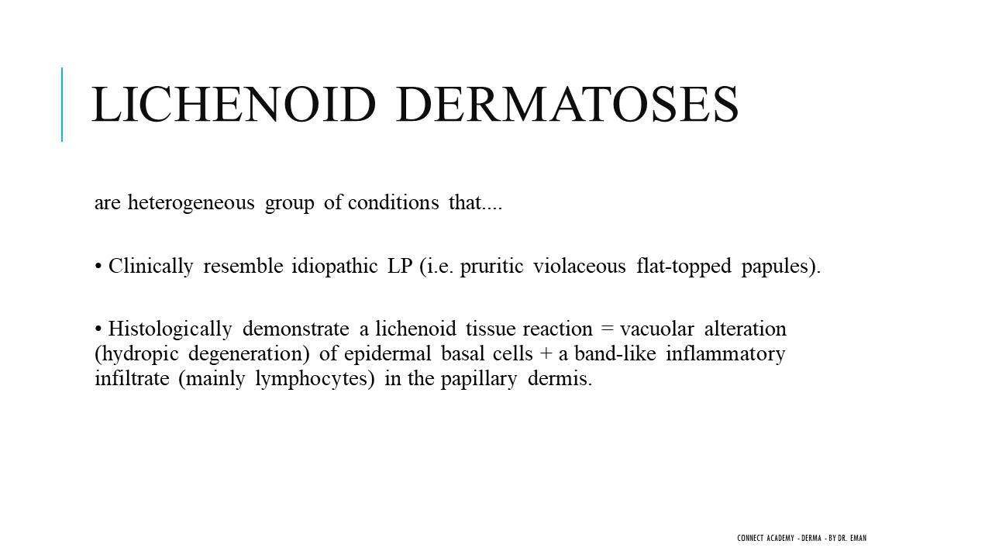

Key Concept: Spectrum Not Dichotomy
- These two patterns are a spectrum, not strict separate entities.
- Mild inflammation → lymphocytes remain perivascular (vacuolar pattern).
- Intense/increasing inflammation → lymphocytes become band-like (lichenoid pattern).
- Understanding this shared histopathology saves time: many diseases share the same BMZ destruction + lymphocytic infiltrate foundation.

Translated & Tidied Audio Transcript
Dr. Eman: Good morning doctors, how are you? Ramadan Kareem, may these blessed days return to us all, God willing.
Student: God is most generous, happy Ramadan to you too doctor.
Dr. Eman: Have you adjusted to the fasting schedule yet? I don't want anyone sleeping through Ramadan — we still need to study! Tell me, how is the revision going? Have you started doing practice questions yet?
Student: It's the start of Ramadan so we're still settling in.
Dr. Eman: Of course, everything stops in the first week of Ramadan. Does anyone have questions from previous lectures? Last time we finished Psoriasis and all the Papulosquamous diseases. Today we'll enter Lichenoid dermatoses and specifically Lichen planus.
Dr. Eman: What are the Lichenoid dermatoses? Last time we briefly touched on this when we discussed PLEVA and PLC. We talked about something called Vacuolar interface dermatitis. What does Interface dermatitis mean?
Dr. Eman: The Lichenoid dermatoses are a heterogeneous group of conditions that clinically resemble Lichen planus — pruritic, violaceous, flat-topped papules with variations. But histopathologically they share a common feature: the Lichenoid tissue reaction, which is vacuolar degeneration of the basement membrane plus a band-like lymphocytic inflammatory infiltrate in the dermis.
Dr. Eman: Interface dermatitis means the basement membrane is destroyed — vacuolar degeneration of the dermoepidermal junction — with inflammatory infiltrate. Based on the pattern of the inflammatory infiltrate, we divide interface dermatitis into two categories: Lichenoid interface dermatitis (band-like lymphocytes beneath the DEJ) or Vacuolar interface dermatitis (perivascular lymphocytes).
Dr. Eman: Don't get confused between the term 'vacuolar interface dermatitis' as a subtype, and the fact that interface dermatitis itself involves vacuolar degeneration. In lichenoid interface dermatitis, the infiltrate is band-like — lined up like a stripe beneath the DEJ. In vacuolar interface, it's perivascular. They used to classify them as two completely separate entities, but recent evidence shows they are actually one spectrum. When the inflammatory infiltrate is mild, it stays around blood vessels. When it becomes very intense, it forms a band-like pattern.
Dr. Eman: Under the band-like (lichenoid) group, anything with 'Lichen' in the name goes here: Lichen planus, Lichen striatus, Lichen nitidus, Lichenoid drug eruption. Under the vacuolar (perivascular) group: GVHD, PLEVA and PLC, Erythema multiforme, Connective tissue diseases like SLE and Dermatomyositis, Fixed drug eruption, Secondary syphilis, and Paraneoplastic pemphigus. These are diseases from completely different chapters, but they all share the same histopathology!
Student (Dr. Narges): Vacuolar interface dermatitis, doctor — which is vacuolar degeneration of the basement membrane and perivascular inflammatory infiltrate.
Dr. Eman: Exactly! This interface dermatitis classification is extremely important and will save you a lot of time. Imagine how many diseases are vacuolar interface dermatitis? So when you're studying SLE and remember it has BMZ destruction with perivascular infiltrate, you've already covered half its histopathology. And when you see a histopathology slide with vacuolar degeneration and lymphocytic infiltrate, you know it's interface dermatitis — now just narrow it down among these diseases.

2. Lichen Planus — Definition, Epidemiology & Etiopathogenesis

Summary

Definition
- Lichen planus (LP) = Idiopathic inflammatory disease affecting the skin, mucous membranes, hair, and nails.
- Name derivation: Lichen = papule; Planus = flat → flat-topped violaceous papules.
- Characterized clinically by the 7 Ps and histopathologically by dense band-like lymphocytic infiltrate with destruction of the basal cell layer (lichenoid interface dermatitis).
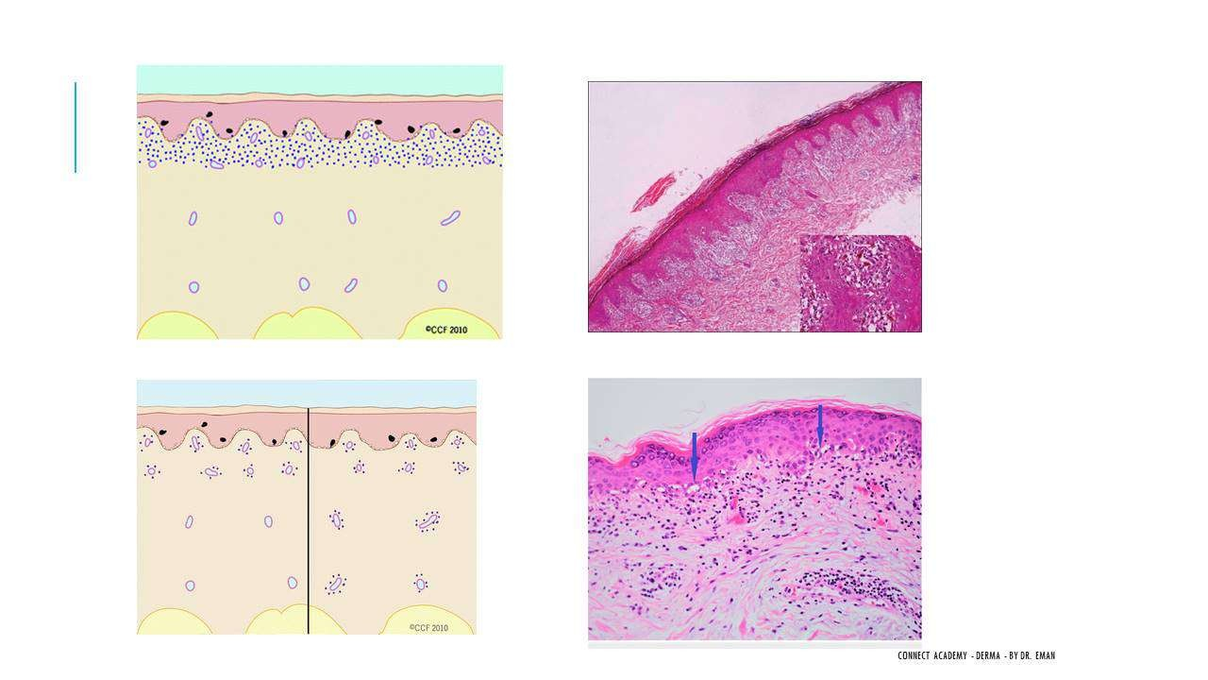

Epidemiology
- Worldwide prevalence: 0.2–1% of the adult population (cutaneous LP).
- Oral LP: 1–4% of the population.
- Age of onset: 5th–6th decade of life.

Etiopathogenesis
- Follows the standard model: Environmental trigger + Genetic susceptibility → Immune dysregulation → Disease.
- This is not a hereditary disease, but the patient must be genetically predisposed.

Environmental Triggers / Risk Factors
- Hepatitis C virus (most important — must screen all LP patients, especially in endemic areas).
- Drugs: antimalarials, D-penicillamine, diuretics (these cause Lichenoid drug eruption).
- Amalgam dental fillings (especially relevant for oral LP).

Immune Mechanism
- CD8+ cytotoxic T-cells attack and destroy basal keratinocytes.
- Same mechanism as Erythema multiforme (EM) and Toxic Epidermal Necrolysis (TEN), but LP is less severe.
- EM/TEN: same CD8+ cytotoxic attack but much more aggressive → complete separation of dermis and epidermis.
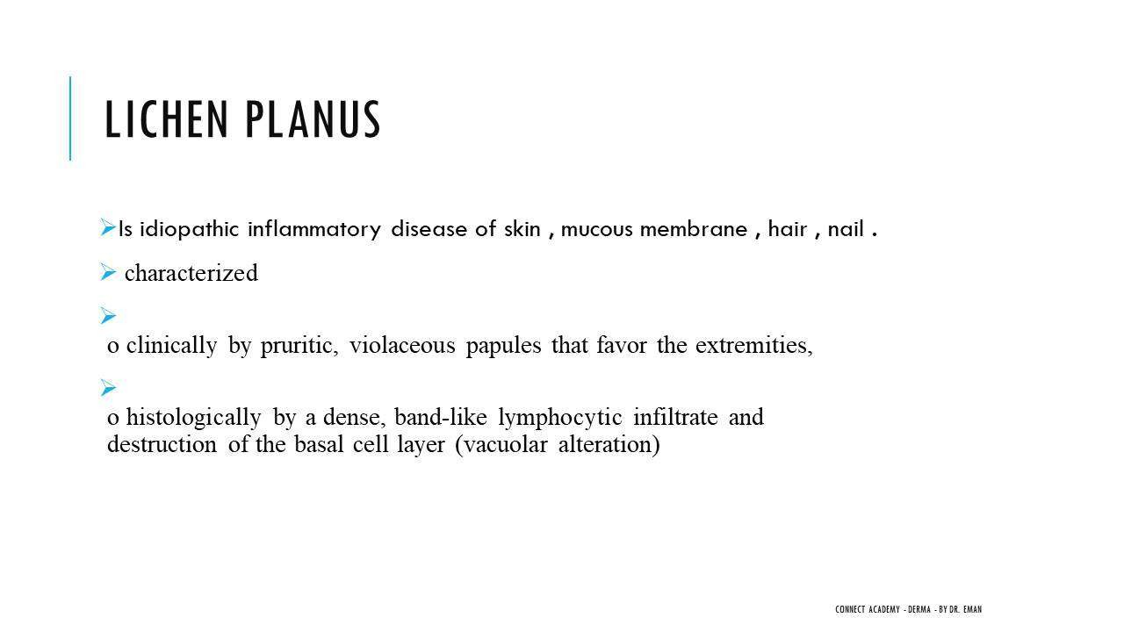

Associations
- Hepatitis C & B (risk factors).
- Liver disease, Diabetes mellitus.
- Autoimmune diseases: Alopecia areata, Vitiligo (LP itself is considered autoimmune, hence association with other autoimmune conditions).

Translated & Tidied Audio Transcript
Dr. Eman: Today's entire lecture will be about Lichen planus. From its name — Lichen means papule and Planus means flat. So it's a flat-topped violaceous papule. Lichen planus is an idiopathic inflammatory disease of the skin, mucous membranes, hair, and nails. Clinically characterized by the 7 Ps: pruritic, violaceous papules that favor the extremities. Histopathologically: dense band-like lymphocytic infiltrate and destruction of the basal cell layer — which is lichenoid interface dermatitis.
Dr. Eman: Have we all seen Lichen planus before? Anyone who has worked in dermatology will know it. We see violaceous, purple papules that are very itchy, commonly on the wrists and hands — those are the most characteristic sites.
Student: Hepatitis C.
Dr. Eman: Yes, Virus C. It's a risk factor. Are there other risk factors? We'll learn them now.
Dr. Eman: The epidemiology: cutaneous LP represents 0.2% to 1% of the adult population. Oral LP represents 1 to 4%. Age of onset is the 5th and 6th decade.
Dr. Eman: What causes Lichen planus? The same arrow diagram I showed you during Psoriasis — Environmental trigger in a genetically susceptible patient causes immune dysregulation, which manifests as disease. This is NOT hereditary — it means the patient is genetically predisposed, and when exposed to the environmental factor, immune problems develop and the disease appears.
Student: Sometimes it's associated with thyroid disease, maybe diabetes. The antidiabetic drugs...
Dr. Eman: Those are associations, not environmental factors. Since LP is an autoimmune disease, it associates with other autoimmune diseases. I'm asking about the environmental trigger specifically.
Dr. Eman: What's the immune dysregulation in LP? Is the problem in T-helper or T-cytotoxic cells?
Student: Probably cytotoxic.
Dr. Eman: Correct — CD8+ cytotoxic T-cells. Does anyone know another dermatological disease with the same mechanism?
Student: Toxic epidermal necrolysis.
Dr. Eman: Excellent! EM and TEN use the same mechanism. But of course in TEN it's much more aggressive — to the point where the dermis and epidermis completely separate from each other.

3. Clinical Features — The 7 Ps & Classification System

Summary

The 7 Ps of Classic Lichen Planus
- Papule
- Pruritic
- Polygonal
- Purple (violaceous)
- Planar (flat-topped)
- Polished (shiny surface)
- Plentiful
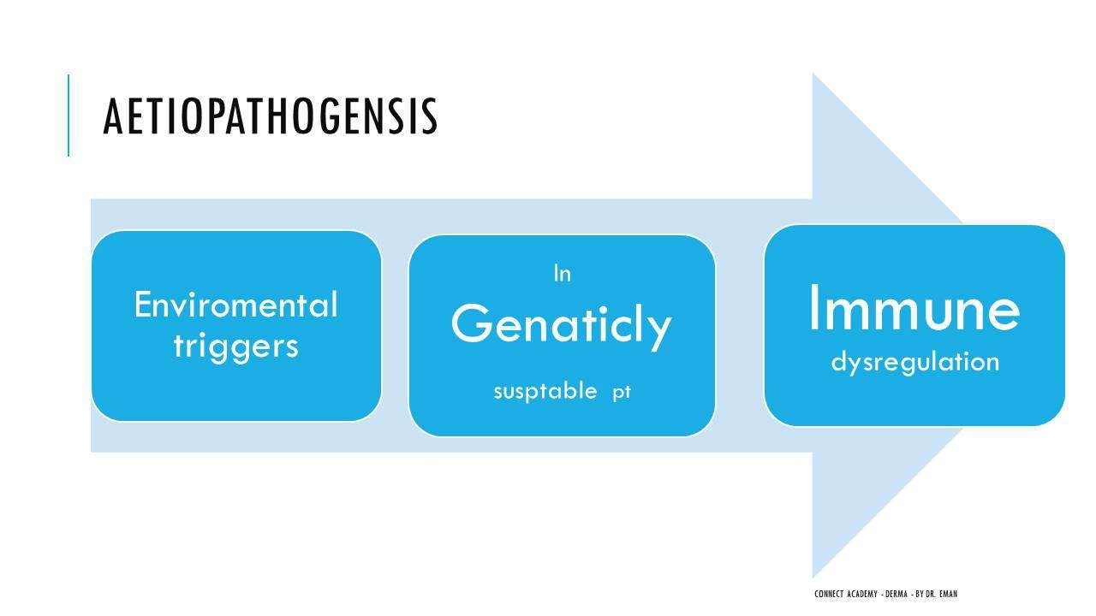

Wickham Striae
- Wickham striae = Whitish streaks on the surface of LP lesions.
- Best seen with dermoscopy (sometimes visible clinically).
- Caused by focal wedge-shaped hypergranulosis in the epidermis.

Most Characteristic Sites
- Flexor surfaces, especially the wrists and forearms.
- Dorsum of the hands.

Classification System: '4 Groups of 4' = 16 Variants Total
- Group 1 — By Site:
- Skin, Mucous membrane (oral/genital), Hair (Lichen planopilaris), Nail.
- Group 2 — Special Types:
- Actinic, Pigmented (LP Pigmentosus), Palmoplantar, Inverse.
- Group 3 — By Configuration:
- Annular, Linear, Ulcerative/Guttate.
- Group 4 — Pairs:
- Hypertrophic/Atrophic, Bullous LP/LP Pemphigoides, LP-LE Overlap, Eruptive.
- Important: In any LP case, always examine the oral cavity, hair, and nails — exam tip!
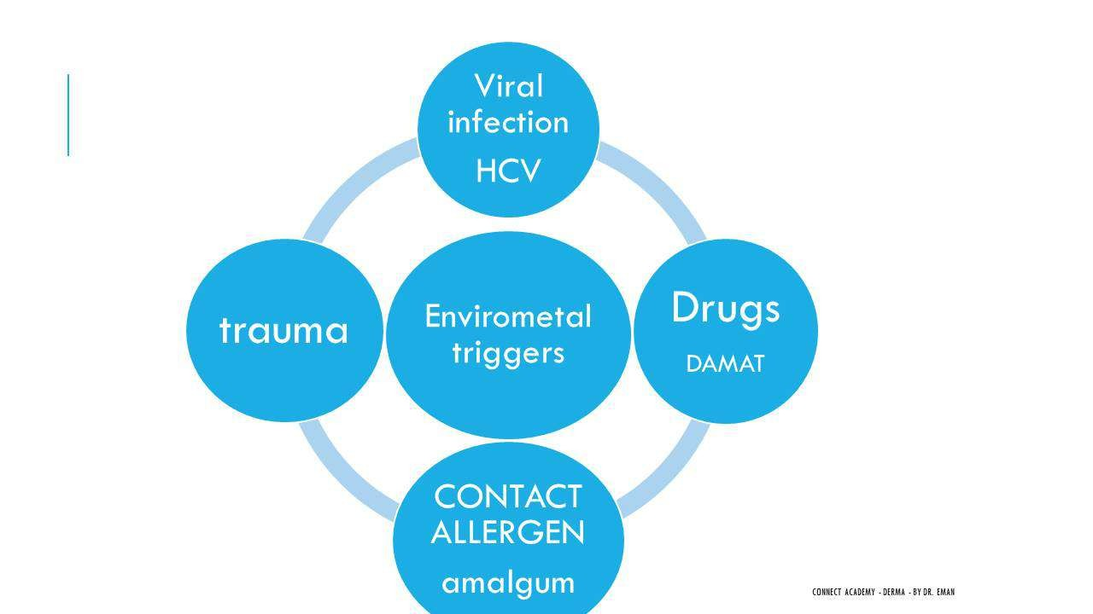

Translated & Tidied Audio Transcript
Dr. Eman: The clinical picture of classic Lichen planus: the 7 Ps. Papule, Pruritic, Polygonal, Purple, Planar, Polished, Plentiful. And there's no Wickham striae in the 7 Ps list — Wickham striae are whitish streaks on the lesion surface. We see them sometimes clinically, but more commonly with the dermoscope. The most characteristic site is the flexor surfaces — wrists, forearms, and dorsum of the hands.
Student: Doctor, regarding environmental factors — when a drug like a diuretic or antimalarial causes it, do you call this Lichen planus or Lichenoid drug eruption?
Dr. Eman: Drug-induced cases are Lichenoid drug eruption. The clinical presentation is different — it tends to be more generalized, affects older patients, and lacks Wickham striae. We'll discuss this at the end of the lecture.
Dr. Eman: How many variants of LP are there? Remember Psoriasis was 4, 7, 2, 8? Here it's 4 groups of 4 — so 16 types total. First group by site: Skin, Mucous membrane (oral or genital), Hair, and Nail. In any LP case you suspect, you MUST examine oral mucosa, hair, and nails. If you're in a clinical exam and don't check these, you've essentially failed the case.
Dr. Eman: Second group: Actinic, Pigmented, Palmoplantar, Inverse. Third group by configuration: Annular, Linear, Ulcerative/Guttate. Last group — pairs: Hypertrophic or Atrophic, Bullous LP or LP Pemphigoides, LP-LE Overlap, and Eruptive LP. So we have 16 types total. Note that each one is a separate variant — the pairs are four variants, not two.

4. Lichen Planus Variants — Mucosal, Hair & Nail

Summary

Oral Lichen Planus
- Three main forms: Erosive/Ulcerative (associated with HCV), Reticular (white lace-like lines), Leukoplakia (whitish patch/plaque).
- May be the only site of LP involvement.
- 50% of patients with cutaneous LP also have oral involvement.
- Differential diagnosis: Pemphigus vulgaris, Behçet's disease, Aphthous stomatitis.
- Risk of SCC (squamous cell carcinoma) — one of the highest-risk LP sites for malignancy.
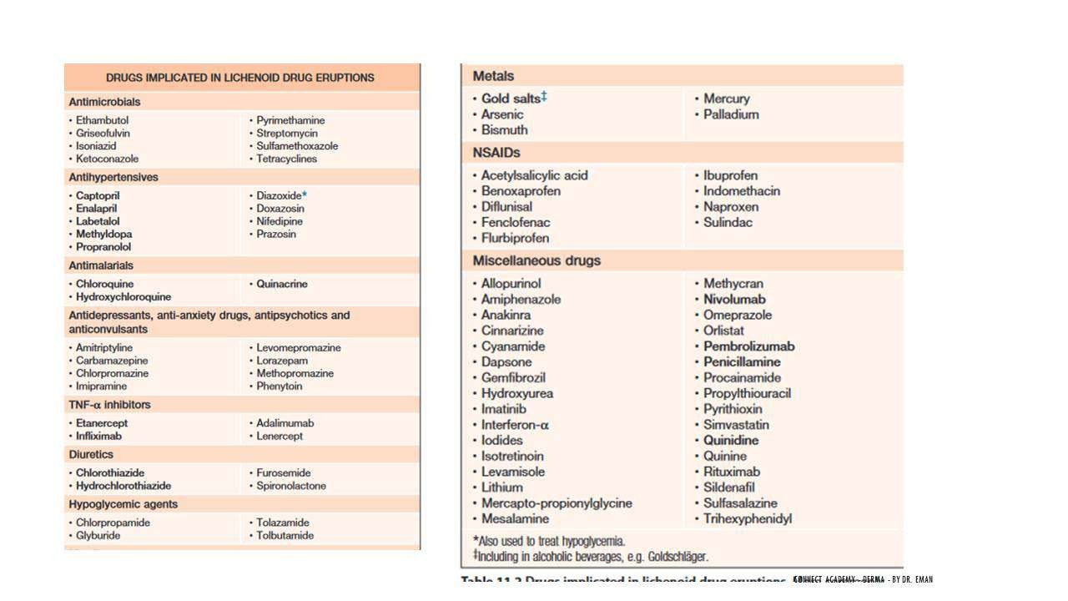

Genital Lichen Planus
- May occur alone or with oral/cutaneous LP.
- Glans penis: Annular violaceous papules; DDx: Syphilis.
- Vulvovaginal LP: Always erosive → scarring → dyspareunia → malignancy risk.
- Differential diagnosis: Lichen sclerosus et atrophicus, Cicatricial pemphigoid.
- Oral and genital LP carry the highest risk of SCC among all LP variants.

Lichen Planopilaris (Hair LP)
- LP affecting the hair follicle = Lichen planopilaris.
- Appearance: Keratotic plug surrounded by violaceous rim — characteristic even without dermoscopy.
- Causes lymphocytic cicatricial (scarring) alopecia.
- Perifollicular scale and hair casts visible on dermoscopy.
- Differential diagnosis: Discoid lupus erythematosus (also causes cicatricial alopecia on scalp).
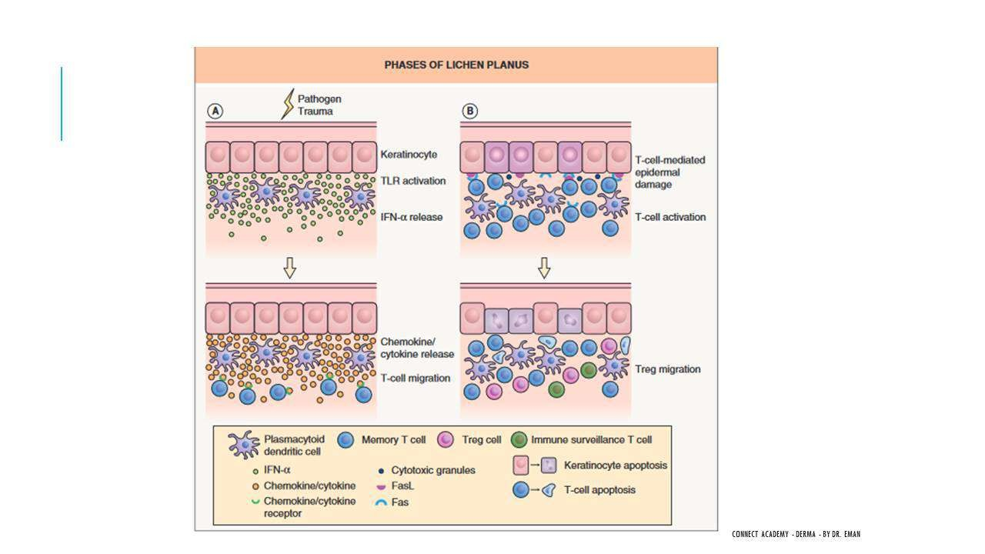

Variants of Lichen Planopilaris
- Frontal Fibrosing Alopecia (FFA):
- Recession of the frontal hairline.
- Predominantly affects postmenopausal females.
- More common in high socioeconomic groups.
- Suspected link to sunscreens and skin care products (no confirmed single cause).
- Skin-colored papules on forehead and chin may be present.
- Graham-Little Syndrome:
- Triad: Cicatricial alopecia of the scalp + Keratotic (spine-like) papules on skin + Non-cicatricial alopecia of body hair (axilla/groin).
- DDx of Graham-Little: Keratosis pilaris, Follicular mucinosis.

Nail Lichen Planus
- Longitudinal lines/striations — most characteristic and earliest sign (what you'll actually see clinically).
- Thinning and shedding of the nail plate.
- Pterygium (dorsal) — end-stage sign: dorsal nail fold adheres to nail bed after nail plate destruction.
- Twenty-nail dystrophy (all 20 nails affected) — specific to LP and atopic dermatitis.
- Melanonychia may occur.
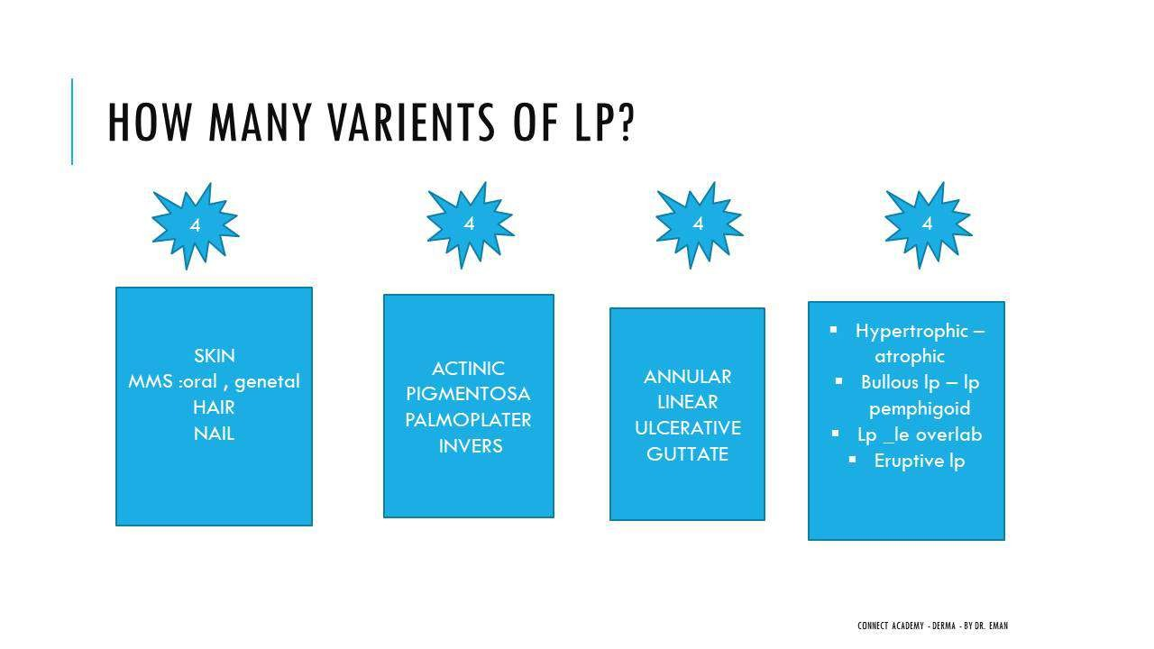

Translated & Tidied Audio Transcript
Dr. Eman: Let's start with Oral LP. It's one of the most important variants. I told you — if you see skin LP, you must examine the oral cavity. Oral LP comes in several forms: Erosive or Ulcerative (this one is always associated with Hepatitis C virus), Reticular (the white lines you can see), and Leukoplakia (whitish patch or plaque). It may be the only site of involvement, and 50% of cutaneous LP patients have oral involvement too.
Dr. Eman: The differential diagnosis for oral LP: Pemphigus vulgaris is the most important, then Behçet's disease, and Aphthous stomatitis.
Dr. Eman: Genital LP — it may occur alone or with oral or cutaneous disease. On the glans penis, you see annular violaceous papules. The DDx is syphilis. Vulvovaginal LP is always erosive, causes scarring, leads to dyspareunia, and ultimately carries malignancy risk. The sites with highest malignancy risk after LP are oral and genital. DDx: Lichen sclerosus et atrophicus and Cicatricial pemphigoid.
Dr. Eman: Hair LP is called Lichen planopilaris. It presents as a keratotic plug surrounded by a violaceous rim — this appearance is so characteristic you can diagnose it even before putting on the dermoscope. It causes cicatricial alopecia. The DDx is Discoid LE.
Dr. Eman: Frontal Fibrosing Alopecia is a variant of Lichen planopilaris. Who does it affect?
Student: Females, postmenopausal, high socioeconomic class.
Dr. Eman: Correct. The suspected cause is sunscreens and skin products — those in higher socioeconomic groups tend to use more of these products. But have they found a definitive cause? No, but this is the strongest association. There's regression of the forehead hairline with skin-colored papules on the forehead and chin.
Dr. Eman: The second variant is Graham-Little syndrome: cicatricial alopecia of the scalp plus keratotic spine-like papules on the skin plus non-cicatricial alopecia of body hair in the axilla and groin.
Dr. Eman: Now the nail. What's the appearance we see here?
Student: Pterygium.
Dr. Eman: Yes, pterygium. But does only pterygium occur? No! Pterygium is the end stage. First: thinning, shedding, and most importantly longitudinal lines — that's the most characteristic sign you'll actually see because patients come early. The pterygium is dorsal pterygium — the dorsal nail fold adheres to the nail bed after the nail plate is destroyed. Twenty-nail dystrophy is also specific to LP. Remember: longitudinal lines, pterygium, and twenty-nail dystrophy are the key nail findings.

5. Lichen Planus Variants — Skin Types

Summary

Actinic Lichen Planus
- Occurs on sun-exposed areas, especially the forehead above the eyebrows (most characteristic site).
- Appearance: Annular hyperpigmented lesion surrounded by a hypopigmented rim.
- Colour is violaceous/dark rather than brown (differentiates from melasma).
- NOT pruritic.
- Variants: Classic (annular), Melasma-like, Dyschromic.
- Differential diagnosis: Melasma.
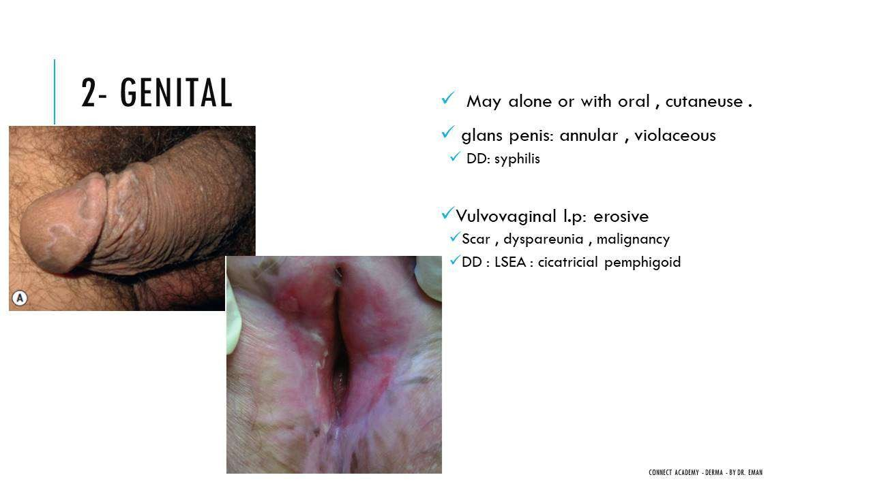

LP Pigmentosus
- Hyperpigmented LP appearing in both sun-exposed AND sun-protected areas (key difference from Actinic LP).
- IS pruritic (differentiates from Actinic LP which is non-pruritic).

Palmoplantar Lichen Planus
- Yellowish, firm papules/plaques surrounded by a violaceous rim — very characteristic.
- Non-itchy.
- Differential diagnosis: Syphilis, Psoriasis, Callosity, Warts.
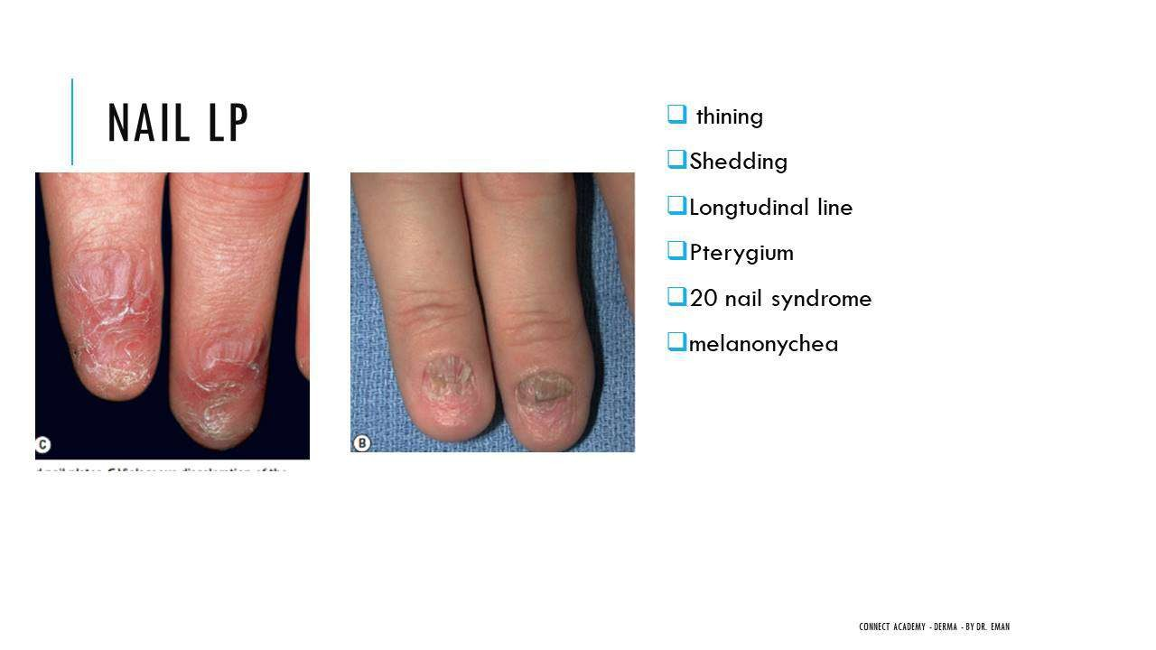

Inverse Lichen Planus
- Intertriginous areas: Axilla (more common) and groin.
- Pink to violaceous papules and plaques.
- DDx: LP Pigmentosus (because inverse LP heals with post-inflammatory hyperpigmentation, mimicking LP pigmentosus).

Annular Lichen Planus
- Most commonly found on the penis and axilla.

Linear Lichen Planus
- Follows Blaschko's lines or has a zosteriform distribution.
- Not truly dermatomal — follows embryological developmental lines.

Ulcerative Lichen Planus
- Characteristically on the sole of the foot.
- Risk of SCC (squamous cell carcinoma).

Hypertrophic Lichen Planus
- Location: Shin of the tibia (anterior lower leg).
- Highly pruritic and chronic.
- Risk of SCC with long-standing lesions.
- Differential diagnosis: Lichen simplex chronicus, Amyloidosis, Prurigo nodularis.
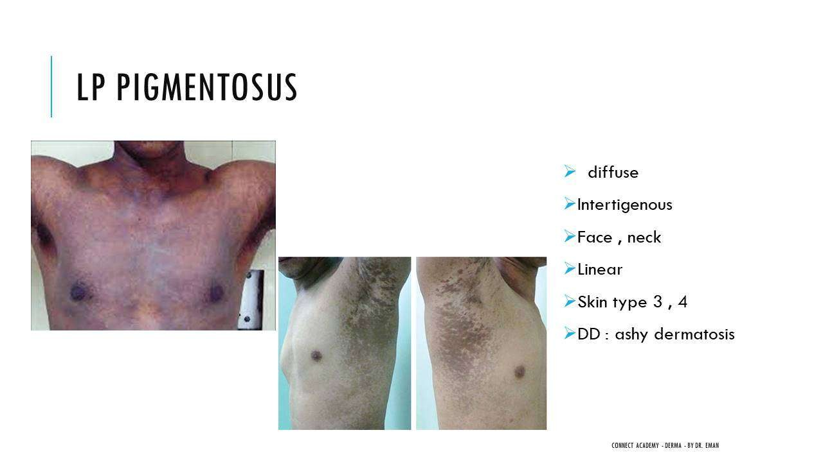

Why LP Leaves Persistent Hyperpigmentation
- BMZ destruction → melanocytes fall from the basal layer into the dermis.
- Melanocytes are engulfed by macrophages → melanophages.
- Melanophages persist indefinitely in the dermis → pigmentation does not fade easily.
- This explains why LP always leaves stubborn post-inflammatory hyperpigmentation.

Translated & Tidied Audio Transcript
Dr. Eman: Actinic LP — from its name, it appears on sun-exposed skin, mainly the face. It doesn't come as typical papules; rather you see pigmentation that looks violaceous, almost purple-black rather than brown like melasma. It's annular hyperpigmented surrounded by a hypopigmented rim. The most characteristic area is above the eyebrows. It is NOT pruritic. DDx: Melasma.
Dr. Eman: LP Pigmentosus is hyperpigmented LP that appears in both sun-exposed AND sun-protected areas. And it IS pruritic. That's how you differentiate it from Actinic LP — Actinic is non-pruritic and only sun-exposed; Pigmentosus is pruritic and involves both areas.
Dr. Eman: Palmoplantar LP — the most characteristic feature is yellowish papules with a rim of violaceous or hyperpigmentation around them. Yellowish, firm, non-itchy papules or plaques surrounded by a violaceous rim. Very characteristic and we see it frequently. DDx: Syphilis, Psoriasis, Callosity, Warts.
Dr. Eman: Inverse LP occurs in the axilla (more common) and groin — intertriginous areas. Pink to violaceous papules and plaques. The DDx is LP Pigmentosus — why? Because when inverse LP heals, it leaves hyperpigmentation. And LP always leaves hyperpigmentation. So when I see that residual hyperpigmentation in the axilla, is it LP Pigmentosus or post-inflammatory from resolved Inverse LP? That's why they're DDx of each other.
Dr. Eman: Now my question — why does LP leave such stubborn hyperpigmentation that barely fades?
Student: Because of degeneration — the melanocytes get deposited deep in the dermis.
Dr. Eman: Excellent! The basement membrane is destroyed, so melanocytes from the basal layer fall down into the dermis, get engulfed by macrophages — we call them melanophages — and these melanophages just sit there permanently. That's why the pigmentation is so persistent.
Dr. Eman: Annular LP is always on the penis and axilla. Linear LP follows Blaschko's lines or a zosteriform distribution — not truly dermatomal but linear along developmental lines. Ulcerative LP occurs on the sole and can cause SCC. Hypertrophic LP — elevated above the skin, on the shin of the tibia, highly pruritic, chronic, and can also cause SCC. DDx: Lichen simplex chronicus, Amyloidosis, Prurigo nodularis.

6. Bullous LP vs LP Pemphigoides & LP-LE Overlap

Summary

Bullous Lichen Planus
- Bullae develop ON existing LP lesions (the bullae are within the LP papules/plaques).
- Cause: Intense inflammatory infiltrate → severe BMZ destruction → Max Joseph space (cleft at DEJ) → fluid accumulates → bullae form.
- This is the same LP pathology, just more severe — no autoantibodies involved.
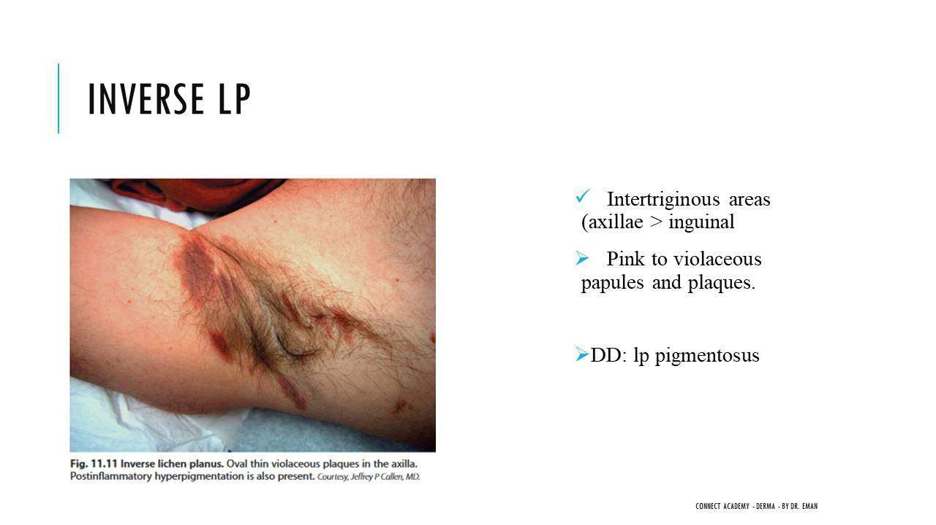

LP Pemphigoides
- Bullae develop on uninvolved (normal) skin — NOT on LP lesions.
- Cause: Autoantibodies (against BP antigen 2 / Collagen XVII) attack skin anywhere, independent of LP lesions.
- DIF (Direct Immunofluorescence) positive: IgG on uninvolved skin.
- Key differentiator: Bullous LP = bullae ON LP lesions; LP Pemphigoides = bullae on NORMAL skin.

LP-LE Overlap
- Features of both LP and Lupus Erythematosus combined.
- Appearance: Violaceous to erythematous patches/plaques with atrophy, mild scaling, and telangiectasia.
- Acral distribution (hands and feet).
- Oral lesions are common.

Eruptive Lichen Planus
- Generalized distribution.
- Tends to affect older patients.
- No Wickham striae (differentiates from classic LP).

Translated & Tidied Audio Transcript
Dr. Eman: Bullous LP versus LP Pemphigoides — who can tell me the difference?
Student: Bullous LP is the bullous variant — the pathology is still Lichen planus. The bullae arise from intense inflammation at the DEJ and Max Joseph space formation.
Dr. Eman: Exactly. The intense inflammatory infiltrate destroys the basal cell layer, causes separation — naturally when the dermis separates from the epidermis, a space forms (Max Joseph space), fills with fluid, and you get bullae. The key point: these bullae appear ON the Lichen planus lesions themselves.
Dr. Eman: LP Pemphigoides is different. Here autoantibodies against BP antigen 2 (Collagen XVII) attack the skin. The bullae appear on uninvolved skin — not necessarily where LP lesions exist. LP did its job destroying the BMZ, which then triggered autoantibody production, and these antibodies attack skin anywhere. DIF shows IgG on uninvolved skin.
Dr. Eman: LP-LE Overlap has features of both LP and Lupus erythematosus — violaceous to erythematous patches and plaques with atrophy, mild scaling, and telangiectasia, usually in an acral distribution. Oral lesions from LP are present alongside LE features.

7. Histopathology & Diagnosis

Summary

Histopathology Features of Lichen Planus
- Compact orthokeratosis — thickened stratum corneum with NO parakeratosis (therefore no significant clinical scaling).
- Focal wedge-shaped hypergranulosis — cause of Wickham striae; appears like 'eyes' beneath the stratum corneum.
- Irregular acanthosis with sawtooth appearance (not regular like psoriasis).
- Vacuolar degeneration of the BMZ — basement membrane zone destroyed.
- Max Joseph spaces — clefts at the DEJ from severe BMZ destruction; when filled with fluid → bullous LP.
- Band-like (lichenoid) lymphocytic infiltrate — dense infiltrate that obscures the DEJ.
- Melanophages in the upper dermis (explain persistent hyperpigmentation).
- Civatte bodies — apoptotic/dyskeratotic keratinocytes (dead keratinocytes from T-cell attack).
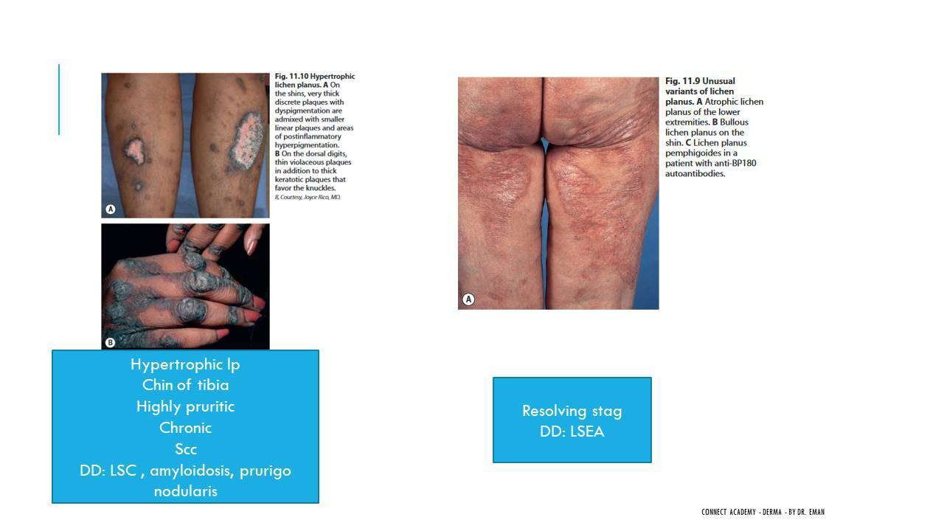

What Creates the Papule?
- The elevated papule results from: Inflammatory infiltrate below (pushing up) + Compact orthokeratosis above (thickened stratum corneum).

Direct Immunofluorescence (DIF)
- Linear fibrin deposits at the DEJ (from keratinocyte destruction).
- Globular IgM deposits below the DEJ (red dot-like pattern).

Dermoscopy
- Wickham striae = whitish streaks on a violaceous/erythematous background.
- Very characteristic and highly visible under dermoscopy.
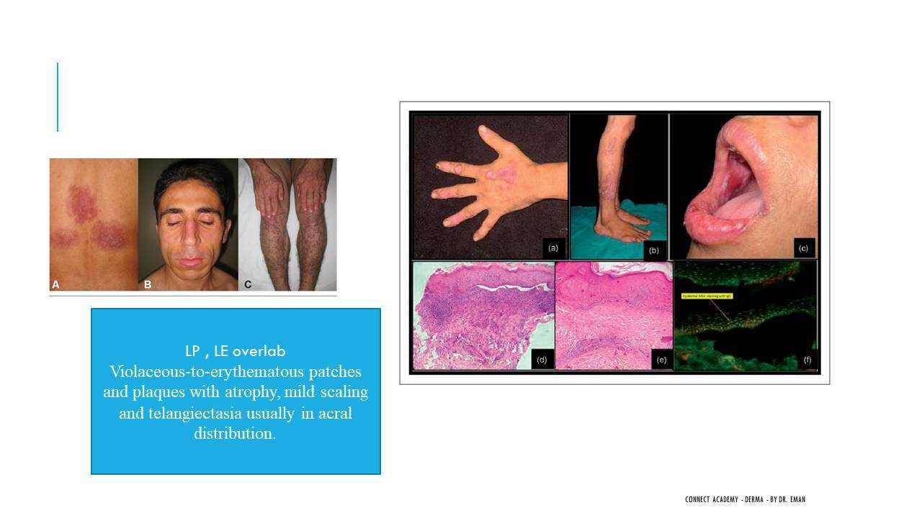

Translated & Tidied Audio Transcript
Dr. Eman: The histopathology of LP. Look at how dissolved this looks — there's barely a basement membrane left from all the destruction. First: vacuolar degeneration of the BMZ, plus the inflammatory infiltrate — see how dense it is? Band-like inflammatory infiltrate.
Dr. Eman: Where does the papule come from? The papule elevation comes from the inflammatory infiltrate pushing up from below and the compact orthokeratosis thickening above. Important: compact orthokeratosis with NO parakeratosis. Underline this 100 times — no parakeratosis! What does this mean clinically? It means no significant scaling in LP. Correct?
Dr. Eman: Then there's focal hypergranulosis in a wedge shape — very characteristic of LP. It looks like eyes beneath the stratum corneum. And this is what causes the Wickham striae! The whitish streaks we see clinically and on dermoscopy are caused by this focal hypergranulosis.
Dr. Eman: Irregular acanthosis with a sawtooth appearance — not regular like psoriasis, but irregular jagged projections. Vacuolar degeneration of the BMZ. Max Joseph spaces — when the infiltrate destroys the BMZ severely, separation occurs and clefts form at the DEJ. If these fill with fluid, that's what gives you bullous LP.
Dr. Eman: Band-like lymphocytic infiltrate. Melanophages — the melanocytes that fell into the dermis and were engulfed by macrophages. And Civatte bodies — these are dyskeratotic (apoptotic) keratinocytes. The keratinocytes die from the T-cell attack and form these Civatte bodies.
Dr. Eman: Direct immunofluorescence in LP shows linear fibrin deposits at the DEJ — from keratinocyte destruction releasing fibrin. And globular IgM deposits below the DEJ — those red dots you see. You must know this for the exam.
Dr. Eman: Dermoscopy — the Wickham striae I've been telling you about all morning. Whitish streaks dividing the papules. You put the dermatoscope on and they light up in your field of view. So LP dermoscopy = Wickham striae = whitish streaks on an erythematous or violaceous background.

8. Treatment

Summary

General Measures
- Exclude risk factors: amalgam dental fillings, causative drugs, screen for HCV (mandatory, especially in endemic areas like Egypt).
- Screen for Hepatitis C and B.
- Antihistamines for pruritus (LP is inherently pruritic).

Topical Treatment
- Potent/superpotent topical corticosteroids — first-line treatment (e.g., Betamethasone valerate / Betnovate).
- Can be used under occlusion for enhanced efficacy.
- Topical calcineurin inhibitors (Tacrolimus/Pimecrolimus) — for areas unsuitable for long-term steroids (face, genitals, oral mucosa).
- Inhaled corticosteroids — for oral LP.
- Intralesional corticosteroid injection (rarely needed as topical steroids work very well for LP).

Systemic Treatment
- Prednisolone 20 mg/day for 2–6 weeks (lower dose than the usual 0.5–1 mg/kg used for other conditions).
- Metronidazole (Flagyl) — newer treatment, effective.
- Griseofulvin — also used effectively.
- Antimalarials — paradoxically can both treat LP AND cause Lichenoid drug eruption.
- Systemic retinoids (Acitretin) — less commonly used.

Phototherapy
- Narrowband UVB — for resistant/long-standing cases.
- Especially useful when LP coexists with HCV (avoids systemic immunosuppression).

Biologics & New Agents
- Basiliximab (anti-IL-2 / IL-2 antagonist) — newest biologic for LP; appears in SCE questions.
- Apremilast (Otezla) — PDE4 (phosphodiesterase 4) inhibitor; anti-inflammatory used in psoriasis and LP.
- JAK inhibitors (Tofacitinib, Upadacitinib) — not first-line for LP but may appear in questions; FDA-approved for Alopecia areata and Vitiligo.
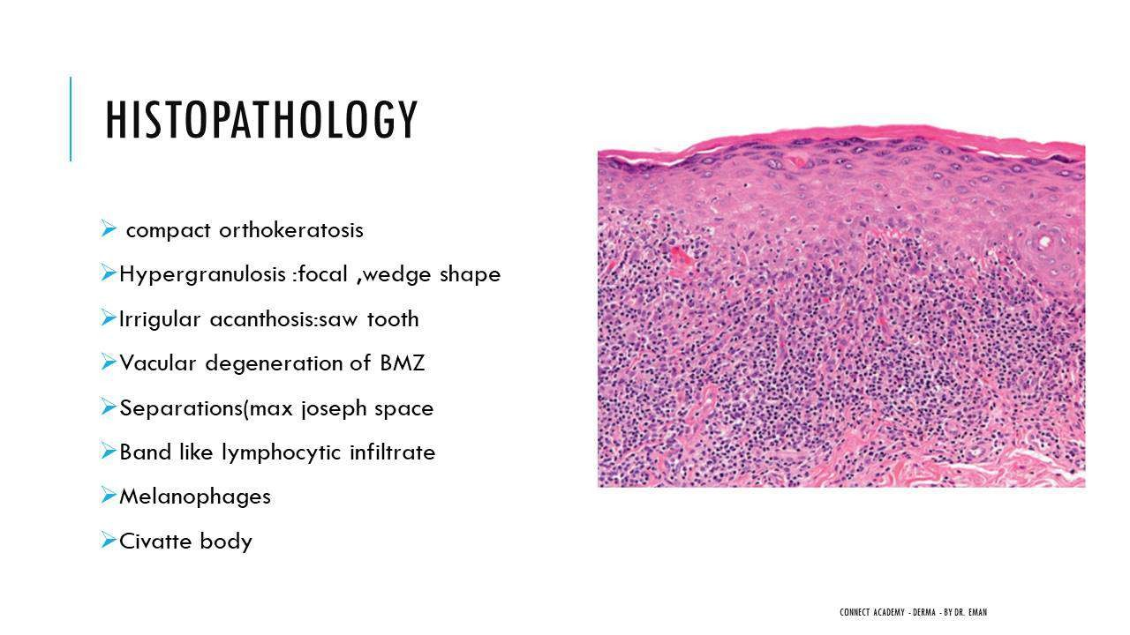

LP with Hepatitis C
- Treat the HCV (antiviral therapy) + Narrowband UVB for the LP.
- Be cautious with systemic corticosteroids in HCV patients.

Translated & Tidied Audio Transcript
Student: Topical corticosteroids.
Dr. Eman: Exactly — that's the first line. Topical, but give potent steroids appropriate to the site. The most important. Second: topical calcineurin inhibitors for areas where you can't give steroids. Then of course systemic steroids.
Dr. Eman: Let me organize the treatment for you systematically. First: general measures. You must look for risk factors — does the patient have amalgam dental fillings? Are they taking any causative drugs? You absolutely must screen for Hepatitis C, especially in Egypt where HCV was so prevalent. No LP case should pass without checking HCV — and you can add HBV screening too. Give antihistamines for the pruritus since LP is inherently itchy.
Dr. Eman: Topical: steroids are essential — topical or intralesional, but topical is the mainstay. For oral LP, we use inhaled steroids. Tacrolimus for areas unsuitable for steroids. Systemic: steroids — the dose for LP is usually 20 mg per day for 2 to 6 weeks. That's lower than the usual 0.5 to 1 mg/kg. Metronidazole and Griseofulvin are both effective newer options. Antimalarials can be used despite also being a potential cause of lichenoid drug eruption — it's a paradox.
Dr. Eman: Phototherapy — narrowband UVB for resistant, long-standing cases. If you have LP with Hepatitis C, treat the virus and give narrowband UVB. Be careful with steroids in HCV patients.
Dr. Eman: Now for biologics — what's the newest one for LP?
Student: Anti-TNF?
Dr. Eman: No — it's Basiliximab, which targets Interleukin-2. Write this down because it appears in SCE questions. Basiliximab against IL-2 — the newest treatment for LP. Then there's Apremilast (Otezla), a PDE4 inhibitor — anti-inflammatory used in psoriasis, LP, and other autoimmune conditions. And JAK inhibitors like Tofacitinib — not first-line for LP but useful for Alopecia areata and Vitiligo. They can appear in exam questions as immunomodulators applicable across multiple conditions.
Student: What is the duration of treatment? For how long do you treat, especially oral treatments like Prednisolone?
Dr. Eman: Clinically, I give patients treatment for a maximum of 6 weeks to 2 months, with follow-up every 2 weeks. The textbooks don't specify a maximum endpoint — it's according to clinical response, risk factors, and side effects. If you're giving oral steroids, consider the dose, whether the patient is diabetic, has HCV, or other comorbidities.

9. Complications & Prognosis

Summary

Complications by Site
- Skin: Post-inflammatory hyperpigmentation (persistent due to melanophages), scarring, atrophy.
- Mucosa: Scarring, stenosis, SCC (especially oral and genital).
- Hair: Cicatricial (permanent, scarring) alopecia.
- Nail: Permanent damage — pterygium (irreversible).
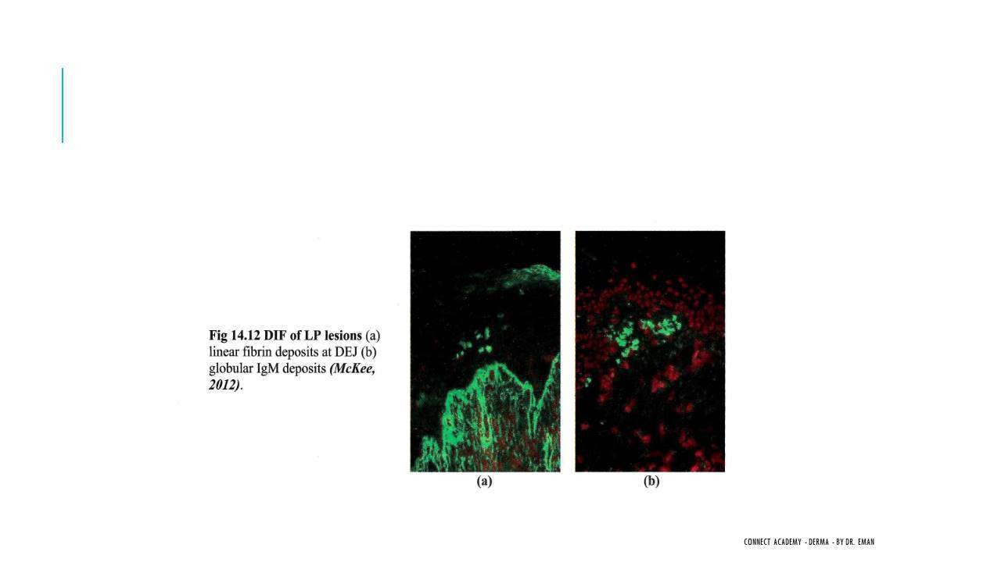

SCC Risk
- Highest risk: Oral LP and Genital LP (especially vulvovaginal).
- Also elevated with: Ulcerative LP (sole) and Hypertrophic LP (shin).

Prognosis
- LP is NOT a chronic disease like psoriasis.
- Responds well to treatment and can resolve completely.
- Especially good prognosis when risk factors are identified and addressed.
- May recur but is NOT typically a lifelong condition requiring indefinite treatment.

Translated & Tidied Audio Transcript
Dr. Eman: Complications of LP. We've been saying it repeatedly — this type causes SCC, that type causes SCC. SCC is very important, especially with oral and genital LP. What else? In the skin: post-inflammatory hyperpigmentation (which I've explained why it persists), scarring, and atrophy. In the mucosa: scarring and stenosis. In hair: cicatricial alopecia — that's permanent. In nails: permanent damage — the pterygium I showed you.
Dr. Eman: Associations — important for the exam: Hepatitis C and B (risk factors), liver disease, diabetes mellitus, and autoimmune diseases like Alopecia areata and Vitiligo. LP itself is considered autoimmune, which is why it associates with other autoimmune conditions.
Student: I've seen LP go on and off, improving then relapsing. Is it a chronic disease?
Dr. Eman: We need to search for the cause. LP is NOT a chronic disease in the same way psoriasis is. It's not something where the patient will be on treatment for life. LP responds well to treatment, improves, and can completely resolve. We look for the risk factor, address it, and the disease goes away. Can it recur? Possibly, but it's not like psoriasis where you're managing it forever. From our clinical experience, we see LP very frequently, and it does improve and may not come back.
Student: Thank you, doctor.
Dr. Eman: You're welcome. Is the material making sense to everyone? Dermatology requires studying, and we all need to put in the work. That's it for today's lecture — I hope it was easy and enjoyable. Any questions? May everyone have a blessed Ramadan.

Lecture 8: Other Lichenoid Dermatoses

1. Lichen Nitidus

Summary

Definition & Clinical Features
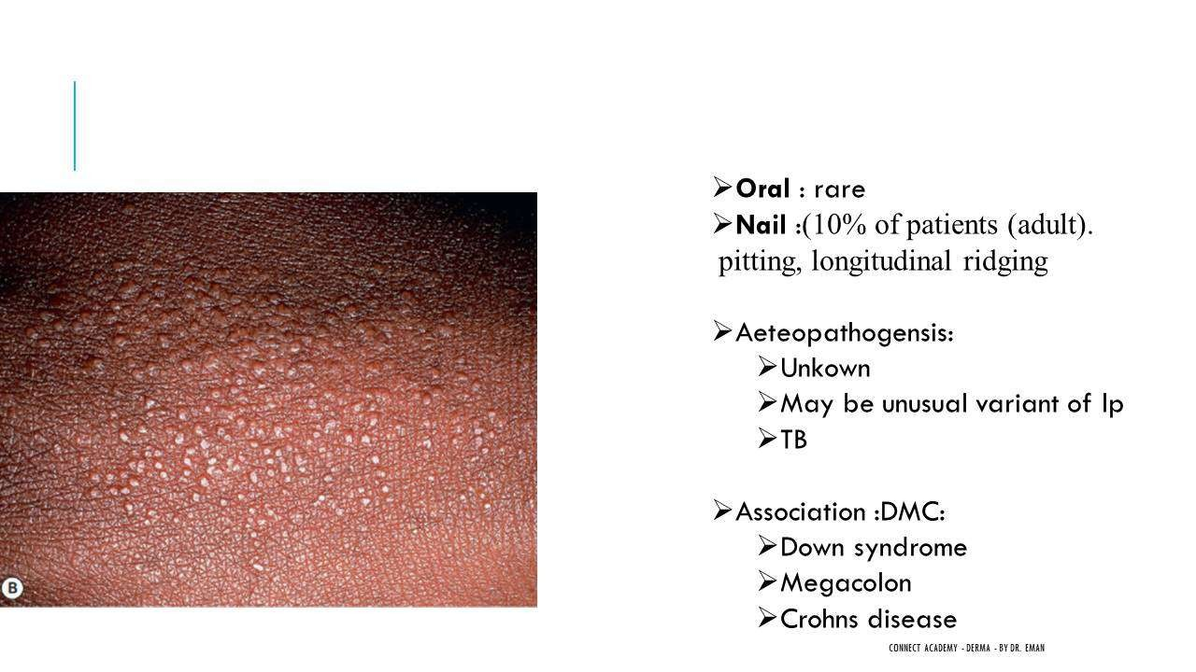
- Lichen Nitidus = Multiple tiny, discrete, skin-colored, dome-shaped, asymptomatic papules.
- Most common site: Dorsum of the hand, upper extremities, flexors, genitalia.
- More common in children and young adults, especially females.
- The papules are pinpoint-sized and skin-colored (not violaceous like LP).

Variants
- Classic (most common)
- Palmoplantar
- Linear
- Follicular
- Generalized
- Perforating

Etiopathogenesis
- Etiology is unknown/debated.
- Theory 1: May be an unusual variant of Lichen planus.
- Theory 2: May be related to tuberculosis (TB) — because the histopathology shows tuberculoid granuloma formation.
- A tuberculoid granuloma = well-circumscribed dermal infiltrate of epithelioid histiocytes surrounded by lymphocytes.

Histopathology — "Ball and Claw Appearance"
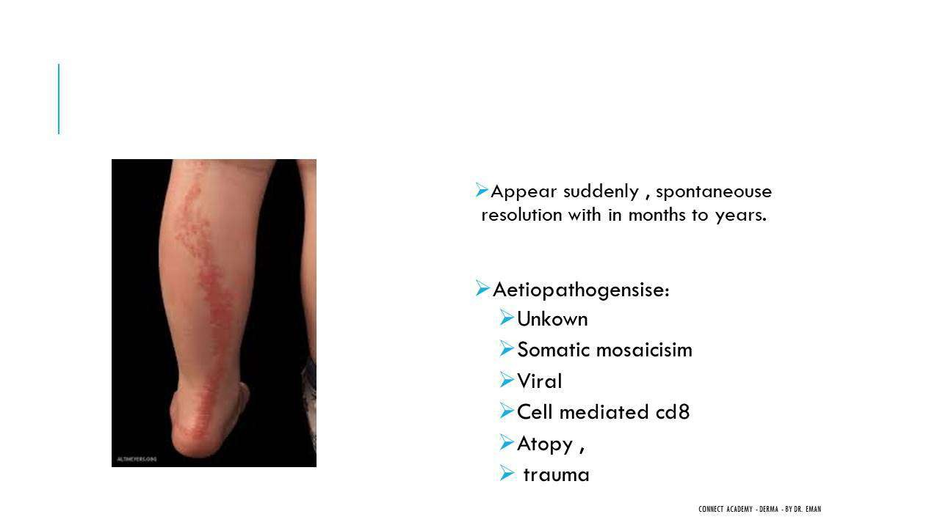
- "Ball and claw appearance" = pathognomonic histological finding.
- The "Ball" = Well-circumscribed dermal infiltrate of epithelioid histiocytes + lymphocytes (granuloma), confined to the width of a single dermal papilla.
- The "Claw" = Elongated rete ridges (dermal papillae) flanking and gripping the granuloma like claws holding a ball.
- Also shows: Lichenoid interface dermatitis + Epidermal atrophy (unlike LP which has acanthosis).
- Parakeratosis is common (vs rare in LP).
- Granular cell layer is thin to absent (vs focally increased in LP).

Nail & Oral Involvement
- Nail involvement: 10% of patients — pitting and longitudinal ridging.
- Key difference from LP: LP has longitudinal ridging and pterygium but NO pitting; Lichen Nitidus has pitting.
- Oral involvement: Very rare.

Associations — Mnemonic "DMC"
- D = Down syndrome
- M = Megacolon
- C = Crohn's disease

Lymphocytes
- Lymphocytes in Lichen Nitidus are CD4+.
- Key difference: LP lymphocytes are CD8+.

Differential Diagnosis
- Plane warts (flat warts) — most important DDx.
- Frictional lichenoid dermatitis.

Treatment
- Usually no treatment needed — asymptomatic and self-limited.
- If symptomatic: Topical steroids, emollients, antihistamines.
- Spontaneous clearing occurs.

Key Differences from Lichen Planus (Summary Table)
- Size: Pinpoint (LN) vs Pinhead to large plaques (LP).
- Color: Skin-colored (LN) vs Violaceous (LP).
- Wickham striae: Absent (LN) vs Present (LP) — because LN has no hypergranulosis.
- Post-inflammatory hyperpigmentation: None (LN) vs Present (LP).
- Histology — Epidermis: Epidermal atrophy (LN) vs Acanthosis (LP).
- Histology — Dermal infiltrate: Granuloma present (LN) vs No granuloma (LP).
- Histology — Parakeratosis: Common (LN) vs Rare (LP).
- Lymphocytes: CD4+ (LN) vs CD8+ (LP).
- DIF — Fibrin deposition: Absent (LN) vs Present/shaggy fibrinogen (LP).
- Koebner phenomenon: Common in both.
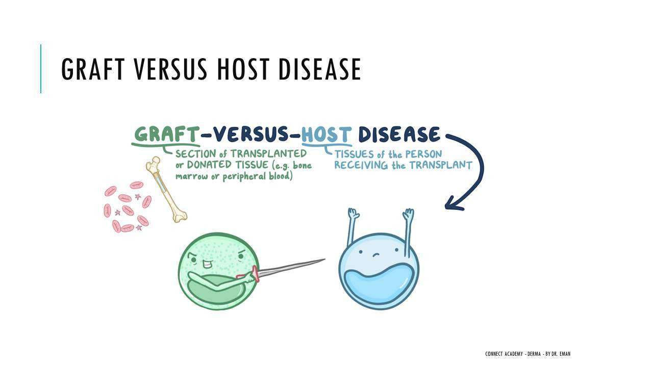

Translated & Tidied Audio Transcript
Dr. Eman: Good morning doctors, how are you all? How is the studying going? Let me check in with everyone. Have you started solving questions yet?
Student (Dr. Naima): Good morning Dr. Eman. I've started reading the first lectures to connect the new material with the old, thank God.
Dr. Eman: The first two lectures are genuinely difficult — they're like a compilation of the entire dermatology base. Try to listen to them multiple times. But the remaining lectures are easier because each one discusses a separate topic — you'll understand the disease and that's it.
Student (Dr. Naima): That's what I'm doing — I listen to them almost every day. With work and Ramadan I'm trying to push myself to listen to a section and read it simultaneously.
Dr. Eman: Excellent, and try to incorporate question-solving too. You must start solving questions because solving is part of studying — it's not just reviewing information you've already learned, there's also new information in the questions themselves.
Student (Dr. Doaa): I'm doing well, thank God. It's Ramadan and time is short, but I feel I'm getting into the mood a bit.
Dr. Eman: May God make it easy for everyone. Let's begin today's lecture. We finished Psoriasis, Other Papulosquamous diseases, and Lichen Planus. Today we'll finish the Other Lichenoid Dermatoses — it should be a light and pleasant lecture, God willing.
Dr. Eman: Last time we finished all of Lichen Planus. We said there are many diseases under the umbrella of Interface dermatitis. There are two types of interface dermatitis — who can tell me what Interface dermatitis means and what are its two types?
Student: Degeneration of the basement membrane.
Dr. Eman: Yes, degeneration of the basement membrane. What are the two types?
Student: Lichenoid and Vacuolar.
Dr. Eman: The Lichenoid type is a band-like inflammatory infiltrate of lymphocytes beneath the dermoepidermal junction. Diseases in this category include: Lichen planus, Lichen nitidus, Lichen striatus, and Lichenoid drug eruption. The Vacuolar interface dermatitis includes: Erythema multiforme, SLE, Dermatomyositis, Fixed drug eruption, and Graft-versus-host disease. This is very important because it encompasses diseases from many different chapters.
Dr. Eman: Let's start with Lichen Nitidus. It's quite different from Lichen planus. It presents as multiple tiny discrete skin-colored papules, as you can see on the hand here. It comes mainly on the dorsum of the hand. Will this confuse us with Lichen planus? No — it looks distinctly different. It's asymptomatic, tiny, discrete, dome-shaped, skin-colored papules on the dorsum of the hand and elbows, more common in children and young adults, more common in females.
Dr. Eman: The most common sites are the dorsal aspect of the hand, upper extremities, flexors, and genitalia. It has variants: the classic form we're seeing, plus palmoplantar, linear, follicular, generalized, and perforating.
Dr. Eman: Now what is Lichen Nitidus pathologically? Part of it — because it's a 'Lichen' — will have interface dermatitis and band-like inflammatory infiltrate. But they also found something unusual in its pathology: the shape of a Granuloma. A granuloma is a collection of histiocytes with lymphocytes around them.
Dr. Eman: That's why there's debate about Lichen Nitidus — some say it's a rare variant of LP, and others say it's related to TB. Why TB? Because it forms a Tuberculoid granuloma: a well-circumscribed dermal infiltrate of epithelioid histiocytes and lymphocytes.
Dr. Eman: The pathology of Lichen Nitidus is very specific and recognizable — we call it the "Ball and claw appearance." The ball is the granuloma collection surrounded by dermal papillae (the claws). Like a ball being held by claws. The ball is the well-circumscribed dermal infiltrate of epithelioid histiocytes and lymphocytes. There's also lichenoid interface dermatitis and epidermal atrophy — unlike LP which has acanthosis.
Dr. Eman: Does it have oral lesions? Very rare. Nail involvement? Yes, 10% of patients have nail abnormalities like pitting and longitudinal ridging. Remember: LP had longitudinal ridging but NO pitting. Lichen Nitidus HAS pitting.
Dr. Eman: The associations of Lichen Nitidus — memorize them with the mnemonic DMC: Down syndrome, Megacolon, and Crohn's disease. Most cases I've seen were normal with no associations, but you must know DMC for the exam.
Dr. Eman: The differential diagnosis — what could this look like? Plane warts (flat warts) are the number one DDx. Also frictional lichenoid dermatitis.
Dr. Eman: The histopathology — what's the key word?
Student: Ball and claw.
Dr. Eman: Ball and claw. Ball from the Granuloma (epithelioid histiocytes with lymphocytes), plus lichenoid interface dermatitis and epidermal atrophy. This is extremely important — the pathology of Lichen Nitidus is very high-yield.
Dr. Eman: Treatment? No treatment needed — it's asymptomatic. If needed: topical steroids, emollient, antihistamines if itchy. Spontaneous clearing occurs.
Dr. Eman: Now here's a comparison table between Lichen Nitidus and Lichen Planus. Size: LN is pinpoint, LP is pinhead to large plaques. Color: LN is skin-colored, LP is violaceous. Distribution: LN favors upper extremities, flexors, genitalia, chest; LP favors wrists, forearms, peri-sacral area. Oral involvement: LN very rare, LP common — over 50%. Nail: LN has pitting (5-10%), LP does NOT have pitting.
Dr. Eman: Wickham striae — will we see them in LN? No. Why do we see them in LP? Because of the focal hypergranulosis. Hyperpigmentation after healing — does LN leave it? No. LP leaves it because of basement membrane damage causing melanocytes to fall into the dermis as melanophages.
Dr. Eman: Histopathology: Parakeratosis is common in LN but rare in LP. Granular cell layer is thin to absent in LN but focally increased in LP. Dermal infiltrate in LN is lymphocytes + epithelioid cells = granuloma! LP has no granuloma — just band-like lymphocytes. In LN the infiltrate is confined to the width of dermal papillae (the ball in the claws), in LP it's a band. Fibrin deposition: absent in LN, present in LP (shaggy fibrinogen on DIF).
Dr. Eman: The lymphocytes in Lichen Nitidus are CD4+. In Lichen Planus they were CD8+.

2. Lichen Striatus

Summary

Definition & Clinical Features
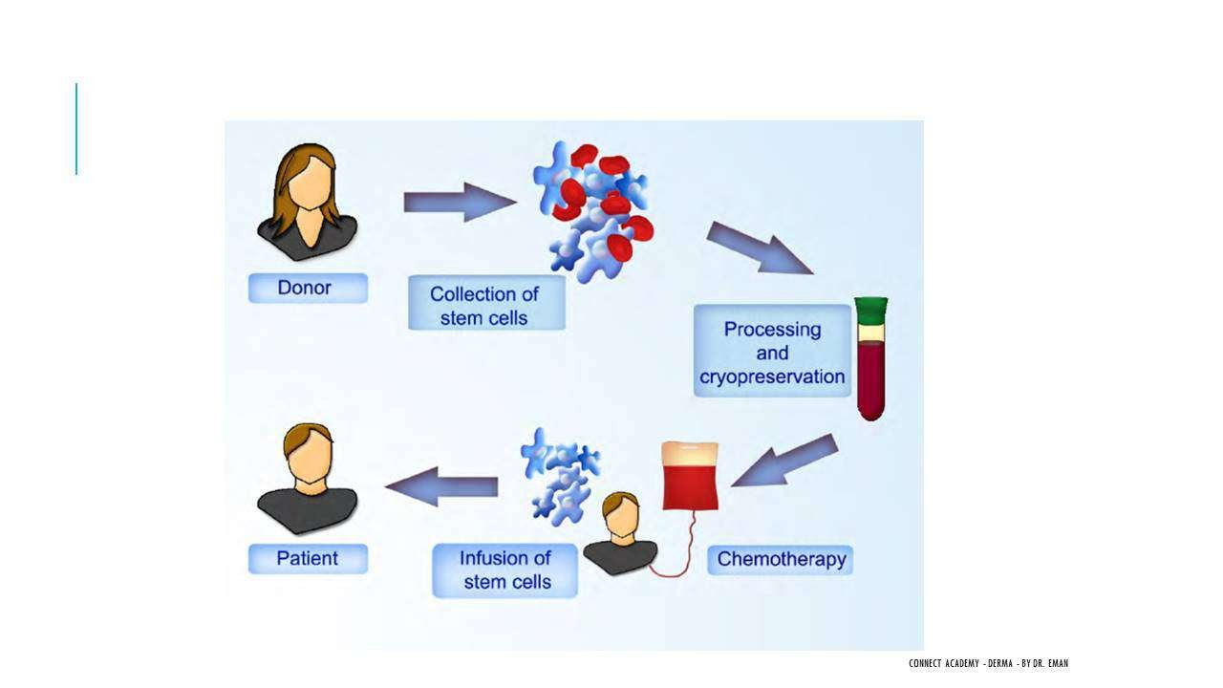
- Lichen Striatus = Uncommon, asymptomatic, self-limited linear dermatosis following Blaschko's lines.
- Appearance: Pink/erythematous lichenoid papules in a linear, unilateral distribution, mainly on extremities.
- More common in children and females.
- Seasonal predilection: Spring and Summer (supports viral infection theory).
- Heals with hypopigmentation (NOT hyperpigmentation like LP).
- Spontaneous resolution within 6 months to years.

Etiopathogenesis (Theories)
- Somatic mosaicism — different cell populations along Blaschko's lines.
- Viral infection — supported by seasonal increase in spring/summer.
- Cell-mediated CD8+ response.
- Atopy.
- Trauma / Koebnerization.

Histopathology
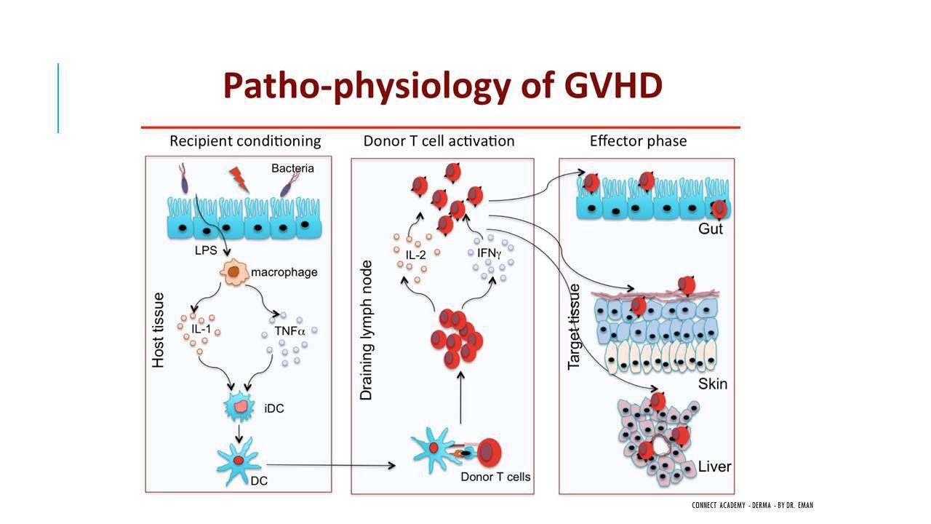
- Eczema-like features in early stages: acanthosis, spongiosis, exocytosis.
- Vacuolar interface dermatitis also present.
- KEY DISTINGUISHING FEATURE: Inflammatory infiltrate around hair follicles and eccrine sweat glands.
- This perifollicular and periadnexal infiltrate differentiates Lichen Striatus from simple eczema or vacuolar interface dermatitis alone.

Differential Diagnosis
- Linear Lichen Planus — older age, pruritic, heals with hyperpigmentation (vs LS: younger, asymptomatic, heals with hypopigmentation).
- Linear GVHD.
- Blaschkitis (inflammation along Blaschko's lines).
- ILVEN (Inflammatory Linear Verrucous Epidermal Nevus) — most similar to Lichen Striatus.

Treatment
- No treatment needed — asymptomatic and self-resolving (resolves within 6 months).

Translated & Tidied Audio Transcript
Dr. Eman: Now we'll move to a completely different topic: Lichen Striatus. It presents as a linear dermatosis — erythematous papules following Blaschko's lines or a linear pattern.
Dr. Eman: Some people classified it as a type of eczema. Others said it might be caused by viral infection because it increases in summer and spring. Some proposed somatic mosaicism. Others suggested Koebnerization or trauma. All these theories exist because the exact cause is unknown.
Dr. Eman: Lichen Striatus is an uncommon, asymptomatic, self-limited disease. A streak of erythematous papules appears in a linear pattern, stays for a while, then heals with hypopigmentation. It's an asymptomatic streak of pink lichenoid papules that's unilateral, on the extremities, along Blaschko's lines.
Dr. Eman: Has anyone seen Lichen Striatus before? It's more common in children and females — same as Lichen Nitidus. It has seasonal variation — more common in summer and spring, which is why they proposed the viral infection theory.
Dr. Eman: It appears suddenly and resolves spontaneously within months to years. The etiopathogenesis is either unknown, or one of these theories: somatic mosaicism (different cells along Blaschko's lines), viral infection (seasonal), cell-mediated CD8 response, atopy, or trauma.
Dr. Eman: The histopathology of Lichen Striatus: First, it has vacuolar interface dermatitis, but not strongly. It also shows eczema-like features — acanthosis, spongiosis, and exocytosis in the early stages.
Dr. Eman: But the KEY distinguishing feature is that the infiltrate surrounds hair follicles and eccrine sweat glands. The lymphocytes encircle the hair follicle and the sweat glands. This is crucial — it's not just eczema-like or vacuolar interface dermatitis on the surface. You have lymphocytes also surrounding the hair follicles and eccrine sweat glands deep in the dermis.
Dr. Eman: Differential diagnosis: Linear lichen planus — but that comes in older age, is very pruritic, and heals with hyperpigmentation. Linear Graft-versus-host disease. Blaschkitis — inflammation of the Blaschko's lines. And ILVEN (Inflammatory Linear Verrucous Epidermal Nevus) — this is the most similar to Lichen Striatus.
Dr. Eman: Treatment? Asymptomatic, resolves within 6 months, nothing needed. Just like Lichen Nitidus — nothing needed. These two topics (Lichen Striatus and Lichen Nitidus) are quick, easy topics on the side.

3. Graft-Versus-Host Disease (GVHD)

Summary

Definition & Concept
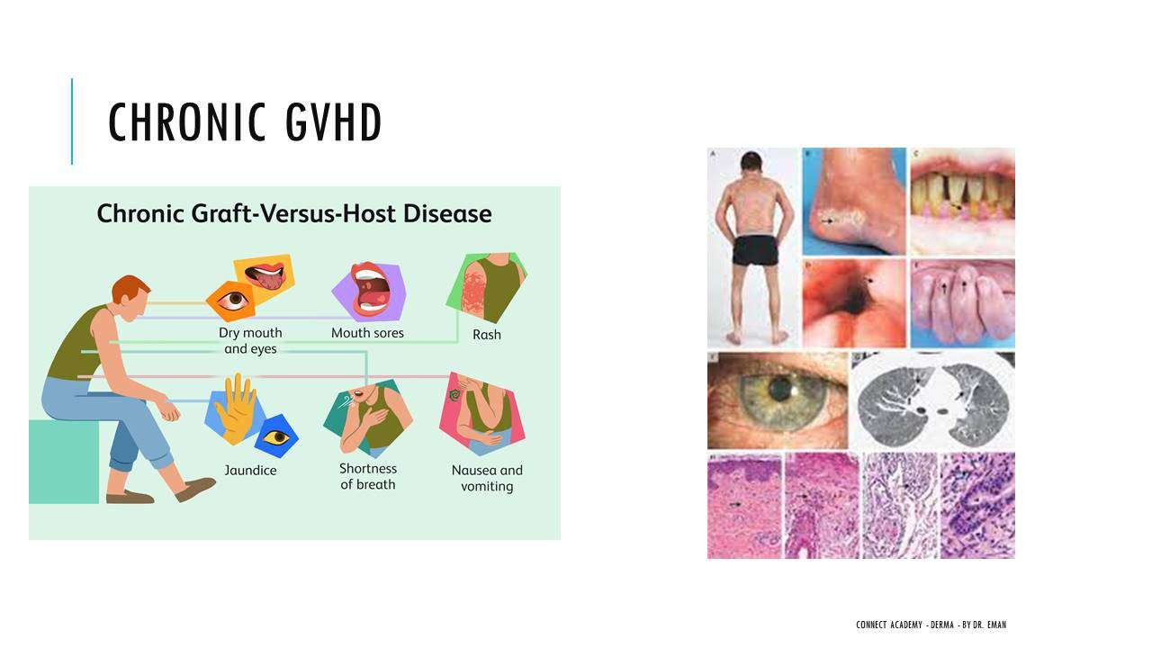
- GVHD = The transplanted immune cells (graft) attack the recipient's body (host).
- Occurs ONLY after hematopoietic stem cell (bone marrow) transplantation — NOT after solid organ transplants.
- Why not solid organs? Solid organs (liver, kidney, heart) do NOT contain immune cells capable of attacking the host. In solid organ transplants, it's the host that rejects the organ (tissue rejection).

Mechanism
- The recipient is immunosuppressed (to prevent rejection of the transplant) → immune system is essentially zero.
- Donor bone marrow contains T-cells that are transplanted into the host.
- The donor T-cells recognize host tissues as foreign → activate → attack the host's organs.
- The host cannot defend itself because it is immunocompromised.

Target Organs
- Skin (most common)
- GI tract (nausea, vomiting, diarrhea, abdominal pain)
- Liver (hepatitis)

Acute GVHD
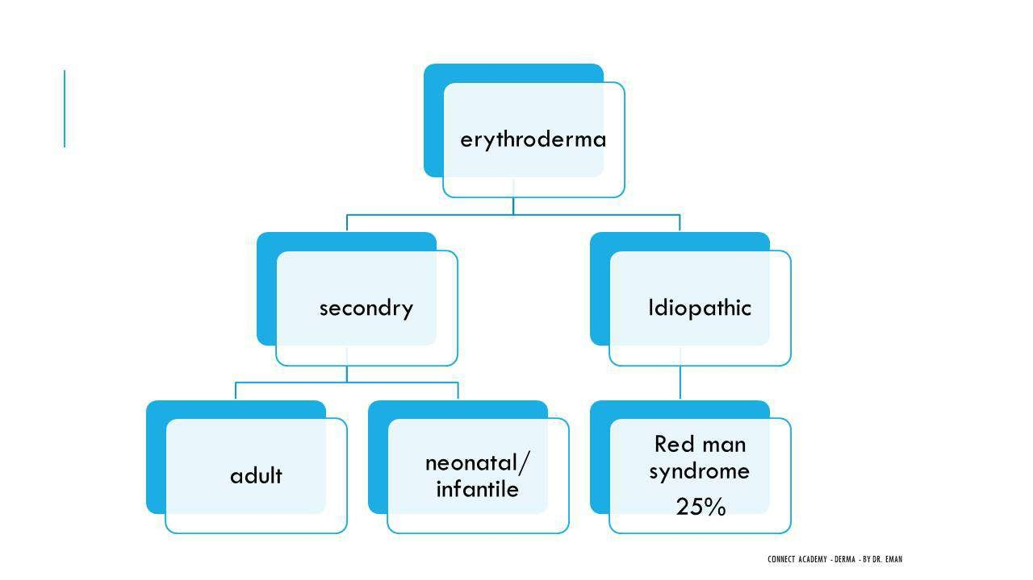
- Mechanism: Recipient tissue damage → T-cell activation → Cytotoxic T-cells cause tissue injury to skin, GI, and liver.
- Skin manifestation: Morbilliform exanthem (maculopapular rash).
- Pathognomonic sign: Peripheral desquamation — bullae and desquamation of the acral area (palms and soles).
- GI: Nausea, vomiting, diarrhea, abdominal pain.
- Liver: Hepatitis.
- Also: Generalized pruritus, cicatricial alopecia, erythroderma (in severe cases).
- Histopathology: Vacuolar interface dermatitis + keratinocyte necrosis.
- DDx: Viral exanthem, Drug eruption (differentiated by peripheral desquamation and clinical history of bone marrow transplantation).
- Treatment: Topical and systemic steroids, Tacrolimus, Mycophenolate mofetil, TNF-alpha inhibitors.

Chronic GVHD
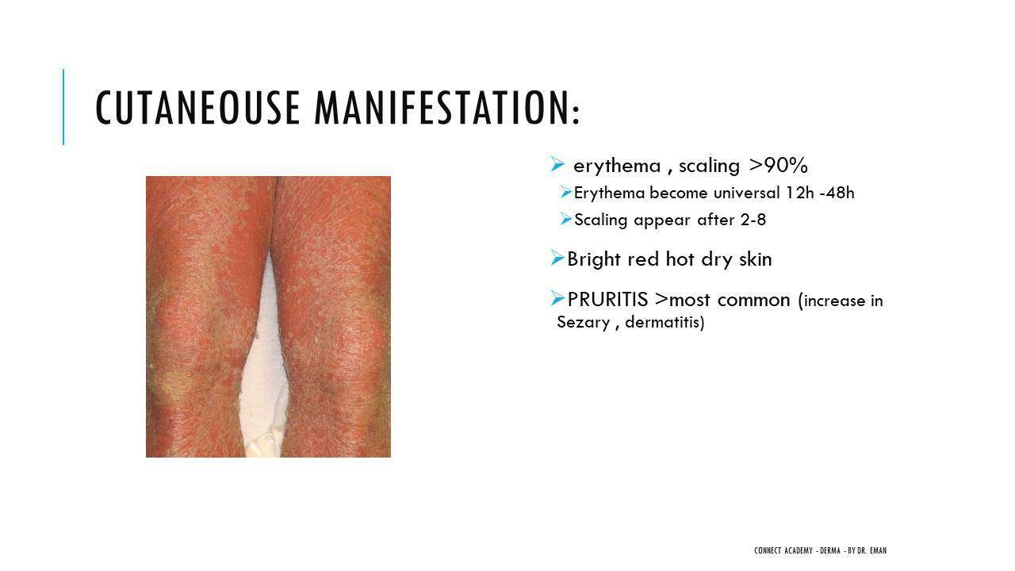
- Mechanism: T-cell activation (same as acute) PLUS B-cell activation → production of autoantibodies (ANA positive, Anti-dsDNA positive).
- The autoantibodies attack host tissues, producing autoimmune-like disease manifestations.
- Skin manifestations mimic:
- Lichen planus-like
- Lichen striatus-like
- Morphea-like
- Scleroderma-like
- Poikiloderma-like
- Eosinophilic fasciitis-like
- Systemic features: Dry mouth, dry eyes, oral sores, rash, jaundice, shortness of breath, nausea, vomiting.
- Can affect any body system.
- Histopathology: Variable — depends on which disease it mimics (LP pathology if LP-like, morphea pathology if morphea-like, etc.).
- Treatment: Sun protection, phototherapy, systemic steroids.
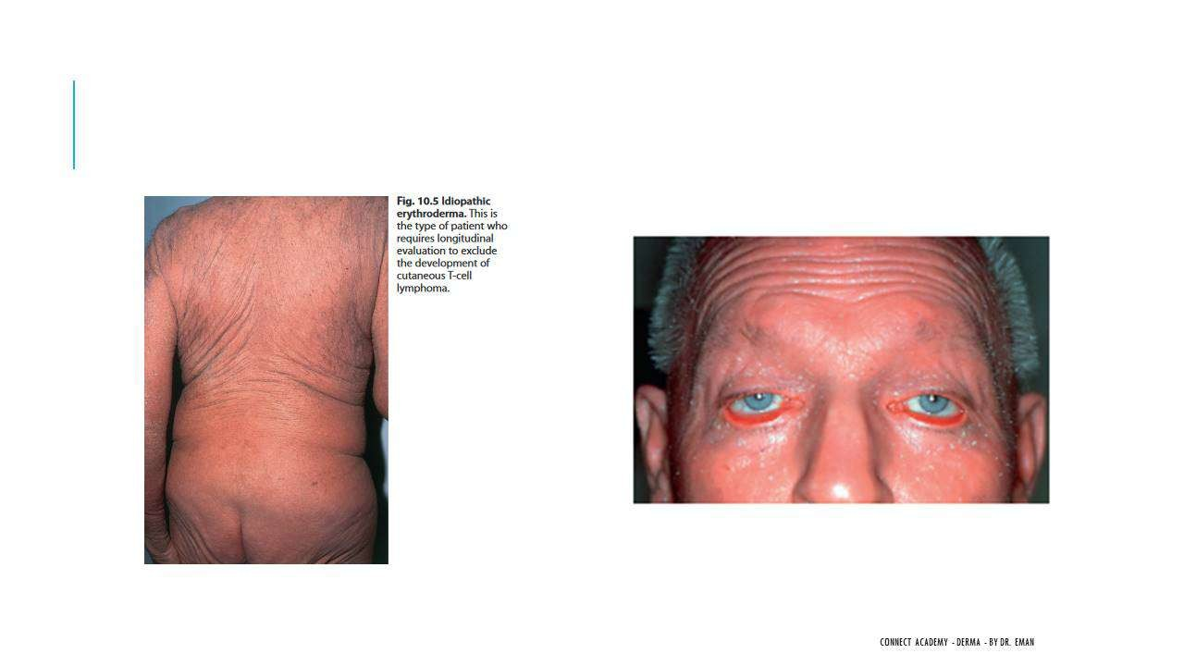

Translated & Tidied Audio Transcript
Dr. Eman: Now let's move to a completely new topic: Graft-versus-host disease (GVHD). Does anyone have any information about this disease or can explain what it means?
Student: In transplantation, rejection of the graft occurs.
Dr. Eman: Rejection happens, yes. But who does the rejection? Does my body reject what was transplanted, or is it the opposite?
Student: I think the opposite.
Dr. Eman: Exactly the opposite! This is NOT tissue rejection. In tissue rejection, the host rejects the organ — that's what happens in any normal organ transplantation. But here the disease is called Graft VERSUS Host disease — the graft attacks the host.
Dr. Eman: Let me explain from scratch. Imagine someone has a problem with their hematopoietic stem cells (bone marrow) — cancer, radiation damage, anything. They need a bone marrow transplant. When we transplant bone marrow, we're transplanting immune cells and blood cells.
Dr. Eman: Where do these immune cells come from? From another person whose HLA is somewhat matched. We take their bone marrow and transplant it. Now, for the transplant to succeed, does the recipient's immunity need to be strong or weak?
Student: Obviously weak.
Dr. Eman: Obviously weak — why? So they don't reject the transplant! I need to suppress their immune system to near zero. Then the new immune cells (the graft full of functional T-cells) enter and what happens? These new immune cells find themselves in a foreign body! It's not their own body. So they start attacking the host's body!
Dr. Eman: That's why it's called Graft versus Host. The immune cells I transplanted (the Graft) attack the patient's body (the Host). The host can't defend itself because it's immunocompromised. Understand the concept?
Dr. Eman: This only happens in hematopoietic stem cell transplantation. Does it happen with other organ transplants? No — because solid organs don't contain immune cells that can attack the body. If I transplant a liver, the liver won't attack the body! The body attacks the liver and rejects it. But here I'm transplanting immune cells (bone marrow/stem cells), so THEY attack the body, and the host can't defend itself.
Dr. Eman: GVHD is divided into Acute and Chronic, and the target organs are: Skin, GI tract, and Liver.
Dr. Eman: In Acute GVHD, the pathognomonic sign is bullae and desquamation of the acral area — desquamation of the palms and soles. On the skin you get a morbilliform eruption (maculopapular rash), and desquamation in the acral area. There's also pruritus and cicatricial alopecia. GI presents with nausea, vomiting, diarrhea, and abdominal pain. Liver presents as hepatitis.
Dr. Eman: So a typical case: an older patient with a history of bone marrow transplantation, presenting with a full-body exanthem that looks like a viral infection or drug eruption, PLUS peripheral desquamation of the palms and soles, PLUS acute abdomen and hepatitis. The peripheral desquamation is what differentiates it from viral or drug causes.
Dr. Eman: The Acute form has 3 phases: Recipient tissue damage → Activation of T-cells → Cytotoxic T-cells cause tissue injury to skin, liver, and GIT. It manifests as morbilliform exanthem, erythroderma, bullae and desquamation in the acral area, generalized pruritus, and cicatricial alopecia.
Dr. Eman: Now the Chronic form. The acute was T-cell activation — the donor T-cells get activated against the host. In Chronic GVHD, the same T-cell activation occurs BUT ALSO B-cell activation. What does B-cell activation mean? It means autoantibodies are produced against the host's body. These antibodies attack the host.
Dr. Eman: What do these autoantibodies produce? ANA positive and Anti-double stranded DNA positive. So the chronic form manifests as: morphea-like, scleroderma-like, poikiloderma-like, eosinophilic fasciitis-like, and lichen planus-like disease. All because autoantibodies are attacking.
Dr. Eman: Chronic GVHD causes dry mouth, dry eyes, mouth sores, rash, jaundice, shortness of breath, nausea, vomiting. On the skin it appears as lichen planus, lichen striatus, morphea-like, scleroderma-like, and poikiloderma-like. It can affect any organ system.
Dr. Eman: Histopathology: Acute GVHD shows vacuolar interface dermatitis and keratinocyte necrosis — that's why it's classified under lichenoid dermatoses. Chronic GVHD is variable — if it looks like LP, it has LP pathology; if it looks like morphea, it has morphea pathology.
Dr. Eman: DDx for Acute: viral exanthem and drug eruption. Treatment for Acute: topical and systemic steroids, Tacrolimus, Mycophenolate Mofetil, and TNF-alpha inhibitors. Treatment for Chronic: sun protection, phototherapy, and systemic steroids.
Student: Doctor, the recipient who receives the graft — they get immunosuppression, correct? So what causes the donor T-cells to activate? They already have no immunity.
Dr. Eman: What activates the donor T-cells? Any stimulus — bacteria on the skin, any antigen presenting cell activation. Why are we transplanting in the first place? To give this person immunity! Their bone marrow had cancer, and I transplanted new bone marrow so they'd have a functioning immune system to protect them from infections. But that immune system turns against them. The T-cells aren't 'theirs' — so they start attacking the host tissue itself.

4. Erythroderma (Exfoliative Dermatitis)

Summary

Definition
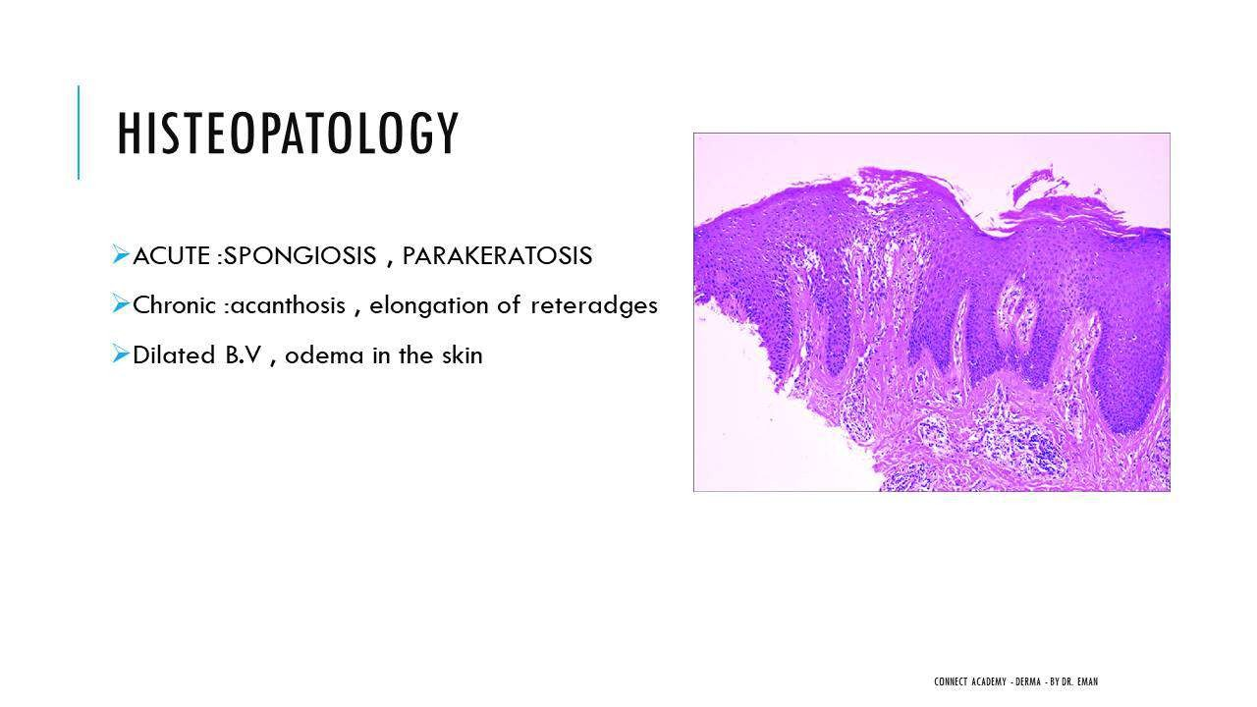
- Erythroderma = Erythema + scaling involving >90% body surface area.
- Also called Exfoliative Dermatitis.
- NOT a disease itself — it is an endpoint/manifestation of many different diseases.
- Course: Chronic (months to years), relapsing-remitting.
- Main cause of death: Pneumonia (secondary infection due to loss of skin barrier).

Causes in Adults — Mnemonic "BAD"
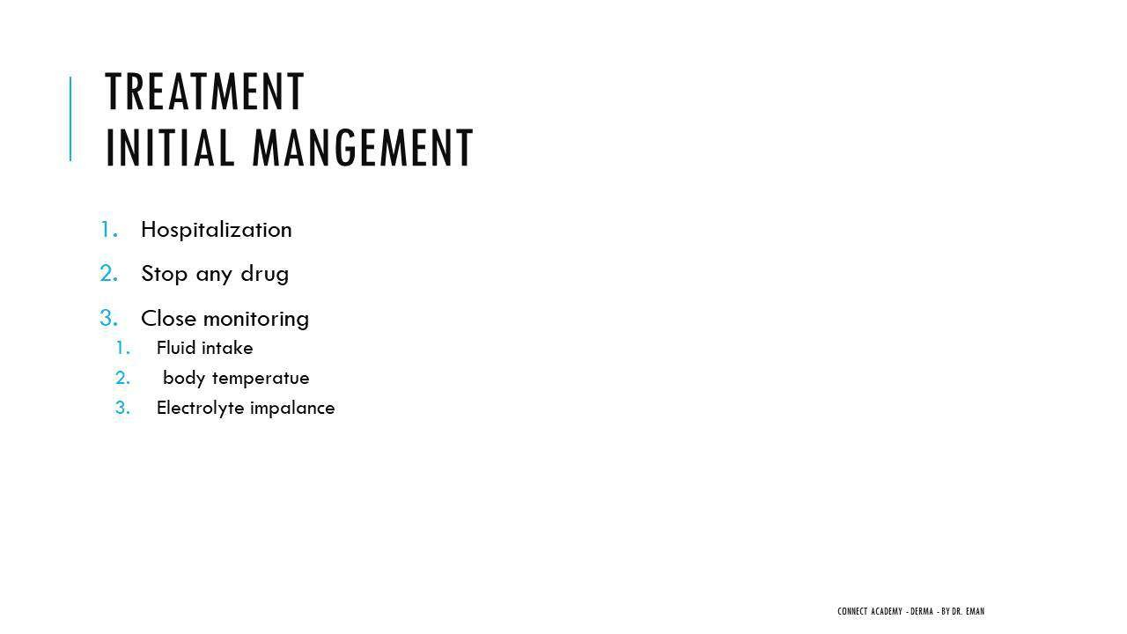
- Most common causes:
- B = (B)ig two: Psoriasis and Atopic dermatitis (most common overall)
- A = (A)ssorted inflammatory conditions
- D = Drugs — mnemonic "ASBAGAK": Allopurinol, Sulfasalazine/Sulfonamides, Phenytoin, Beta-blockers, Gold, Carbamazepine
- Less common causes: Mycosis Fungoides (MF)/Sézary Syndrome, Pityriasis Rubra Pilaris (PRP), Eczema, Paraneoplastic Pemphigus, Pemphigus Foliaceus, Bullous Pemphigoid.
- Rare causes: Crusted Scabies, Congenital Ichthyosiform Erythroderma, Lichen Planus, GVHD.
- Idiopathic (25%) = "Red Man Syndrome" — erythroderma with no identifiable cause.

Causes in Children/Neonates
- Genetic/Ichthyosis: Congenital Ichthyosiform Erythroderma (bullous and non-bullous), Netherton Syndrome.
- Immunodeficiency: Wiskott-Aldrich Syndrome.
- Inflammatory: Atopic dermatitis, Seborrheic dermatitis, Psoriasis.
- Infections: Staphylococcal Scalded Skin Syndrome (SSSS), Congenital Cutaneous Candidiasis.
- Others: PRP, GVHD, Mastocytosis.

Drug Mnemonics Summary
- Erythroderma drugs = "ASBAGAK" (Allopurinol, Sulfasalazine/Sulfonamides, Phenytoin, Beta-blockers, Gold, Carbamazepine).
- Psoriasis exacerbation drugs = "LIPA" (Lithium, Interferon, Beta-blockers, Antimalarials).
- Lichenoid drug eruption/LP drugs = "DAMAT" (Diuretics, Antihypertensives, Antimalarials, Amalgam/Metals, Tetracyclines).

Clinical Features
- Erythema appears first → scaling develops 2–8 days later.
- Skin is bright red, hot, and dry.
- Intense pruritus — worst with Sézary syndrome and Atopic dermatitis.

Complications
- Skin complications: Lichenification, depigmentation, palmoplantar keratoderma, nail changes, alopecia, subungual hyperkeratosis, Staphylococcus aureus infection (no skin barrier).
- Systemic complications: Fever, malaise, generalized lymphadenopathy (50%), peripheral edema (50%), hepatomegaly (20%), splenomegaly.
- Cardiovascular cascade: Vasodilatation → fluid loss → electrolyte disturbance → tachycardia → hypothermia → High-output cardiac failure → cachexia, anemia.
- High-output cardiac failure is the reason for mandatory hospitalization!

Sézary Syndrome — Key Distinction
- Sézary syndrome is NOT the same as erythrodermic Mycosis Fungoides.
- It is a separate leukemic variant of Cutaneous T-cell Lymphoma (CTCL).
- Starts with erythroderma from the beginning — no preceding patches or plaques (unlike MF which progresses through patches → plaques → tumors → erythroderma).
- The malignant T-cell in Sézary is different from the malignant T-cell in MF.
- Features: Sézary cells in blood + Generalized lymphadenopathy.

Histopathology
- Non-specific: Acanthosis, dilated blood vessels, edema.
- Acute: Spongiosis + parakeratosis.
- Chronic: Acanthosis.
- The underlying disease may show its own specific pathology (e.g., psoriasis plaques may still be identifiable).

Treatment
- Hospitalization required (for monitoring and managing cardiovascular complications).
- Stop suspected drugs immediately.
- Close monitoring: Fluid balance, electrolytes, temperature, cardiac function.
- Systemic antibiotics — prevent secondary bacterial infection (no functioning skin barrier).
- Sedating antihistamines — for severe pruritus.
- Topical care:
- Wet dressings
- Emollients
- LOW-potency topical steroids ONLY — high absorption risk over >90% BSA → systemic toxicity if high-potency steroids used
- NEVER cover the entire body with topical steroids

Specific Treatment by Cause
- Psoriasis → Methotrexate, Acitretin, or Biologics. AVOID systemic steroids (causes rebound flare or pustular psoriasis).
- Atopic dermatitis → Systemic steroids OR Cyclosporine.
- Drug-induced → Stop the offending drug + systemic steroids.

Translated & Tidied Audio Transcript
Dr. Eman: We've now finished the Lichenoid dermatoses. Many diseases end up causing erythroderma — including GVHD and Psoriasis. Let's discuss Erythroderma now.
Dr. Eman: What is the definition of Erythroderma?
Student: Generalized erythema and scaling of the skin more than 90% body surface area.
Dr. Eman: Yes — erythema and scales covering more than 90% of the BSA. Is Erythroderma a disease in itself?
Student: No, it's the result of many diseases.
Dr. Eman: Exactly. It can be chronic, lasting months to years, with a relapsing-remitting course. The main cause of death in erythroderma is pneumonia — secondary infection.
Dr. Eman: Causes divide into primary (idiopathic, 25% — called Red Man Syndrome) and secondary. Secondary divides into adult causes and pediatric causes.
Dr. Eman: What are the most important causes of erythroderma in adults?
Student: Psoriasis, Atopic Dermatitis, Drugs.
Dr. Eman: Correct — the three most important adult causes, summarized as "BAD." The drugs causing erythroderma are memorized with "ASBAGAK": Allopurinol, Sulfasalazine/Sulfonamides, Phenytoin, Beta-blockers, Gold, Carbamazepine.
Dr. Eman: Less common causes include Mycosis Fungoides, Pityriasis Rubra Pilaris, Eczema, Paraneoplastic Pemphigus, Pemphigus Foliaceus, and Bullous Pemphigoid. Very rare causes: Crusted Scabies, Congenital Ichthyosiform Erythroderma, Lichen Planus, and GVHD. You must know all of these.
Dr. Eman: In children and neonates, the most important cause is genetic/ichthyosis — a newborn isn't going to get psoriasis or take drugs. Congenital Ichthyosiform Erythroderma (bullous and non-bullous) and Netherton Syndrome are the key genetic causes. Then immunodeficiency syndromes like Wiskott-Aldrich. Then inflammatory causes like Atopic dermatitis, Seborrheic dermatitis, and Psoriasis. Infections like SSSS (Staphylococcal Scalded Skin Syndrome) and Congenital Cutaneous Candidiasis. And others: PRP, GVHD, Mastocytosis.
Dr. Eman: Let me consolidate the drug mnemonics: Erythroderma drugs = "ASBAGAK". Psoriasis exacerbation drugs = "LIPA" (Lithium, Interferon, Beta-blockers, Antimalarials). Lichen Planus/Lichenoid drug eruption drugs = "DAMAT" (Diuretics, Antihypertensives, Antimalarials, Amalgam/Metals, Tetracyclines).
Dr. Eman: The clinical picture: Erythema appears first, then scaling develops 2 to 8 days later. The body is bright red, hot, and dry. Is there pruritus? Most common — it's very intense, especially with Sézary syndrome and Atopic dermatitis.
Dr. Eman: Complications — the skin: Lichenification (increased skin markings), depigmentation, palmoplantar keratoderma, nail changes, alopecia, subungual hyperkeratosis, and Staph aureus infection because there's no skin barrier.
Dr. Eman: Systemic complications: Fever, malaise, generalized lymphadenopathy in 50% of cases, peripheral edema in 50%, hepatomegaly in 20%, splenomegaly.
Dr. Eman: The most important systemic complication — due to massive vasodilatation in the skin: fluid loss, electrolyte disturbance, tachycardia, hypothermia, and ultimately High-output cardiac failure, leading to cachexia and anemia. Can you imagine that erythroderma can cause cardiac failure? That's why these patients require hospitalization.
Dr. Eman: Histopathology is non-specific — acanthosis, dilated blood vessels, edema. Nothing specific to help you identify the cause. In acute erythroderma: spongiosis and parakeratosis. In chronic: acanthosis.
Dr. Eman: Now about Sézary Syndrome — does anyone know what it is?
Student: It's on the spectrum of MF.
Dr. Eman: Actually, it's NOT on the MF spectrum. It's different from MF. Mycosis Fungoides progresses from patches to plaques to tumors to erythroderma. Sézary Syndrome is a SEPARATE entity — a leukemic variant of Cutaneous T-cell Lymphoma. It starts with erythroderma from the very beginning, with no preceding patches or plaques. The malignant T-cell itself is different from MF. It has Sézary cells in the blood at a certain percentage, plus generalized lymphadenopathy.
Dr. Eman: Treatment of Erythroderma: First — hospitalization. Second — stop any suspected drugs. Third — close monitoring for fluid disturbance and cardiac issues; adjust body temperature, electrolyte balance, and fluid replacement. Fourth — systemic antibiotics to prevent secondary bacterial infection since there's no skin barrier. Fifth — sedating antihistamines for severe pruritus. Sixth — topical care: wet dressings, emollients, and low-potency topical steroids.
Dr. Eman: IMPORTANT: You cannot cover the entire body with topical steroids in erythroderma — the absorption will be extremely high over 90% BSA and will cause systemic toxicity.
Dr. Eman: Specific treatment depends on the cause. For Psoriasis: Methotrexate, Acitretin, or Biologics — AVOID systemic steroids because they cause rebound flare or pustular psoriasis. For Atopic dermatitis: systemic steroids or Cyclosporine. For Drug-induced: stop the offending drug and give systemic steroids.
Student: Doctor, regarding erythroderma, when do we use corticosteroids in the acute phase?
Dr. Eman: I would give systemic steroids to control severe inflammation if I know the cause is NOT psoriasis — for example, drug-induced erythroderma. If I'm unsure it's psoriasis and give systemic steroids, there'll be a rebound. If the patient is critically ill, I might give steroids and then determine the underlying disease once things calm down. But if I'm certain it's psoriasis, I'll use Methotrexate or another agent instead. Meanwhile, I treat all the other symptoms — fluid balance, electrolytes, etc.
Dr. Eman: That's it for today's lecture, doctors. We covered Lichen Nitidus, Lichen Striatus, Graft-Versus-Host Disease, and Erythroderma. Any questions?
Dr. Eman: I apologize we won't solve questions today due to time. I'll try to post some questions on the group after iftar for us to solve together. Happy Ramadan to everyone.

Lecture 9: Autoimmune Connective Tissue Disease

1. Introduction to Autoimmune CTD & Autoantibodies

Summary

Definition
- Autoimmune Connective Tissue Diseases (CTD): A group of autoimmune disorders characterized by the production of circulating autoantibodies against multiple body systems.
- These diseases affect both the skin and internal organs (kidney, neurological, lung, heart, etc.).

Difference from Other Immunological Diseases
- Psoriasis / Lichen Planus = T-cell mediated immunological diseases.
- Autoimmune CTD = B-cell / antibody mediated — autoantibodies attack the body's own tissues.

Types of Autoimmune CTD
- Lupus Erythematosus (LE) — the focus of this lecture.
- Scleroderma — Diffuse disease / Limited (CREST syndrome) / Acrosclerosis.
- Morphea
- Dermatomyositis — affects skin + muscle.
- Antiphospholipid Syndrome
- Mixed Connective Tissue Disease (MCTD)
- Overlap Syndrome
- Sjögren's Syndrome
- ANCA-associated Vasculitis — Churg-Strauss, Granulomatosis with Polyangiitis (Wegener's).
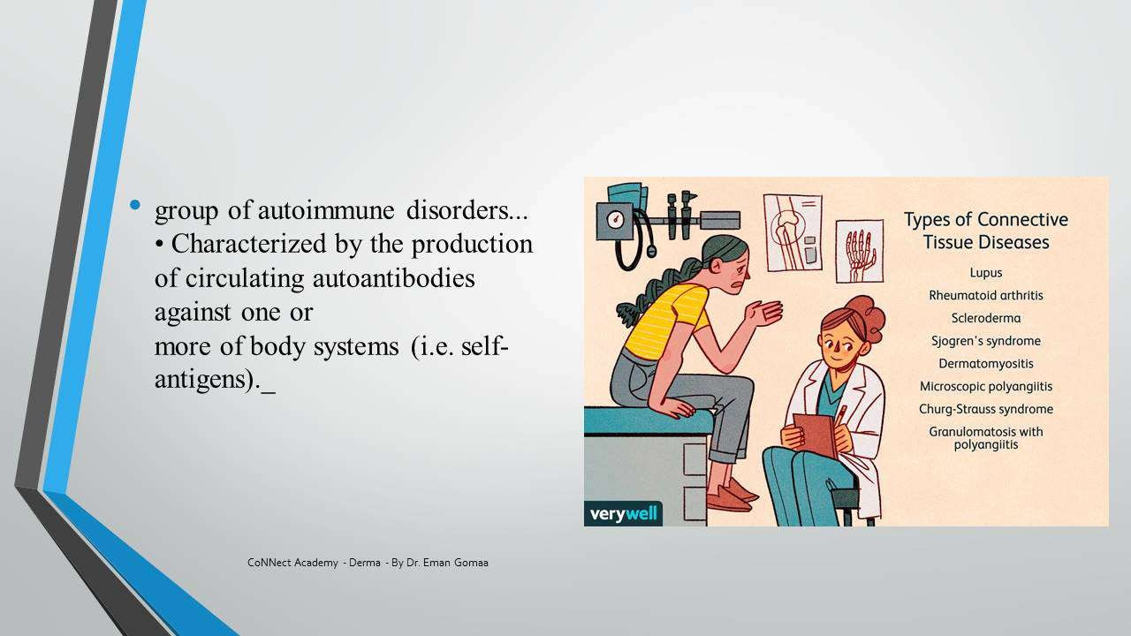

Autoantibodies — Targets in the Cell
- Autoantibodies are directed against all cellular components:
- Nuclear molecules → ANA (Antinuclear Antibody) — the main screening test.
- Cytoplasmic molecules → ANCA (Anti-neutrophil cytoplasmic antibody).
- Cell membrane molecules → Antiphospholipid antibodies (Antiphospholipid syndrome).

Nuclear Components Targeted (What's Inside the Nucleus)
- Nucleic acids: DNA (double-stranded / single-stranded), RNA (transfer, mRNA, rRNA).
- Histones: Proteins around which DNA is wrapped (like thread on a spool).
- Ribonucleoproteins (RNP): Ro, La, U1 RNP, Sm (Smith).
- Enzymes: Helicase, DNA Topoisomerase (Scl-70), Histidyl-tRNA synthetase (Jo-1).
- Centromere — targeted in CREST syndrome.
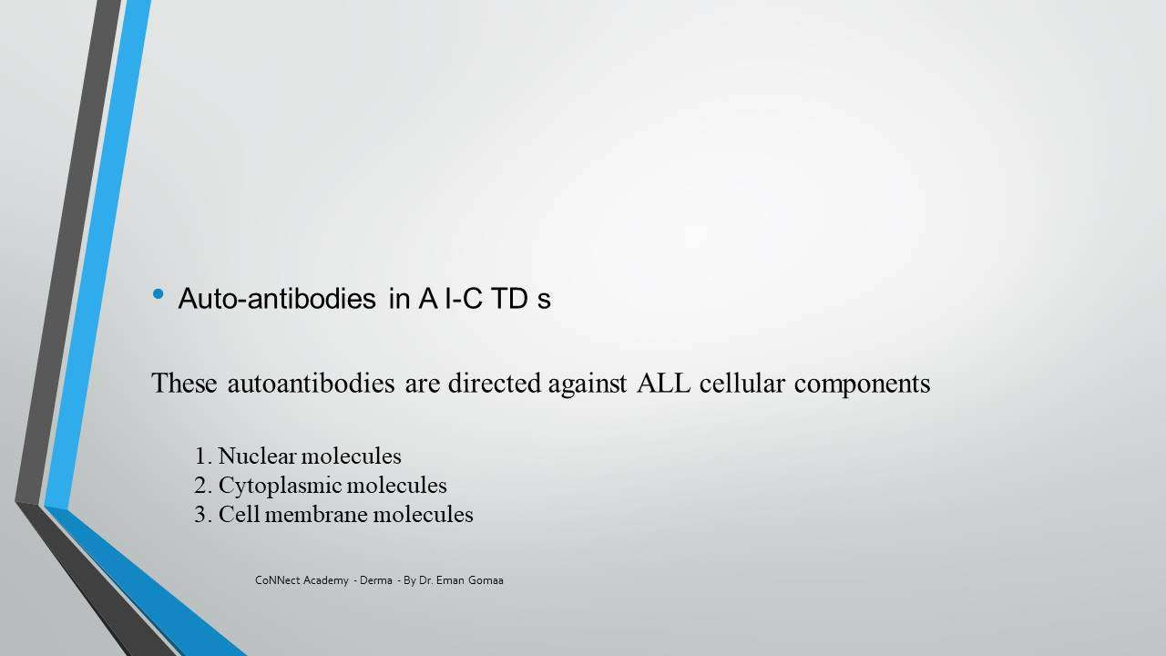

Translated & Tidied Audio Transcript
Dr. Eman: Good morning doctors, how are you? Can you hear me? What's the news? How's the studying going? We've completed the previous lectures — we finished the entire Papulosquamous chapter. Today we're starting a completely new chapter: Autoimmune Connective Tissue Diseases. The lecture will be good, God willing, but it requires your focus. I want you to participate with me. What do we mean by Autoimmune Connective Tissue Diseases? What diseases are we talking about? In Psoriasis I told you it's an immunological disease, and in Lichen Planus it's also an immunological disease. So what's the difference between those and this entire chapter called Autoimmune Connective Tissue Diseases?
Student: Excuse me Dr. Eman, isn't Eczema supposed to be today's lecture according to the schedule?
Dr. Eman: There's no problem, we're following the curriculum but if there's a change in lecture order, it's still within the same schedule. Can you hear me?
Student (Dr. Doaa): Yes, we can hear you. Immunological diseases are T-cell mediated, while autoimmune diseases are B-cell mediated because of the antibodies.
Dr. Eman: Exactly — autoantibodies that attack things in our body and cause specific diseases. What are the Autoimmune CTD diseases?
Student (Dr. Sherifa): Lupus, Scleroderma, Dermatomyositis.
Dr. Eman: Very good. The Autoimmune Connective Tissue Diseases, as Dr. Sherifa said, are a group of autoimmune disorders characterized by production of circulating autoantibodies against multiple body systems. Meaning the skin, kidney, neurological system (I'm talking about Systemic LE for example) — so in every disease we'll find it affects the skin and another systemic part of the body.
Dr. Eman: Here's a slide showing the types of CTD: Lupus, Rheumatoid Arthritis, Scleroderma, Sjögren's Syndrome, Dermatomyositis, Microscopic Polyangiitis, Churg-Strauss Syndrome, and Granulomatosis with Polyangiitis (the ANCA vasculitis ones).
Dr. Eman: The Autoimmune CTD with cutaneous manifestations that we'll cover: First, LE (today's lecture). Second, Scleroderma — divided into Diffuse and Limited. The Limited is called what?
Student: CREST.
Dr. Eman: CREST syndrome, or Acrosclerosis separately and CREST separately. Then Morphea, Dermatomyositis (affects skin + muscle), Antiphospholipid Syndrome, Mixed CTD, Overlap Syndrome, Sjögren's, and ANCA-associated Vasculitis.
Dr. Eman: All of these fall under Autoimmune CTD — meaning autoantibodies are attacking my body. What exactly do they attack in the cell? They attack the cells. What do they attack most in the cell? And based on that we created a major test we perform when we suspect any autoimmune disease. What is it?
Student: The Nucleus.
Dr. Eman: Yes, the Nucleus. So what investigation do we do to detect autoantibodies against the nucleus?
Student: ANA.
Dr. Eman: The ANA — Antinuclear Antibody. The autoantibodies are directed against: first, nuclear molecules (the ANA); second, cytoplasmic molecules (ANCA); third, cell membrane molecules. Can anyone give me a disease example for cell membrane molecules?
Student: Antiphospholipid syndrome.
Dr. Eman: Exactly! From its name — the antibody is directed against the phospholipid that forms the cell membrane. The disease itself is called Antiphospholipid Syndrome.
Dr. Eman: Now, the nuclear antigens — what's inside the nucleus itself: First, nucleic acids (DNA or RNA). DNA can be double-stranded or single-stranded. RNA includes transfer, mRNA, and rRNA. Then proteins — I need DNA to be wrapped around something in the nucleus, it doesn't just exist as a strand...
Student: It's wrapped around histones.
Dr. Eman: Exactly! Remember from before — DNA is kilometers long in the body, so it's wrapped around protein cores called histones, like thread on a spool. There's also RNP (Ribonucleoprotein) — Ro, La, U1 RNP, and Sm (Smith). If an antibody forms against Ro and La, what disease does it give me?
Student: Ro and La give Subacute Lupus, or drug-induced lupus.
Dr. Eman: Yes, Subacute LE, correct. There are also enzymes in the nucleus: helicase, DNA topoisomerase, histidyl-tRNA synthetase. Anti-topoisomerase gives what disease? Scleroderma (Scl-70). Anti-helicase and histidyl-tRNA synthetase? That's Jo-1.
Student: Dermatomyositis.
Dr. Eman: Yes, Dermatomyositis — Jo-1 and Mi-2. And anti-centromere gives CREST syndrome. So the nucleus contains many components, and an antibody against each gives a different disease.

2. ANA Testing — Methodology & Patterns

Summary

What is ANA?
- ANA = Antinuclear Antibodies — a screening test, NOT specific for any single disease.
- Includes all autoantibodies reactive against nuclei of human cells.
- Primarily of the IgG class.

Detection Methods
- Indirect Immunofluorescence (IIF) — most common, most clinically efficient screening test.
- ELISA — gives numerical result; can request 'with pattern' for fluorescence pattern.

How Indirect Immunofluorescence Works
- Take patient serum (contains autoantibodies).
- Place on a substrate (tissue with nuclei) — the autoantibodies bind to the nucleus.
- Add a secondary antibody conjugated with fluorochrome — it binds to the patient's antibody and glows.
- View under fluorescence microscope → see WHERE it glows = the pattern.

Substrate
- HEp-2 cells = Human laryngeal/bronchogenic carcinoma cell line (current standard).
- Previously used animal substrates (rat kidney/liver) — REPLACED because Anti-Ro antigen is NOT present in animals, causing false negatives.
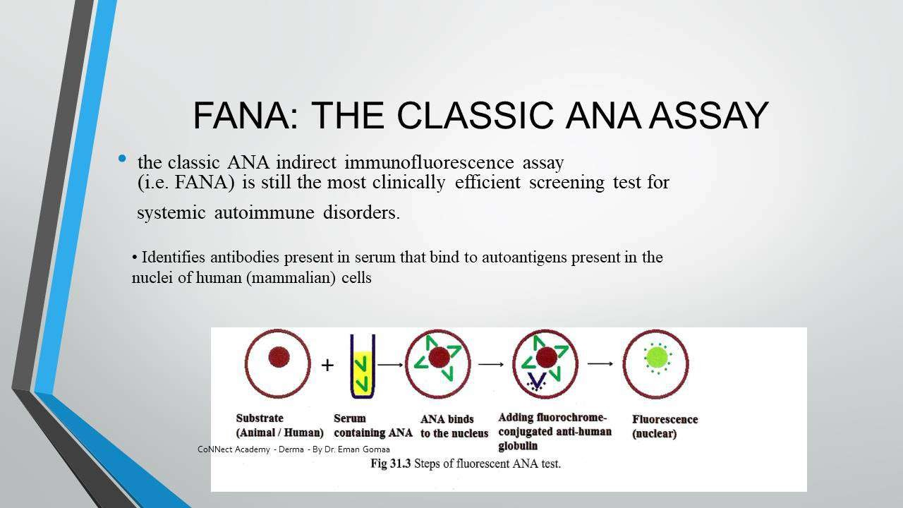

Direct Immunofluorescence = Lupus Band Test
- Patient biopsy + patient serum placed together.
- Antibodies bind at the dermoepidermal junction (DEJ) → fluorescence at the DEJ.
- Shows: Granular deposition of IgG + complement (C3) at the DEJ.
- Used when histopathology is equivocal (cannot clearly diagnose LE).

ANA Patterns & Associated Diseases
- Homogeneous: SLE, Discoid LE, Rheumatoid Arthritis.
- Speckled: SLE, Mixed CTD, Scleroderma.
- Nucleolar: Scleroderma.
- Peripheral: CREST, SLE.
- Centromeric: CREST syndrome (anti-centromere antibody).
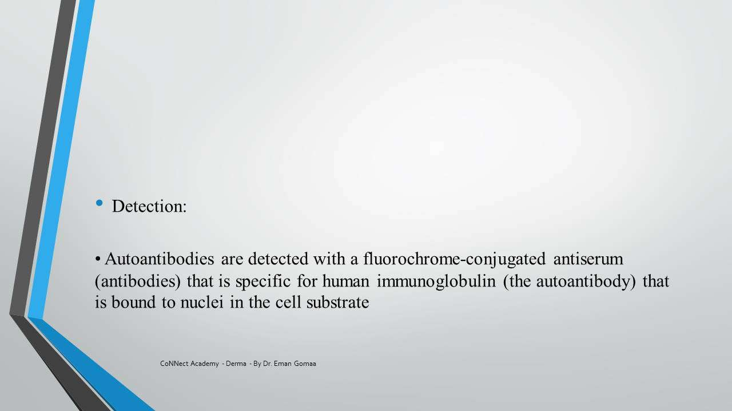

Positive ANA Titer
- Positive: ≥1/160 on HEp-2 cells.
- 1/160 is MORE positive than 1/80 — because it means at higher dilution the antibody is still detected (more concentrated antibody present).
- If positive → proceed to specific autoantibody testing (Anti-dsDNA, Anti-Sm, Anti-Ro, Anti-La, etc.).

Indications for ANA Testing
- Suspected autoimmune CTD — screening test.
- Baseline for Discoid LE patients — 5% convert to Systemic LE; 15% of SLE has Discoid as skin sign.
- Workup of photosensitivity — rule out SLE (malar erythema).
- Baseline before phototherapy (theoretically).
- Chronic cutaneous vasculitis — screen for ANCA-associated disease (Churg-Strauss, Wegener's).

Translated & Tidied Audio Transcript
Dr. Eman: Now we need a test. If I suspect someone has Dermatomyositis or Systemic LE, do I go straight to Anti-dsDNA? Or is there something that tells me we're under the umbrella of Autoimmune CTD without being too specific? What if I suspect something autoimmune but don't know what exactly? What test do I start with?
Dr. Eman: I start with the ANA. The ANA is not specific for any single disease — it tells me if it's positive, then there's a problem with one of these autoimmune conditions. What specifically in the nucleus is being attacked? I don't know yet — I start searching after that.
Dr. Eman: The ANA is detected by indirect immunofluorescence or ELISA. What happens? I take the patient's serum — it contains autoantibodies. I place it on a substrate (tissue with nuclei). The autoantibodies go and bind to the nucleus. Then I add a secondary antibody that glows — it attaches to the patient's antibody like following it, tracking it. It binds and lights up, showing me where the antibodies are — peripheral around the nucleus, speckled, nucleolar, etc.
Dr. Eman: The substrate should be rich in nuclear material. Two types: the human substrate (HEp-2 cell — human tumor cell line) and the animal substrate (rodent cell line — rat kidney/liver). They abandoned animal substrates because not all human nuclear antigens exist in animals. The main problem was Anti-Ro — it's not present in animals, so it caused false negatives.
Dr. Eman: The classic ANA indirect immunofluorescence assay is still the most clinically efficient screening test. Screening means: I have 100 suspected cases, I do ANA. 50 come back positive — those have something. 50 negative — I exclude autoimmune disease in those. The 50 positive ones may or may not have disease depending on specificity, but I've screened the group.
Dr. Eman: The patterns — Homogeneous means the fluorescence covers the entire nucleus uniformly: think SLE, Discoid LE, Rheumatoid Arthritis. Speckled (dotted): SLE, Mixed CTD, Scleroderma. Nucleolar: Scleroderma. Peripheral: CREST and SLE. Centromeric: CREST syndrome.
Dr. Eman: The Lupus Band Test is the direct ANA. You take a biopsy from the patient and place the patient's own serum on it. The antibodies light up at the dermoepidermal junction. We use it when histopathology is equivocal — when we can't clearly diagnose LE from the biopsy alone.
Dr. Eman: What does positive ANA titer mean? Greater than or equal to 1/160. Is 1/160 positive or 1/80? Which is more positive?
Student: 1/160.
Dr. Eman: Yes! Why? Because it's a titer — meaning I'm diluting. At 1/80 the antibody is gone, but at 1/160 it's still there. That means the antibody concentration is higher. So ≥1/160 = autoimmune CTD confirmed. If negative or below that without systemic symptoms, the patient doesn't have anything.
Dr. Eman: Indications for ANA: First, suspected autoimmune CTD screening. Second, baseline for Discoid LE patients (5% convert to SLE). Third, workup of photosensitivity — any patient with photosensitivity and malar rash needs ANA screening. Fourth, chronic cutaneous vasculitis — screening for ANCA (Churg-Strauss, Wegener's).

3. Specific Autoantibodies & Disease Specificity

Summary

Highly Specific Autoantibodies
- Anti-dsDNA (double-stranded DNA): Highly specific for Systemic LE; correlates with nephritis (kidney involvement).
- Anti-Sm (Smith): Highly specific for Systemic LE.
- Anti-U1 RNP: Mixed Connective Tissue Disease (MCTD); mnemonic: 'Rabbit' = U1 RNP; correlates with CNS involvement.
- Anti-Ro / Anti-La: Subacute CLE, Neonatal LE, Drug-induced lupus.
- Anti-Topoisomerase I (Scl-70): Diffuse/Generalized Scleroderma.
- Anti-Centromere: CREST syndrome.
- Anti-Mi-2: Classic Dermatomyositis.
- Anti-Jo-1 (histidyl-tRNA synthetase): Dermatomyositis — specifically the Anti-synthetase syndrome (lung fibrosis, mechanic's hands).
- ANCA (Anti-neutrophil cytoplasmic antibody): Churg-Strauss, Granulomatosis with Polyangiitis (Wegener's).
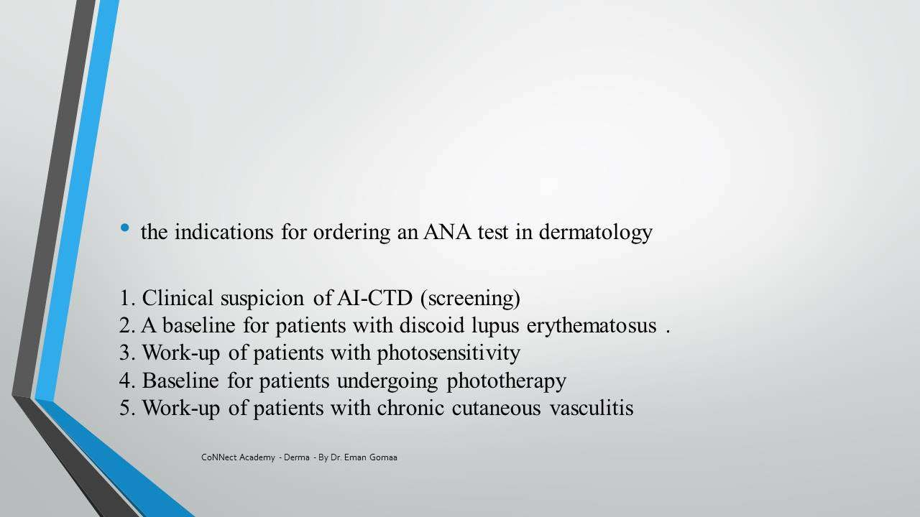

Prognostic Value of Autoantibodies
- Autoantibodies don't just diagnose — they predict organ involvement and prognosis:
- Anti-dsDNA → Nephritis (kidney).
- Anti-U1 RNP → CNS involvement.
- Anti-Jo-1 → Lung fibrosis.
- Clinical pearl: In fellowship exams, they ask which specific autoantibody predicts attack on kidney vs. CNS vs. lung.

Translated & Tidied Audio Transcript
Dr. Eman: Certain antibodies have significant disease specificity. Anti-dsDNA and Anti-Sm are highly specific for Systemic LE. Anti-U1 RNP is for Mixed Connective Tissue Disease — memorize it with the word 'Rabbit' (U1 RNP). Anti-Topoisomerase (Scl-70) is for generalized Scleroderma. Anti-Centromere is for CREST. Anti-Mi-2 is for classic Dermatomyositis. Anti-Jo-1 is the more aggressive Dermatomyositis — the anti-synthetase syndrome with lung fibrosis and mechanic's hands.
Dr. Eman: Here's the important part: if I have positive dsDNA, I think SLE — but it also tells me the patient is more prone to nephritis. It doesn't just diagnose the disease, it tells me WHERE it's going in the body. Is it mild SLE or is it attacking the CNS? The autoantibody tells you. Anti-dsDNA = nephritis, Anti-RNP = CNS. For the lung, this was actually a fellowship exam question — they asked which autoantibody is specific for SLE attacking the lung vs. kidney vs. CNS. We found kidney (dsDNA) and CNS (RNP) but honestly couldn't find a definitive one for lung. These must be memorized!

4. Lupus Erythematosus — Classification & Pathogenesis

Summary

Classification of Cutaneous LE
- Chronic Cutaneous LE:
- Discoid LE (localized / disseminated / hypertrophic).
- Tumid LE.
- Lupus Panniculitis.
- Lupus Profundus (= Discoid + Panniculitis together).
- Chilblain LE.
- Subacute Cutaneous LE:
- Classic (annular/polycyclic or psoriasiform/papulosquamous).
- Neonatal LE.
- Acute Cutaneous LE:
- Malar erythema (butterfly rash).
- Generalized — essentially = Systemic LE with skin features.
- Other: Bullous LE, Rowell Syndrome.
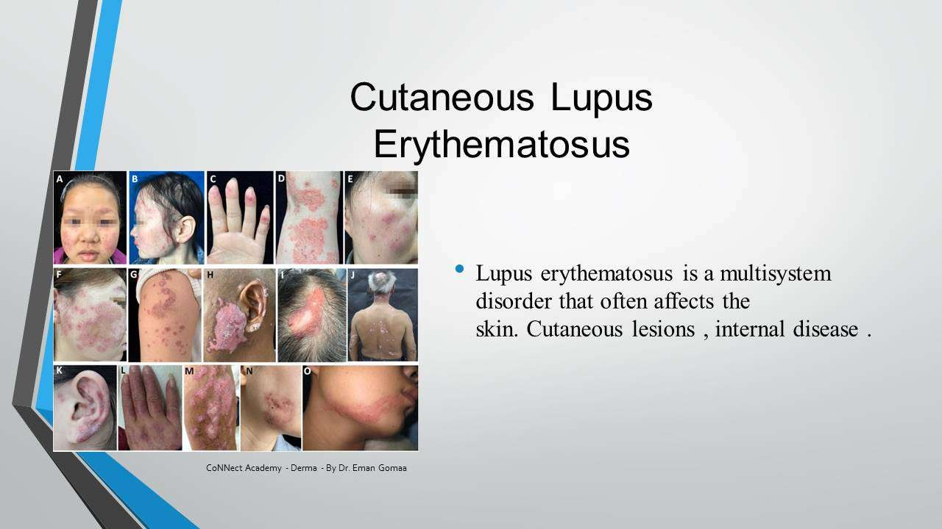

Spectrum: Chronic → Subacute → Acute
- Chronic = MOST skin involvement, LEAST systemic.
- Subacute = Intermediate.
- Acute = LEAST skin (for dermatologist), MOST systemic.
- As you move from Chronic to Acute, systemic involvement increases and skin-only disease decreases.

Pathogenesis
- Environmental trigger + Genetic susceptibility → Immune dysregulation → Disease.
- Immunological outcome: Immune complex (antigen-antibody complex) formation and deposition in tissues.
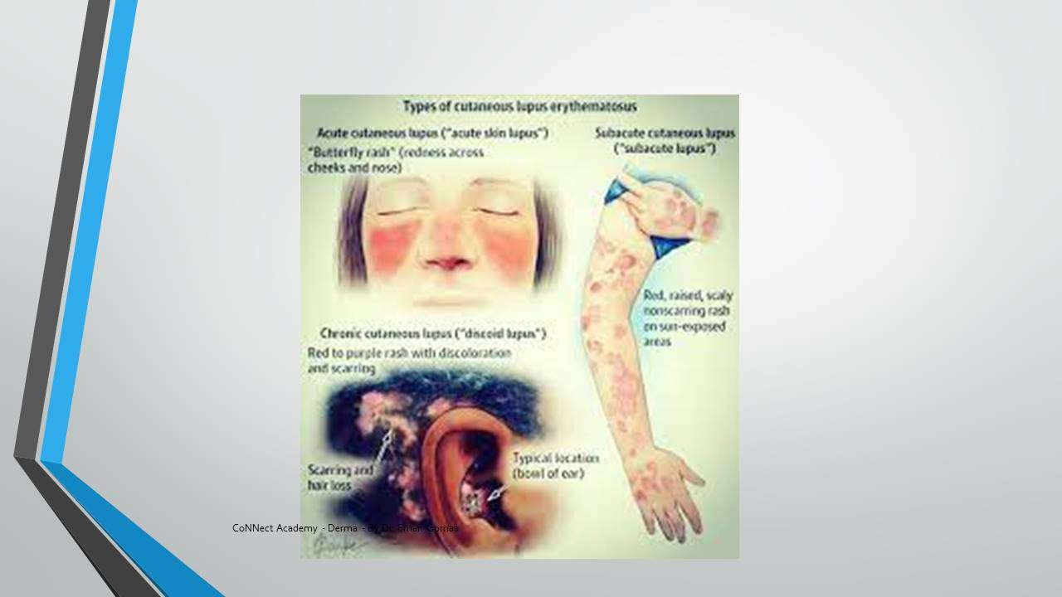

The KEY GENE: STAT4
- STAT4 = Signal Transducer and Activator of Transcription.
- Responsible for clearance of apoptotic bodies (the body's 'garbage collection system').
- Defect in STAT4 → Accumulation of apoptotic cells → Immune system recognizes them as foreign → Antibodies attach → Immune complex formation → Tissue deposition → Inflammation → Organ damage.

The 'Garbage Analogy' (Dr. Eman's Teaching Pearl)
- Our body produces 'garbage' daily (apoptotic cells, damaged nuclei from UV exposure, etc.).
- Normally, a clearance system removes this garbage every day — like garbage collection from a building.
- In LE patients: The 'garbage truck' (STAT4/clearance system) is defective.
- Result: Garbage accumulates → Attracts 'insects' (antibodies) → Antibodies bind the garbage (antigen-antibody complex) → Complexes deposit in organs (kidney, skin, lung, brain, heart) → Immune attack on surrounding tissue.
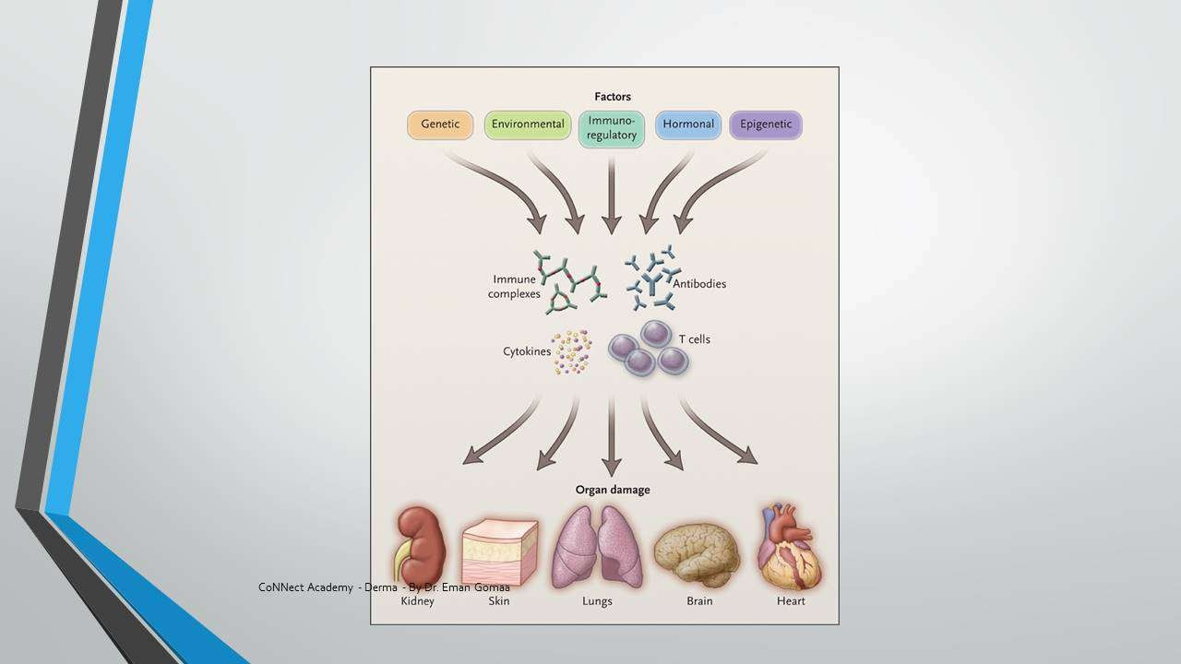

Environmental Triggers
- Ultraviolet radiation — MOST IMPORTANT trigger.
- Drugs: Isoniazid, Griseofulvin, Penicillamine, Dapsone (must memorize).
- Viral infections (e.g., Herpes Zoster).
- Trauma, X-ray, Diathermy, Chemical burn.
- Stress, Seasonal exacerbation.
- Cold exposure.
- Pregnancy, Premenstrual period, Hormonal replacement therapy — hence hormonal component.

Genetic Evidence
- Family history present.
- Association with certain HLA types.
- Role of anti-Ro/anti-La passing from mother to infant (Neonatal LE) proves genetic component.

Immune Complex Deposition
- Antigen-antibody complexes deposit in: Kidney, Skin, Lung, Brain, Heart.
- Immune system attacks the complex AND surrounding tissue → inflammation → organ damage.

Translated & Tidied Audio Transcript
Dr. Eman: Cutaneous LE is divided into three: Chronic, Subacute, and Acute. Can Chronic convert to Systemic? Yes. Can Subacute? Yes. Can Acute? It essentially IS Systemic. The more you go from Chronic toward Acute, the more systemic involvement increases and skin involvement decreases. Chronic has the most skin disease, Acute has the most systemic disease.
Dr. Eman: What causes LE? Environmental trigger in a genetically susceptible patient causes immunological response. The immunological product is immune complex (antigen-antibody complex). These complexes deposit in various organs and cause damage.
Dr. Eman: The most important gene is STAT4 — Signal Transducer and Activator of Transcription. What happens when there's a defect in STAT4? It causes translocation of cellular and nuclear antigens to the cell surface, triggering immunity and inflammation. STAT4 must not be forgotten! I've been explaining for 10 minutes so that when I say 'STAT4' you'll understand it properly.
Dr. Eman: Think of it like this — imagine a building where every day someone comes to collect the garbage. The garbage represents apoptotic cells and waste. Every day the clearance system removes it. Now imagine it stops working — the garbage accumulates, insects appear, everything is ruined. That's exactly what happens in the body. Apoptotic cells accumulate because there's no clearance system. Then antibodies come along and say 'what's this foreign thing?' and attach to it. Antigen-antibody complex forms, deposits in organs, and the immune system attacks both the complex and the surrounding tissue. That's the pathogenesis of SLE.
Dr. Eman: Environmental factors: Ultraviolet radiation is the most important. Medications like Isoniazid, Griseofulvin, Penicillamine, Dapsone — these drugs must be memorized. Viral infections, trauma, cold exposure, pregnancy and hormonal factors. The evidence for genetic involvement: family history, HLA associations, and the fact that anti-Ro/La pass from mother to baby (Neonatal LE).

5. Histopathology of LE & Lupus Band Test

Summary

LE Histopathology Pattern
- All LE = Vacuolar interface dermatitis (NOT lichenoid band-like).
- Means: Perivascular (patchy) lymphocytic infiltrate — lymphocytes around blood vessels, not band-like.
- Interface dermatitis = Vacuolar degeneration of the basement membrane + inflammatory infiltrate.

Discoid LE Histopathology (Most Important)
- Epidermis — Things that INCREASE:
- Hyperkeratosis (in stratum corneum).
- Follicular plugging (keratin plugs in follicles).
- Epidermis — Things that DECREASE:
- Epidermal atrophy (thin epidermis despite hyperkeratosis above).
- Dyskeratosis (death of keratinocytes).
- Dermis:
- Patchy lymphocytic infiltrate (perivascular).
- Periadnexal infiltrate (lymphocytes around hair follicles — specific for LE).
- BMZ (Basement Membrane Zone):
- Thickening — due to immune complex deposition.
- Destruction → causes SCARRING (the BMZ is 'beaten to destruction').
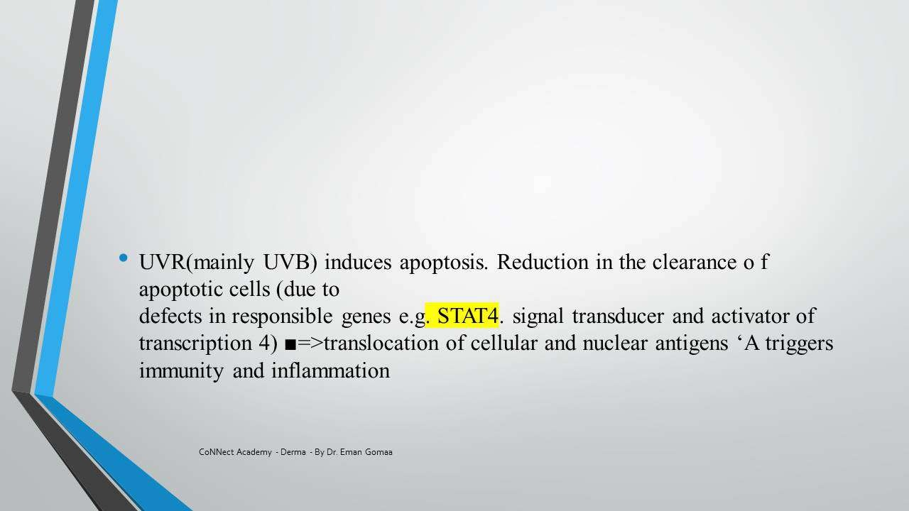

Subacute LE Histopathology
- Epidermis: Normal — NO hyperkeratosis, NO follicular plugging.
- Interface: More intense inflammation — severe hydropic degeneration, may form subepidermal cleft.
- Dermis: Pronounced dermal edema (explains the edematous clinical appearance).
- BMZ: Not completely destroyed → NO scar (heals with hypo/hyperpigmentation only).
- Abundant patchy lymphocytic infiltrate present.

Lupus Band Test (Direct Immunofluorescence)
- Indication: When histopathology is equivocal (cannot diagnose LE from biopsy alone).
- Method: Patient biopsy + patient serum → fluorescence at DEJ.
- Finding: Granular deposition of IgG + complement (C3) at the dermoepidermal junction.
- NOT routinely done — only when diagnosis is uncertain.
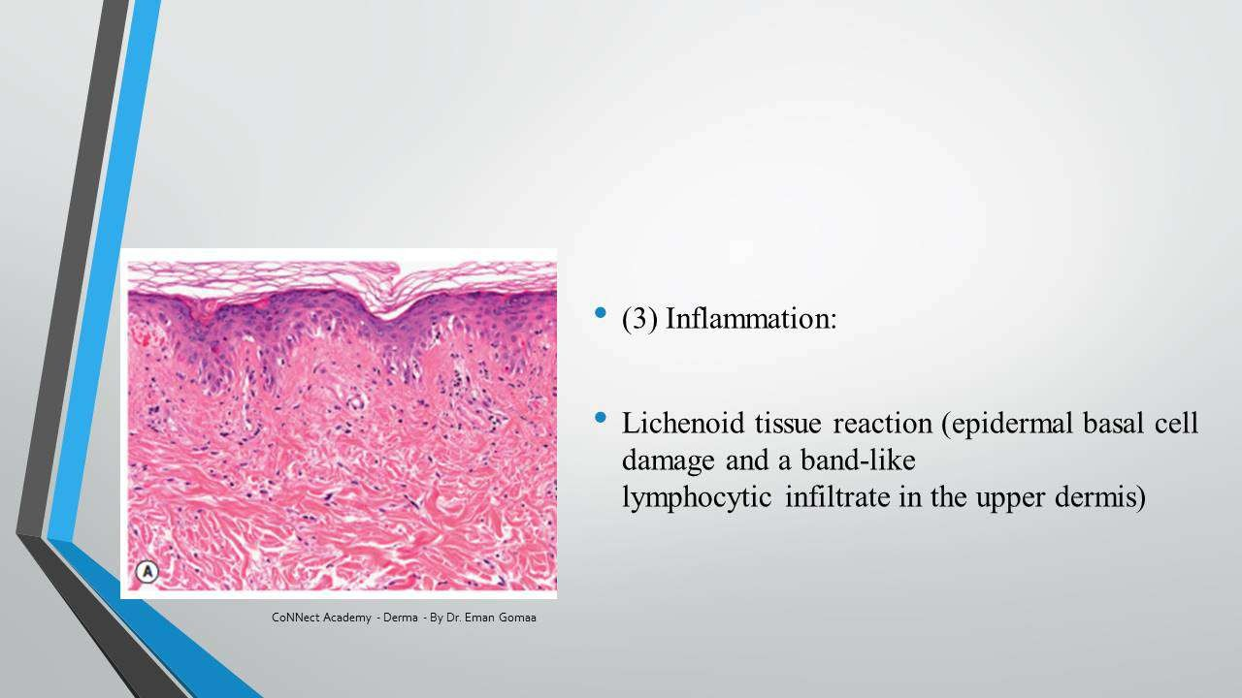

'5L' — Patchy Lymphocytic Infiltrate Differential Diagnosis
- Lupus Erythematosus.
- Lymphocytic lymphoma.
- Lymphocytoma cutis.
- Light eruption (Polymorphous light eruption — PLE).
- Lymphocytic infiltration of Jessner.
- These 5 diseases share patchy lymphocytic infiltrate — must be memorized!

Translated & Tidied Audio Transcript
Dr. Eman: How does LE appear on pathology? What's the most important finding?
Student (Dr. Sherifa): The dermoepidermal junction — interface dermatitis — and there's thickening of the basement membrane from immune complex deposition.
Dr. Eman: Excellent! We're dealing with interface dermatitis — vacuolar degeneration of the basement membrane. Is it vacuolar or lichenoid? It's vacuolar interface dermatitis — meaning perivascular (patchy) lymphocytic infiltrate, not band-like.
Dr. Eman: In Chronic (Discoid) LE, the basement membrane is completely destroyed — that's why it scars. In the epidermis, two things increase (Hyperkeratosis + Follicular plugging) and two things decrease (Epidermal atrophy + Dyskeratosis). The dermis shows patchy lymphocytic infiltrate that's also periadnexal (around follicles) — this is specific for LE.
Dr. Eman: In Subacute LE: no hyperkeratosis, no follicular plugging — the epidermis is normal. There's more intense interface inflammation with severe hydropic degeneration and pronounced dermal edema. But importantly, the BMZ doesn't completely break down — so NO scar forms.
Dr. Eman: The Lupus Band Test is direct immunofluorescence. I take a biopsy from the patient, put the patient's serum on it. If it lights up at the DEJ — granular IgG + complement deposition — it confirms LE. We only do this when histopathology can't clearly diagnose LE.
Dr. Eman: Important differential for patchy lymphocytic infiltrate — the 5L: LE, Lymphocytic lymphoma, Lymphocytoma cutis, Light eruption (PLE), and Lymphocytic infiltration of Jessner. These must be memorized and you should look at their clinical and histopathology images.

6. Chronic CLE — Discoid LE

Summary

Clinical Appearance
- Discoid = coin-shaped (like placing a coin on the skin).
- Erythematous telangiectatic plaque with follicular plugging/stippling.
- Scales present on the surface.
- Severe scarring + atrophy — central depression.
- Central hypopigmentation + Peripheral hyperpigmentation.
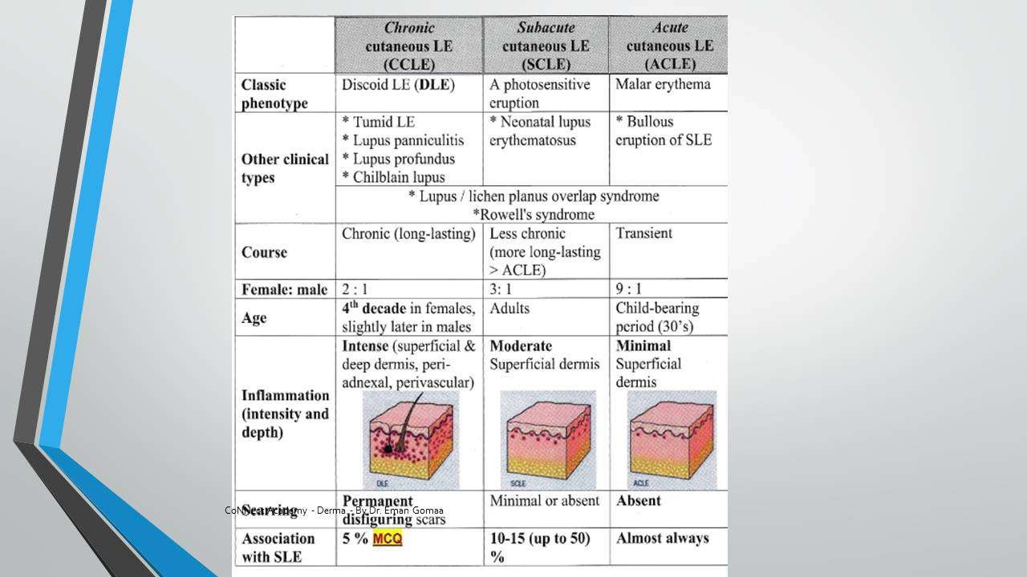

Sites
- Localized: Head, neck, face — sun-exposed areas (confirms UV as main trigger).
- Disseminated: Sun-exposed + sun-protected areas — higher risk of Systemic LE.

Conversion to Systemic LE
- 5% of Discoid LE converts to Systemic LE.
- 15% of Systemic LE has Discoid as a cutaneous manifestation.
- MUST do ANA in ALL Discoid LE cases.

Complications
- Scarring → risk of Squamous Cell Carcinoma (SCC) in scar tissue.
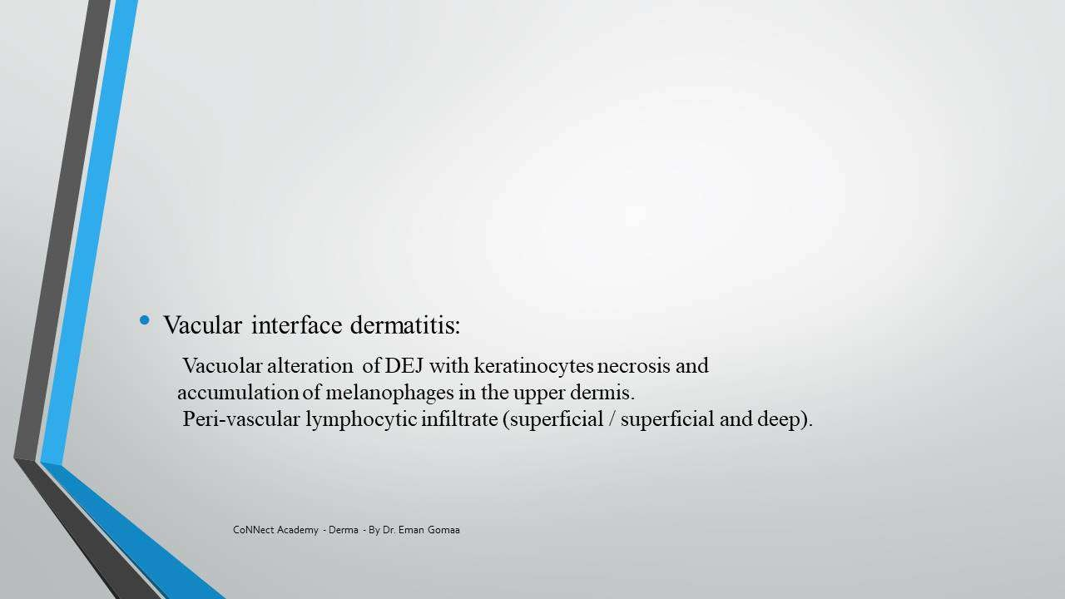

Differential Diagnosis
- Tinea faciei — fungal infection of the face.
- Psoriasis — annular or discoid type.
- Sarcoidosis — fleshy papules/plaques.
- Lupus vulgaris (TB) — shares the severe scarring feature; different disease entirely.
- Granuloma faciale — chronic vasculitis; plaque with follicular dilatation (visible dilated pores).
- Jessner Lymphocytic Infiltrate — T-cell lymphoproliferative disorder.
- Polymorphous Light Eruption (PLE).
- Dimorphic fungal infection.
- Discoid eczema.
- Clinical pearl: Don't just memorize differentials — look at IMAGES of each disease. Photo-memory is the most important tool for clinical dermatology.

Translated & Tidied Audio Transcript
Dr. Eman: Let's talk about Discoid or Chronic Cutaneous LE. What does Discoid mean? It means coin-shaped — like placing a coin on the skin. It's an erythematous telangiectatic plaque with follicular plugging (you can see white dots on the follicles with the naked eye — keratin plugging). There's severe scarring and atrophy, central hypopigmentation with peripheral hyperpigmentation.
Dr. Eman: Location: Localized to head, neck, face — sun-exposed areas. This confirms that UV is the main trigger for LE. There's also a disseminated type that appears in both sun-exposed and sun-protected areas — this should worry us more about Systemic LE.
Dr. Eman: Complications: scarring that can develop SCC. Regarding systemic conversion: 5% of Discoid LE converts to Systemic LE, OR it could be Systemic from the start with Discoid as one of its skin signs (15%). So it is a MUST to do ANA in every Discoid LE case.
Student: Tinea faciei for differential.
Dr. Eman: Yes! Also Psoriasis, Sarcoidosis, Lupus vulgaris (TB — same name 'Lupus' meaning 'wolf' because it eats into the tissue), Granuloma faciale, Jessner lymphocytic infiltrate, PLE, and dimorphic fungal infection. But don't just memorize these — open each one and LOOK at the images. The differentials are about recognizing visual patterns, not memorizing lists.

7. Chronic CLE — Tumid LE, Lupus Panniculitis/Profundus, Chilblain LE

Summary

Tumid LE
- Looks like urticaria — edematous plaque (like a wheal that doesn't fade in 24 hours).
- Only edema + erythema — nothing else.
- NO scale, NO plugging, NO scar, NO atrophy — no epidermal changes.
- Histopathology: No epidermal changes; intense dermal lymphocytic infiltrate (patchy).
- DDx: Urticarial vasculitis, 5L diseases.
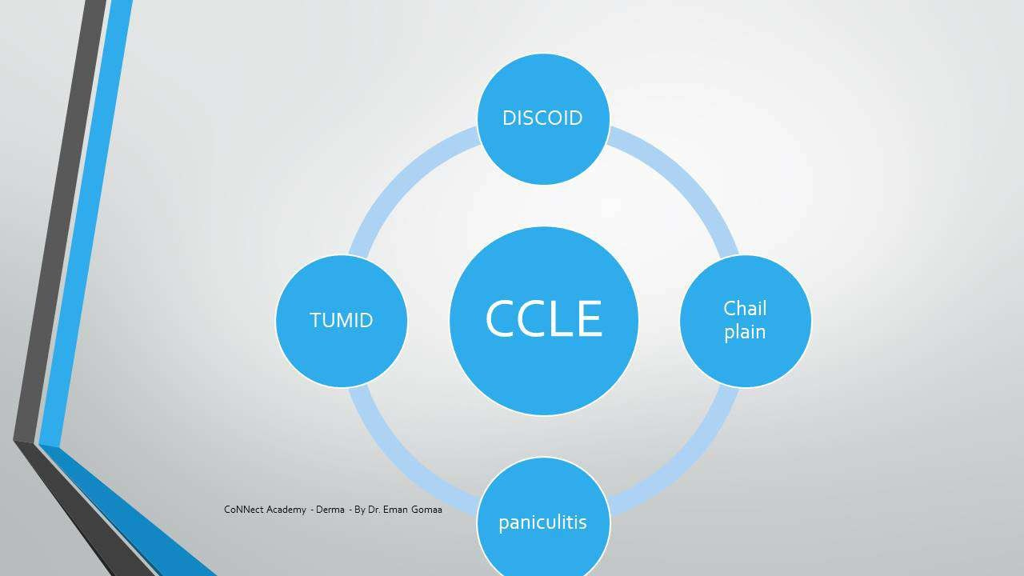

Lupus Panniculitis
- Panniculitis = inflammation in the subcutaneous fat.
- The skin surface is NORMAL — the problem is deep in the fat.
- Presents as: Firm nodule or plaque under normal skin.
- Fat is destroyed → leaves a cup-shaped depression after resolution.
- Sites: Face, upper arm, upper trunk, breast, buttocks.
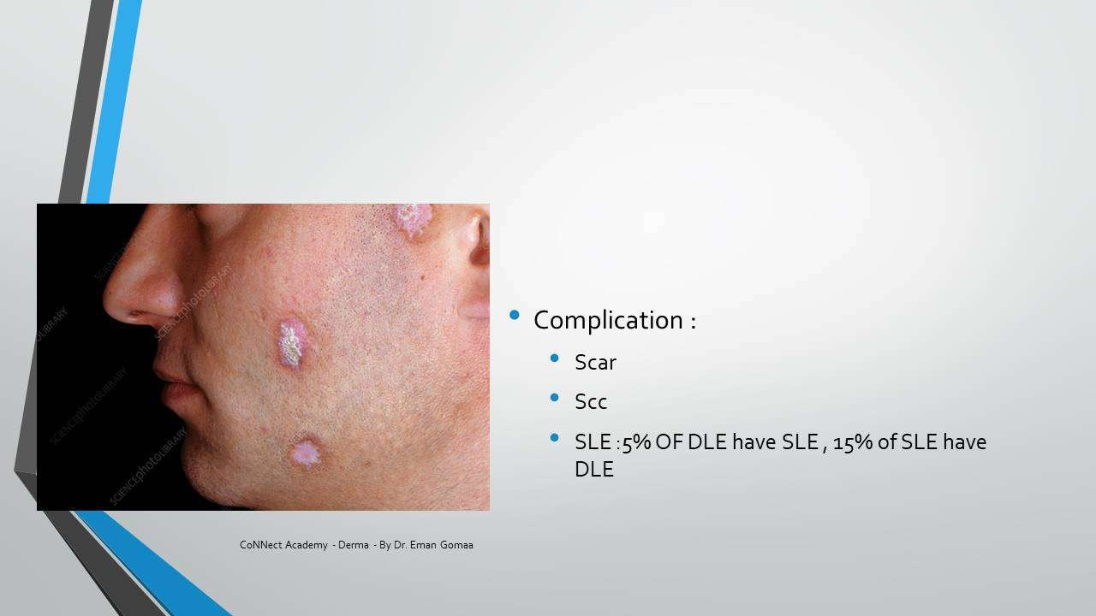

Lupus Profundus
- Lupus Profundus = Discoid LE (surface) + Lupus Panniculitis (deep) TOGETHER.
- Has BOTH: surface scarring/atrophy/plugging (from Discoid) AND deep depression (from panniculitis).

Chilblain LE
- Red-purple papules/plaques on toes, fingers, nose, ears, knees, elbows.
- Triggered by cold + pregnancy.
- Same concept as idiopathic chilblains (vasoconstriction → inflammation) but more severe and persistent.
- Idiopathic chilblains: seasonal (winter only), family history, common in females.
- Chilblain LE: may persist beyond winter (summer too), more aggressive, associated with LE.
- Screening: If severe/persistent → do ANA. Positive = investigate for LE. Negative = idiopathic.
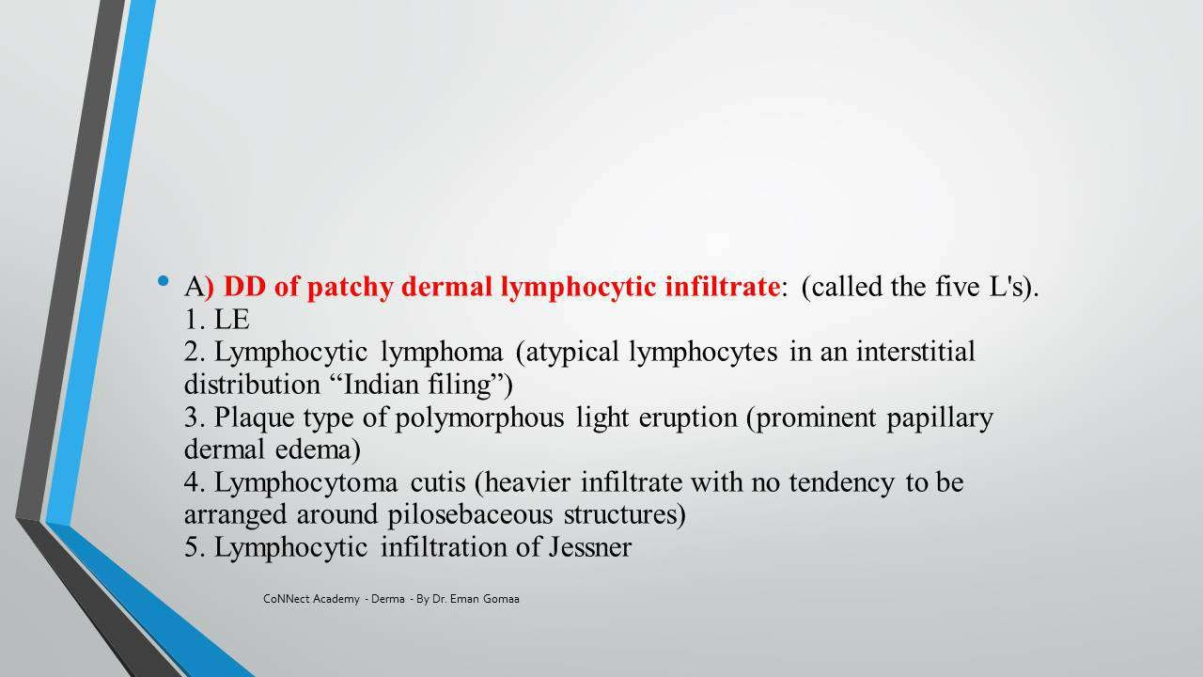

Translated & Tidied Audio Transcript
Dr. Eman: Tumid LE — what does it look like? It looks very much like urticaria! Like seeing a wheal. But of course it's not transient and doesn't fade within 24 hours. I see edema and erythema only — no atrophy, no hyperkeratosis, no scales, no plugging, nothing. Just an edematous plaque that looks urticarial.
Dr. Eman: Lupus Panniculitis — 'panniculitis' means inflammation in the subcutaneous fat. So the skin surface is completely normal — the problem is underneath. When the fat gets inflamed and destroyed, it leaves a cup-shaped depression. It presents as a firm nodule or plaque under normal skin, then resolves leaving a depression. Sites: face, upper arm, trunk, breast, buttocks.
Dr. Eman: Now if I have Lupus Panniculitis underneath AND Discoid LE on the surface at the same time — both together — what's that called?
Student: Lupus Profundus.
Dr. Eman: Exactly! Lupus Profundus means Discoid on the skin plus Panniculitis deep. So you'll see the depression AND the scar/atrophy/plugging.
Dr. Eman: Chilblain LE — what's a chilblain? When we're exposed to cold, peripheral vessels vasoconstrict, causing inflammation that appears as itching, burning, and purple papules on fingers and toes. For idiopathic chilblains, treatment is keeping warm, topical steroids, Minoxidil (vasodilator), Trental (improves circulation), Vitamin C. But Chilblain LE is the same description but more aggressive — red-purple papules on toes, fingers, nose, ears, knees, elbows. Increased by cold and pregnancy. It persists beyond winter. If severe, do ANA screening. Positive = investigate for LE.

8. Subacute CLE & Neonatal LE

Summary

Subacute CLE
- Photosensitive eruption on chest and back (sun-exposed areas).
- Morphology: Annular/polycyclic OR Psoriasiform/papulosquamous.
- No scarring — heals with hypo/hyperpigmentation only.
- Antibodies: Anti-Ro + Anti-La positive.
- Drug triggers (MUST MEMORIZE): Thiazides, Terbinafine.
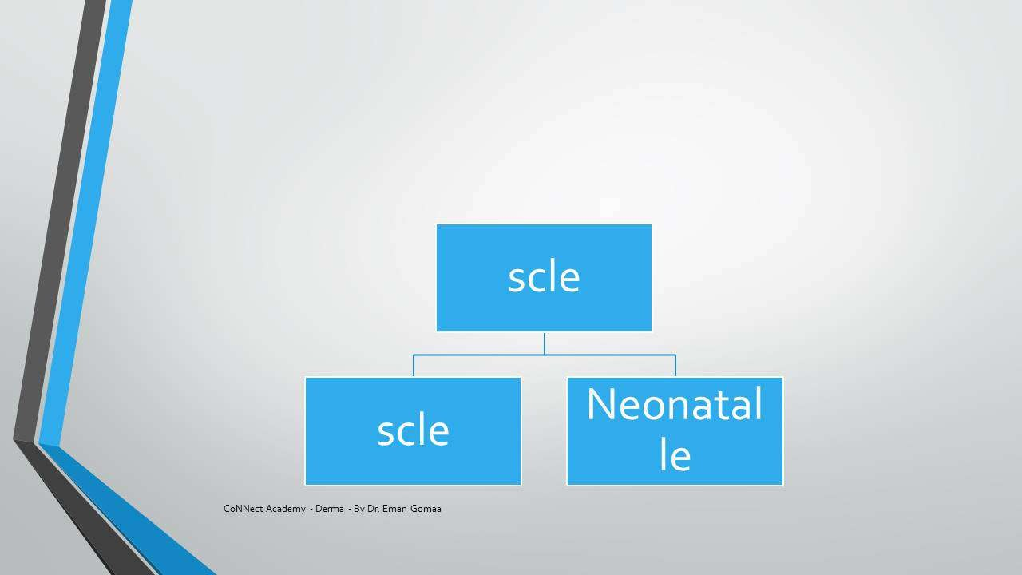

Subacute CLE — Differential Diagnosis
- Disseminated fungal infection — active border resemblance.
- Erythema annulare (eruptive).
- Pemphigus foliaceus — MOST SIMILAR differential (erythema + minimal scales/crustation, doesn't look bullous).
- Annular Psoriasis.
- Tinea corporis.
- Pityriasis rosea.
- Granuloma annulare.
- Annular eczema.

Neonatal LE
- Mother passes Anti-Ro antibodies to infant (transplacental transfer).
- 3 Systems Affected:
- Skin: Raccoon eyes (annular lesions around eyes), photosensitivity — SELF-LIMITED, no treatment needed.
- Heart: Congenital heart block — 20% mortality rate — may need pacemaker. MOST FEARED complication.
- Hepatobiliary + Thrombocytopenia: Reversible, relatively mild.
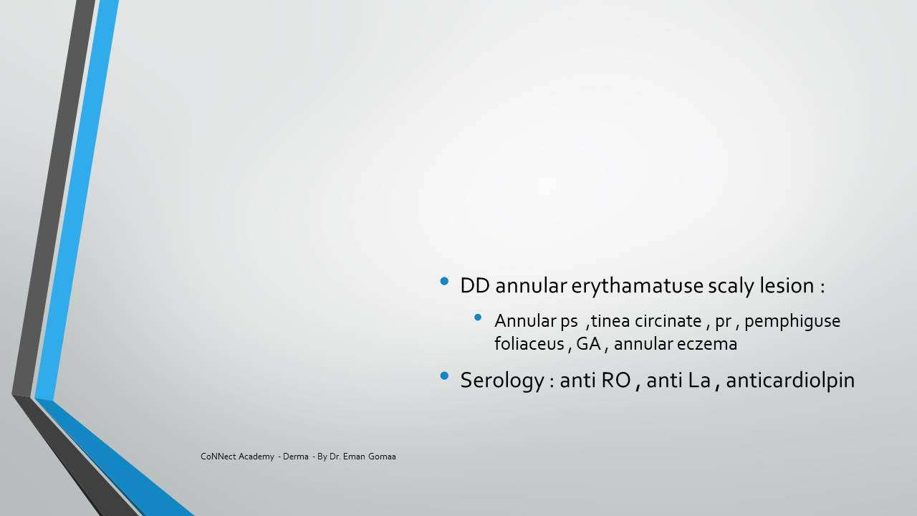

Neonatal LE — Investigations & Treatment
- Investigations: Echo (cardiac), CBC (thrombocytopenia), Liver function tests.
- Treatment — Cutaneous: Self-limited, no treatment.
- Treatment — Cardiac: Pacemaker if heart block.
- Treatment — Hepatic/Hematological: Reversible, supportive care.

Translated & Tidied Audio Transcript
Dr. Eman: Subacute LE comes in two forms: the regular Subacute that affects females, and Neonatal LE. It appears on the chest and back as annular or psoriasiform lesions — a photosensitive eruption in sun-exposed areas. It's positive for anti-Ro and anti-La. Important drug triggers: Thiazides and Terbinafine — memorize these. No scarring — heals with hypopigmentation or hyperpigmentation only.
Dr. Eman: Differential diagnosis for annular lesions: disseminated fungal infection (looks like active border), erythema annulare, Pemphigus foliaceus (the MOST similar — it's erythema with minimal scales, doesn't look bullous at all), annular psoriasis, tinea corporis, pityriasis rosea, granuloma annulare.
Dr. Eman: Neonatal LE — the mother gives anti-Ro or anti-La to her baby. The baby gets Neonatal LE. What do I fear? What am I afraid of?
Student: Heart block.
Dr. Eman: Exactly! I'm afraid of heart block. I see a newborn with annular lesions on the face, especially around the eyes (Raccoon eyes). My fear is congenital heart block — 20% mortality rate. The three systems: Skin (raccoon eyes, photosensitivity — self-limited for us), Heart (congenital heart block — may need pacemaker), and Hepatobiliary plus Thrombocytopenia (reversible). Investigations: Echo, CBC, Liver function. The skin is our concern as dermatologists but it resolves on its own. The heart is the most feared complication.

9. Acute CLE & Systemic LE Overview

Summary

Acute CLE = Multi-Organ Disease (Systemic LE)
- Acute CLE essentially equals Systemic LE — multi-organ disease with skin features.

Specific Cutaneous Signs
- Malar erythema (butterfly rash).
- Poikiloderma.
- Bullous LE — antibody against Collagen VII → separation → bullae.
- Oral ulceration.

Non-Specific Cutaneous Signs (Vascular)
- Raynaud's phenomenon.
- Livedo reticularis.
- Periungual telangiectasia.
- Purpura.

Other Cutaneous Features
- Alopecia.
- Palmar/plantar erythema.
- Scleroderma-like changes.
- Calcinosis cutis.
- Rheumatoid nodules.
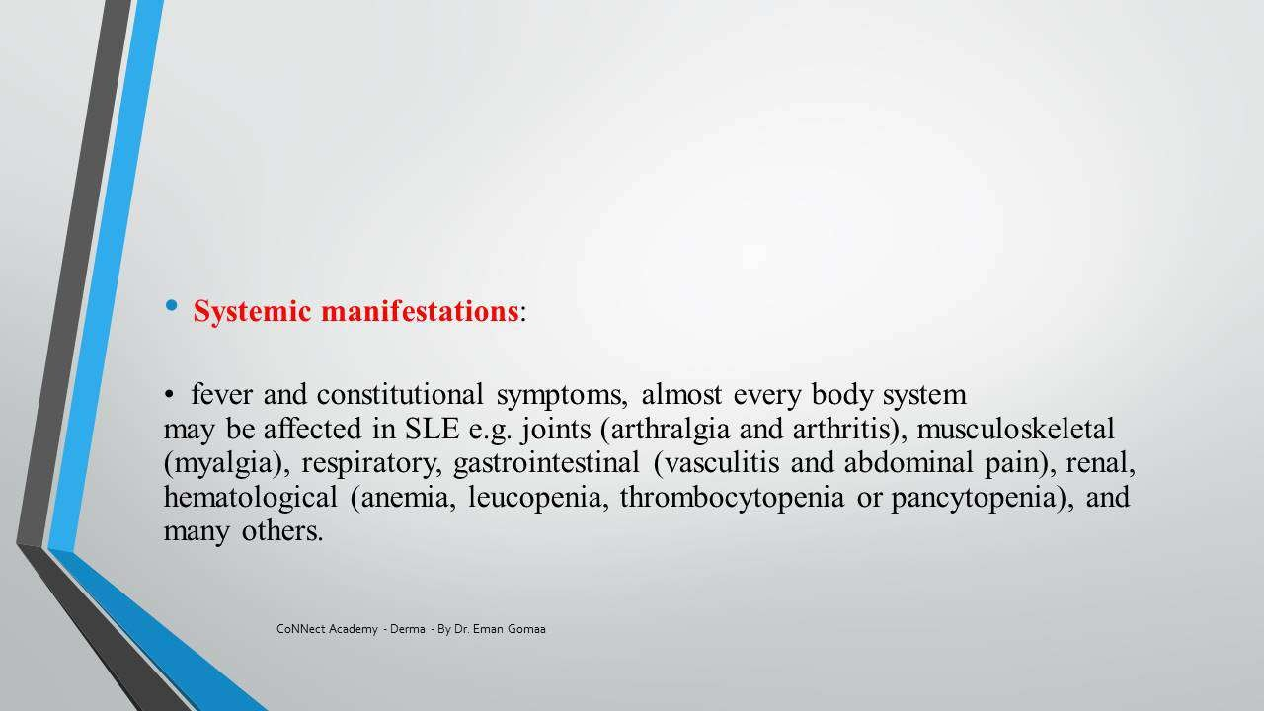

Systemic LE — The 11 Criteria
- Malar rash (butterfly distribution).
- Discoid rash.
- Photosensitivity.
- Oral ulcers.
- Arthritis (non-erosive, 2+ peripheral joints).
- Serositis (pleuritis or pericarditis).
- Renal — persistent proteinuria >0.5g/day OR cellular casts.
- Neurological — seizures OR psychosis.
- Hematological — hemolytic anemia, leukopenia, lymphopenia, OR thrombocytopenia.
- Immunological — anti-dsDNA, anti-Sm, or antiphospholipid antibodies.
- ANA positive.
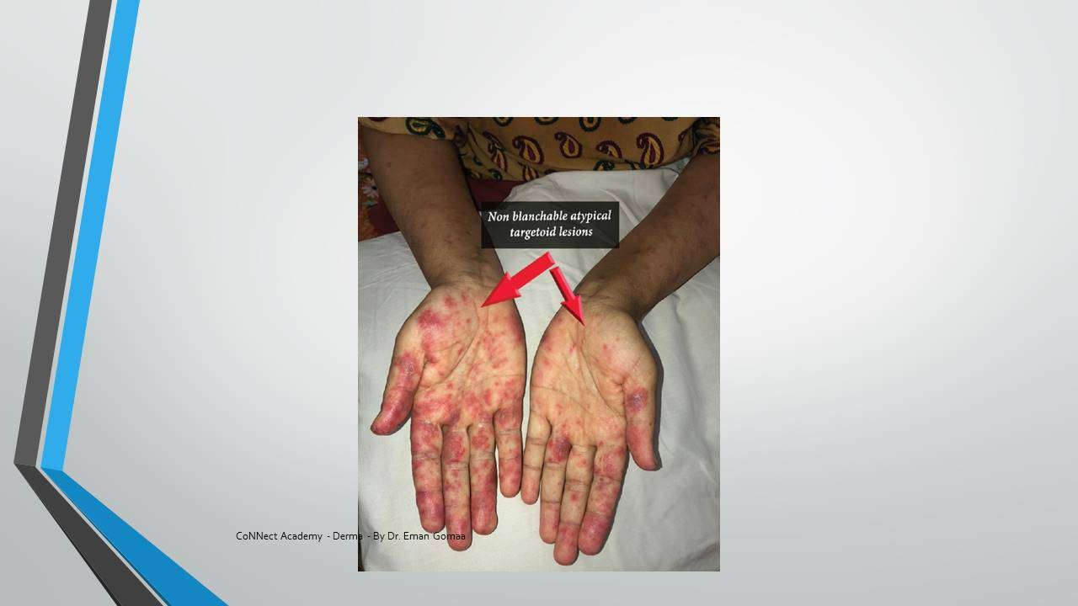

Bullous LE — Special Variant
- Antibody against Collagen VII → basement membrane separation → bullae formation.
- NOT a separate bullous disease — it's part of Systemic LE process (autoantibodies targeting collagen VII just like they target kidney/lung).
- Histopathology: Like Dermatitis Herpetiformis (DH) with neutrophils — memorize this association.

Rowell Syndrome
- Erythema multiforme-like lesions + Cutaneous LE.
- EM-like lesions on face, neck, hands, chest.
- Important for SCE exams — frequently tested.

Translated & Tidied Audio Transcript
Dr. Eman: Acute LE is a multi-organ disease. Remember the SLE criteria we've learned throughout our years of study? That's what this is. From the skin perspective: specific signs include malar erythema, poikiloderma, bullous LE, and oral ulceration. Non-specific vascular signs: Raynaud's, livedo reticularis, periungual telangiectasia, purpura. Other findings: scleroderma, calcinosis cutis, alopecia, palmar erythema.
Dr. Eman: The criteria — approximately 11: Malar rash, Discoid rash, Photosensitivity, Oral ulceration (these four are the skin ones). Then: Arthritis, Serositis, Renal, Neurological, Hematological, Immunological. Renal means persistent proteinuria >0.5 with cellular casts. Neurological means seizures or psychosis. Hematological: hemolytic anemia, leukopenia, lymphopenia. These come as cases in exams.
Dr. Eman: Bullous LE — there's an antibody against collagen VII. What's collagen VII? It's part of the DEJ. If it's destroyed, separation occurs and bullae form. But this is part of Systemic LE — the same autoimmune process that attacks kidney and lung also attacks collagen VII. Histopathology: like DH with neutrophils. The Rowell Syndrome is LE with erythema multiforme-like lesions on face, neck, hands, chest — important for exams!

10. Treatment of LE

Summary

Cutaneous LE Treatment
- Sun protection — essential for all LE patients.
- Topical/intralesional corticosteroids (superpotent).
- Topical calcineurin inhibitors.
- Topical retinoids.
- Systemic antimalarials: Hydroxychloroquine, Chloroquine, Quinacrine 100mg daily.
- Combination antimalarial therapy if needed.

Antimalarial-Resistant Cutaneous LE
- Retinoids (systemic).
- Thalidomide.
- Dapsone.
- Immunosuppressives: Mycophenolate mofetil, Azathioprine.
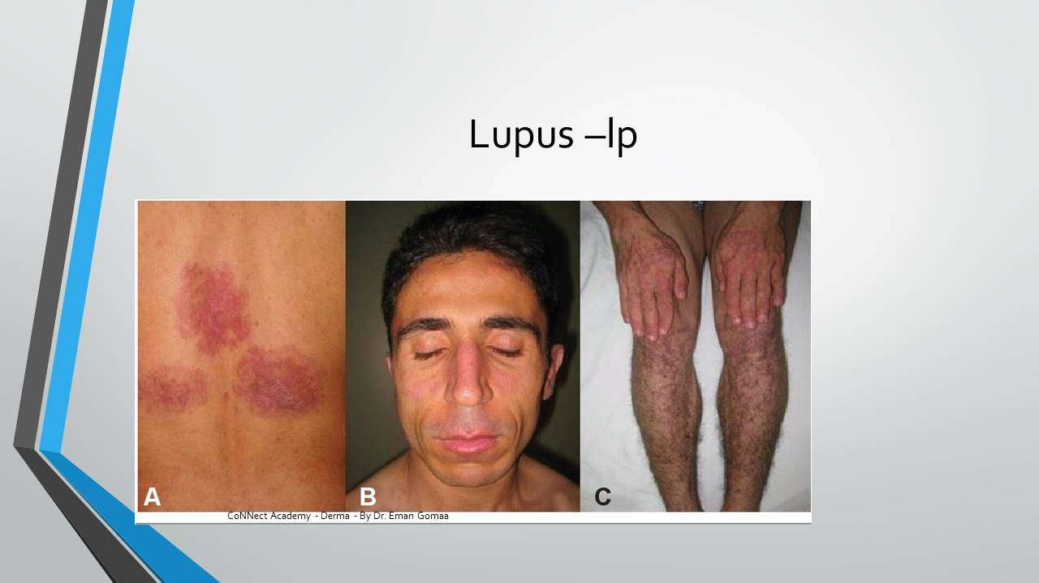

Systemic LE Treatment — By Severity
- Mild (no major organ involvement): NSAIDs.
- Moderate: Corticosteroids + immunosuppressive agents.
- Moderate-Severe: Cyclophosphamide + Corticosteroids.

Biologics
- Rituximab = Anti-CD20 / Anti-B cell monoclonal antibody.
- Used in ANY antibody-mediated disease (attacks B-cells that produce the pathogenic antibodies).
- Also used in: Pemphigus (bullous disease), other antibody-mediated conditions.
- Mechanism: Targets CD20 on B-lymphocytes → depletes B-cells → reduces autoantibody production.

Translated & Tidied Audio Transcript
Dr. Eman: Treatment for cutaneous LE: Sun protection, topical/intralesional steroids, topical calcineurin inhibitors, topical retinoids, and systemic antimalarials — Hydroxychloroquine, Chloroquine, Quinacrine 100mg daily. If antimalarial-resistant: retinoids, thalidomide, dapsone, immunosuppressives like Mycophenolate mofetil and Azathioprine.
Dr. Eman: For Systemic LE — if mild with no major organ involvement: NSAIDs. Moderate: corticosteroids plus immunosuppressive. Moderate to severe: Cyclophosphamide with corticosteroids. What biologic do we use? Something against B-lymphocytes, against CD20. Has anyone heard of Rituximab?
Student: Rituximab... I get confused between it and JAK inhibitors.
Dr. Eman: No, JAK inhibitors are different (Tofacitinib). Rituximab is a monoclonal antibody against CD20, against B-cells. We use it in any disease related to antibodies attacking the body. It's used in Pemphigus as well — any disease related to B-cells and antibodies. It's called anti-CD20 or anti-B cell (Rituximab).

Bonus: End-of-Lecture MCQ Discussion

Q1: Venous Ulcer Management
Dr. Eman: Let's solve a few SCE questions. This one: A 49-year-old woman presented to the leg ulcer clinic with a painful ulcerated area over the left ankle, 4 months duration, dressed with iodine and honey by the practice nurse but gradually enlarging and becoming more painful. She was prescribed antibiotics after a swab grew Pseudomonas. History: diabetes, rheumatoid arthritis, ischemic heart disease. Medications: Ramipril, Simvastatin, Aspirin, Naproxen. Examination: ulcer on left lower leg with dull red indurated surrounding skin; right leg had edema and dull red discoloration with induration. Foot pulses palpable.
Dr. Eman: What is the most appropriate treatment? Options: A) Advise elevating the left lower leg. B) Multi-layer compression bandage. C) Single layer compression bandage. D) Urgent incisional biopsy. E) Compression stocking.
Student: Multi-layer compression bandage.
Dr. Eman: Correct! They're all close to each other. The key is understanding that for varicose veins/venous ulcers, we need compression. But is it multi-layer or single layer? A large systematic review showed that chronic venous ulcers heal faster with compression — specifically with multi-component systems containing elastic, which are more effective than single-component systems. This level of detail won't come up in our lectures but appears in SCE questions. The answer: Multi-layer compression bandage.

Q2: Vitamin A and Isotretinoin
Dr. Eman: A patient with nodulocystic acne on face, chest, and back is about to start Isotretinoin. He asks whether his vitamin supplements would interact. Which vitamin should he discontinue?
Student: Vitamin A.
Dr. Eman: Correct — straightforward question. Isotretinoin is a retinoid, chemically related to Vitamin A. Concomitant use of Vitamin A supplements causes potential danger of hypervitaminosis A. Simple question, nothing complicated.

Q3: Acneiform Eruption from Anti-TB Drugs
Dr. Eman: A patient on TB medications develops inflammatory papules and pustules on cheeks, chin, upper chest, and upper back. No comedones. Which medication is responsible?
Student: Isoniazid and Rifampicin?
Dr. Eman: Let me explain the thought process. First identify WHAT the rash is: papules and pustules, no comedones = acneiform eruption (not true acne — no comedones). What drugs cause acneiform eruption? Steroids, Phenytoin, Barbiturates... and among anti-TB drugs: Isoniazid and Rifampicin. This is uncommon and not well-documented in many textbooks, but it's the answer. The full list of drugs causing acneiform eruption: Anabolic steroids, Androgenic hormones, Anticonvulsants, Antidepressants (Lithium), Corticosteroids, Isoniazid, Rifampicin — know this list.

Bonus Q&A: Drug-Triggered Psoriasis & Biologics
Student (Dr. Doaa): Dr. Eman, about yesterday's psoriasis drug question — Lithium, Indomethacin, and Inderal. Why wasn't the answer 'all of the above'?
Dr. Eman: Because Lithium is the strongest/most important trigger (50% trigger rate). Indomethacin (NSAID) is mentioned in some sources but isn't among the 'classic strong triggers' for psoriasis. The question logic: always pick the MOST correct or STRONGEST answer. For SCE specifically, the questions are case-based, so always choose the best single answer.
Student (Dr. Doaa): And the Crohn's disease biologics question — why Ustekinumab over Infliximab?
Dr. Eman: Ustekinumab (Stelara) is FDA-approved for Psoriatic Arthritis AND Crohn's disease. Secukinumab (Cosentyx) should NOT be used with Crohn's — it can actually trigger/worsen IBD. Infliximab has specific indications. Read the explanation — it clarifies why Ustekinumab was the correct answer for a patient with both Psoriatic Arthritis and Crohn's.

