Analysis Of Machine Learning Algorithms

Ali Nauman (18L-1863)
Computer Science Department
FAST-NUCES
Lahore, Pakistan

Abstract— The purpose of the assignment is to implement a linear model using the first principle (i.e. implementation from scratch using the basic definition/algorithms) and to check and see if the simple linear models can really be applied to solve some real word problems. Furthermore, we shall implementing Kernel Perceptron Learning and SVM HOG on one of the datasets.

Keywords—Machine Learning; MINIST; Urban Sound; Perceptron Learning; Gradient Descent; Normal Equation; Kernel Perceptron; SVM – HOG;

Introduction
In this paper, we are going to implement numerous learning algorithms for the linear models. Also, we are going to experiment with Kernel Perceptron Learning and SVM Hog on one of the datasets.
The rest of this paper is organized as follows: Section 2 describes the specific details related to our work. This will include in detail about the algorithm we shall implement and an overview of the datasets. Comparative analysis is done in Section 3. Section 4 concludes the whole paper.
This paper gives a clear picture of algorithmic efficiency of the above-mentioned models in terms of accuracy and efficiency.

Background Knowledge & literature review

Machine Learning
Machine learning is an application of artificial intelligence (AI) that provides systems the ability to automatically learn and improve from experience without being explicitly programmed. Machine learning focuses on the development of computer programs that can access data and use it learn for themselves. The process of learning begins with observations or data, such as examples, direct experience, or instruction, in order to look for patterns in data and make better decisions in the future based on the examples that we provide. The primary aim is to allow the computers learn automatically without human intervention or assistance and adjust actions accordingly. [1].

Normal Equation
The first implementation is of Normal Equation. In this method, we have a matrix and we have to find the resulting labels by matrix multiplication. Let’s assume that we have n x n Matrix, M and a vector Matrix, Y. We need to find the weights Matrix, W.
- Finding the transpose of the Matrix, M.
- This will be followed by the matrix multiplication of the 'transpose matrix, M' and ‘M’.
- Then we need to find the inverse of the above calculated matrix multiplication.
- Matrix multiplication between the 'transpose matrix, M' and vector matrix, Y.
- In the next step, calculate the matrix multiplication between ‘Step-3’, which is the inverse of the matrix multiplication, and ‘Step-4’, which is the matrix multiplication between the 'transpose matrix, M' and vector matrix, Y[4].

Gradient Descent
In understanding this, we need to realize a few basics before we delve into more complexities. Y has a nice linear relationship with X.
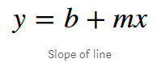
We express the equation for a line in terms of machine learning in a different way. I would call y as my hypothesis and represent it as J (theta) and call b as theta0 and m as theta1.
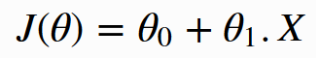
The idea is to choose theta0 and theta1 so that J (theta) is close to ‘y’ for our training examples (x, y). Now for this, we need to have a learning rate, which is the size of steps we need to take on the slope in any direction. Also, we need to find a cost function.

Cost function is a measure of how wrong the model is in terms of its ability to estimate the relationship between X and y. This is typically expressed as a difference or distance between the predicted value and the actual value. The cost function can be estimated by iteratively running the model to compare estimated predictions against “ground truth” — the known values of y.

Moving forward, the objective of the model is to find parameters, weights that minimize the cost function.

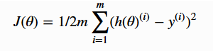
The model learns by minimizing a cost function and gradient descent is used to minimizing it. Gradient descent is an efficient optimization algorithm that attempts to find a local or global minima of a function.
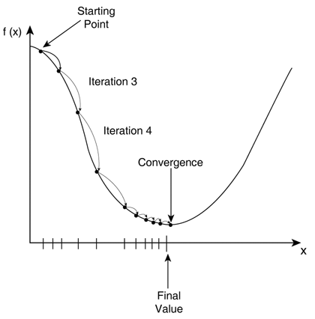
We start with a random Theta vector and predict the j (Theta), then derive cost using the above equation which stands for Mean Squared Error (MSE). The MSE in this case is the cost function. It is simply the mean of the squared differences between predicted y and actual y.
Furthermore, we need to calculate theta0 and theta1, and we have a mathematical calculations for these as described below:
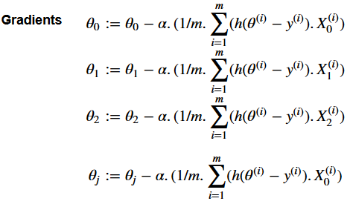 Where alpha = Learning Rate.

With small learning rates it takes long to converge to the solution whereas with larger learning rates it is quicker. However, the learning rate value is very dependent on the data we have. The best way is to start with a larger learning rate and then slowly reduce the learning rates as we approach the solution [3].

Perceptron Learning
We need to understand that perceptron learning algorithm is the simplest type of artificial neural network. The Perceptron is inspired by the information processing of a single neural cell called a neuron.
A neuron accepts input signals via its dendrites, which pass the electrical signal down to the cell body.

Perceptron receives input signals from examples of training data that we weight and combine it in a linear equation. It is then transformed into an output value or prediction.

Perceptron is a classification algorithm for problems with two classes (0 and 1) where a linear equation can be used to separate the two classes.

The weights of the Perceptron algorithm are estimated from the training data. Then it is applied on the test data to fit and predict values/labels [4].

Kernel Perceptron Learning
The kernel perceptron is a variant of the popular perceptron learning algorithm that can learn kernel machines, i.e. non-linear classifiers that employ a kernel function to compute the similarity of unseen samples to training samples. The algorithm was invented in 1964, making it the first kernel classification learner.
Formally, a kernel function is a non-negative semi-definite kernel (see Mercer's condition), representing an inner product between samples in a high-dimensional space, as if the samples had been expanded to include additional features [7].

SVM HOG
A Support Vector Machine (SVM) is a discriminative classifier formally defined by a separating hyper-plane. In other words, given labeled training data (supervised learning), the algorithm outputs an optimal hyper-plane which categorizes new examples. In two dimensional space this hyper-plane is a line dividing a plane in two parts where in each class lay in either side.
In this analysis Support Vector Machines (SVM) are used to train a model to classify if an image contains a number or not. The feature representation method Histogram of Oriented Gradients (HOG) are used as the feature representation.
The histogram of oriented gradients (HOG) is a feature descriptor used in computer vision and image processing for the purpose of object detection. The technique counts occurrences of gradient orientation in localized portions of an image. This method is similar to that of edge orientation histograms, scale-invariant feature transform descriptors, and shape contexts, but differs in that it is computed on a dense grid of uniformly spaced cells and uses overlapping local contrast normalization for improved accuracy.
[8].

MNIST Data Set
The MNIST database (Modified National Institute of Standards and Technology database) is a large database of handwritten digits. The MNIST database contains 60,000 training images and 10,000 testing images.

I have imported the data using Pandas data-frame. Given the huge amount of data, I have divided the test dataset file into training and test dataset. During the exploration of the dataset, we came through a lot of things to learn before we begin our implementation.
Let’s have a look into the rows of the dataset. We see it as n x m matrix, with n = 9999 examples (images) in the dataset. We also visualized the original images, taking 5 rows at random,
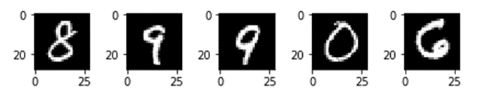
Now we need to find the general statistical properties of the dataset. As we know that many of the pixels have intensity '0'.
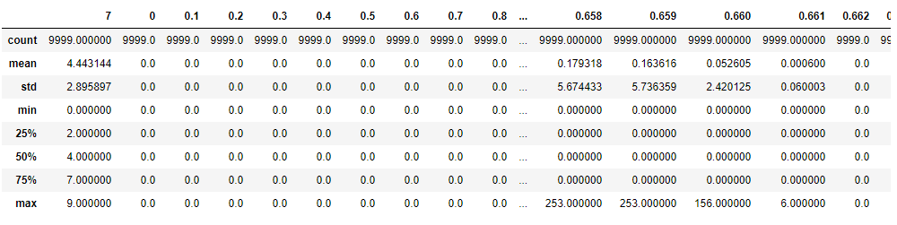
While exploring the dataset, we also found the most likely pixel responsible for containing the digit. This can be calculated by finding the pixel column with the maximum mean.
Column Name: '0.370' [5].

Urban Sound Data Set
This dataset contains 8732 labeled sound excerpts (<=4s) of urban sounds from 10 classes: air conditioner, car horn, children playing, dog bark, drilling, enginge_idling, gunshot, jackhammer, siren, and street music.
We have performed feature extraction on the audio files. As we can see the below diagram, which states the type of features available in the audio file,
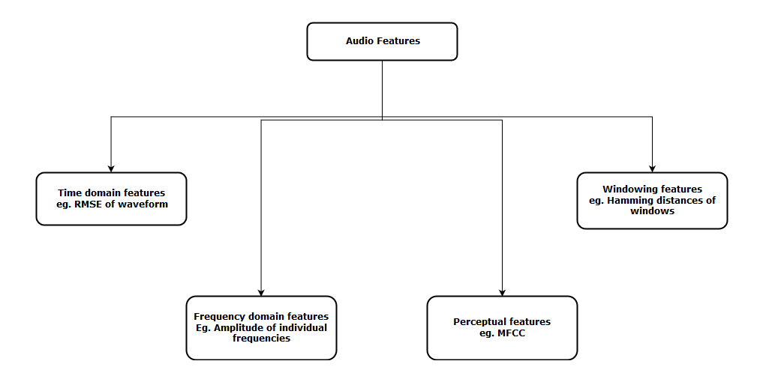
We will be using a few extra libraries such as ‘librosa’, ‘soundfile’ and ‘python_speech_features’ to extract features out of the sound file.
Also, we have plotted, MFCC, one of the features,
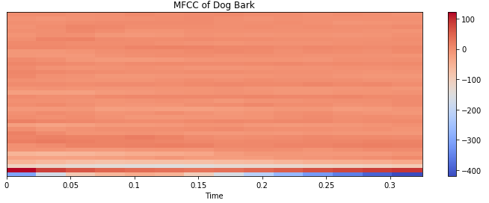

Mel-Spectrogram of the dog bark sample, which is another feature we will be working with,
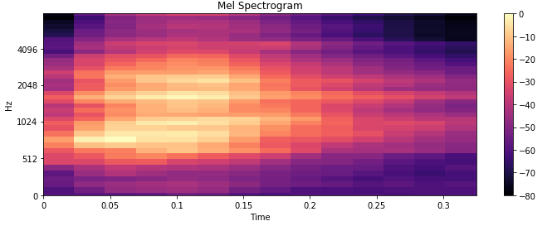

Linear Regression
Linear regression is a linear approach to modelling the relationship between a scalar response (or dependent variable) and one or more explanatory variables (or independent variables). The case of one explanatory variable is called simple linear regression. For more than one explanatory variable, the process is called multiple linear regression. [6]

Methodology & CompAritive analysis of Algorithms
In this section we have presented the methodology used for determining the accuracy of the models and the comparison of the discussed algorithms. The results are obtained for two different data sets MNIST & Urban Sound. The accuracy of the model can be easily determined through how much labels it has predicted. The following formulae has been utilized to calculate the accuracy of the prediction values in comparison to the original ones. The result obtained are shown in Table 1.

Table 1. Comparative Analysis of Accuracy

Data Set | Perceptron Learning | Gradient Descent | Normal Equation
MNIST | 85.4% | 73.15% | 71.09%
URBAN SOUND | 84.9% | 76.5% | 73.4%

Furthermore, we have used Kernel Perceptron Learning and SVM HOG, to classify the MNIST data.

Dataset | Kernel Perceptron | SVM HOG Classifier
MNIST | 86.5% | 87.9%

Conclusion
Thus, it can be concluded that gradient descent forms the basis of any model. It is simple yet it can provide us with a base accuracy to experiment with. And we can move on from that to other models and keep on improving our prediction base.
Furthermore, Kernel Perceptron and SVM Hog has further increased our performance of the model. Kernel Perceptron, allows the features to be mapped in high dimensional space. Hog counts occurrences of gradient orientation in localized portions of an image.
Thus, we can safely say, as we keep on enhancing the model, by tuning and adding extra features for better accuracy.

References
- https://www.expertsystem.com/machine-learning-definition/
- https://en.wikipedia.org/wiki/Perceptron#Steps
- https://machinelearningmastery.com/gradient-descent-for-machine-learning/
- http://mathworld.wolfram.com/NormalEquation.html
- https://en.wikipedia.org/wiki/MNIST_database
- https://en.wikipedia.org/wiki/Linear_regression
- https://en.wikipedia.org/wiki/Kernel_perceptron
- https://www.kaggle.com/manikg/training-svm-classifier-with-hog-features

