**MIS 3690 – Web Technologies**

**Operations and Information Management - Babson College**

**Midterm Exam – Spring 2021 – Section 1**

This is an INDIVIDUAL EXAM. This is an open-book, open-notes, open-Web examination. However, you may not use email or IM, and you may not communicate in any way with other people during the course of this exam. You may NOT share any documents in any form with anyone in the course during the completion of this exam.

The exam is worth 100 points. You have 90 minutes to complete this examination. Please make sure that you use a few minutes towards the end to upload the exam to the server and test the pages to make sure that they work the right way. **Please test all files using Mozilla Firefox with a FULL SCREEN WEB PAGE**– that is the browser and format that will be used to evaluate your pages for formatting and look/feel.

**Question 1 – Q1.htm (50 points) – This question has 2 parts – both to be completed using the file Q1.htm given to you.**

**Q1a. (20 points): Please use the file Q1.htm to build a web page that looks like the one shown in figure 1 below. The following are the specifications to complete this question**. Each is worth a point unless stated otherwise.

1. **The heading is formatted with a <h1> tag.**
2. **The acknowledgement below is formatted as a paragraph.**
3. **The sub-headings (3 of them) use <h3> tags.**
4. **The words starting with “USDA” and until “handout” is a paragraph.**
5. **The words starting with “The basic..” and including the words “For example:” is a paragraph.**
6. **The words starting with “The plan..” and until “..the future” is a paragraph.**
7. (3 points) Create the following lists using the text described below:
   1. **Convert the text in the third paragraph right after “For example…” into an unordered list (refer to figure 1 to see what it looks like).**
   2. **The words in the first line, “whole grain cereals”, “rice, or” and “pasta;” must be in an ordered list within the first item in the unordered list.**
   3. **The other two statements must be part of the unordered list started earlier.**
8. **Please hyperlink the following the words in the acknowledgement “**[**http://www.choosemyplate.gov/downloads/MyPyramid_Getting_Started.pdf**](http://www.choosemyplate.gov/downloads/MyPyramid_Getting_Started.pdf) **“ to that same URL.**
9. (5 points) Create a hotspot on the image “choosemyplate25.jpg” so that the RED area labeled “Fruits” is hyperlinked to <http://en.wikipedia.org/wiki/Fruits>. Use a rectangle as the shape and use the coordinates: ”62, 39,128, 92”.
10. (4 points) Add the image “choosemyplate25.jpg” with the hotspot as the first line in the paragraph under the subheading “MyPyramid’s Basic Messages”. Please make sure that the image definition is complete.
11. (2 points) Add the words “Q2.htm” and “Q3.htm” at the bottom of the page and hyperlink it to the second and third questions on this exam (Q2.htm and Q3.htm).

**Q1b. (30 points) the instructions for stylizing Q1.htm are as follows:**

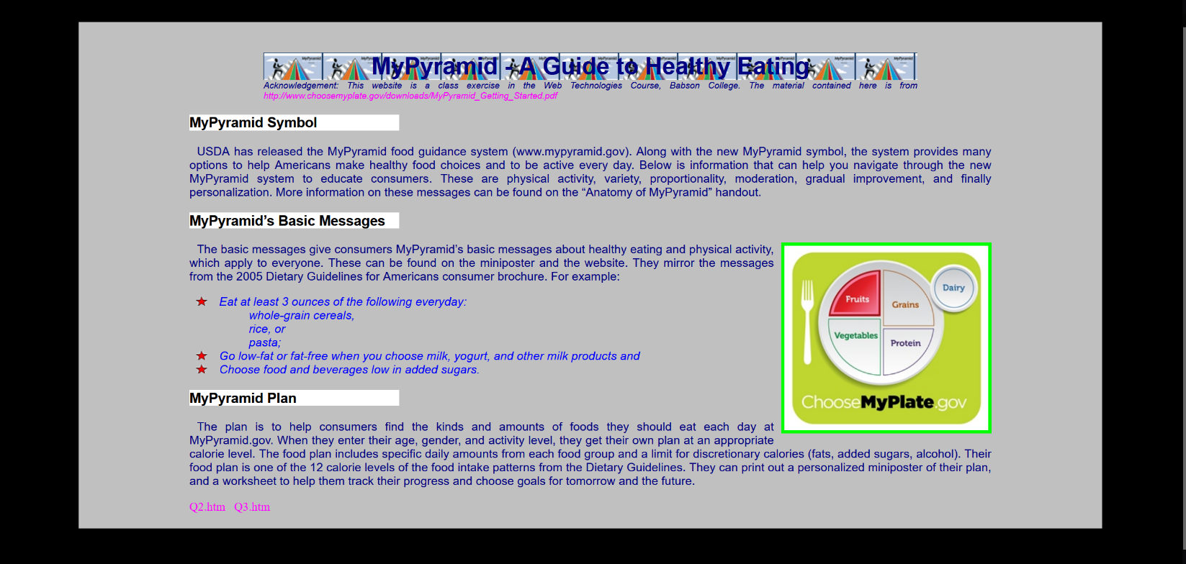

1. (5 points)
   1. The page must have a black color background.
   2. The content on the page must be placed in a silver section as shown. The black strip on either side of the silver area is 100px. The black area to the top and bottom of the silver section is 50px.
   3. All of the text in the silver area must be 150px from the left edge and from the right edge of the silver section. The heading must be 20px from the top edge. The last line on the page must be 20px from the bottom.
   4. The first line of every paragraph must be indented by 10px.
2. (5 points) Center the heading on the page.
   1. “Pyramid.jpg” must be the background for the heading “MyPyramid: A Guide to Healthy Eating”, as shown in figure below.
   2. The heading must have a 250px silver area on each side (left and right)
   3. The heading must use a bold face font of 2em size, Arial and must be in Navy color and must be centered.
3. (4 points) Italicize the acknowledgement paragraph. The font must be 12px in size, navy color and must be justified (alignment). The entire paragraph must be the same width as the heading’s background. There must be no space between the heading and the acknowledgement paragraph (see figure).
4. (3 points) Position the image (choosemyplate25.jpg) as shown to the right. Make sure there is a 10px space between the image and the text-on-the-left-side and between the image and the text-below-the-image. Add a 5px border that is lime in color. The type of border is your choice.
5. (2 points) Each of the 3 sub-headings must have a white background. The background must not extend the width of the page – they must be significantly shorter than one-half the width of the page and all three must be the same width (as seen in figure).
6. (3 points) The ordered list must not have any numbering
7. (5 points) The unordered list must use “star.gif” as the bullet.
8. (3 points) There are 3 hyperlinks on the page (one in the acknowledgement paragraph and two at the bottom of the page). These must not be underlined, must be in magenta colored font. When your mouse-over, their background must change to yellow and return to silver when you mouse-out.

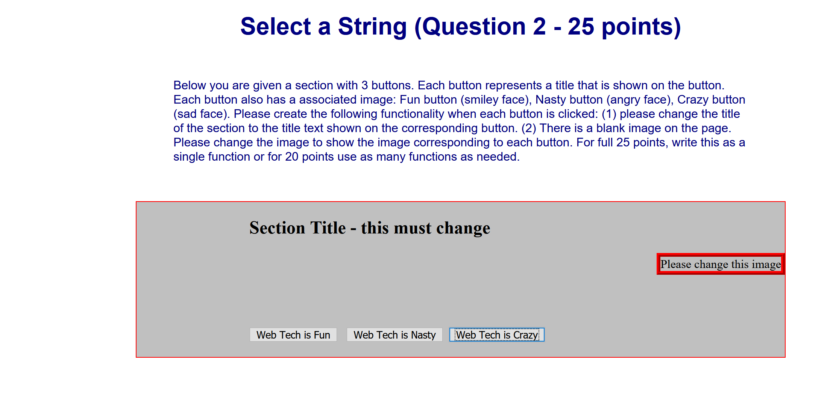

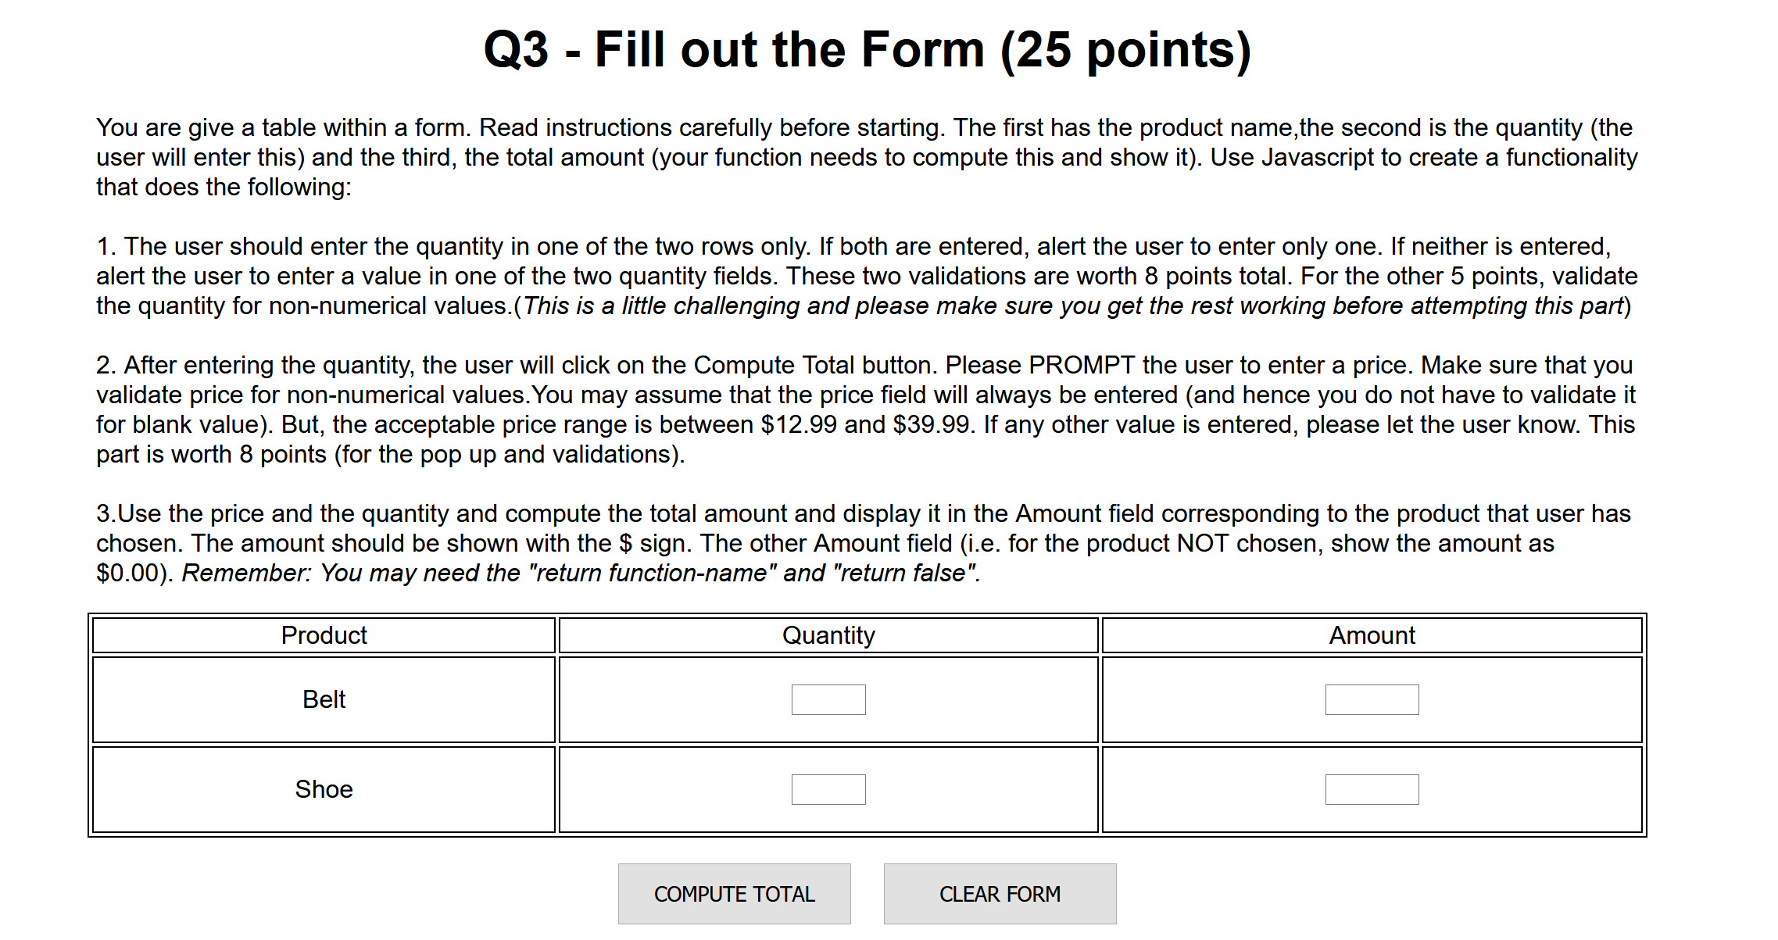

**Make sure the folder has the following files:**

1. Q1.htm
2. Q2.htm
3. Q3.htm
4. Pyramid.gif
5. Choosemyplate25.jpg
6. Star.gif
7. Smiley.jpg
8. Angry.jpg
9. Frown.jpg