**MIS 3690 – Web Technologies**

**Technology, Operations, and Information Management - Babson College**

**Midterm Exam – Spring 2021**

**PLEASE “SIGN” and UPLOAD THIS PAGE ALONG WITH THE EXAM FILES.**

This is an INDIVIDUAL EXAM. This is an open-book, open-notes, open-Web examination. However, you may not use email, IM, and you may not communicate in any way with other people during the course of this exam. You must be present on WebEx for the duration of the exam with video on and audio-muted.

**About the exam:** The exam is worth 100 points. You have 90 minutes to complete this examination. Please make sure that you use a few minutes towards the end to upload the exam to GitHub and test the pages to make sure that they work the right way. **Please test all files using Mozilla Firefox with a FULL SCREEN WEB PAGE**– that is the browser and format that will be used to evaluate your pages for formatting and look/feel.

The exam has a total of 3 questions. The first question requires you to create a web page using HTML and CSS. The other two require you to create the specified functionality using JavaScript. The template for each question is provided to you with the names **Q1M.htm**, **Q2M.htm, and Q3M.htm. Please do not change the names.**

**Availability:** The exam files will be available at the specified time. For students with accommodations, the exam may be available earlier or emailed to your email address at the time agreed upon. For all others, the exam will be available at 9:55am on Tuesday, 30th March, 2021.

**Exam Instructions: (1)** Please download and save all of the exam files, including this document into your SECRET folder. Please DO NOT change the names of ANY of the files. (2) When done, please PUSH the secret folder to GitHub. (3) **Once you have uploaded the files and tested it, please write down the time-stamp on the folder (secret code folder) below your name. Do not do anything that might change/modify the time-stamp of this folder on the server. In other words, do not PUSH anything to GitHub until I tell you to.**

**How to get the time-stamp:** If you place your mouse on the far-right column (see image below on the next page – the column that says “1 minute ago”, or “2 months ago”) on GitHub, on the row corresponding to your secret folder, it will show you the date/time of the last commit to this folder. Please test it before the exam so that you know how to find it. It will work for pretty much any file or folder on Github.com (not your desktop, but the web based GitHub server).

You may test your exam question Q1.htm ON GitHub using the following URL – please substitute your userid, your webtech folder, and your secret folder name in the URL below:

[**http://alindner1.github.io/webtechspring2021/anr2360/Q1.htm**](http://alindner1.github.io/webtechspring2021/anr2360/Q1.htm)

**Honor Code:**

**I pledge my honor that I have neither received nor provided unauthorized assistance during the completion of this work.**

Your Name (in lieu of signature): ­­­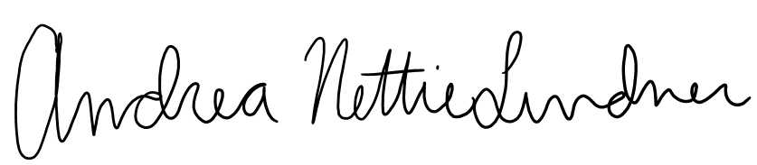

Timestamp: 11:29am

