Module 01 Configuring Your Development Environment

# Log in to Azure

* This Lab introduction can be done on computer or tablet. Phones are too small.
* Log into your Azure account, if you have not already done so.

Create a Storage Account

* Click +**New** located at the top left corner of your dashboard above the icons.
* A pane titled New opens.
* Type the word **Storage** in the filter text box and press **Enter**.
* A new pane opens titled Storage.
* Click on **Storage account (blob, file, table, queue)**.
* A new pane open titled Create storage account.
* Click **Create**.
* Type a **Name** for the storage account in the Name text box (must be all small case).
* Make sure:
* **Deployment model** is **Resource manager**.
* **Account kind** is **General purpose**.
* **Performance** is **Standard**.
* **Important**: Change **Replication** to **Locally-redundant storage (LRS)**.
* Make sure:
  + **Storage service encryption** is **Disabled**.
* For **Resource group** choose the **Create new** radio button.
* **Type a unique name** in the **Resource group text box**.
* **Important**: Make sure **Location** is **Central US**.
* Check the **Pin to dashboard** option.
* Click **Create**.

Deploy a LAMP Virtual Server

* Click +**New** located at the top left corner of your dashboard above the icons
* A pane titled New opens.
* Click inside the **filter text box**.
* **Type “Lamp**” and press **Enter**.
* A pane titled Everything opens that lists a number of options.
* Click on the **LAMP Certified by Bitnami** option**.** DO NOT PICK LAMP Multi-Tier.
* A pane titled LAMP opens.
* Click **Create** at the bottom of the pane.
* A Create virtual machine pane opens.
* Another pane titled Basics opens.
* In the **Name** text box, type in a unique name for your server. Once you click out of the name text box a green checkmark to the right of the name should appear.
* !!! Save this username somewhere you can look it up later. It is the server administrator username.
* **Important**: In the choice drop down for **VM disk type** choose **HDD**.
* Under **Authentication type** click the **Password** option button.
* **Type in an acceptable password** in the two text boxes for **Password** and **Confirm password**.
* !!! Save this password with the administrator user name. It is the server administrator password.
* Under **Resource group** choose the **Use existing** radio button.
* Click the **dropdown list** that appears under Resource group.
* Choose the resource group that you created for your storage account.
* **Important**: For **Location** choose **Central US**.
* Click **OK** at the very bottom.
* **Important**: In the new Choose a size pane that opens click **View all** link on the far right - top of the pane. DO NOT choose one of the recommended choices that first appear. Instead, after choosing **View all**, scroll all the way down and **click on** the **A0** **Basic** **option.**
* The click **Select**.
* A new Settings pane will open.
* Make sure **High Availability** is set to **None.**

Change **Storage: Use managed disks** to **No.**

* Leave the defaults for the **Network settings as is (defaults)**.
* Make sure:
* **Extensions** is set to **No extensions**.
* **Auto-shutdown** is **Off**
* **Boot diagnostics** is **Enabled**.
* **Guest OS diagnostics** is **Disabled.**
* Click on Diagnostics storage account (even if it has a name in it).
* If a **Create Storage account** pane opens, **close it** (Click x on upper right). DO NOT create a new storage account.
* A **Choose storage account pane** will open.
* In the Choose a storage account pane, **choose the storage account you created earlier**.
* **Click OK** at the bottom of the Settings pane.
* A new create pane will open*. Fill the email and telephone with mock data if desired.*
* **Click Create** at the bottom of the pane.
* The panes will close and your dashboard will appear with a new small deployment box for the LAMP server.
* It will take a little bit for the server to be created so have patience. Do not stop the server until this lab is done because you will need to find an entry in the initial boot log near the end of this lab.

Configure the Virtual Server

* Once the server is deployed a new pane for the server should open. If you took a break and it is on your Azure dashboard or in the resource group you created, find and click on the server or server box to open it.
* After you have opened the server administration pane, in the server administration pane there will be a number of options on the left.
* Make sure **Overview** is selected from the options on the left.
* Whenever you stop and restart the server it may acquire a new IP address. Therefore, it is best to give the server a Fully Qualified Domain Name (FQDN) or DNS name so you can use the FQDN to connect to the server.
* In the right pane, under **DNS name** click **Configure.**
* A Configuration pane will open.
* Click in the text box below where it says “**DNS name label (optional)**”.
* Type your **server name**, or a unique name, into the box (must be all lower case).
* Click out of the box to make sure the name is accepted. It will show a green check if it is ok. If not choose a different name.
* DO NOT change the IP address.
* DO NOT change the IP address Assignment. Leave it set to Dynamic.
* Click **Save** at the top and **close the Configuration pane**.
* !!! Copy and save the name and suffix located below DNS name to the right, for later use. The suffix should be **.centralus.cloudapp.azure.com** or something similar. The server name you entered together with the suffix make a FQDN, e.g. *exampleserver.centralus.cloudapp.azure.com*. You can now connect to your server using a web browser using the DNS name in the address bar of the browser.
* Because of the way that the Bitnami server installs it’s MySql database management system software, you will need to locate the MySql application password in the boot log. You will use this password later when you work with or sign in to the MySql application or its associated software that is installed on the server.
* In the Server administration pane’s left hand side options, scroll down and click on “**Boot diagnostics**”.
* A new Boot diagnostics pane opens with a boot diagnostics file showing.
* Scroll down the boot diagnostics file. You will need to scroll down quite a bit, estimated past line 1000+. Scroll until you see the entry that looks like this:

Setting Bitnami application password to 'ytj0Gf91FzjM'

(NOTE: It may take a while for the server to make this entry in these log files. Even though Azure lets you see into the server, the server may still be configuring itself, including creating the application password. You may have to wait a few minutes and come back to this log or refresh it. Do not wait for more than ½ hour as the server may overwrite this password over time)

* Copy the password that shows up in your boot diagnostics file. DO NOT USE THIS EZAMPLE, ytj0Gf91FzjM. Your application password will be different than the example above.
* !!! You will need the password later. It is different than the server administrator password. This password will be used with an application administrator user named “root”. Save the password and make sure you don’t lose it or you will have to delete this server and create a new one.

# Connect to your VM with SSH

SSH (Secure Shell) is a secure, encrypted connection to your virtual machine. Free SSH clients are available for every platform. Download one like putty for your computer if necessary (Mac OS X and Linux users should already have one installed) and set up a connection using your VM hostname and login information.

For Windows:

* Download putty from: <http://www.chiark.greenend.org.uk/~sgtatham/putty/download.html>
* Run the putty program.
* Put the **FQDN for your server** you saved in the **host name** box of putty.
* Put **22** in the **Port** text box
* Select the **SSH** radio button.
* Under Saved Sessions type a name for this configuration setup.
* Click Save.
* (If you open putty again later, you can click on the saved session name in the list and putty will populate all the settings for you that you designated.)
* Click **Open**.
* When the Putty Security alert pops up click **Yes**.
* When it ask, type in your LAMP **server Admin name** and press enter.
* Type in the LAMP **server Admin password** and press enter. (!!! Note as you type nothing will appear. This is a security feature. What you type is there, you just cannot see it.)
* You should now be successfully logged in to your server using SSH as shown below.
* You should see a window with a command line that looks something like this:

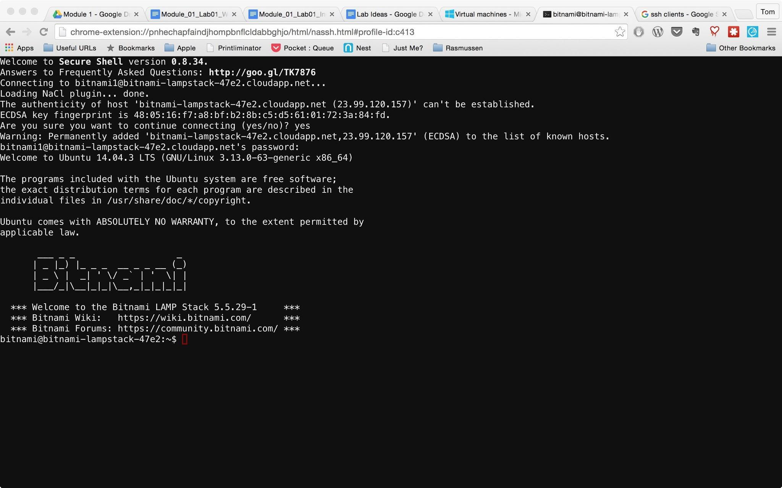

You've successfully logged in to the server.

Type **exit** at the command prompt and **press enter**.

You are now logged out of the Putty server connection.