Azure and AdventureWorks Software Setup

# Before You Begin

At this point you should have:

* A LAMP VM deployed in Azure.
* Your VM FQDN, Admin name, password, and application password.

# Create a Secure Tunnel

The MySql database management system (DBMS) is typically installed on the server securely, so that it can only be accessed by applications on the server itself. To allow for a remote connection from your home computer we will need to create a secure tunnel between the server and your computer. We can then reach through the tunnel and use the phpMyAdmin program on the server to access the MySql DBMS on the server. To do this we will first need to create tunnel settings in Putty.

* **Open** the **Putty** program

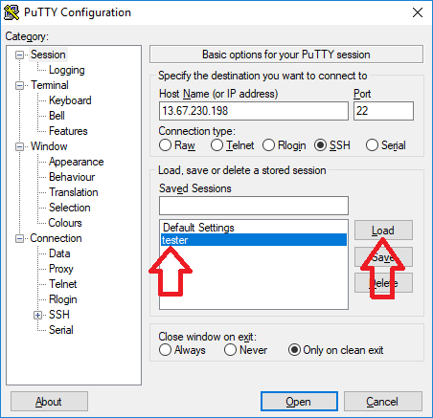

* **Click** on the **saved name** of your server then click Load.

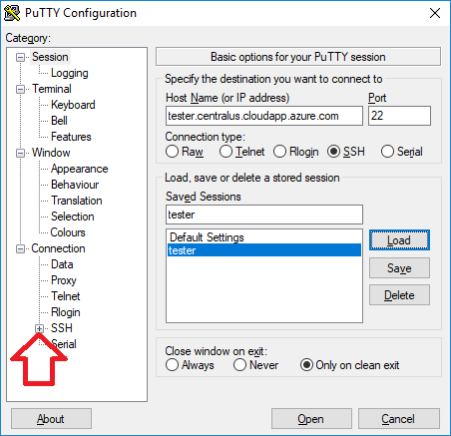

* **Click** the **+ sign** to the left of SSH

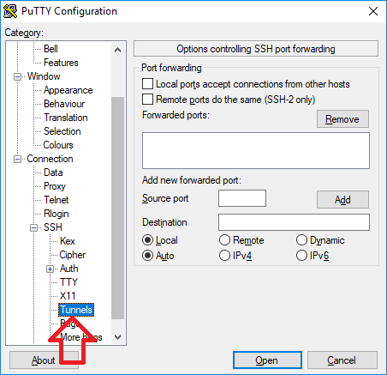

* **Click Tunnels**

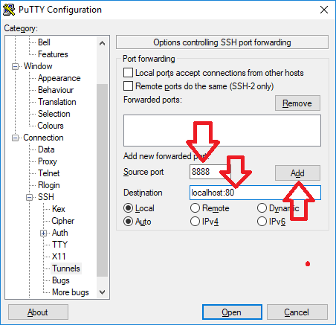

* In the **Source port** text box type **8888**
* In the **Destination** text box type **localhost:80**
* *Note there is a full colon between localhost and 80.*
* Then **click** the **Add** button.

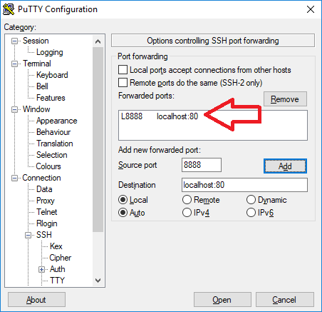

* You will now see an entry L8888 localhost:80 in the forwarded ports text box.

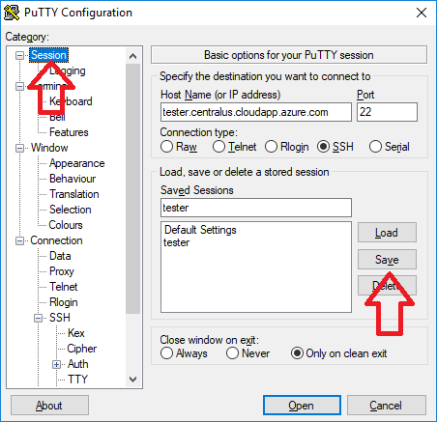

* Lastly, **click** on **Session** and **then click** the **Save** button.
* Your tunnel settings should now be saved in putty.
* Go ahead and open the session.
* Enter the server admin user name and password.
* Minimize Putty (do not close it).
* Putty establishes your secure tunnel while it is connected but for the next steps you do not need to issue commands at the server prompt, therefore you can minimize putty to get it out of the way. Do not close it, as this will close the secure connection to the server.

# Log into phpMyAdmin

Next we will log in to phpMyAdmin so we can manipulate the MySql DBMS.

* Open a browser.
* In the address bar at the top of the browser type the following:   
  <http://localhost:8888/phpmyadmin>

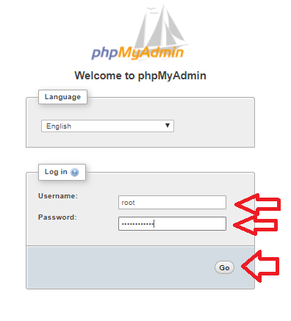

* The phpMyAdmin login page will appear.
* In the **Username** textbox type **root**
* In the **password** textbox type in the **application password** you saved from the server boot file.
* Then **click Go**.

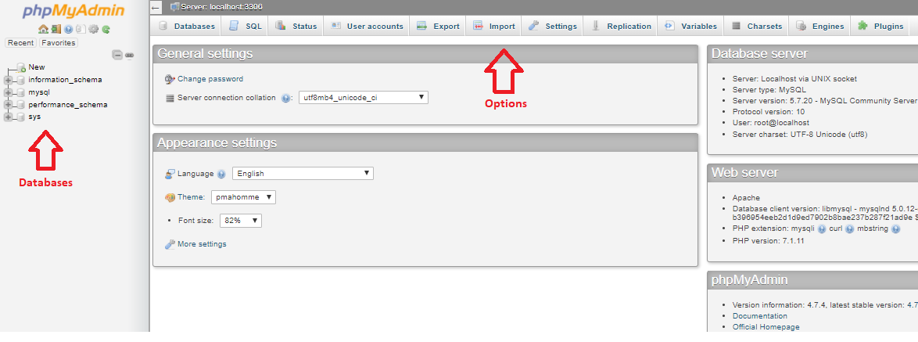

* Current databases in the MySql DBMS show on the left.
* Interface options show at the top.

# Create a Custom MySql DBMS User

* We will now create a custom MySql DBMS user. DBMS users can only log into the DBMS. They are not server users. These users can access the DBMS but they cannot log in to the server that the DBMS resides on.

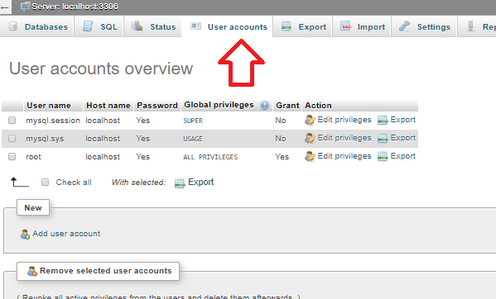

* **Click** on **User accounts** at the top of the page. The current DBMS users will show.

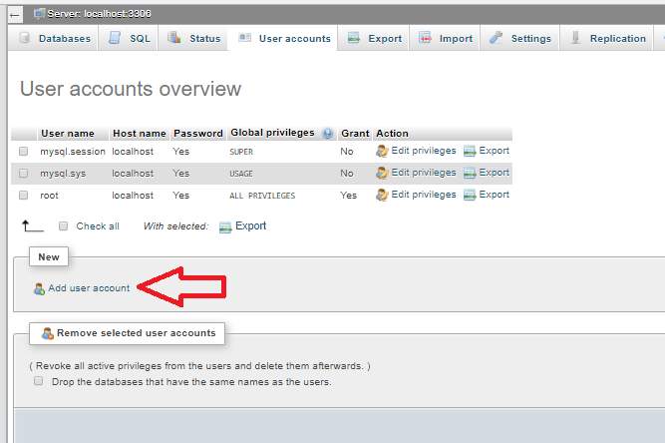

* **Click** the **Add user account** link under the user listing.

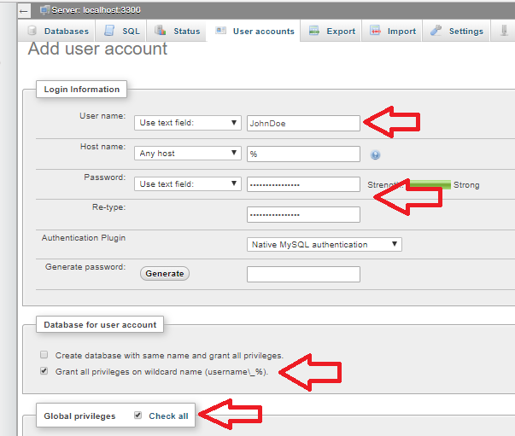

* An Add user account page appears.
* In the **User name** text box **type the name of your new DBMS user**.
* Leave the **Hostname** textbox with the default **%**. The % signifies that the user can log in from any location or remote machine.
* In the **Password** and **Re-type** text boxes **type a strong password**.
* **Check** the checkbox for **Grant all privileges on wildcard name**.
* **Check** the **Check all** checkbox for **Global privledges.**

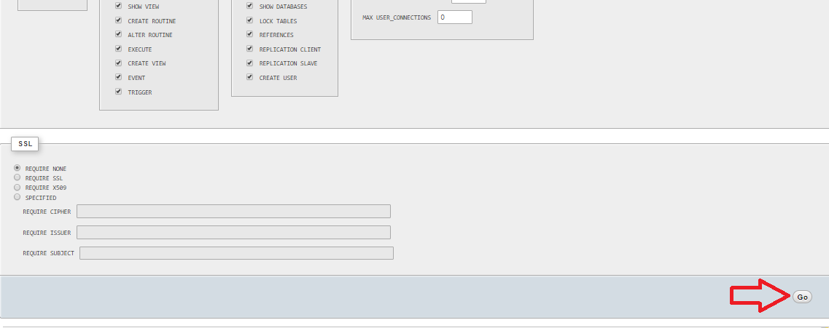

* Scroll to the bottom of the page and **click Go**.

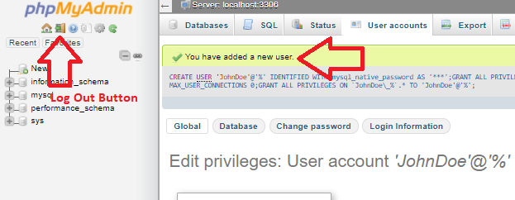

* A new screen will appear that says “You have added a new user”

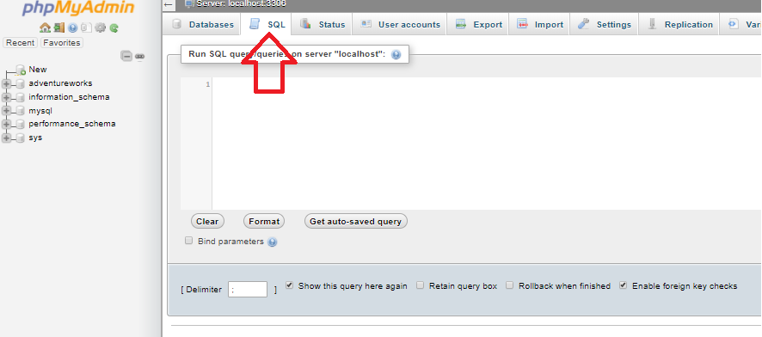

* Click **SQL** at the top of the phpMyAdmin page

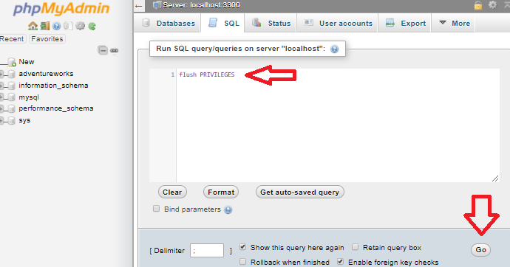

* Type **flush privileges** in the **SQL command box** (resets all user privileges in the DBMS to current settings including new user settings you just made).
* **Click Go** on the bottom right
* Click on the phpMyAdmin Log Out button (top left, little doorway icon).
* Log back in using the new DBMS user name and password.
* Make sure to save the new DBMS user name and password somewhere where you can get to it. We will next use these credentials to restore the Adventureworks database into the MySql DBMS.

# Restoring the AdventureWorks Database

* Make sure Putty is logged in to the server.
* Restore or Unminimize the Putty command prompt window for your server.
* At the command prompt type:

**wget http://sotd.us/rodneycrater/AWBackup.zip**

and press enter.

* Once the file is downloaded to your VM, unzip it by typing:

**unzip AWBackup.zip**

and press enter.

* Once the file is unpacked, type:

**mysql -u *DBMSUserName* -p < AWBackup.sql**

Make sure to replace *DBMSUserName* with the new MySql username that you created in the previous section.

Then press **Enter.**

* You'll be prompted for a password. Use the new MySql user password that you created in the previous section.

|  |
| --- |
| The install script is approximately 90 MB so it will take a few minutes to install. You will see no response until the installation is done. When your command prompt returns, the database should be installed. |

It may take a little while for the command to finish. You will see nothing happen in the command window at this time. Assuming there were no error messages, once the command window returns a prompt, you are done with the command.

# Managing Our Database

* Important: Start a SSH session using Putty and minimize the Putty window but do not close Putty as it is maintaining a secure tunnel connection for you.
* Point your browser to http://localhost:8888/phpmyadmin.
* Log in as user **root** with the application password you saved.
* You are now connected to the server’s MySQL DBMS using the phpMyAdmin program in a browser window.

If you don't expect to use your VM for a while, PLEASE shut it down (stop it) in the Azure Management Portal. You can start it up again if ever you need to work with it again.

|  |
| --- |
| Please stop your VM when you are done to help reduce student costs. If you need to use the VM again in the future you can start it and use it with no problems. Be aware that Azure is a metered service. If you shut down the VM at the operating system level, the meter will keep running. You must **stop** the VM from the Portal. |