PROJECT REPORT TOUR AND TRAVEL

Uwase Aline

# ABSTRACT

Here I have developed a project on Tour and Travel. Online Tour and Travel Booking is a system that gives you the facility of booking any type of packages (Summer special packages, tour packages, Shimla special packages, adventures etc ). This system is made, so that customer can easily book ticket for all packages of tourist place such as hills, trekking, adventures, spirituals and user can also register for hotels for different types of room.

The project ‘Tours and Travels’ is developed to replace the currently existing system, which helps in keeping records of the customer, details of destination as well as payment received. It saves the precious asset that is time, and also accuracy, reliability and uniformity can be maintained. This project is useful for the manager of the company as it helps them to search the data faster than existing system, to get customer record easily and report of the customer payment, etc are generated as per requirement.

Details of different types of tours which include tours like family tours, couple tours, general tours, date and time of departure and the fair of the tours etc are maintained. Through this site we can provide different types of travel packages to the customers. This sites provide everything related to it itineraries.

This site gives new packages on flexible price, so that user can book easily. According to season admin can change packages. We revise our itineraries regularly. Vacation-O-City offers a large range of travel opportunities. Tours and Travels Project is designed in asp.net programming language, and SQL server used for this site.

In this site, Admin can add packages, add destinations (adventures, spirituals), add hotels details, and delete hotel details. Admin can also add different types of rooms.

# TABLE OF CONTENTS

### PAGE

**ACKNOWLEDGEMENTS**……………………………………………………………… i

**ABSTRACT**……………………………………………………………………………… ii

LIST OF TABLE v

LIST OF FIGURE vi

1. INTRODUCTION

1.1 General Introduction …………………………………………………………………. 1

1.2 Area of computer science……………………………………………………………... 2

1.3 Hardware and Software Requirements………………………………………………... 3

1. PROBLEM DEFINITION AND OBJECTIVE 4
2. BACKGROUND 6
3. DESIGN
   1. Working of Website on .net platform………………………………………………… 7
   2. Database Design… 7
   3. Database Schema 8
   4. Dataflow Diagram 14

#### METHODOLGY

5.1 Methodology………………………………………………………………………… 18

#### IMPLEMENTATION DETAILS 19

* 1. Screenshot of Website 19

#### CONCLUSION 35

#### REFERENCES 36

**LIST OF TABLES**

**Page**

* 1. User Register… 08
  2. Add Package 09
  3. Add Source 09
  4. Add Destination… 10
  5. Package Description 10
  6. Package Booking and Payment 11
  7. Add Hotel Details 12
  8. Add Room Type 12
  9. Hotel Booking 13
  10. Payment 14
  11. Add Adventure 14
  12. Destination of Adventure 15
  13. Booking Adventure and Payment 15

# LIST OF FIGURES

4.1 Level 0 Data Flow Diagram 16

4.1 Level 1 Data Flow Diagram 17

* 1. Add Package 20
  2. Delete Package 21
  3. Add Source 21
  4. Add Destination… 22
  5. Add Package Description… 22
  6. Add Hotel Details 23
  7. User Registration… 24
  8. User Login… 24
  9. Change Password… 25
  10. Package Demo… 25
  11. Book Package 29
  12. payment for package 29
  13. List of Hotels 30
  14. Book Hotel 31
  15. Payment Hotel 33
  16. Add Adventure 33
  17. Book Adventure 34
  18. Payment Adventure 34

**CHAPTER 1 INTRODUCTION**

#### General Introduction

Online Tour and Travel is a very user friendly project. In this project user can easily understand and book all packages and also register for hotel. In this project there are various types of forms, like all types of packages, book for package and Room Registration Page in which user can insert his personal needs & facilities then upload his form by which user can register in the web site. In this website user can also pay money through credit card.

This site provides different tour packages, hotel booking and summer special tour packages. Through this site, user can book different types of room such as deluxe room, ac room etc on flexible price.

This site provides different packages, destination, and hotel booking services in one particular state of India. Himachal Pradesh is very popular hill station of north India. Visitors enjoy snow covered mountain peaks and adventure sports like trekking, mountaineering and skiing.

In this website, according to the tour packages it provides services like online booking facilities for all packages and hotels registration to the customer. In this project user can easily understand and fill up the Room Reservation form. User can search for various types of rooms.

Online Tour and Travel is a web based application made in Asp.Net. So with the help of this project user can apply for packages of tour and room reservation.

1

2

In this project, Admin can add travel packages and all details of hotels which is located in Himachal Pradesh and also add all details of bus for this particular city.

#### Organization

HCL Company is multinational IT Services Company, headquartered in Noida, Uttar Pradesh, India. It is a subsidiary of HCL Enterprise. Originally the research and development division of HCL Limited, it emerged as an independent company in 1991 when HCL Limited ventured into the software services business. HCL Technologies (often called Hindustan Computer Limited) offers services including IT consulting, enterprise transformation, remote infrastructure management, engineering and R&D, and business process outsourcing.

HCL Company has offices in 32 countries and operates across a number of verticals industry including aerospace and defense, automotive, consumer electronics, energy.

#### Area of Computer Science

**Web Development** is a broad term for the work involved in developing a [web site](https://en.wikipedia.org/wiki/Web_site) for the internet or an Intranet (a private network). Web development can range from developing the simplest static single page of [plain text](https://en.wikipedia.org/wiki/Plain_text) to the most complex web based [internet](https://en.wikipedia.org/wiki/Internet_application) [applications](https://en.wikipedia.org/wiki/Internet_application), [electronic businesses](https://en.wikipedia.org/wiki/Electronic_business), and [social network services](https://en.wikipedia.org/wiki/Social_network_service).

Using Web development we can design different types of websites and the web application. A more comprehensive list of tasks to which web development commonly refers, may include [web engineering](https://en.wikipedia.org/wiki/Web_engineering), [web design](https://en.wikipedia.org/wiki/Web_design), [web content development](https://en.wikipedia.org/wiki/Web_content_development), client liaison, e- commerce development. Among web professionals, "web development" usually refers to the main non-design aspects of building web sites: writing [markup](https://en.wikipedia.org/wiki/Markup_language) and [coding](https://en.wikipedia.org/wiki/Computer_programming).

2

#### HARDWARE AND SOFTWARE REQUIREMENTS

* + 1. **Software Requirements:**
       - Operating System: Windows 7/8/10
       - Application: ASP.Net using C#
       - Database: SQL SERVER
       - Software: Internet Explorer/Google Chrome

#### Hardware Requirements:

* + - * Processor: Preferably 1.0 GHz or Greater.
      * RAM : 1GB or Greater.

**CHAPTER 2**

3

2

## PROBLEM DEFINITION AND OBJECTIVES

The purpose of tour and travel is mainly to provide online booking services for the user. This statement describes the problem definition of the proposed system. The purpose of this site is to book online ticket for hotels and all tourist places of Himachal Pradesh.

The problem definition of the vacation-o-city is to book online ticket for hotel and tourist place where user wants to visit. It is a Web Based Application to develop website in which end user interact with the web-app easily. In this website, Customer or User can search and book all tourist places and all hill stations and all hotels of Himachal Pradesh.

The problem is that we although have many websites but they offer a different kinds of services. The customers are enjoying a lot but there is a lack of relationship between travel agency and customers and hence we are establishing that relationship by carrying and servicing all customers in the same manner that we wish to serve.

# OBJECTIVES

This system provides Online Registration, Tour Package Information, Bus ticket booking and all other destinations. The purpose of this project is very clear that user can find room facilities easily & hotel service providers also get good customers very easily. Customer can register in the website & can create his own registration then he can receive email for his room status related to his reservation and book all packages. User can register hotel for different types of room what they want.

The Main Goal of this project is to provi er room reservation services and also

de a very fast

4

booking services for different types of packages so any user can get this service very easily.

* Our objective is to make strong relationship with customers so that they can enjoy the holiday of their dreams.
* It saves lots of time , now a days there is a fast process world any one can work quickly so, this project helps that people who are searching for reservation in organization, so they can easily fill up the form and search rooms and different tourist place.
* Possess complete back up services.

.

# CHAP 5

**TER 3**

**BACKGROUND**

People wish to see the website in an even better and organized form always. The use of this website is to book online packages and online hotel reservation etc. for fun have become a favorite pass time of the people. Features vary from website to website. Usually this website focuses on the different types of packages, adventure and destination, what they want.

This tour and travel website is based on .net 4.5 platform. Along with several architecture domains, Applications Architecture from the pillars of an solution architecture. Application architecture is used for an internal structure of an application. These apps have become common trend now.

Online Tour and Travel is a web based application made in the Asp.Net. So with the help of this project user can apply for packages of tour and room reservation. All details of packages, adventure, destination and hotels are added by Admin on the Admin panel. User can search more attractive packages, destination etc. you will create web pages that visitors can interact with in wonderful way.

# CHAPTER 4

**DES** 6

**IGN**

#### Working of .Net Website

Website Tour and Travel is used to book online ticket for different packages and hotels, adventures and different destinations of Himachal Pradesh. The main page of this website has Home page which contains Register for new account, Login for account.

The user can choose different packages, destinations and hotels from gallery. The user also has the option of changing the password for security purpose and new user must have to create the account to book the packages and hotels. The first option in the navigation drawer is Home, Packages, Hotel, and Destinations (Adventures, Spirituals). Online payment option is also available on this website.

#### DATABASE DESIGN / DATA STRUCTURE DESIGN Tables and Relationship

* + - In my Project Tour and travel, I used VISUAL STUDIO 2008 as a front end and use

SQL server 2008 as a backend.

* + - Front end is mainly used for the designing purpose or designing the various kinds of forms and implement the logic and the backend is mainly used for, to store the data, records, or the information.
    - I make all the tables in the SQL Server 2008. My tables name are Add package, add

package description, add source, add destination, add hotels, Hotel Rooms, Hotel Info., add adventures, delete and update adventure and city. These are the tables to store the

7

e back en

records, data, and information in th d means in the SQL Server 2008.

* All the tables are used to store the records, and administrator is able to watch all the data. Now we talk about the tables and how this tables work in a back end that we can know but the main thing is the relationship of the tables.
* That’s the most important thing for the back end. In my project there is a relationship between the tables means all the tables are connected with each other so all the records or the data or the information can easily stored and there is a no chance of the mistakes in the tables.
* The Relationship between the tables is also considered as a security part if the records are not stored properly so candidate can not able to work further so it can avoid the chance of the dummy records.

#### Database Schema

**User Register:** This is the schema of User.

|  |  |  |
| --- | --- | --- |
| **Fields** | **Type** | **Constraint** |
| UserID | int | Auto Incre. (Primary Key) |
| UserName | nvarchar(max) |  |
| Password | nvarchar(max) |  |
| UserEmailAddress | Text |  |
| UserPhoneNumber | nvarchar(10) |  |
| Address | nvarchar(max) |  |

Table 4.1 User Register

8

**Add package:** By this admin can add all details of packages. In this table PackageID is auto incremented and unique. Image will be upload by FileUpload control.

|  |  |  |
| --- | --- | --- |
| **Fields** | **Type** | **Constraint** |
| PackageID | int | Auto Incre.(Primary Key) |
| HotelName | nvarchar(max) |  |
| Image | Nvarchar(max) |  |
| Duration1 | Text |  |
| Duration2 | nvarchar(10) |  |
| Duration3 | nvarchar(10) |  |
| Duration4 | Nvarchar(10) |  |
| Image1 | nvarchar(100) |  |
| Image2 | nvarchar(max) |  |
| PackageAmount | Nvarchar(max) |  |

Table 4.2 Add package

**Add Source:** On the behalf of this table admin will add the source in database. Here SourceId is primary key and auto Incremented.

|  |  |  |
| --- | --- | --- |
| **Fields Name** | **Type** | **Constraint** |
| SourceId | Int | Auto Incre (Primary Key) |
| SourceName | nvarchar(50) |  |

Table 4.3 Add Source

9

**Add Destination:** By this admin will add all Destination name and DestinationID will auto Incremented. DestinationID is primary key.

|  |  |  |
| --- | --- | --- |
| **Fields Name** | **Type** | **Constraint** |
| DestinationId | Int | Auto Increment (Primary Key) |
| DestinationName | nvarchar(50) |  |

Table 4.4 Add Destination

**Package Description:** By this Admin can add package Name, days number, source and destination and details of particular package.

|  |  |  |
| --- | --- | --- |
| **Fields** | **Type** | **Constraint** |
| Package_desID | Int | Auto Incre  (Primary Key) |
| packageID | Int | (foreignkey) |
| PackageName | nvarchar(200) |  |
| Days Number | nvarchar(max) |  |
| Source | nvarchar(max) |  |
| Destination | nvarchar(max) |  |
| Package_Details | Nvarchar(max) |  |

Table 4.5 Package Description

**Package Booking and Payment** : In this schema, BookingID is auto Incremented and primary key. BookingID will Auto Increment and packageId, packageName, packageAmount all will come on the behalf of add package table. UserID, UserName, UserPhoneNumber, UserAddress will fill on the behalf of User_Register Schema.

10

2

|  |  |  |
| --- | --- | --- |
| **Fields** | **Type** | **Constraint** |
| BookingID |  | Auto Incre. (Primary Key) |
| PackageID | int |  |
| PackageName | nvarchar(max) |  |
| PackageAmount | nvarchar(max) |  |
| UserID | int |  |
| UserName | nvarchar(max) |  |
| UserPhoneNumber | nvarchar(max)  ) |  |
| UserAddress | nvarchar(max) |  |
| CardNumber | nvarchar(100) |  |
| CVVNumber | nvarchar(3) |  |
| ExpiryDate | nvarchar(max) |  |
| NameOnCard | Nvarchar(max) |  |
| BookingDate | Nvarchar(max) |  |

Table 4.6 Package Booking and Payment

**Add Hotels** : In this table Admin will add HotelName, CityName, Amount of Room, Room Type, hotel details and admin can also upload hotel image and HotelID is primary key and it will auto increment.

11

2

|  |  |  |  |  |
| --- | --- | --- | --- | --- |
| **Fields** | **Type** | | **Constraint** | |
| HotelID | int | | Auto Incre.(Primary Key) | |
| HotelName | nvarchar(max) | |  | |
| CityName | nvarchar(max) | |  | |
| Amount | nvarchar(max) | |  | |
| HotelImage | nvarchar(max) | |  | |
| HotelDetails | nvarchar( | 11 | |  |
| RoomType | Nvarchar(max) | |  |  |

Table 4.7 Add Hotel Details

max)

**Room Type:** In this schema admin will add different types of room of hotel.

|  |  |  |
| --- | --- | --- |
| **Fields Name** | **Type** | **Constraint** |
| RoomTypeId | Int | Auto Incre (Primary Key) |
| RoomTypeName | nvarchar(50) |  |

Table 4.7 Room Type

**Hotel Booking:** In this schema, BookingID is auto Incremented and primary key. BookingID will Auto Increment and HotelID, HotelName, Amount, Room Type all will come on the behalf of User Booking. UserID, UserName, UserPhoneNumber, UserAddress will fill on the behalf of User_Register Schema. Dateof Booking is selected date of user.

nt

|  |  |  |
| --- | --- | --- |
| **Fields** | **Type** | **Constraint** |
| BookingID | i 12 | Auto Incre (Primary Key) |
| HotelID | int |  |

|  |  |  |
| --- | --- | --- |
| HoteName | nvarchar(max) |  |
| UserID | int |  |
| UserName | nvarchar(max) |  |
| RoomType | nvarchar(max) |  |
| Adults | int |  |
| Child | int |  |
| DateOFBooking | nvarchar(max) |  |
| UserEmailAddress | nvarchar(max) |  |

Table 4.8 Hotel Booking

**Hotel Payment:** When user will book for particular hotel room, that details of user and hotel will come. BookingID will Auto Increment.

|  |  |  |  |
| --- | --- | --- | --- |
| **Fields** | **Type** | | **Constraint** |
| 13 | | |
| BookingID | int |  | Auto Incre (Primary Key) |

|  |  |  |
| --- | --- | --- |
| HotelID | int |  |
| HoteName | nvarchar(max) |  |
| UserID | int |  |
| UserName | nvarchar(max) |  |
| CardNumber | nvarchar(16) |  |
| cvvnumber | int |  |
| expirydate | nvarchar(max) |  |
| Amount | nvarchar(max) |  |
| Booking Date | nvarchar(max) |  |

Table 4.9 Payment

**Add Adventures:** Admin will add details of adventure and AdventureID will auto Increment.

|  |  |  |
| --- | --- | --- |
| **Fields** | **Type** | **Constraint** |
| AdventureID | int | Auto Incre.(Primary Key) |
| AdventureName | nvarchar(max) |  |
| Amount | nvarchar(max) |  |
| Duration | nvarchar(max) |  |
| AddImage | nvarchar(max) |  |
| Destination | nvarchar(max) |  |
| Details | nvarchar(max) |  |

Table 4.10 Add Adventure

14

**Destination of Adventure:** Admin will Name of Adventure and CityID will auto Increment.

add City

|  |  |  |
| --- | --- | --- |
| **Fields Name** | **Type** | **Constraint** |
| CityID | int | Auto Incre (Primary Key) |
| CityName | nvarchar(50) |  |

Table 4.11 Destination of Adventure

**Book Adventure and Payment:** Details of booking and details of user will come in this schema.

|  |  |  |
| --- | --- | --- |
| **Fields** | **Type** | **Constraint** |
| BookingID | int | Auto Incre (Primary Key) |
| AdventureID | int |  |
| AdventureName | nvarchar(max) |  |
| Amount | nvarchar(max) |  |
| UserID | int |  |
| UserName | Nvarchar(max) |  |
| UserPhoneNumber | nvarchar(max) |  |
| Address | nvarchar(max) |  |
| CardNumber | int |  |
| cvvnumber | int |  |
| expirydate | nvarchar(max) |  |
| Booking Date | nvarchar(max) |  |

Table 4.12 Booking and Payment for Adventure

15

#### Data Flow Diagram LEVEL 0

2 **System**

Register

**User**

Login

Book Package/Hotel

Payment

Add Packages/Hotel/ Adventures/Tem ples

Modify (Search/Update/Delete) Packages/Hotel/Adventure

/Temples

Add

Hot el

Admin

#### Figure 4.1 Data Flow Level 0

16

**LEVEL 1:**

**Manage Packages/ Hotels/Adventures**

**System**

**Register User**

Input

#### Figure 4.2 Dataflow Level 1

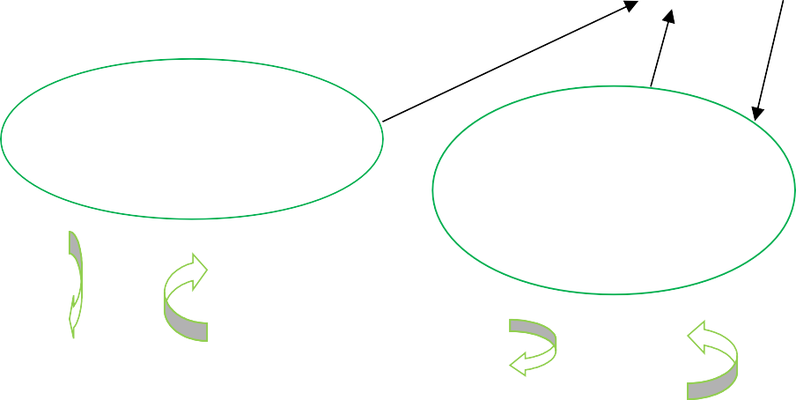

**Login**

**Search Packages**

**Display Packages/H otels/Destina tion**

Output

**CHAPTER 5**

**Meth** 17

**odology**

#### Front end design and tour booking

Front end refers to the visual layer of website and applications. The UI, layout, images and other visual elements and their styling comprises of:

* Developing visual standards.
* Handling site accessibility.
* Page layout
* Form design

It is very helpful in business applications. Since, it is web based it gives online booking facility for packages, destinations i.e adventures, spirituals and hotels and customer can also payment by card. Vacation-o-city is to book online ticket for hotel and tourist place. It is a Web Based Application to develop website in which end user interact with the webapp easily. In this website, Customer or User can search and book all tourist places and all hill station, adventures, spirituals and all hotels of Himachal Pradesh**.**

#### 5.2 Choose working page.

1. This is the home screen that contains the title in the toolbar and has four links which takes the user to four different features.
2. On the top right corner of title bar is a button which on clicking opens the navigation, on which user will click.
3. In the navigation drawer, the user can choose package from package link, destination from destination link, or hotels from hotels link. The user also has the option of changing the user password which in return changes it to your password in the database.
4. User has also option for payment a 18

fter the bookin

which includes adventures, spirituals.

g of package, hotels and destinations

**CHAPTER 6**

19

## IMPLEMENTATION DETAILS

#### 6.1 Admin Panel

**Step 1:** Add packages: In this step admin added package name and also uploaded image. When package added successfully it will show Inserted successfully in label.

Admin can add package, delete package, modify package and admin can also add all description of packages and add duration.

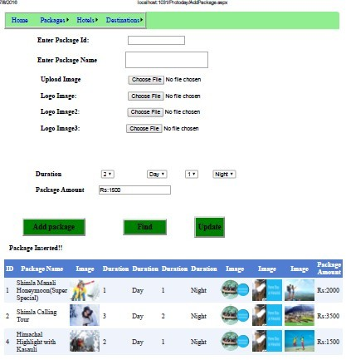

Figure 6.1 Add package

20

wing Edit butto

**Step 2: Delete Package**: By the follo n and Delete button Admin can update

and delete details particular package.

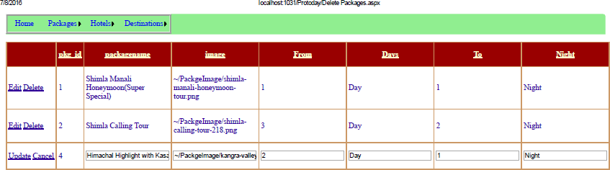

Figure 6.2 Delete Package

**Step 3: Add Source:** Admin are adding Source.

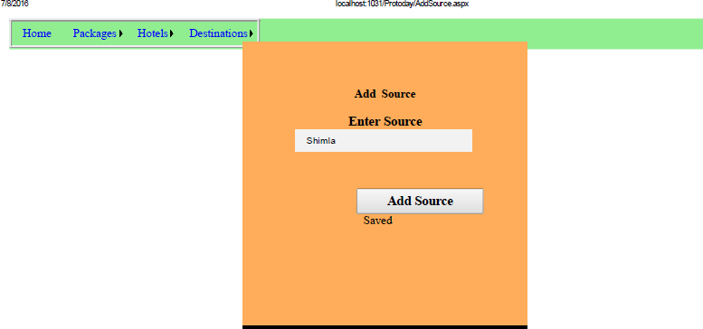

Figure 6.3 Add Source

21

**Step 4: Add Destination:** Admin can add destination name. If Destination name will add in the database, it will show Saved in label

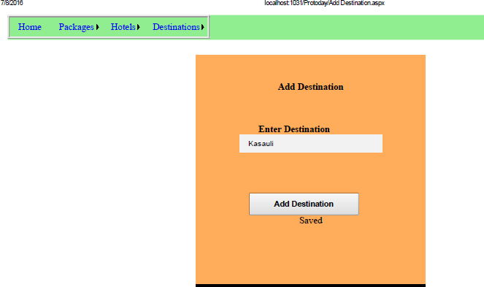

Figure 6.4

**Step 5: Add Package Description:** Admin added all the details of package and package name will select from Dropdown list which referred from the database.

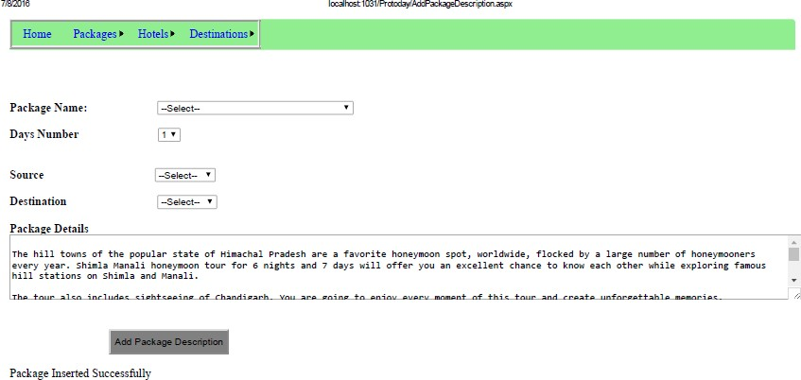

Figure 6.5 Package Description

#### Step6 Add Hotel Details

22

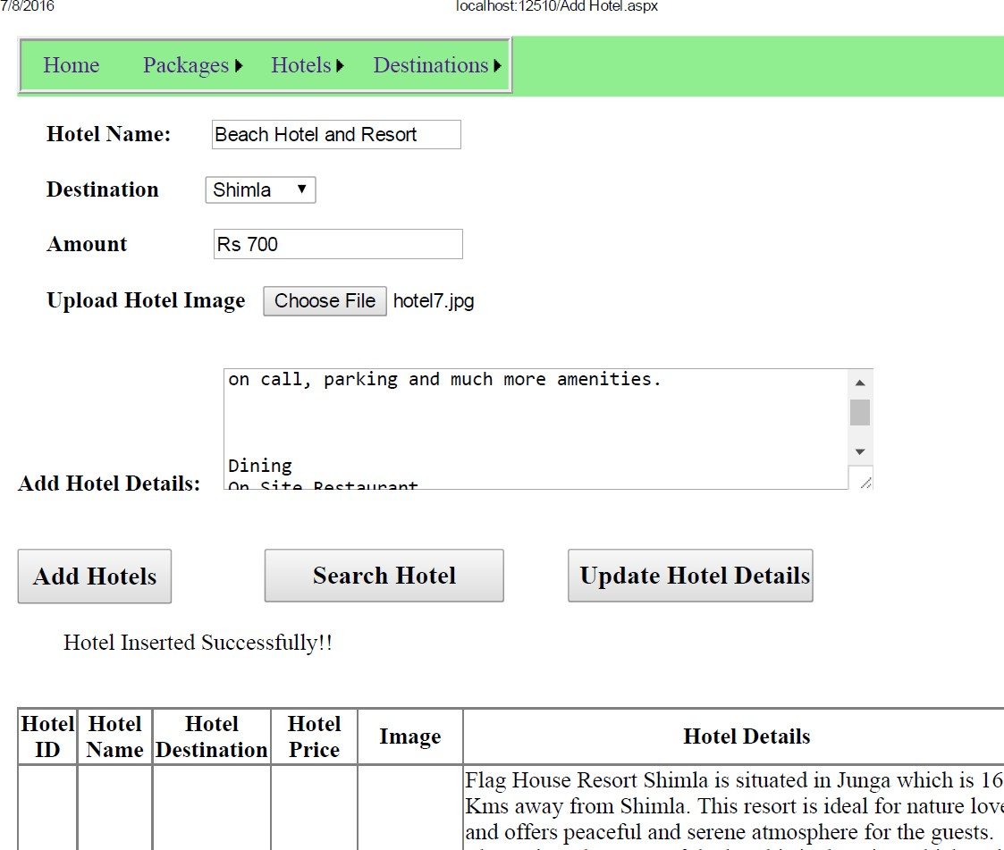

Figure 6.6 Add Hotel Details

#### User Panel:

User Register: In this step new user must have to create account. Login is possible only after the registration. User can also change his/her password.

23

2

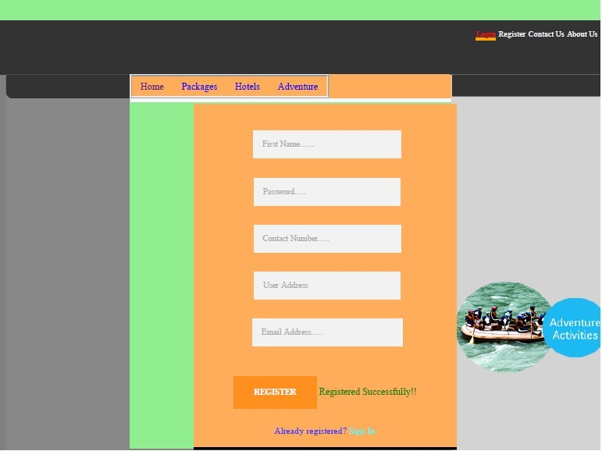

#### Figure 6.7 User Registration

**Step: 2 User Login:** In this step registered customer can login/signin the account. Login is possible only after the registration. User can also change his/her password.

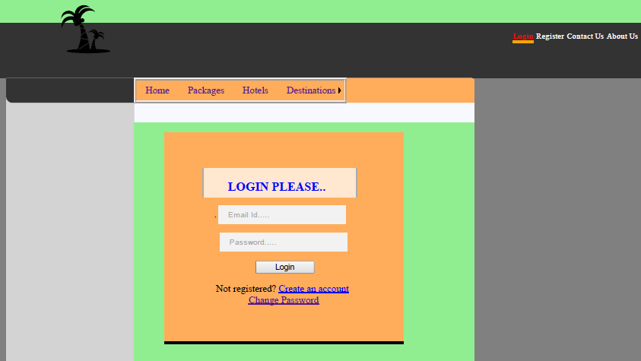

#### Figure 6.8 User Login

24

2

**Step 3: Change password:** By this page user can change own password.

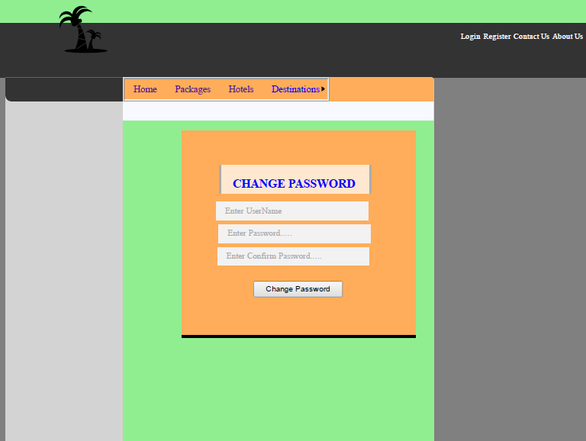

Figure 6.9 Change Password

**Step4:** For booking, User will first login after login user can go to package panel this page will open. By this user can know details of package.

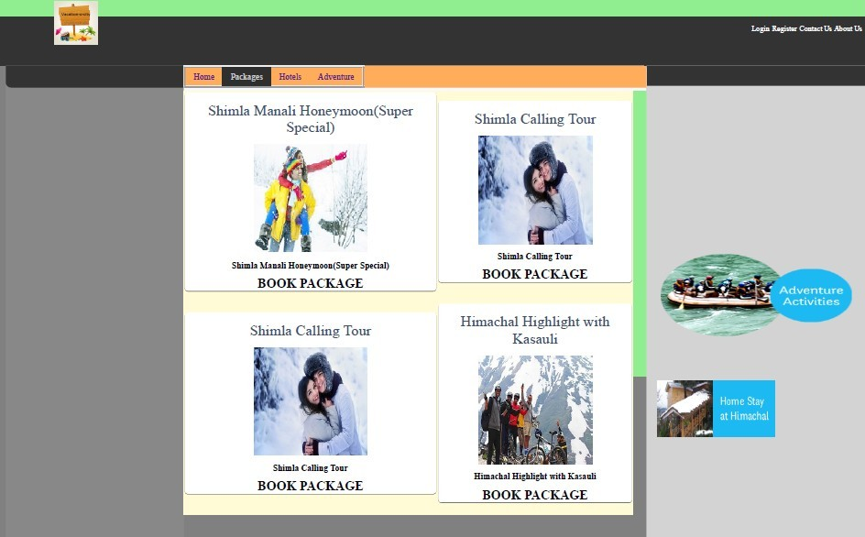

Figure 6.10 Package demo

25

2

**Step 5: Booking Package:** When user will click on booking package button, user will go to the Payment.

#### Code snippet for Book Package and Payment for package

protected void Page_Load(object sender, EventArgs e)

{

this.UnobtrusiveValidationMode = System.Web.UI.UnobtrusiveValidationMode.None;

try

{

if (!IsPostBack)

{

if (Session["username"] != null)

{

DataTable _Dt1 = mydbconnection.CreateInstance().GetSingleTable("select * from User_Registers where UserEmailAddress='" + Session["userName"].ToString() + "'");

if (_Dt1 != null && _Dt1.Rows.Count > 0)

{

txtTotalAmount.Text = Session["PackageAmount"].ToString();

Session["UId"] = _Dt1.Rows[0]["UserID"].ToString(); UserID = _Dt1.Rows[0]["UserID"].ToString(); Username = _Dt1.Rows[0]["UserName"].ToString();

txtAddress.Text = _Dt1.Rows[0]["UserAddress"].ToString();

btnSaveandBuy.Enabled = true; if (txtAddress.Text != "")

{

Label14.Visible = btnUpdateAddress.Visible = false; txtAddress.ReadOnly = true;

}

else

{

Label14.Visible = btnUpdateAddress.Visible = true;

}

txtPhoneNo.Text = _Dt1.Rows[0]["UserPhoneNumber"].ToString(); if (txtPhoneNo.Text != "")

{

Label14.Visible = btnUpdatePhone.Visible = false; txtPhoneNo.ReadOnly = true;

}

else

{

Label14.Visible = btnUpdatePhone.Visible = true;

}

DataTable dt2 = mydbconnection.CreateInstance().GetSingleTable("select * from pkg join package_detail on pkg. pkg_id=package_detail.pkg_id where pkg.pkg_id='" + Session["pkg_id"].ToString() + "'");

if (dt2 != null && dt2.Rows.Count > 0)

{

26

2

packageid = dt2.Rows[dt2.Rows.Count - 1]["pkg_id"].ToString(); packageName = dt2.Rows[dt2.Rows.Count - 1]["packagename"].ToString(); PackageAmount = dt2.Rows[dt2.Rows.Count - 1]

["PackageAmount"].ToString();

DataList1.DataSource = dt2; DataList1.DataBind();

}

}

}

else

{

Label14.Visible = false; btnSaveandBuy.Enabled = false;

}

}

}

catch (Exception ex)

{

Label14.Text = ex.Message;

}

}

protected void btnUpdateAddress_Click(object sender, EventArgs e)

{

try

{

SqlConnection conn = new SqlConnection("Data Source=.; Initial Catalog=vacation;Integrated Security=true;");

string Qry = "update User_Registers set UserAddress='" + txtAddress.Text + "' where UserID='" + UserID + "'";

SqlCommand comm = new SqlCommand(Qry, conn); conn.Open();

int i = comm.ExecuteNonQuery(); conn.Close();

if (i > 0)

{

Label14.Visible = btnUpdateAddress.Visible = false; txtAddress.ReadOnly = true;

}

}

catch (Exception ex)

{ }

}

protected void btnUpdatePhone_Click(object sender, EventArgs e)

{

try

{

SqlConnection conn = new SqlConnection("Data Source=.; Initial Catalog=vacation;Integrated Security=true;");

string Qry = "update User_Registers set UserPhoneNumber='" + txtPhoneNo.Text + "' where UserID='" + UserID + "'";

SqlCommand comm = new SqlCommand(Qry, conn); conn.Open();

uteNonQuery();

2

int i = comm.Exec 27

conn.Close(); if (i > 0)

{

Label14.Visible = btnUpdatePhone.Visible = false; txtPhoneNo.ReadOnly = true;

}

}

catch (Exception ex)

{ }

}

static string UserID = ""; static string Username = ""; static string Address = ""; static string phoneno = ""; static string packageid = "";

static string packageName = ""; static string PackageAmount = "";

protected void btnSaveandBuy_Click(object sender, EventArgs e)

{

try

{

Address = txtAddress.Text; phoneno = txtPhoneNo.Text; SqlConnection conn = new SqlConnection("Data Source=.; Initial

Catalog=vacation;Integrated Security=true;"); SqlCommand comm;

string exp = ddlExpireMonth.SelectedValue + "/" + ddlExpireYear.SelectedValue; string Qry = "Insert into Booking values ('" + packageid + "','" + packageName + "','"

+ PackageAmount + "','" + UserID + "','" + Username + "','" + phoneno + "','" + Address + "','" + txtCardNumber.Text + "','" + txtCvv.Text + "','" + exp + "','" + txtNameonCard.Text + "','" + DateTime.Now.ToString() + "')";

comm = new SqlCommand(Qry, conn); conn.Open();

int i = comm.ExecuteNonQuery(); conn.Close();

Label7.Text = "Payment Successfully.";

}

catch (Exception ex)

{ }

}

28

2

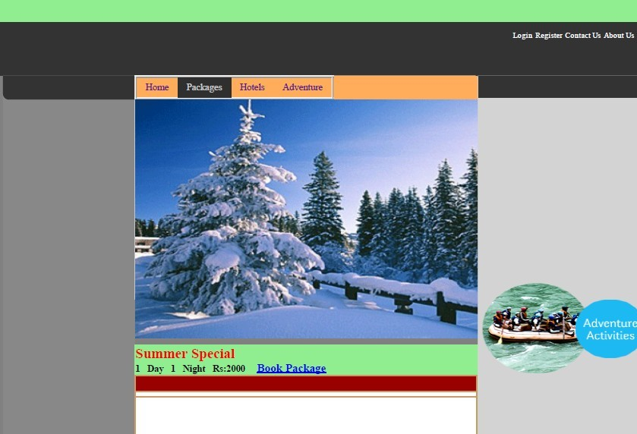

Figure 6.11 Book Package

**Step 6: Payment:** In this step user will payment for package.

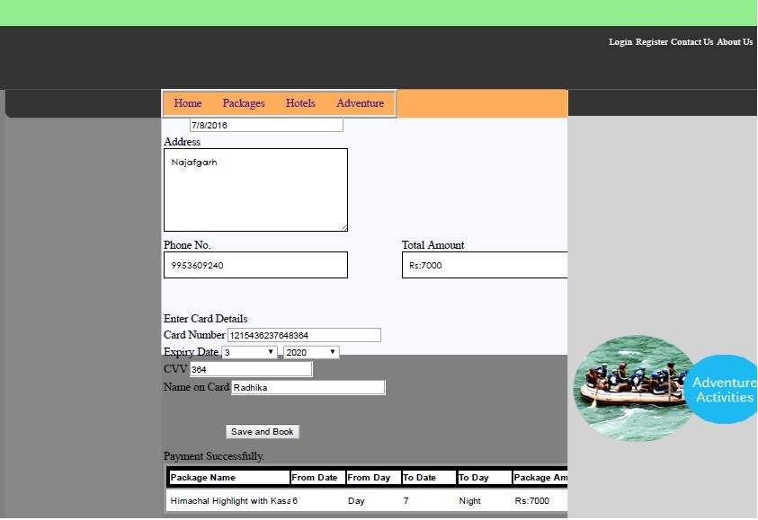

Figure 6.12 Payment for package

29

2

**Hotel:**

**Step1: List of Hotels**

When User will click on Hotel link, this page will open and when user will click Book Hotel button, user will go to hotel details page and on the last user will go to payment page, on which user can pay for hotel.

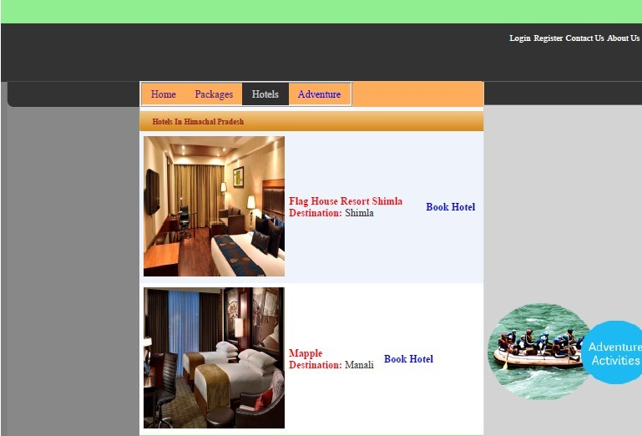

#### Figure 6.13 List of Hotels

**Step 2:** User can see Hotels Details and they can register for hotel and choose different types of rooms from the dropdown list.

30

2

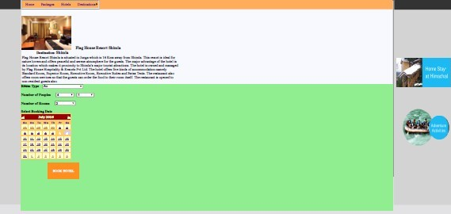

#### Figure 6.14 Book Hotel

**Step 3:** Payment Gateway for Hotel.

Code Snippet for Payment of Hotel

protected void btnSaveandBuy_Click(object sender, EventArgs e)

{

try

{

if (Session["HotelID"] != null)

{

DataTable _Dt1 = mydbconnection.CreateInstance().GetSingleTable("select * from AddHotel where AddHotel.HotelID='" + Session["HotelID"].ToString() + "'");

if (_Dt1 != null && _Dt1.Rows.Count > 0)

{

Session["hotelId"] = _Dt1.Rows[0]["HotelID"].ToString(); hotelid = _Dt1.Rows[0]["HotelID"].ToString();

Session["HotelName"] = _Dt1.Rows[0]["HotelName"].ToString(); hotelname = _Dt1.Rows[0]["HotelName"].ToString();

Session["amount"] = _Dt1.Rows[0]["Amount"].ToString(); amount = _Dt1.Rows[0]["Amount"].ToString();

}

}

if (Session["UserName"] != null)

{

DataTable _Dt2 = mydbconnection.CreateInstance().GetSingleTable("select * from User_Registers where UserEmailAddress='" + Session["UserName"].ToString() + "'");

if (_Dt2 != null && _Dt2.Rows.Count > 0)

{

[0]["UserID"

Session["Userid"] = _Dt2.Rows 31

].ToString();

Userid = _Dt2.Rows[0]["UserID"].ToString();

**6.15 Payment**

Session["Username"] = _Dt2.Rows[0]["UserName"].ToString(); Username = _Dt2.Rows[0]["UserName"].ToString();

}

}

SqlConnection conn = new SqlConnection("Data Source=.; Initial Catalog=vacation;Integrated Security=true;");

SqlCommand comm;

string exp = ddlExpireMonth.SelectedValue + "/" + ddlExpireYear.SelectedValue; string Qry = "Insert into Payment values ('" + bookingId + "','" + hotelid + "','" +

hotelname + "','" + Userid + "','" + Username + "','" + txtNameonCard.Text + "','" +

txtCardNumber.Text + "','" + txtCvv.Text + "','" + exp + "','" + amount + "','" + DateTime.Now.ToString() + "')";

comm = new SqlCommand(Qry, conn); conn.Open();

int i = comm.ExecuteNonQuery(); conn.Close();

Label1.Text = "Payment Successfully!";

}

catch (Exception ex)

{

Label1.Text = ex.Message;

}

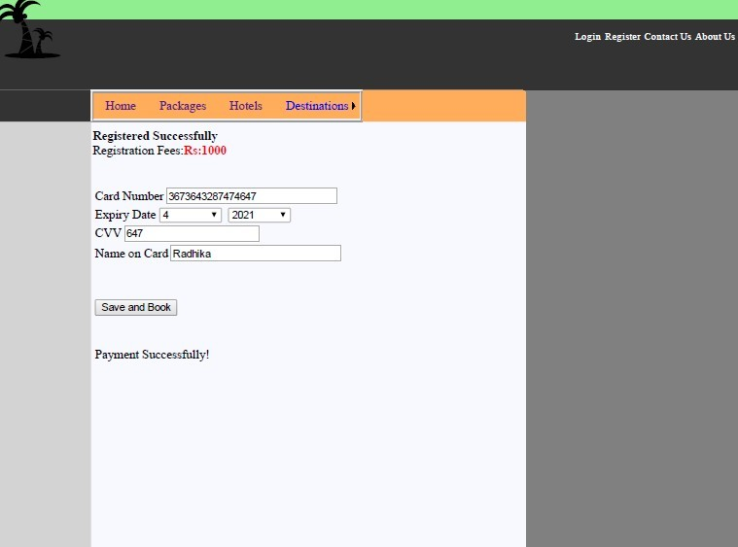

**Figure**

32

**for hotel**

**Adventures:**

**Admin Panel of Adventures:** Admin can add adventures, Modify adventures (ie. Delete,

Update details.

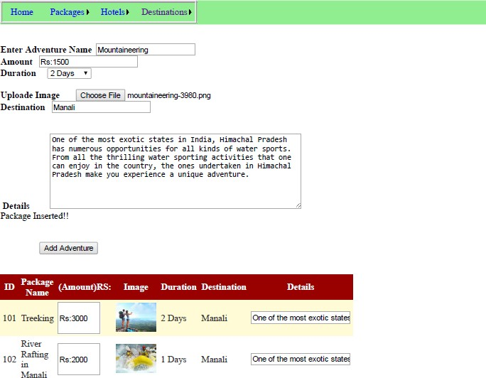

Figure 6.16 Add Adventure

**Book Adventure:** when user will click 33

on Book Advent

payment gateway**.**

ure Button, it will go to the

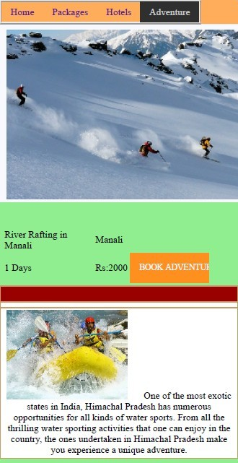

Figure 6.17 Book Adventure

**Pyment for Adventure:** User can pay online for Adventure, and all details of logged in user will update automatically. Address, phone number of logged in people will showing.

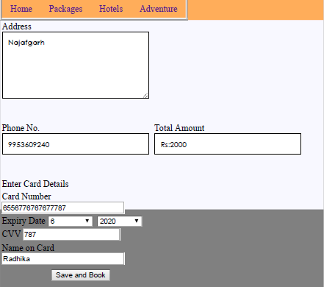

Figure 6.18 Payments for Adventure

**CONC** 34

**LUSION**

This web application provides easy way to book tickets online. This application developed is designed in such a way that any further enhancements can be done with ease.

Through this website user can book all packages of tourist places and hotels. By using this site we can save our time.

# REFERENCES

35

1. Mathew Macdonald, Apress Beginning ASP.net 4.5 in C#
2. Tutorialspoint.com for searching for new options and features to add in the application
3. Thenewboston.com for basic application development learning.

36