***Final Project Report***

***Aline Sathler Delfino, 8914268***

***Instructor Name: Hamad Zawawi***

***Date Submitted: 08/12/2024***

# Description

**Class Helper** is an app designed to simplify managing academic progress by providing detailed insights into class schedules, assignments, and grades. The app serves as an all-in-one platform for students to track their courses and simulate their academic outcomes.

## Key Features

1. Program and Course Information: Students can input detailed information about their programs, courses, and assignments. The app organizes this data to help students keep track of their academic progress.
2. Grade Simulation: **Class Helper** offers a feature where users can simulate different combinations of grades for each assignment to predict their final grade in a course. This allows students to experiment with potential outcomes based on their performance.
3. Minimum and Maximum Grades: The app helps students monitor their academic standing by calculating minimum and maximum grades. If the student enters a minimum grade requirement for a course, the app will inform them if they meet the requirements for approval. If the term end date is reached and the student hasn't met the minimum grade, they are informed of their status (approved or not).
4. Grade Summarization: The app offers a page summarizing the overall program information, including grades in various formats such as numeric, alpha, and GPA. This feature provides students with a comprehensive view of their academic standing.
5. Calendar Integration: A standout feature of **Class Helper** is its calendar functionality. It uses the class and assignment data to populate a calendar, showing the student their class schedules, location, assignment deadlines, and exam dates. This integration is meant to help students better manage their time and stay organized with reminders for important academic events.
6. Overall, **Class Helper** is designed to be an intuitive and powerful tool for students to track their academic journey, manage their time effectively, and optimize their performance across courses.

# Set up

First, click in the “Institutions” tab in the navbar to enter a new institution. Enter a name and an address. Although the institution isn’t required to use the grades part of the app, it’s required if user wants to use the calendar function. The address will be used to add in person classes to the calendar:

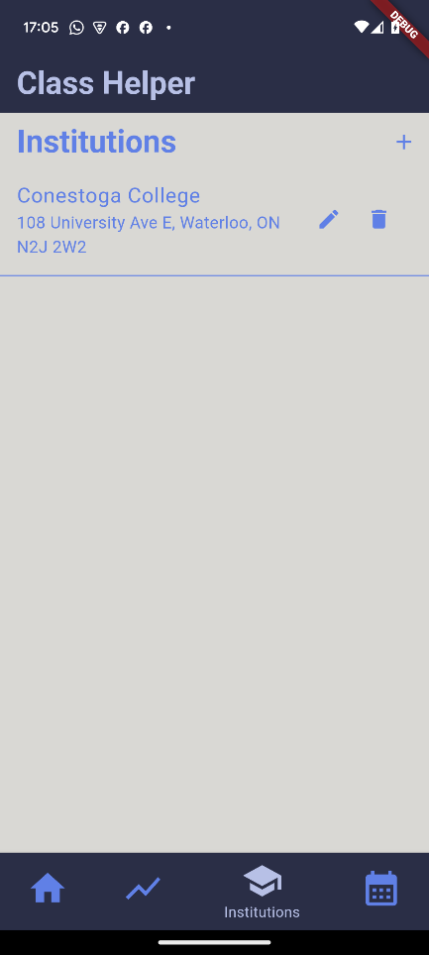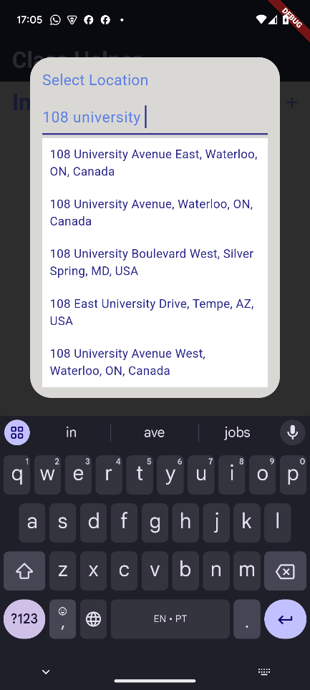 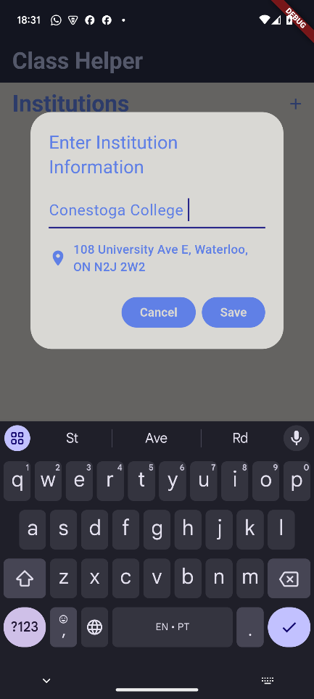

After that, click in “Home” in the navbar, here is where the most part of information should be entered. In the “Programs” screen, users can add a new program by entering the name and selecting an institution (not required).

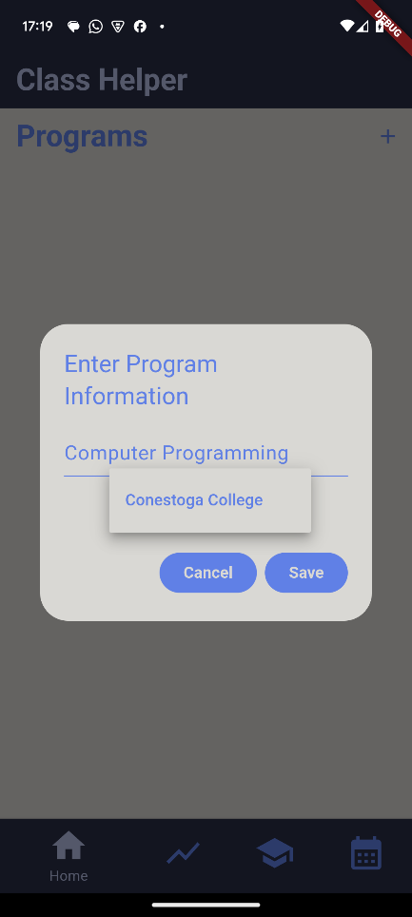 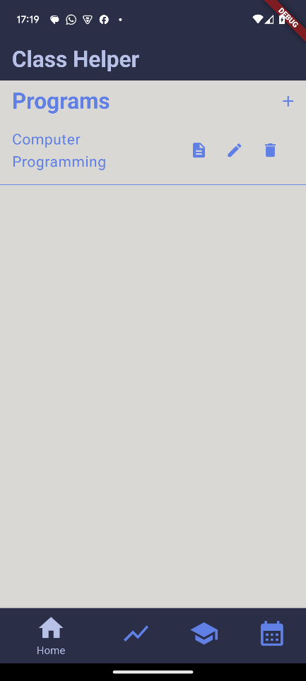

To access the “Terms” screen, click in the button details for the program the user wants to add the term. In this screen user should enter start and end date for each term. **Class Helper** will automatically sort and name the terms accordingly with the information entered.

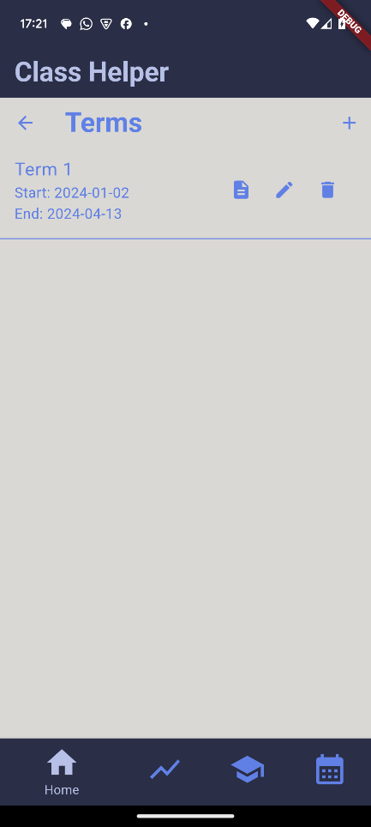 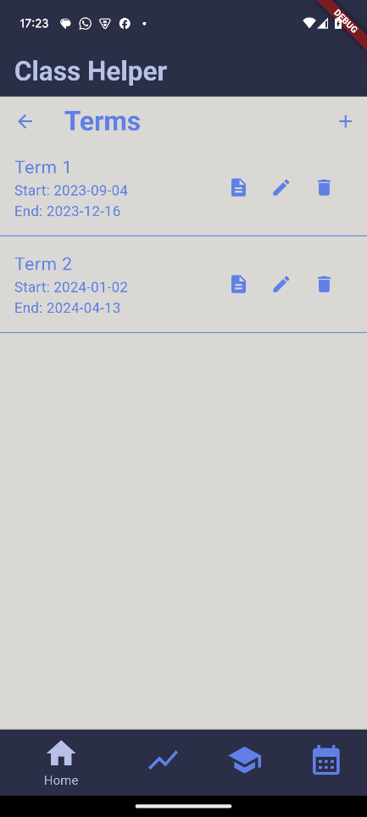

Click in details to access the “Courses” screen and enter the course information for each term. In this screen user can enter course code, name, professor and minimum grade required for approval. Minimum grade isn’t required but it’s necessary for the full experience as the app can calculate if the student was approved or not. Courses that the term already ended will be classified as approved or not approved. Also courses that the term still didn’t add but the user already achieved the minimun grade will the classified as approved. Each course has options to access the “Assignments” and “Classes” screens.

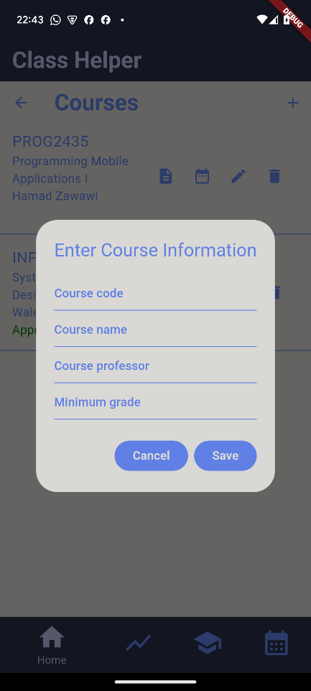 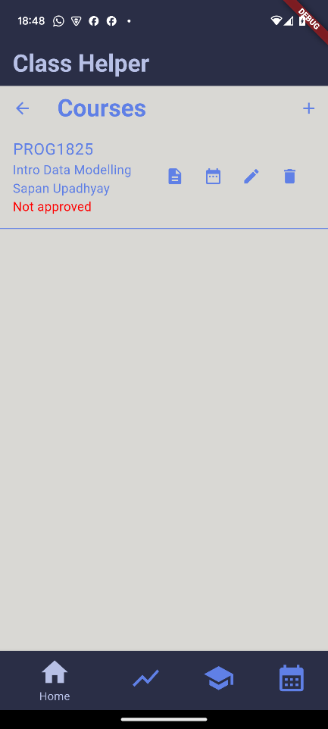 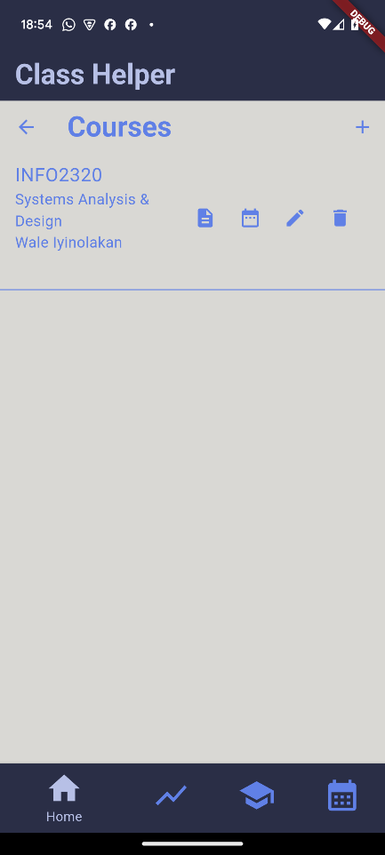

In the “Classes” screen, user can enter the room, day of the week, start time, end time and if the class is online or not. Class Helper will automatically check if any class is conflicting with any other class on its agenda and inform the user.

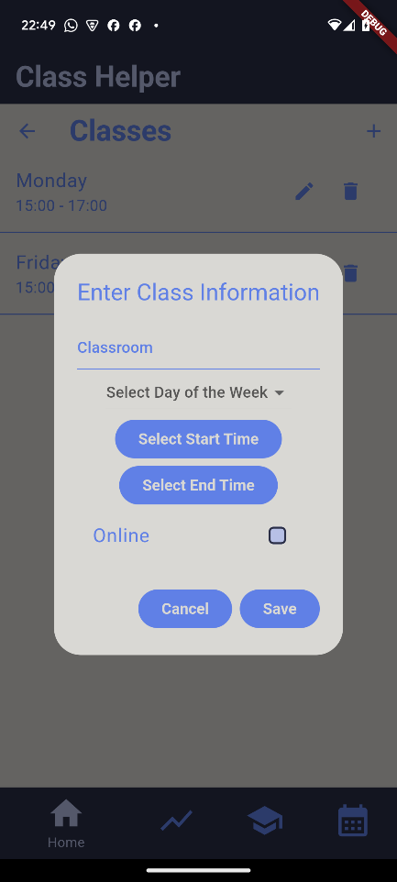

In the “Assignments” screen user can enter the name, points, weight, points earned and the due date. **Class Helper** will calculate the total weight and grade achieved based of the information entered. User can click in the calculator to go to the “Grades Calculator” screen.

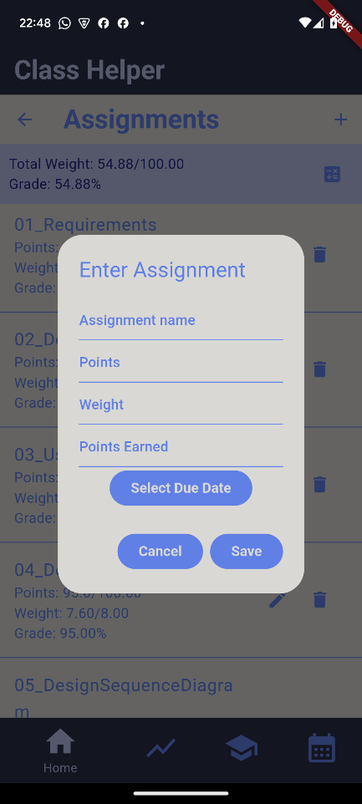

In the “Grades Calculator” screen user will has access to a simulated grade, based on the real grades achived and information that they can enter. Assignments that already have a final grade can also be changed, to reset it to the real grade, user can click in the reset button. They also have access to the minimum and maximum grade based on the assignments points and weight.

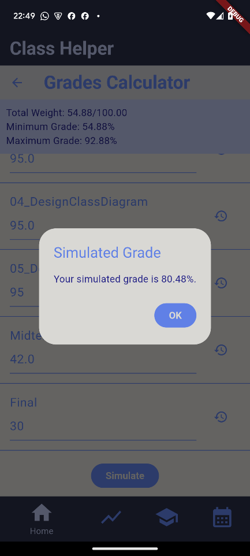

Use the navbar to access the “Grades” screen. This screen will calculate the numeric, alpha and GPA grades for each course that the term is alread finished. It will also calculate the numeric and GPA grades for the program, based on each course grade and credits (assignments and classes information).

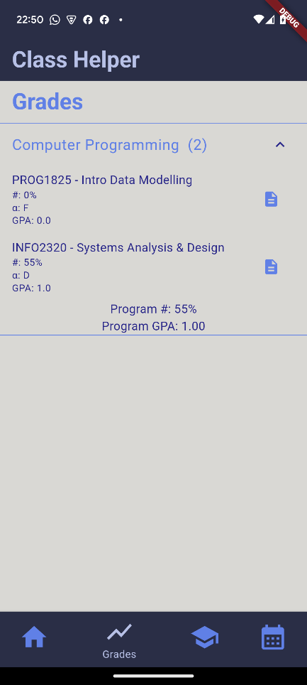

The last tab in the navbar is the “Calendar” screen. In the screen user can choose what classes and assignments they want to add to their calendar. Classes will be added with recurrence until the end of the semester. In person classes will have room and institution location information. Assignments will be added with the “all day” option activated. Both already have the default reminders and colors of the calendar.

