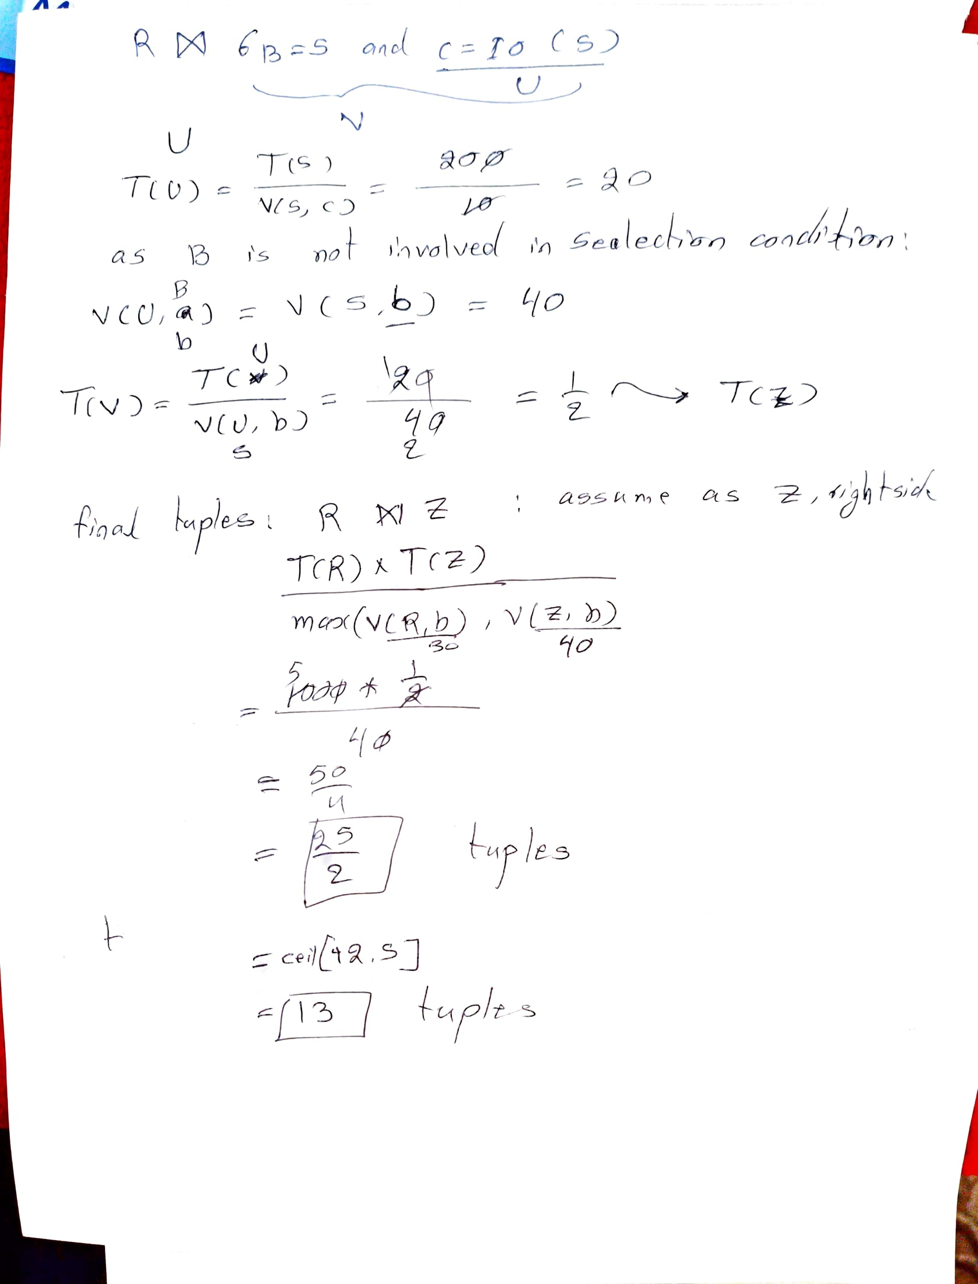
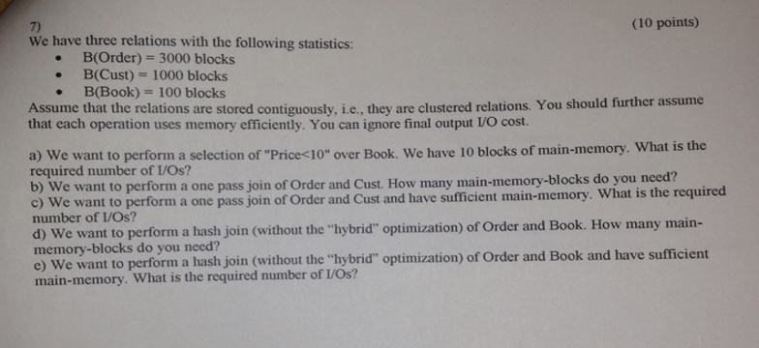
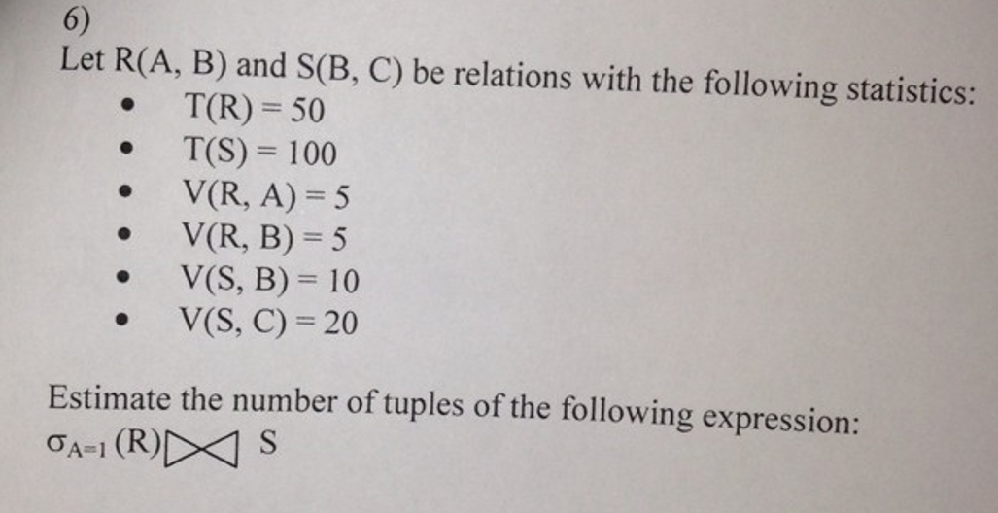

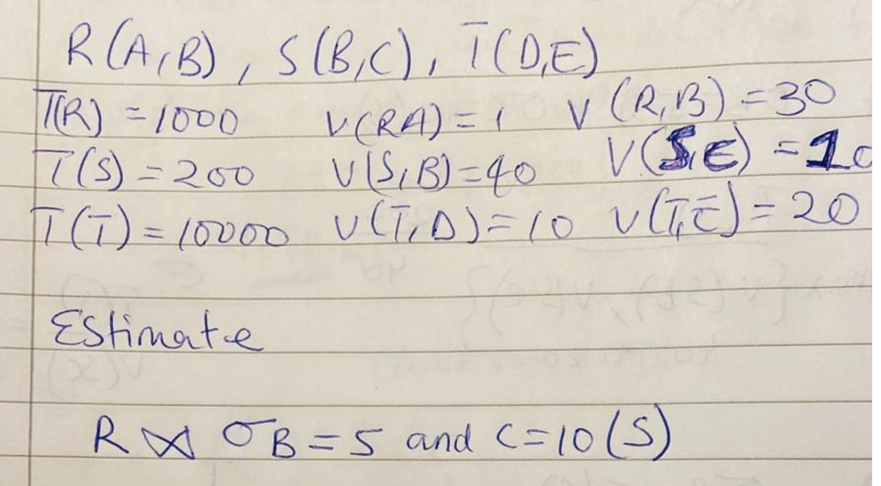

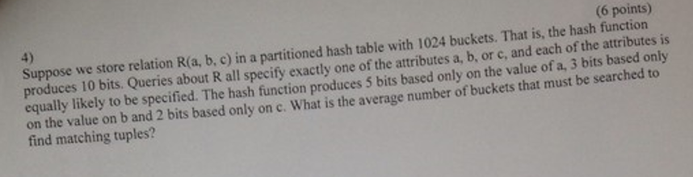

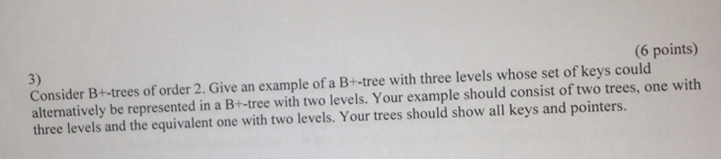

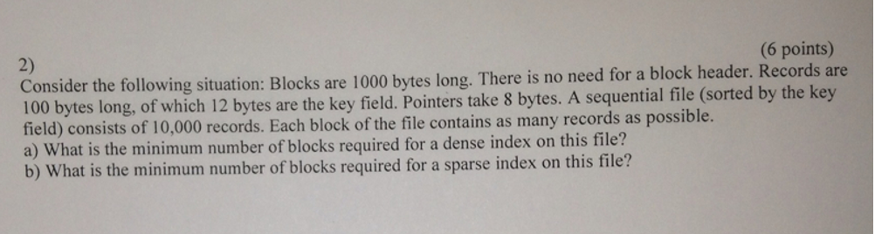

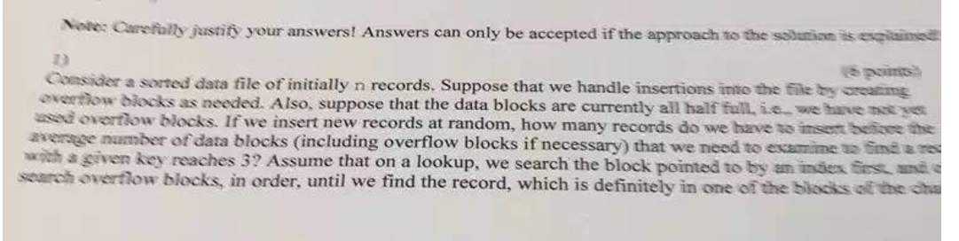

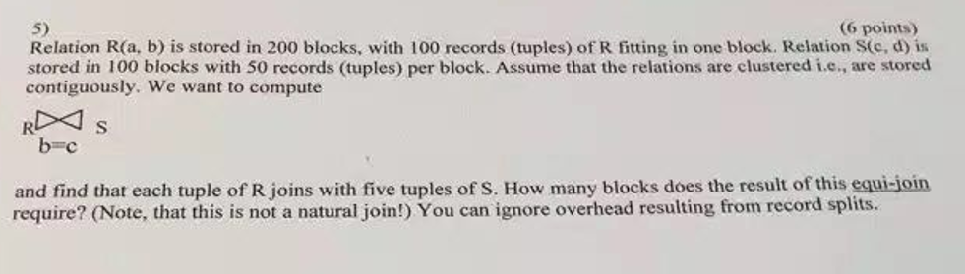

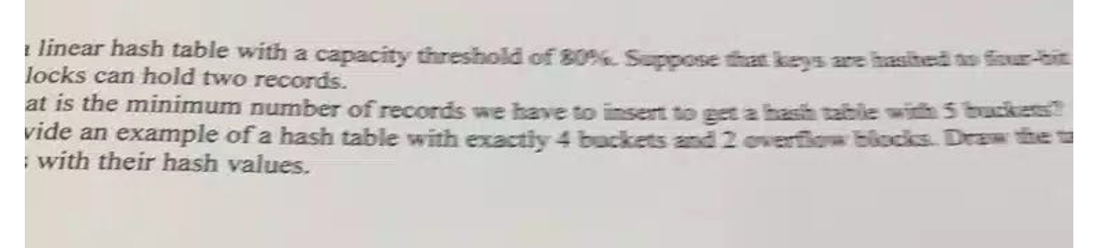
Use a linear hash table with a capacity threshold of 80%. Suppose that keys are hashed to four-bit sequences and that blocks can hold two records.
a) What is the minimum number of records we have to insert to get a hash table with 5 buckets?
b) Provide an example of a hash table with exactly 4 buckets and 2 overflow blocks. Draw the records along with their hash values.

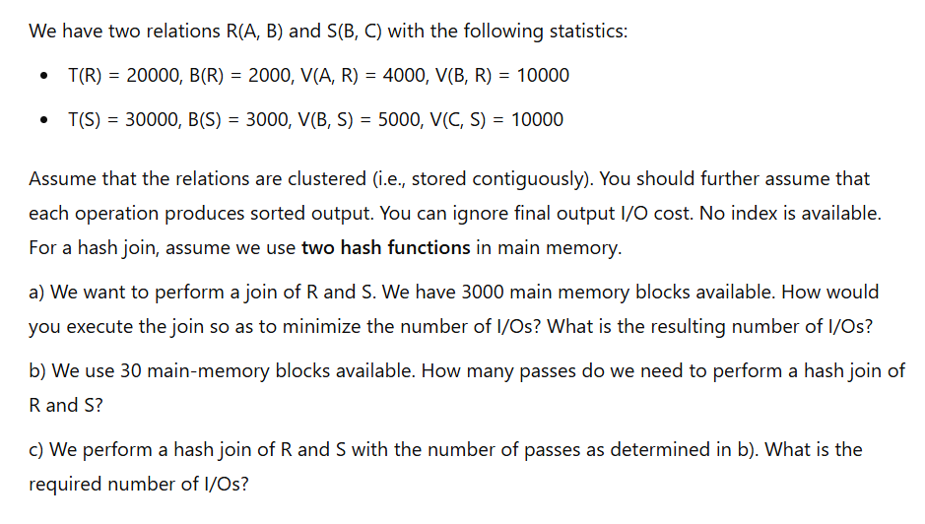
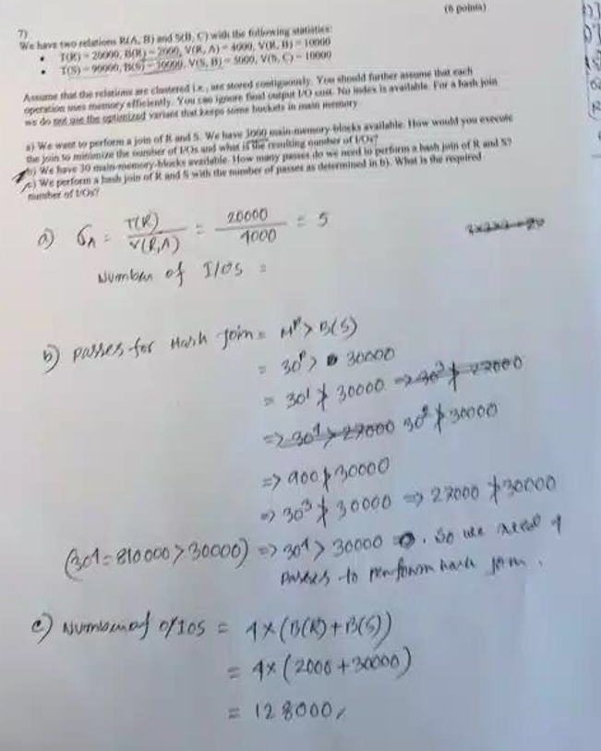

"A linear hash table with a capacity threshold of 80%. Suppose that keys are hashed to four-bit blocks can hold two records.
What is the minimum number of records we have to insert to get a hash table with 5 buckets?
Provide an example of a hash table with exactly 4 buckets and 2 overflow blocks. Draw the records with their hash values."

