Two Way MergeSort - Iterative method by Abdul Bari

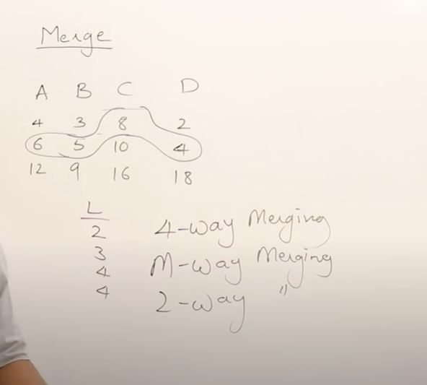
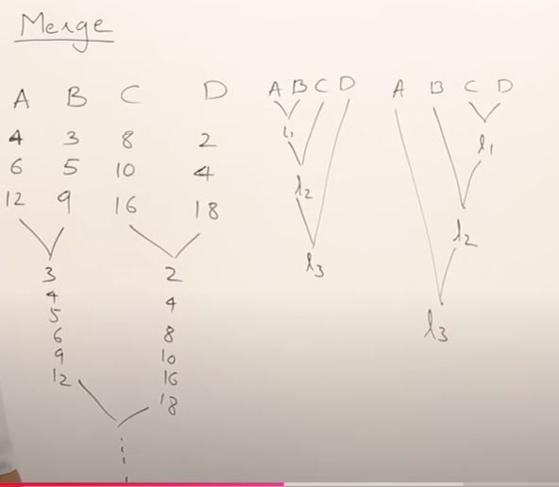

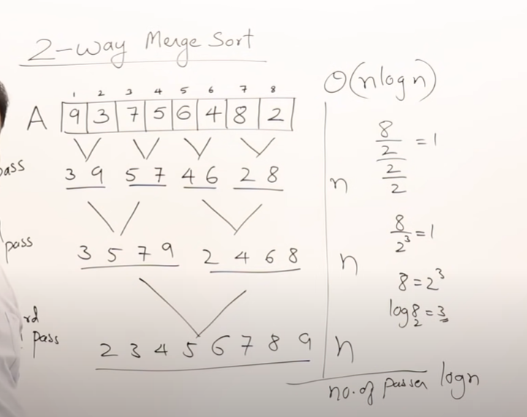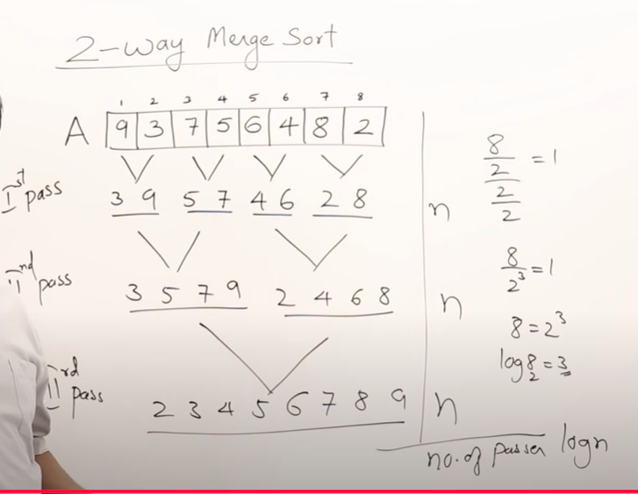

in Two-Phase, Multiway Merge Sort algorithm which phase is done in main memory and which in disk? with examples

In the Two-Phase, Multiway Merge Sort algorithm, each phase utilizes main memory and disk differently:
- Phase 1 (Sorting and Creating Sorted Sublists) - Main Memory and Disk
  - Main Memory: Records are loaded into main memory up to its capacity. Within main memory, they are sorted using an in-memory sorting algorithm (like QuickSort, MergeSort, or HeapSort).
  - Disk: After each batch of records is sorted in memory, it is written back to disk as a "sorted sublist." This phase repeats until the entire dataset is split into multiple sorted sublists on disk.
Example for Phase 1:
  - Imagine a dataset with 100 million records that is too large to fit entirely in main memory. If main memory can hold 10 million records at once, the algorithm will:
    - Load the first 10 million records into main memory, sort them, and write them as Sorted Sublist 1 on disk.
    - Load the next 10 million records, sort them, and write them as Sorted Sublist 2 on disk.
    - This continues, creating 10 sorted sublists on disk (each containing 10 million sorted records) by the end of Phase 1.
- Phase 2 (Merging Sublists into a Single Sorted List) - Disk and Main Memory
  - Disk: Each sorted sublist created in Phase 1 remains stored on disk. During Phase 2, each sorted sublist is read into main memory one block (or "buffer") at a time.
  - Main Memory: A buffer (a small section of main memory) is allocated for each sorted sublist to hold a portion of its records. An additional output buffer is used to collect the merged, sorted records.
  - Process: The algorithm repeatedly finds the smallest record across the sublist buffers and moves it to the output buffer. When a sublist buffer is exhausted, it reloads with the next block from the respective sublist on disk. Once the output buffer fills up, it is written back to disk as part of the final sorted list.
Example for Phase 2:
  - Suppose we have 10 sorted sublists on disk (each with 10 million records).
  - Each sublist gets its own buffer in main memory (e.g., each buffer can hold 1,000 records at a time from its respective sublist).
  - The algorithm:
    - Loads the initial blocks of each sublist into their buffers.
    - Finds the smallest record across all buffers and moves it to the output buffer.
    - Writes the output buffer to disk whenever it fills, creating the final merged sorted list in a single pass.
In summary:
- Phase 1: Uses main memory for sorting chunks of data and disk for storing sorted sublists.
- Phase 2: Uses disk to hold sorted sublists and main memory buffers to merge them into a single sorted list.

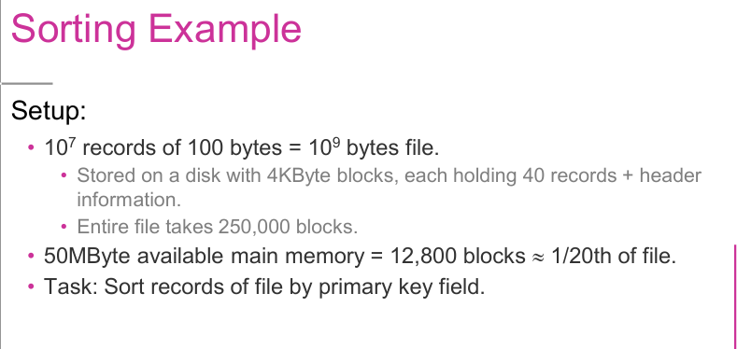

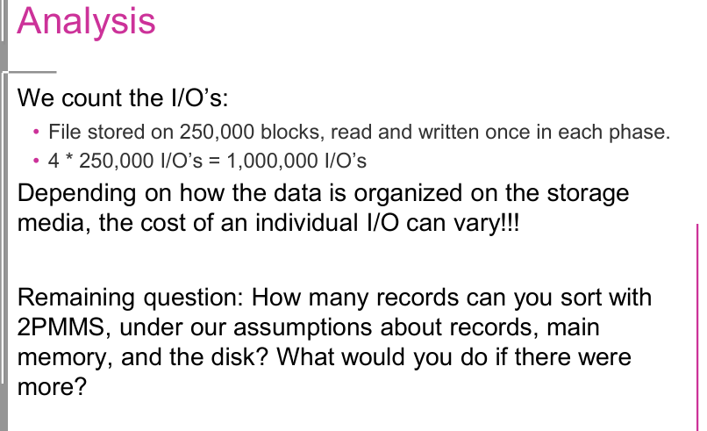
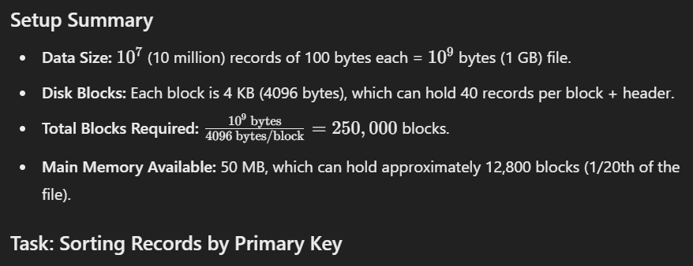
The goal is to sort this 1 GB file by the primary key field using 2PMMS.
Phase Analysis
In 2PMMS, we use two main phases to sort large datasets that don’t fit entirely in main memory:
- Phase 1: Create Sorted Sublists (Runs)
  - Main memory can hold 12,800 blocks at a time, so we load 12,800 blocks, sort them in memory, and write them back to disk as a sorted sublist (a "run").
  - Total Sorted Sublists (Runs): Since the entire file has 250,000 blocks, we will need: 250,000 blocks12,800 blocks/run≈20 runs\frac{250,000 \text{ blocks}}{12,800 \text{ blocks/run}} \approx 20 \text{ runs}12,800 blocks/run250,000 blocks​≈20 runs
  - After Phase 1, we have 20 sorted runs, each containing 12,800 blocks, stored on disk.
- Phase 2: Merge Sorted Sublists
  - During this phase, we use one buffer for each sorted sublist (run) and one buffer as an output buffer.
  - We need 20 buffers (one per run) plus an output buffer, totaling 21 buffers. With 12,800 blocks of memory, this is feasible since 21 buffers are manageable within available memory.
  - The 2PMMS process will read from each buffer and write sorted records into the output buffer, completing the merge into a single sorted file.
I/O Cost Analysis
Each phase requires reading and writing all blocks once:
- Phase 1 (Create Runs): Read 250,000 blocks and write 250,000 blocks, totaling 500,000 I/Os.
- Phase 2 (Merge Runs): Read 250,000 blocks and write 250,000 blocks again, totaling another 500,000 I/Os.
So, the total I/O cost is:
500,000 I/Os (Phase 1)+500,000 I/Os (Phase 2)=1,000,000 I/Os
Remaining Questions and Solutions
- How many records can be sorted with 2PMMS under these assumptions?
  - With the setup given (50 MB main memory and 4 KB blocks), 2PMMS can sort files that are approximately 20 times the size of main memory.
  - Since our main memory can handle 12,800 blocks at once, we can handle up to 20 times that in file size, equating to about 250,000 blocks or 10 million records.
- What to do if there are more records than can be sorted in 2PMMS with available memory?
  - Increase the Memory Allocation: Adding more main memory can reduce the number of runs, which makes merging more manageable.
  - Multi-Phase Merge Sort: If memory cannot be increased, an additional phase can be added to merge sorted runs in stages. For example, after Phase 2, if there are still too many runs to merge in a single pass, you could perform a multi-level merge until the final file is completely sorted.
  - Optimize Disk I/O (if possible): Techniques like reducing seek time through sequential reading or improving disk layout (e.g., RAID) can help manage additional records more efficiently, though they don’t address memory limits directly.

Two Way External Memory Merging

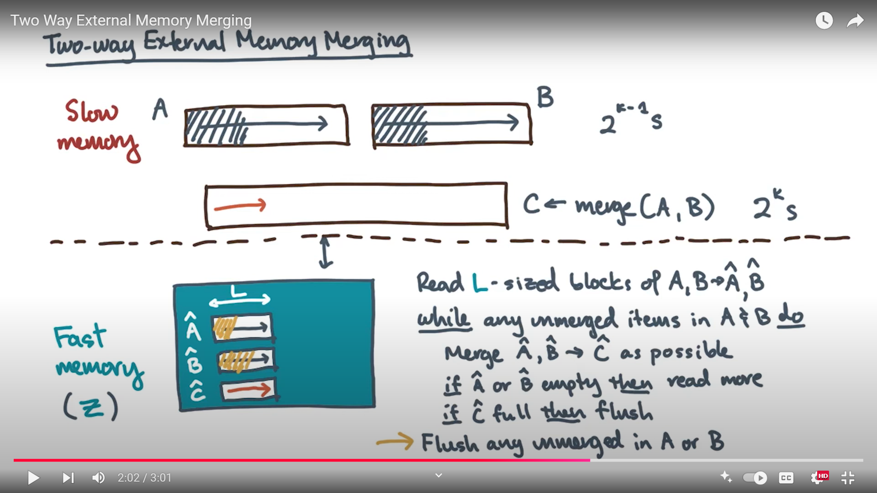

The Two-Phase, Multiway Merge Sort algorithm is commonly used in database management systems to efficiently sort large datasets that cannot fit entirely in main memory. Here’s a step-by-step breakdown of each phase and example exercise questions to understand the algorithm.
Two-Phase, Multiway Merge Sort Overview
The algorithm operates in two main phases:
- Phase 1: Create Sorted Sublists
  - Step 1: Fill main memory with as many records as it can hold.
  - Step 2: Sort these records using an in-memory sorting algorithm (like QuickSort or MergeSort).
  - Step 3: Write the sorted records (now a "sorted sublist") back to disk.
  - Step 4: Repeat this process until all records have been organized into sorted sublists on the disk.
Objective: Break the dataset into several sorted sublists that are stored on disk.
- Phase 2: Merge Sorted Sublists into a Final Sorted List
  - Step 1: For each sorted sublist on disk, allocate one buffer in main memory to hold its data.
  - Step 2: Initially load each buffer with the first block of data from its respective sorted sublist.
  - Step 3: Use a "competition" approach to find the smallest (or "least") record among the first records in each buffer.
  - Step 4: Move this "smallest" record to the output buffer.
  - Buffer Management:
    - If an input buffer is emptied, refill it with the next block from the respective sublist.
    - If the output buffer is filled, write it to disk and clear the buffer for more records.
Objective: Combine the sorted sublists from Phase 1 into a single, fully sorted list.
Common Exercise Questions
Here are some questions to deepen understanding of the Two-Phase, Multiway Merge Sort algorithm:
- Describe each step of the Two-Phase, Multiway Merge Sort algorithm. Explain the purpose of each phase.
- In Phase 1, why do we need to use an in-memory sorting algorithm, and what are some examples of algorithms that can be used here?
- Explain how the buffers are used in Phase 2 of the Two-Phase, Multiway Merge Sort. Why is it necessary to manage the buffers carefully?
- What is the role of the "competition" among buffered records in Phase 2, and how does it ensure that the final output list is sorted?
- Consider a dataset with N records and a memory that can hold M records at a time. How many sorted sublists will be created in Phase 1?
- Why is the Two-Phase, Multiway Merge Sort considered efficient for large datasets? What advantages does it have over single-phase sorting?
- Illustrate the Two-Phase, Multiway Merge Sort process using a small dataset example. Include steps for both phases and show how records are managed.
- Assume you have three sorted sublists of records on disk, and each buffer can hold two records. Walk through how Phase 2 would sort and merge these sublists.
- Describe scenarios where the Two-Phase, Multiway Merge Sort algorithm is particularly beneficial. What types of data management tasks is it suited for?
- Discuss potential limitations or challenges when implementing the Two-Phase, Multiway Merge Sort algorithm. How might buffer size affect performance?
These questions cover the key concepts and practical understanding needed to implement and analyze the effectiveness of the Two-Phase, Multiway Merge Sort algorithm in a DBMS context.

