Sheet-6
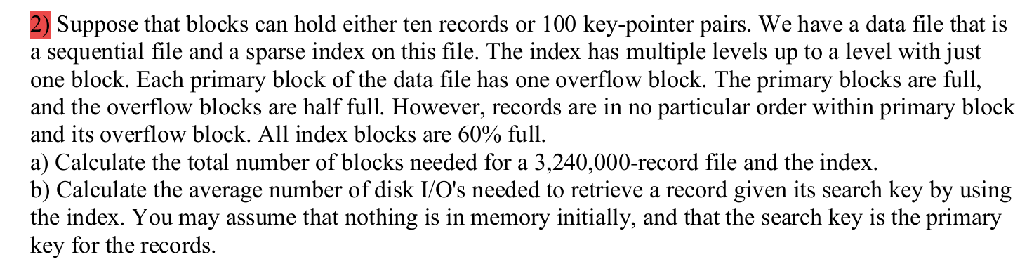
a) Calculate the total number of blocks needed for a 3,240,000-record file and the index. Solution: A pair of a primary block and an overflow block contains 10 + 5 records = 15 records. Therefore, we need for the data file ⎡(3,240,000 records) / (15 records / pair of blocks)⎤ = 216000 pairs of a primary block and an overflow block. Hence, we need 432000 blocks. As we have a sparse index, we need one pointer for each primary block of the data file. As the index blocks can store 100 key-pointer pairs but are only 60% full, we have in an index block 60 key-pointer pairs. Therefore, we need for the index levels:
1st level index: ⎡(216000 key-pointer pairs) / (60 key-pointer pairs / block)⎤ = 3600 blocks.
2nd level index ⎡(3600 key-pointer pairs) / (60 key-pointer pairs / block)⎤ = 60 blocks
3rd level index ⎡(60 key-pointer pairs) / (60 key-pointer pairs / block)⎤ = 1 block
In total we need 3661 blocks for the index and 435661 blocks including the data file.
b)
We need one I/O for each level of the index, i.e., 3 I/O’s for the index. For finding a record in the primary bock, we need to examine just one block. For finding a record in the overflow block we need to examine two blocks. The fraction of records which reside in a primary block is 10/15 = 2/3 and for an overflow block 5/15 = 1/3. Therefore, the average number of I/O’s for the data file is: 2/3 * 1 I/O + 1/3 * 2 I/O’s = 4/3 I/O’s. In total, the average number of I/O’s is 4 + 1/3 I/O’s.
Exercise Sheet 7
1) Suppose that blocks can hold either three records, ten key-pointer pairs, or fifty pointers.
a) We use the indirect bucket scheme. If each search-key value appears in 10 records, how many blocks do we need to hold 3000 records and its secondary index structure? How many blocks would we need if we did not use buckets but a key-pointer pair for each record?
b) We want to retrieve all records for a particular search key. In doing so, we sequentially scan the key-pointer pairs in the index from the beginning until we find the search key value we are looking for. We assume that records with the same search key never share a block. We also assume that buckets never extend across different blocks and that key-pointer pairs with the same key are all in the same block. How many blocks do you have to inspect on average, for the two scenarios in a)?
a)
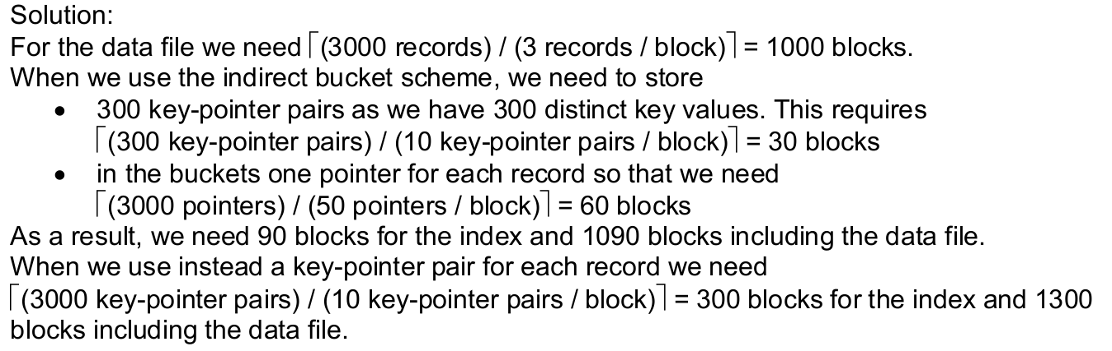

b)
Solution: When we use the indirect bucket scheme, we start with a sequential search of the blocks containing key-pointer-pairs. It is equally likely that we find the key in any of these blocks. Thus, the number of blocks to inspect is uniformly distributed. The best case is that we can stop after the first block. The worst case is that we need to inspect all 30 blocks. Thus, the average number of inspected blocks is (1 + 30) / 2 = 15.5 blocks. The pointer, that accompanies the key, points to the corresponding bucket so that we have to inspect exactly one bucket-block. The bucket contains pointers to the ten records in the data file. Each record is in a different block so that we have to inspect 10 data blocks. In total we need to inspect 15.5 + 1 + 10 = 26.5 blocks.
In the alternative approach we also perform a sequential search of the blocks containing key pointer-pairs. With a similar reasoning as above, we inspect on average (1 + 300) / 2 = 150.5 blocks. However, this time the pointers point directly to the records of the data file. Therefore, the remaining blocks to be inspected are the 10 data blocks containing the records. In total we need to inspect 150.5 + 10 = 160.5 blocks.
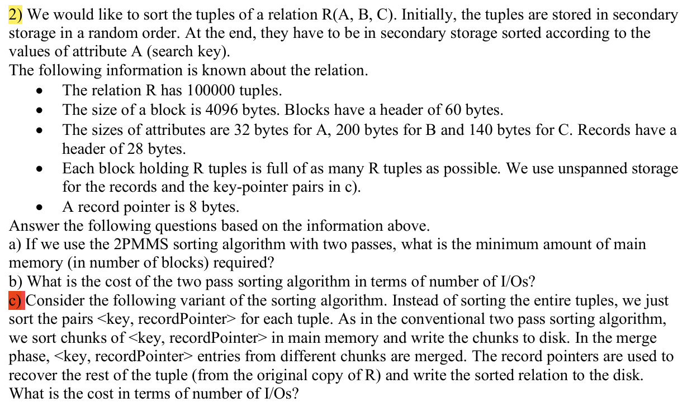
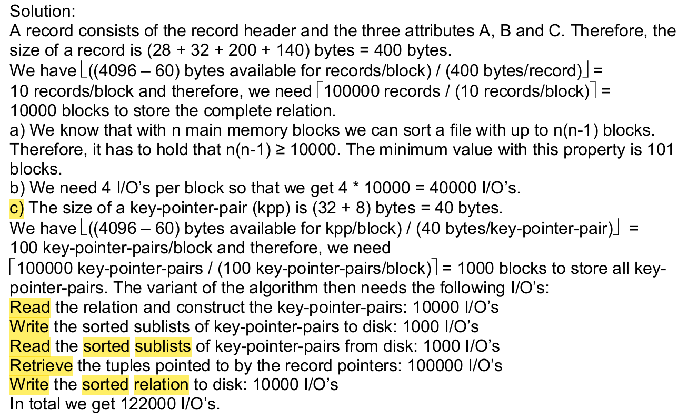
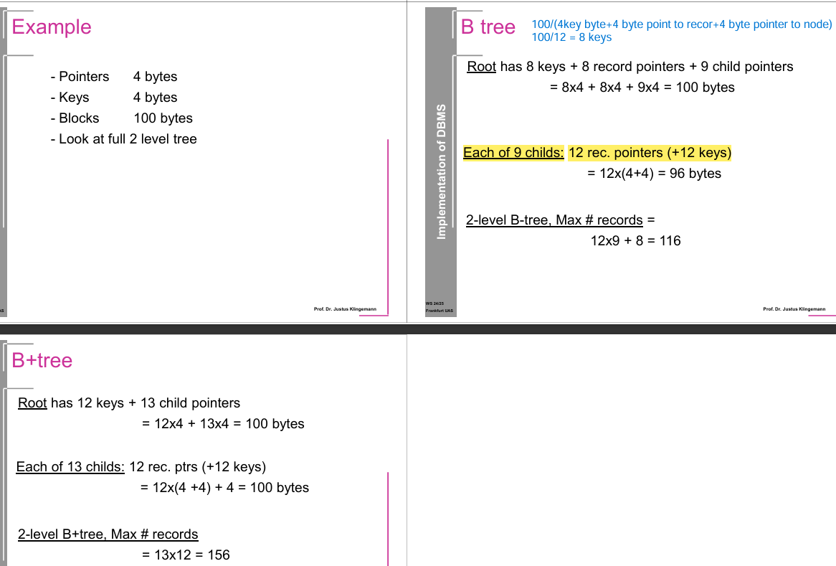
B-Tree Calculation
- Given Data:
  - Pointer size = 4 bytes
  - Key size = 4 bytes
  - Block size = 100 bytes
  - 2-Level B-Tree
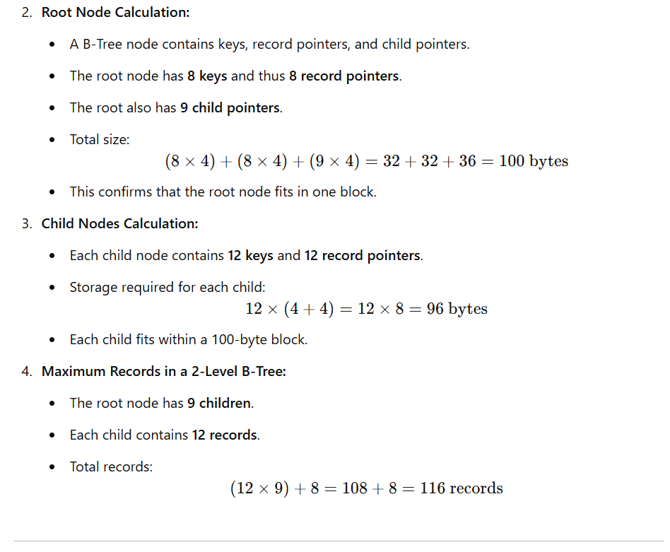

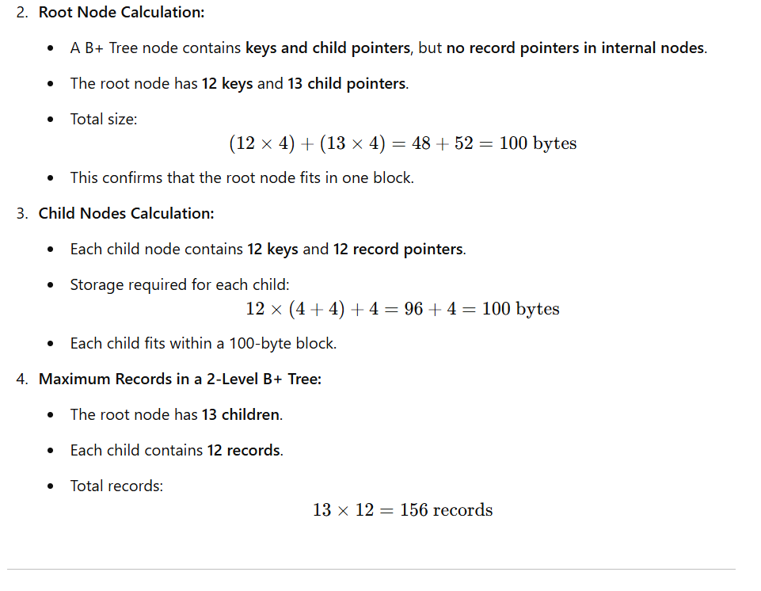
Example 1
• Pointers: 8 bytes
• Keys: 8 bytes
• Blocks: 200 bytes
• Look at full 2-level tree
We need to determine:
- The maximum number of keys a node can store (both root and child nodes).
- The maximum number of records a 2-level tree can store.
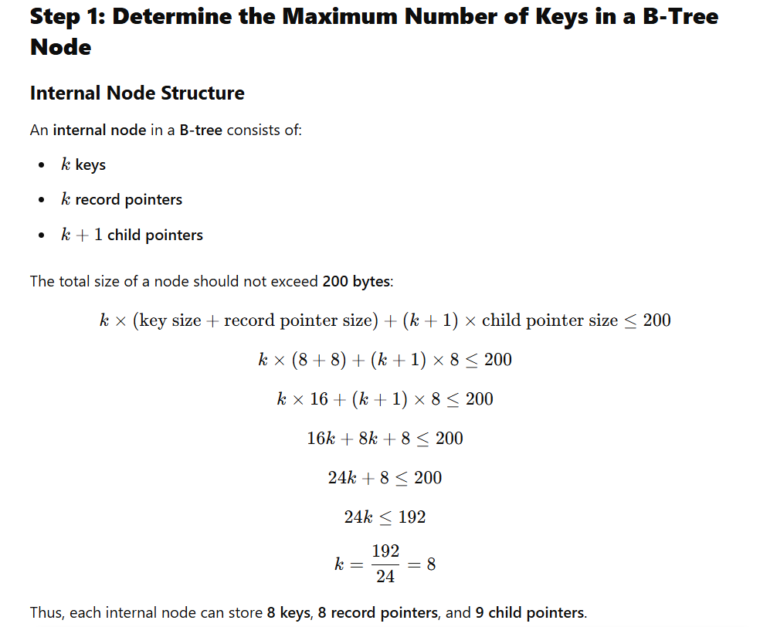
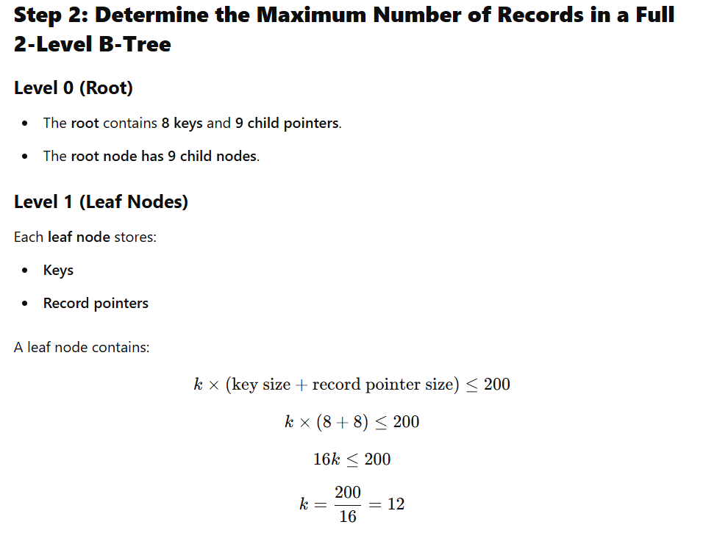
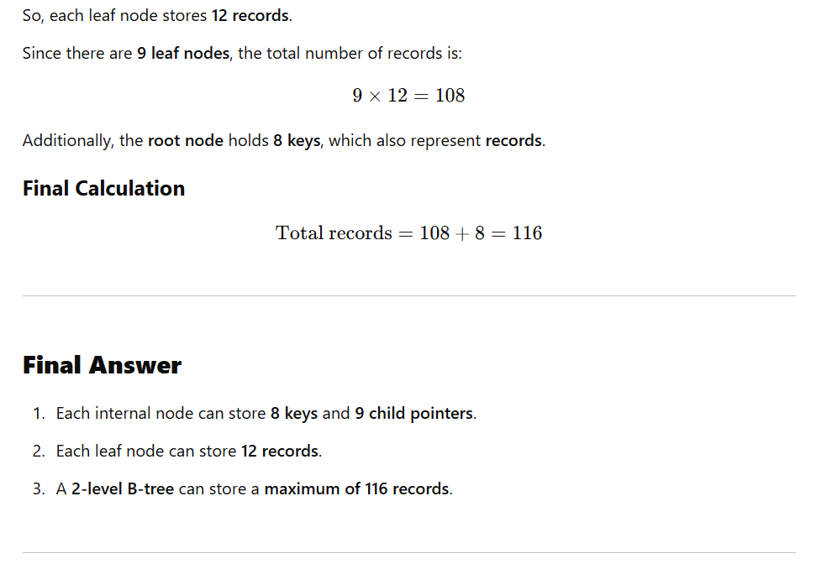
Given Information
- Pointer size = 5 bytes, Key size = 5 bytes, Block size = 120 bytes
- Tree structure: We are looking at a full 2-level tree (one root and its child nodes).
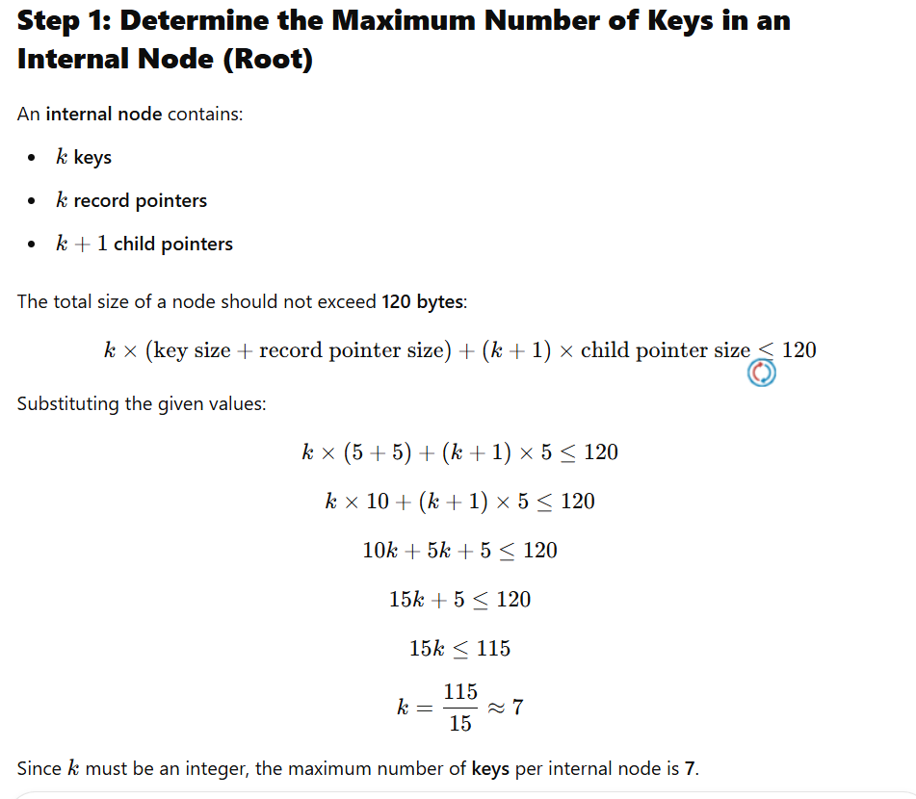
Thus, the root can hold:7 keys, 7 record pointers, 8 child pointers (since there are k+1 child pointers)

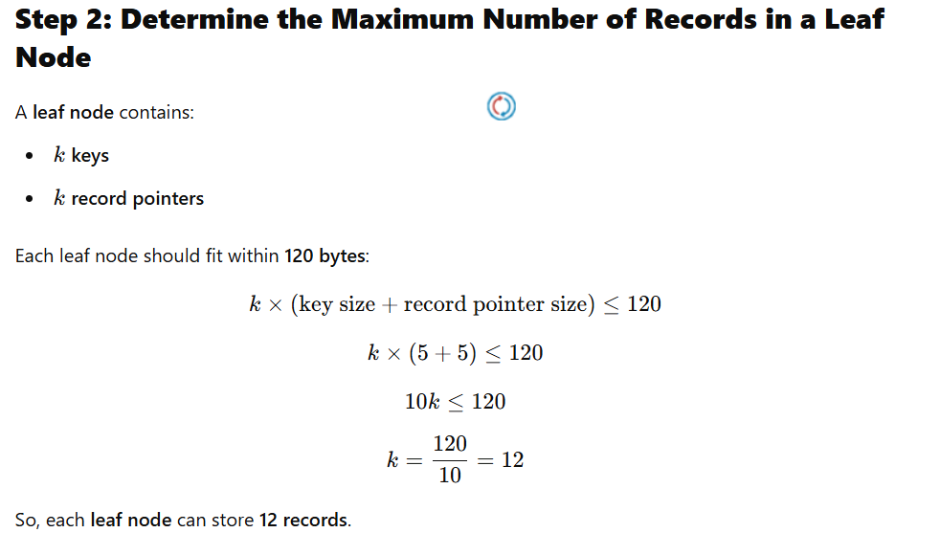
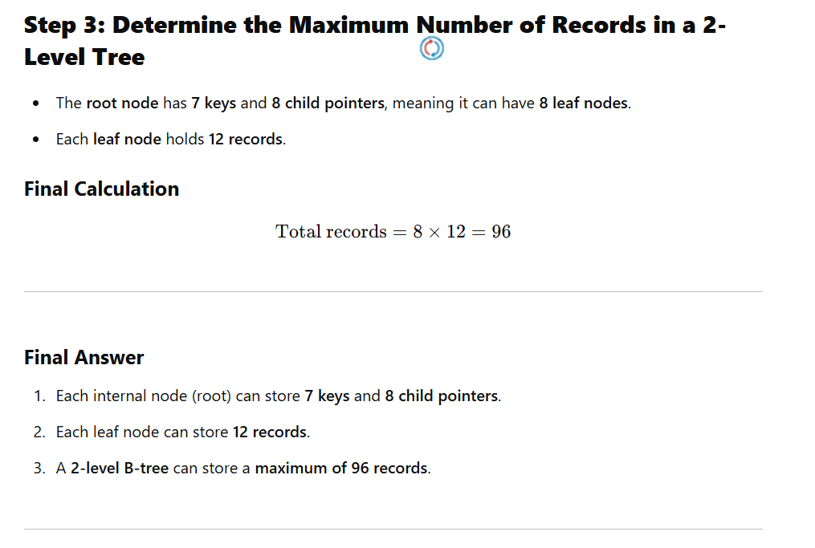
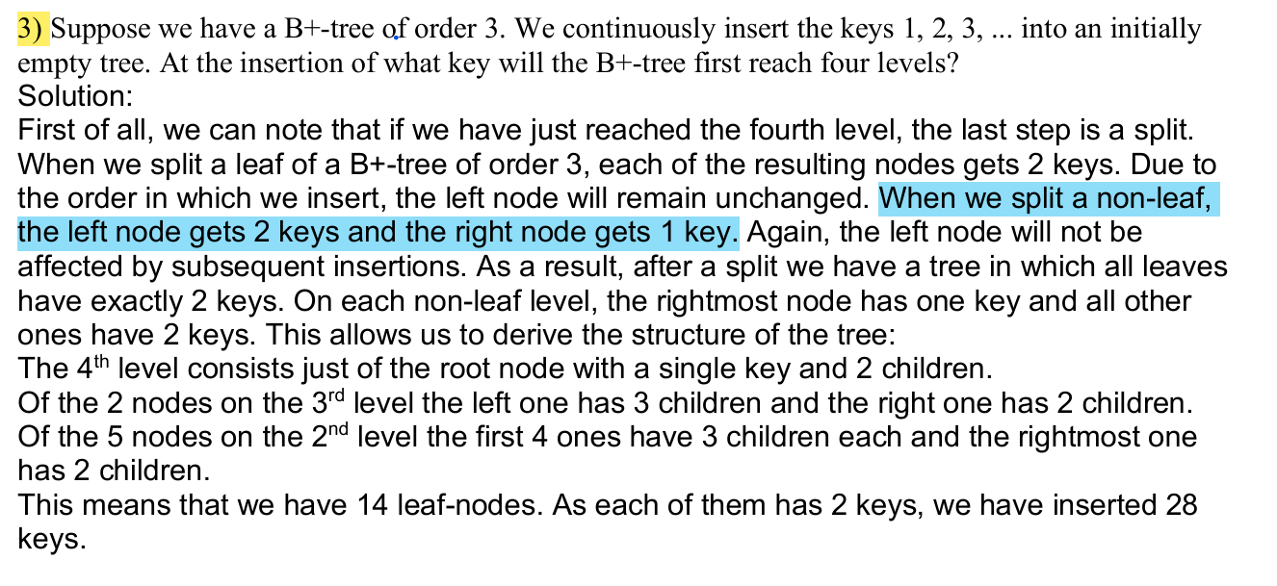
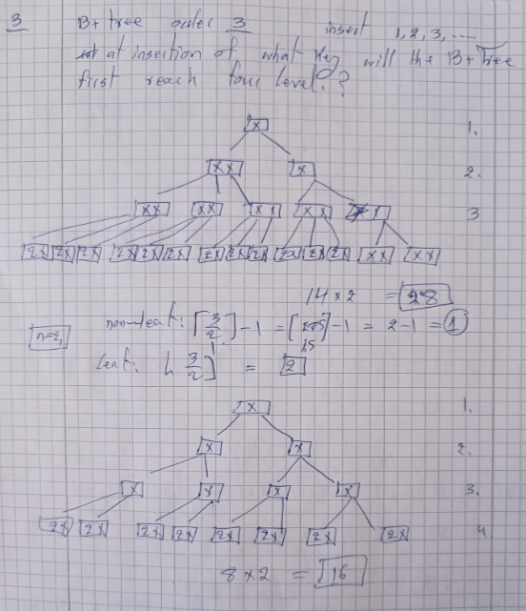
3a) Suppose we have a B+-tree of order 3. We continuously insert the keys 1, 2, 3, ... into an initially empty tree. At the insertion of what key will the B+-tree first reach four levels?
