Here’s a summary of your lecture note “Sprint 1 – Introductory Data Analysis” (Prof. Dr. Matteo Marouf):

🧠 Summary: Sprint 1 – Introductory Data Analysis

1. Course Overview
- Focus: Understanding data analysis using Python.
- Tools: pandas, numpy, matplotlib, seaborn, scikit-learn.
- Structure: 12 learning blocks from Python basics → statistical inference → storytelling with data.
- Requirements:
  - 80% attendance in exercises for exam eligibility.
  - Rehearsal exam required.
  - No AI assistance in assignments; collaboration is encouraged.

2. Data Analysis Process
Goal: Convert raw data → meaningful insights.

Stages:
- Collect Data (sampling)
- Summarize Data (descriptive statistics)
- Interpret and Analyze (inferential statistics)

3. Statistical Investigation Cycle
- Problem Understanding – define research question.
- Produce Data – collect a representative sample.
- Exploratory Data Analysis (EDA) – summarize, visualize.
- Modeling & Analysis – apply statistical tools.
- Inference – generalize findings to population.
- Communication – storytelling and recommendations.

4. Data Representation
- Convert various data (text, image, signal) into numerical form for analysis.
Examples:
  - Text: TF-IDF, Word2Vec.
  - Image: pixel intensity values or spectrograms.
  - Graph: Node2Vec embeddings.

5. Data Types
Type | Description | Examples
Qualitative (Categorical) | Non-numeric categories | Gender, Color
Quantitative (Numeric) | Measurable values | Age, Salary
Structured | Tables, databases | Customer records
Unstructured | Free text, media | Tweets, Videos
Semi-structured | JSON, XML | Web logs
Signal Data | Sequential numeric data | ECG, audio waveform

6. Sampling Concepts
- Population: Entire group of interest.
- Sample: Subset studied due to practical limits.
- Good Sampling Practices:
  - Clear definition
  - Representativeness
  - Random selection
  - Adequate sample size
  - Bias avoidance (selection/nonresponse bias)

7. Descriptive Statistics

Measures of Center:
Measure | Description | Use Case
Mean | Average value | Normal data
Median | Middle value | Skewed data
Mode | Most frequent | Categorical data

Measures of Variability:
- Range: max - min
- Variance (s²) and Standard Deviation (s): how spread out the data is.

Percentiles:
- Indicate relative standing (e.g., 85th percentile = better than 85% of observations).

Five-number summary:
- Min, Q1, Median, Q3, Max → forms Boxplot to show spread and outliers.

8. Measures of Shape
Measure | Meaning | Interpretation
Skewness | Asymmetry | Right-skew → long right tail
Kurtosis | Tail heaviness | High → frequent extreme values

9. Visualizations
Type | Purpose
Histogram | Distribution of numeric data
Bar Chart / Pie Chart | Categorical distribution
Box Plot | Spread, outliers
Scatter Plot | Relationship between two variables
Time Chart | Change over time

10. Common Statistical Pitfalls
- Simpson’s Paradox – Aggregated data can mislead.
- Always check subgroups and denominators.

11. Communication & Storytelling
- Combine data, visualization, and narrative.
- Outcome: clear insights for decision-making.

🧾 Exam Cheat Sheet

Key Formulas

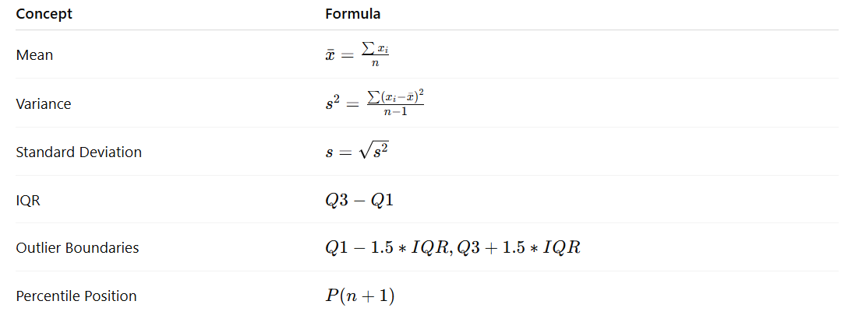

Data Analysis Steps
- Define question
- Collect data (sampling)
- Clean & visualize
- Summarize (mean, median, mode, SD)
- Analyze (correlation, distributions)
- Infer and communicate

Visualization Shortcuts (Python)
# Histogram
df['age'].hist()

# Boxplot
sns.boxplot(x='sex', y='age', data=df)

# Scatterplot
sns.scatterplot(x='age', y='fare', data=df)

# Correlation heatmap
sns.heatmap(df.corr(), annot=True)

🧾 DATA ANALYSIS EXAM CHEAT SHEET

🔹 1. DATA ANALYSIS PROCESS
Goal: Turn raw data → meaningful insights.
Steps:
- Define problem
- Collect sample data
- Clean and summarize
- Visualize patterns
- Analyze (statistical tools)
- Draw conclusions & communicate

🔹 2. TYPES OF DATA
Type | Description | Example
Qualitative (Categorical) | Names or labels | Gender, Color
Quantitative (Numeric) | Measurable values | Age, Salary
Structured | Tabular format | SQL tables
Unstructured | Free text/media | Tweets, Images
Semi-structured | JSON/XML | Web logs
Signal Data | Sequential numeric | Audio, ECG

🔹 3. SAMPLING CONCEPTS
- Population: All individuals of interest.
- Sample: Subset used for analysis.
- Good Sampling: Random, representative, adequate size, unbiased.
- Common Biases: Selection bias, nonresponse bias.

🔹 4. DESCRIPTIVE STATISTICS

Measures of Center
Measure | Description | Best For
Mean | Arithmetic average | Symmetrical data
Median | Middle value | Skewed data
Mode | Most frequent value | Categorical data

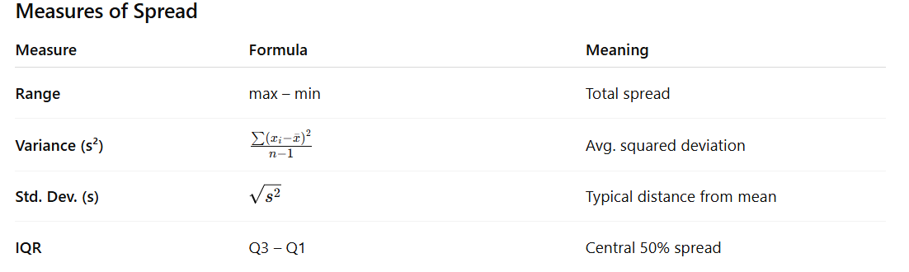
Outliers:
- Lower bound = Q1 - 1.5×IQR
- Upper bound = Q3 + 1.5×IQR

🔹 5. SHAPE OF DISTRIBUTION
Measure | Meaning | Interpretation
Skewness | Asymmetry | Right-skew = long right tail
Kurtosis | Tail heaviness | High = more extreme values

🔹 6. VISUALIZATION TYPES
Chart | Purpose
Histogram | Show distribution of numeric data
Bar Chart / Pie Chart | Compare categories
Box Plot | Show median, quartiles, outliers
Scatter Plot | Relationship between two variables
Line / Time Plot | Trends over time
Heatmap | Correlation matrix visualization

🔹 7. COMMON STATISTICAL FALLACIES
- Simpson’s Paradox: Trends change when groups are combined.
👉 Always check subgroup data.
- Misleading Averages: Mean distorted by outliers.
- Ignoring Variability: Always pair mean with SD/IQR.

🔹 8. PYTHON COMMANDS (Pandas & Seaborn)
Task | Command
Import pandas | import pandas as pd
Load dataset | df = pd.read_csv('file.csv')
View first rows | df.head()
Shape (rows, cols) | df.shape
Missing values | df.isnull().sum()
Summary stats | df.describe()
Select rows | df.loc[0] / df.iloc[0]
Filter | df[df['age'] < 18]
Group mean | df.groupby('sex')['age'].mean()
New column | df['fare_per_age'] = df['fare']/df['age']
Correlation | df.corr()

🔹 9. VISUALIZATION COMMANDS
Plot | Python Command
Histogram | df['age'].hist()
Box Plot | sns.boxplot(x='sex', y='age', data=df)
Scatter Plot | sns.scatterplot(x='age', y='fare', data=df)
Bar Plot | sns.barplot(x='sex', y='survived', data=df)
Pie Chart | df['survived'].value_counts().plot.pie()
Heatmap | sns.heatmap(df.corr(), annot=True, cmap='coolwarm')

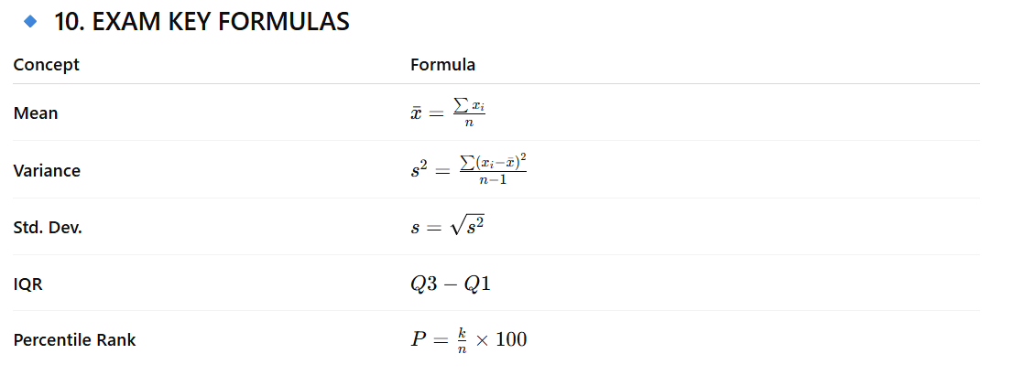

🔹 11. DATA STORYTELLING TIPS
- Use simple visuals (avoid clutter).
- Combine data + visuals + narrative.
- Always answer:
“What does this mean and why does it matter?”

