✅ SUMMARY of the Lecture Notes
Key concepts covered include:
- Sample space, simple events, events
- Event operations: union, intersection, complement
- Mutually exclusive vs. independent events
- Calculating probabilities in system reliability and quality-control scenarios
- Conditional probability and interpretation
- Independence using P(A|B) = P(A)
- Law of Total Probability for partitioned events
- Applications in real systems (flight control, manufacturing defects)
The goal is to enable students to compute probabilities, understand how events interact, and apply probabilistic reasoning to real-world systems.

📘 CHEAT SHEET — Probability & Events (Exam Ready)
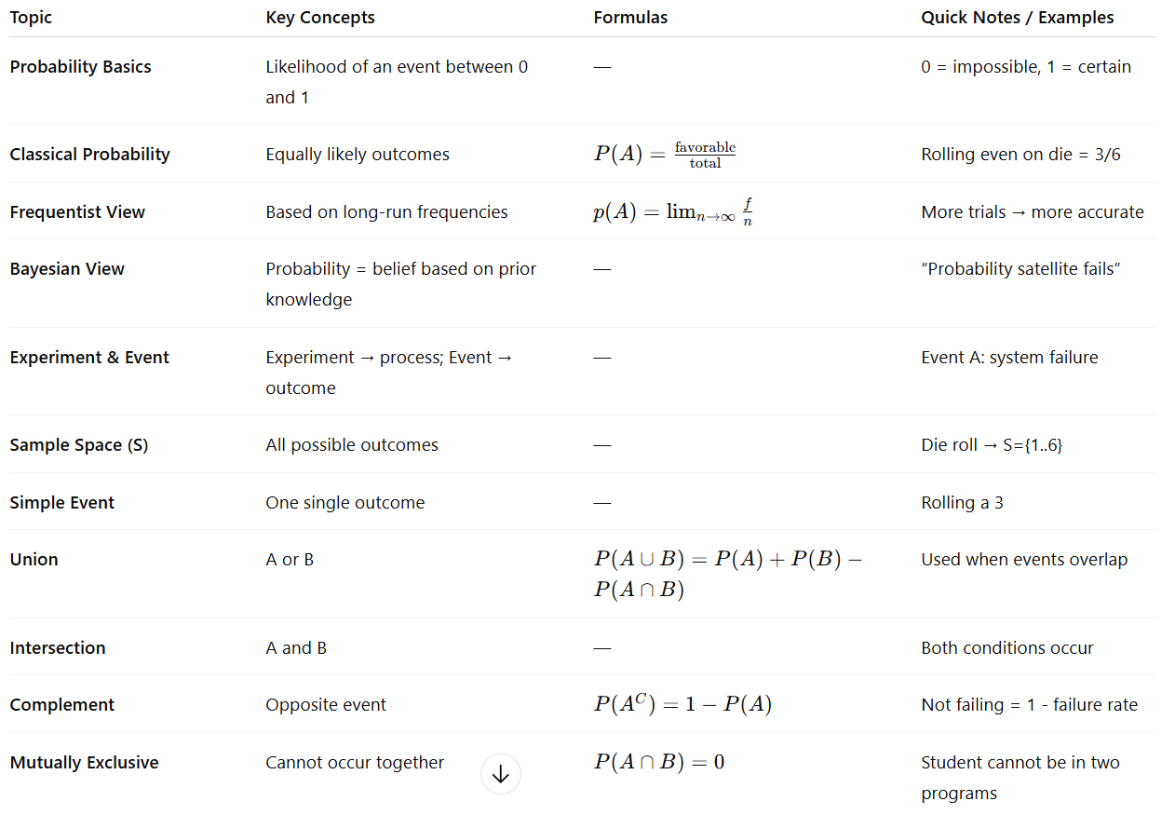

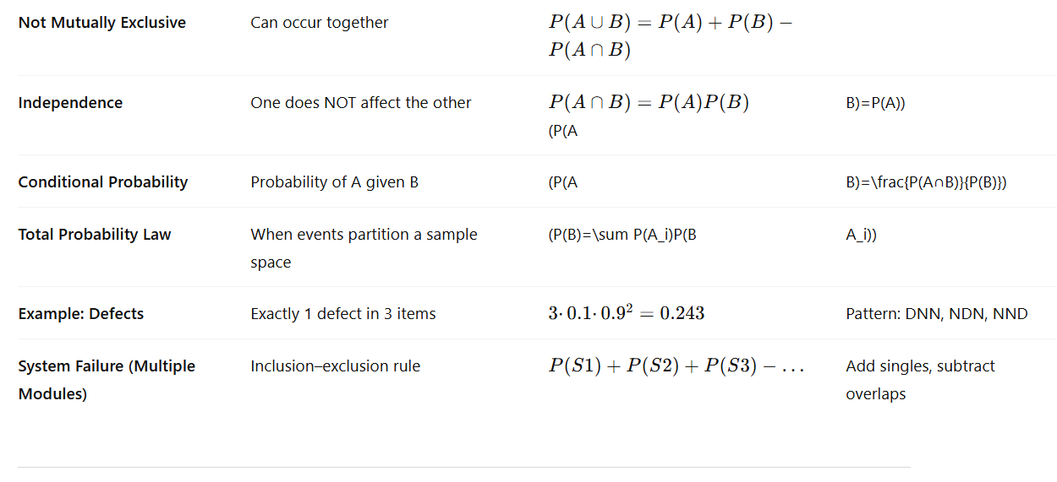
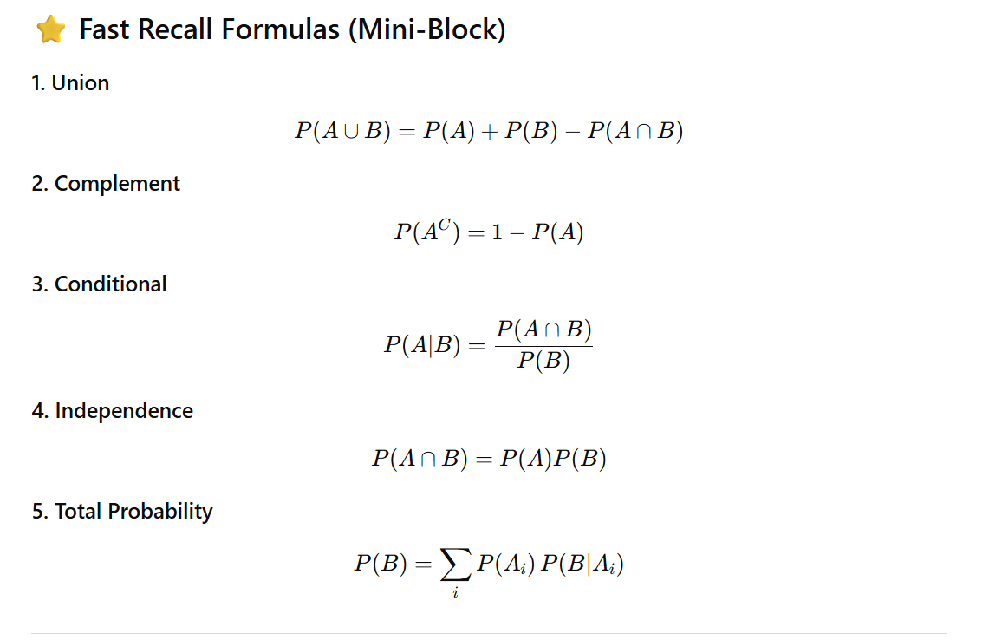

2) Two similar, well-posed practice questions (with solutions)

Practice Question A (clear inclusion / overlap)
Problem: In a department of 250 students, 150 are enrolled in IDA and 80 are enrolled in Project HIS. If 40 students are enrolled in both IDA and Project HIS, how many students are enrolled in at least one of these two activities?
Solution: Use inclusion–exclusion:
$$\#(IDA∪HIS)=\#IDA+\#HIS-\#(IDA∩HIS)=150+80-40=190.$$
Answer: 190 students.

✅ Question 1 (same structure as original)
How many students study both Statistics and Machine Learning Project under Dr. Karim?
- There are 240 Machine Learning students in total.
- Dr. Karim supervises 25 students on the ML Project.
- He teaches 230 students in his Statistics course.
This is NOT mutually exclusive — a student may take both.
Let b = number of students taking BOTH Statistics and ML Project.
Then:
- Students in Statistics only = $230-b$
- Students in ML Project only = $25-b$
Total ML students is 240, so:
$$(230-b)+b+(25-b)=240 \\ 255-b=240 \\ b=15$$
✔️ Answer: 15 students study both Statistics and ML Project under Dr. Karim.

✅ Question 2 (same structure, different numbers)
How many students take both Data Mining and Thesis Project with Prof. Aisha?
- There are 300 Thesis-track students overall.
- Prof. Aisha supervises 40 Thesis Project students.
- She teaches 290 Data Mining students.
Not mutually exclusive — overlap is possible.
Let b = number of students taking BOTH Data Mining and Thesis Project.
Then:
- Data Mining only = $290-b$
- Thesis Project only = $40-b$
Total students on the Thesis track = 300:
$$(290-b)+b+(40-b)=300 \\ 330-b=300 \\ b=30$$
✔️ Answer: 30 students take both Data Mining and Thesis Project under Prof. Aisha.

✅ Original Question
In a factory, 10% of products have defects. Three products are selected at random.
What is the probability that exactly one of the three has a defect?
This follows a binomial distribution:
- Probability of defect: $p=0.10$
- Probability of non-defect: $q=0.90$
- Number of trials: $n=3$
- We want exactly $k=1$defect.
Formula
$$P(X=k)=({n \atop k})p^{k}(1-p)^{n-k}$$
Compute
$$P(X=1)=({3 \atop 1})(0.10)^{1}(0.90)^{2} \\ =3⋅0.1⋅0.81 \\ =3⋅0.081=0.243$$
✔ Final Answer: 0.243 (≈ answer choice b: 0.234)
(The correct value is 0.243; option b is closest.)

✅ Two New Similar Questions (with solutions)

Question 1
A machine produces 5% defective items. Five items are selected at random.
What is the probability that exactly two are defective?
Solution
$$p=0.05, q=0.95, n=5, k=2$$
$$P(X=2)=({5 \atop 2})(0.05)^{2}(0.95)^{3} \\ =10⋅0.0025⋅0.857375 \\ =10⋅0.0021434=0.02143$$
✔ Answer: 0.0214 (about 2.14%)

Question 2
The probability that a randomly chosen customer makes a complaint is 15%.
Four customers are selected.
What is the probability that none complain?
Solution
We want zero complaints, so:
$$P(X=0)=(1-0.15)^{4}={0.85}^{4} \\ =0.522$$
✔ Answer: 0.522 (52.2%)

Example 1 — Spacecraft Reaction-Control Thrusters (ALL-fail case)
Scenario. A spacecraft uses three redundant thrusters for attitude control. The system loses attitude control only if all three thrusters fail during a critical maneuver. Failures are assumed independent.
- Events: $T_{1},T_{2},T_{3}$= “thruster $i$fails”.
- Probabilities (per maneuver):
$P(T_{1})=2×{10}^{-4}$, $P(T_{2})=3×{10}^{-4}$, $P(T_{3})=1×{10}^{-4}$.
Model / formula. System failure $A$occurs only when all three fail:
$$P(A)=P(T_{1}∩T_{2}∩T_{3})=P(T_{1})P(T_{2})P(T_{3})$$
(independence used).
Compute (numbers):
$$P(A)=2⋅{10}^{-4}×3⋅{10}^{-4}×1⋅{10}^{-4}=6⋅{10}^{-12}.$$
Takeaway. The probability of simultaneous thruster failure is extremely small (~$6×{10}^{-12}$). Designing for “all-fail” is conservative; we typically also analyze “at least k fail” cases depending on required safety level.

Example 2 — Autonomous Vehicle Sensor Suite (Majority-fail case)
Scenario. An autonomous car uses LIDAR, radar and camera. The vehicle is considered to lose safe perception if at least two of the three sensors fail (majority failure). Failures are independent but sensors have different reliabilities.
- Events: $L,R,C$= LIDAR, Radar, Camera fail.
- Probabilities: $P(L)=0.01$, $P(R)=0.02$, $P(C)=0.015$.
Model / formula. System failure = (exactly two fail) $+$(all three fail).
For unequal independent probabilities:
$$\begin{matrix}P(\text{system fail}) & =\sum_{\text{pairs }(i,j)}{}P(i)P(j)\prod_{k≠i,j}{}(1-P(k)) \\ & +P(L)P(R)P(C).\end{matrix}$$
Compute (numbers):
- Exactly two fail:
  - $L\&R$only: $P(L)P(R)(1-P(C))=0.01⋅0.02⋅0.985=0.000197$.
  - $L\&C$only: $0.01⋅0.015⋅0.98=0.000147$.
  - $R\&C$only: $0.02⋅0.015⋅0.99=0.000297$.
Sum = $0.000197+0.000147+0.000297=0.000641$.
- All three: $0.01⋅0.02⋅0.015=0.000003$.
Total:
$$P(\text{fail})≈0.000641+0.000003=0.000644 (≈6.44×{10}^{-4}).$$
Takeaway. Majority failure probability ~0.064% per mission segment — small, but much larger than the triple-fail probability alone. Unequal component reliabilities must be handled by summing appropriate combination probabilities.

Example 3 — Data-Center Power Redundancy (UPS + Generator)
Scenario. A data center has two independent UPS units (primary and backup) and an automatic backup generator. The data center loses power only if both UPS units fail and the generator fails to start (i.e., all three fail to provide power). Events are independent.
- Events: $U_{1},U_{2},G$= UPS1 fails, UPS2 fails, Generator fails-to-start.
- Probabilities (per outage event):
$P(U_{1})=5×{10}^{-4}$, $P(U_{2})=4×{10}^{-4}$, $P(G)=1×{10}^{-3}$.
Model / formula. System outage $A$happens if all three fail:
$$P(A)=P(U_{1})P(U_{2})P(G).$$
Compute (numbers):
$$P(A)=5⋅{10}^{-4}×4⋅{10}^{-4}×1⋅{10}^{-3}=2⋅{10}^{-10}.$$
Takeaway. The probability of complete loss of power under these independent-failure assumptions is extremely small (~$2×{10}^{-10}$). In practice one also models correlated failures (common-mode), maintenance windows, and latent defects which can raise risk above the independent estimate.

Short summary / patterns to remember
- “Any one fails ⇒ system fails” (OR logic):
$P(A)=1-\prod_{i}{}(1-P(S_{i}))$.
- “All must fail ⇒ system fails” (AND logic):
$P(A)=\prod_{i}{}P(S_{i})$.
- k-out-of-n failure (e.g., majority): sum probabilities of exactly $k,…,n$components failing; for identical $p$use binomial; for unequal $p$sum the appropriate combinations.
- Correlations matter: independence often underestimates risk if there are common-mode causes.

Example 1 — Engine Control & Hydraulic Leak (conditional probability)
System & events
- Event A: Engine control unit (ECU) failure.
- Event B: Hydraulic system leak (degradation).
Given
- $P(A∩B)=0.0005$(both ECU failure and hydraulic leak occur together)
- $P(B)=0.01$(hydraulic leak probability)
Find $P(A∣B)$— probability the ECU fails given a hydraulic leak.
Compute
$$P(A∣B)=\frac{P(A∩B)}{P(B)}=\frac{0.0005}{0.01}=0.05.$$
Interpretation: If a hydraulic leak is observed, there is a 5% chance the ECU will also fail (given these numbers). This suggests a non-negligible conditional risk — investigate common-cause links (e.g., hydraulic contamination affecting electronics).

Example 2 — Navigation Software & GPS Interference
System & events
- Event A: Navigation-software anomaly (unexpected behavior).
- Event B: GPS signal interference / spoofing event.
Given
- $P(A∩B)=2×{10}^{-4}$(both anomaly and GPS interference together)
- $P(B)=0.001$(probability of GPS interference in the operating environment)
Find $P(A∣B)$— probability of a navigation anomaly given GPS interference.
Compute
$$P(A∣B)=\frac{2×{10}^{-4}}{0.001}=0.20.$$
Interpretation: When GPS interference occurs, the navigation software has a 20% chance of exhibiting an anomaly under these assumptions. This high conditional probability indicates strong coupling; mitigation (robust GPS filtering, alternative sensors) is warranted.

independent events

Example 1 — Medical Test & Population Source
Quiz
• A hospital screens patients for a certain infection.
• 40% of the tested patients come from Ward A, and 60% come from Ward B.
• The infection rate is 5% in Ward A and 12% in Ward B.
• If one patient is selected at random, what is the probability that the patient has the infection and comes from Ward A?
Solution
$$P(\text{A and infected})=P(A)×P(\text{infected}∣A) \\ =0.40×0.05=0.02$$
👉 Final Answer: 0.02 (2%)

Example 2 — Shipment Quality & Supplier
Quiz
• A company receives materials from two suppliers:
– Supplier X delivers 30% of the materials
– Supplier Y delivers 70%
• Supplier X has a defect rate of 4%, while Supplier Y has a defect rate of 7%.
• If a material item is selected randomly during inspection, what is the probability that it is defective AND comes from Supplier Y?
Solution
$$P(\text{Y and defective})=P(Y)×P(\text{defective}∣Y) \\ =0.70×0.07=0.049$$
👉 Final Answer: 0.049 (4.9%)
Example 1: The Law of Total Probability — Network Downtime
Example: The Law of Total Probability
• Let A = “Network outage occurs”
• Partition the environment into:
• B₁: Server running under normal load (P(B₁) = 0.85)
• B₂ = B₁′: Server under high load (P(B₂) = 0.15)
Suppose:
• P(A | B₁) = 0.002
• P(A | B₂) = 0.03
Then the total probability of network outage is:
$$P(A)=P(A∣B_{1})P(B_{1})+P(A∣B_{2})P(B_{2}) \\ P(A)=0.002(0.85)+0.03(0.15)=0.0017+0.0045=0.0062$$

Example 2: The Law of Total Probability — Battery Failure
Example: The Law of Total Probability
• Let A = “Battery fails during operation”
• Partition conditions into:
• B₁: Normal temperature (P(B₁) = 0.7)
• B₂ = B₁′: High temperature (P(B₂) = 0.3)
Suppose:
• P(A | B₁) = 0.01
• P(A | B₂) = 0.05
Then the total probability of battery failure is:
$$P(A)=P(A∣B_{1})P(B_{1})+P(A∣B_{2})P(B_{2}) \\ P(A)=0.01(0.7)+0.05(0.3)=0.007+0.015=0.022$$

📘 1. Probability: Different Definitions
Probability measures how likely something is to happen.
There are three major interpretations:

1. Classical Probability (Theoretical)
Used when all outcomes are equally likely.

Formula
$$P(A)=\frac{\text{Number of favorable outcomes}}{\text{Total number of possible outcomes}}$$

Example
Roll a fair die. Probability of rolling a 4:
$$P(4)=\frac{1}{6}$$

2. Frequentist Probability
Defined by long-run frequencies through repeated trials.

Formula
$$P(A)=\underset{n→∞}{lim⁡}\frac{f_{A}}{n}$$
where
- $f_{A}$= number of times A occurs
- $n$= total trials

Example
If you flip a coin 10,000 times and get 4,980 heads:
$$P(\text{Heads})=0.498$$

3. Bayesian Probability
Defines probability as a degree of belief, updated with new info.

Example
Before a medical test, you believe there’s a 1% chance you have a disease.
This is your prior probability.
After a test result, you update this belief using Bayes’ Theorem.

📘 2. Experiments & Events

Experiment
Any process that leads to a result.
Examples:
- Rolling a die
- Running a medical test
- Letting a server run and observing whether it crashes

Outcome
A single result of an experiment.
Example: Rolling a 5 on a die.

Sample Space (S)
All possible outcomes.
Example:
$$S=\{1,2,3,4,5,6\}$$

Event
A set of outcomes.
Example: “Rolling an even number”
$$A=\{2,4,6\}$$

Event Operations
Operation | Meaning | Formula
Union (A ∪ B) | A or B or both | $$P(A)+P(B)-P(A∩B)$$
Intersection (A ∩ B) | A and B | —
Complement (Aᶜ) | Not A | $$1-P(A)$$
Disjoint (mutually exclusive) | Cannot occur together | $$P(A∩B)=0$$

Example
Draw a card from a deck:
A = Ace, B = Heart
$$P(A∪B)=\frac{4}{52}+\frac{13}{52}-\frac{1}{52}=\frac{16}{52}$$

📘 3. Conditional Probabilities
Conditional probability is the probability of event A given that B has already happened.

Formula
$$P(A∣B)=\frac{P(A∩B)}{P(B)}$$
Interpretation:
Knowing B has occurred reduces the sample space to only B-cases.

Example
Suppose 30% of emails are spam.
60% of spam emails contain the word “Offer”.
Find:
$$P(\text{Spam}∣\text{Offer})$$
Given:
- $P(S)=0.3$
- $P(\text{Offer}∣S)=0.6$
- Suppose 20% of non-spam emails contain “Offer”: $P(\text{Offer}∣¬S)=0.2$
We need Bayes for this, but for now:
Joint probability:
$$P(S∩O)=P(O∣S)⋅P(S)=0.6⋅0.3=0.18$$

📘 4. Bayes’ Theorem
Used to update beliefs after observing evidence.

Formula
$$P(A∣B)=\frac{P(B∣A) P(A)}{P(B)}$$
Where:
- $P(A)$= prior
- $P(A∣B)$= posterior
- $P(B∣A)$= likelihood
- $P(B)$= evidence

Example: Medical Test
Disease prevalence:
$$P(D)=0.01$$
Test accuracy:
$$P(\text{Positive}∣D)=0.99$$
False positive rate:
$$P(\text{Positive}∣¬D)=0.05$$
Compute:
$$P(D∣\text{Positive})$$
Step 1: Total probability of being positive
$$P(P)=0.99(0.01)+0.05(0.99)=0.0594$$
Step 2: Use Bayes
$$P(D∣P)=\frac{0.99⋅0.01}{0.0594}=0.166$$
So despite testing positive, the chance of actually having the disease is only 16.6%!

📘 5. Random Variables
A random variable assigns numbers to outcomes.

Types

Discrete Random Variable
Takes countable values.
Examples:
- Number of defects per batch
- Number on a die
- Number of emails received in 1 hour

Continuous Random Variable
Takes infinite values over an interval.
Examples:
- Height
- Time to failure
- Temperature

📘 6. Probability Distributions
A probability distribution describes how probability is spread across all possible outcomes.

Discrete Distributions

Bernoulli Distribution
Two outcomes: success (1) or failure (0).
Parameter:
$$p=P(\text{success})$$
Mean: $μ=p$
Variance: $σ^{2}=p(1-p)$
Example:
- Valid DNA sample: 0.7 probability
- Invalid: 0.3

Binomial Distribution
Multiple Bernoulli trials.
$$X∼Bin(n,p) \\ P(X=k)=({n \atop k})p^{k}(1-p)^{n-k}$$
Example:
Out of 10 DNA samples (p=0.7), what’s the probability exactly 8 are valid?

Continuous Distributions

Normal Distribution
Used when data clusters around a mean.
Formula (don’t memorize unless required):
$$f(x)=\frac{1}{σ\sqrt{2π}}e^{-\frac{(x-μ)^{2}}{2σ^{2}}}$$

Exponential Distribution
Models time until an event occurs (e.g., system failure).
$$f(x)=λe^{-λx}$$

