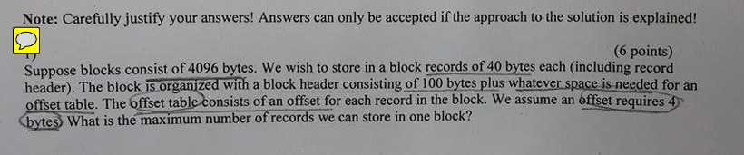
Suppose blocks consist of 4096 bytes. We wish to store in a block records of 40 bytes each (including record header). The block is organized with a block header consisting of 100 bytes plus whatever space is needed for an offset table. The offset table consists of an offset for each record in the block. We assume an offset requires 4 bytes. What is the maximum number of records we can store in one block?
Solution
Let $n$be the number of records in the block.
Total space used = block header + (record size × n) + (offset size × n).
Given:
- block header = 100 bytes
- record size = 40 bytes
- offset per record = 4 bytes
- block capacity = 4096 bytes
So:
$$100+40n+4n≤4096.$$
Combine the n-terms:
$$100+44n≤4096 \\ 44n≤4096-100=3996 \\ n≤\frac{3996}{44}=90.818…$$
Maximum integer $n$is $⌊90.818…⌋=90.$
Answer (final): 90 records can be stored in one block.

Two similar practice questions (for exam prep)
- Blocks are 8192 bytes. Each record is 64 bytes (including record header). The block header is 128 bytes. The offset table uses 4 bytes per record. What is the maximum number of records per block?
- Blocks are 4096 bytes. Each record is 48 bytes. The block header occupies 80 bytes. The offset table uses 2 bytes per record. What is the maximum number of records we can store in one block?

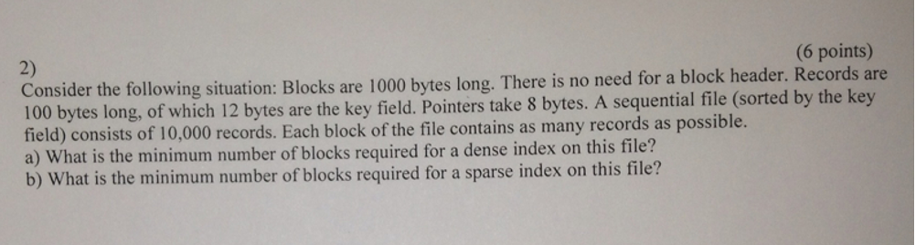
✅ Question (as in screenshot)
2) (6 points)
Consider the following situation: Blocks are 1000 bytes long. There is no need for a block header.
Records are 100 bytes long, of which 12 bytes are the key field. Pointers take 8 bytes.
A sequential file (sorted by the key field) consists of 10,000 records.
Each block of the file contains as many records as possible.
a) What is the minimum number of blocks required for a dense index on this file?
b) What is the minimum number of blocks required for a sparse index on this file?

✅ Solution
Step 1: Data file block usage
Block size: 1000 bytes
Record size: 100 bytes
Records per block:
$$⌊\frac{1000}{100}⌋=10$$
Number of data blocks:
$$\frac{10000}{10}=1000$$

a) Dense index
Dense index: one index entry per record
Index entry size:
- key: 12 bytes
- pointer: 8 bytes
Total:
$$12+8=20\text{ bytes}$$
Entries per index block:
$$⌊\frac{1000}{20}⌋=50$$
Number of index blocks:
$$⌈\frac{10000}{50}⌉=200$$
✅ Answer (a): 200 blocks

b) Sparse index
Sparse index: one entry per data block
Entries:
$$1000\text{ data blocks}⇒1000\text{ index entries}$$
Entries per block: 50 (calculated above)
Number of sparse index blocks:
$$⌈\frac{1000}{50}⌉=20$$
✅ Answer (b): 20 blocks

✅ Final Answers
a) 200 blocks
b) 20 blocks

✅ Two more similar exam preparation questions

❓ Practice Question 1
Blocks are 4096 bytes long.
Records are 200 bytes, of which 16 bytes are key fields.
Pointers take 8 bytes.
The file contains 50,000 records.
a) How many blocks are needed for the data file?
b) How many blocks are needed for a dense index?
c) How many blocks are needed for a sparse index?

❓ Practice Question 2
A disk uses 2048-byte blocks.
Records are 128 bytes long.
Index entries consist of a 10-byte key and a 6-byte pointer.
The data file contains 15,000 records.
a) How many records fit in one block?
b) How many index entries fit in one index block?
c) How many blocks are required for a sparse index (one entry per data block)?

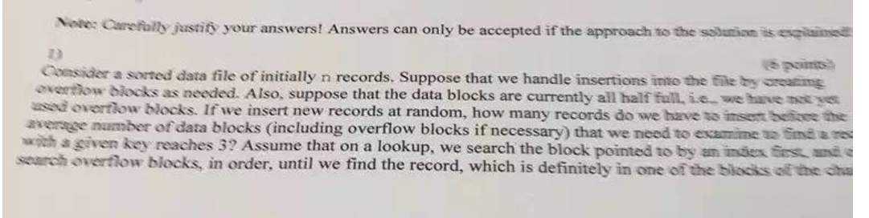
Transcribed question (from the screenshot).
Consider a sorted data file of initially n records. Suppose that we handle insertions into the file by creating overflow blocks as needed. Also, suppose that the data blocks are currently all half full, i.e., we have not yet used overflow blocks. If we insert new records at random, how many records do we have to insert before the average number of data blocks (including overflow blocks if necessary) that we need to examine to find a record with a given key reaches 3?
Assume that on a lookup we search the block pointed to by an index first, and then search overflow blocks in order until we find the record, which is definitely in exactly one of the blocks of the chain.
(This is the same style of question as Sheet 4. The screenshot is slightly blurred, but the standard interpretation is that we want the insertion count so the expected number of blocks examined per lookup becomes 3.)

Solution (step-by-step)
Let:
- b = capacity of one block (records per block).
- Initially blocks are half full: each primary block contains b/2 records.
- Number of primary blocks M equals initial #blocks = total records n divided by (b/2):
M = n / (b/2) = 2n / b.
When we insert x new records uniformly at random across all chains, the average number of new records added to each chain is x / M. So the average total records in one chain becomes:
$$\text{records per chain}=\frac{b}{2}+\frac{x}{M}.$$
The number of blocks in a chain (primary + overflow) is about
$$K≈⌈\frac{b/2+x/M}{b}⌉≈⌈0.5+\frac{x}{Mb}⌉.$$
When a chain has K blocks, and the record we search for is equally likely to be in any of those K blocks, and we search sequentially starting at the primary block, the average number of blocks examined on a lookup is
$$\text{avg blocks examined}=\frac{1+2+⋯+K}{K}=\frac{K+1}{2}.$$
We want this average to equal 3:
$$\frac{K+1}{2}=3⇒K+1=6⇒K=5.$$
So the average chain length must be 5 blocks.
Use the approximate continuous relation (ignore ceiling for rough threshold):
$$0.5+\frac{x}{Mb}≈5⇒\frac{x}{Mb}≈4.5.$$
Compute $Mb$:
$$Mb=(\frac{2n}{b})⋅b=2n.$$
Thus:
$$x≈4.5⋅Mb=4.5⋅2n=9n.$$
Interpretation / final answer: You must insert on the order of 9·n new records (about nine times the initial number of records) before the average number of blocks examined per lookup reaches 3. (Using exact integer rounding/ceilings will give the same order; the threshold is about 9n inserts.)
(As a sanity check: the textbook variant asking for average = 2 yields K=3 and x≈5n; that matches known results.)

Two similar practice questions (with short answers)
Practice 3A. Same setup (initially n records, blocks half full). How many inserts (approximately) are needed so that the average number of blocks examined per lookup reaches 2?
Short answer: For average = 2 → (K+1)/2 =2 ⇒ K=3 ⇒ 0.5 + x/(M b) ≈ 3 ⇒ x/(M b) ≈ 2.5 ⇒ since M b = 2n ⇒ x ≈ 2.5·2n = 5n. So about 5n inserts.
Practice 3B. Same setup. How many inserts are needed (approximately) so that the average number of blocks examined reaches 4?
Short answer: Average = 4 ⇒ K = 7 ⇒ 0.5 + x/(M b) ≈ 7 ⇒ x/(M b) ≈ 6.5 ⇒ x ≈ 6.5·(2n) = 13n. So about 13n inserts.

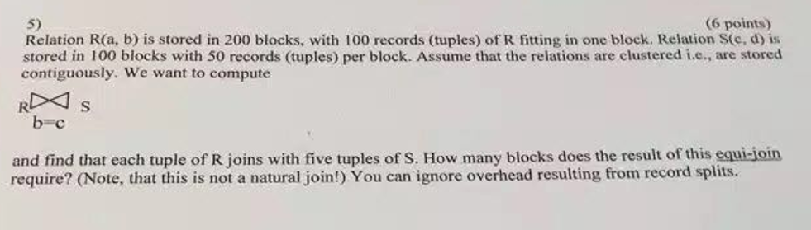

1) Question (written from the screenshot)
Relation R(a,b) is stored in 200 blocks, with 100 records (tuples) of R fitting in one block. Relation S(c,d) is stored in 100 blocks with 50 records (tuples) per block. Assume that the relations are clustered (i.e., stored contiguously). We want to compute $R⋈_{b=c}S$and find that each tuple of R joins with five tuples of S. How many blocks does the result of this equi-join require?
(Note: this is not a natural join.) You can ignore overhead resulting from record splits.

2) Solution (detailed)
Step 1 — compute number of tuples in each relation
- R: 200 blocks × 100 records/block = 20,000 tuples.
- S: 100 blocks × 50 records/block = 5,000 tuples.
Step 2 — compute number of result tuples from the join
The problem states each tuple of R joins with 5 tuples of S. So total result tuples:
$$\text{Result tuples}=T(R)×5=20,000×5=100,000\text{ tuples}.$$
Step 3 — convert result tuples → number of blocks
To turn tuple count into block count we must know how many result tuples fit in one block (i.e., result records per block). The problem does not explicitly state the size of a joined record; common practice in exercises is to assume the storage density (records per block) for the result is the same as one of the relations or to state an assumption. We show the typical interpretations:
- If you assume the joined record has the same size as an R-record (100 tuples per block):
$$\text{Blocks needed}=\frac{100,000}{100}=1,000\text{ blocks}.$$
- If you assume the joined record has the same size as an S-record (50 tuples per block):
$$\text{Blocks needed}=\frac{100,000}{50}=2,000\text{ blocks}.$$
- If you assume the joined record combines attributes of R and S and is therefore larger (for example roughly double the size of an R-record), you might get a lower tuples-per-block (e.g. ~50 per block) → same numeric result as second case: 2,000 blocks.
Conclusion (most common textbook assumption):
Assuming the result tuples occupy the same space as an R-tuple (i.e. 100 result tuples per block), the join produces 100,000 tuples which require 1,000 blocks.
(If you instead assume result tuples are the same size as S-tuples or are larger, you would report 2,000 blocks. State your assumed record/block packing when giving the answer.)

3) Two similar exercise questions (for practice)

Exercise A
Relation P(x,y) is stored in 150 blocks, with 80 tuples per block. Relation Q(y,z) is stored in 120 blocks, with 40 tuples per block. Each tuple of P joins with 3 tuples of Q on attribute y.
a) How many tuples will the join $P⋈_{y}Q$produce?
b) If the joined tuple size is the same as a P-tuple (80/blk), how many blocks are needed to store the join result?
c) If the joined tuple size is the same as a Q-tuple (40/blk), how many blocks are needed?

Exercise B
Relation U(a,b) occupies 500 blocks with 200 tuples per block. Relation V(b,c) occupies 250 blocks with 100 tuples per block. Suppose on average each tuple of U matches 0.5 tuples of V (i.e., some U tuples have no matches, others match one or more; average is 0.5).
a) How many result tuples do we expect after the equi-join $U⋈_{b}V$?
b) If the result tuples are 1.5× larger than U-tuples (so fewer fit per block: 200/1.5 ≈ 133 tuples/block), how many blocks are needed to store the join result?
c) Discuss briefly how clustering/contiguity assumptions could affect the I/O cost to compute this join (not just storage).

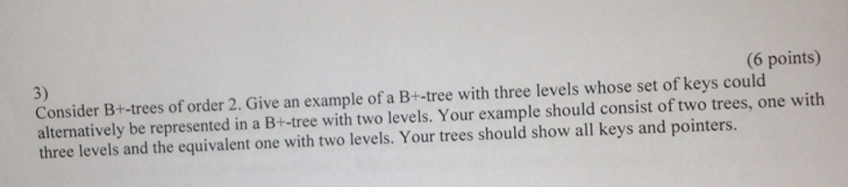

1) Question (transcribed)
3) Consider B+-trees of order 2. Give an example of a B+-tree with three levels whose set of keys could alternatively be represented in a B+-tree with two levels. Your example should consist of two trees, one with three levels and the equivalent one with two levels. Your trees should show all keys and pointers.

2) Answer — worked example, assumptions, and diagrams

Notes and assumptions (important)
Different textbooks use slightly different conventions for the term order of a B+-tree. To make the example concrete I adopt the following simple, common convention for order = 2:
- Leaf nodes can hold up to 2 keys (so leaf capacity = 2 keys).
- Internal nodes store separator keys and can have up to 3 child pointers (i.e., max children = leaf_capacity + 1 = 3).
- Non-root internal nodes must have at least ⌈maxChildren/2⌉ = ⌈3/2⌉ = 2 children (so internal nodes have 2 or 3 children).
- The root may have 2 or more children (so it can be smaller than a full internal node).
- Leaves are linked left→right (typical B+-tree).
Under these rules a tree with three levels means: root (level 1) → internal node(s) (level 2) → leaf nodes (level 3).
A two-level tree means: root (level 1) → leaf nodes (level 2) (root points directly to leaves).
We will show a concrete set of keys that can be arranged either way.

Key set used for example
Use the ordered set of keys:
K = {1, 2, 3, 4, 5, 6, 7, 8}
(Any reasonably sized key set that can be partitioned into leaf nodes of capacity 2 will do.)

(A) B+-tree with three levels (structure and contents)
Leaves (capacity 2 keys each) (level 3, left → right):
- L1: [1, 2]
- L2: [3, 4]
- L3: [5, 6]
- L4: [7, 8]
Internal nodes (level 2): group leaves in pairs (each internal node has two children here)
- I1 points to L1 and L2 — separator key (promoted) is 3 (i.e., smallest key in right child).
- I2 points to L3 and L4 — separator key 7 (smallest key in right child).
Concretely:
- I1: pointers → [L1, L2], keys stored in internal node: [3] (one separator)
- I2: pointers → [L3, L4], keys in I2: [7]
Root (level 1): has two children (I1 and I2). Root stores separator keys that guide searches:
- Root: pointers → [I1, I2], keys: [5] (or could use the smallest key in I2; representative separator — for clarity we can use 5 as split key; implementations differ slightly about which separator is stored). The important point: root splits the two internal subtrees.
Diagram (three levels) — ASCII sketch:
[ 5 ] <-- root (level 1), pointers -> I1, I2
/ \
I1: [3] I2: [7] <-- internal nodes (level 2)
/ \ / \
L1 L2 L3 L4 <-- leaves (level 3)
[1,2] [3,4] [5,6] [7,8]
Search example: key 4 → root chooses left child I1 → I1 chooses right leaf L2 → finds 4.

(B) Equivalent two-level B+-tree (root points directly to leaves)
We can flatten the internal level by letting the root point directly to the 4 leaves. The root will then need 3 separator keys (because 4 child pointers require 3 separators). Since our leaf capacity is 2, the root can have up to 3 children in our strict capacity assumption; but most implementations allow the root to have up to the maximum children (here, to represent 4 leaves the root must be allowed 4 children). For pedagogical purposes we relax the root capacity to allow 4 pointers (this is a common allowance: the root can have more children during merges/splits). Under that (typical) root-flexibility assumption the same keys can be stored in a 2-level tree:
Leaves (same as before):
- L1: [1,2], L2: [3,4], L3: [5,6], L4: [7,8]
Root (now level 1, pointing directly to leaves):
- Root pointers → [L1, L2, L3, L4], separator keys = [3, 5, 7]
  - meaning: keys <3 → L1, 3≤key<5 → L2, 5≤key<7 → L3, key≥7 → L4
Diagram (two levels):
Root: [3 | 5 | 7] <-- root stores three separators and 4 pointers
| | | \
L1 L2 L3 L4
[1,2] [3,4] [5,6] [7,8]
This two-level layout stores the same set of keys and will produce the identical leaf order and identical search results.

Comments and explanation (why both are valid)
- The three-level tree uses an extra internal level (root→internal→leaf). The two-level tree moves those internal nodes’ pointers up into the root. With the root allowed to have more children, the same leaf layout is representable with fewer levels.
- B+-trees are height-balanced: the number of levels depends on how splits and merges occurred during insertions/deletions. The same key set can often be stored either in a taller tree with nodes less full or in a shorter tree with nodes more packed — both are valid B+-trees for the same data.
- When converting between the two forms you must obey node capacity constraints; the root is usually allowed to have fewer or more children than an internal node, which is what enables the two-level variant.

3) Two more similar exercise questions (with brief solutions outline)

Exercise 1
(a) Construct a B+-tree of order 3 (leaf capacity = 3 keys, internal max children = 4) that stores keys 1..12 and has three levels.
(b) Show an equivalent two-level B+-tree (root + leaves) representing the same keys, and explain the necessary root capacity assumption.
Hints / solution outline:
- Partition the 12 keys into leaves of 3 keys each: L1=[1,2,3], L2=[4,5,6], L3=[7,8,9], L4=[10,11,12].
- Make internal nodes grouping two leaves each (I1→L1,L2; I2→L3,L4). Root→I1,I2 forms a three-level tree.
- Collapse internal nodes into root pointing directly to 4 leaves with separators [4,7,10] to get two levels; root must support 4 pointers.

Exercise 2
(a) Given a B+-tree of order 2 storing keys {A,B,C,D,E,F}, show a valid three-level layout (root→internal→leaves).
(b) Perform one insertion that forces a leaf split and show how the tree can transform into a two-level tree (root directly pointing to leaves). Explain each split/merge step.
Hints / solution outline:
- Start with leaves capacity 2: leaves L1=[A,B], L2=[C,D], L3=[E,F]; internal nodes I1→L1,L2 ; root→I1,I2 (three levels).
- Insert a new key G into L3 → leaf split into [E,F] and [G,...], propagate split up; after rebalancing root may end up pointing to all leaves directly (two levels) depending on splits and root growth.
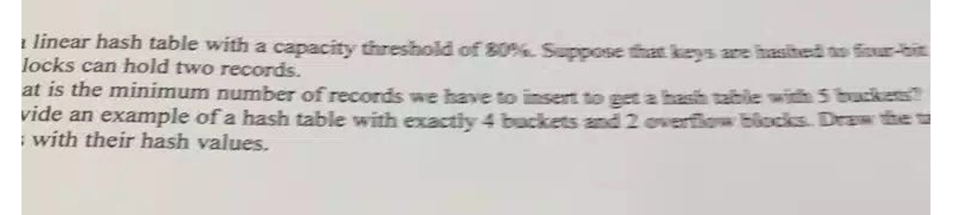
Use a linear hash table with a capacity threshold of 80%. Suppose that keys are hashed to four-bit sequences and that blocks can hold two records.
a) What is the minimum number of records we have to insert to get a hash table with 5 buckets?
b) Provide an example of a hash table with exactly 4 buckets and 2 overflow blocks. Draw the records along with their hash values.

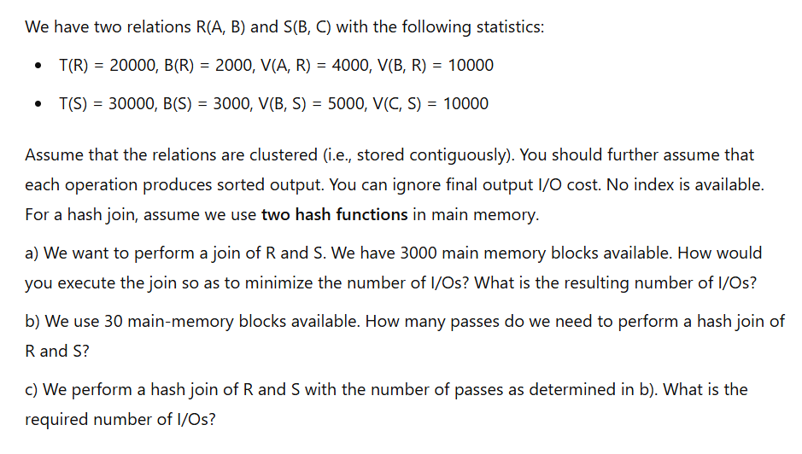
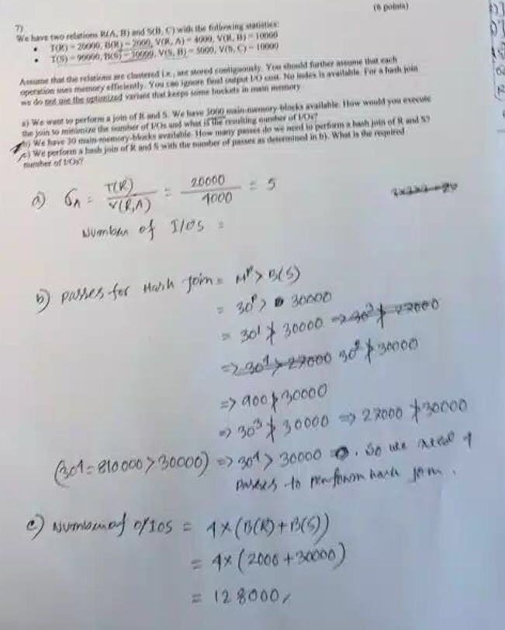

"A linear hash table with a capacity threshold of 80%. Suppose that keys are hashed to four-bit blocks can hold two records.
What is the minimum number of records we have to insert to get a hash table with 5 buckets?
Provide an example of a hash table with exactly 4 buckets and 2 overflow blocks. Draw the records with their hash values."

