Exercise 1.1:
Suppose that in 2008 the typical computer has a processor chip with two processors ("cores") that each run at 3 gigahertz, has a disk of 250 gigabytes, and a main memory of 1 gigabyte. Assume that Moore's law (these factors double every 18 months) holds into the indefinite future.
a) When will petabyte disks be common?
b) When will terabyte main memories be common?
c) When will terahertz processor chips be common (i.e., the total number of cycles per second of all the cores on a chip will be approximately 10121012)?
d) What will be a typical configuration (processor, disk, memory) in the year 2015?
Exercise 1.2:
Commander Data, the android from the 24th century on Star Trek: The Next Generation, once proudly announced that his processor runs at “12 teraops.” While an operation and a cycle may not be the same, let us suppose they are, and that Moore’s law continues to hold for the next 300 years. If so, what would Data’s true processor speed be?
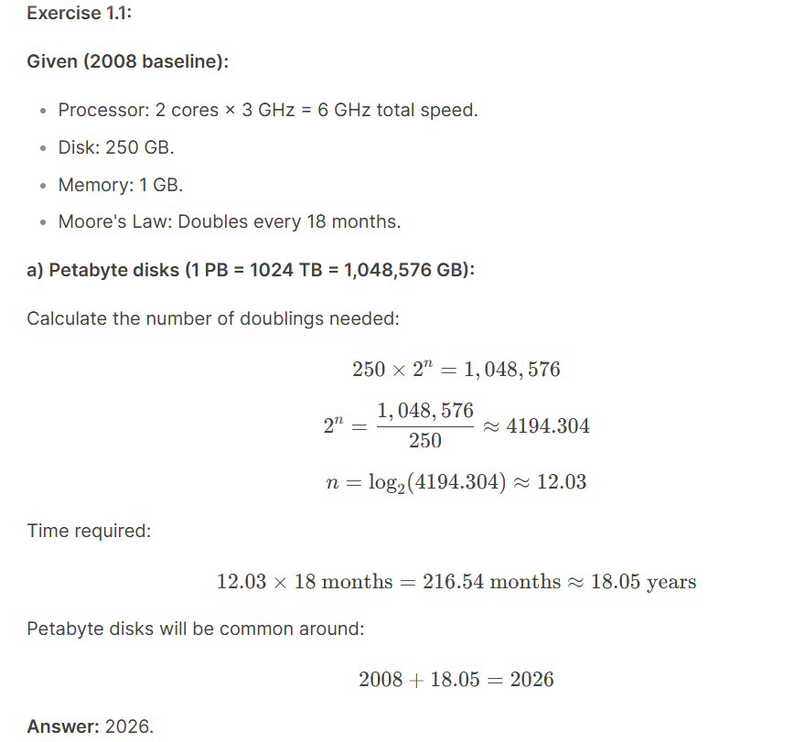

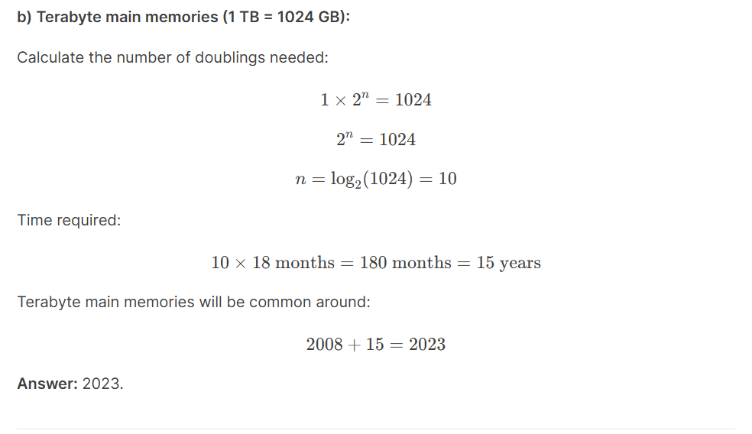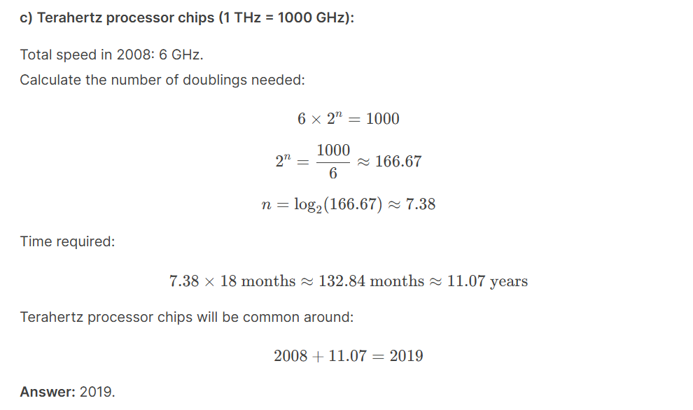

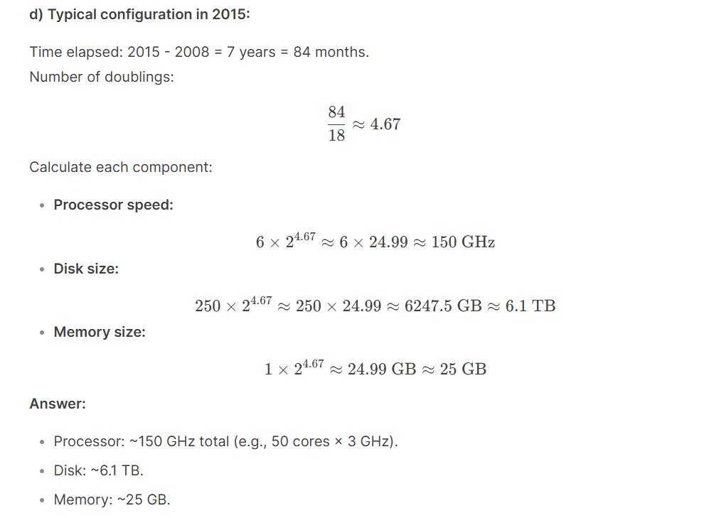
Exercise 1.2: Given:
- Current processor speed (2008): 6 GHz (from Exercise 1.1).
- Commander Data's speed (24th century): 12 teraops = 12,000 GHz.
- Moore's Law: Doubles every 18 months.
- Timeframe: 300 years = 3600 months.
