mqtt api overview

Topic: mqtt/devices/<device_id>/up/events/<event>

Payload: The payload will be a string with the value in a JSON-style encoding.

Events

* /devices/<device_id>/events/sensor
* /devices/<device_id>/events/remote
* /devices/<device_id>/events/

Topic: mqtt/devices/<device_id>/events/

{

“hardware_serial”: “”,

“counter”: 2, // times it needed to retry to send the data.

“is_retry”: false, // is set to tru if this message is a retry ( you could also detect this from the counter)

“uptime”: timespan,

“airtime”: timestamp. // time it was online connected to wifi

“software_version”: 1.0

“metadata” {

“timestamp”: 1234, // Timestamp when the gateway received the message

“rssi”: -25 // Signal strength of the received message

“batteryLevel”: 60

}

}

Error event

mqtt/devices/<device_id>/events/error

{

“error” : “message”

}

Hardware / Device

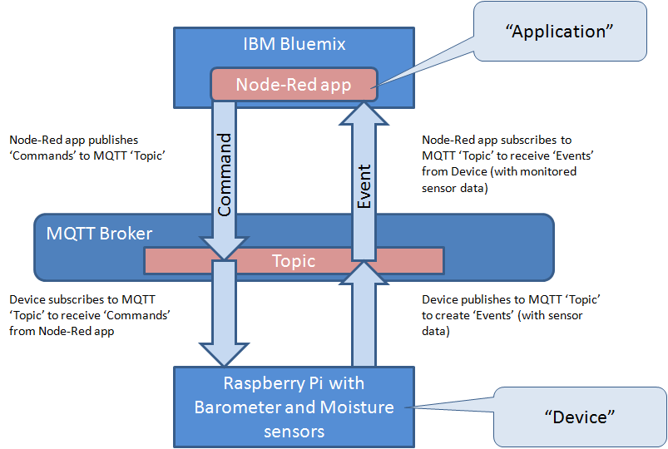

Device subscribed t o MQTT ‘Topic’ to receive ‘commands’

