RESTAURANT

Document de analiza si design

Numar echipa: 2

Studenti:

* S1: Baluș Mihaela-Cosmina
* S2: Iloie Mădălina-Alexandra
* S3: Mariș Andreea-Alexandra
* S4: Scarlat Alin Nicolae
* S5: Szabo-Schuller Daniel
* S6: Todescu Andrei

**Grupa: 30239, 302310**

Contents

I Specificatia proiectului 3

1.1 Diagrama Domain Model 3

II Modelul Use-Case 3

2.1 Identificarea Use-Case-uri 4

2.2 Diagrama UML Use-Case 4

III Design arhitectural 5

3.1 Arhitectura conceptuala 5

3.2 Diagrama de pachete 5

3.3 Diagrama de clase 5

3.4 Diagrama bazei de date 6

3.5 Diagrame de secventa 6

3.6 Diagrame de activitati 6

IV Specificatii suplimentare 6

4.1 Specificatii non-functionale 6

4.2 Constrangeri de design 6

V Testare 7

5.1 Testarea functionalitatii aplicatiei 7

5.2 Dezvolatari ulterioare 7

VI Bibliografie 7

# I Specificatia proiectului

*<Aici de obicei se prezintapescurt o idee principal a proiectului si niste specificatii in mare.Scris cu Times New Roman font 13.*

*/>*

## 1.1 Diagrama Domain Model

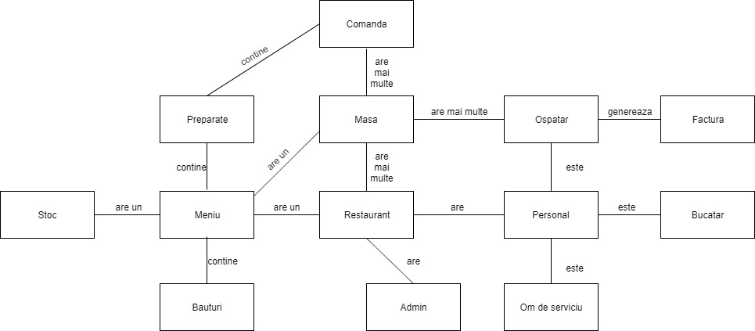

# II Modelul Use-Case

*< Se va scrie o mica introducere./>*

## 2.1 Identificarea Use-Case-uri

Use case: Order food from the menu

Level: User-goal

Primary actor: Client

Main success scenario: The client can order food from the restaurant. To do that, he should select the option 'see menu'. Then, he will select the desired items from the menu, which will include a list of all the meals. To complete the order, he will select the 'order food' option. The client will be notified that his order was successful and informed about the average waiting time.

Extension: The client selects something out of stock. Instead of a notification of success, the client will be informed about the item out of stock and will be able to drop the order or select something else from the menu.

OR

The client places the order and receives the notification regarding the average waiting time. He will choose to drop the order because of the exceeded waiting time.

Use case: Receive an order

Level: User-goal

Primary actor: Chief

Main success scenario: The chief recives an order. The order will be added in the chief's orders list. He will notify the client that the order is in progress and the average waiting time. When the meals are ready to be served, the chief will notify the waiter and the order will be removed from the list.

Extension: When receiving an order, if the maximum limit of orders is exceeded, the chief can reject the order or postpone it.

Use case: Generate invoice for order

Level: User-goal

Primary actor: Waiter, Client

Main success scenario: The waiter generates an invoice for an order. First, the client will select the option 'request invoice.' The waiter will be notified that the client has requested an invoice and will compute the total value of the order. The client will receive the invoice, select the payment method and the waiter will cash in.

Extension: The waiter generates the invoice and notifies the client. The client will select the card payment option, but the pos will reject the credit card due to a system failure.

## 2.2 Diagrama UML Use-Case

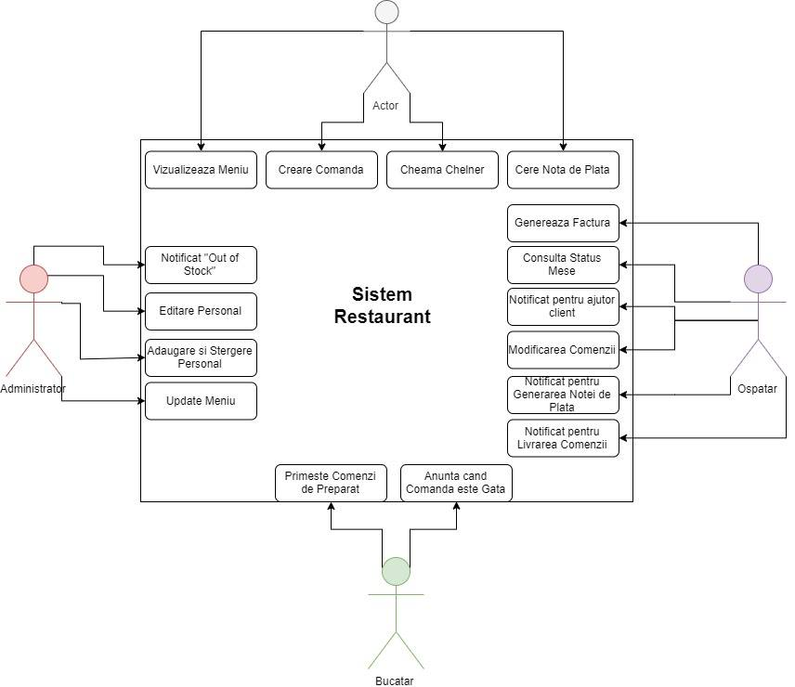

# III Design arhitectural

*< Se va scrie o mica introducere./>*

## 3.1 Arhitectura conceptuala

*<In acest capitol se vor prezenta arhitectura proiectului.Este o aplicatie web sau desktop. Are baze de date? Cate componente are?Client-Server?etc*

*/>*

## 3.2 Diagrama de pachete

*< (Package Diagram)/>*

## 3.3 Diagrama de clase

*< (Class Diagram)/>*

## 3.4 Diagrama bazei de date

*< (Data Model)/>*

## 3.5 Diagrame de secventa

*< (Sequence Diagram)/>*

## 3.6 Diagrame de activitati

*< (Activity Diagram)/>*

# IV Specificatii suplimentare

*< Se vascrie o mica introducere./>*

## 4.1 Specificatii non-functionale

*<Specificatiile non-functionale ale aplicatiei. Se va discuta la laborator./>*

## 4.2 Constrangeri de design

*< Se va discuta la laborator./>*

# V Testare

*< Se va discuta la laborator./>*

## 5.1 Testarea functionalitatii aplicatiei

## 5.2 Dezvolatari ulterioare

# VI Bibliografie