VOiCES Background Classification and Voice Activity Detection
Digital Speech Processing Mini Task
Amirkabir University of Technology
Instructor: Dr. Mohammad Khaloei
Student: Ali Nasif Jasim | Student ID: 404131076

1 Objective and scope
This experiment studies two tasks on a small VOiCES subset: classification of recording background conditions and detection of speech activity over time. SVM achieved 55% background classification accuracy and Random Forest achieved 50% on 40 test recordings. A pretrained Silero VAD model produced speech intervals for eight test recordings, which were reviewed by listening and visual inspection.
The event-related component is implemented as recording-level background condition classification. It does not estimate event onset and offset times or evaluate temporal event detection. The VAD component locates speech intervals without recognizing words, identifying speakers, or removing noise.

2 Dataset and subset
VOiCES contains English speech recorded in reverberant rooms with different background conditions. The four labels used here are none, musi, tele, and babb. The none condition means no added distractor; it does not mean silence. Television and babble may themselves contain intelligible or overlapping speech.
Background code | Meaning | Train | Test
none | No added distractor | 20 | 10
musi | Music | 20 | 10
tele | Television | 20 | 10
babb | Babble | 20 | 10
Total | All conditions | 80 | 40

The notebook streamed the official devkit archive and retained a small quota-based subset. Within each split, at most one recording per speaker and background condition was selected. This selection follows archive order rather than random sampling, so the subset is a convenience sample and is not representative of the full benchmark.
Original training and test membership was preserved. The saved manifest contains no shared speakers or source utterances between the selected training and test sets. Inspection also showed that all selected training recordings came from room 1 and all selected test recordings came from room 4. This room change is a material condition of the reported evaluation.

3 Background classification method
Audio was read using SoundFile, averaged to mono where needed, and resampled to 16000 Hz when necessary. Classification used at most the first 10 seconds of each recording. Shorter recordings retained their available duration.
The input representation combined the means and standard deviations of 20 MFCC coefficients with the same statistics for spectral centroid, spectral bandwidth, spectral rolloff, zero crossing rate, and RMS energy. The resulting vector had 50 features per recording. Filenames and metadata supplied labels and grouping information only; they were not classifier features.
Model | Settings
SVM | StandardScaler followed by RBF SVC; C 1; balanced class weights
Random Forest | 200 trees; balanced class weights; random seed 42

StandardScaler was fitted using training features only. Both classifiers used the same fixed subset. No test-based hyperparameter search was performed. Accuracy and macro F1 were computed on the 40 balanced test examples; fit time measured model training only.

4 Background classification results
Model | Accuracy | Correct of 40 | Macro F1 | Fit time s
SVM | 55% | 22 | 0.5196 | 0.006567
Random Forest | 50% | 20 | 0.4920 | 0.463702

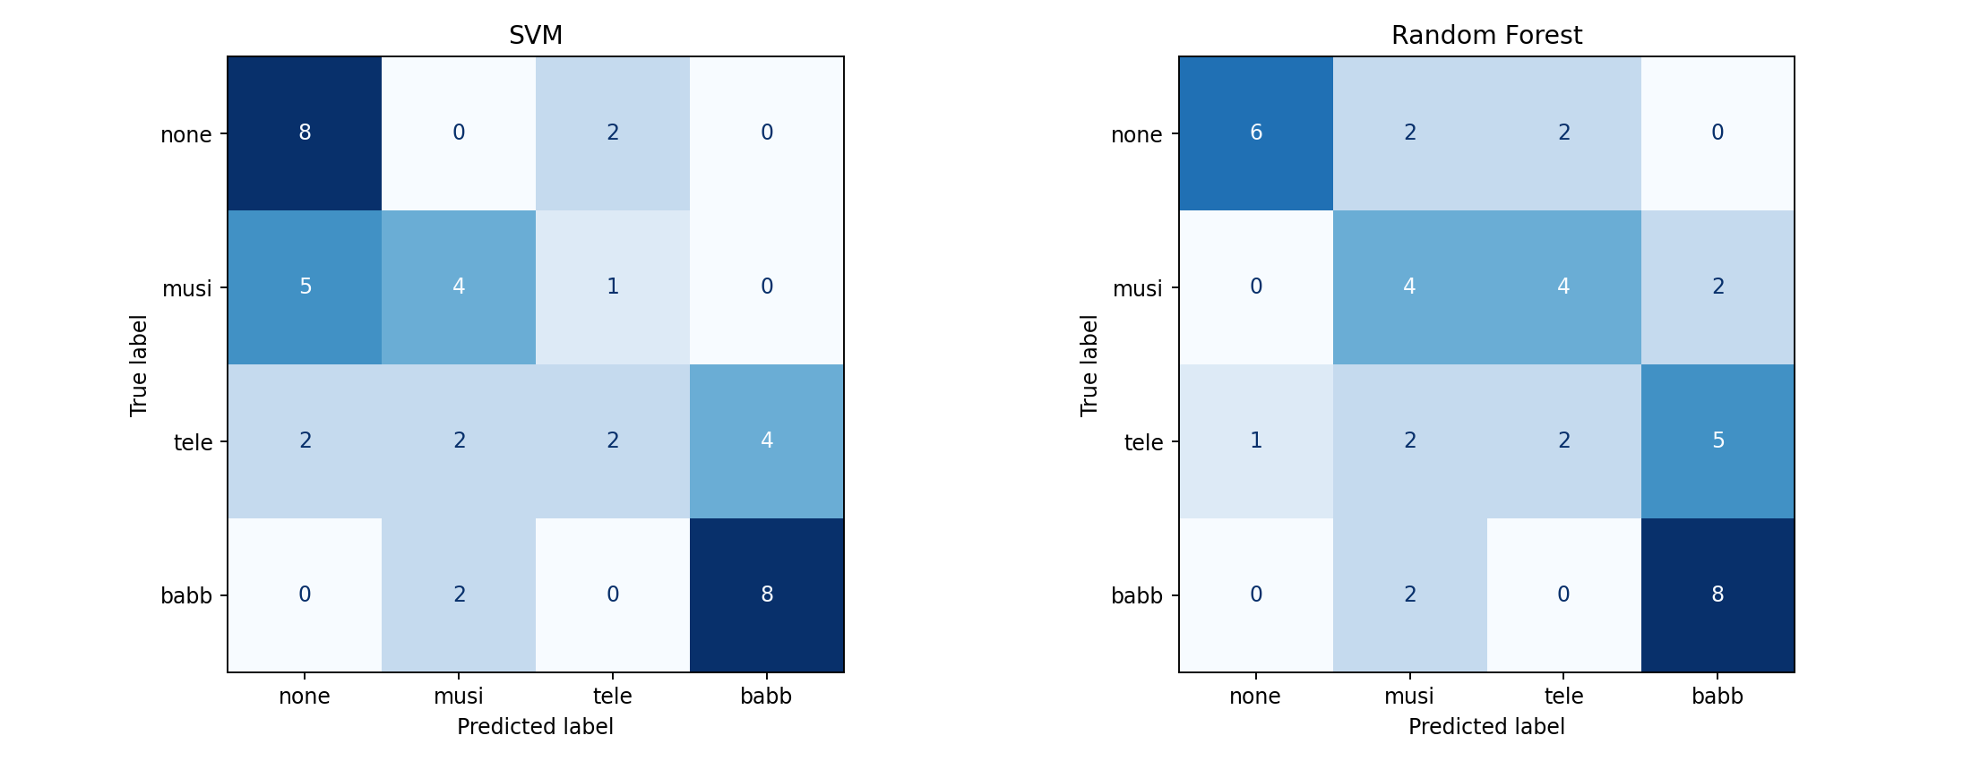
Figure 1 Background condition confusion matrices
SVM was ahead by two correctly classified test recordings. Television was the most difficult condition for both classifiers, with recall of 0.20. Babble recall was 0.80 for both. These results show limited separation of the background conditions with the current feature summary and small training sample. No statistical significance claim is made for the five percentage point difference.
The training-to-test room change can contribute to acoustic mismatch. Foreground speech, microphone variation, recording duration, and sample selection may also affect the features. This experiment does not isolate their individual effects. A 25% uniform random baseline is an expected reference for four balanced classes, not an experimentally measured baseline here.

5 Voice activity detection method
Silero VAD was loaded as a pretrained model and was not retrained on this subset. Audio was provided as a mono 16000 Hz tensor. The detection threshold was fixed at 0.5. Two test recordings from each condition were selected, and processing was limited to the first 30 seconds per recording. All eight selected recordings were shorter than that limit.
The model returned speech start and end sample indices. These were converted to seconds, plotted as green regions over the original waveform, and used to save speech clips. The clips retain the original noise; VAD performs temporal selection rather than speech enhancement or source separation.
VAD detects speech from any source. Speech from a television or from background babble can therefore be a valid detection. The system was not configured to identify only the foreground speaker.

6 VAD outputs
Clip | Condition | Duration s | Speech s | Intervals | Speech share
1 | none | 15.325 | 13.903 | 4 | 90.72%
2 | none | 15.890 | 13.836 | 5 | 87.07%
3 | musi | 14.950 | 12.244 | 5 | 81.90%
4 | musi | 16.315 | 13.872 | 4 | 85.03%
5 | tele | 8.970 | 7.776 | 3 | 86.69%
6 | tele | 15.970 | 13.976 | 3 | 87.51%
7 | babb | 15.940 | 13.266 | 5 | 83.22%
8 | babb | 3.670 | 2.748 | 1 | 74.88%

Across the eight recordings, the model produced 30 speech intervals and saved 30 audio clips. Speech share is detected speech duration divided by the processed recording duration. It is a descriptive output, not a measure of detection accuracy.
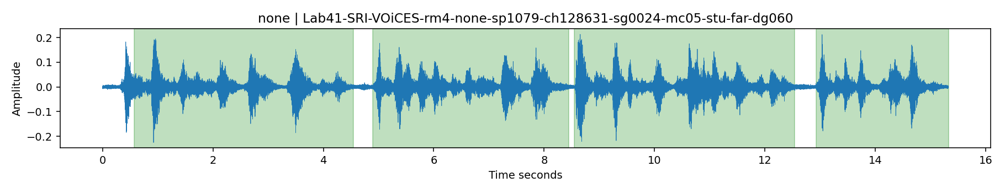
Figure 2 Detected speech regions in the no added distractor condition
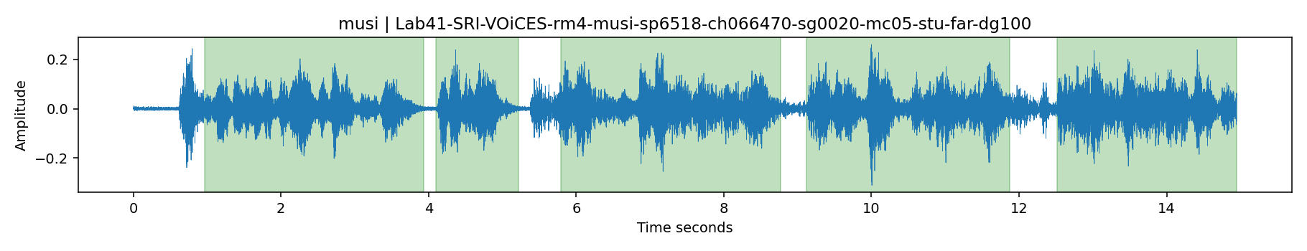
Figure 3 Detected speech regions in the music condition

7 Listening review and interpretation
I compared the audio with the green speech regions, using the synchronized playback cursor to locate the current time on the waveform. In the recordings I reviewed, audible human speech occurred within the detected green regions. This supports qualitative alignment between the detections and the observed speech, but it is not an independently annotated accuracy measurement.
Green regions indicate predicted speech; white regions indicate time outside the predicted intervals. The blue waveform is the complete audio mixture. A visible waveform in a white region can represent noise or music, but can also represent missed speech. Signal amplitude alone cannot establish whether speech is present.
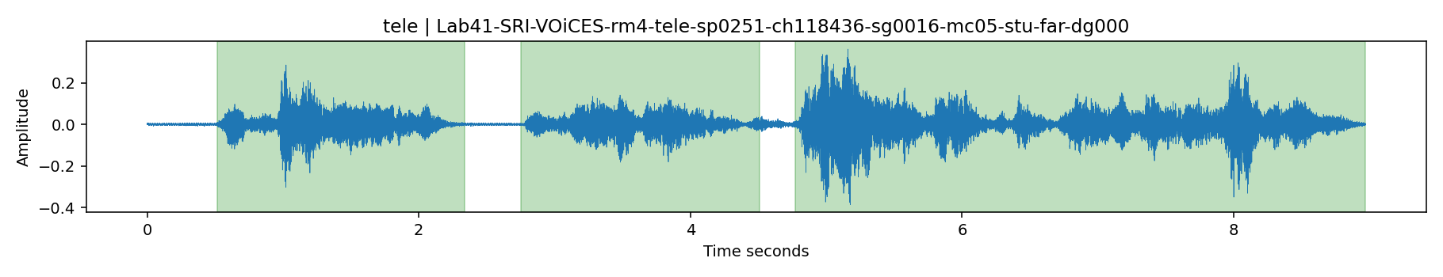
Figure 4 Detected speech regions in the television condition
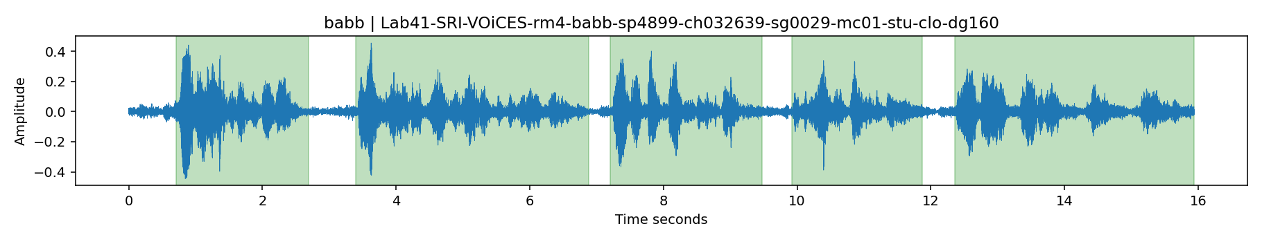
Figure 5 Detected speech regions in the babble condition

8 Limitations and conclusion
Background results are based on 120 recordings selected by quotas and archive order, with different rooms in training and testing. The experiment is a small baseline rather than a full VOiCES evaluation. Recording-level background labels do not provide temporal event annotations, so event localization was not evaluated.
No independent frame-level VAD reference was supplied. Consequently, VAD accuracy, precision, recall, and F1 were not reported. The manual reference template and optional evaluation code remain available in the notebook for future annotation. Listening review cannot exclude subtle boundary errors or quantify missed and falsely detected speech.
SVM achieved the higher measured background classification accuracy in this run, while both classifiers showed substantial confusion between conditions. Silero generated interpretable speech intervals in noisy recordings, and listening review supported their qualitative alignment. Further work should use a larger controlled sample, account for room and microphone effects, and evaluate VAD against independent speech interval annotations.

References
1. VOiCES dataset and detailed README.
https://iqtlabs.github.io/voices/
https://iqtlabs.github.io/voices/Lab41-SRI-VOiCES_README/
2. Silero VAD repository.
https://github.com/snakers4/silero-vad

