YESNO Audio Classification
Digital Speech Processing Mini Task
Amirkabir University of Technology
Instructor: Dr. Mohammad Khaloei
Student: Ali Nasif Jasim | Student ID: 404131076

1 Objective and dataset
This experiment compares SVM, a multilayer perceptron neural network, KNN, and Random Forest for binary classification of spoken YES and NO words. All four classifiers achieved 100% accuracy on the 96 test words in the selected recording-level split. This result is limited to the present single-speaker dataset.
The torchaudio YESNO dataset contains 60 recordings of one speaker saying Hebrew words for yes and no at a sampling rate of 8000 Hz. The filename encodes eight binary labels in temporal order: 0 means NO and 1 means YES. Filenames supply the target labels and recording groups; they are not classifier input features.
For example, 0_0_0_0_1_1_1_1.wav has four NO labels followed by four YES labels. The inspected example lasts 6.35 seconds. Its waveform shows the main word regions, while its spectrogram displays changes in spectral energy over time.
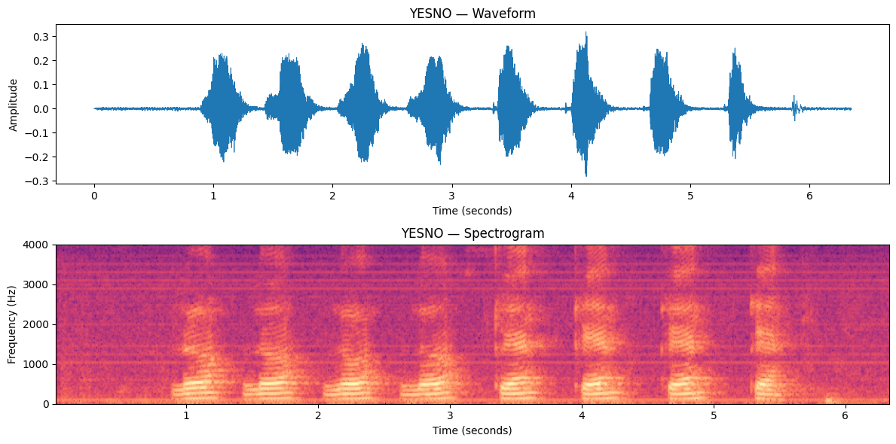
Figure 1 Example waveform and spectrogram at 8000 Hz

2 Preprocessing and word segmentation
Audio was loaded as floating-point samples using SoundFile. Multichannel audio, if present, was averaged into one channel. Recordings were divided into candidate word intervals using librosa silence-based segmentation. Short regions were filtered and nearby intervals were merged. An accepted recording had to produce eight intervals, matching its label count.
The initial segmentation accepted 56 recordings. A finer threshold search recovered three additional recordings. Their intervals were expanded by up to 120 ms on each side, constrained by neighboring interval midpoints to avoid overlap. The standard recordings used 40 ms padding. The recovered words were checked by listening and confirmed to contain complete words. The segmentation thresholds were selected by interval count, not classifier accuracy.
One recording, 0_1_0_1_0_0_0_0.wav, was excluded because listening suggested seven audible words despite eight filename labels. This is a suspected audio-label mismatch, not a confirmed dataset error. Excluding it avoids assigning uncertain labels to word segments, but also restricts the evaluated data to accepted recordings.
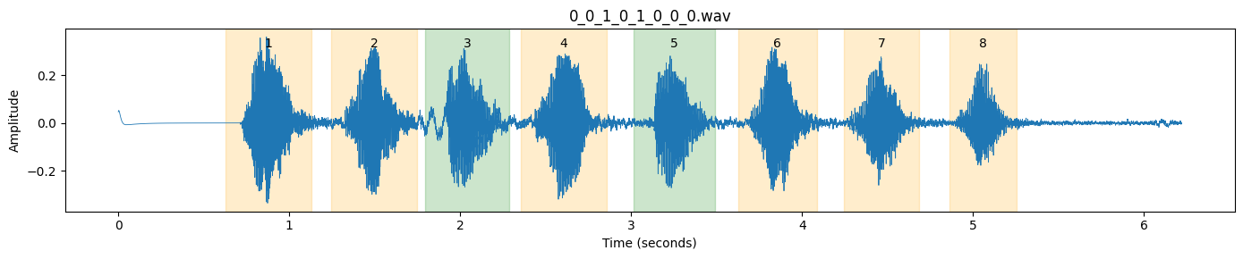
Figure 2 Expanded boundaries of one recovered recording

3 Feature extraction and experimental split
Each word was represented by 13 MFCC coefficients calculated over short-time frames using a 256-sample FFT, an 80-sample hop, and 40 Mel bands. The mean and standard deviation of each coefficient across frames produced 26 features per word. This fixed-length representation summarizes spectral characteristics and variability, but does not preserve the full temporal sequence.
Quantity | Value
Accepted recordings | 59 of 60
Words and feature matrix | 472 words; 472 × 26
Class counts | 223 NO; 249 YES
Training set | 47 recordings; 376 words
Test set | 12 recordings; 96 words
Test class counts | 43 NO; 53 YES
Split and seed | GroupShuffleSplit; test_size 0.20; seed 42

All words from a recording stayed in the same set. There were zero shared recordings between training and testing. The split prevents recording overlap, although the same speaker remains in both sets. StandardScaler was fitted on training data only inside the SVM, MLP, and KNN pipelines; Random Forest used unscaled features.

4 Classifiers and evaluation
Classifier | Configuration
SVM | RBF kernel; C = 1.0
Neural Network | MLP; hidden layers 64 and 32; L-BFGS; max_iter 2000
KNN | 5 nearest neighbors
Random Forest | 200 trees; random_state 42

All models used the same features and train/test split. No hyperparameter search was performed. Accuracy measures the proportion of correctly classified words. Precision, recall, and F1 in the comparison table treat YES as the positive class. Training time measures the fit operation only, not prediction time or end-to-end processing.

5 Results
Model | Train acc | Test acc | Precision | Recall | F1 | Fit time s
SVM | 100% | 100% | 1.00 | 1.00 | 1.00 | 0.005837
Neural Network | 100% | 100% | 1.00 | 1.00 | 1.00 | 0.371567
KNN | 100% | 100% | 1.00 | 1.00 | 1.00 | 0.007000
Random Forest | 100% | 100% | 1.00 | 1.00 | 1.00 | 0.482300

All four classifiers correctly classified all 96 test words. Precision, recall, and F1 were also 1.00 for each class in the classification reports. Consequently, accuracy does not distinguish the classifiers in this split.
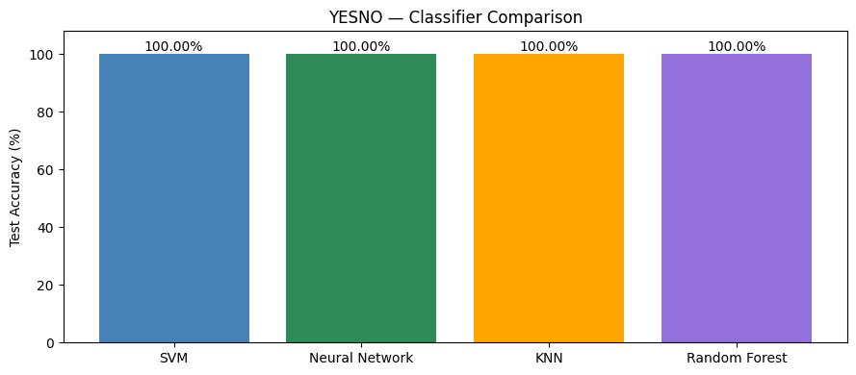
Figure 3 Test accuracy comparison for the four classifiers
SVM had the shortest measured training time in this run, followed by KNN. These very short timing measurements depend on runtime conditions and may change across runs. They do not establish a general speed ranking or compare inference latency. The experiment ran on CPU with PyTorch 2.11.0 and torchaudio 2.11.0.

6 Confusion matrices and interpretation
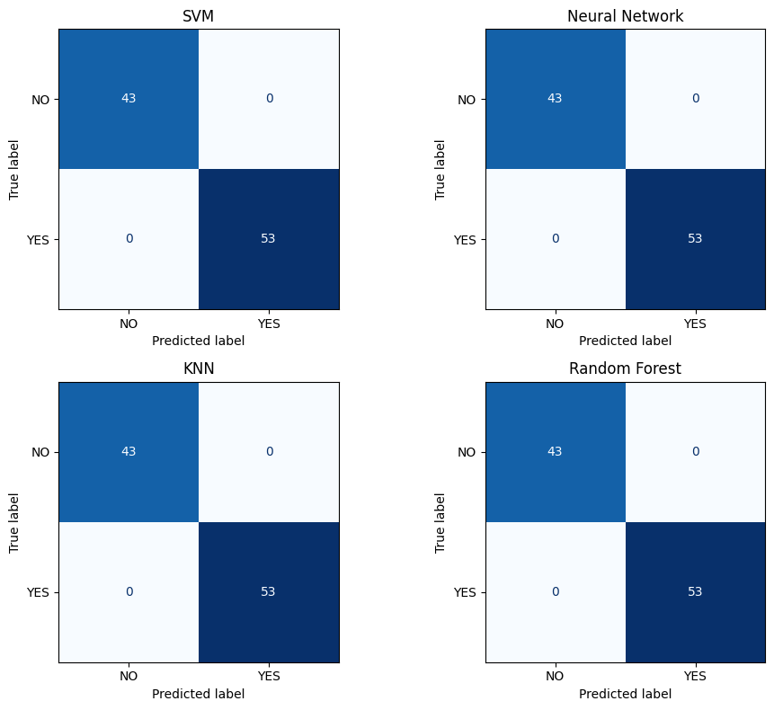
Figure 4 Confusion matrices with true labels on rows and predictions on columns
Each matrix contains 43 correct NO predictions and 53 correct YES predictions, with zero off-diagonal errors. The perfect result is plausible for a small two-word, single-speaker task, but it does not demonstrate reliable performance under broader conditions.

7 Limitations and conclusion
Evaluation used one recording-level holdout split, with no cross-validation, independent speaker test, or robustness test under new recording conditions. Silence-based segmentation depends on thresholds and boundary quality. Three recovered recordings were manually checked by listening, and one uncertain recording was excluded. These preprocessing decisions and the accepted-data coverage should be considered when interpreting the accuracy.
MFCC summary statistics were sufficient to separate YES and NO in the evaluated test set for all four classifiers. SVM was the fastest to fit in the reported run. A useful extension would evaluate fixed model settings across additional recording-level splits and, with suitable data, on unseen speakers and noise conditions.

References
1. PyTorch. Torchaudio YESNO dataset documentation.
https://docs.pytorch.org/audio/stable/generated/torchaudio.datasets.YESNO.html
2. OpenSLR. SLR1 YESNO original dataset.
https://www.openslr.org/1/

