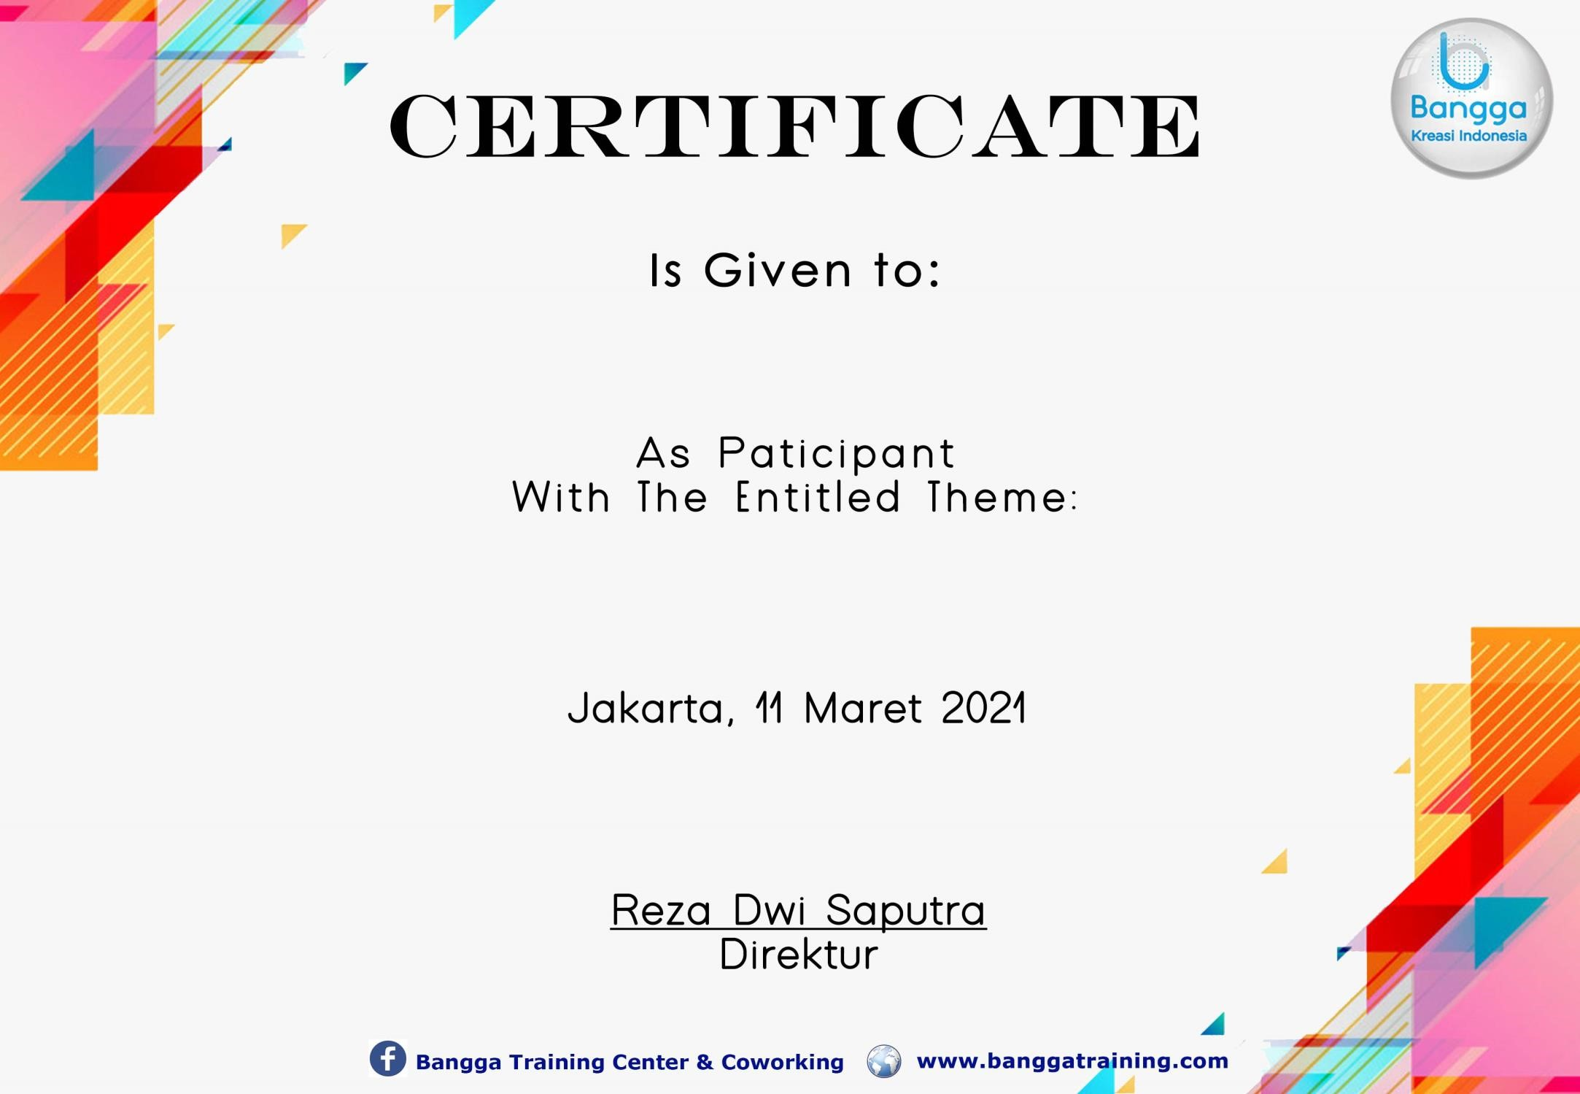



No. 003/BKI/III/2021
Training Online Expertise in Cyber Security
Learn a Practical Skill
-
Set in Defeating All Online Threats
M YUSUF BAGUS RASYIIDIN

