Noon / Amazon · Use-case flow view: “Frequently Bought Together” at Checkout (+ WhatsApp Recovery)
Use case. A user adds an item (e.g. an iPhone) to their cart and opens checkout. In under 150 ms, we show 3 matching in-stock add-ons (charger, case, screen protector) priced for their customer segment. If they leave checkout without paying after 30 minutes, Flink triggers a WhatsApp reminder with the same cart + bundle discount. 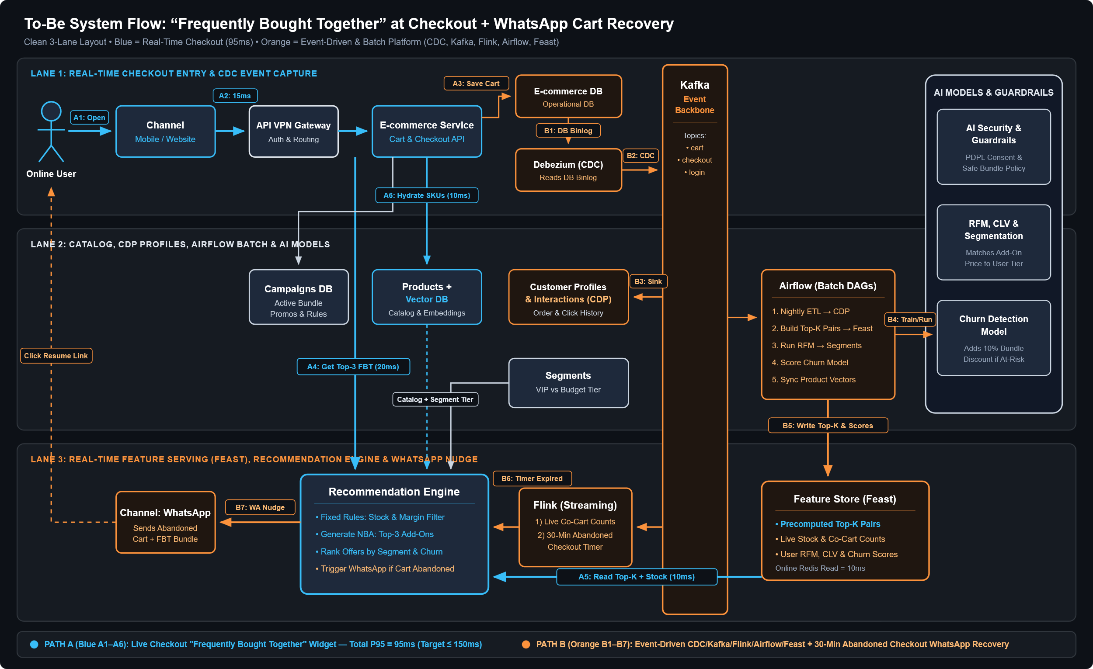
Two paths (Every component in the To-Be diagram has an active role):
1. Real-Time Checkout Path (A1–A7, Blue): Online User → Mobile/Web Channel → API VPN Gateway → E-commerce Service (writes cart to E-commerce DB) → calls Recommendation Engine. The Engine reads precomputed Top-K pairs, live stock, RFM & Churn scores from Feature Store (Feast) + user tier from Segments & CDP, hydrates product details/vectors from Products + Vector DB and active bundle promos from Campaigns, and renders Top-3 add-ons on screen.
2. Background Event & Batch Platform (B1–B8, Orange): Debezium (CDC) reads E-commerce DB binlog → Kafka Event Backbone → sinks history to CDP. Airflow runs nightly DAGs to train RFM/CLV Segmentation and Churn Models, checks AI Security & Guardrails, and writes Top-K features to Feast. Meanwhile, Flink tracks live cart events; if no checkout happens after X min, it fires an abandoned-cart event to the Recommendation Engine, which sends a bundle nudge to the WhatsApp Channel.

Options for serving the Top-3 add-ons at Checkout (Step A4)
Factor | Option A · Read Precomputed Top-K from Feast + Vector DB Fallback (Chosen) | Option B · Query Vector DB in Real Time for Every Request
Latency | ~10 ms read from Feast online store (fits 150ms checkout SLA) | ~70–120 ms vector search on every checkout (too slow)
Cost | Low: Airflow computes co-purchases once nightly; Vector DB is only called for new/cold-start products. | High: Needs expensive high-RAM vector nodes for 100% of checkout traffic.
Operational DB Load | Near Zero: CDC + Kafka offload all analytics from E-commerce DB. | High: Queries Products & E-commerce DB for dozens of candidate items per user.
Decision: Option A. It gives fast 10 ms reads from Feast for known items while still using the Vector DB as a smart fallback when a brand-new product has no purchase history yet.

Over-engineering check (Against the To-Be High-Level View)
- All High-Level Components Have a Role: Channels (Web/Mobile for live checkout + WhatsApp for abandoned checkout), API VPN Gateway, E-commerce Service + DBs (E-commerce, Campaigns, Products/Vector DB), Debezium CDC → Kafka → Flink, Airflow + CDP + Segments, Feature Store (Feast), Recommendation Engine, and AI Guardrails/RFM/Churn models.
- Kept Simple (Avoided Over-Engineering): We do not call a heavy LLM during live checkout; AI Security & Guardrails run asynchronously on CDP/Campaign rules, and WhatsApp uses pre-approved templates.
- Missing from High-Level View: 1) Circuit Breaker (100ms timeout) on the Recommendation call so slow AI never blocks checkout payment, and 2) WhatsApp Frequency Cap / Consent Check (max 1 reminder per abandoned checkout, respecting PDPL quiet hours).

Latency budget per hop (P95)
Path | Hops (Step by Step) | Total P95 | Target
A · Live Checkout FBT | API VPN Gateway 15ms · E-commerce Service + DB 20ms · Feast Online Read 10ms · Engine Rank + Segment/Churn Rules 20ms · Hydrate Products/Campaigns 10ms · Render UI 20ms | 95 ms | ≤ 150 ms
B · Abandoned Checkout WhatsApp | (After Flink timer fires) Flink → Engine 40ms · Feast + Guardrail check 20ms · WhatsApp API send 500ms | 560 ms | ≤ 2 s

