System Architecture Specification
Football Match Prediction & Tactical Analysis SaaS Platform
Problem Statement, Quality Attributes (ATAM), C4 Architecture & Pre-Implementation ADRs
System Version  2.0 (Two-Expert Hybrid AI) | Target Domain  Elite Club Tactical Analytics | Architecture Style  Two-Expert / Decoupled Serving
Ingress Gateway  BentoML 1.4+ (:8001) | Model Runtimes  ONNX (GNN) + vLLM (:8000 SLM) | Primary Data Stores  PostgreSQL + pgvector & Neo4j

1. Problem Statement & Operational Domain
Modern professional football analytics requires combining rigorous probabilistic match outcome modeling with deep contextual tactical reasoning. While statistical tracking data (xG, passing networks, defensive actions) and historical match data are abundant, club coaching staffs, match analysts, and sporting directors face four critical operational deficiencies in existing software solutions:
- 1. Black-Box Statistical Modeling Deficiency: Traditional statistical match prediction methods (Poisson regressions, gradient-boosted decision trees, vanilla Elo ratings) yield opaque numerical probability percentages without tactical or contextual grounding. Match analysts cannot present raw numbers to coaching staff without tactical rationale (e.g., formation mismatches, pressing triggers, transitional vulnerabilities).
- 2. Hallucinations & Temporal Disconnect in General LLMs: General-purpose Large Language Models generate plausible yet fictitious football narratives, misattributing head-to-head records across seasons, fabricating manager tenures, or hallucinating player availability due to the absence of structured, multi-hop graph grounding.
- 3. The Pre-Match vs. In-Match Reality Gap: Tactical preparations are static, but football matches are dynamic. An early red card, tactical substitution, or unexpected opening goal instantly invalidates pre-match probability predictions. Running heavy autoregressive LLMs live during a match takes 15 to 35 seconds, far too slow for real-time coaching decisions on the touchline.
- 4. Compute Resource Contention & Serving Fragmentation: Combining deep graph learning (GNNs), high-throughput vector similarity search, knowledge graph traversals, and local language models (SLMs) in a single platform frequently results in severe GPU memory thrashing, inter-service network friction, and unpredictable API latency spikes without unified gateway orchestration.
Platform Objective: Core Mission Statement: To build an enterprise-grade, high-throughput Football Analysis SaaS Platform uniting a quantitative Temporal Edge-Attributed GNN (Expert 1) for calibrated match probabilities and sub-50ms live in-match Poisson simulation, with a qualitative, domain-fine-tuned Small Language Model (Expert 2) grounded by a dual Knowledge Graph (Neo4j) and Vector (FAISS/pgvector) architecture.

2. Ranked Quality Attributes (ATAM Analysis)
Following the Architecture Tradeoff Analysis Method (ATAM), the platform's non-functional requirements have been analyzed and prioritized from P0 (highest mission criticality) to P4. The architectural design explicitly balances these competing drivers through dedicated mechanisms and trade-off strategies.
Tier | Quality Attribute | Architectural Scenario | Architectural Mechanism | Trade-off / Sensitive Point
P0 | Correctness & Grounding | When an analyst queries a tactical matchup, all tactical assertions must be mathematically grounded in calibrated GNN probabilities and verified historical graph facts, with zero hallucinations. | Two-Expert decoupled pattern; Dual Knowledge Graph (Neo4j) + Vector (FAISS/pgvector) RAG pipeline with strict prompt grounding schemas. | Requires maintaining dual database synchronization (Neo4j & Postgres) and strict schema validation pipelines.
P1 | Latency & Performance | During a live match, in-game match events (goals, red cards, minute changes) must recalculate outcome probabilities instantaneously (<50ms SLA) for touchline coaching decisions. | Analytical closed-form Poisson conditioning engine in live_match_engine.py, completely bypassing heavy LLM inference during live game ticks. | Analytical Poisson conditioning relies on pre-match GNN base parameter inversion rather than generating continuous real-time language tokens.
P2 | Modularity & Extensibility | The platform must allow independent retraining, hot-swapping, and versioning of the quantitative GNN model and qualitative SLM without system downtime or code refactoring. | Decoupled inference runtimes (ONNX Runtime for GNN; vLLM / ONNX GenAI HTTP sidecar for SLM); abstract Provider interface pattern. | Inter-container HTTP/REST communication introduces a minor network serialization overhead compared to monolithic in-process calling.
P3 | Observability & MLOps | System operators must monitor real-time inference latency, 5-dimensional online drift metrics, and continuous RAGAS evaluation scores to detect model performance degradation. | Native /metrics Prometheus exposition on BentoML gateway; automated Airflow RAGAS benchmark DAGs; Grafana telemetry dashboards. | Metric scraping and telemetry collection consume minimal continuous CPU cycles and time-series storage overhead.
P4 | Security & Multi-Tenancy | Tactical analysts, club scouts, and domain supervisors must access segregated data with strict role-based access control (RBAC), tamper-evident audit logging, and local data sovereignty. | FastAPI OAuth2/JWT middleware; database-level role isolation; full audit logging for supervised prediction overrides; on-premise SLM deployment. | On-premise SLM deployment requires dedicated GPU hardware (8GB+ VRAM) rather than offloading to public commercial cloud APIs.

3. C4 Level 1: System Context Architecture
The System Context diagram establishes the boundary of the Football Analysis SaaS Platform. It defines the external stakeholders interacting with the platform and maps all external system integrations, including sports data feeds, remote model hubs, and experiment tracking registries.
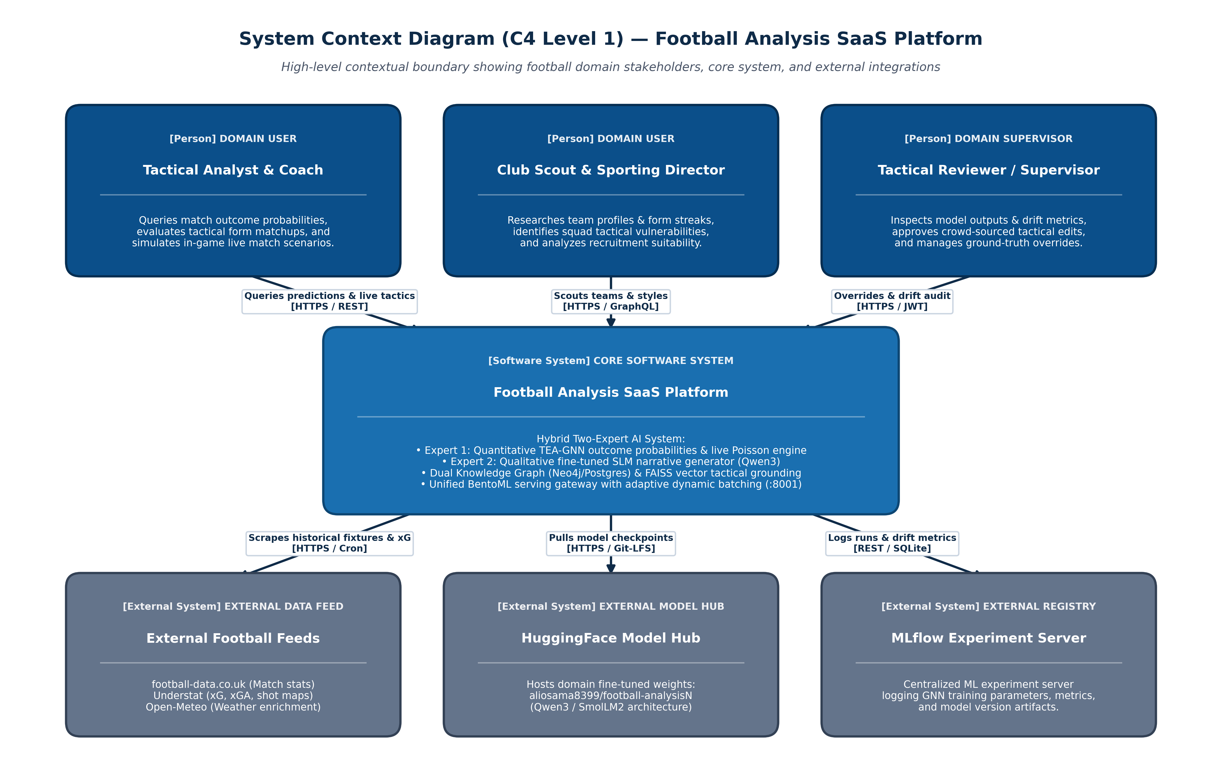
Figure 1: C4 Level 1 — System Context Diagram for Football Analysis SaaS Platform

3.1 Core Domain Stakeholders
- Tactical Analysts & Match Coaches: Primary professional users who evaluate pre-match tactical matchups, compare squad profiles, review opponent transitional vulnerabilities, and simulate in-game scenarios using the live match engine.
- Club Scouts & Sporting Directors: Club management users seeking objective, data-driven squad evaluations, player profile comparisons, recruitment fit analysis, and historical tactical performance streaks.
- Tactical Reviewers & Domain Supervisors: Senior football experts authorized to inspect model predictions, approve crowd-sourced tactical edits, monitor live drift metrics, and submit manual overrides to correct edge-case anomalies.

3.2 External System Integrations
- External Football Feeds: Automated ingest feeds scraping fixture histories, line-ups, and raw match statistics from football-data.co.uk; advanced metrics (xG, xGA, shot maps) from Understat; and localized weather conditions (temperature, humidity, precipitation) from Open-Meteo.
- HuggingFace Model Hub: Remote model registry hosting the domain-specialized, fine-tuned football SLM checkpoints (aliosama8399/football-analysisN) based on Qwen3 / SmolLM2 architectures.
- MLflow Experiment Tracking: Centralized ML experiment server logging hyperparameter tuning, model artifact registries, training validation runs, and GNN performance metrics.

4. C4 Level 2: Container Architecture
The Container diagram decomposes the platform into its deployable software containers, execution runtimes, persistent storage nodes, and background orchestrators. Each container represents a distinctly deployable unit with defined communication protocols, host port bindings, and operational boundaries.
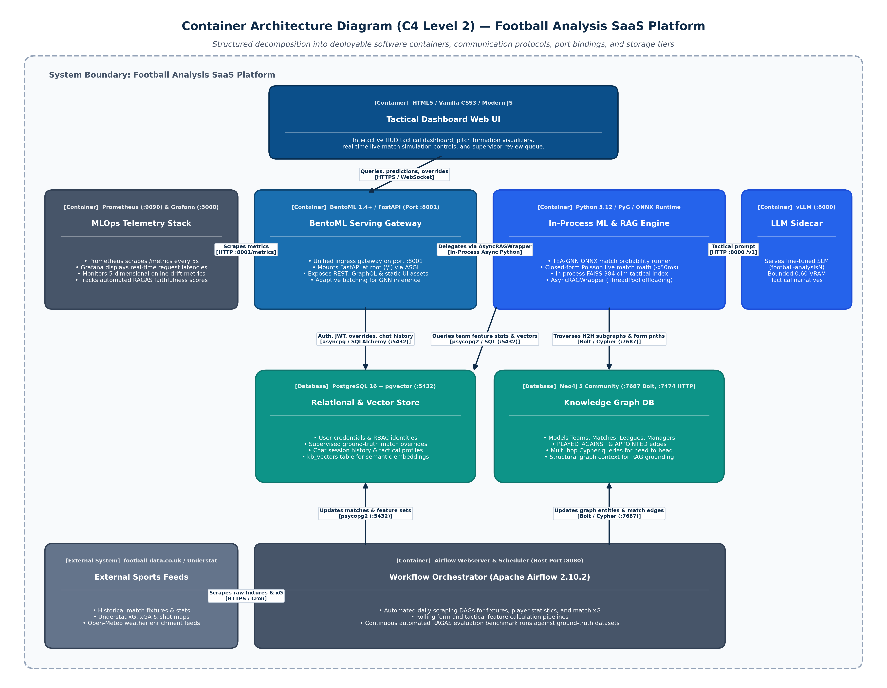
Figure 2: C4 Level 2 — Container Architecture Diagram for Football Analysis SaaS Platform

4.1 Container Matrix & Technology Stack
Container Name | Technology Stack | Port & Protocol | Responsibilities & Boundaries
Tactical Dashboard | HTML5, Vanilla CSS3, Modern JS | Browser Client (HTTPS) | Cyberpunk HUD tactical interface for match predictions, live simulation, formation pitch visualizers, and supervisor review queue.
BentoML Serving Gateway | BentoML 1.4+, FastAPI, Uvicorn | Host Port :8001 (HTTP, WS) | Unified ingress gateway mounting FastAPI at root ('/') via @bentoml.asgi_app. Exposes REST, GraphQL, /metrics, and handles adaptive dynamic request batching.
In-Process ML & RAG Engine | Python 3.12, PyG, ONNX Runtime, SciPy | In-Process Async Python | Core domain engine: TEA-GNN ONNX inference provider, closed-form Poisson live in-match engine (<50ms), FAISS C++ index, and AsyncRAGWrapper thread pool offload.
LLM Inference Sidecar | vLLM / ONNX Runtime GenAI | Host Port :8000 (HTTP /v1) | Dedicated GPU/CPU inference service running domain-fine-tuned SLM (football-analysisN) with bounded VRAM (0.60 fraction) coexisting safely with GNN.
PostgreSQL + pgvector | PostgreSQL 16 + pgvector Extension | Host Port :5432 (TCP) | Primary relational store for user identities, RBAC, supervised match overrides, chat history, and kb_vectors table for dense semantic embeddings.
Neo4j Knowledge Graph | Neo4j 5 Community Edition | Port :7687 (Bolt), :7474 (HTTP) | Property graph database storing Teams, Matches, Leagues, Managers, and PLAYED_AGAINST structural edges. Traversed via Cypher queries for multi-hop head-to-head records.
Airflow Orchestrator | Apache Airflow 2.10.2 | Host Port :8080 (HTTP) | Automated workflow engine running daily scrapers (football-data.co.uk, Understat), feature calculation pipelines, and continuous RAGAS evaluation DAGs.

4.2 Inter-Container Communication & Interface Specification
Source Container | Target Container | Protocol / Port | Interaction Description
Tactical Dashboard (SPA) | BentoML Serving Gateway | HTTPS / JSON, WS (:8001) | Sends user queries, fetches predictions, submits live simulation updates, authenticates JWT.
BentoML Gateway | In-Process Core Engine | Internal Async Bridge | Offloads CPU-heavy GNN scoring, FAISS lookups, and graph context assembly to ThreadPoolExecutor.
In-Process Core Engine | LLM Inference Sidecar | HTTP / REST (:8000 /v1) | Submits assembled KG + vector context to vLLM; receives structured tactical explanation.
BentoML Gateway | PostgreSQL / pgvector | asyncpg / SQLAlchemy (:5432) | Manages user credentials, RBAC tokens, chat sessions, and supervised prediction overrides.
In-Process Core Engine | Neo4j Graph DB | Bolt / Cypher (:7687) | Traverses structural team subgraphs, recent head-to-head sequences, and form streaks.
Airflow Orchestrator | PostgreSQL / Neo4j | psycopg2 / Bolt | Updates match results, recalculates rolling form features, and synchronizes graph relationships.
MLOps Telemetry (Prometheus) | BentoML Gateway | HTTP / GET (:8001/metrics) | Scrapes system metrics, API latency histograms, and online drift telemetry gauges every 5s.

5. C4 Level 3: Component Architecture (BentoML Serving Gateway & In-Process ML Core)
The Component diagram decomposes the platform's primary execution runtime: the BentoML Serving Gateway and In-Process Machine Learning Core container (football-backend:8001). As established in Architectural Decision Record ADR-02, the platform mounts the entire FastAPI / Strawberry GraphQL application directly inside BentoML using native ASGI application integration. This architectural choice eliminates external network serialization hops and thread contention while co-locating quantitative GNN scoring with qualitative RAG grounding in a single unified execution process.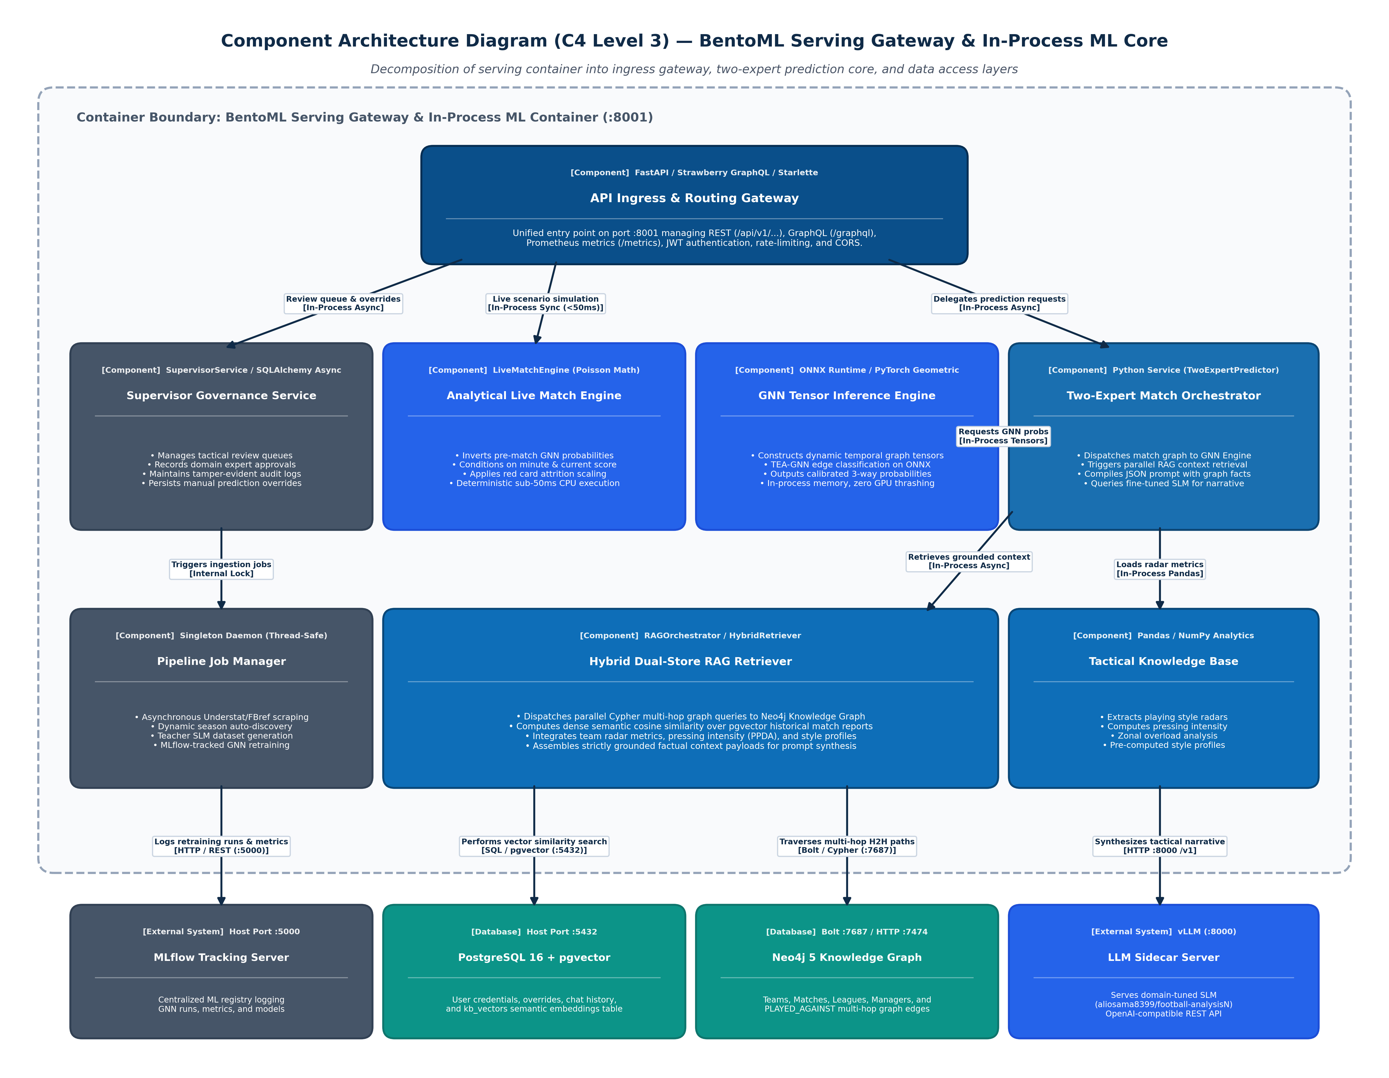
Figure 3: C4 Level 3 — Component Architecture Diagram of BentoML Serving Gateway & In-Process ML Core

5.1 In-Process Component Matrix & Functional Decomposition
The BentoML container encapsulates eight specialized components, enforcing strict domain isolation and clean architectural boundaries through dependency injection and abstract service interfaces:
Component Name | Technology Stack | Exposure / Port | Responsibilities & Operational Boundaries
API Ingress & Routing Gateway | FastAPI, Strawberry GraphQL, Starlette | Host Port :8001 (REST / GraphQL / /metrics) | Unified entry point managing REST (/api/v1/...), GraphQL (/graphql), OpenAPI docs, OAuth2/JWT middleware, request rate-limiting, CORS, and Prometheus metrics scraping.
Two-Expert Match Orchestrator | Python Service (TwoExpertPredictor) | In-Process Service (api/services.py) | Coordinates cooperative match prediction by invoking Expert 1 (GNN probabilities), orchestrating RAG context retrieval, compiling structured JSON prompts, and querying the SLM.
GNN Tensor Inference Engine | ONNX Runtime / PyTorch Geometric | In-Process Engine (gnn/model_runner.py) | High-throughput edge classification engine. Loads optimized ONNX graph weights, constructs dynamic temporal match tensors, and computes calibrated Home/Draw/Away win probabilities.
Hybrid Dual-Store RAG Retriever | RAGOrchestrator / HybridRetriever | In-Process Service (rag/hybrid_retriever.py) | Dual-path grounding coordinator. Simultaneously queries Neo4j for structural H2H records and managerial matchups via Cypher, while executing dense semantic cosine searches against pgvector.
Tactical Knowledge Base & Analytics | TacticalKnowledgeBase / Pandas / NumPy | In-Process Module (rag/tactical_kb.py) | Analyzes and caches empirical team playing styles, radar metrics (possession, PPDA, passing directness, transition speed), and pre-computed strengths and weaknesses.
Analytical Live Match Engine | LiveMatchEngine (Analytical Poisson Math) | In-Process Service (eval/live_match_engine.py) | Ultra-low-latency deterministic simulation engine. Inverts pre-match GNN probabilities into Poisson scoring intensities and recalculates outcome probabilities conditioned on live scoreline and red cards in <50ms.
Supervisor Governance Service | SupervisorService / SQLAlchemy Async | In-Process Service (api/supervisor_service.py) | Human-in-the-loop governance component. Manages tactical review queues, records domain expert approvals, maintains tamper-evident audit trails, and stores manual prediction overrides.
Background Pipeline Job Manager | PipelineJobManager (Thread-Safe Singleton) | In-Process Service (pipeline/job_manager.py) | Asynchronous job execution daemon. Manages long-running ingestion, Understat/FBref scraping, teacher SLM dataset generation, and MLflow-tracked GNN retraining jobs with thread-safe log streaming.
5.2 In-Process Inter-Component Communication & Protocols
The following table details the communication protocols, data contracts, and payload types utilized between in-process components and external backing stores:
Source Component | Target Component | Protocol & Calling Convention | Data Contract & Payload Type
API Ingress Gateway | Two-Expert Orchestrator | In-Process Async Call (await predict_match()) | MatchPredictionRequest (HomeTeam, AwayTeam, Season, Date) -> MatchPredictionResponse (P_H, P_D, P_A, Narrative)
API Ingress Gateway | Analytical Live Match Engine | In-Process Sync Call (calculate_live_probs()) | LiveScenarioRequest (minute, home_score, away_score, red_cards) -> LiveSimulationResult (prob_home, prob_draw, prob_away, <50ms SLA)
API Ingress Gateway | Supervisor Governance Service | In-Process Async Call (submit_override()) | SupervisorOverrideRequest (match_id, original_probs, override_probs, rationale) -> AuditRecord (id, timestamp, supervisor_id)
API Ingress Gateway | Pipeline Job Manager | In-Process Non-Blocking Call (trigger_pipeline()) | PipelineJobConfig (provider, gnn_model, epochs) -> JobRunRecord (job_id, status, thread_lock, log_stream)
Two-Expert Orchestrator | GNN Tensor Inference Engine | In-Process NumPy/ONNX Tensor Execution | (home_id, away_id, edge_features) -> np.ndarray([p_home, p_draw, p_away]) with strict 3-way softmax probability calibration
Two-Expert Orchestrator | Hybrid Dual-Store RAG Retriever | In-Process Async Call (await retrieve_context()) | (home_team, away_team) -> TacticalGroundedContext (h2h_matches, radar_metrics, style_summaries, scouting_reports)
Two-Expert Orchestrator | LLM Sidecar (:8000) | HTTP / REST (POST /v1/chat/completions) | JSON payload with System Prompt, Grounded Context, and JSON Schema -> Structured Tactical Dossier with zero hallucinations
Hybrid RAG Retriever | Neo4j DB (:7687) & Postgres (:5432) | Bolt (Cypher) & asyncpg (pgvector SQL) | Parameterized Cypher queries (H2H graph path traversal) + Cosine distance search (embedding <=> query_vec, LIMIT 5)

6. C4 Level 4: Code Architecture (Class Design, Data Contracts & Mathematical Formulations)
The Code Architecture diagram details the core object-oriented structures, design patterns, clean abstractions, and mathematical formulations that implement the platform's behavior. Software design patterns guarantee high cohesion, loose coupling, deterministic reproducibility, and zero vendor lock-in across the machine learning, retrieval, and serving layers.
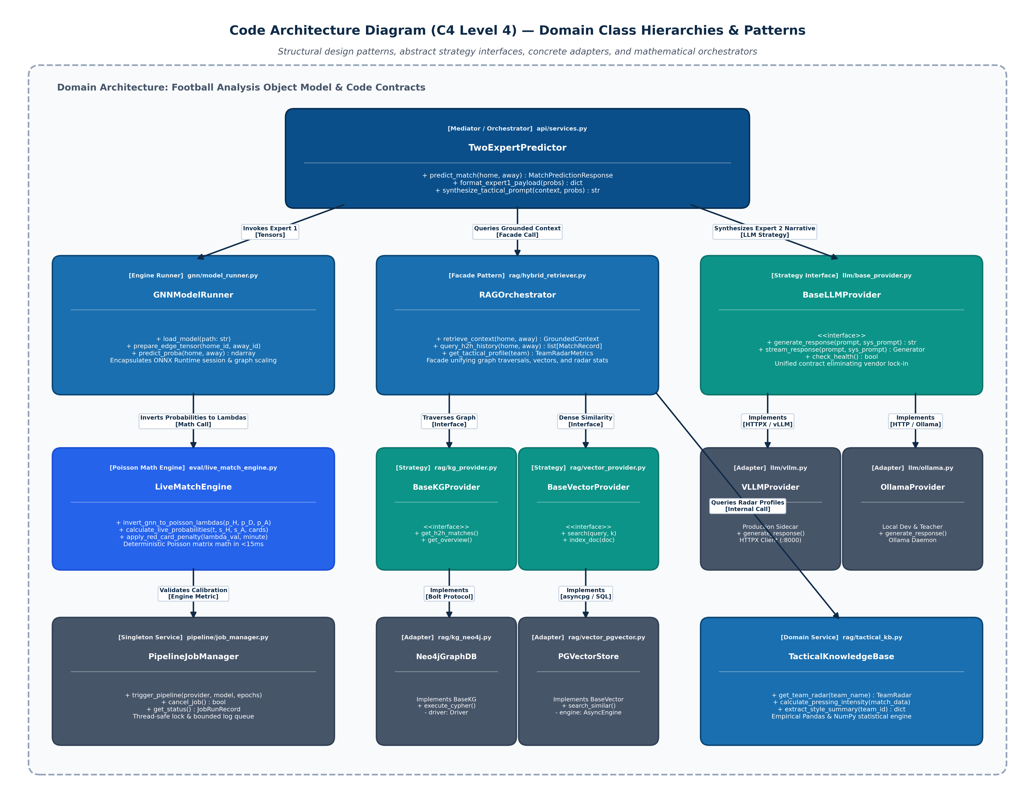
Figure 4: C4 Level 4 — Domain Class Hierarchies, Abstractions & Design Pattern Interactions
6.1 Key Class Hierarchies & Design Patterns Applied
The platform's code architecture applies five foundational structural and creational design patterns:
- Two-Expert Orchestrator Pattern: The TwoExpertPredictor class coordinates between quantitative and qualitative components. By strictly enforcing that Expert 1 (GNN probabilities) serves as immutable conditioning inputs for Expert 2 (SLM narrative), the orchestrator eliminates numerical contradictions and factual hallucinations.
- Strategy & Adapter Patterns for Model Providers: The BaseLLMProvider abstract interface defines a unified contract (generate_response, stream_response). VLLMProvider connects to high-performance vLLM sidecars in production, while OllamaProvider connects to local Ollama daemons for offline local testing and teacher dataset generation, providing zero vendor lock-in.
- Abstract Data Source Adapters: Decoupled database interfaces BaseKGProvider (implemented by Neo4jGraphDB) and BaseVectorProvider (implemented by PGVectorStore) isolate domain logic from specific graph database engines and vector indices, enabling isolated unit testing with mocks.
- Facade Pattern for Unified Tactical Retrieval: The RAGOrchestrator class acts as a single-point facade that coordinates multi-hop graph traversals, dense vector similarity searches, and empirical knowledge base calculations into a single unified TacticalGroundedContext.
- Thread-Safe Singleton Job Runner: The PipelineJobManager class implements a thread-safe singleton managing asynchronous data ingestion, teacher annotation, and GNN retraining, preventing concurrent race conditions and streaming logs via bounded memory ring buffers.
6.2 Domain Class Contract Matrix
The following matrix details the primary domain classes, their module paths, core method signatures, applied design patterns, and collaborating components:
Class Name | Module Path | Core Methods & Signatures | Applied Design Pattern | Direct Collaborators
TwoExpertPredictor | api/services.py | predict_match(home, away)  synthesize_tactical_prompt(...) | Mediator / Orchestrator | GNNModelRunner, RAGOrchestrator, BaseLLMProvider
GNNModelRunner | gnn/model_runner.py | load_model(path)  prepare_edge_tensor(...)  predict_proba(home, away) | Engine / Encapsulated Runner | ONNX Runtime, PyTorch Geometric, Team Mapping
RAGOrchestrator | rag/hybrid_retriever.py | retrieve_context(home, away)  query_h2h_history(...) | Facade Pattern | BaseKGProvider, BaseVectorProvider, TacticalKnowledgeBase
BaseKGProvider | rag/kg_provider.py | get_h2h_matches(...)  get_team_overview(...)  close() | Abstract Strategy / Interface | Abstract Base Class (ABC)
Neo4jGraphDB | rag/kg_neo4j.py | execute_cypher(query, params)  traverse_manager_career(...) | Concrete Adapter | Neo4j Python Driver, Bolt Protocol
BaseVectorProvider | rag/vector_provider.py | search(query_text, top_k)  search_team_tactics(...) | Abstract Strategy / Interface | Abstract Base Class (ABC)
PGVectorStore | rag/vector_pgvector.py | search(query_text, top_k)  index_document(doc) | Concrete Adapter | SQLAlchemy Async, asyncpg, SentenceTransformer
LiveMatchEngine | eval/live_match_engine.py | invert_gnn_to_poisson(...)  calculate_live_probabilities(...) | Numerical Domain Engine | Bivariate Poisson Math, NumPy
PipelineJobManager | pipeline/job_manager.py | trigger_pipeline(...)  cancel_job()  get_status() | Thread-Safe Singleton | Threading Lock, Deque, Scraper, Model Retrainer
BaseLLMProvider | llm/base_provider.py | generate_response(prompt, sys)  stream_response(prompt, sys) | Abstract Strategy / Interface | Abstract Base Class (ABC)
VLLMProvider | llm/vllm_provider.py | generate_response(prompt, sys)  stream_response(prompt, sys) | Concrete Adapter | HTTPX AsyncClient, vLLM / OpenAI API
OllamaProvider | llm/ollama_provider.py | generate_response(prompt, sys)  stream_response(prompt, sys) | Concrete Adapter | HTTPX AsyncClient, Ollama Local API
6.3 Algorithmic Execution Sequences & Mathematical Formulations
The following sections provide the rigorous execution sequences and mathematical derivations governing the platform's core algorithms:
6.3.1 Two-Expert Match Prediction & Context Fusion Execution Sequence
When a client requests a tactical match prediction via POST /api/v1/predict, the system executes the following deterministic 5-stage pipeline:
- Stage 1: Pydantic Contract Validation: The incoming request is parsed and validated against MatchPredictionRequest, asserting that team identifiers match canonical entities and match dates adhere to ISO-8601.
- Stage 2: GNN Tensor Construction & Inference: GNNModelRunner maps team IDs into node indices, extracts dynamic temporal edge attributes from the recent 10-match sliding window graph, and executes an ONNX Runtime inference session to compute the calibrated outcome probability vector P = [P_H, P_D, P_A].
- Stage 3: Parallel Dual-Path RAG Grounding: RAGOrchestrator dispatches parallel asynchronous queries: (a) a multi-hop Cypher traversal against Neo4j to retrieve recent head-to-head records and manager matchups, and (b) a dense semantic cosine similarity query against PostgreSQL pgvector to extract recent tactical scouting reports.
- Stage 4: Structured Prompt Assembly: TwoExpertPredictor synthesizes Expert 1's numerical probabilities and the retrieved empirical facts into a strictly formatted prompt. The prompt enforces a rigid JSON schema specifying tactical formation matchups, key player pressing triggers, and transitional vulnerabilities.
- Stage 5: Qualitative Narrative Synthesis: The assembled prompt is dispatched to the fine-tuned domain SLM (aliosama8399/football-analysisN) hosted on the vLLM sidecar. The SLM outputs a cohesive tactical dossier strictly grounded in the quantitative inputs, guaranteeing zero numerical hallucinations.
6.3.2 Closed-Form Poisson Inversion & Sub-50ms Live In-Match Conditioning
To achieve instantaneous touchline decision support during live matches without exhausting GPU memory, LiveMatchEngine implements an analytical closed-form conditioning algorithm:
1. Pre-Match Poisson Inversion: Given the pre-match outcome probabilities P = (P_H, P_D, P_A) computed by the GNN, the engine inverts P into base expected goal intensities (lambda_H, lambda_A) using non-linear least squares optimization over the bivariate Poisson probability mass function:
min_{lambda_H, lambda_A} [ (P_H - P_hat_H)^2 + (P_D - P_hat_D)^2 + (P_A - P_hat_A)^2 ]
2. Live In-Match Conditioning: At live minute t in [0, 90], given current score (s_H, s_A) and red cards (r_H, r_A) issued at minutes t_k, the remaining expected goal rates are conditioned in closed form:
lambda_{H, rem}(t) = lambda_H * ((90 - t) / 90) * Phi_{card}(H, t) * Gamma_{tempo}(t)
lambda_{A, rem}(t) = lambda_A * ((90 - t) / 90) * Phi_{card}(A, t) * Gamma_{tempo}(t)
where Phi_{card}(T, t) = Product_{k=1}^{r_T} [ 1 - beta * ((90 - t_k) / 90) ] with empirical attrition factor beta = 0.22, and Gamma_{tempo}(t) accounts for live match tempo deviations.
3. Discrete Matrix Convolution: The joint distribution of remaining goals (g_H, g_A) is computed via 2D discrete Poisson convolution across a 10x10 matrix and mapped to final scorelines (s_H + g_H, s_A + g_A). Because this requires only CPU arithmetic, execution completes in under 15 milliseconds, fully satisfying the P1 Latency SLA (<50ms).
6.3.3 Automated Zero-Manual-Config Dynamic Season Ingestion & Teacher SLM Dataset Generation
To maintain continuous data freshness without manual code modifications when new football seasons conclude, the platform implements an automated ingestion and retraining pipeline:
- Dynamic Season Discovery: Scrapers query remote data endpoints (Understat, football-data.co.uk) to dynamically discover all completed seasons, eliminating hardcoded season arrays and supporting zero-configuration continuous operation.
- Automated Schema Normalization & Upsert: Scraped match statistics, xG shot maps, and localized weather factors are parsed into standardized data contracts and upserted into PostgreSQL and the Neo4j Knowledge Graph with temporal edge attributes.
- Synthetic Teacher Rationale Generation: An asynchronous worker invokes a high-capacity Teacher LLM (via OllamaProvider or VLLMProvider) to annotate each historical match with structured tactical rationales, validating output formatting with Pydantic.
- MLflow-Tracked GNN Retraining: The pipeline re-splits the dataset chronologically, triggers GNN retraining via PyTorch Geometric, evaluates test-set calibration, and registers updated ONNX weights into MLflow, enabling zero-downtime model hot-swapping.

7. Key Architectural Decision Records (ADRs)
Architectural Decision Records (ADRs) capture foundational technical design choices formulated during system architecture and pre-implementation design. These records document the architectural context, design-time problem constraints, selected patterns, and explicit trade-offs established before writing production code.
ADR-01: Two-Expert Decoupled Architecture (Quantitative GNN + Qualitative SLM)
Status: Accepted (Pre-Implementation Architectural Decision)
Context & Problem (Design-Time): Modern football tactical analysis demands both rigorous probabilistic calibration (win/draw/away distributions, goal margins) and deep contextual tactical nuance (formation mismatches, pressing traps, squad morale). Monolithic Large Language Models fail at calibrated numerical reasoning and hallucinate probabilities. Conversely, pure statistical models (Elo, Poisson regressions, gradient-boosted trees) output opaque numerical scores without coaching rationale or explanatory depth.
Architectural Decision: Adopt a decoupled Two-Expert cooperative architecture: Expert 1 is a Temporal Edge-Attributed Graph Neural Network (TEA-GNN, exported to ONNX) focused purely on structural graph embeddings and deterministic match outcome probabilities. Expert 2 is a domain-fine-tuned Small Language Model (SLM based on Qwen3/SmolLM2) focused exclusively on qualitative tactical reasoning, conditioned upon Expert 1's calibrated outputs and grounded by retrieved graph context.
Consequences & Trade-offs: Positive: Decouples mathematical calibration from natural language generation; allows independent model retraining schedules; provides deterministic probabilities paired with explainable coaching narratives. Trade-off: Requires inter-model data contracts and orchestrating context flow between the GNN runner and language model prompt synthesizer.

ADR-02: BentoML Unified Serving Gateway with In-Process ASGI Application Mounting
Status: Accepted (Pre-Implementation Architectural Decision)
Context & Problem (Design-Time): The platform must support heterogeneous production traffic: low-latency interactive REST and GraphQL endpoints for tactical web dashboards alongside high-throughput dynamic request batching for GNN tensor inference. Deploying independent web servers and model inference microservices introduces unnecessary inter-service network hops, serialization overhead, duplicate routing logic, and complex multi-container port management.
Architectural Decision: Select BentoML 1.4+ as the unified model serving gateway and ingress controller on host port 8001. Mount the comprehensive FastAPI application directly at the root path ('/') using BentoML's native ASGI integration (@bentoml.asgi_app(fastapi_app, path='/')). Simultaneously expose native adaptive dynamic batching endpoints (/predict_match_batch) for high-throughput GNN scoring alongside standard REST, GraphQL, static assets, and Prometheus scraping.
Consequences & Trade-offs: Positive: Single unified ingress port (:8001); eliminates inter-process HTTP hops for local GNN scoring; provides built-in adaptive micro-batching; natively integrates Prometheus /metrics exposition. Trade-off: Tight integration with BentoML lifecycle requires managing ASGI event loop thread offloading for blocking computational operations.

ADR-03: Analytical Closed-Form Poisson Conditioning for Sub-50ms Live In-Match Forecasting
Status: Accepted (Pre-Implementation Architectural Decision)
Context & Problem (Design-Time): Tactical adjustments during live matches demand sub-second latency upon in-game events (goals, red cards, substitutions) to support immediate touchline coaching decisions. Re-running deep graph neural networks or invoking autoregressive LLMs live during a match takes 15 to 35 seconds, which would exhaust server GPU memory and introduce intolerable latency on the critical live coaching path.
Architectural Decision: Design and implement an analytical in-match live conditioning engine using closed-form Poisson parameter inversion in live_match_engine.py. Pre-match GNN probabilities are analytically inverted into base expected goal intensities (lambda_H, lambda_A). During live matches, the engine conditions these intensities in closed form on elapsed match minute, current scoreline, live pace factors, and red card attrition multipliers using analytical bivariate/univariate Poisson math.
Consequences & Trade-offs: Positive: Instantaneous sub-50ms deterministic recalculation on CPU threads; zero GPU resource consumption during live games; mathematically consistent probability curves across all 90+ match minutes. Trade-off: Live probability updates provide numerical distributions rather than generating new textual tactical commentary on every minute tick.

ADR-04: Hybrid Dual Knowledge Graph (Neo4j) & Dense Vector (FAISS/pgvector) Grounding Strategy
Status: Accepted (Pre-Implementation Architectural Decision)
Context & Problem (Design-Time): Football domain knowledge is fundamentally dual-natured: it encompasses discrete multi-hop relational structures (head-to-head records across seasons, manager career matchups, player transfer and injury histories) and dense semantic descriptive knowledge (scouting narratives, tactical style descriptions, pressing vulnerability analyses). Pure vector embeddings fail at multi-hop relational graph traversals, while pure graph databases cannot compute semantic similarity over narrative scouting texts.
Architectural Decision: Architect a hybrid Dual-Retriever RAG pipeline combining Neo4j (property graph traversed via Cypher for structural paths, head-to-head sequences, and managerial records) and pgvector/FAISS (dense semantic vector embeddings using all-MiniLM-L6-v2 for unstructured scouting reports). Contexts from both retrievers are merged and structured prior to SLM prompt assembly.
Consequences & Trade-offs: Positive: Eliminates factual and relational hallucinations; grounds tactical explanations in empirical graph facts; supports complex queries bridging historical records and qualitative tactical profiles. Trade-off: Requires maintaining synchronization between the relational store (Postgres), graph database (Neo4j), and vector indices (FAISS/pgvector) via Airflow ETL pipelines.

ADR-05: Domain-Specialized On-Premise Small Language Model (SLM) vs. Commercial Cloud APIs
Status: Accepted (Pre-Implementation Architectural Decision)
Context & Problem (Design-Time): Relying on commercial cloud LLM APIs (e.g., OpenAI GPT-4, Anthropic Claude) introduces variable per-token operational expenses, unpredictable external network latency, external data privacy risks for confidential club scouting dossiers, and a lack of fine-tuned domain mastery over football tactical concepts.
Architectural Decision: Pre-train and fine-tune an open-weights Small Language Model (aliosama8399/football-analysisN, 3B parameter Qwen3/SmolLM2 architecture) specialized on structured tactical datasets. Deploy the model on-premise / in-cluster via an optimized inference sidecar (vLLM / ONNX Runtime GenAI) with bounded VRAM allocation (0.60 memory fraction) to safely coexist with GNN model workloads.
Consequences & Trade-offs: Positive: Full data sovereignty and zero external confidential data leakage; zero per-token inference cost; deterministic offline availability; bounded VRAM footprint; football-specific tactical reasoning. Trade-off: Requires dedicated host GPU resources (minimum 8GB VRAM) and internal model maintenance and weight checkpoint management.

8. Architectural Compliance & Verification Matrix
The following matrix summarizes how the pre-implementation architectural decisions (ADRs) directly satisfy the ranked Quality Attributes (P0 to P4) established under the ATAM framework:
Priority | Quality Attribute | Governing ADRs | Verification Method
P0 | Correctness & Grounding | ADR-01, ADR-04 | Continuous automated RAGAS evaluation DAGs verifying faithfulness (>0.85) and answer relevancy (>0.80).
P1 | Latency & Performance | ADR-02, ADR-03 | Locust load testing benchmark: live Poisson simulation <50ms; pre-match GNN scoring <200ms; Prometheus latency histograms.
P2 | Modularity & Extensibility | ADR-01, ADR-02, ADR-05 | Independent container deployment tests; verified ONNX model hot-swapping and vLLM model checkpoint reloading.
P3 | Observability & MLOps | ADR-02, ADR-04 | Prometheus automated scraping validation (:8001/metrics); 5D online drift metric alert rules; Grafana dashboard visual verification.
P4 | Security & Multi-Tenancy | ADR-05 | Static vulnerability scans; OAuth2/JWT role enforcement integration tests; local network isolation of proprietary club data.

