**Task Management Application**

Description: Develop a task management application that helps individuals or teams efficiently manage their tasks and projects. The application should have the following features:

1. Task Creation and Organization: Users can create tasks, assign due dates, set priorities, and categorize them into different projects or categories.
2. Task Assignment and Collaboration: Users can assign tasks to themselves or other team members, enabling effective collaboration. They can also add comments, attachments, and updates to tasks.
3. Task Tracking and Progress Monitoring: The application should provide a dashboard or overview where users can track the status and progress of their tasks. This can include features like task completion percentage, upcoming deadlines, and notifications for overdue tasks.
4. Calendar Integration: The ability to sync tasks with popular calendar applications (such as Google Calendar or Outlook) would help users manage their time effectively and visualize task deadlines alongside other commitments.
5. Reminders and Notifications: Users should receive reminders and notifications for upcoming tasks, deadlines, and any task-related updates or discussions.
6. Reporting and Analytics: Generate reports and visualizations to provide insights into task completion rates, team productivity, and overall project progress.
7. User-Friendly Interface: The application should have an intuitive and user-friendly interface, making it easy to navigate, create, and manage tasks.

**Functional Requirements:**

1. User Registration: Users should be able to create an account and register with the application.
2. Task Creation: Users should be able to create new tasks with details such as title, description, due date, and priority.
3. Task Assignment: Users should be able to assign tasks to themselves or other team members.
4. Task Organization: Users should be able to categorize tasks into different projects or categories for better organization.
5. Task Update: Users should be able to update task details, such as status, priority, and due date.
6. Task Tracking: Users should be able to track the status and progress of their tasks.
7. Collaboration: Users should be able to add comments, attachments, and updates to tasks, facilitating collaboration with team members.
8. Notifications: Users should receive notifications for task assignments, updates, and approaching deadlines.
9. Reporting: Users should have access to reports and visualizations that provide insights into task completion rates, team productivity, and project progress.
10. Calendar Integration: The application should integrate with popular calendar applications to sync tasks and deadlines.

**Non-Functional Requirements:**

1. User-Friendly Interface: The application should have an intuitive and user-friendly interface for easy navigation and task management.
2. Performance: The application should be responsive and provide a smooth user experience even with a large number of tasks and users.
3. Security: The application should implement proper security measures, including user authentication, data encryption, and protection against unauthorized access.
4. Scalability: The application should be able to handle a growing number of users and tasks without significant performance degradation.
5. Reliability: The application should be reliable, ensuring tasks and data are stored and retrieved accurately and consistently.
6. Availability: The application should have a high uptime, minimizing downtime for users.
7. Compatibility: The application should be compatible with different devices, browsers, and operating systems.
8. Accessibility: The application should be accessible to users with disabilities, following accessibility standards.
9. Data Backup: Regular backups of task data should be performed to prevent data loss in case of system failures.
10. Documentation: The application should have comprehensive documentation, including user guides and technical documentation for developers.

**ER DIAGRAM:**

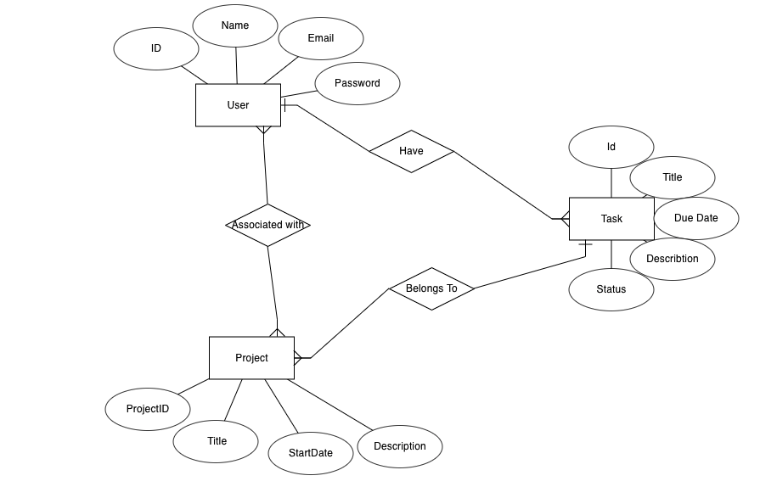

**USE CASE DIAGRAM:**

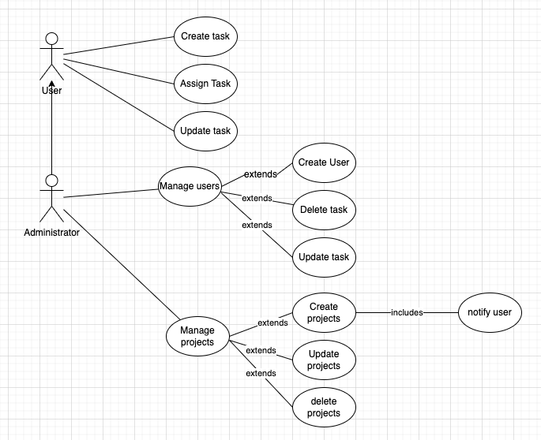

**Description:**

The "Assign Task" use case represents the functionality of assigning a task from a user to another user or a team within the task management application. This use case allows for effective task delegation and collaboration among users.

**Actors:**

* User (Initiating User)
* Administrator (Optional)

**Preconditions:**

* The initiating user must be logged in to the task management application.
* The initiating user must have appropriate permissions to assign tasks.
* The target user or team must be registered within the application.

**Flow of Events:**

* The initiating user accesses the task management application and navigates to the task they want to assign.
* The initiating user selects the "Assign Task" option for the desired task.
* The application presents the available options for assignment, such as a user or a team.
* The initiating user chooses either a specific user or a team as the assignee for the task.
* If the user chooses a specific user, the application validates the selection, ensuring that the assignee is a valid and active user.
* If the user chooses a team, the application verifies that the team exists and is an active team within the system.
* Once the assignee is selected and validated, the task is assigned to the chosen user or team.
* The application updates the task's assignment details, recording the assignee and the assignment date.
* If an administrator is involved, they may receive a notification about the task assignment for monitoring or auditing purposes.
* The assigned user or team is notified about the newly assigned task through system-generated notifications or email alerts.
* The assigned user or team can then access and manage the task within their task list or dashboard.

**Postconditions:**

* The task is successfully assigned to the chosen user or team.
* The assigned user or team can proceed with working on the task and updating its status as necessary.
* The initiating user and any relevant administrators are notified of the task assignment.

**Alternate Flows and Exceptions:**

* If the chosen user or team is inactive or invalid, the application displays an error message and prompts the initiating user to select a different assignee.
* If an administrator is involved, they may have the ability to override certain assignment restrictions or review and approve the assignment before it takes effect.
* This use case allows for efficient delegation of tasks within the task management application, ensuring that responsibilities are appropriately assigned to the relevant users or teams, facilitating collaboration and progress towards task completion.

**DFD0 diagram:**

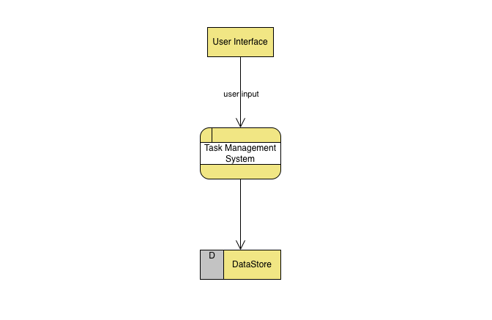

**DFD level 1:**

