The Birmingham-Dubai Digital Wall

Fundamentals of Software Engineering

2017-2018



Group Members:

Alan Lam (1451999) - axl499@student.bham.ac.uk

Ali Oztas (1851731) - axo731@student.bham.ac.uk

Ghaniya Bi (1237947) - gxb749@student.bham.ac.uk

Idowu Oniti (1749060) - iao760@student.bham.ac.uk

Sam Carr (1337987) - sxc392@student.bham.ac.uk

Irvin Ren(1824003) - xxr703@student.bham.ac.uk

**Table of Content**

**Scope of the System** **2**

1.1 Project Summary 3

1.2 Project Scope 3

1.3 Assumptions 4

**Functional Requirements** **5**

**Non-Functional Requirements** **8**

**Use Case Diagram** **9**

**Documented Use Cases** **10**

5.1 Use Case 1: Event Streaming and Playback 10

5.2 Use Case 2: SMS and Video Chat Service 14

5.3 Use Case 3: Campus Virtual Tours 17

**Activity Diagrams** **19**

6.1 Live 19

6.2 Playback 20

**Class Analysis** **21**

7.1 Noun-Verb Analysis 21

7.2 CRC Cards - Responsibility Driven Analysis 23

7.3 First-Cut Class Diagram 27

7.4 Class Diagram 28

**Object Diagram** **29**

**Sequence Diagram** **30**

**Architecture Choices** **32**

**Component Diagram** **36**

**Development Diagram** **37**

**Summary** **37**

**References** **37**

# Scope of the System

## 1.1 Project Summary

An interactive cloud based system that displays real-time content between the University of Birmingham Edgbaston and Dubai campuses on a multi-faceted digital wall that will be displayed in various locations on the campuses to encourage collaboration and communication.

## 1.2 Project Scope

The system will include several features to support all students, staff and visitors. All variations of the wall shall include the following:

* an interactive map of the campuses which can give directions and hints on major artefacts and traffic around campus
* a live feed comprising of all the social media content from all university related feeds, including societies and university partners and sponsors where relevant.
* The time across the multiple campuses and live weather updates, along with a 3-day forecast.
* Information on how to contact security, medical, finance, welfare and IT facilities and what each should be used for
* All variations of the system displayed on various locations throughout the campuses will be linked on a single network and be synchronised.

The system will include a variety of live updates from various media and social sources. This will be an interactive live feed, linked to social media accounts and will enable to publication of visual updates in the form of pictures and videos and will include the latest local news in collaboration with the redbrick and other university publications.

The system will provide virtual tours of the campuses and buildings once a week and be made available for instant play on the main wall in the Aston Webb Building and the main wall on the Dubai campus. Faculties can provide faculty tours and introductory videos using the same method on the walls located in specific schools. This enables all members and visitors of the university to discover the campus where ever they are. When using a mobile device, the system shall permit the use of VR technologies.

*The system will enable to live streaming of debate, public lectures and events on campus. This shall provide the ability to perform virtual lectures and classes, and the ability to teach a lesson simultaneously in both campuses and facilitate interaction with the audiences in both campuses.*

The system will be scalable and available on mobile devices (laptops, tablets and smartphones). On these platforms, the system will take advantage of student and staff information and input to provide a personalised wall.

The system will include the following as additional features on the mobile version:

* key information about the modules, courses, campus events and live news and weather updates.
* The ability to add, remove and change the content displayed on their wall
* Information on modules, lectures, lecture recordings and upcoming assignments or exams
* An SMS chat and discussion function to facilitate collaboration and communication.
* An account of their library record and a personalised list of relevant course readings
* Live updates from university mailboxes and the ability to notify students of incoming emails.

## 1.3 Assumptions

Single Sign On will be permitted when the system is used on a mobile device by a member of the university. This will need to the support and help of IT and security services to ensure it is safe and applicable on mobile systems

Applications and databases such as mybham, Limelight and panopto will compatible and accessible additional widgets for the application when used on a mobile device to enable the personalised view.

The date, time and weather will require support and attention from the School of Geography, Earth and Environment Sciences to collaborate and maintain the functionality on a consistent basis.

# Functional Requirements

Functional Requirements with Specifications:

1. The campus screen should show campus lectures
   1. It should show campus lectures from separate databases located in main campus and dubai campus
   2. It should show in sequence of first of time sequence, rolling fashion. The sequence of the same lecture between different subject should be according to alphabetical order of corresponding course name/subject name.
   3. The data should be refreshed daily from external sources, specifically, at midnight time when the screen is turned down.
2. The campus screen should show weather condition
   1. It should get real time weather data from major, reliable data source, such as weather.com or yahoo weather.
3. Virtual Campus Tours and Exploration
   1. Students are able to access virtual tours of all campuses
   2. Students should be able to select buildings they would like to explore from campus map.
   3. Students and visitors should be able to interact with the 3D virtual model of tour on the main wall
   4. The mobile version will be 2D only
   5. Students should be able to get hinted when there are major events happening in that building.
   6. Students should be able to go to the live stream of that events if there is video stream alive.
   7. It requires SSO authentication of students or staff’s identity before they start to explore the campus or an access code for visitors
   8. It should be synchronized with the university calendar to provide event information and locations
   9. Data should be refreshed daily from external sources at midnight time when screen is shut down.
4. The campus screen should show video/photos of students societies
   1. Photos should be showed in rolling fashion, the sequence should be in time series of the events, for the same events, photo should be showed in time series too.
   2. Videos should be short enough, put a limit of 5 minutes in length.
   3. Audio scream of the audio should be muted or very low to save power.
   4. Data should be refreshed daily at midnight time from external source.
5. Major notifications on campus screen
   1. If there is, please show separately. If there isn’t please make it disappear to save screen space.
   2. İt should always show days number of the week (i.e. “Week 6 12:00“).
   3. Data should be refreshed daily at midnight time.
6. Social media on campus screen
   1. twitter and facebook stream for major organizations in school, like guild, career center, data should be realtime.
   2. There should be ways to modify the source of these tweets by administrators after authentication.
7. Indoor screen linking to campus screen
   1. Indoor screen should have option to show campus screen in both campus.
   2. When the campus screen is turned off, user should be notified to stop.
8. Indoor screen of Visual Building exploration
   1. Students should be able to get hinted when there is major events happening in that building.
   2. Students should be able to go to the live stream of that events if there is video stream alive.
   3. It requires SSO authentication of students or staff’s identity before they start to explore the campus.
   4. Only one student can operate at a time.
   5. Students should be able to switch to a 2D version of the building map.
   6. Data should be refreshed daily from external sources at midnight time when screen is shut down.
9. Indoor screen of Visual library
   1. It requires SSO authentication of students or staff’s identity before they start to explore the library.
   2. Only one student can operate at a time.
   3. Students should be able to browse the bibliography of the library.
   4. Students should be able to check the storage of specific book.
   5. Students should be able to search the library based on book name, author or publisher and get the location of that book in library.
   6. Students should be able to browse the library storage by categories, subjects as real library
   7. Data should be as real time as possible.
10. Indoor screen of Major progress in research for specific school
    1. Should be in forms of short video stream completed by major contributors.
    2. The length of the video should be less than half an hour for each progress.
    3. Should be in time series.
    4. Data should be refreshed at midnight daily.
11. Indoor screen of Upcoming/Ongoing lectures
    1. İt should display the most recent lecture first, rolling in time series.
    2. İt should display career opportunities related to a specific school/department
    3. It requires SSO authentication of students or staff’s identity before they start to explore the lecture or event.
    4. Student should be able to watch the live stream if possible as the vitual building.
12. Extracurricular opportunities for a specific school
    1. Photos should be showed in rolling fashion, the sequence should be in time series of the events, for the same events, photo should be showed in time series too.
    2. Videos should be short enough, put a limit of 30 minutes in length.
    3. Audio scream of the audio should be muted or very low to save power.
    4. Data should be refreshed daily at midnight time from external source.
13. Private screen Linking to previous 2 groups of screens at anytime
    1. Students should be able to choose which screen to link to
    2. Students should search screens based on location, and school or department.
    3. Those 2 groups of screens should be read-only.
    4. It requires SSO authentication of students or staff’s identity before they start to explore other 2 groups of screens.
14. SMS and video chatting between private screen
    1. Should be real time SMS/Vıdeo chatting
    2. It requires SSO authentication to verify students and staffs’ identity.
    3. Should get agreement from both sides to add each other as contacts.
    4. Only contacts can communicate with each other.
    5. All university Services should have an automated system to log, allocate and respond to queries
15. Private screen should display timetable with locations
    1. Should be refreshed as real time as possible of upcoming lectures.
    2. It requires SSO authentication to verify students and staffs’ identity.
    3. Should be able to select to see the video stream of historical lecture.
16. Event Streaming and Playback
    1. All public events held on the university are able to be streamed live or after the event
    2. They should be recorded using a web based webcast
    3. All recordings should be saved and and stored in a depository
    4. Recording are given and title and categorised by type
    5. Playback is provided in High Quality and Standard Quality
    6. SSO authentication is required for students and Staff, and access codes are required from external viewers

# Non-Functional Requirements

Non-Functional Requirements with Specifications:

1. Campus screens only active from 6AM to 8PM and close to term time
   1. incorporate summer daylight saving
   2. should be closed in holiday to save power.
   3. The latency of Virtual Campus should be less than 1 second.
   4. The real time latency should be less than 30 seconds in weather forecast compared with data source.
   5. The latency of live video stream should be less than 1 minute.
   6. Data refreshment if necessary, should start at midnight 12AM and end before 6AM when the screen is turned on.
2. Indoor screen available except holidays
   1. incorporate summer daylight saving
   2. should be closed in holiday to save power.
   3. The latency of Virtual Building and Virtual Library should be less than 1 second.
   4. The real time latency should be less than 30 seconds in weather forecast compared with data source.
   5. The latency of live video stream should be less than 1 minute.
   6. Data refreshment if necessary, should start at midnight 12AM and end before 6AM when the screen is turned on.
3. Private screen available permanently.
   1. İt should be available on laptop as website, applications on mobile phone.
   2. When linked to other 2 groups of screens, latency should be less than 5 seconds.
   3. SMS chatting with other terminal should has less than 0.5 second delay.
   4. Video chatting with other terminal should has less than 0.5 seconds delay.

# Use Case Diagram

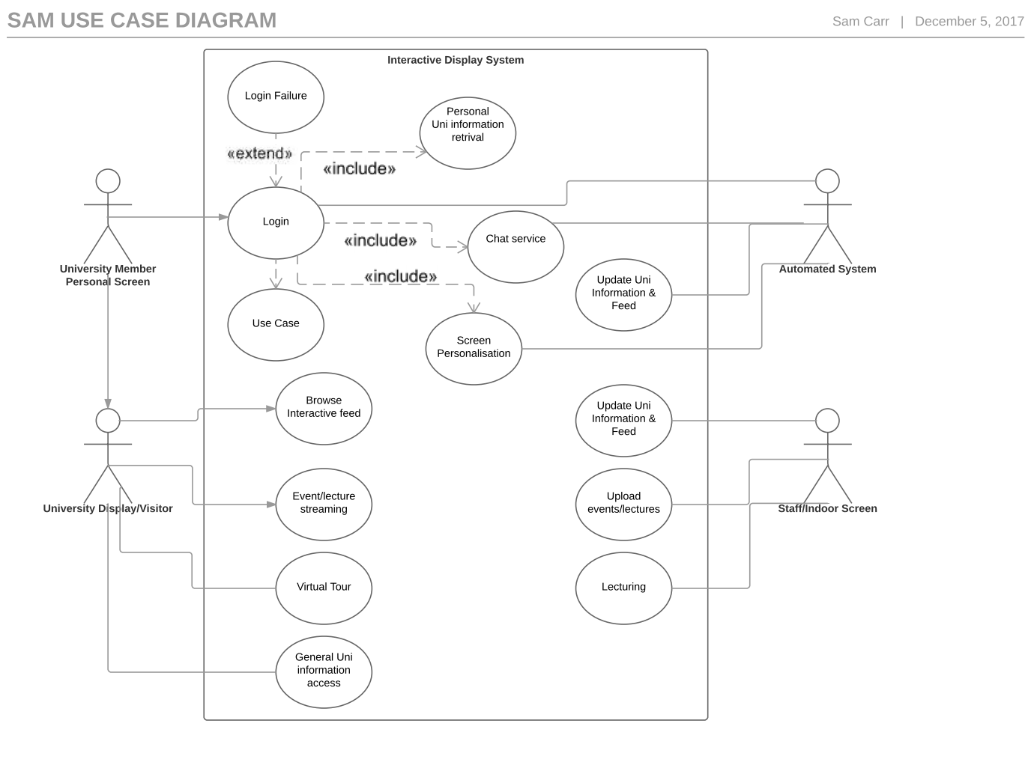

# Documented Use Cases

Three use cases have been chosen for further documenting, where we will detail the actors, preconditions, flow of events and postconditions. The cases to be documented are:

1. Event Streaming and Playback
2. SMS and Video Chat Service
3. Campus Virtual Tours

At the end of each section, we will provide a selection of non trivial scenarios for the use cases which describe a particular circumstance and the flow of events that follow thereafter within the system.

## 5.1 Use Case 1: Event Streaming and Playback

Case Description

Event Streaming encompassing guest talks, lectures and live sports and society events will enable users to access these events via the wall. It will enable the user to register and log onto live events from any campus, participate in discussion forums and access an event replay depository.

Actors

The primary actor in this use case is the Event Lead who initiates the process by activating the webcast on the panopto subsystem.

Secondary actors in this use case are the panopto subsystem which provides the webcast and event depository, the SMS Service which provide the event discussion forum and registered users (students and university staff) and unregistered users (visitors and alumni) who participate and interact in the with the system.

Preconditions

* The user must be registered to participate in the Live Stream
* The user must have a registered account or access code
* Users have access to Panopto Live Streaming and Webcasting
* The live stream is connected to a secure and stable network
* The user has access to the SMS chat function

Flow of Events

1. The use case starts when the primary User logs on to panopto
2. The User selects the webcast option
3. The panopto system produces a live stream of the event
   1. A link to the event is produced for access
   2. The system begins to record the event
   3. The User is notified that the event is now streaming live
   4. Registered users already logged in are added to the webcast
   5. The event discussion forum is activated by the SMS subsystem
4. The system updates and notifies registered users the event is now live
   1. The system sends an application notification to registered users
   2. The system sends an email notification to unregistered users
5. User logs onto the event
   1. Registered user logs into the event from the user’s’ events section
   2. Unregistered user logs into the event via an access code
   3. The User is notified on their display when a new user logs into the event
6. The system checks the code validation of unregistered users
   1. If the access code is invalid, the system will prompt the user to enter their name and email address
      1. The system sends the user a new code
   2. If the access code has timed out, the system will prompt the user to enter their name and email address
      1. The system sends the user a new
   3. If the code is valid, the webcast will open
7. The system displays the event and discussion forum
8. The User inputs text in the forum
   1. The User opens a poll
   2. The User asks an open question
   3. The User provides some event commentary
9. The SMS subsystem displays the information in the user’s webcast
   1. The user responds to the poll
   2. The user responds to a question
   3. The user asks a question
10. The event stream is ended
    1. The SMS subsystem saves the discussion forum
11. The panopto system saves the event to an event depository
    1. The User is prompted to add a title to the event
    2. The date, time and length of the event are updated by the system
12. The recording is displayed in the events replay section of the wall
13. The user selects the events replay section
14. The user selects an event recording
15. The recording of the event and the SMS forum are played

Postconditions

* The user has real time access to event streaming
* The user can participate in discussion during the stream
* The stream is saved into a replay depository
* The user has access to replays and the discussion forms in replays

Scenarios

Scenario 1: Vice Chancellor University Address on Main Wall

Professor Sir David Eastwood, the Vice Chancellor is presenting a talk on the University of Birmingham Dubai campus on plans to increase the degree offerings available in the location. The talk is to be streamed on the main wall on the Edgbaston and Dubai campuses. The Vice Chancellor initiates the stream by ensuring his microphone is on and presses start on the recording. The Webcast open for all users and is displayed on the main walls. Alongside the stream, the discussion forum is shown. The Vice Chancellor delivers his speech and it lasts for 30 minutes, before taking question from the crowd. After 15 minutes of Q&A the Vice Chancellor saves the recording and exits the video. The system prompts the Vice Chancellor to provide a name for his recording so it can be saved in the depository. The Vice Chancellor calls the recording “Dubai Expansion Talk”, and clicks on save. The talk is saved to the playback depository. The Head of the Business school would like to access the recording of the file as he missed it due to having a lecture. He want to access the recording on his mobile device. The system notifies the him that there is a High Quality and Standard Quality version of the file available for streaming, but it will adjust the quality of the playback dependent on internet speed.

Scenario 2: Accessing the a replay of an event

A student, Alan Lam in doing a semester on the Dubai campus for part of his course. He missed the live stream of the American Football Xplosion event on Friday due to family commitments and would like to watch the replay. Alan would like the discussion forum to be viewed alongside the video so he can read watchers comments as it adds to the atmosphere when watching games. Alan logs onto the Digital Wall mobiles application on his Macbook and is provided with his personalised wall. He navigates to the event replay depository in the top right hand corner of his screen and searches for the event by name. The event does not come up so he searches for the event by date and location. The system filters the events and provides Alan with a selection of events on Wednesday on the University of Edgbaston campus. Alan finds the event in the depository and presses play. The system opens the recording but the discussion forum is hidden. Alan clicks on the toolbar and selects “show discussion forum”. The forum displays the information alongside the feed and it updates as the video plays, showing the comments in real time alongside the replay.

Scenario 3: Guest Lecture from Dubai campus being live Streamed

Rami Maleek, a PhD researcher of neural networks is providing a lecture at the University of Birmingham Dubai campus on the power of neural networks and how we can used them to build more intelligent systems. Before Rami begins his lecture, he logs onto panopto and begins the live webcast. The system notifies Rami that the stream is live and displays information on the number of people currently viewing the event. After 20 minutes explaining his research, Rami asks the viewers to vote yes or no on whether they have learned something new about neural networks, and would consider being a part of his research project. 73% say yes 27% say no. Rami thanks those in attendance and provides his contact details in the discussion forum. Rami then ends the recording. The systems saves the recording and prompts Rami to provide name for the recording. Rami names the recording “Are Neural Networks the future of intelligent systems” and clicks on save. The system auto updates the time, date and length of the recording, and saves it to the recording depository.

## 5.2 Use Case 2: SMS and Video Chat Service

Case Description

The SMS and Video Chat service will enable users to communicate via SMS and Video services between Dubai and Birmingham and on the same Campus.

Actors

The primary actor in this use case registered users who initiate the process by opening a chat with another registered user.

The secondary actors in this use case are University Services, who provide communication services for registered users and the university email system, which links all accounts to a university email address and load the information

Preconditions

* The user has a mobile device with the wall application
* The user has a registered account
* The user is connected with the user they communicate with
* The user can communicate with University services without a connection

Flow of Events

Flow 1:

1. The use case starts when a user opens a chat with another user
2. The university email system displays the user’s information in a chat window
3. The system checks the status of the user to see if they are online
   1. If the user is online, the system displays this status
   2. If the user is offline, the system displays the last seen time and date (if the last seen is not on the same day)
4. The user sends a message
   1. If it is a video call, the user sends a video call
   2. If SMS message, the sent message is displayed in the chat window
5. The receiving user is notified of the message
   1. The user will be notified of the call
      1. If the user accepts the call, a live video call will take place
      2. If the user rejects or misses the call, a notification will be sent to the sending user
   2. The user is notified of a SMS message
6. The user reads the message
7. The systems updates the user’s status
8. The user responds the the message

Flow 2:

1. The use case starts when a user initiates a chat with a university service
2. The system displays a chat window
3. The user sends a message
   1. The systems notifies the university service of the message
   2. The university services receives a copy of the message on its email account
   3. An enquiry case is opened in the university service system
4. The university service views the message
5. The university services responds to the message
   1. The university service sends a prompt message asking if this solves the issue
6. The system updates the user’s chat display
7. The message is shown to the user
   1. The enquiry case is closed if user selects the response yes
   2. If the response is no, the user goes back to step 3

Postconditions

* The user can send messages in real time
* The user can access the other user’s profile
* The users can engage in a live video call
* The user can communicate with university services

Scenarios

Scenario 1: Video call between 2 users

Janet, an IT services member of staff in Dubai would like to call Tamara, an IT services member of staff on the Edgbaston campus to discuss how to fix an application problem she is having. Janet has decided to use a video call so she show Tamara the problem and they can solve it by talking through it. Janet logs onto the wall and locates the messenger service on her wall. She searches for Tamara within her contacts and the system states that Tamara is currently online. Janet initiates a video call. Tamara receives the call and decides to accept it. The application opens the video window and enables the two to view each other and the problem they are trying to solve. Halfway through the call the video image quality begins to blur due to connectivity issues. Tamara decides to adjust the video quality to convert the video to SD rather than HD to match the current connection speed. The video player converts the video to SD for both users and presents an unbuffered video stream.

Scenario 2: SMS chat between with university services

Charlotte would like to know what times the library is open during the Christmas Holiday. Charlotte logs onto the wall and uses the email search function to find the the library services account. Charlotte selects the account. The system states that the user is a service. Charlotte poses a question to the services, asking what time it is open over the holidays. The system notifies the library services desk that a message has been sent and sends them an email of the message. Alongside this, a customer enquiry case is opened. The person currently in charge at the library service desk locates the information and provides the information to Charlotte and a prompt to Charlotte asking if she requires further information. Charlotte is satisfied with the information she has been provided and states she does not requires any further information. This results in the enquiry case being closed on the university services system.

## 5.3 Use Case 3: Campus Virtual Tours

Case Description

Campus Virtual tours allow users to access virtual tours of the Campuses in Dubai, Selly Oak and Edgbaston, and provide real time updates of ongoing events and places of interest at various places on campuses.

Actors

The primary actor in this use case is an account holder who initiates the process by signing onto the app. In this case, the account holder can be a registered user/ or a user who has an access code.

Secondary actors in this use case are the mapping system which updates maps to reflect the layout of campus and places of interest on a weekly basis and the university events calendar subsystem, which provides time, date and location information for the tour and central university calendar

Preconditions

* The user has a mobile device with the wall application
* The virtual tour is visible on the wall landing page
* The user has a registered account or an access code
* There is real time information and video of the current campus map
* Live Streams and places of interest are highlighted

Flow of Events:

1. The use case starts when the primary user signs into the system and is shown the main wall
   1. A registered user signs in by using their account details
   2. An unregistered user signs in by using an access code
      1. If the access code is invalid, the system will prompt the user to enter their name and email address
         1. The system sends the user a new code
      2. If the access code has timed out, the system will prompt the user to enter their name and email address
         1. The system sends the user a new
      3. If the code is valid, the wall will open
2. The system displays the mobile version of the wall
   1. The system displays the personalised wall of a registered user
   2. The system displays a wall relevant to the purpose i.e. open day
3. The user selects the virtual campus tour
4. The system displays virtual tour options
5. The user selects the campus
   1. The user selects the University of Birmingham Edgbaston campus
   2. The user selects the University of Birmingham Selly Oak campus
   3. The user selects the University of Birmingham Dubai Campus
6. The system prompts the user to select a starting point
   1. The user selects a specific location
   2. The user selects their current location
7. The system updates the starting point and displays the tour route
8. The system provides a tour of campus
   1. Information is provided when events are in the area
   2. Information is provided on places of interest around university

Postconditions

* The user has the option to go on a virtual tour of the campus
* The user is provided real time information of what events are going on in the area
* The user is provided with information on areas of interest

Scenarios

Scenario 1: Virtual Tour access via an access code on an open day

Kyle is attending an open day at the University of Birmingham Edgbaston campus and has been provided a code to access the wall application so he can access the open day wall. As part of the wall, there is a virtual tour of the campuses. The systems prompts Kype stating the code that he has entered is invalid. A message is shown on screen asking Kyle to provide his name and email address so the system can check if he is registered for the open day. Kyle enters his information is is emailed a new code. Once he obtains the code, he enters the code onto the app is is provided access to the wall. Kyle would like to know more about campus and opts to take a virtual tour of the Edgbaston campus, which is located on the landing page of the wall. Kyle is currently at the Sports and Fitness Centre. The application prompts Kyle to choose a start location. Kyle chooses his current location of the Sports centre. The virtual tour begins to guide Kyle around campus. As Kyle walks past the Aston Webb building, he is notified that there is a “how to be prepared for university” talk at the university currently taking place. As he continues on his tour, he is notified of events currently taking place in the Business school.

# Activity Diagrams

## 6.1 Live

Activity diagram describing the live event video streaming scenario.

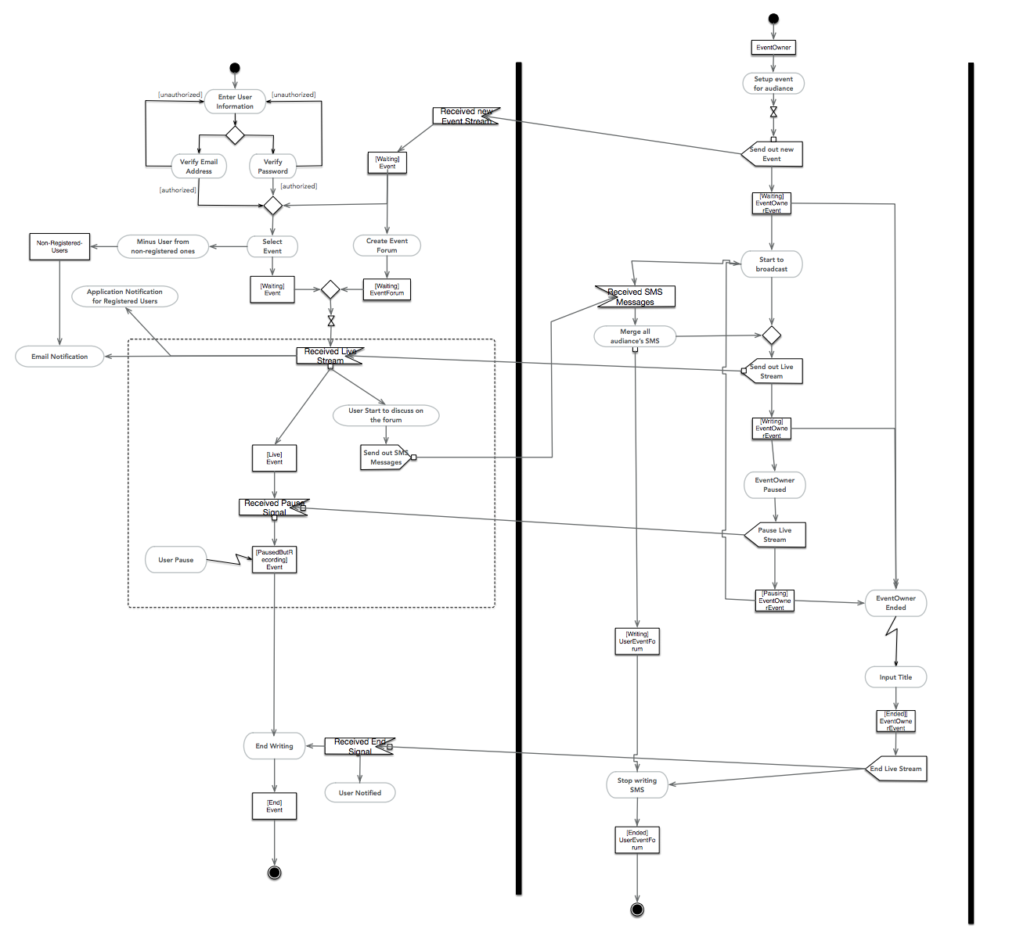

## 6.2 Playback

Activity diagram describing the playback scenario of historical events.

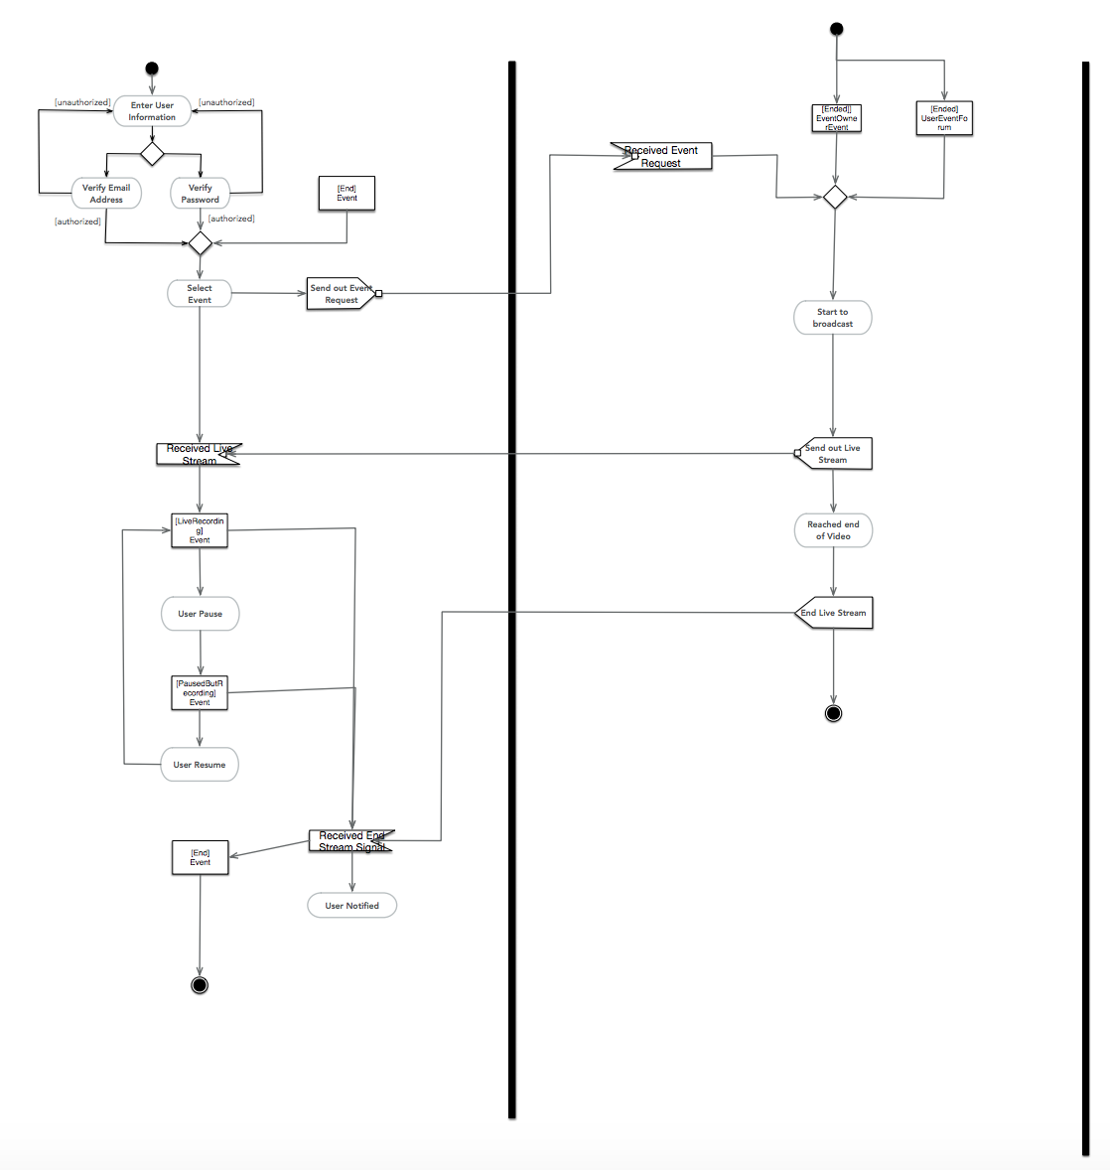

# Class Analysis

## 7.1 Noun-Verb Analysis

To specify the candidate classes and methods, noun/verb analysis is performed to functional requirements. Candidate classes and methods are shown in the following tables as the methods will be explained further.

**Candidate Classes**

|  |  |  |
| --- | --- | --- |
| Screens | PrivateScreen | IndoorScreen |
| CampusScreen | Lecture | Student |
| Staff | Building | Room |
| Library | Chat | Video |
| Timetable | SMS | User |
| VisualExploration | Department | Time |

Chat, SMS and Video are not going to be defined as classes since they are going to be applications. VisualExploration is not needed as a class since it is going to be a function to start the exploration or to see the library.

**Candidate Methods**

|  |  |  |  |
| --- | --- | --- | --- |
| **showScreenTitle()** | To show the title | **showIndoorScreen()** | Accessing indoor screen from private screen. |
| **showCampusScreen()** | Accessing campus screen from private screen. | **isAuthenticated()** | To check if the user is authenticated. |
| **login()** | To login. | **startVisualExploration()** | To start visual exploration. |
| **getLectures()** | Getting lectures for related room. | **getStudentTimetable()** | To get the student’s timetable with locations |
| **getTeacherTimetable()** | To get the teacher’s timetable with locations. | **getBuildingName()** | Getting building name for visual exploration. |
| **getRoom()** | Getting room name for writing the timetable and for exploration. | **getRoomTimetable()** | Getting the corresponding timetable for the room. |
| **getNotifications()** | Getting notifications for campus screen. | **getTime()** | To display the time as “Week 7 Thursday 1:00PM” |
| **showSocieties()** | Displaying videos and photos of societies. | **showVisualLibrary()** | Displaying the visual library. |
| **openChatSystem()** | To start the chat system from the private screen. | **showVisualLibrary()** | Showing the visual library to private screen. |
| **getWeather()** | To display the weather condition. | **getSocialInput()** | To display the social media input. |
| **createAccount()** | To create an account to have a private screen. | **displayMap()** | Displaying map in CampusScreen. |
| **getUserClass()** | To determine whether a student or a teacher has logged in. | **register()** | To register a user with a username and a password |

All methods are selected and will be used in the class diagram.

## 7.2 CRC Cards - Responsibility Driven Analysis

Responsibility driven analysis is done with information learned from noun/verb analysis and functional requirements. This will help to understand the relationship between classes and responsibilities of the class.

|  |  |
| --- | --- |
| **Screen** | |
| **Responsibilities** | **Collaborators** |
| The responsibility of this class is to have a general class for screens and having the general methods which will be on all of them. | PrivateScreen  IndoorScreen |

|  |  |
| --- | --- |
| **PrivateScreen** | |
| **Responsibilities** | **Collaborators** |
| The responsibility of this class is to show how the private screens will be shown for different classes of users. | Time  User  Lecture  Timetable |

|  |  |
| --- | --- |
| **IndoorScreen** | |
| **Responsibilities** | **Collaborators** |
| Responsibility of this class is to show how the indoor screens will be displayed and what methods will they have. | Room  Lecture  User |

|  |  |
| --- | --- |
| **CampusScreen** | |
| **Responsibilities** | **Collaborators** |
| Responsibility of this class is to show how the campus screens will be displayed and what methods will they use. | Time |

|  |  |
| --- | --- |
| **Lecture** | |
| **Responsibilities** | **Collaborators** |
| Responsibility of this class is to have the lectures of a User or have the lectures in a Room of a Building in school. | Timetable  Room  Building  Student  Teacher |

|  |  |
| --- | --- |
| **Student** | |
| **Responsibilities** | **Collaborators** |
| Responsibility of this class is to define which user is logged in to the private screen and getting the related information for them such as lectures and timetables. | Timetable  Lecture  User |

|  |  |
| --- | --- |
| **Staff** | |
| **Responsibilities** | **Collaborators** |
| Responsibility of this class is again to define which user is logged in to the private screen and to display corresponding screen with related information on it. | Timetable  Lecture  User |

|  |  |
| --- | --- |
| **Building** | |
| **Responsibilities** | **Collaborators** |
| Responsibility of this class is to make certain which building is going to be explored in the virtual exploration and to have an ordered list of rooms for each building. | Room |

|  |  |
| --- | --- |
| **Room** | |
| **Responsibilities** | **Collaborators** |
| Responsibility of this class is to show the upcoming or ongoing lectures and timetable of the lectures on Indoor screens. | Lecture  Timetable  IndoorScreen |

|  |  |
| --- | --- |
| **User** | |
| **Responsibilities** | **Collaborators** |
| The purpose of this class is to have a general class for users which will be students and staff and to have general methods which will be used in both. | Student  Staff |

|  |  |
| --- | --- |
| **Timetable** | |
| **Responsibilities** | **Collaborators** |
| Responsibility of this class is to have the list of timetables with locations to the related object which may be student, teacher or room. | User  Room  PrivateScreen  IndoorScreen |

|  |  |
| --- | --- |
| **Library** | |
| **Responsibilities** | **Collaborators** |
| **Responsibility of this class is to have a class which will have the books with their names, prices and dates.** | **PrivateScreen** |

|  |  |
| --- | --- |
| **Department** | |
| **Responsibilities** | **Collaborators** |
| Responsibility of this class is to have the department and the year of the user to display corresponding timetables of the user. | User  Timetable |
| **Time** | |
| **Responsibilities** | **Collaborators** |
| Responsibility of this class is to have the time which is going to be displayed in all the screens. | Screen |

## 7.3 First-Cut Class Diagram

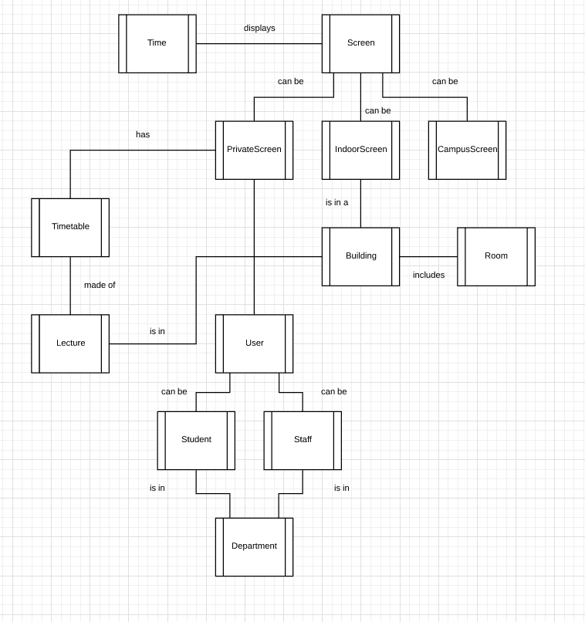

## 7.4 Class Diagram

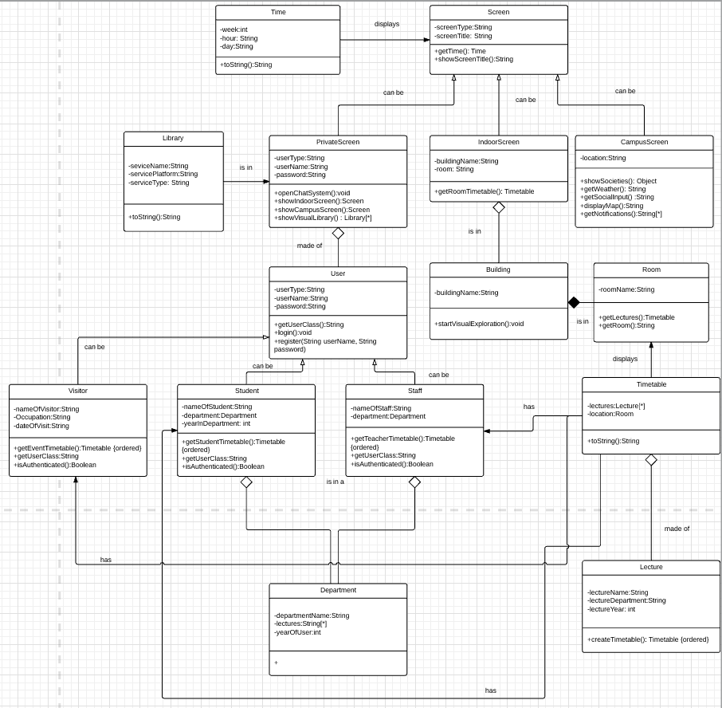

# Object Diagram

The object diagram below depicts Use Case 1 Scenario 2, where a student named Alan Lam wants to watch the xPlosion event replay through his macbook using the university system.

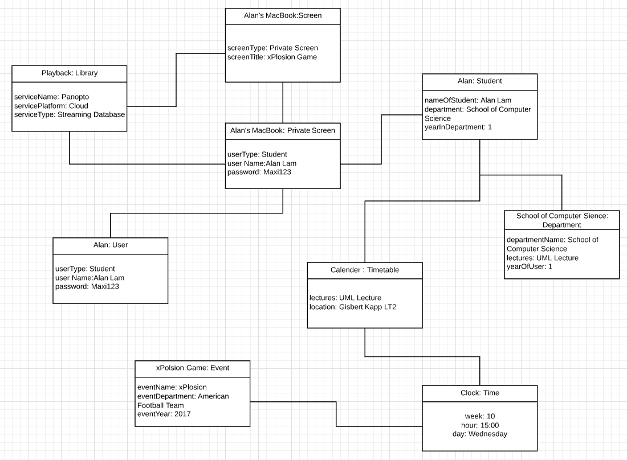

# Sequence Diagram

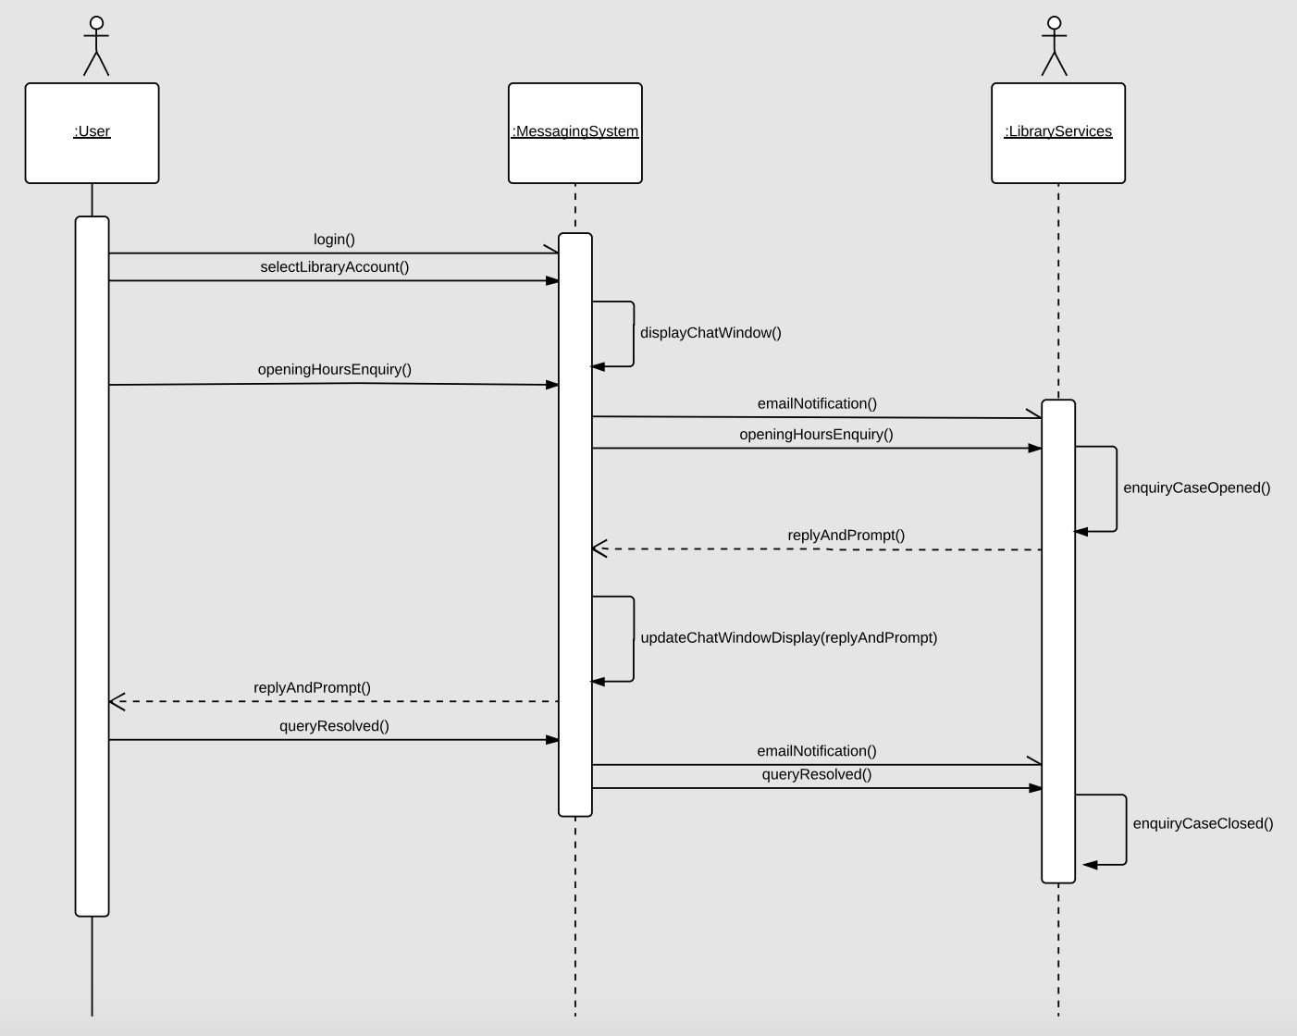

1. **State Diagram**

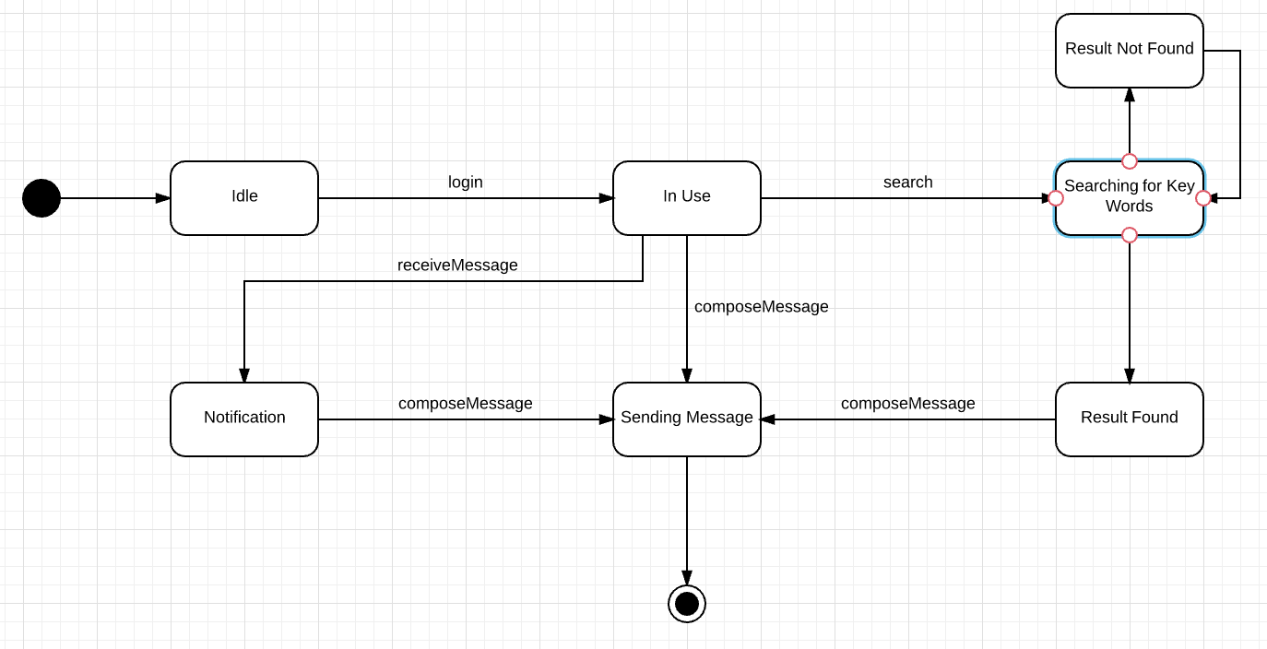

# Architecture Choices

Before we create our deployment and object diagram, we must first decide on the software architecture that will be used to structure the system. From our research, we have decided that the two architecture models that would be best suited to the system are Service-Oriented Architecture (SOA) and Model-View-Controller Architecture (MVC). During this section, we will analyse the strengths and weaknesses of each architecture model, followed by a conclusion of our chosen architecture.

Service-Oriented Architecture

The first architecture model considered for modelling our system is Service-Oriented Architecture (SOA). According to Sommerville (2009), SOA is a architecture model for application systems in which services are structured in a self-contained manner. These services can communicate with each other over a network, sending requests and invoking responses from one another, with the communication being understandable and translatable by the services communicating.

One clear benefit of this model is the idea of services being designed and deployed in the system which are able to function individually, but also communicate with other services which provide differing functionality. This presents an element of availability and modifiability to the system as you are able to modify standalone services without changing or taking other services offline. Other Benefits of SOA include:

* Reuse - Code and services are reusable as they are assembled independent of one another, and can there be used in other applications to aid communication with other services. This makes the model more efficient as it is possible to replicate work done across multiple services with existing work.
* Interoperability - Through the enables of independent services to communicate through a multi tiered architecture, SOA increases interoperability between the services, both realised and potential, that can be integrated and communicate on the platform. This is a key benefit of SOA as it enables developers will be able to analyse services as in a silo and analyse how to interoperate and communicate with them without having to worry about the additional complications that are attached to more multiple services in one component
* Scalability - SOA enables applications to have a maintainable and manageable list of services and applications that can be efficiently scaled to meet the volumes and demands of the system.

However, the SOA model is not without fault. Weaknesses of this model include but are not limited to:

* Complexity - A complex system and communication and data transfer protocols are required to ensure multiple services can continue to interact and exchange information with one another over a network. This may be hard to achieve and maintain in the long run, especially without the right skills and staff to manage and understand the architecture of the system,
* Maintainability - As more services are added to the system or application, the number of interactions and flows of information increase. Although beneficial in large systems, this increases the amount of data and information being processed by services, which will require more CPU space, bandwidth and/or more complex processes to manage the exchange of information and the data transactions, making larger systems harder to maintain. However, this can be somewhat mitigated through the provision of services through cost effective platforms such as SaaS.
* Security - Compared to rigid architectural models. SOA functionality is segmented intro various separated components and services, resulting in it being both time and cost effective to ensure all the services within the accessible within the architecture have the same level of security and encryption. This presents problems services of differing security levels communicate with each other, and could lead to some services not being able to communicate with each other, particularly where one contains information deemed personal or sensitive.

Model-View-Controller Architecture

The second architecture model considered is Model-View-Controller (MVC). MVC is a multi tier software paradigm. According to Sommerville (2009), MVC is an architectural design pattern that separates data, presentation and system interaction. For MVC, model represents the data and operation of said data. This data is translated into a view, which is adaptable for the user, enabling the data to be presented to the user in their desired format. The controller input allows the user to interact with the data and passes messages to model and view.

One clear benefit of a model such as this one is the separation between the data inputs, the user interface and the user's actions. This enable flexibility as the various elements are separated and do not have an over reliance on the other tiers. Consequently, the various tiers are able to adapt to various formats and types (of data and user input).

* Data Exchange and Layer independence - One of the key benefits of this system is the indepence of data exchange between the data itself and its representation. This enable to data to be presented in a manner that suits a user preferences. An additional feature of independence within this software model is layer independence. In theory, the separation of model, view and controller create three independent layers of architecture which data can be communicated through. This division leads to a separation of concerns, meaning concerns on one layer can be dealt with without harming the performance of another.
* Supports Multiple Presentation views - Due to the advantages explained above, this method enables the data to be presented in multiple ways. This is a key benefit of the system, which enable systems to suit user preferences. Employing MVC offers benefits for software systems dealing with a range of data model objects that the user can manipulate using an interactive interface. (Holzinger et al, 2010). An additional benefit is that changes made at the controller or data level will be translated to the presentation level despite the differentiated view presented to the user.
* Code and Component Reuse - When using MVC, data is exchanged between the various levels without formatting changes being applied, enabling the same components and code to be reused and called for within any any interface within the system. This is beneficial for building new components and classes within the system.

However, there are also several disadvantages to using to using MVC such as:

* Complexity - One drawback of MVC is complexity. This is a result of additional and complex code being required for simple interactions, therefore being time and and cost intensive for minor system improvements (Sommerville, 2009).
* Scalability - Although MVC supports the multiple ways of presenting information to the user, a recent criticism of the method is that you need to mutate the entire application state to enable scalability of a system or application. This is particularly disadvantageous for modern technologies, in which many systems, and in particular applications, are scalable to large devices such as PC’s and TV’s, and smaller more mobile devices such as tables and mobile phones.
* Cost of Frequent Updates - An additional disadvantage of MVC is the cost of frequent updates to the model. In situations when the model aspect of an MVC system needs updating, which is common in modern systems in applications, frequent changes lead to views being flooded with application and system update requests. Although beneficial, this contradicts the separation of concerns and puts the system or application at risk if critical updates are not accepted by the controller.

Following the evaluation of the SOA and MVC architecture models, we have concluded that the SOA will be our chosen architecture model. As shown in our evaluations, and considering key factors such as maintainability and scalability, we believe that this model offers the main benefits that will be beneficial to base our design on. In regards to MVC, it become hard to use this model given the scalability issues that arise when scaling applications, which is a fundamental requirement of the system.

# Component Diagram

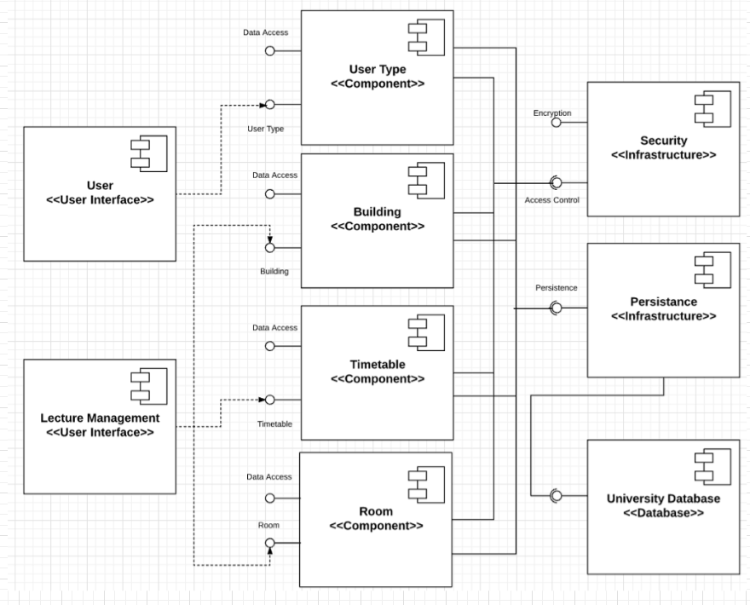

# Deployment Diagram

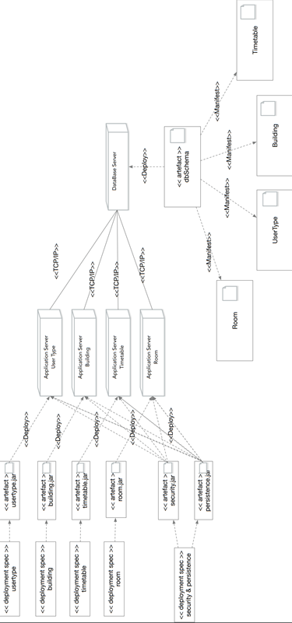

# Summary

The project is based the requirement that new Birmingham-Dubai Digital Wall that displays real-time content from both campuses. In this project, we designed Event Streaming function, which encompasses guest talks, lectures and live sports and society events. it will enable users to access these events via the wall. We also included the software architecture design and the hardware architectural design including the deployment of new codes in production environment.

In the project, 6 team members are all involved and cooperated in a very short time window. The outcome couldn’t be called perfect, but it included intelligence from every team member.

The contents we learnt from the class was implemented in this project, which enabled us to get better understanding of how software was built. The process of evolutionary development was implemented in the design process. It is very important to do timely communication between team members so each part of the UML diagrams would stand for excellent outcome.

It wouldn’t be such a complete project if any of team members was absent.

Still, since the short time window, it wouldn’t be perfect project. There is no implementation of the project, all the software and hardware design is just conceptional. It would meet a lot of unexpected problems in implementation in reality. But we have tried our best to figure them out as much as we could in the early stage to reduce the risk of design failure.

Through this project, we have learnt a lot. It was an interesting and tough job. We are very eager to learn more knowledge and utilize them to produce high quality software designs and implementations in the future.

# References

(Ashraf et al, 2016), Ashraf, D., Farrimond, R., Ghazanfar, M. and Stuber, J. BookMeHolidays Advertisement Subsystem. 9th December 2016.

[Accessed Online on Thursday 7th December 2017 via]:

(Holzinger et al, 2010), Holzinger, A., Struggl, K.H. and Debevc, M. Applying Model-View-Controller (MVC) in design and development of information systems: An example of smart assistive script breakdown in an e-Business application. ICE-B 2010 - Proceedings of the International Conference on e-Business, 2010, pp.63-68.

[Accessed Online on Thursday 7th December 2017 via]:

* <http://ieeexplore.ieee.org/stamp/stamp.jsp?tp=&arnumber=5740449>

Sommerville, I. (2011). Software engineering. 9th ed. Boston: Pearson