REAL-TIME SALES PERFORMANCE DASHBOARD

Power BI Internship Project Report

Name: SMD ALI PEERULLA
Role: Power BI Intern
Company: CODTECH
Course: BTech

1. Introduction
This project was developed during my internship at CODTECH to demonstrate skills in data analytics, data visualization, and business intelligence using Power BI.

2. Objectives
- To build interactive dashboards
- To integrate multiple data sources
- To simulate real-time data updates
- To use Python for advanced analytics

3. Task 1: Sales Dashboard
A comprehensive dashboard was created to visualize sales performance across different categories, regions, and time periods.

4. Task 2: Data Integration
Data from multiple sources was combined and relationships were established using Customer_ID to create a unified data model.

5. Task 3: Real-Time Dashboard
Dynamic measures were created using DAX functions like NOW() and RANDBETWEEN(). Auto-refresh was enabled to simulate real-time updates.

6. Task 4: Python Integration
Python scripts were used within Power BI using pandas and matplotlib to create custom visualizations.

7. Tools & Technologies
- Power BI
- DAX
- Python (pandas, matplotlib)
- Excel

8. Key Insights
- Clothing category has highest sales
- North region performs best
- Returning customers contribute more to revenue

9. Conclusion
This project enhanced my practical knowledge in Power BI, data modeling, and real-time dashboard development
IMAGES:
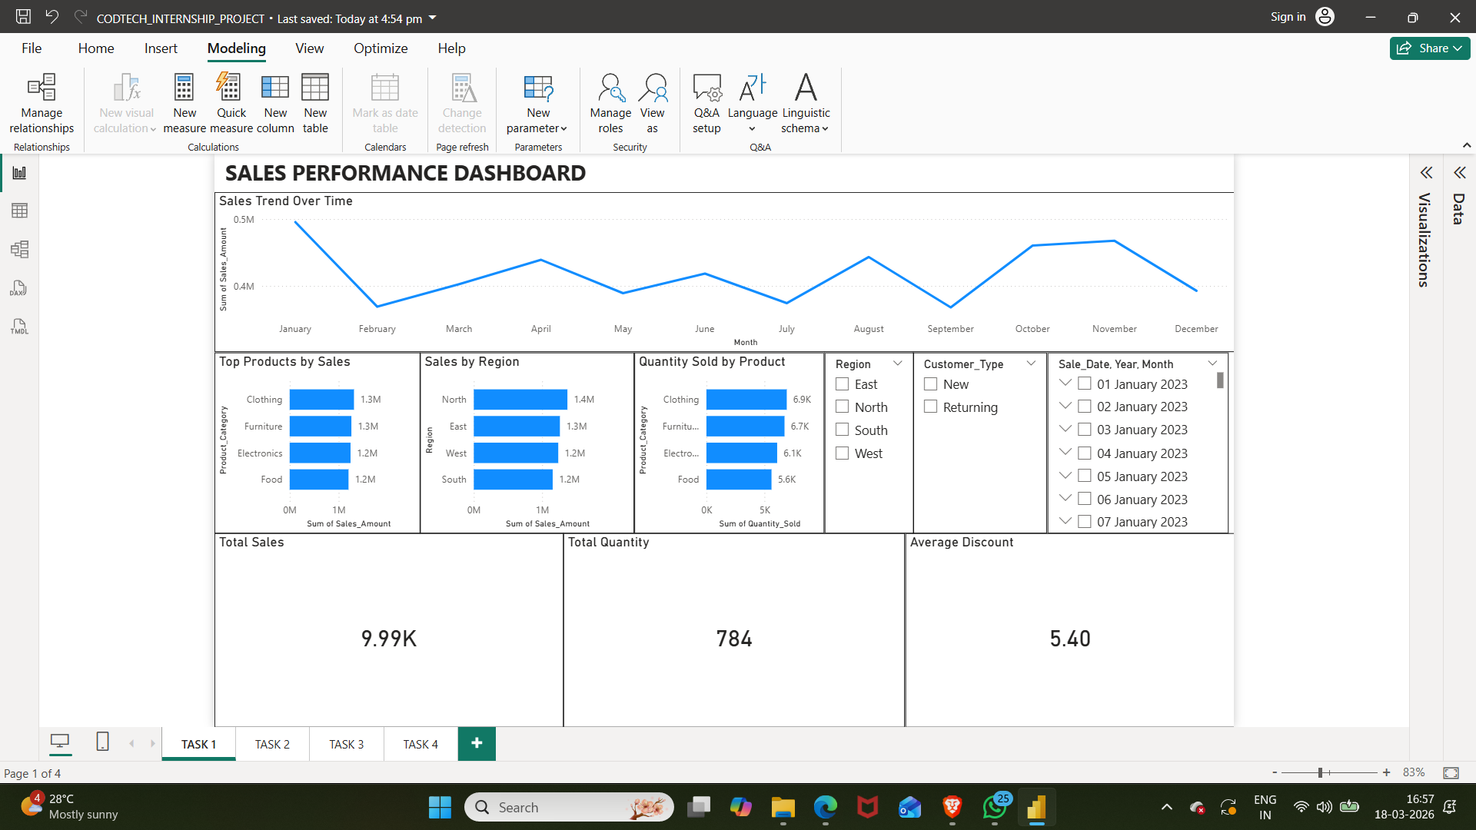
TASK 1
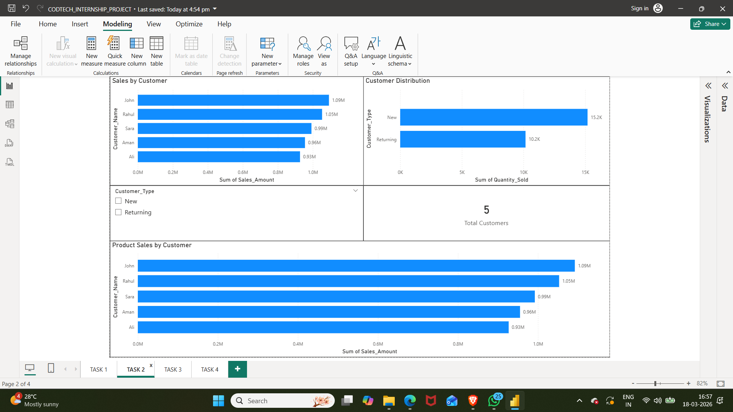
TASK2
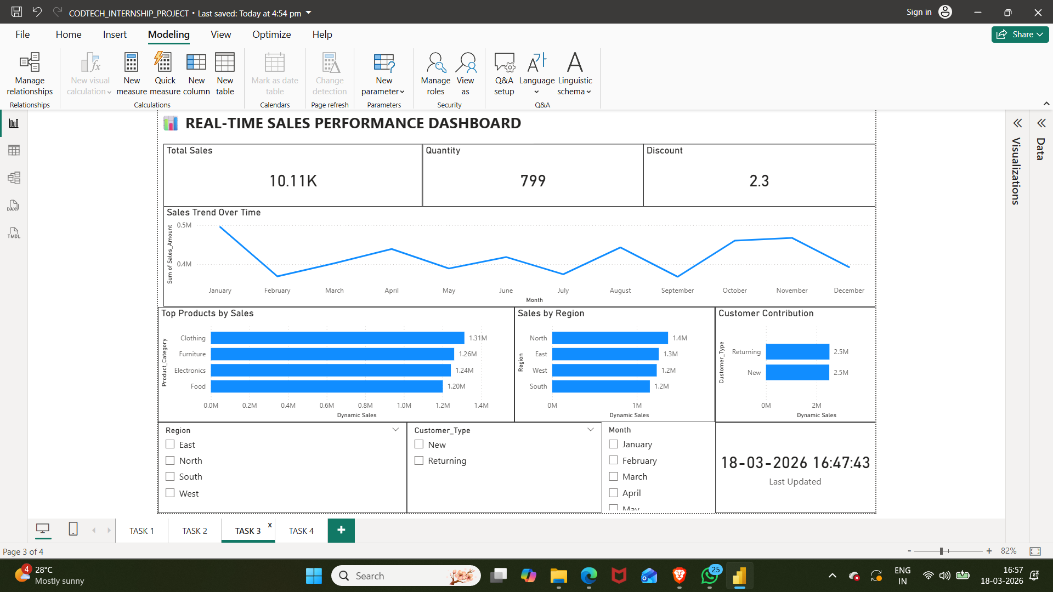
TASK 3

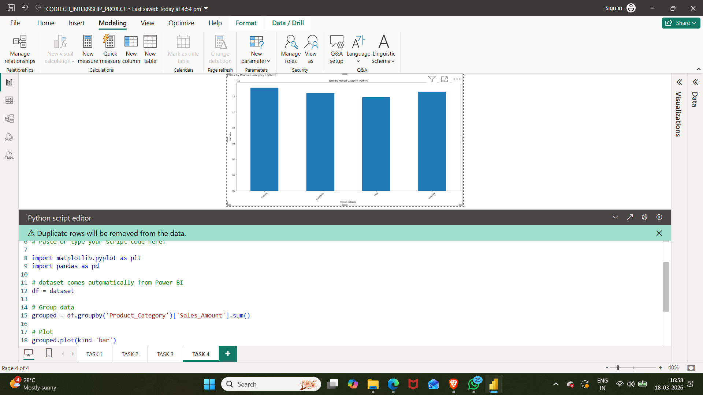
TASK 4

