

**BBM473 PROJECT REPORT**

**HACETTEPE UNIVERSITY**

**COMPUTER SCIENCE AND**

**ENGINEERING DEPARTMENT**

**Name and Surname**

Ali Peker

Rabia Ayar

**Identity number**

21427291

36170506

**Course**

BBM473

# E-Mail

[ali.peker@hacettepe.edu.tr](mailto:ali.peker@hacettepe.edu.tr)

[rabiayar@gmail.com](mailto:rabiayar@gmail.com)

# 1 Project Defination

This Project is goal to create an electronic library web site. Users who want to provide from this site can use online this platform.

Some Technologies as Oracle, Php, Bootstrap were used while creating this website.

Applied These Facilities:

-Users of different authority can login and logout.

-Users who have authority can add items, users, books, wallpapers, caricatures, authors, publishers and addresses.

-Users who have authority can change attributes of items, users, books, wallpapers, caricatures, authors, publishers and addresses.

-Users who have authority can delete items, users, books, wallpapers, caricatures, authors, publishers and addresses.

- Admins or normal users can see the history of processes they had done.

-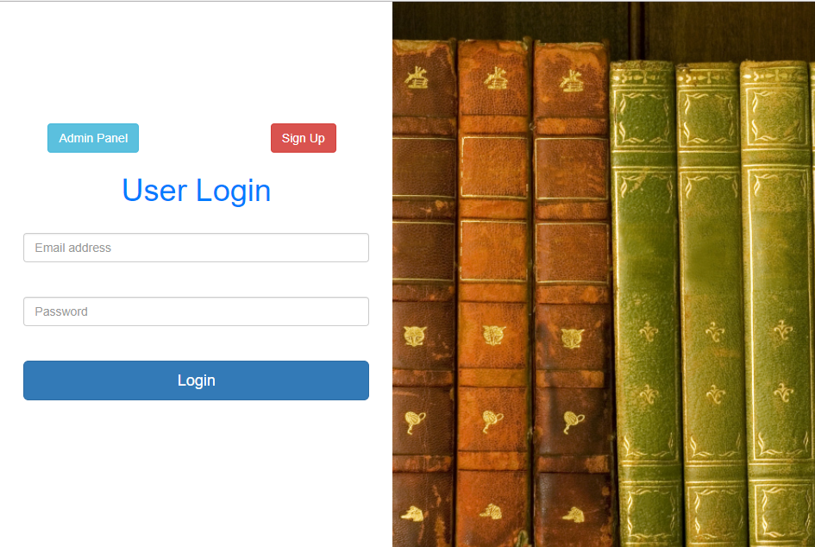

It gives to some users who were regeistered to site upload/download book, caricature, wallpaper.