**CSE 333 OPERATING SYSTEMS PROJECT 1 REPORT**

Tuncay Türk 150111043

Mustafa Necati Özdoğan 150112076

**Q1)**

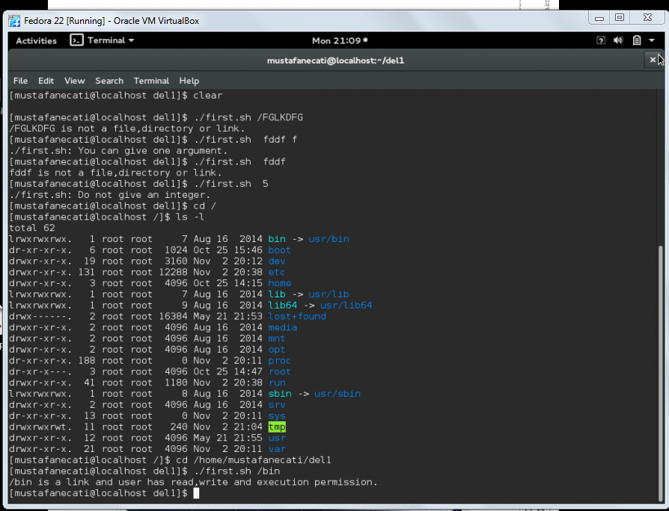

In that question, we determine some important dots when the problem is being solved:

-Prompt proper inputs to find desired file,directory or links : We used $1 variable to handling prompted input.

-Use of "cd $var 2</dev/null":It provided us interrupting displaying "No such a file or a directory" we determined whether input is suitable or not by return value this statement.0 indicate input is directory 1 indicates input is not directly directory but it can be file,link or nothing.We get directories possible file or links by "dirname $var"

-Warn nonproper inputs:We placed if statements to forbid wrong inputs

-Access file,directory and links under root:There was big problem when we place output file in proper input directory is caused that terminal do not access any desirable root or "/" inputs.Therefore we placed output file as in directory "/home/user/output.sh" to access more efficiently.

-Writing list of file,directories or links of upper directory of proper input to a output file and reading and controlling from file to knowwhether desired input f,l or d exist.

**Q2)**

It name is myprog2. This example is finding maximum number in fedora.

Yo want us such as; enter the numbers as you want and is you enter the “end” key ,program must be exit and print screen maximum number. Firstly we enter the first number and identified maximum number.

We use to read function. “”read number”” “”maxnumber=$number”” There is a while loop for if user enter the end key . “while [ "$number" != "end" ] “” we use four if conditions to error massages. When returns error masseges in this conditions. ?

if you enter the string or invalid values , program must be error massages. “”echo "Opps! $number is not number”"

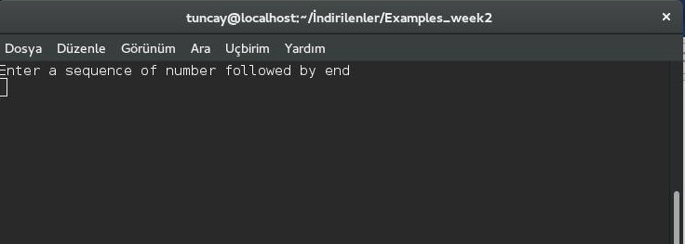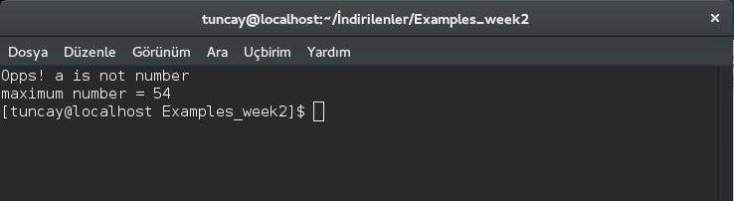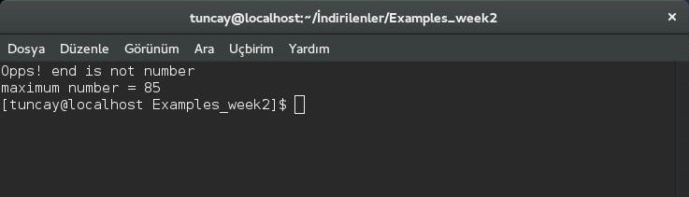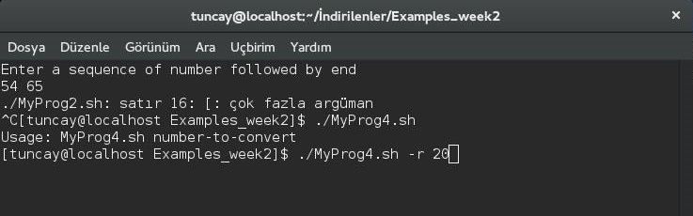

**3)**

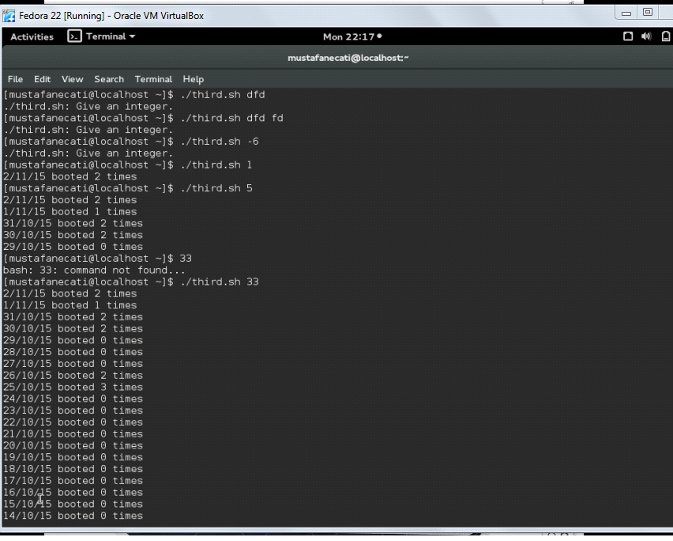

Third question have important topic is make relation between the numeric form with name of months we provided that case-switch.

Case-switch is provided also is that holds previous month maximum nmber of day.

We are careful about discriminating days and month regularly.

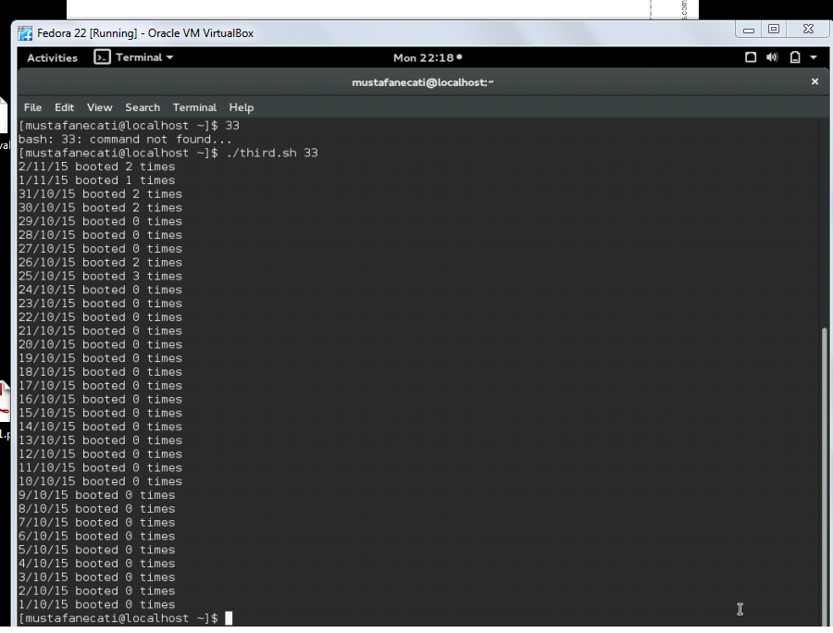

**4)**

It name is myprog4. It aims that converts from alphabet to number . Firstly we identified LIMIT for input .

“LIMIT=29” Then we use to if conditions for input, users do not enter the empty input. “”İf [ -z "$1" ]””

We use for loop to how many enter the integer for convert.,but it is not Professional code. Because we are new coder. “”for (( i=2; i<=$#; i++ )) do if [ $i -eq 1 ] then”” We control all numbers to LIMIT. For loop provide us. “” if [ "$num" -gt $LIMIT ]” then echo "Out of range! exit $E_OUT_OF_RANGE fi “” we use four if conditions.

What do you want to return. “” if [ "$1" == "-r" ]”” “”elif [ "$1" == "-R" ]”” “”elif [ "$1" == "-a" ]”” “”elif [ "$1" == "-A" ]”” We defined for methods. to_roman () to_roman2 () to_latin () to_latin2 () Four funtions convert to roman number and latin alphabet.

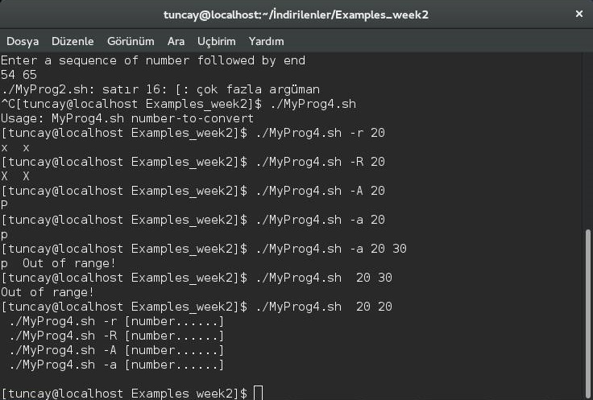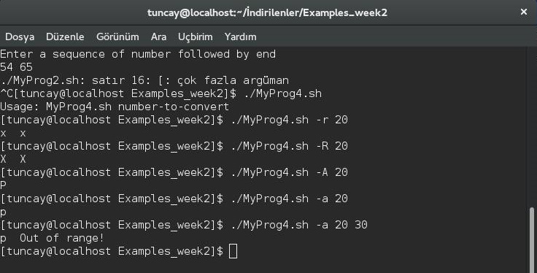

5)

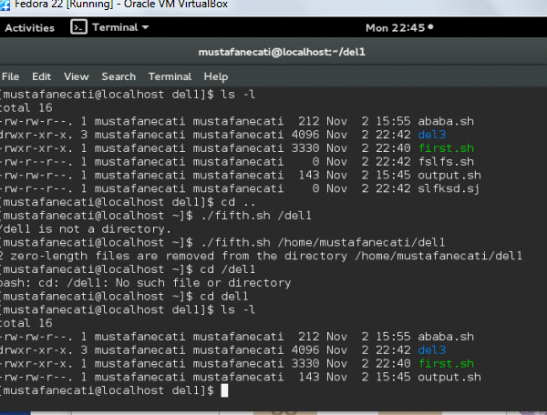

Deleting in current directory or input directory as shown above.

The all speciality is indicating by commands