Ali Prasla

Sricharan “Stich” Asuri

Peter Litts

Levi Joseph

Project 4 – Option Pricing

1. STOCK: GOOG
   1. Current Stock Price: $791.98
   2. Date when Data was Taken (“Today”): November 11th 2016
   3. Option Info:
      1. Strike Price: $790.00
      2. Price: $37.41
      3. Option Expiry Date: March 17th 2017
2. Sigma vs. Current Price (Price at each sigma)

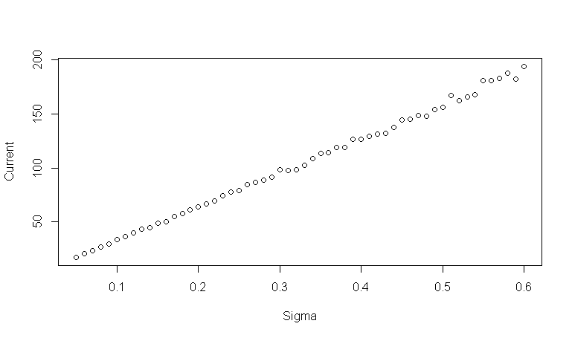

* 1. When Sigma = .12, the variance of current price and target price is the lowest. Therefore, the implied volatility of this option is about 12%

1. Exotic Option:
   1. We chose to price an Asian Option. The option Payoff formulation is the following:
      1. Max[mean(prices) – strike price,0] = Payoff
2. With an implied volatility estimate of .12, we expect this option to be priced at $21.09.