CARE-NEXUS AI – Foundry IQ
Enterprise Clinical Workflow Intelligence Agent
Demo Document with Screenshot Placeholders

1. Purpose of the Demo

CARE-NEXUS AI
CARE-NEXUS AI is a multi-agent, enterprise workflow intelligence assistant designed to evaluate requests, retrieve authoritative policies from SharePoint, reason over contextual data, and generate explainable recommendations through a Copilot-style interface.
The solution demonstrates how enterprise-grade AI agents can integrate with Microsoft Graph and SharePoint to provide real-time, policy-grounded decision support, combining structured workflow logic with contextual understanding and transparent reasoning.
The system architecture incorporates:
- Knowledge retrieval (Foundry IQ aligned) via SharePoint document libraries
- Context-aware reasoning engine for workflow decision evaluation
- Explainability layer with citations, evidence, and traceable output
- User interaction layer through an intuitive web dashboard
This enables a seamless flow from user input → enterprise knowledge retrieval → decision reasoning → actionable output.

2. Problem Statement
Healthcare enterprise environments (such as HMC/HICT systems) face significant operational challenges:
- Fragmented workflows across multiple systems (EHR, SharePoint, email, administrative platforms)
- High administrative burden due to manual approvals, validation, and documentation processes
- Delayed decision-making caused by dependency on human coordination and multi-step validation workflows
- Limited visibility and traceability of decisions made across systems
In practice, many of these workflows depend on:
- policy documents stored in SharePoint
- human interpretation and manual evaluation
- repetitive and error-prone approval processes

Real-world evidence shows: AI agents are increasingly used to automate documentation, scheduling, and clinical workflows to reduce burden and improve efficiency. Many healthcare processes involve multi-step workflows across systems, which are ideal candidates for agent-based automation

3. Opportunity for AI Agents
CARE-NEXUS AI demonstrates how these challenges can be addressed using enterprise AI agents:
- Automating policy retrieval from SharePoint using Microsoft Graph
- Enabling context-aware workflow evaluation based on real enterprise data
- Providing explainable recommendations with citations and evidence
- Reducing reliance on manual decision-making through structured reasoning

4. Solution Value (What was achieved)
The system delivers:
- Grounded decisions using real SharePoint policies (no hallucination)
- Traceable AI output with citation and evidence
- Workflow intelligence tailored to approval, escalation, and security scenarios
- Reduced administrative effort through automation
- Enterprise-ready integration approach aligned with the Microsoft ecosystem

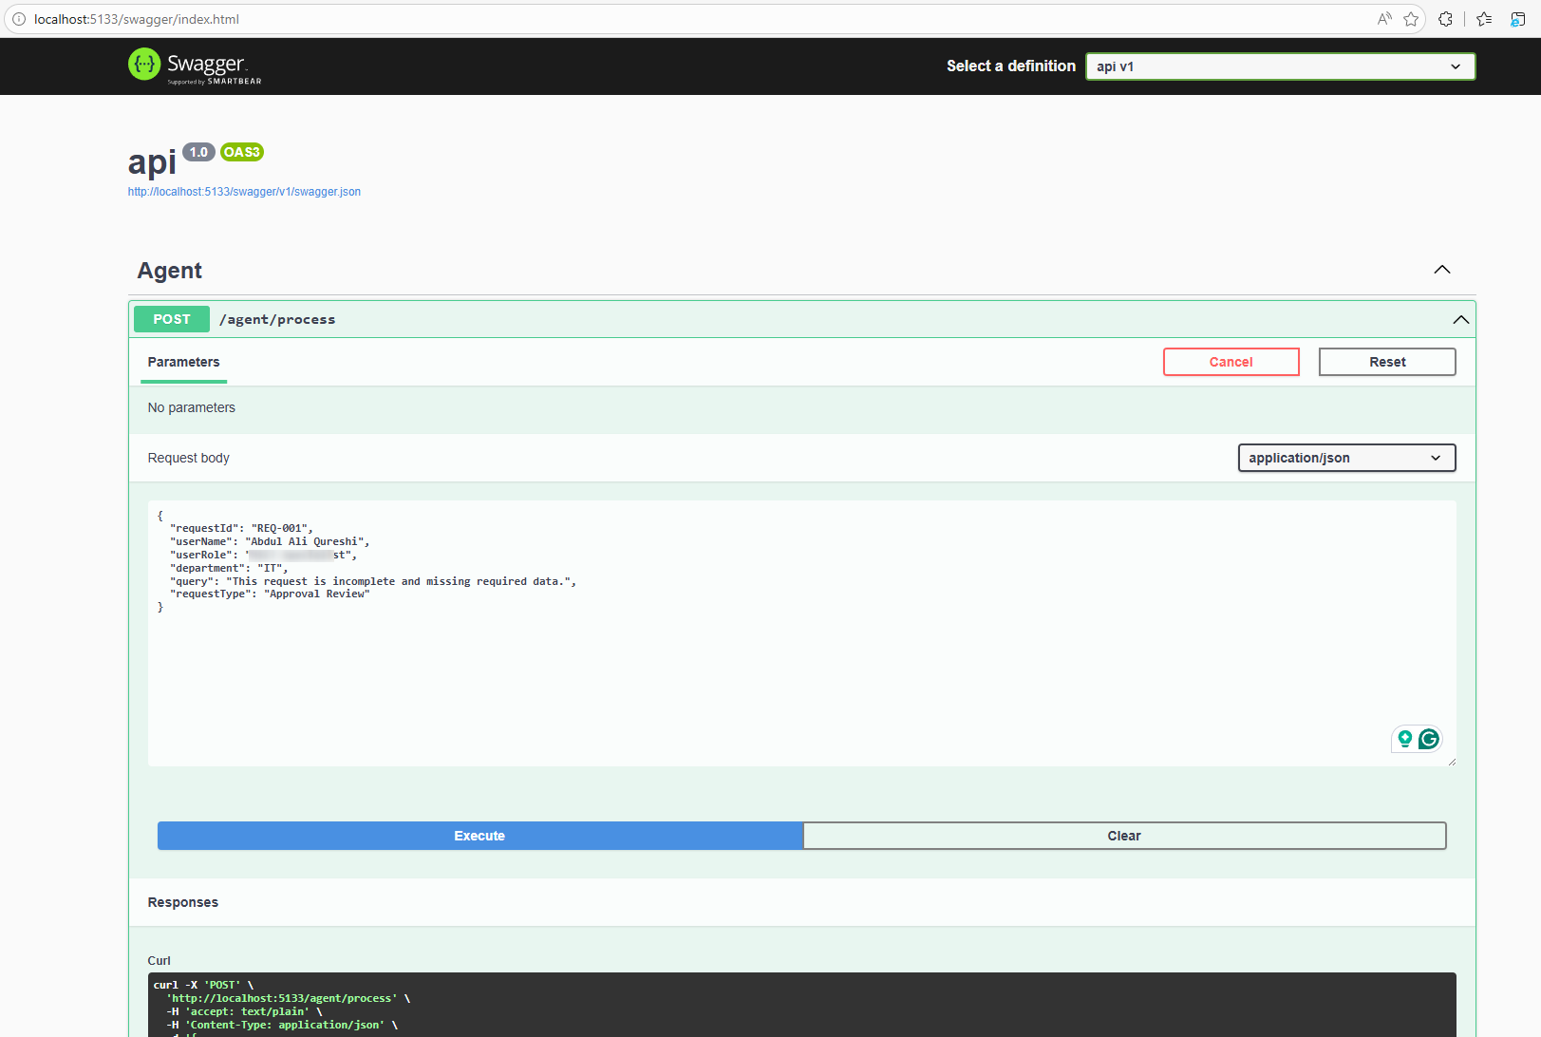

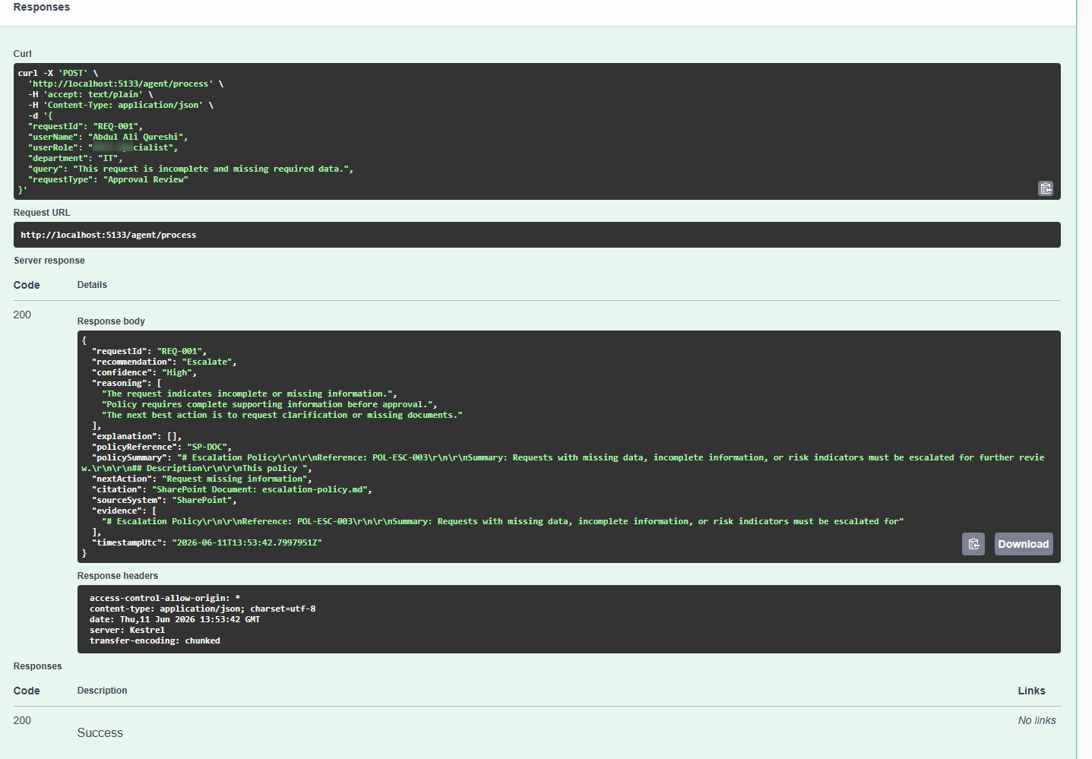

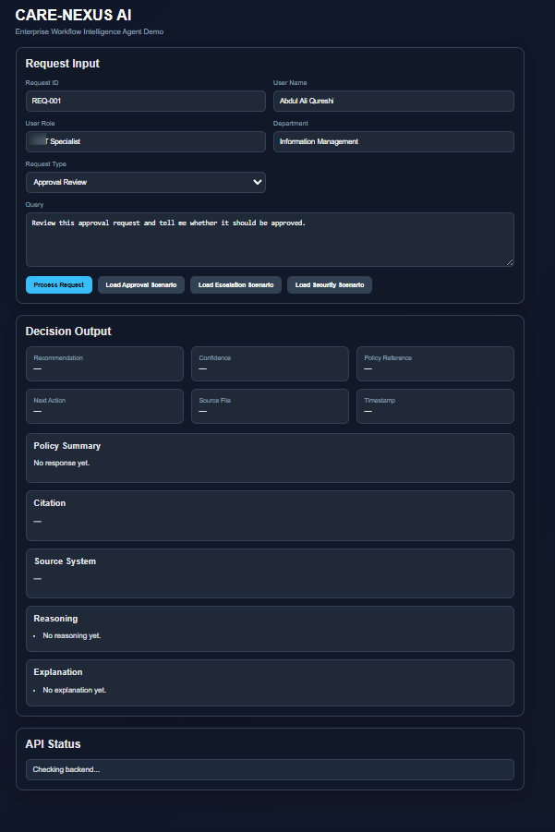
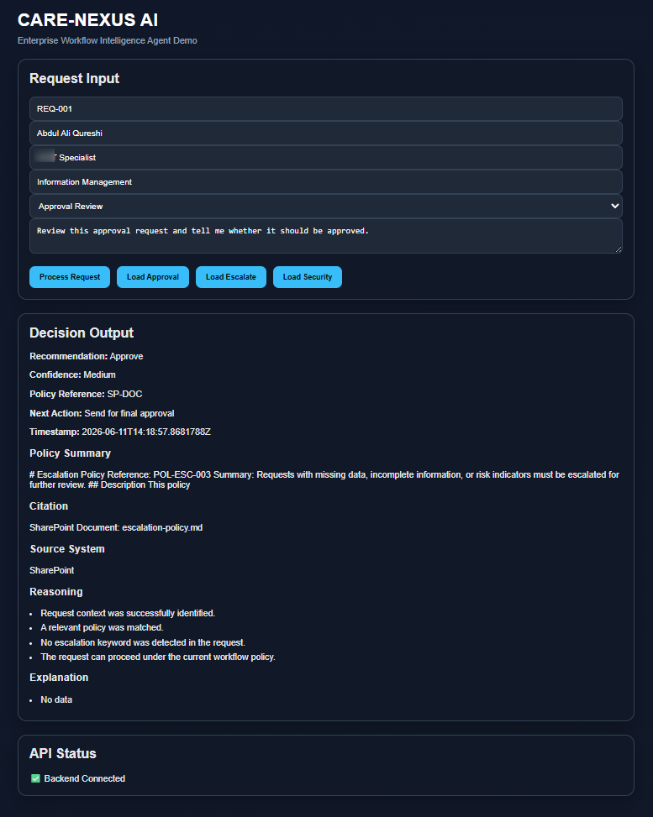

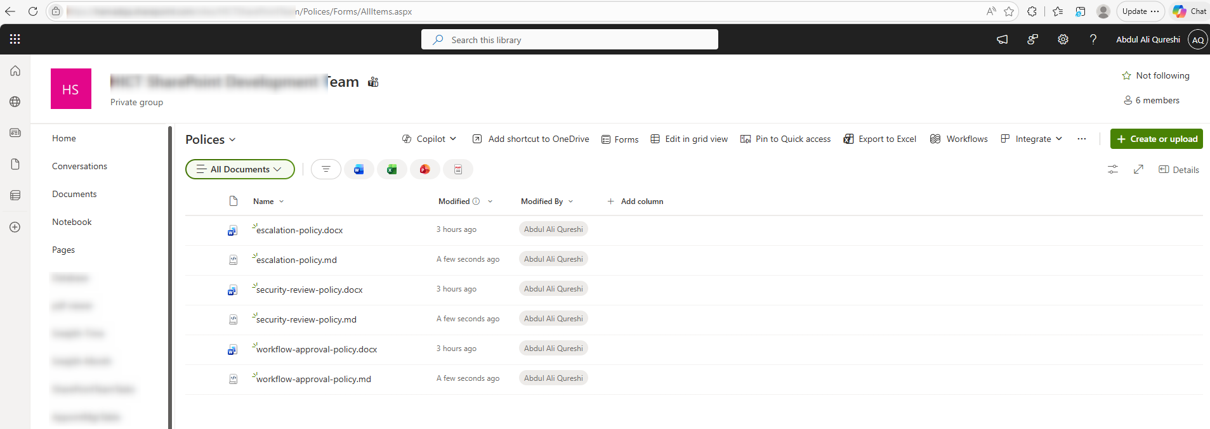
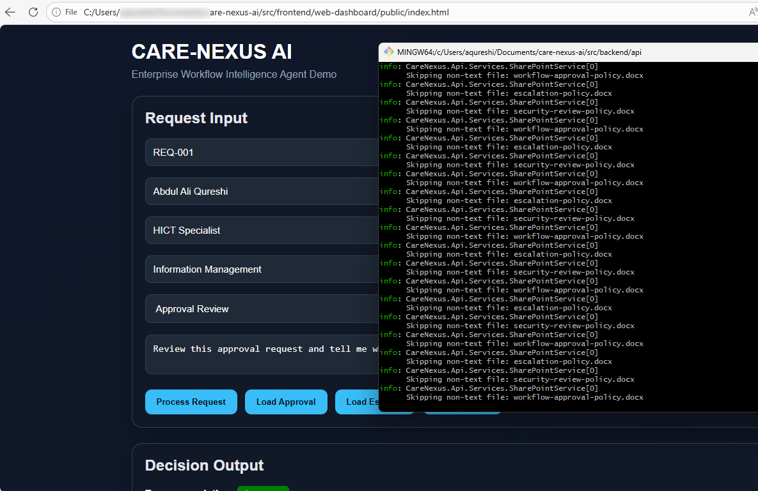
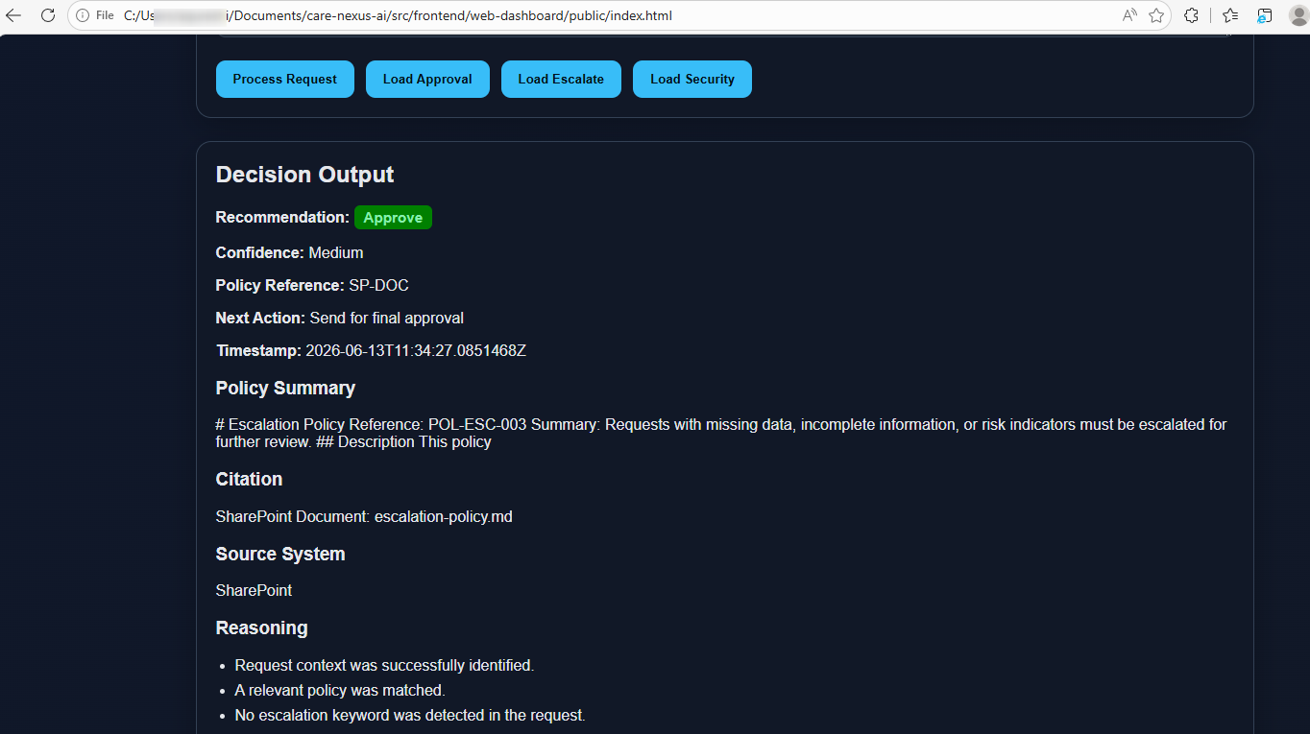



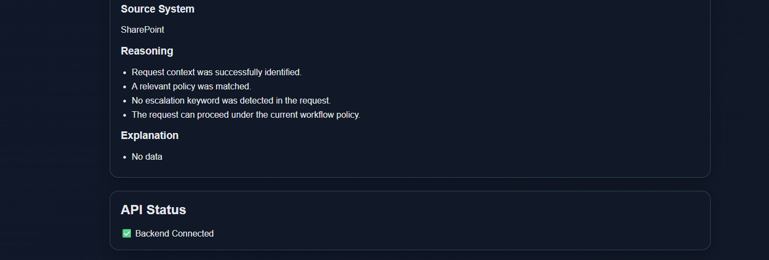
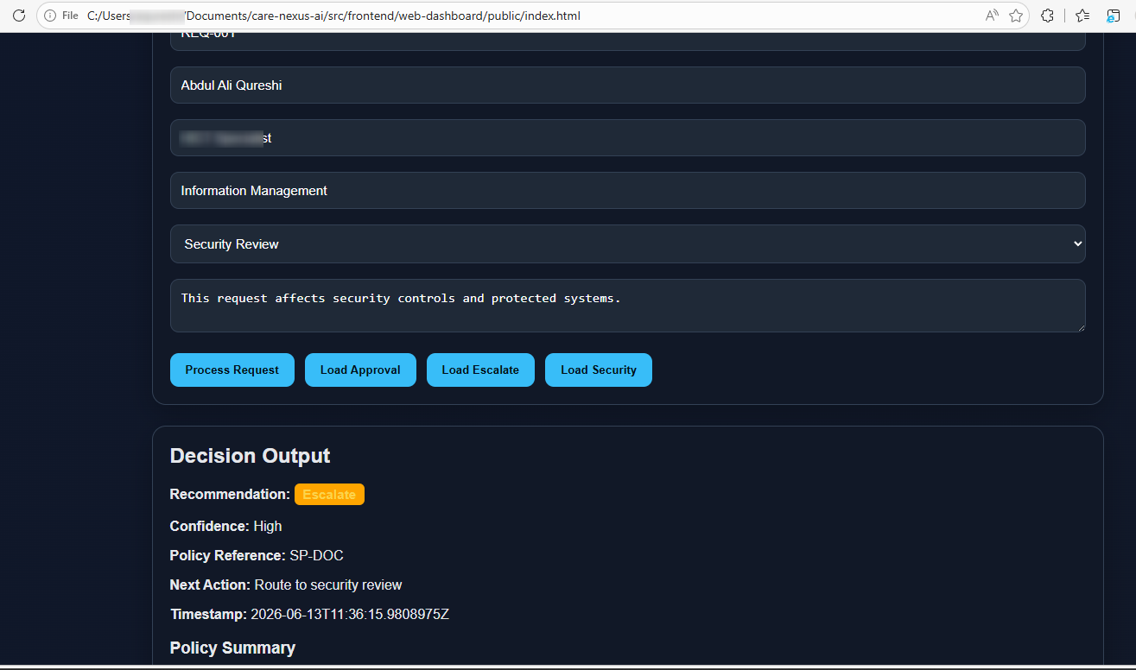
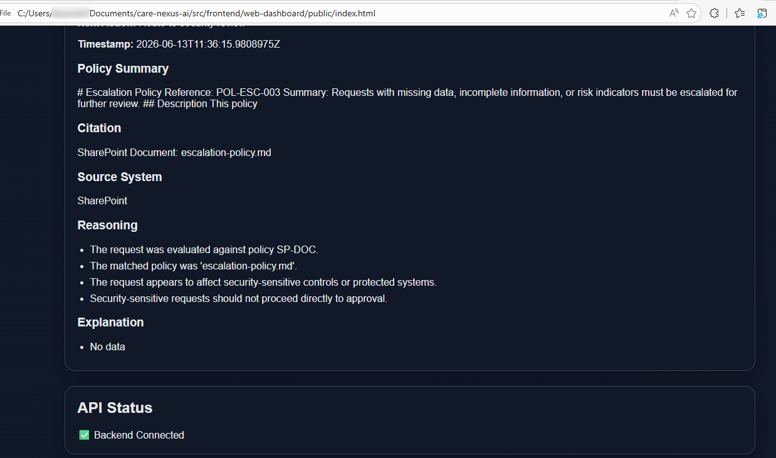
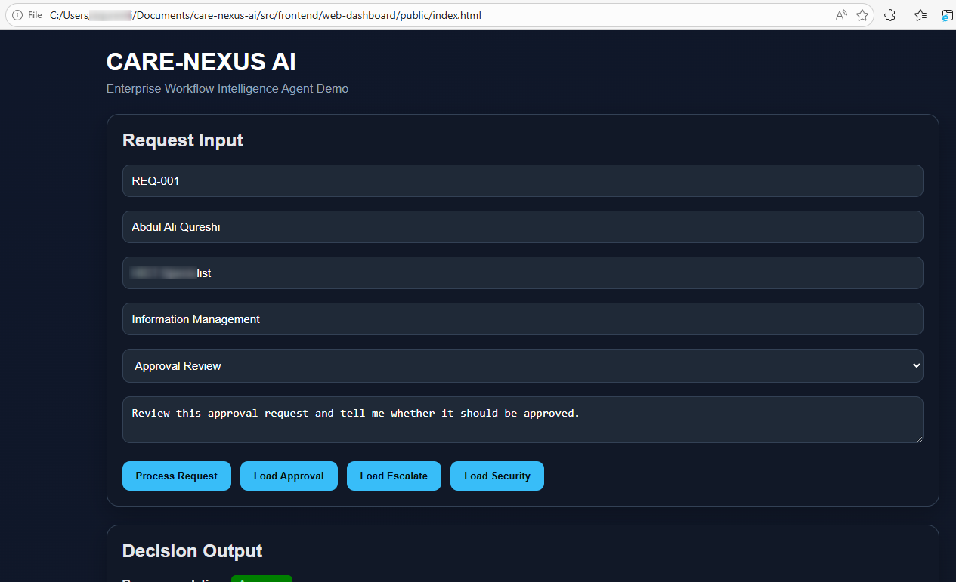

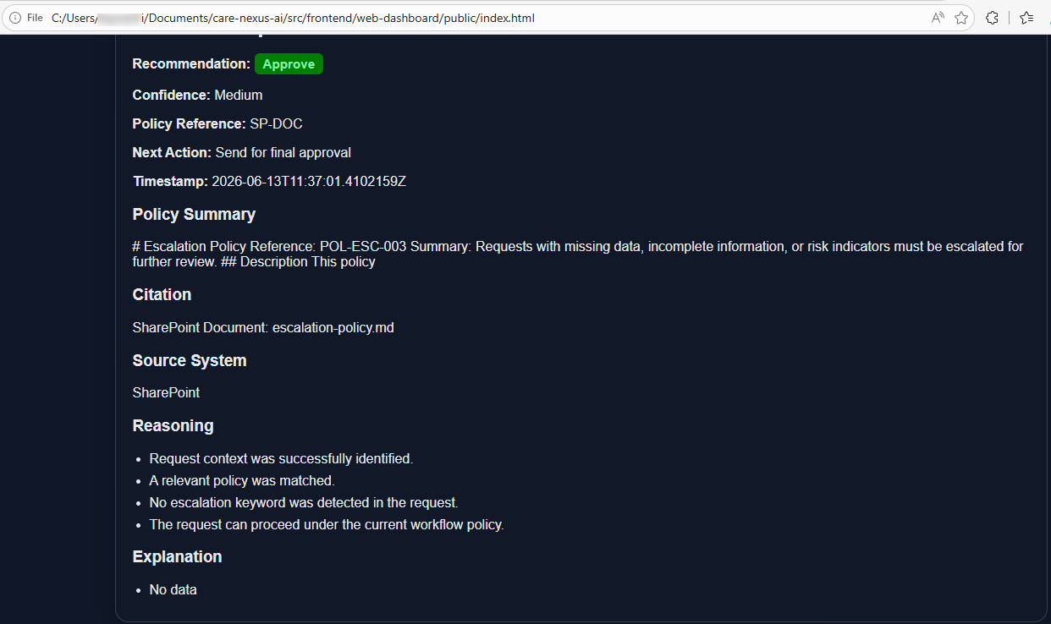
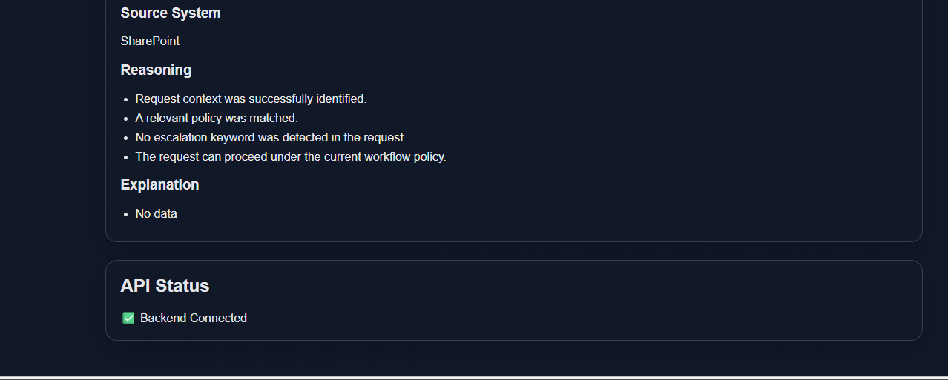

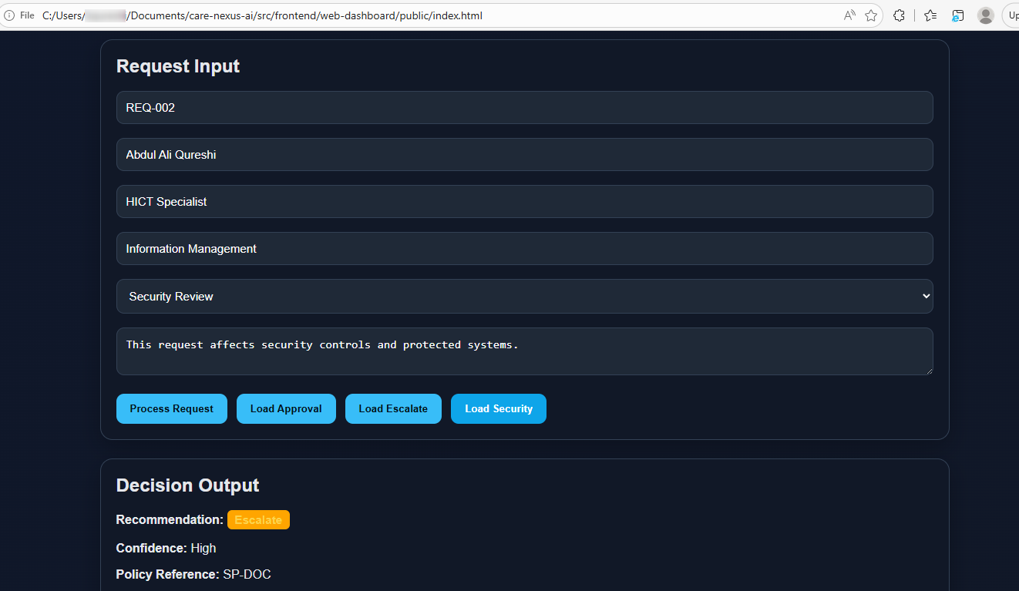

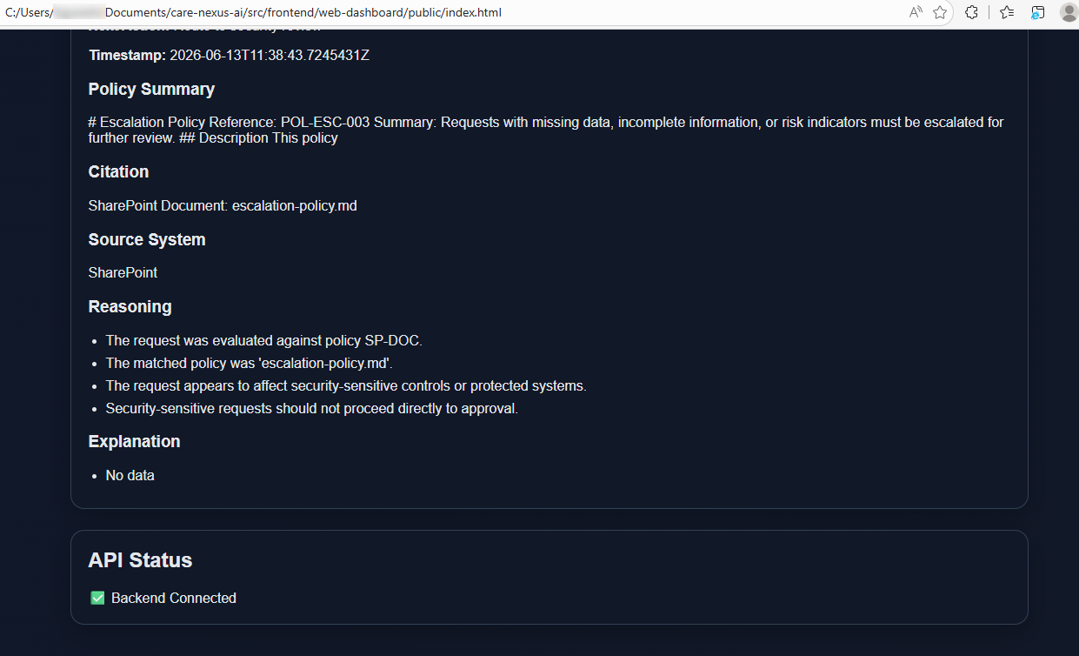

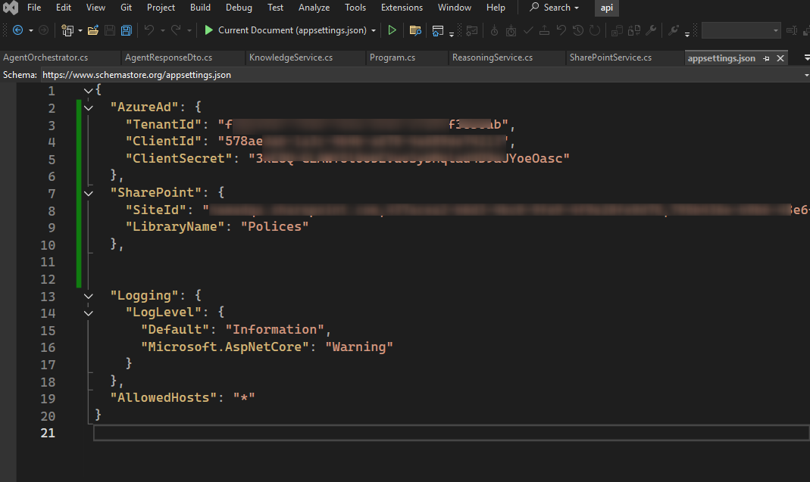

Azure-App Registration / Graph
