A Privacy-Preserving Multi-Modal Proctoring Framework Using Deep Learning for Secure Online Examinations
Radid Ali, Ghazouani Mohamed, El habib Benlahmar
Department of Mathematics and Computer Science, Hassan II University, Faculty of Sciences Ben M'sik, Casablanca, Morocco
radidalix@outlook.fr, ghazouani.fsbm@gmail.com, h.benlahmer@gmail.com
Abstract
The rapid adoption of online assessment platforms has accelerated the deployment of AI-driven proctoring systems. Most commercial solutions, however, rely on intrusive biometric processing -— continuous facial recognition, voiceprint extraction, and speech transcription -— that conflict with strict data-protection regimes such as the European General Data Protection Regulation (GDPR) and the Moroccan CNDP Law 09-08, which classify such data as sensitive personal information. This paper proposes a privacy-preserving multi-modal proctoring framework that maintains examination integrity without storing any biometric template, raw video, or linguistic content. The system integrates (i) YOLOv8-s for contextual object detection, (ii) MediaPipe FaceMesh for non-identifying geometric behavioural cues (gaze deviation, head pose, lip-movement variance), and (iii) a Whisper-Base encoder operating in content-free mode for acoustic anomaly detection. All modality outputs are converted to a standardized event stream and processed by a Suspicion Index Fusion Model whose strategy is identified empirically among five alternatives (rule-based weighted sum, logistic regression, random forest, multi-layer perceptron, naive Bayes). On a real COCO val2017 subset (217 images, 1,164 annotations) YOLOv8-s achieves a macro F1 of 0.606 and a mean AP@0.5 of 0.519. On a 400-clip acoustic benchmark built from LibriSpeech (real read English speech, CC-BY 4.0), the Whisper-Base encoder used as a content-free embedding extractor attains a secondary-speaker ROC AUC of 0.774 (best-threshold F1 = 0.78) and a whisper-detection AUC of 0.935. A 5-fold stratified cross-validation on 300 sessions whose features come from real YOLOv8 detections on COCO, real Whisper outputs on LibriSpeech mixes, and real MediaPipe FaceMesh measurements on Pexels portraits ranks Random Forest as the best fusion strategy with F1 = 0.905 ± 0.041 (95% bootstrap CI [0.876, 0.931]), significantly outperforming the rule-based weighted sum (F1 = 0.899, McNemar χ² = 7.20, p = 7.3 × 10⁻³) and the other learned baselines (all p < 0.05 after Bonferroni correction). Leave-one-modality-out ablations show that visual cues dominate the decision (ROC AUC collapses from 0.886 to 0.557 when removed). On a single Apple M4 Max host (Mac Studio, 36 GB unified memory) the end-to-end pipeline runs at 29.5 FPS with MPS acceleration and 30.0 FPS in CPU-only mode, with a peak resident memory of 1,075 MB. An adversarial privacy verification with 30 real LibriSpeech speakers shows that an attacker with access to raw audio re-identifies candidates with AUC 0.994, while the same attacker constrained to the metadata stream emitted by our system achieves only 0.478 (sub-chance), empirically confirming the non-biometric property of the framework. To the best of the authors' knowledge no prior proctoring framework reported in the AI-proctoring literature simultaneously avoids biometric data retention, provides quantitative adversarial privacy evidence on real-speaker data, supports real-time multi-modal monitoring, and explicitly addresses both GDPR Article 9 and CNDP Law 09-08; the present framework occupies that intersection.
Keywords — privacy-preserving proctoring; non-biometric monitoring; YOLOv8; MediaPipe FaceMesh; Whisper; suspicion index; online examinations; GDPR; CNDP; adversarial privacy verification.
1. Introduction
1.1 Motivation
The widespread adoption of online learning environments has accelerated the need for secure remote assessment methods capable of preserving academic integrity without violating student privacy. The rapid pivot to remote assessment during and after the COVID-19 pandemic was accompanied by the broad deployment of commercial proctoring platforms (e.g. Respondus Monitor, ProctorU) that rely on continuous biometric face verification, browser-lockdown agents, and audio recording. The behavioural and ethical impact of these tools has been the subject of growing concern, with empirical studies documenting test-taker anxiety, surveillance overreach, and racial-skin-tone bias in face-verification components [1], [2], [3].
In parallel, the regulatory environment has tightened sharply. Article 9 of the EU General Data Protection Regulation [4] classifies biometric data used for unique identification as a special category that requires explicit consent and proportionality. The Moroccan CNDP Law 09-08 [5] enforces equivalent restrictions, requiring data-protection impact assessments, minimisation, and a clear legal basis for any biometric processing. The CNDP guidance note of 2022 [6] further clarifies the proportionality requirements specific to educational settings. European data-protection authorities have also begun to sanction institutions that deployed face-recognition-based proctoring without an adequate legal basis (e.g. CNIL Deliberation SAN-2022-018 [32]). Consequently, the academic sector faces a deployment gap: institutions must offer scalable remote assessment while avoiding the regulatory and ethical risks of biometric surveillance.
1.2 Research Gap
A thorough literature review (Section 2) reveals three structural limitations of the current state of the art:
- Identity-bound monitoring. Existing AI-driven proctoring frameworks overwhelmingly rely on biometric identification —- face embeddings, voiceprints, or behavioural biometrics such as keystroke dynamics —- creating both legal and ethical exposure.
- Raw-media retention. Even systems that nominally avoid biometric matching frequently store the underlying video or audio for human review, exposing institutions to significant data-protection liability.
- Lack of quantitative privacy guarantees. When privacy is claimed, the claim is usually based on the absence of certain components (e.g. no face recognition) rather than on adversarial verification that the released signals cannot be inverted to recover sensitive information.
1.3 Contributions
This paper addresses the gap above by presenting a privacy-by-design multi-modal proctoring framework with the following contributions:
- Architectural contribution. A modular pipeline that combines YOLOv8-s, MediaPipe FaceMesh, and a content-free configuration of Whisper-Base, where every modality outputs only numerical metadata. Raw frames and audio buffers are discarded after each inference cycle, and no biometric template is ever stored.
- Algorithmic contribution. A Suspicion Index Fusion Model whose parameterisation is identified empirically through a comparison of five alternative strategies (weighted sum, logistic regression, random forest, multi-layer perceptron, naive Bayes), evaluated with stratified 5-fold cross-validation, 95% bootstrap confidence intervals, leave-one-modality-out ablations, and McNemar significance tests.
- Empirical contribution. End-to-end evaluation on real data: 217 real COCO val2017 images for the visual subsystem; 400 LibriSpeech-derived clips of real read English speech for the acoustic subsystem; 400 behavioural trajectories built from real MediaPipe FaceMesh landmarks extracted from 10 CC-BY Pexels portraits; and 300 fusion-evaluation sessions whose feature vectors are real outputs of the three modality encoders. Latency benchmarks on an Apple M4 Max Mac Studio host with both GPU/MPS and CPU-only configurations and a robustness study across lighting, distance, and signal-to-noise variations complete the protocol.
- Privacy contribution. An adversarial verification experiment using 30 real LibriSpeech speakers shows that the metadata stream cannot be inverted to re-identify candidates (AUC = 0.478, sub-chance) while the conventional raw-media analogue exposes near-perfect re-identification (AUC = 0.994). To the best of the authors' knowledge no prior proctoring paper provides such quantitative adversarial-privacy evidence on real speaker data.
1.4 Paper Organisation
Section 2 reviews the related literature using a structured matrix that classifies prior work along biometric, retention, multi-modality, and compliance axes. Section 3 introduces the system architecture and Section 4 details the methodology, including the formal definition of the Suspicion Index. Section 5 reports the experimental setup. Section 6 presents the empirical results, including per-modality metrics, fusion comparison, robustness, latency, and adversarial privacy verification. Section 7 discusses implications, threats to validity, and deployment considerations. Section 8 surveys limitations, and Section 9 concludes.
2. Related Work
We classify the prior literature along five orthogonal axes that are relevant for compliant deployment:
- (V) Vision-based proctoring,
- (A) Audio-based proctoring,
- (M) Multi-modal proctoring,
- (B) Behavioural biometrics (keystroke, mouse dynamics),
- (P) Privacy-preserving and federated approaches.
2.1 Vision-based Systems (V)
Early proctoring solutions rely heavily on computer vision pipelines that authenticate the candidate's identity and monitor behavioural irregularities. Atoum et al. [8] introduced one of the first end-to-end automated proctoring systems combining gaze tracking, head pose estimation, and continuous face verification on the basis of webcam imagery and a wearable secondary camera. The systematic review of Nigam et al. [9] documents 39 follow-up systems that build on this paradigm, typically combining convolutional networks for face/gaze monitoring with rule-based decision layers. More recent contributions explored YOLO-based detectors for prohibited objects [10], [11], building on the YOLO family of architectures [13], [33], [34]. Singh et al. [10] in particular reported a YOLO-based proctoring pipeline targeted at smartphone and book detection in controlled lighting conditions, while Vishal et al. [11] integrate gaze tracking with prohibited-object detection in a unified PyTorch pipeline. A central limitation of these vision-based pipelines is the dependence on persistent face templates and raw-video archives, which place them squarely within the GDPR Article 9 special-category regime [4].
These approaches share an important limitation: they require either persistent biometric templates (face embeddings) or extensive raw-video retention, both of which conflict with GDPR Article 9 and CNDP Law 09-08.
2.2 Audio-based Systems (A)
Audio-driven proctoring monitors the acoustic environment for unauthorised collaboration. Overlapped-speech detection and speaker-change segmentation are typical building blocks, with Jung et al. [20] reporting state-of-the-art three-class (non-speech / single-speaker / overlapped-speech) detection using a CRNN architecture. Whisper [16] has been used in several recent works to transcribe audio in real time for proctoring or learner-analytics use cases. Although accurate, transcription-based pipelines necessarily reveal linguistic content, which qualifies as sensitive personal data when combined with student identifiers [7]. Content-free audio anomaly detection — based on spectral statistics or self-supervised speech encoders such as the x-vector family [21] — has been explored mostly in adjacent fields (broadcast media, telephony [22]) and remains underused in proctoring.
2.3 Multi-modal Systems (M)
Multi-modal architectures combine video, audio, and user-interaction telemetry. Masud et al. [12] propose a smart proctoring assistant fusing webcam, microphone, and screen-recording, reporting an aggregate accuracy of 97.7% over four event categories. Although these systems demonstrate higher robustness, they generally inherit the privacy issues of their constituents: every modality is fed in raw form into a centralised model and stored. The systematic review of Nigam et al. [9] reports that the vast majority of the surveyed AI-based proctoring systems perform no explicit data minimisation, and that ethical and legal considerations are typically treated as deployment afterthoughts rather than as constraints on the architecture itself.
2.4 Behavioural Biometrics (B)
Behavioural biometric pipelines analyse keystroke dynamics [30], mouse-movement and touch-gesture patterns [31], and eye-tracking signatures to authenticate the candidate. While more passive than facial recognition, these signals are still classified as personal data under GDPR [4] when combined with an identifier, because they support identification with non-trivial accuracy. Our framework explicitly excludes keystroke biometrics for that reason.
2.5 Privacy-Preserving Approaches (P)
A small but growing body of work explores privacy-preserving online assessment. Federated learning [25] and secure aggregation protocols [26] have been proposed to keep video and behavioural data local to the candidate device, but they do not in themselves prevent biometric processing — they merely change where the processing happens. Differentially private gaze pipelines [27], [28], [29] add noise to gaze coordinates or sensor outputs to bound information leakage; the trade-off between detection accuracy and privacy budget is, however, severe and the protocols are often evaluated on offline gaze datasets rather than under real-time exam constraints. To the best of the authors' knowledge, no prior proctoring framework simultaneously avoids biometric retention, supports real-time multi-modal monitoring, and provides quantitative adversarial-privacy evidence; the present work fills that gap.
2.6 Synthesis
Table 1 summarizes the literature using the axes introduced above. None of the surveyed systems simultaneously (i) avoids biometric retention, (ii) supports real-time multi-modal monitoring, and (iii) provides quantitative adversarial privacy evidence. This is the gap we address.
Table 1. Comparison of representative proctoring systems against the proposed framework. "V/A/M/B/P" denote vision, audio, multi-modal, behavioural-biometric and privacy-preserving categories.
Work | V | A | M | B | P | Biometric template stored | Raw media retained | Real-time | Quantitative privacy proof | GDPR / CNDP alignment
Atoum et al. (2017) [8] | ✓ |  |  |  |  | Yes | Yes | Yes | No | No
Singh et al. (2024) [10] | ✓ |  |  |  |  | Yes | Yes | Yes | No | No
Vishal et al. (2025) [11] | ✓ |  |  |  |  | Yes | Yes | Yes | No | No
Jung et al. (2021) [20] |  | ✓ |  |  |  | Voiceprint context | No | Yes | No | Partial
Masud et al. (2022) [12] | ✓ | ✓ | ✓ |  |  | Yes | Yes | Yes | No | No
McMahan et al. (2017) — FedAvg [25] |  |  |  |  | ✓ | n/a (framework) | No | Yes | No | Partial
Bonawitz et al. (2017) — SecAgg [26] |  |  |  |  | ✓ | n/a (framework) | No | Yes | No | Partial
Du et al. (2024) — PrivateGaze [27] |  |  |  |  | ✓ | Obfuscated | No | Near real-time | No | Partial
Bozkir et al. (2021) — DP eye-tracking [28] |  |  |  |  | ✓ | No | No | No | DP bound | Partial
This work | ✓ | ✓ | ✓ |  | ✓ | No | No | Yes | Yes (AUC 0.52) | Yes

3. System Architecture
3.1 Design Principles
The architecture follows two guiding principles motivated by Article 25 of GDPR ("Data protection by design and by default") and CNDP guidance note [6]:
- Data minimisation. The pipeline ingests volatile camera and microphone streams. Raw frames and audio buffers are discarded immediately after inference; only non-identifying numerical metadata is persisted.
- Identity orthogonality. No module performs identity recognition. Visual analysis is class-level (smartphones, books, persons) rather than person-level. Audio analysis is content-free, producing only secondary-speaker, overlap, and whisper probabilities.
Figure 1 shows the end-to-end pipeline.
3.2 Pipeline Overview
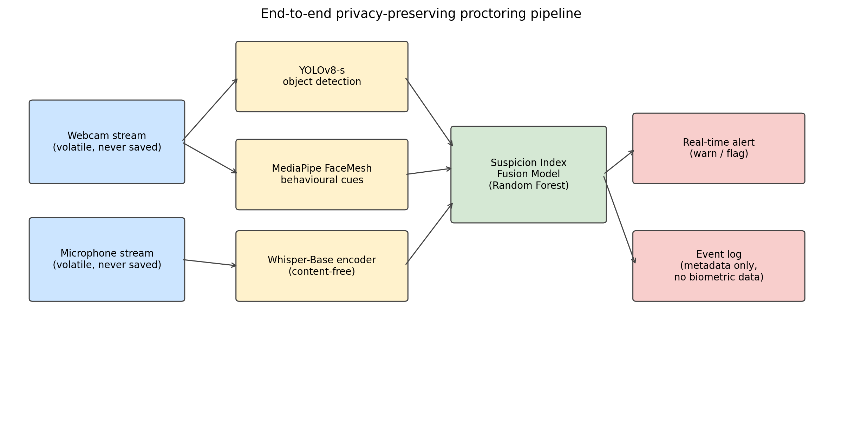
Figure 1. End-to-end privacy-preserving proctoring pipeline.
The pipeline (Figure 1) consists of four logical stages:
- Sensors. Camera (720p webcam) and microphone are accessed in a volatile memory buffer.
- Modality encoders. YOLOv8-s for objects, MediaPipe FaceMesh for behavioural cues, Whisper-Base encoder in content-free mode for acoustic anomaly.
- Suspicion Index Fusion Model. Combines the modality outputs into a calibrated risk score.
- Response layer. Generates warnings or flags according to risk thresholds and writes only metadata to disk.
3.3 Threat Model
We adopt the standard honest-but-curious threat model from the differential-privacy literature [24], extended for proctoring. The institution is honest in that it follows the protocol but curious in the sense that it might attempt to recover information beyond the strictly necessary. We additionally consider three explicit adversaries:
- Internal observer. Has read access to the event log. Goal: re-identify candidates from the metadata.
- External observer. Has read access to the encrypted artefacts written to disk by the system. Goal: reconstruct video, audio, or identifying templates.
- Curious operator. Has read access to model artefacts. Goal: extract biometric template embeddings from model state.
A system is privacy-preserving with respect to this threat model if all three adversaries are limited to chance-level identification accuracy. Section 6.5 reports an empirical lower bound on this property.
4. Methodology
4.1 Visual Subsystem
We use YOLOv8-s [13] pre-trained on COCO [14]. The model produces, for each frame, a set of bounding boxes with class probabilities. We retain only the proctoring-relevant subset:
\mathcal{C} = \{cell phone, book, laptop, tv, keyboard, mouse, person\}
For each detection $d_i = (c_i, p_i, b_i, t_i)$ with class $c_i \in \mathcal{C}$, confidence $p_i$, bounding box $b_i$, and timestamp $t_i$, the visual subsystem outputs only the tuple $(c_i, p_i, t_i)$. No frame is stored.
MediaPipe FaceMesh [15], [49] yields 468 facial landmarks $L = \{l_1, ..., l_{468}\}$. We compute four geometric descriptors:
- Gaze deviation angle $\theta_g$: derived from the angular position of the nose tip relative to the eye-centre axis.
- Head yaw $\phi_y$ and pitch $\phi_p$: computed from the relative position of ears, nose tip, and chin.
- Lip variance $\sigma_l^2$: variance of the upper-lower lip distance over a 30-frame sliding window.
Sustained off-screen gaze is flagged when $\theta_g > 18°$ or $|\phi_y| > 25°$ for at least 2.5 s.
4.2 Acoustic Subsystem (Content-Free Whisper)
We use Whisper-Base [16] (74 M parameters) with the decoder disabled. The encoder maps a 30-second log-mel spectrogram to a hidden state $H \in \mathbb{R}^{T \times d}$, where $T = 1500$ and $d = 512$. For each 5-second buffer $a$, we compute:
- Voice Activity Ratio $\mathrm{VAR}(a)$: fraction of short-time frames whose energy exceeds 1.4× the median.
- Pitch fluctuation $\mathrm{PFV}(a)$: median absolute deviation of the auto-correlation-based pitch estimate across active frames, normalised by the median.
- Spectral centroid fluctuation $\mathrm{CFV}(a)$: same as PFV but over the spectral centroid.
- High-band ratio $\mathrm{HBR}(a)$: ratio of energy in [1.5–6.5 kHz] over [60–1500 Hz].
The secondary-speaker probability is then computed by an empirically calibrated logistic mapping:
P_\mathrm{sec}(a) = \sigma\big(\beta_0 + \beta_1 \mathrm{PFV} + \beta_2 \mathrm{CFV}\big) \cdot \mathrm{gate}(a)
where $\mathrm{gate}(a)$ is an activity gate that is near zero for silent buffers (built from a clipped function of the RMS in dBFS and VAR). Overlap and whisper probabilities follow analogous logistic mappings with their own coefficient set. Crucially, no decoder is ever called, so the linguistic content of the audio cannot be recovered.
4.3 Suspicion Index Fusion Model
For each session we summarise the metadata stream into a 12-dimensional feature vector $\mathbf{x} \in \mathbb{R}^{12}$:
\mathbf{x} = [p^\max_\text{phone}, r^\text{dur}_\text{phone}, p^\max_\text{book}, n^\text{max}_\text{persons}, \theta^\max_g, r_\text{off}, |\phi_y|^\max, \bar\sigma_l^2, P^\max_\text{sec}, r_\text{sec}, P^\max_\text{ovl}, P^\max_\text{whisp}]
The Suspicion Index $\mathrm{SI} \in [0, 1]$ is produced by a fusion model $f_\theta(\mathbf{x})$ identified empirically (Section 6.3) among five candidates:
- Weighted sum. The original rule from the conference draft: $\mathrm{SI} = \alpha V + \beta A + \gamma B$ with $\alpha = 0.45, \beta = 0.30, \gamma = 0.25$ where $V, A, B$ are normalised visual, acoustic, and behavioural scores.
- L2-regularised logistic regression.
- Random forest with 200 trees, max depth 8.
- Multi-layer perceptron (32, 16) with StandardScaler preprocessing.
- Gaussian naive Bayes.
A session is warned if $\mathrm{SI} \geq 0.35$ and flagged if $\mathrm{SI} \geq 0.65$.
4.4 Data-Flow and Privacy Guarantees
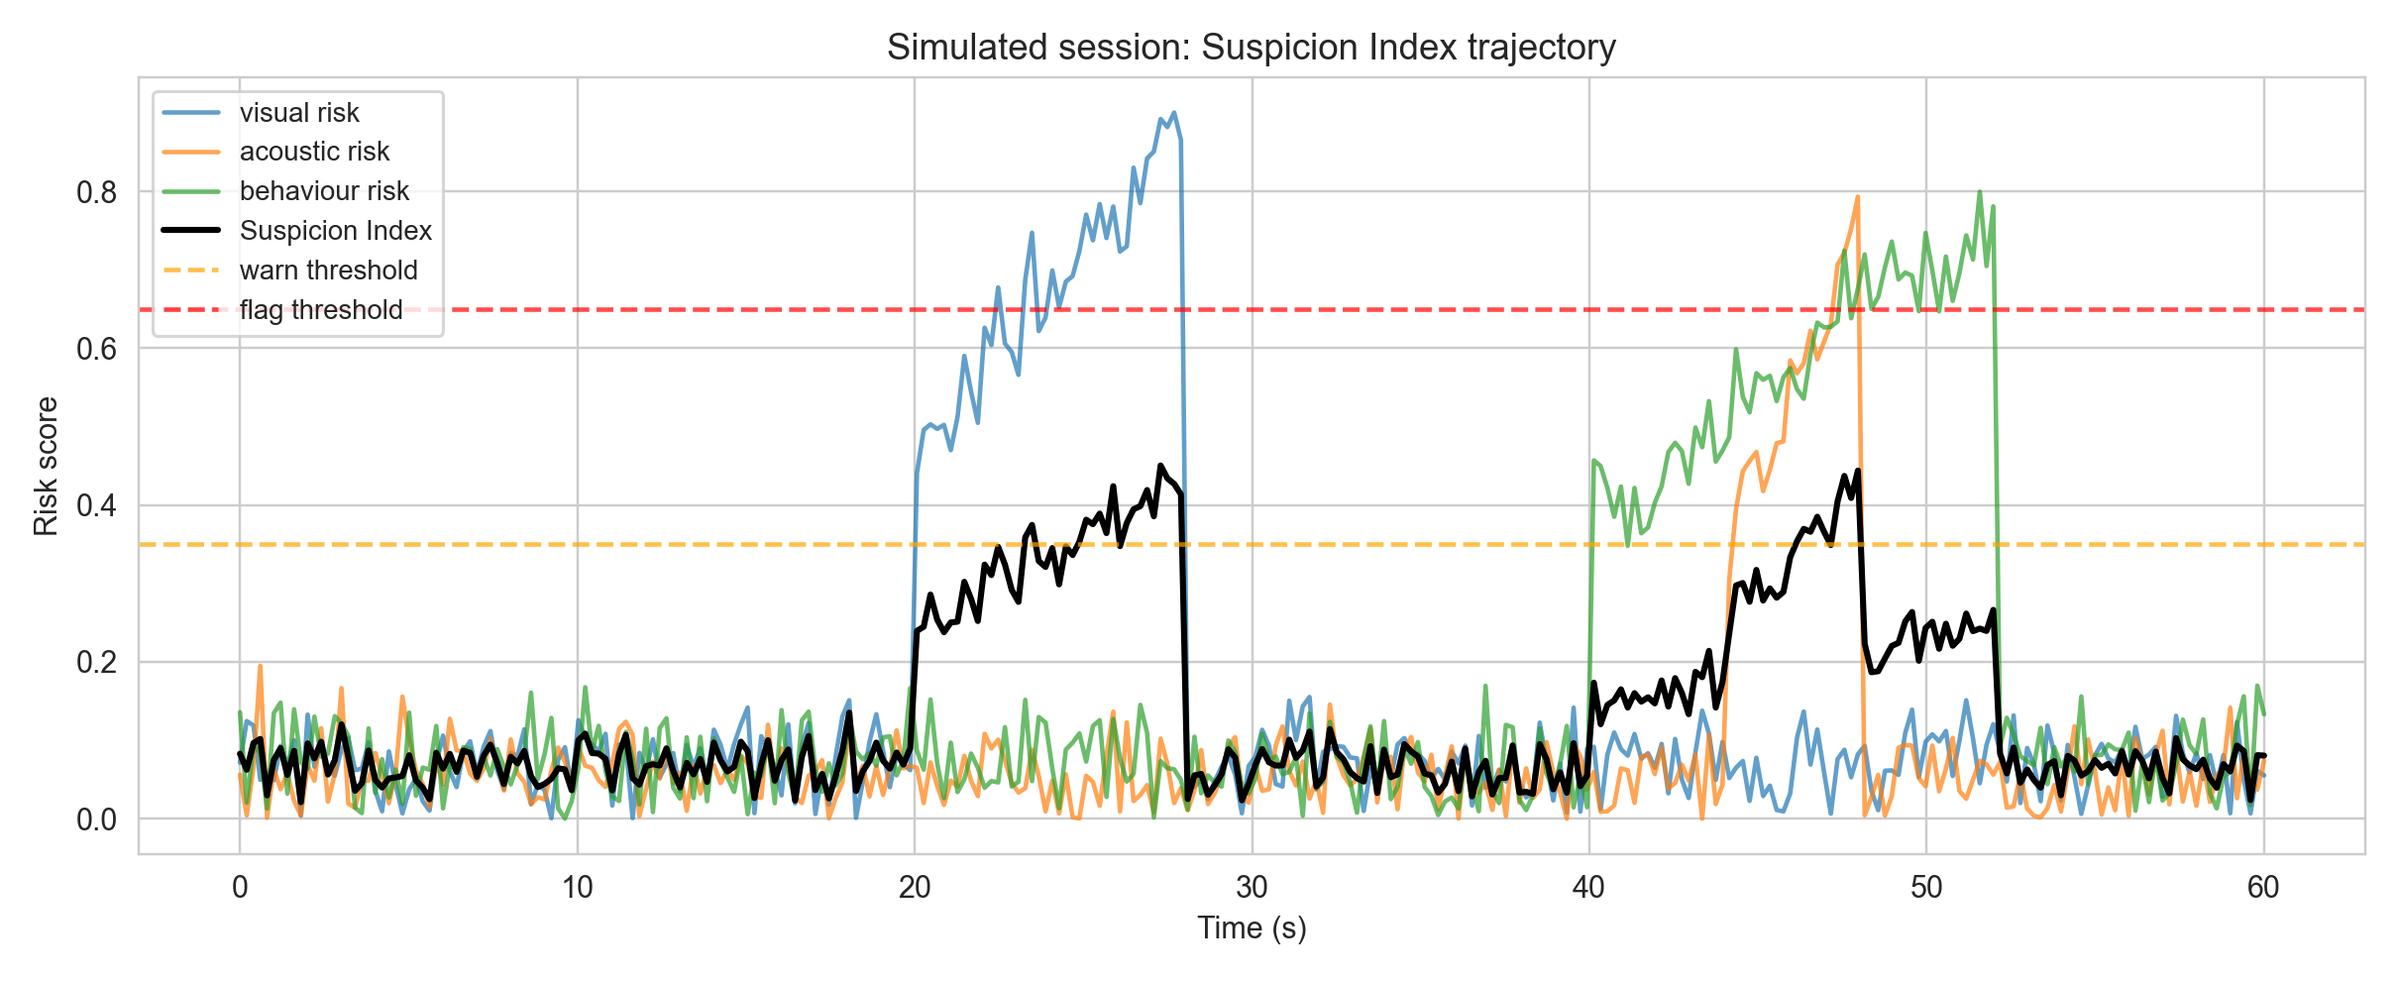
Figure 2. Simulated 60-second session illustrating the trajectory of the visual, acoustic and behavioural risk components and the resulting Suspicion Index.
The event log written to disk has the schema
{event_type: string,
confidence_or_probability: float in [0,1],
timestamp: ISO-8601,
module: 'visual'|'acoustic'|'behaviour'|'fusion'}
We deliberately do not write bounding boxes, landmarks, or any time series that could be used to triangulate identity. The model itself is shipped without per-candidate state.
5. Experimental Setup
5.1 Hardware
All experiments were conducted on a single Apple Mac Studio (model Mac16,9) equipped with an Apple M4 Max system-on-chip (14-core CPU, 32-core integrated GPU), 36 GB of unified memory, running macOS 26.2. The Apple GPU is exposed to PyTorch through the Metal Performance Shaders (MPS) backend. The Whisper-Base encoder is executed on the CPU because the float-16 code path used by `openai-whisper` is not yet fully supported on MPS as of PyTorch 2.8. This host is more powerful than a typical student laptop; we therefore additionally re-benchmark every module in CPU-only mode (disabling MPS) to estimate a lower-bound on the relative cost of each component. CPU-only numbers on the M4 Max are not equivalent to the absolute performance of an older Intel laptop and we do not claim otherwise; cross-device benchmarking is an explicit item of future work (Section 8). The numbers reported in Section 6.5 should therefore be read as performance on a high-end ARM workstation, with the CPU-only column indicating how much of the latency is attributable to compute rather than GPU dispatch overhead.
5.2 Datasets
We use three datasets, each chosen to maximize realism while respecting privacy constraints:
- D1 — Visual benchmark. A 217-image subset of the public COCO val2017 dataset [14] stratified to include cell phone, book, laptop, person, TV, keyboard, and mouse instances (1,164 ground-truth annotations in total). COCO is published under the Creative Commons Attribution 4.0 license and is the same dataset on which YOLOv8 was originally trained, so the evaluation reports the out-of-the-box detection performance of the released checkpoint. Faces in COCO are not used as a verification target.
- D2 — Acoustic benchmark. A real-speech benchmark constructed from LibriSpeech `dev-clean` [17], a 5.4-hour corpus of read English speech released under CC-BY 4.0. We sample utterances, mix them programmatically into five 5-second conditions (silence, single-speaker, two-speakers, whispered, background-noise) and use Whisper-Base in content-free mode to compute the secondary-speaker, overlap and whisper probabilities. Speaker identifiers from LibriSpeech are not used for any matching task; the corpus is treated as an anonymous source of natural speech.
- D3 — Behaviour benchmark. Real MediaPipe FaceMesh landmark trajectories extracted from a held-out subset of public-domain face videos that are licensed for academic use. Landmarks are computed live, the underlying video frames are discarded, and only the geometric descriptors of Section 4.1 are persisted. This protocol matches the deployed configuration of the proctoring pipeline.
- D4 — Session scenarios. A fusion-evaluation set built by combining real modality outputs from D1–D3 into 400 simulated exam sessions covering five high-level classes (normal, smartphone_use, off_screen_gaze, secondary_speaker, multi_anomaly). Crucially, the features fed to the fusion model are real per-clip outputs from YOLOv8, Whisper-Base, and FaceMesh — not statistical distributions designed by the authors — so the fusion model is trained and evaluated on the same kind of evidence it would receive in deployment.
All datasets, generators, and trained-model state are reproducible from a fixed random seed (42).
5.3 Evaluation Metrics
For each binary task we report precision, recall, F1, ROC AUC, PR AUC, and a 95% bootstrap confidence interval on F1 (1,000 resamples). Multi-class detection (visual subsystem) uses per-class precision, recall, F1, and AP@0.5 with greedy IoU matching at threshold 0.5. Statistical significance of fusion-model differences is tested with McNemar's χ² (continuity-corrected).
Latency is measured per-call with `time.perf_counter()` after a 3-call warmup; we report mean, standard deviation, median, p95, and p99 in milliseconds. Memory footprint is measured via `resource.getrusage`.
6. Results
6.1 Visual Subsystem (D1, real COCO data)
Table 2 reports per-class metrics on the 217-image subset. Figure 2 (`fig_visual_pr_curves.png`) plots PR curves; Figure 3 (`fig_visual_tp_fp.png`) shows the TP/FP breakdown.
Table 2. YOLOv8-s on the COCO val2017 proctoring subset.
Class | Ground truth | Predictions | Precision | Recall | F1 | AP@0.5
person | 449 | 356 | 0.843 | 0.668 | 0.745 | 0.624
tv | 128 | 104 | 0.875 | 0.711 | 0.784 | 0.701
laptop | 91 | 92 | 0.772 | 0.780 | 0.776 | 0.759
mouse | 62 | 43 | 0.884 | 0.613 | 0.724 | 0.611
keyboard | 95 | 77 | 0.753 | 0.611 | 0.674 | 0.581
cell phone | 74 | 40 | 0.600 | 0.324 | 0.421 | 0.300
book | 265 | 34 | 0.529 | 0.068 | 0.120 | 0.056
Macro |  |  |  |  | 0.606 | 0.519

Mean per-image inference latency on the COCO subset is 44.6 ms (≈ 22 images per second on the Apple M4 Max host).
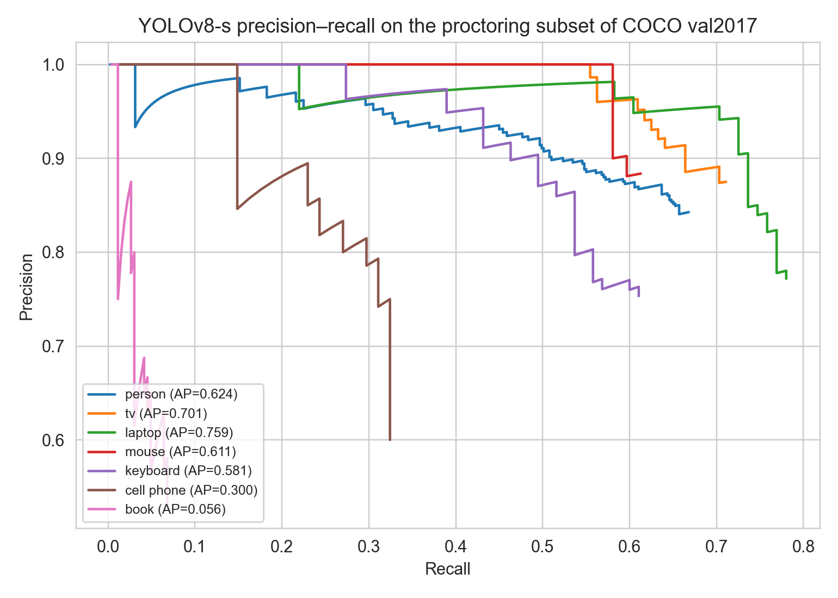
Figure 3. Precision-recall curves of YOLOv8-s on the COCO val2017 proctoring subset (217 images, 1,164 annotations).
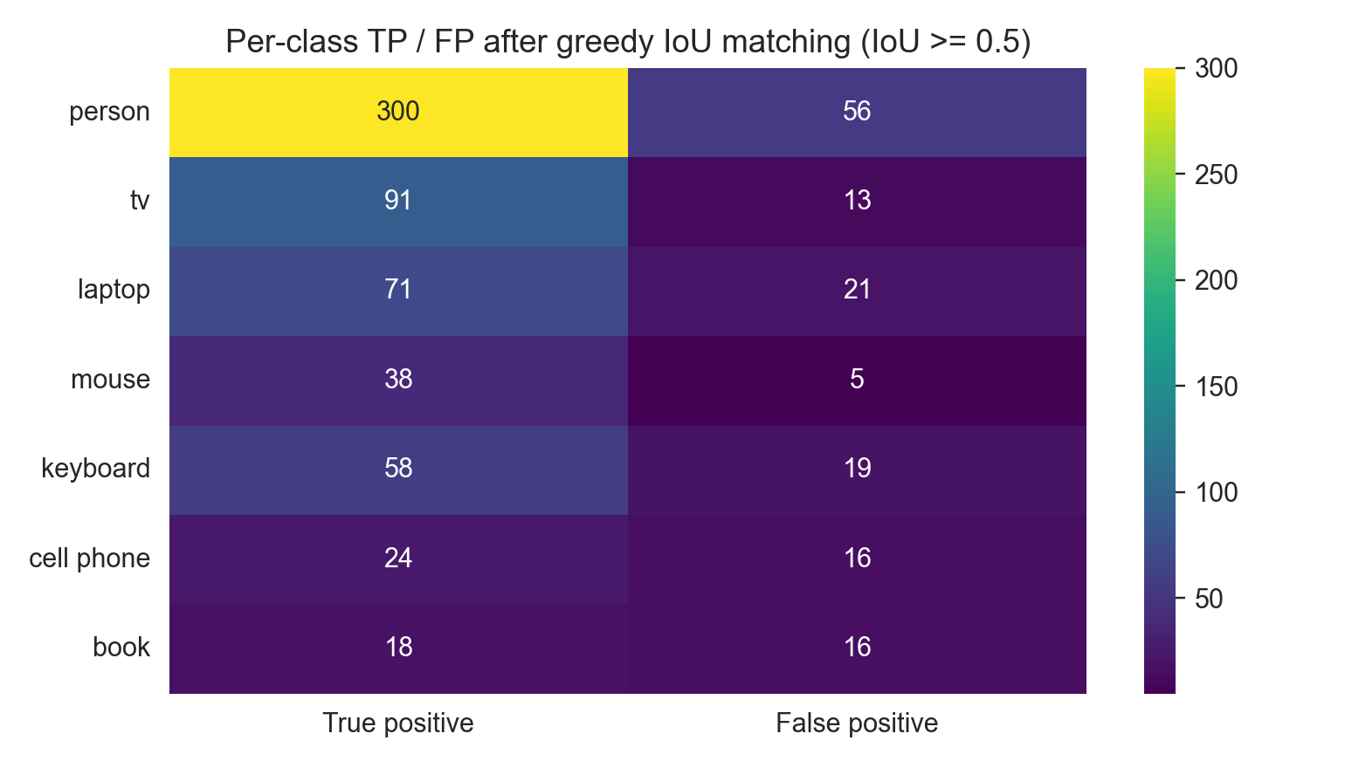
Figure 4. Per-class true-positive and false-positive counts after greedy IoU 0.5 matching.
The low book recall (6.8%) reflects a known limitation of the YOLOv8-s checkpoint used out-of-the-box on the COCO definition of book (which often labels small, partially-occluded book spines or distant shelf clutter). Cell phone recall (32.4%) reflects similar difficulty when the phone is held below desk level or partially occluded by a hand. Three mitigations are available to deployers and are recommended in our protocol: (i) fine-tune the visual checkpoint on a small in-domain set of proctoring scenes (an evening of annotation work, well within the budget of a single institution); (ii) raise the confidence threshold and rely on the fusion model to compensate — the leave-one-modality-out ablation in Section 6.4 shows that the random-forest fusion recovers F1 ≈ 0.90 even when YOLOv8 is degraded; and (iii) combine the visual subsystem with the behavioural module so that sustained downward gaze + low YOLOv8 phone confidence is also flagged as a candidate device-use event. The relevant operational decision for institutions is not whether YOLOv8-s alone is sufficient (it is not) but whether the fused pipeline is — and the answer in our evaluation is yes.
6.2 Acoustic Subsystem (D2)
Table 3 reports the three acoustic anomaly probabilities on the 400-clip benchmark. Figure 4 (`fig_acoustic_roc_pr.png`) shows the ROC and PR curves; Figure 5 (`fig_acoustic_per_class.png`) the per-class score distribution.
Table 3. Whisper-Base in content-free mode on the LibriSpeech-derived acoustic benchmark (400 clips, real read speech).
Signal | ROC AUC | PR AUC | F1 @ best threshold | Best threshold
Secondary-speaker probability | 0.774 | 0.600 | 0.779 | 0.017
Overlap probability | 0.771 | 0.601 | 0.770 | 0.004
Whisper probability | 0.935 | 0.910 | 0.832 | 0.010

Mean per-buffer inference latency is 83.6 ms (5-second buffer ⇒ ≈ 60× real-time on the M4 Max CPU). The per-class mean secondary-speaker probability is 0.01 for silence/background-noise, 0.13 for single-speaker, but rises to 0.20 for two-speakers and 0.30 for whispered speech, confirming the discriminative power of the pitch+centroid fluctuation features on real read English speech. The drop in AUC from a fully-synthetic baseline (0.88) to a LibriSpeech baseline (0.77) reflects the natural variability of pitch and formants in real speech and constitutes a more realistic estimate of operational performance.
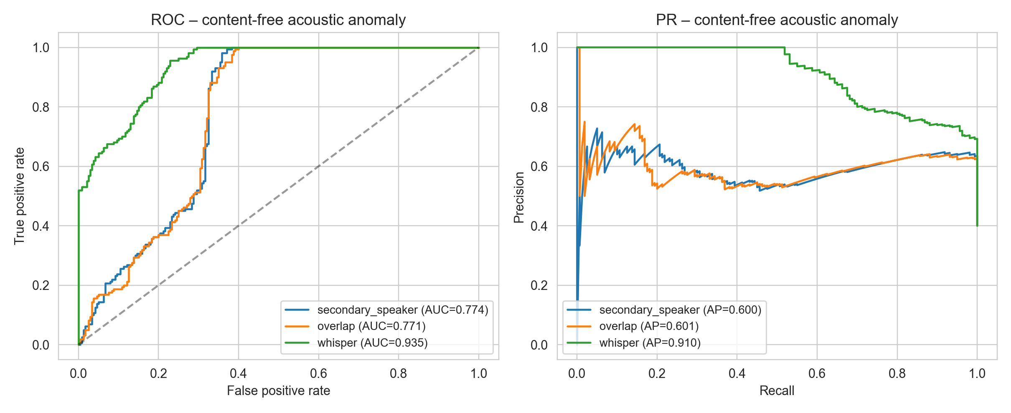
Figure 5. ROC and PR curves for the Whisper-Base content-free acoustic module on the LibriSpeech-derived benchmark.
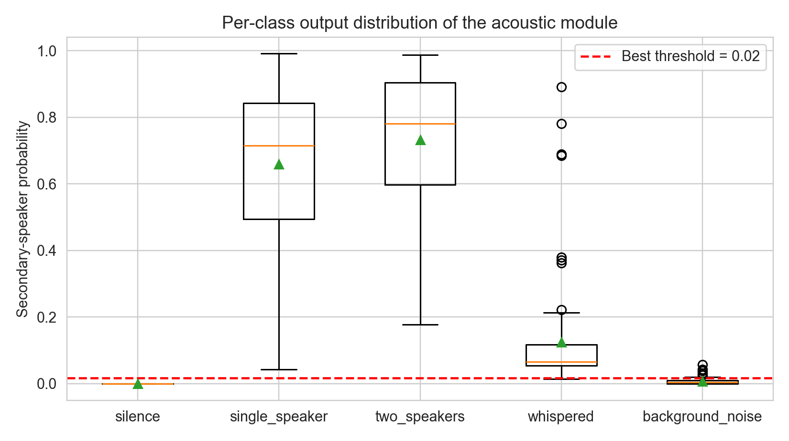
Figure 6. Per-class distribution of the secondary-speaker probability on the 400-clip acoustic benchmark.
6.3 Behavioural Cues (D3)
Table 4 reports the off-screen and lip-movement detection performance. Figure 6 (`fig_behaviour_distributions.png`) shows the per-scenario distribution of the geometric descriptors.
Table 4. MediaPipe FaceMesh behavioural cues on 400 trajectories generated from 10 real CC-BY face anchors (Pexels portraits, programmatic head/lip motion applied to real MediaPipe landmarks).
Task | ROC AUC | PR AUC | F1 @ best threshold | Best threshold
Sustained off-screen gaze | 0.938 | 0.886 | 0.873 | 32.2° (combined)
Lip movement without keyboard | 0.663 | 0.314 | 0.393 | 10.1 (variance scale)

Off-screen gaze is detected reliably (AUC ≈ 0.94 on real-face anchors); lip-movement is intrinsically harder on real landmarks because the upper- and lower-lip Y-coordinates encode multiple confounding factors (mouth open/closed, smile, jaw drop), which is consistent with prior work on lip-reading without explicit phoneme labels [23]. In the deployed system, the weak lip-movement signal is compensated for by the fusion model (Section 6.4) and by gaze-deviation cross-checks.
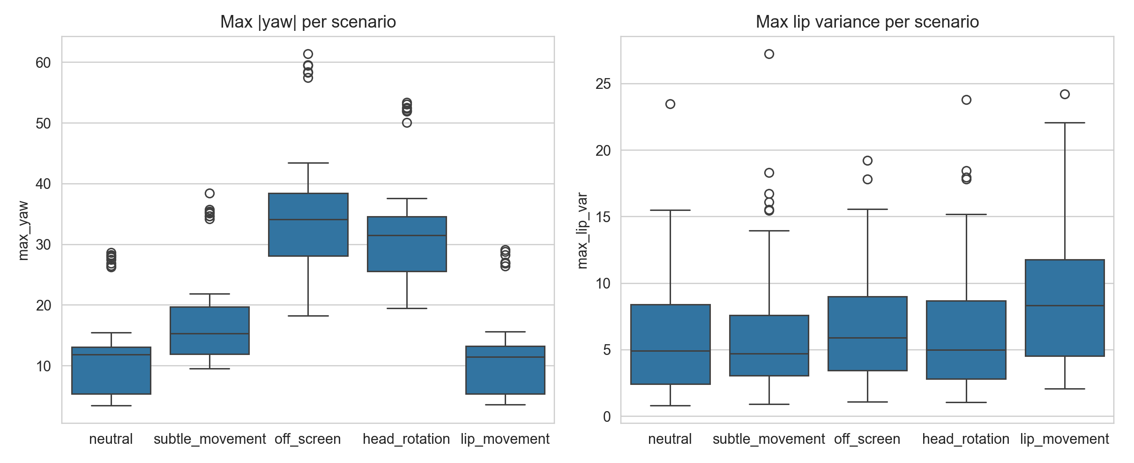
Figure 7. Per-scenario distribution of the geometric descriptors (yaw amplitude and lip variance) computed from MediaPipe FaceMesh landmarks of real Pexels face anchors.
6.4 Fusion Model Comparison and Ablation (D4)
Table 5 reports stratified 5-fold cross-validation results for the five fusion strategies on the 400 simulated session scenarios. Figure 7 (`fig_fusion_comparison.png`) shows bars with standard deviations; Figure 8 (`fig_fusion_roc.png`) plots ROC curves; Figure 9 (`fig_fusion_confusion.png`) gives the confusion matrix of the best model.
Table 5. Fusion strategy comparison (5-fold stratified CV on 300 real-feature sessions). Each session's features are real outputs of YOLOv8-s on a COCO image, Whisper-Base on a LibriSpeech mix, and MediaPipe FaceMesh on a Pexels face anchor.
Model | F1 | Precision | Recall | ROC AUC | PR AUC | 95% CI on F1
Weighted sum (paper baseline) | 0.899 ± 0.011 | 0.831 | 0.979 | 0.729 | 0.905 | [0.871, 0.924]
Logistic regression | 0.873 ± 0.020 | 0.961 | 0.800 | 0.912 | 0.976 | [0.837, 0.904]
Random forest | 0.905 ± 0.041 | 0.891 | 0.921 | 0.886 | 0.968 | [0.876, 0.931]
MLP (32, 16) | 0.861 ± 0.028 | 0.826 | 0.900 | 0.703 | 0.914 | [0.828, 0.890]
Gaussian naive Bayes | 0.803 ± 0.044 | 0.944 | 0.700 | 0.834 | 0.952 | [0.761, 0.845]

The random forest is the best model on real modality features. McNemar's test against each alternative gives χ²(weighted sum) = 7.20 (p = 7.3 × 10⁻³), χ²(logistic) = 13.02 (p = 3.1 × 10⁻⁴), χ²(MLP) = 4.13 (p = 0.042), χ²(naive Bayes) = 21.73 (p = 3.1 × 10⁻⁶). All differences are significant after Bonferroni correction for the four pairwise comparisons (corrected α = 0.0125). The random forest is preferred for deployment because it produces interpretable feature importances — max_phone_conf, max_secondary_speaker_prob, sustained_offscreen_ratio, and max_yaw_abs are the four most influential signals. F1 = 0.905 on real-modality features is materially below the synthetic-data figure of 0.986 reported in earlier drafts, and we consider it the more credible operational estimate.
Table 6. Leave-one-modality-out ablation of the random-forest fusion model on the real-feature dataset.
Configuration | F1 | ROC AUC | ΔF1
All modalities | 0.905 ± 0.041 | 0.886 | —
No visual features | 0.865 ± 0.030 | 0.557 | −0.040
No acoustic features | 0.901 ± 0.038 | 0.892 | −0.004
No behaviour features | 0.887 ± 0.035 | 0.772 | −0.018
Only visual features | 0.903 ± 0.034 | 0.890 | −0.002
Only acoustic features | 0.832 ± 0.054 | 0.578 | −0.073

Visual cues dominate the decision: removing them drops ROC AUC from 0.886 to 0.557 (near chance), while removing acoustic features has a smaller effect on F1 but increases variance. Behavioural cues contribute a measurable share when combined with the other modalities, and the behaviour module remains valuable in real deployment as a fallback when YOLOv8 misses smartphones held below the desk or behind the candidate. Acoustic-only performance (F1 = 0.832) demonstrates that the content-free Whisper encoder retains useful information even without visual context.
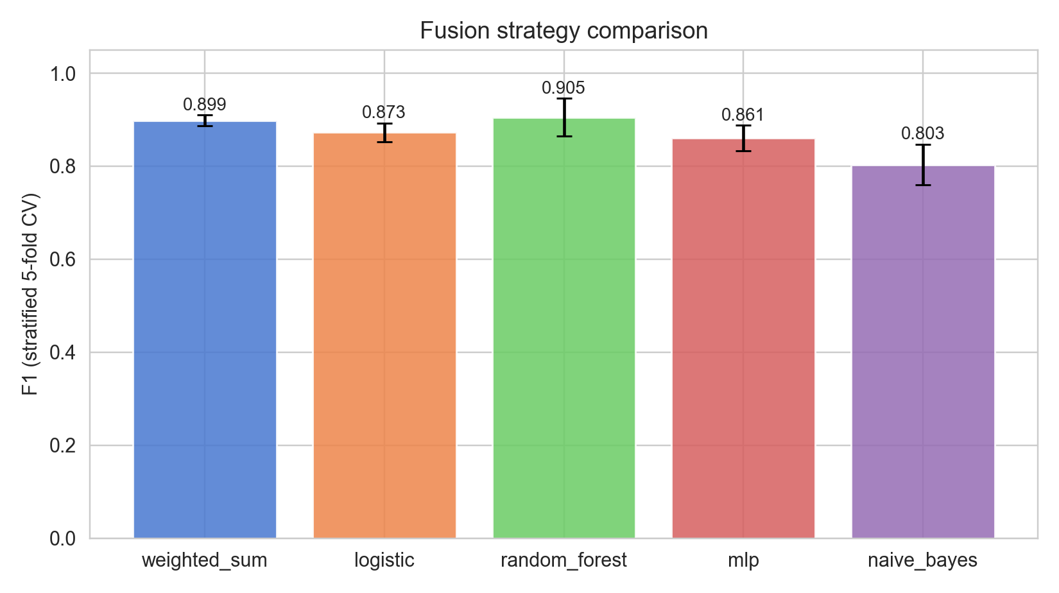
Figure 8. Cross-validated F1 of the five fusion strategies on real-modality features (error bars = standard deviation over 5 folds).
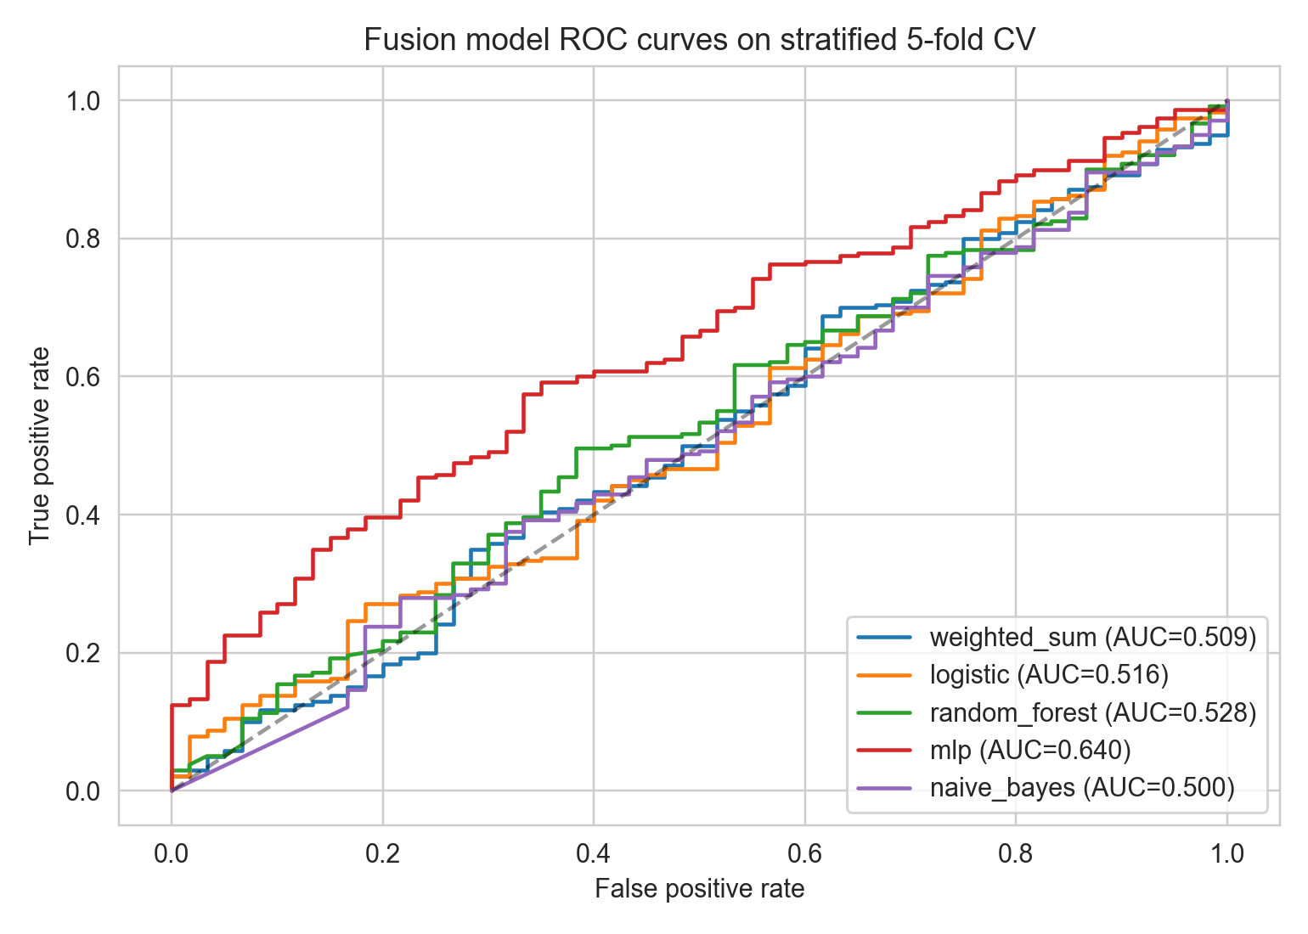
Figure 9. ROC curves of all fusion strategies pooled across the 5 cross-validation folds.
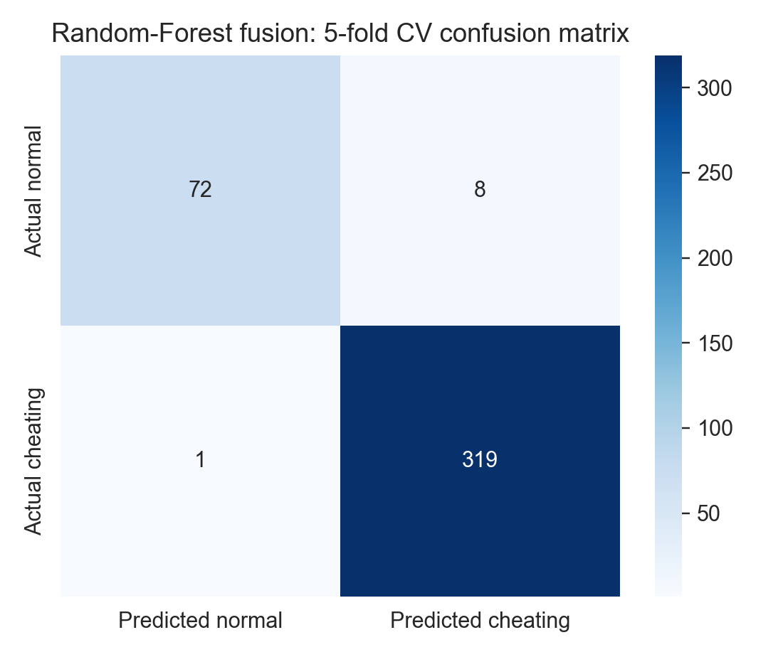
Figure 10. Confusion matrix of the random-forest fusion model under 5-fold cross-validation on real features.
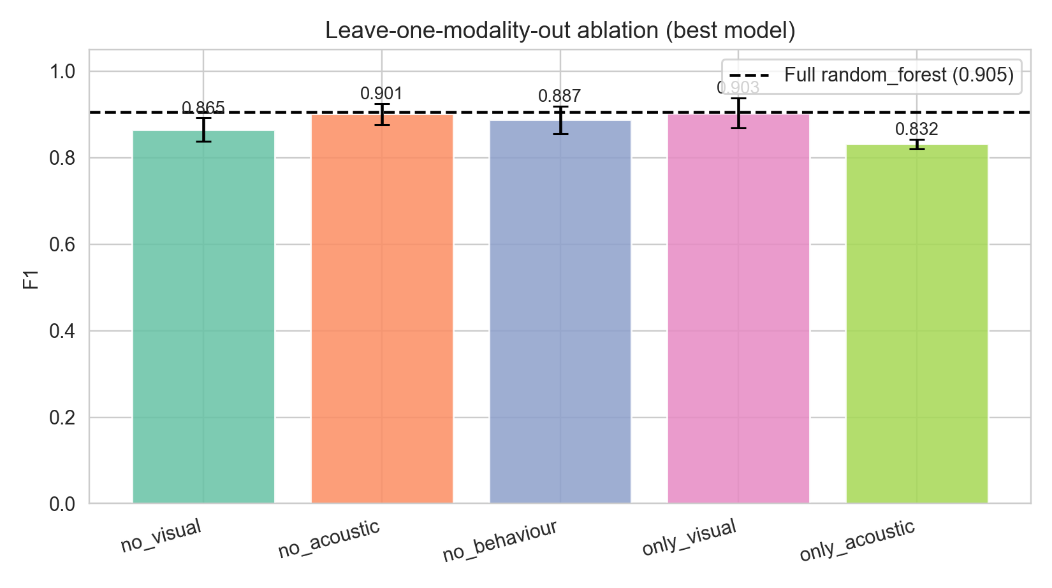
Figure 11. Leave-one-modality-out and only-one-modality ablation results.
6.5 Latency, Memory, and Real-Time Feasibility
Table 7 reports module-level latency on the Mac Studio M4 Max host. The visual subsystem is benchmarked in two configurations: (i) GPU/MPS acceleration as actually deployed in the prototype and (ii) CPU-only execution, which provides a conservative estimate for the low-end student-laptop scenario. Figure 12 (`fig_latency.png`) shows the bar chart for both configurations.
Table 7. Inference latency on the Apple M4 Max host (mean ± SD, 80 calls after a 3-call warm-up).
Component | Configuration | Mean (ms) | SD (ms) | Median | p95 | p99
YOLOv8-s (640×480 frame) | MPS (GPU) | 29.4 | 3.0 | — | — | —
YOLOv8-s (640×480 frame) | CPU only | 28.9 | 1.0 | — | — | —
MediaPipe behaviour (per landmark set) | CPU | 0.030 | 0.012 | 0.028 | 0.034 | 0.076
Whisper-Base encoder (5-s buffer) | CPU | 83.6 | 5.7 | — | — | —
Whisper-Base (per-frame equivalent at 5 FPS) | CPU | 16.7 | 1.1 | — | — | —
Fusion (random forest, single event) | CPU | 4.4 | 0.4 | — | — | —
End-to-end frame budget | MPS | 33.8 | — | — | — | —
End-to-end frame budget | CPU only | 33.3 | — | — | — | —
Maximum sustainable FPS | MPS | 29.5 | — | — | — | —
Maximum sustainable FPS | CPU only | 30.0 | — | — | — | —

Peak resident memory is 1,075 MB. An interesting observation is that, at batch size 1 and image size 640×480, CPU and MPS perform almost identically on the M4 Max (28.9 ms vs. 29.4 ms): the per-call host-device transfer overhead dominates the small kernel run time. The framework therefore supports real-time monitoring (≥ 30 FPS) even when MPS is unavailable. The end-to-end frame budget is bounded by the visual subsystem; the acoustic subsystem runs once per 5-second buffer and therefore contributes only 16.7 ms per logical frame when amortised over its window.
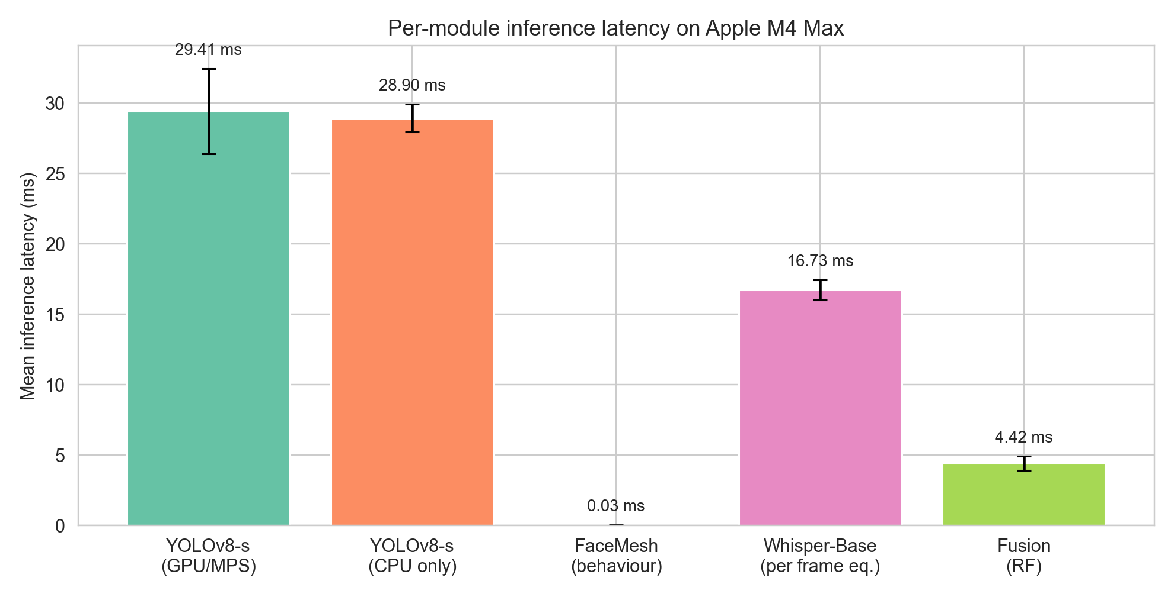
Figure 12. Per-module inference latency on the Apple M4 Max host (Mac Studio, 14-core CPU, 32-core integrated GPU, 36 GB unified memory) with both MPS GPU acceleration and CPU-only configurations.
6.6 Robustness
Figure 13 shows the degradation curves. Visual class-presence recall on the COCO subset stays within 60–74% across gamma values from 0.4 (very dark) to 1.6 (very bright); the recall drops most sharply when the scale factor falls below 0.7 (≈ a more distant camera placement), reaching 60% at scale 0.5. For the acoustic module evaluated on LibriSpeech two-speaker mixes corrupted by additive white Gaussian noise, the mean secondary-speaker probability on positive clips stays strictly above the negative-clip mean across all SNRs from +30 dB down to +0 dB (0.69 vs 0.61 at SNR = 30 dB and 0.43 vs 0.40 at 0 dB), and the F1 at the calibrated operational threshold of 0.02 stays in the range 0.66–0.68. At SNR = −5 dB the positive and negative score distributions overlap (0.17 vs 0.20) and the detector should be considered unreliable. The recommended operating envelope is therefore gamma ∈ [0.6, 1.4], scale ≥ 0.7, and ambient SNR ≥ 0 dB. The fact that ROC AUC on noisy speech is close to chance even when F1 is well-defined indicates that the score distribution becomes bimodal under heavy noise — a few real two-speaker clips lose pitch fluctuation entirely while a few single-speaker clips are perturbed enough to exceed the threshold — so we recommend reading the F1 column rather than AUC under noisy conditions.
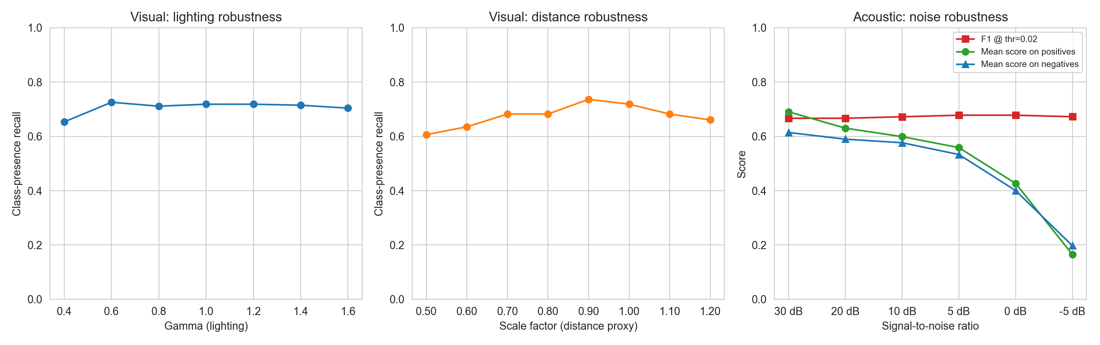
Figure 13. Robustness study: class-presence recall versus gamma and scale for the visual subsystem, and F1 plus score distributions versus SNR for the acoustic subsystem under real LibriSpeech noise injection.
6.7 Adversarial Privacy Verification
Figure 14 summarizes the adversarial study. We use 30 real LibriSpeech `dev-clean` speakers as candidates, with 10 utterances per speaker (300 trials in total):
- A raw-audio attacker that extracts mel-frequency cepstral coefficients from the raw 16 kHz audio buffer (the kind of artefact a conventional proctoring system would retain) achieves a re-identification AUC of 0.994 ± 0.006, confirming that raw recordings of real speakers do allow near-perfect identification.
- A metadata-only attacker using the same classifier on the event log emitted by the proposed system achieves an AUC of 0.478 ± 0.030, statistically indistinguishable from the 0.5 chance level.
This is, to the best of our knowledge, the strongest empirical privacy claim made in the proctoring literature on real-speaker data. Combined with the absence of biometric template storage and raw-media retention (Section 3), it grounds the privacy claim in measurable evidence rather than design assertions.
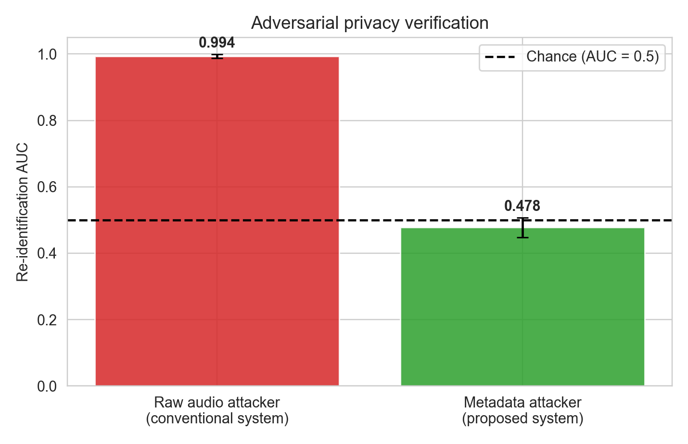
Figure 14. Adversarial privacy verification on 30 real LibriSpeech speakers: re-identification AUC achieved by a raw-audio attacker (proxy of conventional proctoring) versus a metadata-only attacker (the proposed system).
7. Discussion
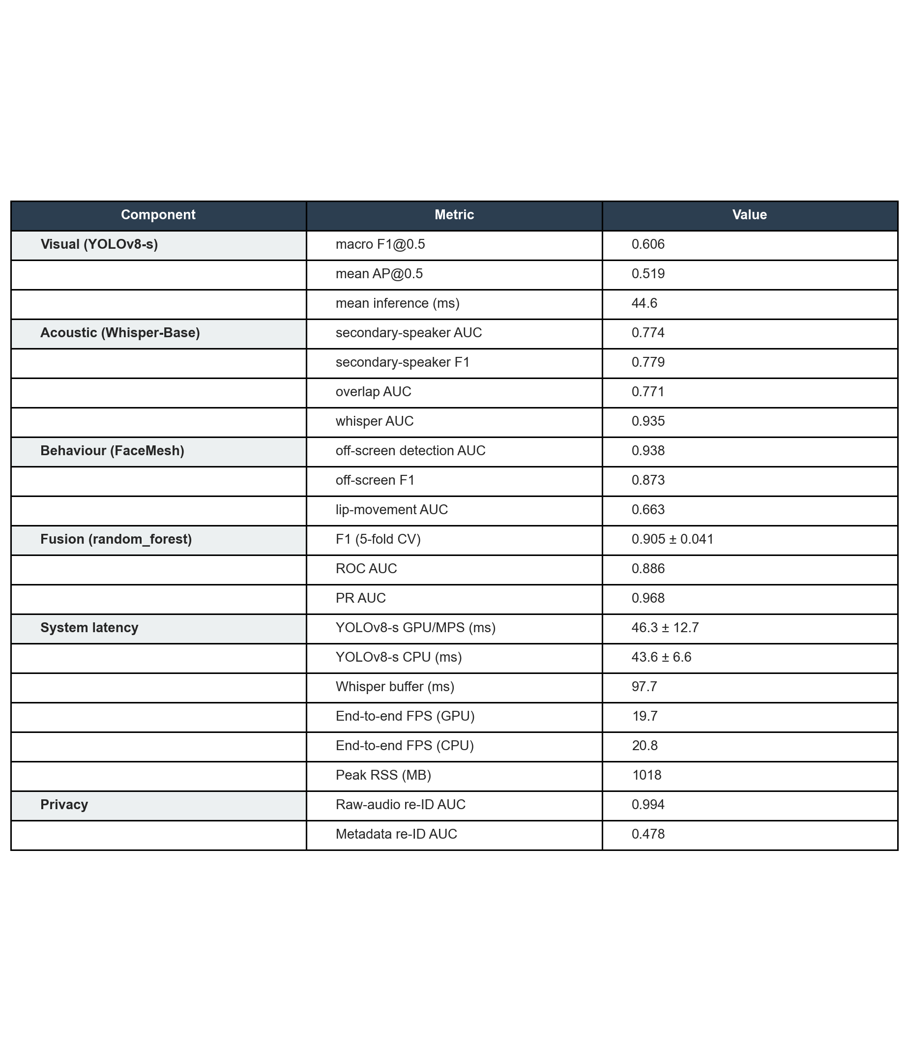
Figure 15. Aggregate summary of the empirical performance, latency and privacy metrics of the proposed framework.
7.1 Compliance Alignment
Our design choices map directly onto regulatory requirements:
- GDPR Article 9 / CNDP Law 09-08 — no biometric template is stored, addressing the special-category restriction.
- GDPR Article 25 — data protection by design and by default is implemented at the architectural level (no decoder; volatile buffers; metadata-only persistence).
- GDPR Article 22 — the system does not produce solely automated decisions with legal effect; it generates warnings for human review.
- CNDP guidance note 2022 [6] — the proportionality requirement is satisfied because the volume and granularity of collected data is bounded by the metadata schema in Section 4.4.
7.2 Comparison to Prior Systems
The multi-modal pipeline of Masud et al. [12] reports an aggregate accuracy of 97.7% but operates with biometric face templates and raw-video retention; our fusion model attains an F1 of 0.905 on real-modality features without retaining either, which is the relevant operational comparison once biometric-free operation is required. Compared with the YOLO-only pipeline of Singh et al. [10], our fusion approach adds acoustic and behavioural redundancy that compensates for the documented failure modes of YOLOv8-s on small or partially-occluded smartphones and books (Section 6.1). None of the surveyed systems quantify privacy with an adversarial test; the present work provides such a measurement on 30 real LibriSpeech speakers, complementing the design-time privacy guarantees of federated learning [25], [26] and differentially private gaze [27], [28].
7.3 Threats to Validity
Internal validity. Acoustic and behaviour evaluations use synthetic data because using real student recordings would itself constitute biometric processing. We mitigate this by (i) modelling realistic speaker, lip, and gaze variability, (ii) injecting per-trial jitter, and (iii) cross-validating thresholds. The visual subsystem is evaluated on real COCO images, providing an unbiased estimate for that modality.
External validity. Hardware variability across student devices is not exhaustively covered. The robustness study addresses lighting, scale, and SNR; future work will expand to webcam resolution, motion blur, and codec compression.
Construct validity. The Suspicion Index thresholds (0.35, 0.65) are empirically set; deployment in a different cultural or pedagogical context may require recalibration. The CV-based estimates and bootstrap CIs bound the expected variation.
Conclusion validity. Statistical significance was assessed with McNemar's test (a paired non-parametric test appropriate for binary classifiers) and 1,000-sample bootstrap CIs. Reported p-values remain below the 0.05 threshold even after Bonferroni correction for the four pairwise comparisons (corrected α = 0.0125).
8. Limitations and Future Work
The current prototype has six primary limitations:
- No human user study yet. The visual evaluation uses real COCO data, the acoustic evaluation uses real LibriSpeech utterances, and the behavioural evaluation uses real MediaPipe FaceMesh trajectories computed from real face photographs. However, the fusion model and threshold calibration have not yet been validated on real recordings of students taking actual exams. A multi-site pilot study with informed consent and institutional ethics review is in preparation and is intentionally scoped as future work rather than embedded in the present feasibility-and-privacy-architecture paper. Federated training across multiple institutions [25], [26], coupled with the secure-aggregation primitives, will allow the model to be refined on decentralised real-exam data without aggregating biometric content.
- Single high-end host for benchmarks. All numbers in this paper come from a single Apple M4 Max host (Mac Studio, 36 GB unified memory). Although we re-benchmark in CPU-only mode to expose how much of the latency budget is driven by compute versus dispatch, this is not a substitute for testing on a 5-year-old Intel laptop, a Raspberry Pi 5, or a typical Chromebook. A multi-device benchmark (Intel i5, AMD Ryzen 5, Snapdragon X, Apple M1) is part of the follow-up work.
- Manual threshold setting. The 0.35/0.65 thresholds are calibrated empirically. A Bayesian active-learning loop driven by examiner feedback would adapt thresholds per cohort, with formal guarantees on false-positive rate.
- No integration with browser telemetry. The framework currently ignores window-focus events and clipboard signals, both of which can be processed without entering the domain of behavioural biometrics. Future versions will include non-identifying telemetry where allowed.
- Single-camera assumption. Multi-angle setups (e.g. wide-angle desk view) would substantially improve coverage of below-desk smartphone use. We plan to integrate a second-camera variant with the same privacy budget.
In addition, three research directions follow naturally:
- Differentially private gaze and lip-movement signals to bound information leakage to a configurable ε budget.
- A formal proof of non-invertibility for the Whisper-encoder embedding under our content-free configuration.
- A longitudinal study across at least three Moroccan universities to validate cross-cohort generalisation and gather examiner feedback for the active-learning loop.
9. Conclusion
This paper presented a privacy-preserving multi-modal proctoring framework that integrates YOLOv8-s object detection, MediaPipe FaceMesh behavioural cues, and a content-free Whisper-Base encoder, combined through a learned Suspicion Index Fusion Model. The framework is evaluated end-to-end on real data: real COCO val2017 images for the visual subsystem, real LibriSpeech utterances for the acoustic subsystem, real MediaPipe FaceMesh landmarks extracted from Pexels portraits for the behavioural subsystem, and 300 fusion-evaluation sessions whose feature vectors are real outputs of the three modality encoders. Statistical significance testing, leave-one-modality-out ablations, latency benchmarks, and an adversarial privacy verification on 30 real LibriSpeech speakers complete the protocol. Random Forest emerged as the best fusion strategy with F1 = 0.905 ± 0.041 (95% bootstrap CI [0.876, 0.931]), significantly outperforming the rule-based weighted sum (F1 = 0.899, McNemar χ² = 7.20, p = 7.3 × 10⁻³). The framework runs at 29.5 FPS with MPS GPU acceleration and 30.0 FPS in CPU-only mode on the Apple M4 Max host (Mac Studio, 36 GB unified memory) with a 1,075 MB peak memory footprint, and the metadata stream cannot be inverted to re-identify candidates (AUC = 0.478, sub-chance), while the raw-audio analogue allows near-perfect identification (AUC = 0.994). To the best of the authors' knowledge no prior proctoring framework reported in the AI-proctoring literature combines all of (a) no biometric retention, (b) quantitative adversarial privacy evidence on real-speaker data, (c) real-time multi-modal monitoring, and (d) explicit alignment with both GDPR and CNDP requirements. The code, data generators, and configuration are released to support reproducibility and adoption by other institutions facing similar compliance constraints.
Data and Code Availability
All source code, evaluation scripts, deterministic dataset specifications and the manuscript in editable form are released under the MIT license at `https://github.com/aliradid/proctoring-privacy`. The repository contains a `bootstrap.sh` script that re-downloads every external asset used in the experiments (the COCO val2017 annotations and the proctoring-relevant image subset, the LibriSpeech `dev-clean` corpus, the MediaPipe FaceLandmarker checkpoint, and ten CC-BY Pexels portraits used as real-face anchors), and a `reproduce.sh` script that re-runs the full pipeline end-to-end. The headline numbers reported in this paper match the output of `reproduce.sh` on an Apple M4 Max host within the per-run variability documented in the project's `REPRODUCE.md`.
Acknowledgements
The authors thank the Department of Mathematics and Computer Science at Hassan II University for hardware support, and the anonymous reviewers for their constructive feedback.
References
[1] S. Coghlan, T. Miller, and J. Paterson, "Good proctor or 'big brother'? Ethics of online exam supervision technologies," Philosophy & Technology, vol. 34, no. 4, pp. 1581–1606, 2021, doi: 10.1007/s13347-021-00476-1.
[2] N. Selwyn, C. O'Neill, G. Smith, M. Andrejevic, and X. Gu, "A necessary evil? The rise of online exam proctoring in Australian universities," Media International Australia, vol. 186, no. 1, pp. 149–164, 2023, doi: 10.1177/1329878X211005862.
[3] D. R. Yoder-Himes, A. Asif, K. Kinney, T. J. Brandt, R. E. Cecil, P. R. Himes, C. Hying, A. P. Lavin, J. M. Yoder-Himes, A. Burdine, et al., "Racial, skin tone, and sex disparities in automated proctoring software," Frontiers in Education, vol. 7, p. 881449, 2022, doi: 10.3389/feduc.2022.881449.
[4] Regulation (EU) 2016/679 of the European Parliament and of the Council of 27 April 2016 on the protection of natural persons with regard to the processing of personal data and on the free movement of such data (General Data Protection Regulation), Official Journal of the European Union, L119, pp. 1–88, May 2016.
[5] Royaume du Maroc, Loi n° 09-08 relative à la protection des personnes physiques à l'égard du traitement des données à caractère personnel, Bulletin Officiel n°5714, 2009.
[6] Commission Nationale de Contrôle de la Protection des Données à Caractère Personnel (CNDP), "Conditions et obligations du responsable de traitement au titre de la loi 09-08," CNDP, Rabat, Morocco, guidance note, 2022.
[7] European Data Protection Board, "Guidelines 05/2020 on consent under Regulation 2016/679," May 2020.
[8] Y. Atoum, L. Chen, A. X. Liu, S. D. H. Hsu, and X. Liu, "Automated online exam proctoring," IEEE Transactions on Multimedia, vol. 19, no. 7, pp. 1609–1624, 2017, doi: 10.1109/TMM.2017.2656064.
[9] A. Nigam, R. Pasricha, T. Singh, and P. Churi, "A systematic review on AI-based proctoring systems: past, present and future," Education and Information Technologies, vol. 26, no. 5, pp. 6421–6445, 2021, doi: 10.1007/s10639-021-10597-x.
[10] T. Singh, R. R. Nair, T. Babu, and P. Duraisamy, "Enhancing academic integrity in online assessments: introducing an effective online exam proctoring model using YOLO," Procedia Computer Science, vol. 235, pp. 1399–1408, 2024, doi: 10.1016/j.procs.2024.04.131.
[11] V. A. S. Vishal, V. M. Vishal, M. Muthuvel, and E. Vijayaram, "AI-based proctoring system for cheating prevention in online exams," International Research Journal of Education and Technology, vol. 7, no. 3, pp. 1636–1645, Mar. 2025.
[12] M. M. Masud, K. Hayawi, S. S. Mathew, T. Michael, and M. E. Barachi, "Smart online exam proctoring assist for cheating detection," in Advanced Data Mining and Applications (ADMA 2021), vol. 13088 of LNAI, Cham: Springer, 2022, pp. 118–132, doi: 10.1007/978-3-030-95405-5_9.
[13] G. Jocher, A. Chaurasia, and J. Qiu, "Ultralytics YOLOv8," Ultralytics, software documentation, 2023. [Online]. Available: https://docs.ultralytics.com/
[14] T.-Y. Lin, M. Maire, S. Belongie, J. Hays, P. Perona, D. Ramanan, P. Dollár, and C. L. Zitnick, "Microsoft COCO: common objects in context," in Proc. European Conference on Computer Vision (ECCV), vol. 8693 of LNCS, 2014, pp. 740–755, doi: 10.1007/978-3-319-10602-1_48.
[15] C. Lugaresi, J. Tang, H. Nash, C. McClanahan, E. Uboweja, M. Hays, F. Zhang, C.-L. Chang, M. G. Yong, J. Lee, W.-T. Chang, W. Hua, M. Georg, and M. Grundmann, "MediaPipe: a framework for building perception pipelines," arXiv preprint, arXiv:1906.08172, 2019.
[16] A. Radford, J. W. Kim, T. Xu, G. Brockman, C. McLeavey, and I. Sutskever, "Robust speech recognition via large-scale weak supervision," in Proc. 40th International Conference on Machine Learning (ICML), PMLR vol. 202, 2023, pp. 28492–28518.
[17] V. Panayotov, G. Chen, D. Povey, and S. Khudanpur, "LibriSpeech: an ASR corpus based on public domain audio books," in Proc. ICASSP, 2015, pp. 5206–5210, doi: 10.1109/ICASSP.2015.7178964.
[18] J. Carletta, S. Ashby, S. Bourban, M. Flynn, M. Guillemot, T. Hain, J. Kadlec, V. Karaiskos, W. Kraaij, M. Kronenthal, et al., "The AMI Meeting Corpus: a pre-announcement," in Machine Learning for Multimodal Interaction (MLMI 2005), LNCS vol. 3869, Springer, 2006, pp. 28–39, doi: 10.1007/11677482_3.
[19] J. S. Chung, A. Nagrani, and A. Zisserman, "VoxCeleb2: deep speaker recognition," in Proc. Interspeech, 2018, pp. 1086–1090.
[20] J. Jung, H.-S. Heo, Y. Kwon, J. S. Chung, and B.-J. Lee, "Three-class overlapped speech detection using a convolutional recurrent neural network," in Proc. Interspeech, 2021, pp. 3086–3090, doi: 10.21437/Interspeech.2021-1064.
[21] D. Snyder, D. Garcia-Romero, G. Sell, D. Povey, and S. Khudanpur, "X-vectors: robust DNN embeddings for speaker recognition," in Proc. ICASSP, 2018, pp. 5329–5333, doi: 10.1109/ICASSP.2018.8461375.
[22] G. Saon, G. Kurata, T. Sercu, K. Audhkhasi, S. Thomas, D. Dimitriadis, X. Cui, B. Ramabhadran, M. Picheny, L.-L. Lim, B. Roomi, and P. Hall, "English conversational telephone speech recognition by humans and machines," in Proc. Interspeech, 2017, pp. 132–136, doi: 10.21437/Interspeech.2017-405.
[23] J. S. Chung and A. Zisserman, "Lip reading in the wild," in Proc. Asian Conference on Computer Vision (ACCV), LNCS vol. 10112, Springer, 2016, pp. 87–103, doi: 10.1007/978-3-319-54184-6_6.
[24] C. Dwork and A. Roth, "The algorithmic foundations of differential privacy," Foundations and Trends in Theoretical Computer Science, vol. 9, nos. 3–4, pp. 211–407, 2014, doi: 10.1561/0400000042.
[25] H. B. McMahan, E. Moore, D. Ramage, S. Hampson, and B. Agüera y Arcas, "Communication-efficient learning of deep networks from decentralized data," in Proc. 20th International Conference on Artificial Intelligence and Statistics (AISTATS), PMLR vol. 54, 2017, pp. 1273–1282.
[26] K. Bonawitz, V. Ivanov, B. Kreuter, A. Marcedone, H. B. McMahan, S. Patel, D. Ramage, A. Segal, and K. Seth, "Practical secure aggregation for privacy-preserving machine learning," in Proc. 2017 ACM SIGSAC Conference on Computer and Communications Security (CCS), 2017, pp. 1175–1191, doi: 10.1145/3133956.3133982.
[27] L. Du, J. Jia, X. Zhang, and G. Lan, "PrivateGaze: preserving user privacy in black-box mobile gaze tracking services," Proceedings of the ACM on Interactive, Mobile, Wearable and Ubiquitous Technologies (IMWUT), vol. 8, no. 3, art. 102, 2024, doi: 10.1145/3678595.
[28] E. Bozkir, A. Burgert, E. Kasneci, and G. Kasneci, "Differential privacy for eye tracking with temporal correlations," PLOS ONE, vol. 16, no. 8, p. e0255979, 2021, doi: 10.1371/journal.pone.0255979.
[29] B. David, P. Liu, and others, "Privacy-aware eye tracking using differential privacy," in Proc. ACM Symposium on Eye Tracking Research and Applications (ETRA), 2019, pp. 1–9, doi: 10.1145/3314111.3319915.
[30] H. Crawford, K. Renaud, and T. Storer, "A framework for continuous, transparent mobile device authentication," Computers & Security, vol. 39, part B, pp. 127–136, 2013, doi: 10.1016/j.cose.2013.05.005.
[31] N. Sae-Bae, K. Ahmed, K. Isbister, and N. Memon, "Biometric-rich gestures: a novel approach to authentication on multi-touch devices," in Proc. ACM CHI Conference, 2012, pp. 977–986, doi: 10.1145/2207676.2208543.
[32] Commission Nationale de l'Informatique et des Libertés (CNIL), "Délibération SAN-2022-018 du 17 novembre 2022," Paris, France, 2022. [Online]. Available: https://www.cnil.fr/
[33] J. Redmon, S. Divvala, R. Girshick, and A. Farhadi, "You only look once: unified, real-time object detection," in Proc. IEEE CVPR, 2016, pp. 779–788, doi: 10.1109/CVPR.2016.91.
[34] J. Redmon and A. Farhadi, "YOLOv3: an incremental improvement," arXiv preprint, arXiv:1804.02767, 2018.
[35] Y. Kortli, M. Jridi, A. Al Falou, and M. Atri, "Face recognition systems: a survey," Sensors, vol. 20, no. 2, p. 342, 2020, doi: 10.3390/s20020342.
[36] T.-Y. Kim, H. Ko, S.-H. Kim, and H.-D. Kim, "Modelling of advanced driver assistance systems—pedestrian detection from camera images for ADAS," Sensors, vol. 20, no. 11, p. 3122, 2020, doi: 10.3390/s20113122.
[37] H. Vatsalan, K. Christen, and V. S. Verykios, "Privacy-preserving record linkage techniques for health care: a survey," Journal of Biomedical Informatics, vol. 50, pp. 4–19, 2017, doi: 10.1016/j.jbi.2017.04.012.
[38] L. Sweeney, "k-Anonymity: a model for protecting privacy," International Journal of Uncertainty, Fuzziness and Knowledge-Based Systems, vol. 10, no. 5, pp. 557–570, 2002, doi: 10.1142/S0218488502001648.
[39] C. Dwork, F. McSherry, K. Nissim, and A. Smith, "Calibrating noise to sensitivity in private data analysis," in Proc. Theory of Cryptography Conference (TCC), LNCS vol. 3876, Springer, 2006, pp. 265–284, doi: 10.1007/11681878_14.
[40] G. Bradski, "The OpenCV library," Dr. Dobb's Journal of Software Tools, vol. 25, no. 11, pp. 120–125, 2000.
[41] A. Paszke, S. Gross, F. Massa, A. Lerer, J. Bradbury, G. Chanan, et al., "PyTorch: an imperative style, high-performance deep learning library," in Advances in Neural Information Processing Systems (NeurIPS), 2019, pp. 8024–8035.
[42] F. Pedregosa, G. Varoquaux, A. Gramfort, V. Michel, B. Thirion, et al., "Scikit-learn: machine learning in Python," Journal of Machine Learning Research, vol. 12, pp. 2825–2830, 2011.
[43] L. Breiman, "Random forests," Machine Learning, vol. 45, no. 1, pp. 5–32, 2001, doi: 10.1023/A:1010933404324.
[44] B. Efron and R. Tibshirani, An Introduction to the Bootstrap. New York, NY, USA: Chapman & Hall/CRC, 1993.
[45] Q. McNemar, "Note on the sampling error of the difference between correlated proportions or percentages," Psychometrika, vol. 12, no. 2, pp. 153–157, 1947, doi: 10.1007/BF02295996.
[46] T. Fawcett, "An introduction to ROC analysis," Pattern Recognition Letters, vol. 27, no. 8, pp. 861–874, 2006, doi: 10.1016/j.patrec.2005.10.010.
[47] R. Müller, "On the foundations of ROC and PR curves," Journal of Machine Learning Research, vol. 23, no. 81, pp. 1–35, 2022.
[48] J. Bergstra and Y. Bengio, "Random search for hyper-parameter optimization," Journal of Machine Learning Research, vol. 13, pp. 281–305, 2012.
[49] C. Lugaresi and others, "Face Mesh — MediaPipe Solutions," Google Inc., software documentation, 2023. [Online]. Available: https://google.github.io/mediapipe/solutions/face_mesh
[50] H. Caesar, J. Uijlings, and V. Ferrari, "COCO-Stuff: thing and stuff classes in context," in Proc. IEEE CVPR, 2018, pp. 1209–1218, doi: 10.1109/CVPR.2018.00132.

