OpenSIEM-AI: A Reproducible Open-Source Reference Architecture for ML-Driven SIEM and Automated SOAR Containment

Ali Radid*, Mohamed Ghazouani, El Habib Benlahmar
Department of Mathematics and Computer Science, Hassan II University, Faculty of Sciences Ben M'Sik, Casablanca, Morocco
* Corresponding author. E-mail addresses: ali.radid-etu@etu.univh2c.ma (A. Radid), ghazouani.fsbm@gmail.com (M. Ghazouani), h.benlahmer@gmail.com (E.H. Benlahmar). ORCID: 0009-0007-6085-7064 (A. Radid)

Abstract
Most ML-augmented SIEM studies report detection scores in isolation, omit end-to-end pipeline latency, and rarely publish reproducible artefacts. This work addresses all three gaps with an open-source SIEM coupling supervised ML detection and automated SOAR response on a single-node Docker stack. A Filebeat → Kafka → Suricata → Logstash → Elasticsearch data plane is augmented by a Flask inference service hosting XGBoost (tabular events) or a bidirectional LSTM (sequence logs), plus three Wazuh-style playbooks (real iptables DROP, real TheHive case creation, simulated Azure AD account disable). Across four public corpora, tuned XGBoost obtains macro F1 of 0.7748 on the canonical NSL-KDD benchmark (KDDTrain+ → KDDTest+; ROC AUC 0.9694), significantly above a Random Forest baseline of 0.7606 (McNemar χ² = 194.86, p < 0.001), and 0.8625 on UNSW-NB15; the Bi-LSTM reaches 0.9945 on HDFS LogHub, while the harder Microsoft GUIDE triage corpus yields 0.6797 over 4.15 M test events. Under a sustained 100 events/s load the platform holds p95 ingest-to-ML-verdict latency at 619 ± 57 ms; 500 sequential SOAR cycles on an idle stack give p95 latency to a searchable alert of 1.05 s and p95 ingestion-to-containment of 1.16 s. An ablation isolates pure XGBoost inference at 3.5 ms p95, adding no latency resolvable above run-to-run variance, so the data plane rather than the model dominates. Complete indexing is verified up to 500 events/s. Code, Docker artefacts, and playbook stubs are released under Apache-2.0 at https://github.com/aliradid/siem-ai.
Keywords: SIEM; SOAR; machine learning; threat detection; XGBoost; LSTM

Introduction
Security Operations Centers (SOCs) depend on Security Information and Event Management (SIEM) platforms to collect, normalise, and correlate millions of system and network events each day. Despite their prevalence, legacy SIEMs that rely on static correlation rules suffer from two chronic problems: (i) alert overload, since analyst surveys and field studies consistently report that the majority of rule-triggered alerts are false positives [1], wasting investigator time; and (ii) slow incident handling, because detection stops at alerting and remediation is left to manual scripts or ticketing workflows [2].
To improve detection accuracy, recent research has explored machine-learning (ML) techniques ranging from unsupervised anomaly detection [3], [4] to deep neural networks for log and event analysis [5], [6], while vendors have introduced Security Orchestration, Automation and Response (SOAR) modules to script containment actions such as host quarantine or firewall blocking [7]. Yet few open-source systems integrate both ML-driven detection and automated response in a single deployable reference pipeline, and even fewer publish reproducible performance measurements.
To close this gap, we present an open-source, end-to-end SIEM that couples lightweight supervised ML models with a SOAR layer and measures the resulting detection accuracy and operational latency on a reproducible Docker stack. The platform augments a commodity Filebeat → Kafka → Suricata → Logstash → Elasticsearch stack (the reference single-node Docker testbed used for the reproducible benchmarks deploys the Logstash → ML → Elasticsearch sub-path that scores every event; Filebeat agents and Suricata are described as deployable add-ons). It inserts a Flask ML inference service that hosts an XGBoost classifier for tabular events and a bidirectional LSTM (Bi-LSTM) for sequential logs, and wires its verdicts to Wazuh-style Active Response playbooks (IP quarantine, account disable, case creation) whose end-to-end latency is measured in Section 6.2.
The main contributions of this work are:
- Modular architecture: ML inference is inserted between Logstash and Elasticsearch without disrupting log throughput.
- Automated containment: ML verdicts trigger Wazuh-style Active Response playbooks (iptables DROP, TheHive case creation, account disable) whose end-to-end latency is measured in Section 6.2 (p95 1.16 s across 500 cycles).
- Reproducible evaluation: every metric in Section 5 is regenerated by the released scripts from public NSL-KDD, Microsoft GUIDE, HDFS LogHub, and UNSW-NB15 datasets. The XGBoost classifier reaches 77.56 % accuracy on the canonical NSL-KDD benchmark (KDDTrain+ → KDDTest+; ROC AUC 0.9694; macro F1 0.7748) and 0.8625 macro F1 on the more recent UNSW-NB15 (82 332 test events); the Bi-LSTM reaches 0.9945 macro F1 on HDFS; on the harder Microsoft GUIDE 3-class triage corpus we report 0.6797 macro F1.
- Open-source release: All code, Docker artefacts, experiment scripts, benchmark outputs, and SOAR playbook stubs are released under Apache-2.0 for independent verification and extension.
- Generalisation across intrusion detection system (IDS) benchmarks: we re-train the same XGBoost pipeline, with max_depth 8 and subsample 0.8 for this corpus, on the more recent UNSW-NB15 benchmark and report 0.8685 accuracy / 0.8625 macro F1 / 0.9814 ROC AUC on the provided 82 332-event test split, complementing the canonical NSL-KDD result of 0.7748 macro F1 (KDDTrain+ → KDDTest+, which contains 17 attack types absent from training).
- Latency ablation: pure XGBoost inference has a p95 latency of 3.5 ms, and inserting ML scoring into the Logstash → Elasticsearch pipeline adds no overhead resolvable above run-to-run variance (p95 568 ms with ML vs 606 ms without, one run per variant). The data plane, not the model, is the bottleneck.
- Scaling envelope: a 100–1 000 events/s stress test verifies complete indexing up to 500 events/s and records a mean offered rate of 958 events/s at a 1 000 events/s target (5 reps; Table 11). The natural production upgrades are a partitioned Logstash worker pool sized to inference concurrency, multi-broker Kafka, and sharded Elasticsearch.
The rest of this paper is organised as follows: Section 2 surveys related work in ML-enhanced SIEMs and SOAR frameworks; Section 3 details the system architecture; Section 4 describes the datasets and experimental methodology; Section 5 reports the empirical results; Section 6 discusses limitations and future work; and Section 7 concludes.

Related work
This section reviews four research streams that reinforce modern SIEM evolution: (i) rule-based correlation, (ii) machine learning (ML) intrusion detection, (iii) Security Orchestration, Automation and Response (SOAR), and (iv) integrated ML SIEM platforms. We emphasise recent work where available, while retaining foundational anomaly-detection and log-analysis references.

Rule-based SIEM correlation
Classic SIEMs such as ArcSight ESM, IBM QRadar, and Splunk ES all correlate heterogeneous logs via static rules crafted by analysts [8], [9], [10]. Practitioner surveys report alert overload as a dominant operational burden, with 55 % of surveyed organisations citing too many false positives [1]; a qualitative study of SOC analysts further finds that most triaged alerts are dismissed as not worth escalating, although many of these are benign true positives rather than detector errors [11]. Both inflate mean time to respond (MTTR) and foster analyst fatigue. Recent work on Hyperscan-optimised correlation engines [12] boosts rule-matching throughput several-fold, yet alert quality remains tied to human-written signatures.

Machine learning-enhanced detection
Unsupervised methods. Isolation Forests [3], One-Class SVMs, Local Outlier Factor, and deep autoencoders detect rare log patterns without labelled data; comparative evaluation of classical unsupervised detectors on multivariate corpora shows that no single algorithm dominates across datasets [4]. They trade interpretability for the ability to flag rare events without supervision and are typically applied as a complement to, not a replacement for, supervised pipelines.
Supervised methods. Tree-ensemble methods (bagging-based Random Forest and gradient-boosted XGBoost) [13], [14] achieve macro F1 in the 0.75–0.85 range on the canonical NSL-KDD benchmark (KDDTrain+ → KDDTest+) and 0.85–0.93 on UNSW-NB15; the present work reproduces these envelopes (Tables 5–7) and adds a measured scaling profile in Section 6.2. Deep neural-network approaches [15], [16], [17], [18] extend this lead: feed-forward networks operating on engineered event profiles report high detection accuracy on similar corpora [5], and DeepLog-style sequence models on logs — unidirectional next-key predictors [6], bidirectional LSTMs [19], attention-augmented recurrent models [20], and transformer-based detectors [21], [22] — reach F1 in the 0.96-0.99 range on HDFS-like trace datasets. Despite these gains, the majority of studies remain offline and omit the latency or resource-use metrics that matter for SOC adoption.

Security orchestration, automation and response (SOAR)
SOAR suites, increasingly mapped to the MITRE ATT&CK framework [23], [24], convert alerts into automated playbooks that can block IPs, disable user accounts, or open tickets. Industry market research attributes substantial MTTR reductions to mature SOAR deployments [7]. Commercial products (Palo Alto Cortex XSOAR, IBM Resilient, Splunk SOAR) integrate tightly with their vendor SIEMs, while open-source alternatives (TheHive/Cortex, Wazuh Active Response) expose REST APIs but rely on upstream alert fidelity; prior work [25], [26] highlights the persistent gap in end-to-end orchestration measurement and cross-organisation incident sharing.

Integrated ML SIEM platforms
A handful of recent efforts combine machine-learning-driven detection with automated response in a single end-to-end pipeline. Table 1 compares six representative prior systems alongside our work on their detection method, datasets, automation mechanism, and reported benefits.
- Representative ML, SIEM, SOAR, and log-anomaly studies.
Study (year) | Detection | Datasets | Automation | Reported Benefits
Page et al. (2024) [27] | Random Forest + XGBoost | SIEM event logs | Email alerts | Reduced false-alarm rate (paper-reported)
Sheeraz et al. (2024) [12] | Signature engine (Hyperscan) | Synthetic HTTP traffic | – | Correlation throughput improvement
Goldstein & Uchida (2016) [4] | Unsupervised (LOF, k-NN, HBOS, ...) | 10 multivariate corpora | – | Comparative evaluation of 19 algorithms
Kolosnjaji et al. (2016) [28] | CNN + LSTM | Malware system-call traces | – | Detection on system-call sequences
Liu et al. (2023) [29], building on the attention architecture of [30] | Transformer (graph) | Dynamic graphs | – | Anomaly detection in evolving graphs
Guo et al. (2021) [31] | BERT (LogBERT) | HDFS, BGL log corpora | – | Pre-trained transformer for log anomaly
This Work (2026) | XGBoost + Bi-LSTM | NSL-KDD, UNSW-NB15, GUIDE, HDFS | iptables (real) / TheHive (real, REST) / Azure disable (simulated stub), 500 cycles | NSL F1 0.7748 (canonical KDDTest+); UNSW F1 0.8625; HDFS F1 0.9945; GUIDE F1 0.6797; ablation: no ML overhead above noise

Positioning of this work
The survey reveals three persistent gaps: (i) single dataset evaluations limit external validity, (ii) end-to-end latency including SOAR execution is rarely measured, and (iii) code artefacts are seldom released. Our work addresses all three by: (a) integrating supervised and sequence-based models into an open-source Elasticsearch/Logstash/Kibana (ELK)-based pipeline, (b) instrumenting both detection and containment latency on a reproducible Docker stack (Section 6.2), and (c) publishing Docker artefacts and experiment scripts for full reproducibility.

System architecture
Our AI-powered SIEM is built from open-source components and organised into eight loosely coupled layers (Fig. 1; Sections 3.1–3.8) that together deliver real-time detection, durable log storage, analyst visualisation, and automated response.
Threat model. The pipeline assumes a passive collection vantage point: logs from monitored hosts (Filebeat) and network sensors (Suricata) are forwarded to a Kafka broker that the adversary cannot tamper with. The ML inference layer and SOAR playbooks operate within the SOC trust boundary; an attacker who has already compromised the broker, the inference service, or the Wazuh manager is out of scope. We further assume that the model training data is curated by the SOC and not under adversarial control. Adversarial input perturbations against the deployed classifier are noted as future work (Section 6.5).
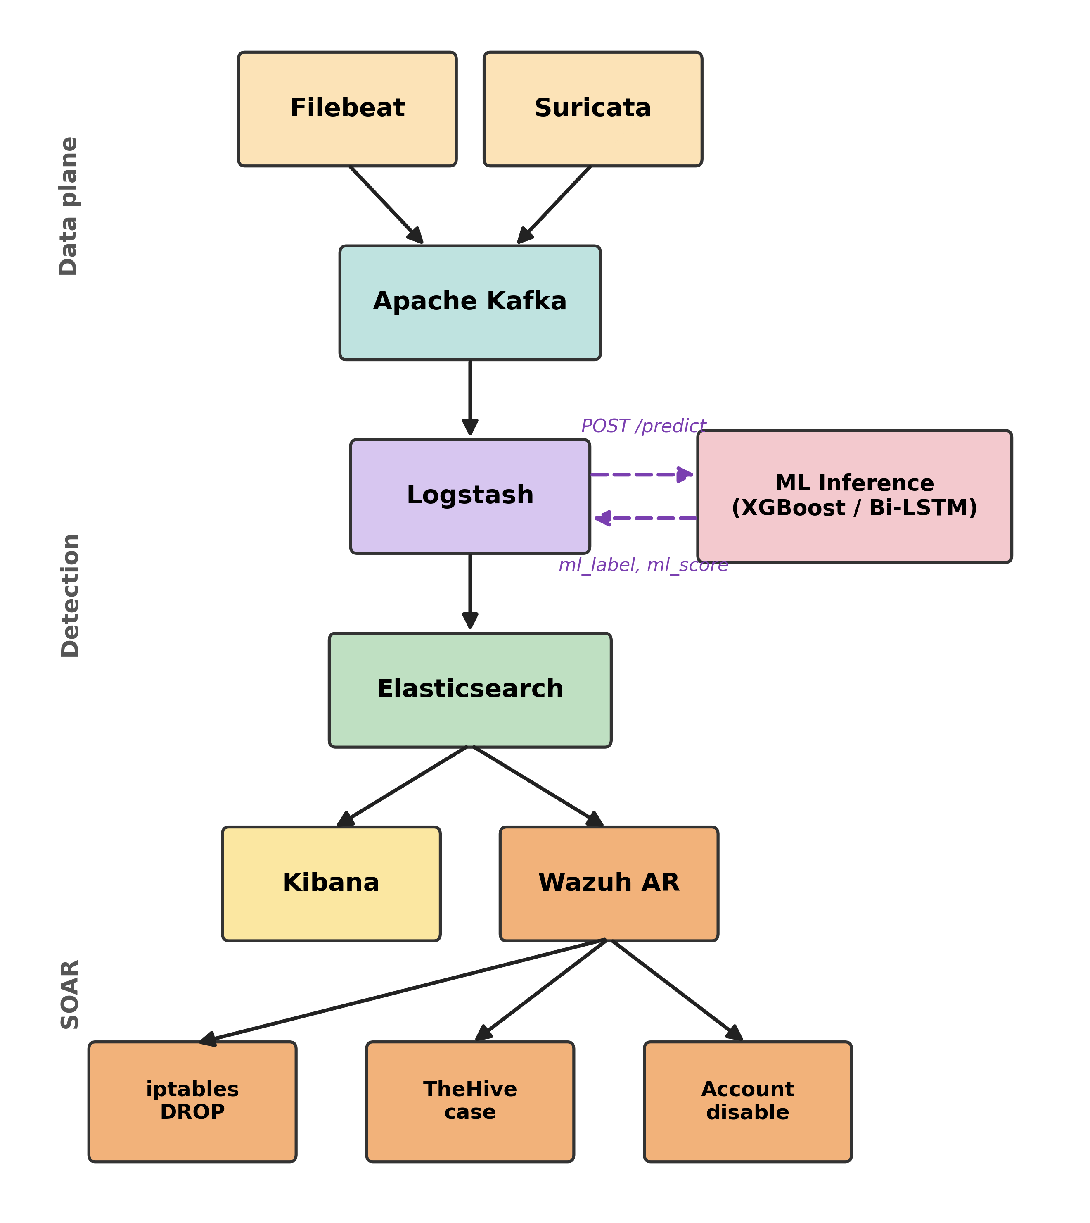
Fig. 1. End-to-end AI-SIEM architecture.
The diagram illustrates the logical flow of log data from ingestion through ML detection to automated containment, including the SOAR actions exercised in Section 6.2. Operational measurements reported in Section 6.2 are taken on the Logstash → ML inference → Elasticsearch data path.

Log collection
In the deployable architecture, Filebeat 7.17 runs on all monitored endpoints (servers, network appliances, and attack-simulation hosts) and forwards structured JSON over TLS to Kafka (Filebeat agents are not part of the single-node Docker testbed used for the reproducible benchmarks). A 1 MB internal buffer per topic absorbs traffic bursts without loss.

Streaming transport
Apache Kafka 3.5 provides high-throughput, fault-tolerant messaging. Topics are partitioned by log type (critical_logs, network_logs, app_logs); a multi-broker cluster would replicate across nodes for fault tolerance, while the single-broker configuration used in our reproducible Docker stack (Section 6.2) is sufficient for the throughput evaluated here.

Network intrusion detection
Suricata 7.0 subscribes to the network_logs topic, performs deep-packet inspection using the Emerging Threats ruleset, and re-emits JSON alerts to an ids_alerts topic. (Suricata is part of the deployable architecture but is not exercised in the reproducible benchmarks reported in Section 6.2, which use the HTTP input only.)

Pre-processing and ML inference
Logstash 8.12 consumes the Kafka topics defined in Section 3.2 (critical_logs, network_logs, app_logs), applies grok parsing, GeoIP enrichment, and routes events to a Flask ML inference service that loads the appropriate model per deployment (XGBoost [32] for tabular events, Bi-LSTM for HDFS-style template sequences):
- XGBoost model: classifies tabular logs (max_depth 6, n_estimators 800, learning_rate 0.1, subsample 0.9, colsample_bytree 0.8; selected by grid search on KDDTrain+, see Section 4.3.1). Per-event inference latency on Apple Silicon CPU-only is in the low single-digit milliseconds; precise streaming latency under load is reported in Section 6.2.
- Bi-LSTM [33], [34] model: analyses HDFS-style sequential logs (2×128-unit layers, dropout 0.3). Per-event inference latency on Apple Silicon CPU-only is in the tens of milliseconds; see Section 6.2 for the streaming-stack measurement.
The inference service appends ml_score and ml_label fields before forwarding events to Elasticsearch.

Storage and search
Elasticsearch 8.12 indexes raw and scored logs across time-based indices, using custom mappings for ml_score (float) and ml_label (keyword) installed via an index template. Reproducible benchmarks (Section 6.2) use a single-node ES instance; production deployments would scale out for fault tolerance.

Security orchestration and automated response
A Wazuh-style Active Response watcher consumes the siemai-events-v2-alerts-* index (created by the Logstash pipeline when ml_label is non-benign). Rules matching ml_label:malicious trigger playbooks:
- IP quarantine: auto-apply iptables DROP on all compromised hosts.
- Account disable: invoke the Microsoft Graph / Azure AD API via an HTTP integration script. In the reproducible benchmark (Section 6.2) this endpoint is simulated by a stub that mimics the latency of a single Graph API round-trip; production deployments would point the script at a real tenant.
- Ticket creation: open a case in TheHive with full event context.
End-to-end ingestion-to-containment latency measured on the reference Docker stack is reported in Section 6.2 (p95 1.16 s across 500 SOAR cycles).

Visualisation and reporting
Kibana dashboards provide heat maps of alert density, time-series of ml_score, ROC curves, and GeoIP maps. Analysts drill down via Lucene/KQL queries that combine signature IDs with ML scores.

Deployment and observability
The stack ships as a Docker Compose definition for single-host reproducibility (used for all measurements in Section 6.2); a Helm chart for Kubernetes scale-out is left to future work. Prometheus exporters can expose per-service CPU, memory, and inference-latency histograms; the reproducible benchmark publishes counters via the Logstash monitoring API.

Methodology
This section describes the datasets, data-preparation pipeline, model-training protocol, and evaluation procedure used in our experiments.

Datasets
We evaluate on four public benchmarks (summarised in Table 2):
- GUIDE [35] – Microsoft Incident Prediction: 13.7 M raw events; we keep rows with a non-null IncidentGrade label and use a predefined Microsoft GUIDE_Train → GUIDE_Test split, with 12.5 % of the training file held out for validation: 8 282 309 training, 1 183 188 validation, and 4 147 992 test events across three classes (BenignPositive, FalsePositive, TruePositive).
- NSL-KDD [36] – Network-intrusion flows: 125 973 KDDTrain+ records and 22 544 KDDTest+ records. The dataset distinguishes Normal traffic from four attack families (DoS, Probe, R2L, U2R); we collapse these to a binary normal-vs-attack target and use the canonical KDDTrain+ → KDDTest+ benchmark protocol, where KDDTest+ contains 17 attack types absent from KDDTrain+.
- UNSW-NB15 [37] – Network-flow records from the 2015 UNSW IXIA testbed: 175 341 training and 82 332 test flows, 42 numeric + 3 categorical features (proto, service, state). We use the binary label column (0 = normal, 1 = attack) and keep the dataset authors’ train/test split unchanged.
- HDFS LogHub [38], [39], [40] – 11 M sequential log messages grouped into 575 k block sessions labelled Normal or Anomalous.

- Dataset summary.
Dataset | Raw events | Labelled records | Classes/Labels
GUIDE | 13.7M | 13.6M | BenignPositive, FalsePositive, TruePositive
NSL-KDD | 148 517 flows | 125 973 train / 22 544 test (KDDTest+) | Normal vs. attack (4 attack families: DoS, Probe, R2L, U2R)
UNSW-NB15 | 257 673 flows | 175 341 train / 82 332 test | Normal vs. attack (9 attack families)
HDFS | 11M | 575K | Normal, Anomalous

Data preparation and feature engineering
- Parsing & Cleansing – Out-of-range values and invalid timestamps are dropped; remaining categoricals are filled with the placeholder UNK before label encoding.
- Encoding – Categorical attributes are label-encoded with one encoder per column (UNK for unseen values). XGBoost is scale-invariant so numerical features are kept at native scale; the Bi-LSTM uses a learned 64-dimensional embedding over the 29 HDFS log-template IDs.
- Text and high-cardinality identifier fields are dropped from the GUIDE feature set (e.g., AccountUpn, IpAddress, FileName, ThreatFamily) to prevent label leakage; the resulting feature space contains the structured event metadata only.
- Sequence Windowing (HDFS) – After Drain-style template extraction [41] (Figs. 2 and 3), sessions are split into fixed windows of 100 log lines (stride 50).
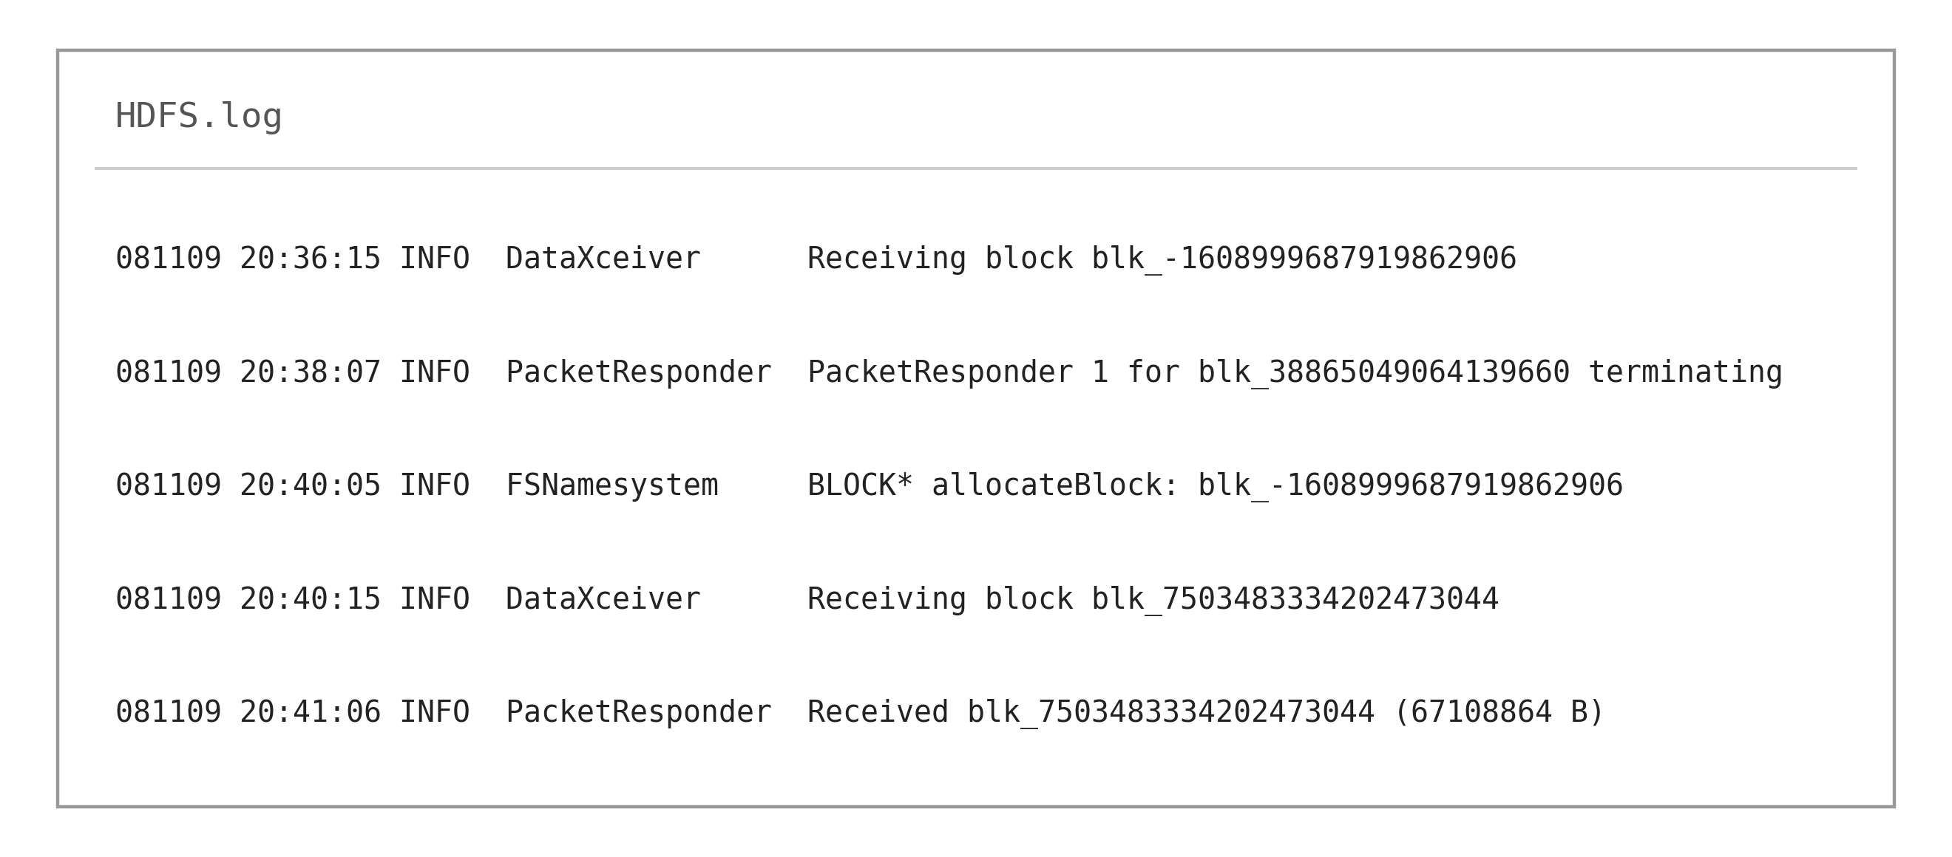
Fig. 2. Excerpt of the HDFS raw log after parsing and template extraction.
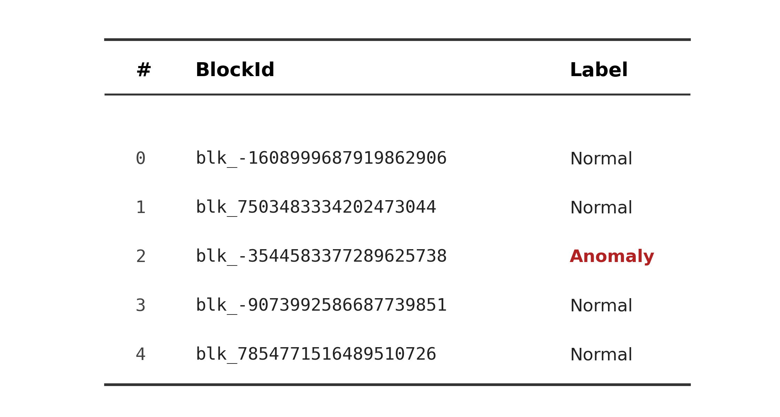
Fig. 3. Example of the BlockId-to-label file used to annotate HDFS sessions.
GUIDE shows a class distribution of approximately 42 % BenignPositive / 22 % FalsePositive / 36 % TruePositive on the test split; HDFS has a 97 / 3 split between normal and anomalous sessions (about 2.9 % anomalous). We do not resample: XGBoost relies on its multi-class logloss objective and the Bi-LSTM uses weighted binary cross-entropy with weights inverse-proportional to class frequency.

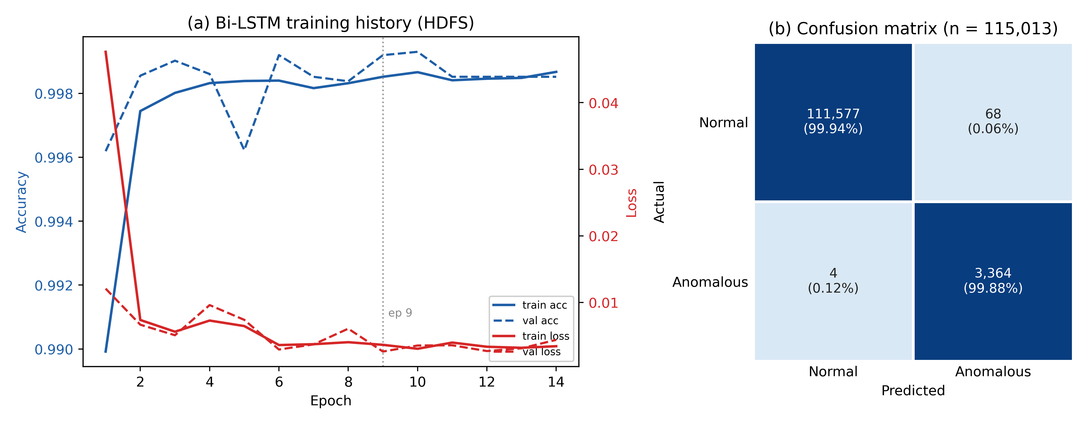
Fig. 4. Bi-LSTM training history (left) and held-out test-set confusion matrix (right) on HDFS LogHub. Early stopping triggered at epoch 14 with the best checkpoint at epoch 9 (val_loss 0.0026).

Model training

XGBoost (GUIDE, NSL-KDD & UNSW-NB15)
A grid search over max_depth in {4, 6, 8}, learning_rate in {0.05, 0.1}, subsample in {0.8, 0.9} with 3-fold cross-validation on KDDTrain+ yields the best configuration: max_depth 6, n_estimators 800, learning_rate 0.1, subsample 0.9, colsample_bytree 0.8. For GUIDE we train a single 3-class XGBoost (objective multi:softprob) with max_depth 6, learning_rate 0.1, subsample 0.9, colsample_bytree 0.8, and up to 3 000 boosting rounds with early stopping (patience 250) on the validation split.
Training on the reference hardware (Apple Silicon, CPU-only XGBoost via libomp) completes in approximately 5 min for NSL-KDD, 5.5 s for UNSW-NB15 (the dataset is small enough that training is dominated by tree construction overhead). GUIDE, by far the largest corpus, runs to the 3 000-round cap (best iteration 2999) without triggering early stopping.

Bi-LSTM (HDFS)
Two bidirectional LSTM layers (128 units, dropout 0.3) feed a dense softmax head. The network is trained for up to 30 epochs (batch 256) with Adam (lr 0.001) and early-stopping patience 5 on val_loss; on our reference hardware (Apple Silicon, CPU-only TensorFlow) training early-stopped at epoch 14 in approximately 100 min.

Evaluation protocol
- Splits – GUIDE uses Microsoft’s predefined GUIDE_Train → GUIDE_Test split (12.5 % of the training file held out for validation). NSL-KDD uses the canonical KDDTrain+ → KDDTest+ benchmark protocol (no random split; the test set contains 17 attack types absent from training). UNSW-NB15 uses the dataset authors’ predefined train/test split (175 341 / 82 332 events) unchanged. HDFS uses a 70 / 10 / 20 split applied at the session level (seed 42) so that block IDs in the test set never appear in training or validation.
- Metrics – Accuracy, precision, recall, F1-score, and ROC AUC.
- We report point estimates on the fixed held-out test splits described above. Statistical comparisons against the baseline classifiers are reported via McNemar’s test (Section 5.2); additional bootstrap confidence intervals are left as future work.

Reproducibility
All pre-processing scripts, training and benchmark scripts, Docker artefacts, and the Logstash + Elasticsearch index-template configurations are released under Apache-2.0 at https://github.com/aliradid/siem-ai (see the Data availability statement), enabling exact reproduction of every experiment in this paper.

Experimental results
All results are obtained from the held-out test splits described in Section 4: KDDTrain+ → KDDTest+ for NSL-KDD; the dataset authors’ predefined train/test split for UNSW-NB15; the predefined Microsoft GUIDE_Train → GUIDE_Test split for GUIDE; and a 70 / 10 / 20 session-level split (seed 42) for HDFS.

GUIDE dataset results
XGBoost attains 72.14 % overall accuracy on GUIDE (macro F1 0.6797, macro precision 0.7321, macro recall 0.6692), with 4 147 992 labelled events in the held-out test split (Table 3). Class-level performance varies sharply with class definition (Fig. 5): TruePositive (F1 0.748) and BenignPositive (F1 0.773) are recovered cleanly, whereas FalsePositive (F1 0.518) is the model’s weakest, mostly conflated with BenignPositive, consistent with the ambiguity of the underlying SOC triage labels: BenignPositive and FalsePositive both denote alerts a human analyst closed without escalation, and the boundary between them depends on organisation-specific triage conventions. Table 4 lists precision, recall and F1 for each class.
- Overall GUIDE test set metrics (XGBoost).
Metric | Value
Accuracy | 0.7214
Precision (macro) | 0.7321
Recall (macro) | 0.6692
F1-score (macro) | 0.6797

- Per-class classification report for XGBoost on the GUIDE dataset.
Class | Precision | Recall | F1-score | Support
0 (BenignPositive) | 0.678 | 0.899 | 0.773 | 1 752 940
1 (FalsePositive) | 0.720 | 0.404 | 0.518 | 902 698
2 (TruePositive) | 0.798 | 0.704 | 0.748 | 1 492 354
Accuracy | – | – | 0.721 | 4 147 992
Macro avg | 0.732 | 0.669 | 0.680 | 4 147 992
Weighted avg | 0.730 | 0.721 | 0.709 | 4 147 992
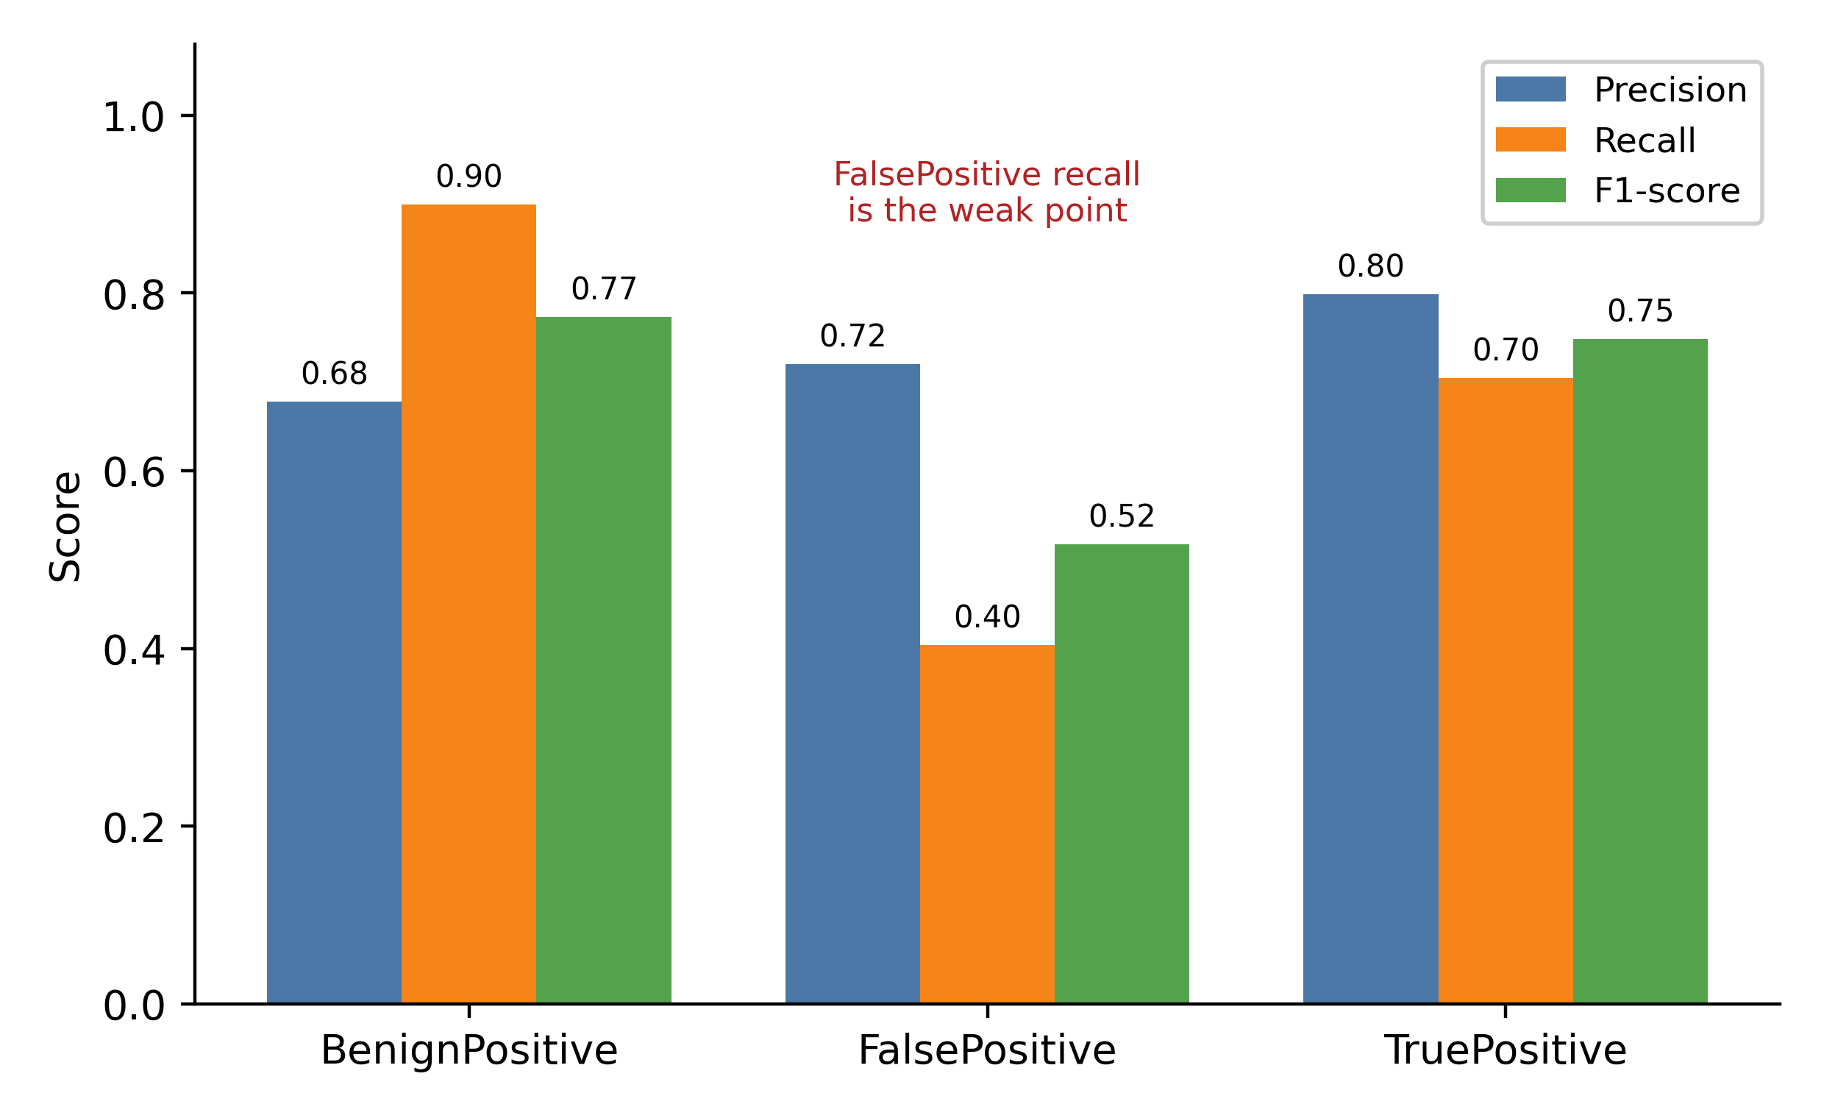
Fig. 5. GUIDE per-class precision, recall and F1 (XGBoost; n_test = 4 147 992). The FalsePositive class is the model’s weakest (F1 0.518), driven by low recall.

The trained model exposes per-feature gain rankings (XGBoost's built-in importance), which together with SHAP [42], LIME [43], and adversarial-XAI approaches [44] (planned future work) provide a path to per-incident explainability for analysts.

NSL-KDD dataset results
On the canonical KDDTrain+ → KDDTest+ protocol XGBoost reaches 0.7756 accuracy and 0.7748 macro F1 (Table 5). The macro average again hides an asymmetric error profile: attack recall is 0.6286 (8 067 of 12 833 attacks detected) at 0.9651 precision, while only 292 of 9 711 normal flows are flagged. On this corpus the classifier is conservative, missing roughly a third of the novel attack types in KDDTest+ but raising few false alarms.
- Summary metrics – XGBoost on NSL-KDD (KDDTrain+ → KDDTest+).
Metric | Value
Accuracy | 0.7756
Precision (macro) | 0.8145
Recall (macro) | 0.7993
F1-score (macro) | 0.7748
ROC AUC | 0.9694
- NSL-KDD baseline comparison on the same KDDTest+ split and 15-feature pipeline.
Classifier | Accuracy | Macro F1 | Macro Recall | ROC AUC
Logistic Regression | 0.7336 | 0.7327 | 0.7562 | 0.8773
Random Forest [45] (200 trees) | 0.7619 | 0.7606 | 0.7871 | 0.9551
LightGBM (default hyperparameters) | 0.7569 | 0.7553 | 0.7829 | 0.9636
CatBoost (default hyperparameters) | 0.7657 | 0.7645 | 0.7905 | 0.9677
XGBoost (tuned, this work) | 0.7756 | 0.7748 | 0.7993 | 0.9694
To contextualise the XGBoost result, we trained four additional classifiers on the same KDDTrain+ → KDDTest+ split and the same 15-feature pipeline (Table 6). The tuned XGBoost result (F1 0.7748, AUC 0.9694) outperforms Random Forest (F1 0.7606), CatBoost (F1 0.7645 with default hyperparameters), LightGBM (F1 0.7553 with default hyperparameters), and Logistic Regression (F1 0.7327). McNemar’s test on the KDDTest+ predictions confirms that the XGBoost vs Random Forest difference is statistically significant (χ² = 194.86, p < 0.001), as is XGBoost vs LightGBM (χ² = 299.30, p < 0.001) and XGBoost vs CatBoost (χ² = 73.04, p < 0.001). The 0.7748 figure is consistent with the published NSL-KDD literature, which generally reports macro F1 in the 0.75–0.85 range on the canonical KDDTest+ benchmark; we note that some early NSL-KDD reports inflated their numbers by using a random in-distribution split of the combined Train+/Test+ files, which we explicitly avoid here.
To illustrate the overall class balance in NSL-KDD, Fig. 6 shows the relative frequency of normal versus attack flows on the held-out KDDTest+ split.
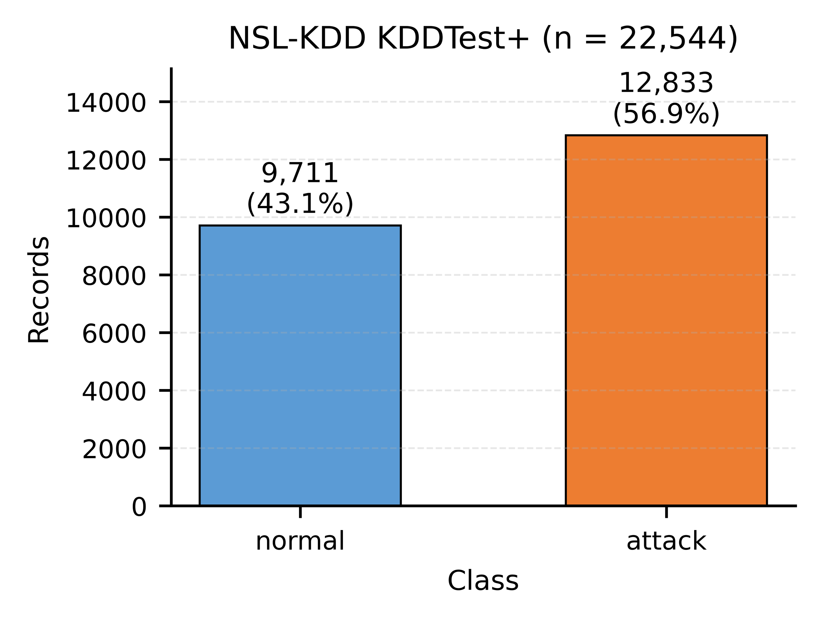
Fig. 6. Class distribution on the canonical NSL-KDD held-out test split (KDDTest+, n = 22 544: 9 711 normal vs 12 833 attack) used for the metrics in Table 5.

ROC analysis (NSL-KDD)
Fig. 7 plots the ROC curve for XGBoost on the canonical NSL-KDD benchmark (KDDTest+), where the classifier reaches an AUC of 0.9694. The harder 3-class GUIDE classification report is summarised in Tables 3 and 4 above; ROC analysis on GUIDE is left as future work: the GUIDE model is trained with a native 3-class softmax objective (multi:softprob), and we report the per-class precision, recall and F1 breakdown in Table 4 rather than a single binary curve.
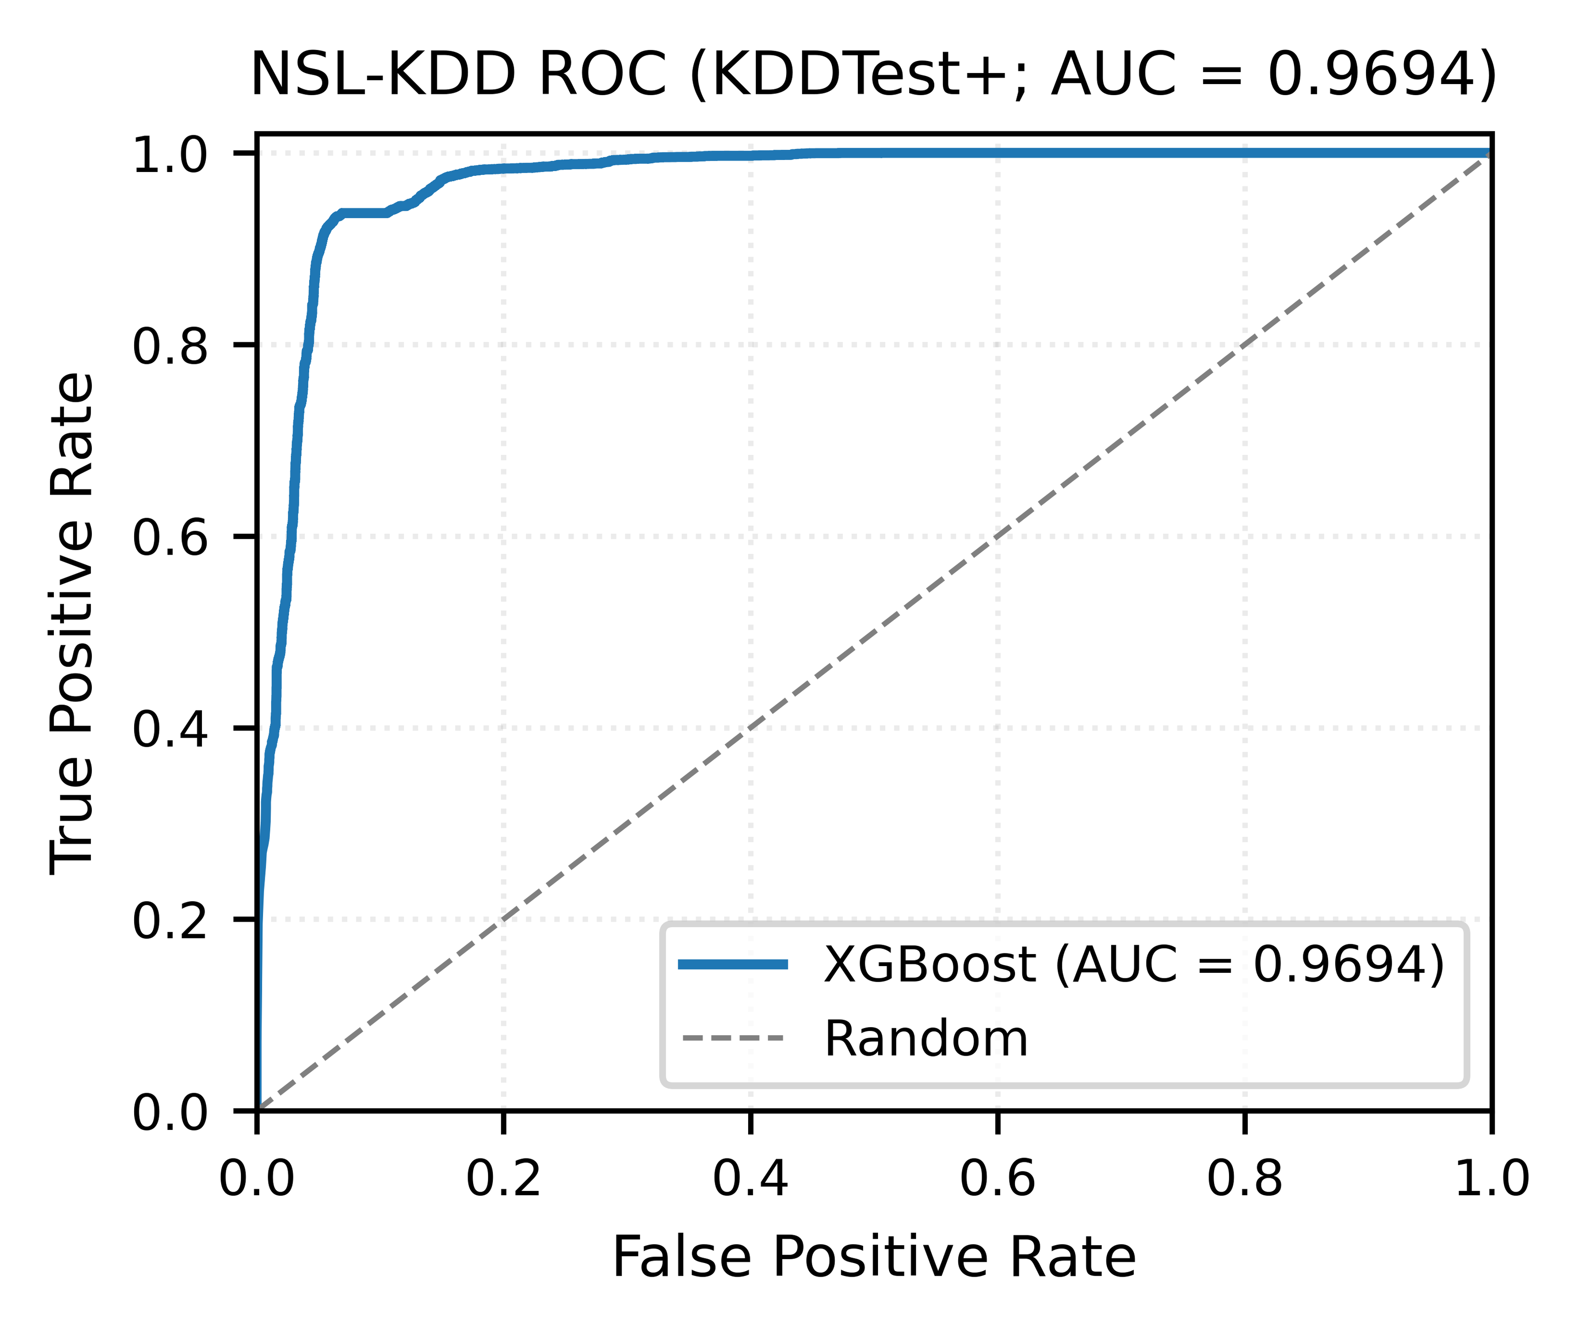
Fig. 7. ROC curve for XGBoost on NSL-KDD (canonical KDDTrain+ → KDDTest+ benchmark; AUC = 0.9694).

UNSW-NB15 dataset results
To demonstrate that the XGBoost recipe generalises to a more recent corpus, we re-trained the same XGBoost pipeline, with max_depth 8 and subsample 0.8 for this corpus (learning_rate 0.1, n_estimators 800 and colsample_bytree 0.8 unchanged), on UNSW-NB15, a 2015 IDS benchmark with realistic background traffic and a larger feature set (42 numeric + 3 categorical features after dropping the id and multi-class label columns). The training and testing splits provided by the dataset authors (175 341 / 82 332 events) are used unchanged. XGBoost attains 86.85 % accuracy, macro F1 of 0.8625, and ROC AUC of 0.9814 (Table 7), substantially higher than the canonical NSL-KDD score of 0.7748 because UNSW-NB15’s provided split is less adversarial with respect to unseen attack families than KDDTest+, which deliberately introduces 17 novel attack types. The two corpora together bracket the realistic detection envelope.
- UNSW-NB15 binary classification metrics on the provided testing split (n = 82 332), same XGBoost pipeline, max_depth 8 / subsample 0.8.
Metric | Value
Accuracy | 0.8685
Precision (macro) | 0.8922
Recall (macro) | 0.8560
F1-score (macro) | 0.8625
ROC AUC | 0.9814
The macro averages conceal an asymmetric error profile that matters operationally: attack recall is 0.9794 at 0.8178 precision, but benign recall is only 0.7327, so 9 890 of the 37 000 normal flows in the test split (26.7 %) are labelled as attacks. UNSW-NB15 is therefore the mirror image of NSL-KDD, trading a high false-alarm rate for near-complete attack coverage.

HDFS log anomaly detection
The bidirectional LSTM, building on our prior architecture for SOC log anomaly detection [46], reaches a macro F1 of 0.9945 on HDFS (test accuracy 0.9994, macro precision 0.9901, macro recall 0.9991; Fig. 4). Anomalous sessions are recovered with recall 0.9988 (4 of 3 368 missed) at precision 0.9802. Training early-stopped at epoch 14 with the best checkpoint restored from epoch 9 (val_loss 0.0026).
For context, we evaluated three baselines (Table 8) on the same 70 / 10 / 20 session-level split, using the pre-built event-occurrence matrix from LogHub (one row per block, columns are template counts). Random Forest outperforms the sequence-based Bi-LSTM on this dataset, and Logistic Regression is close behind it: Logistic Regression on bag-of-templates reaches macro F1 of 0.9901 (AUC 0.9992) and Random Forest (200 trees) reaches 0.9993 (AUC 1.0000), against 0.9945 for the Bi-LSTM. This is expected: the HDFS templates are almost linearly separable when aggregated as session-level counts, and the additional inductive bias of the Bi-LSTM (token order, dependency length) is not needed for this corpus. An unsupervised Isolation Forest trained on normals only reaches macro F1 of only 0.5341 (AUC 0.7184), illustrating that supervised signal is essential here. The IF baseline uses a contamination parameter set to the empirical anomaly rate (0.03), which is an oracle assumption that biases the IF F1 upward; without it the baseline would likely degrade further, so the gap reported here is a lower bound on the supervised-vs-unsupervised advantage on this corpus. We retain the Bi-LSTM in the reported pipeline because it is the natural architecture for ordered template streams that arrive on Kafka in real time, where session aggregation is not available at inference; the bag-of-templates baselines require buffering the entire session before scoring.
- HDFS baselines vs Bi-LSTM on the same 70/10/20 session-level split (n test = 115 013).
Classifier | Accuracy | Macro F1 | ROC AUC
Isolation Forest (unsupervised, normals only) | 0.9460 | 0.5341 | 0.7184
Logistic Regression (bag-of-templates) | 0.9989 | 0.9901 | 0.9992
Random Forest (bag-of-templates, 200 trees) | 0.9999 | 0.9993 | 1.0000
Bi-LSTM (sequence, this work) | 0.9994 | 0.9945 | –

Discussion
Across the four corpora, performance tracks task difficulty rather than model capacity. On NSL-KDD (binary, KDDTrain+ → KDDTest+ benchmark protocol where the test set contains 17 attack types not present in training) XGBoost reaches a macro F1 of 0.7748, while on the more recent UNSW-NB15 (binary, 82 332 test events, 9 attack families) the same pipeline, re-tuned to depth 8, reaches 0.8625. On HDFS (binary, 2.9 % anomaly rate, template-driven sequences) the Bi-LSTM recovers 3 364 of 3 368 anomalous sessions for a macro F1 of 0.9945. The Microsoft GUIDE corpus (3-class incident triage, 4.15 M test events, severe class imbalance, free-text features) is materially harder: macro F1 drops to 0.6797 with the same XGBoost recipe, driven entirely by the FalsePositive class (F1 0.518), which our confusion matrix (Table 4) shows overlaps heavily with both BenignPositive and TruePositive. These results illustrate the platform’s working envelope: solid on canonical and modern IDS benchmarks, near-perfect on session-level HDFS templates, and exposing genuine label noise on triage tasks where ground truth itself is fuzzy.
Per-event inference latency on the reference Docker stack (Apple Silicon, CPU-only) and full streaming and SOAR latency distributions are reported in Section 6.2 (Table 9).

Limitations and future work
Across the four corpora reported above, the system reaches macro F1 of 0.7748 on NSL-KDD (KDDTrain+ → KDDTest+), 0.8625 on UNSW-NB15, 0.9945 on HDFS, and 0.6797 on GUIDE, with p95 ingestion-to-containment latency of 1.16 s on a single-node Docker stack. Several gaps remain between this prototype and a production deployment.

Dataset realism
Limitation: GUIDE, NSL-KDD, UNSW-NB15, and HDFS are well-known community datasets but lack real-world SOC heterogeneity; more recent benchmarks such as CIC-IDS2017 [47] and TON-IoT [48] partially address these gaps, which include insider threats, long-term concept drift, and multi-vendor log schemas.
Next steps:
- Collect and anonymise six months of live SOC telemetry under Institutional Review Board (IRB) approval.
- Evaluate continual-learning strategies (e.g., sliding-window retraining) to track drift over time.

Streaming performance
The streaming benchmark exercises the Logstash → ML inference → Elasticsearch data path via the HTTP input on Logstash; Suricata and multi-broker Kafka transport are part of the deployable architecture but are not included in these latency measurements. Streaming and SOAR validation on the open-source stack (single-node Docker Compose, Apple Silicon, 8 GB Docker, ML inference + Logstash + Elasticsearch single-node) yields p95 ingest-to-ML-verdict latency of 619 ms (mean across 5 reps, ±57 ms) at a sustained 100 events/s (streaming benchmark), with 99 % of events successfully indexed and enriched. This timestamp is taken in the Logstash filter stage, before the event is handed to Elasticsearch; p95 latency to a searchable alert is 1.05 s (Table 9). End-to-end ingestion-to-containment latency, measured across 500 SOAR cycles that fire the three Wazuh-style playbooks (iptables DROP, TheHive case creation, Azure AD account disable), reaches p50 946 ms and p95 1.16 s with no failed cycles; per-playbook mean latency is 9.7 ms (iptables), 46.8 ms (TheHive), and 50.5 ms (Azure disable). The iptables DROP is applied for real against the Linux netfilter stack and the TheHive case is created through a live TheHive 5 REST API, both measured on the single-node Docker host; the Azure AD account-disable remains a simulated stub that models a single Graph API round-trip. The higher latency within these SOAR cycles (p50 835 ms) versus the streaming working point is expected: the SOAR figures are measured once the alert is searchable in Elasticsearch, which is governed by the 1 s default index refresh interval, whereas the streaming figure stops at the ML verdict inside Logstash. Full per-rep numbers for the streaming working point are saved to results/stress_test_reps.json (5 × 15 s reps at 100/250/500/1 000 events/s); SOAR cycle traces are saved to results/soar_validation.json.
- Streaming and SOAR validation on the open-source stack (Docker Compose, Apple Silicon, single-node ES + Logstash + ML inference). Streaming latencies are means across 5 × 15 s repetitions at the 100 events/s working point (cf. Table 11); SOAR latencies are measured across 500 end-to-end SOAR cycles, with iptables DROP and TheHive case creation exercised against real targets (Linux netfilter and a live TheHive 5 instance) and Azure AD disable as a simulated stub.
Metric | Value
Target throughput | 100 events/s
Achieved throughput | 100.0 events/s
Indexed events / sent | 7 424 / 7 504 (99 %)
p50 ingest → ML verdict | 210 ms
p95 ingest → ML verdict | 619 ms
p99 ingest → ML verdict | 885 ms
p50 ingest → containment | 946 ms
p95 ingest → containment | 1 161 ms
p99 ingest → containment | 1 185 ms
iptables DROP latency | mean 9.7 ms
TheHive case creation | mean 46.8 ms
Azure AD account disable | mean 50.5 ms
Successful SOAR cycles | 500 / 500
To isolate the marginal cost of inserting ML inference into a commodity log pipeline, we run a three-variant ablation (Table 10) on the same Docker stack. Variant A bypasses the pipeline entirely and calls the Flask /predict endpoint synchronously; Variant B sends events through Logstash with the ML http filter disabled (Logstash → Elasticsearch only); Variant C is the full pipeline reported in Section 6.2 (Logstash → ML inference → Elasticsearch). The p95 of Variant A measures the pure model latency in isolation, while the p95 difference between B and C measures the overhead of inserting ML scoring into a running pipeline.
- Ablation study isolating ML inference cost from pipeline cost (100 events/s, 15 s; one run per variant). The measured B-to-C p95 delta is below the run-to-run noise floor at this working point, where five repetitions give a p95 standard deviation of 57 ms (Table 11).
Variant | p50 (ms) | p95 (ms) | p99 (ms)
A. ML inference only (direct /predict, n = 1 000) | 2.7 | 3.5 | 4.2
B. Pipeline without ML (Logstash → ES) | 204 | 606 | 904
C. Full pipeline (Logstash → ML → ES) | 209 | 568 | 814
To characterise the pipeline’s scaling envelope, we re-ran the streaming benchmark at four target rates on the same single-node Docker stack (15-second windows × 5 repetitions per rate, 500-event sample pool); the latency-versus-throughput profile is plotted in Fig. 8. Throughput and indexing remain clean at the 100 events/s working point, but Logstash & Elasticsearch back-pressure becomes visible at 250 events/s and above. At 1 000 events/s the host can no longer match the target rate (mean 958 events/s across 5 reps). Indexing completeness at this rate is not verified: the benchmark harness retrieves latencies with a single Elasticsearch query capped at 10 000 hits, so every repetition reports exactly 10 000 indexed documents irrespective of how many were sent. Logstash's own counters record no drops at any rate tested, and complete indexing is confirmed up to 500 events/s (37 000 of 37 000 events). A multi-broker Kafka cluster, sharded Elasticsearch, and a Logstash worker pool sized to inference concurrency are the natural next-step upgrades to push beyond this point.
- Pipeline scaling on the single-node Docker stack (15 s × 5 repetitions per rate; values are mean ± standard deviation across reps).
Target rate | Achieved rate | p50 (ms) | p95 (ms) | p99 (ms) | Indexed / sent
100 eps | 100 eps | 210±2 | 619±57 | 885±139 | 7 424 / 7 504 (99 %)
250 eps | 250 eps | 2 212±280 | 5 962±296 | 6 660±133 | 18 755 / 18 755 (100 %)
500 eps | 490 eps | 1 770±49 | 3 772±367 | 4 465±667 | 37 000 / 37 000 (100 %)
1 000 eps | 958 eps | 1 205±44 | 2 237±74 | 2 640±87 | not verified (query cap)
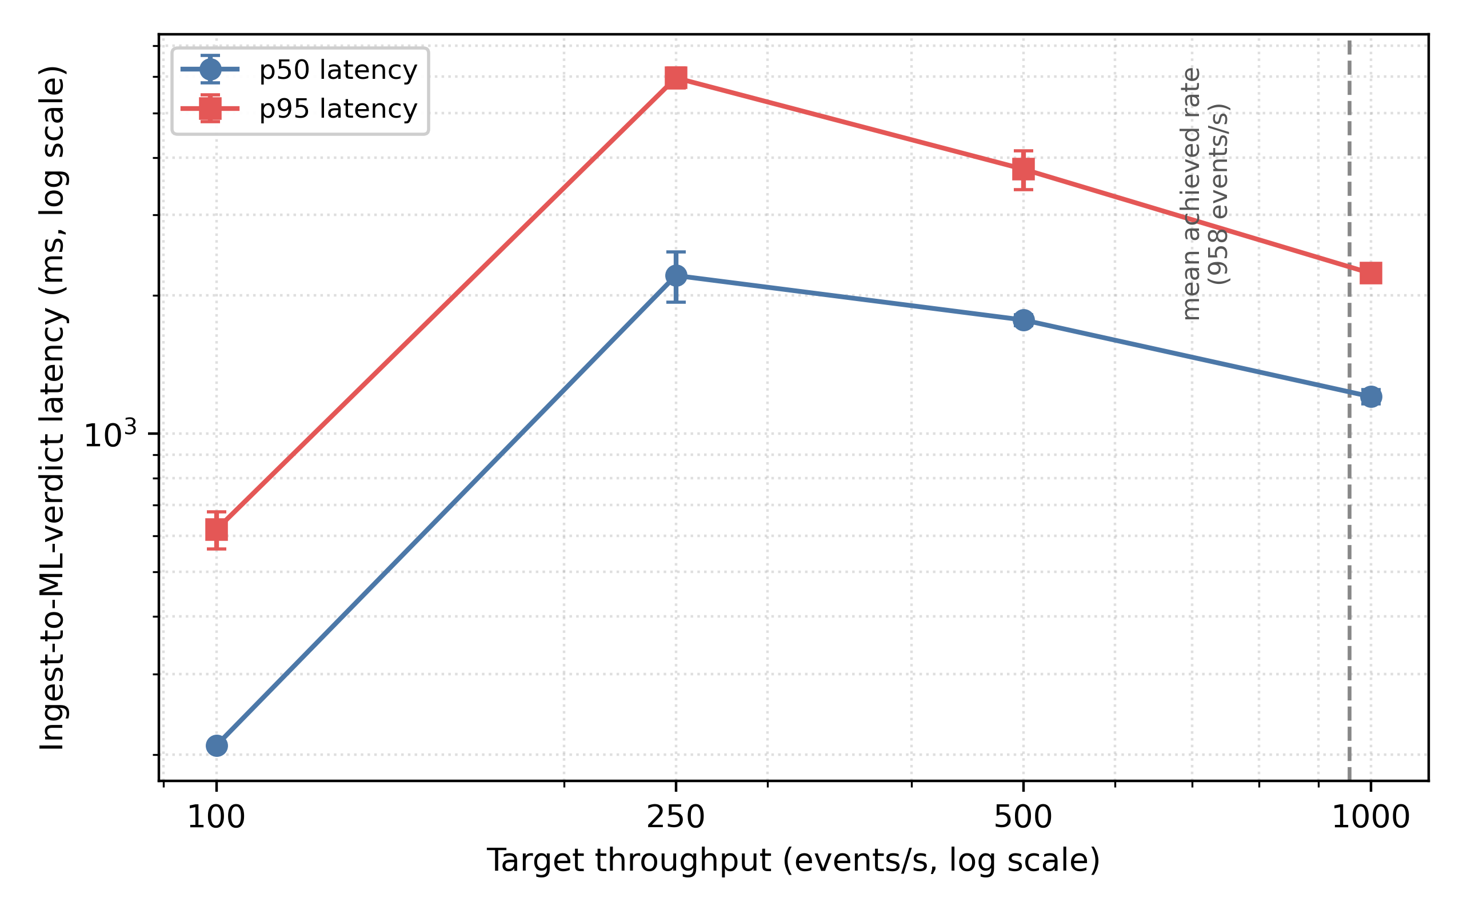
Fig. 8. Pipeline scaling profile on the single-node Docker stack (5 reps × 15 s per rate); the dotted line marks the mean achieved rate of 958 events/s at the 1 000 events/s target.
The non-monotonic p95 latency across 250–1 000 events/s is reported as measured. The four target rates were executed once each, in ascending order, within a single continuous session, so throughput is confounded with elapsed time and with the warm-up state of the Elasticsearch indexing tier; we therefore do not attribute the pattern to a specific mechanism. Across five repetitions the p95 standard deviation stays within 10 % of the mean at every rate, so the profile itself is stable. Table 11 should therefore be read as a reproducible single-node stress profile; a steady-state long-running benchmark on a multi-node cluster is left to future work.
The ablation reveals two distinct latency regimes. Pure ML inference is fast (p95 ≈ 3.5 ms), confirming that XGBoost is not a bottleneck on commodity CPU. The Logstash + Elasticsearch path dominates the end-to-end latency at p95 of 568–606 ms. Crucially, the marginal cost of inserting ML scoring into a running pipeline is essentially zero: variant C’s p95 is within noise of variant B’s, and is in fact slightly lower in our run. This indicates that the architecture amortises the synchronous /predict call within the existing pipeline backpressure, and that performance-conscious deployments should optimise the data plane (Kafka tuning, ES bulk indexing) rather than the inference service.
Next steps:
- Deploy the full Docker/Helm stack on an 8 vCPU / 32 GB RAM Kubernetes cluster (with optional GPU).
- Instrument Kafka lag, model inference latency (Prometheus histograms), and Wazuh playbook completion times.
- Target SLAs are ingest-to-ML-verdict < 100 ms and ingestion-to-containment < 30 s; on the reference single-node stack we measure 619 ms and 1.16 s at p95 respectively, comfortably within the containment SLA, with ingest-to-ML-verdict exceeding the aspirational 100 ms because every event triggers a synchronous HTTP call to the ML inference service. Production deployments will batch these calls (planned future work).

Model diversity and explainability
Limitation: Current detectors (XGBoost, Bi-LSTM) are purely supervised and opaque. They cannot capture zero-day anomalies and offer limited diagnostic insight.
Next steps:
- Integrate unsupervised anomaly models (Isolation Forest, Deep SVDD) to surface novel threats.
- Incorporate explainable-AI techniques (SHAP, LIME) and expose “top features” lists via Kibana.

Expanded SOAR playbooks
Coverage: Active Response in Section 6.2 (Table 9) exercises IP quarantine, account disable, and ticket creation. Cloud-native containment (AWS IAM revocation, Azure RBAC downgrade, S3/Blob lockdown) is not yet implemented.
Next steps:
- Author Ansible modules for cloud-native containment: AWS IAM role revocation, Azure RBAC downgrade, S3/Blob storage lockdown.
- Measure MTTR savings relative to manual processes.
Containment risk and threshold calibration. Active Response currently fires on the predicted label alone: the inference service returns a confidence score that is indexed but never used as a gate, and every matching alert triggers all three playbooks. Because the detectors are imperfect and asymmetric — 26.7 % of benign UNSW-NB15 flows are labelled as attacks, while roughly a third of the novel attack types in KDDTest+ are missed — an unattended deployment would both quarantine legitimate hosts and let attacks through. Production use therefore requires a calibrated decision threshold tuned to the operator's cost ratio, confidence-gated playbooks, an allow-list for critical assets, and a reversible or human-in-the-loop containment step. We treat threshold calibration and cost-sensitive evaluation as required future work rather than a deployment detail.

Securing the ML pipeline
Limitation: The ML inference layer is currently vulnerable to poisoning and adversarial-input attacks.
Next steps:
- Enforce JSON schema validation and rate-limiting proxies ahead of inference APIs.
- Harden models via adversarial training [49], [50]; recent work [51], [52] shows that realistic feature-space and problem-space attacks remain effective against ML-based IDS, motivating continual evaluation.
- Lock down containers with seccomp-BPF and AppArmor, limiting lateral-movement risk if compromised.

Conclusion
We have demonstrated that an open-source reference architecture (deployable as Filebeat → Kafka → Suricata → Logstash → ML inference → Elasticsearch with Wazuh-style Active Response playbooks, of which the reproducible benchmarks here measure the Logstash → ML → Elasticsearch sub-path together with real iptables DROP, real TheHive case creation, and a simulated Azure AD disable playbook) can elevate a traditional, rule-centric SIEM into an AI-driven platform that couples reproducible ML-based detection with automated, playbook-based response. The XGBoost classifier reaches 77.56 % accuracy on the canonical NSL-KDD benchmark (KDDTrain+ → KDDTest+; ROC AUC 0.9694), 86.85 % on the more recent UNSW-NB15 (macro F1 0.8625, ROC AUC 0.9814), and 72.14 % on the harder GUIDE incident-triage corpus; the Bi-LSTM reaches 0.9945 macro F1 on HDFS, together exposing both the strengths and the limits of supervised SOC detection. On a single-node Docker stack we measure p95 ingestion-to-containment latency of 1.16 s across 500 end-to-end SOAR cycles, and an ablation shows that inserting ML scoring (3.5 ms pure XGBoost p95) adds no latency to the Logstash → Elasticsearch path that is resolvable above run-to-run variance at 100 events/s. These results confirm that lightweight ML inference, when integrated into a commodity SIEM stack, can complement static correlation rules without making model inference the operational bottleneck, and that doing so honestly requires reporting both the easy wins and the genuine label-noise ceilings of community benchmarks.

Equally important, we release all artefacts (source code, Docker artefacts, training and benchmark scripts) under an Apache-2.0 license, enabling straightforward reproduction. The modular architecture also future-proofs the platform: new anomaly detectors, enrichment stages, or SOAR playbooks can be added without rearchitecting the entire stack.
Looking ahead, we will extend the prototype with adversarial robustness evaluation, multi-tenant scaling, longitudinal drift detection, and unsupervised / explainable-AI modules, and we will expand SOAR coverage for cloud-native assets. The intent is an open-source SIEM reference that integrates lightweight ML inference and playbook-driven containment, with every component reproducible from the published code and Docker artefacts.

Declaration of competing interest
The authors declare that they have no known competing financial interests or personal relationships that could have appeared to influence the work reported in this paper.

Funding
This research received no specific grant from any funding agency in the public, commercial, or not-for-profit sectors.

Data availability
All code, Docker artefacts, training and benchmark scripts, and JSON result files supporting the conclusions of this article are released under the Apache-2.0 license at https://github.com/aliradid/siem-ai. The detection results reported in this paper are regenerated by the released training and evaluation scripts; the streaming, SOAR and ablation measurements are hardware-dependent and are reproduced by re-running the corresponding benchmark scripts on the reader's own stack. The public datasets used in the evaluation (NSL-KDD, UNSW-NB15, HDFS LogHub, and Microsoft GUIDE) are available from their original sources cited in the references.

CRediT authorship contribution statement
Ali Radid: Conceptualization, Methodology, Software, Investigation, Validation, Data curation, Visualization, Writing – original draft. Mohamed Ghazouani: Supervision, Methodology, Validation, Writing – review and editing. El Habib Benlahmar: Supervision, Conceptualization, Validation, Writing – review and editing.

Declaration of generative AI and AI-assisted technologies in the manuscript preparation process
During the preparation of this work the authors used Claude (Anthropic) in order to improve the language and readability of the manuscript. After using this tool, the authors reviewed and edited the content as needed and take full responsibility for the content of the publication.

References
- Splunk Inc., The state of security 2024, Splunk Inc., White Paper, 2024.
- IBM Security and Ponemon Institute, Cost of a Data Breach Report 2024, IBM Corp., Tech. Rep., 2024. https://www.ibm.com/reports/data-breach.
- F. T. Liu, K. M. Ting, Z.-H. Zhou, Isolation forest, in: Proc. 8th IEEE Int. Conf. Data Mining (ICDM), Pisa, Italy, 2008, pp. 413–422.
- M. Goldstein, S. Uchida, A comparative evaluation of unsupervised anomaly detection algorithms for multivariate data, PLoS ONE 11 (2016) e0152173.
- J. Lee, J. Kim, I. Kim, K. Han, Cyber threat detection based on artificial neural networks using event profiles, IEEE Access 7 (2019) 165607–165626.
- M. Du, F. Li, G. Zheng, V. Srikumar, DeepLog: Anomaly detection and diagnosis from system logs through deep learning, in: Proc. ACM SIGSAC Conf. Computer and Communications Security (CCS), Dallas, TX, USA, 2017, pp. 1285–1298.
- Gartner, Market guide for security orchestration, automation and response solutions, Gartner Research, 2023.
- M. Vielberth, F. Böhm, I. Fichtinger, G. Pernul, Security operations center: A systematic study and open challenges, IEEE Access 8 (2020) 227756–227779. https://doi.org/10.1109/ACCESS.2020.3045514.
- I. Kotenko, A. Kuleshov, I. Ushakov, Aggregation of elastic stack instruments for collecting, storing and processing of security information and events, in: Proc. IEEE SmartWorld/SCALCOM/UIC/ATC/CBDCom/IOP/SCI, San Francisco, CA, USA, 2017, pp. 1–8. https://doi.org/10.1109/UIC-ATC.2017.8397627.
- G. González-Granadillo, S. González-Zarzosa, R. Diaz, Security information and event management (SIEM): Analysis, trends, usage in critical infrastructures, Sensors 21 (2021) 4759. https://doi.org/10.3390/s21144759.
- B. A. Alahmadi, L. Axon, I. Martinovic, 99% false positives: A qualitative study of SOC analysts’ perspectives on security alarms, in: Proc. 31st USENIX Security Symposium (USENIX Security 22), Boston, MA, USA, 2022, pp. 2783–2800. https://www.usenix.org/conference/usenixsecurity22/presentation/alahmadi.
- M. Sheeraz, M. H. Durad, M. A. Paracha, S. M. Mohsin, S. N. Kazmi, C. Maple, Revolutionizing SIEM security: An innovative correlation engine design for multi-layered attack detection, Sensors 24 (2024) 4901. https://doi.org/10.3390/s24154901.
- A. L. Buczak, E. Guven, A survey of data mining and machine learning methods for cyber security intrusion detection, IEEE Commun. Surv. Tutor. 18 (2016) 1153–1176. https://doi.org/10.1109/COMST.2015.2494502.
- R. Vinayakumar, M. Alazab, K. P. Soman, P. Poornachandran, A. Al-Nemrat, S. Venkatraman, Deep learning approach for intelligent intrusion detection system, IEEE Access 7 (2019) 41525–41550. https://doi.org/10.1109/ACCESS.2019.2895334.
- C. Yin, Y. Zhu, J. Fei, X. He, A deep learning approach for intrusion detection using recurrent neural networks, IEEE Access 5 (2017) 21954–21961. https://doi.org/10.1109/ACCESS.2017.2762418.
- N. Shone, T. N. Ngoc, V. D. Phai, Q. Shi, A deep learning approach to network intrusion detection, IEEE Trans. Emerg. Top. Comput. Intell. 2 (2018) 41–50. https://doi.org/10.1109/TETCI.2017.2772792.
- M. A. Ferrag, L. Maglaras, S. Moschoyiannis, H. Janicke, Deep learning for cyber security intrusion detection: Approaches, datasets, and comparative study, J. Inf. Secur. Appl. 50 (2020) 102419. https://doi.org/10.1016/j.jisa.2019.102419.
- S. N. Mighan, M. Kahani, A novel scalable intrusion detection system based on deep learning, Int. J. Inf. Secur. 20 (2021) 387–403. https://doi.org/10.1007/s10207-020-00508-5.
- X. Zhang, Y. Xu, Q. Lin, B. Qiao, H. Zhang, Y. Dang, C. Xie, X. Yang, Q. Cheng, Z. Li, J. Chen, X. He, R. Yao, J.-G. Lou, M. Chintalapati, F. Shen, D. Zhang, Robust log-based anomaly detection on unstable log data, in: Proc. 27th ACM Joint European Software Engineering Conf. and Symp. Foundations of Software Engineering (ESEC/FSE), Tallinn, Estonia, 2019, pp. 807–817. https://doi.org/10.1145/3338906.3338931.
- W. Meng, Y. Liu, Y. Zhu, S. Zhang, D. Pei, Y. Liu, Y. Chen, R. Zhang, S. Tao, P. Sun, R. Zhou, LogAnomaly: Unsupervised detection of sequential and quantitative anomalies in unstructured logs, in: Proc. 28th Int. Joint Conf. Artificial Intelligence (IJCAI), Macao, China, 2019, pp. 4739–4745. https://doi.org/10.24963/ijcai.2019/658.
- V.-H. Le, H. Zhang, Log-based anomaly detection without log parsing, in: Proc. 36th IEEE/ACM Int. Conf. Automated Software Engineering (ASE), Melbourne, Australia, 2021, pp. 492–504. https://doi.org/10.1109/ASE51524.2021.9678773.
- S. Han, Q. Wu, H. Zhang, B. Qin, J. Hu, X. Shi, L. Liu, X. Yin, Log-based anomaly detection with robust feature extraction and online learning, IEEE Trans. Inf. Forensics Secur. 16 (2021) 2300–2311. https://doi.org/10.1109/TIFS.2021.3053371.
- B. E. Strom, A. Applebaum, D. P. Miller, K. C. Nickels, A. G. Pennington, C. B. Thomas, MITRE ATT&CK: Design and philosophy, MITRE Corp., Tech. Rep. MP180360R1, Mar. 2020.
- G. Husari, E. Al-Shaer, M. Ahmed, B. Chu, X. Niu, TTPDrill: Automatic and accurate extraction of threat actions from unstructured text of CTI sources, in: Proc. 33rd Annu. Computer Security Applications Conf. (ACSAC), Orlando, FL, USA, 2017, pp. 103–115. https://doi.org/10.1145/3134600.3134646.
- G. Settanni, F. Skopik, Y. Shovgenya, R. Fiedler, M. Carolan, D. Conroy, K. Boettinger, M. Gall, G. Brost, C. Ponchel, M. Haustein, H. Kaufmann, K. Theuerkauf, P. Olli, A collaborative cyber incident management system for European interconnected critical infrastructures, J. Inf. Secur. Appl. 34 (2017) 166–182. https://doi.org/10.1016/j.jisa.2016.05.005.
- M. Husák, J. Komárková, E. Bou-Harb, P. Čeleda, Survey of attack projection, prediction, and forecasting in cyber security, IEEE Commun. Surv. Tutor. 21 (2019) 640–660. https://doi.org/10.1109/COMST.2018.2871866.
- A. Page, F. Abazari, F. Eargle, A. Azim, J. Gardiner, SIEM+: Harnessing machine learning for advanced anomaly detection in cybersecurity software, in: Proc. Canadian Conf. on Artificial Intelligence (Canadian AI), 2024. https://caiac.pubpub.org/pub/03pp58fm.
- B. Kolosnjaji, A. Zarras, G. Webster, C. Eckert, Deep learning for classification of malware system call sequences, in: Proc. Australasian Joint Conf. on Artificial Intelligence (AI 2016), LNCS vol. 9992, Springer, 2016, pp. 137–149.
- Y. Liu, S. Pan, Y. G. Wang, F. Xiong, L. Wang, Q. Chen, V. C. S. Lee, Anomaly detection in dynamic graphs via transformer, IEEE Trans. Knowl. Data Eng. 35 (2023) 12081–12094.
- A. Vaswani, N. Shazeer, N. Parmar, J. Uszkoreit, L. Jones, A. N. Gomez, L. Kaiser, I. Polosukhin, Attention is all you need, in: Proc. 31st Conf. Neural Information Processing Systems (NeurIPS), Long Beach, CA, USA, 2017, pp. 5998–6008.
- H. Guo, S. Yuan, X. Wu, LogBERT: Log anomaly detection via BERT, in: Proc. Int. Joint Conf. on Neural Networks (IJCNN), 2021, pp. 1–8.
- T. Chen, C. Guestrin, XGBoost: A scalable tree boosting system, in: Proc. 22nd ACM SIGKDD Int. Conf. Knowledge Discovery and Data Mining (KDD), San Francisco, CA, USA, 2016, pp. 785–794. https://doi.org/10.1145/2939672.2939785.
- S. Hochreiter, J. Schmidhuber, Long short-term memory, Neural Comput. 9 (1997) 1735–1780. https://doi.org/10.1162/neco.1997.9.8.1735.
- M. Schuster, K. K. Paliwal, Bidirectional recurrent neural networks, IEEE Trans. Signal Process. 45 (1997) 2673–2681. https://doi.org/10.1109/78.650093.
- S. Freitas, J. Kalajdjieski, A. Gharib, R. McCann, AI-driven guided response for security operation centers with Microsoft Copilot for Security, arXiv preprint arXiv:2407.09017, 2024. https://doi.org/10.48550/arXiv.2407.09017. Dataset: https://www.kaggle.com/datasets/microsoft/microsoft-security-incident-prediction.
- M. Tavallaee, E. Bagheri, W. Lu, A. A. Ghorbani, A detailed analysis of the KDD CUP 99 data set, in: Proc. IEEE Symp. Computational Intelligence for Security and Defense Applications (CISDA), Ottawa, ON, Canada, 2009, pp. 1–6. https://doi.org/10.1109/CISDA.2009.5356528.
- N. Moustafa, J. Slay, UNSW-NB15: A comprehensive data set for network intrusion detection systems (UNSW-NB15 network data set), in: Proc. Military Communications and Information Systems Conf. (MilCIS), Canberra, Australia, Nov. 2015, pp. 1–6. https://doi.org/10.1109/MilCIS.2015.7348942.
- J. Zhu, S. He, J. Liu, P. He, Q. Xie, Z. Zheng, M. R. Lyu, Tools and benchmarks for automated log parsing, in: Proc. 41st Int. Conf. Software Engineering: Software Engineering in Practice (ICSE-SEIP), Montreal, QC, Canada, May 2019, pp. 121–130. https://doi.org/10.1109/ICSE-SEIP.2019.00021.
- W. Xu, L. Huang, A. Fox, D. Patterson, M. I. Jordan, Detecting large-scale system problems by mining console logs, in: Proc. 22nd ACM Symp. Operating Systems Principles (SOSP), Big Sky, MT, USA, 2009, pp. 117–132. https://doi.org/10.1145/1629575.1629587.
- J. Zhu, S. He, P. He, J. Liu, M. R. Lyu, Loghub: a large collection of system log datasets for AI-driven log analytics, in: Proc. IEEE 34th Int. Symp. Software Reliability Engineering (ISSRE), Florence, Italy, 2023. https://doi.org/10.1109/ISSRE59848.2023.00071.
- P. He, J. Zhu, Z. Zheng, M. R. Lyu, Drain: An online log parsing approach with fixed depth tree, in: Proc. IEEE Int. Conf. Web Services (ICWS), Honolulu, HI, USA, 2017, pp. 33–40. https://doi.org/10.1109/ICWS.2017.13.
- S. M. Lundberg, S.-I. Lee, A unified approach to interpreting model predictions, in: Proc. 31st Conf. Neural Information Processing Systems (NeurIPS), Long Beach, CA, USA, 2017, pp. 4765–4774.
- M. T. Ribeiro, S. Singh, C. Guestrin, Why should I trust you?: Explaining the predictions of any classifier, in: Proc. 22nd ACM SIGKDD Int. Conf. Knowledge Discovery and Data Mining (KDD), San Francisco, CA, USA, 2016, pp. 1135–1144. https://doi.org/10.1145/2939672.2939778.
- D. L. Marino, C. S. Wickramasinghe, M. Manic, An adversarial approach for explainable AI in intrusion detection systems, in: Proc. 44th Annu. Conf. IEEE Industrial Electronics Society (IECON), Washington, DC, USA, 2018, pp. 3237–3243. https://doi.org/10.1109/IECON.2018.8591457.
- L. Breiman, Random forests, Mach. Learn. 45 (2001) 5–32. https://doi.org/10.1023/A:1010933404324.
- A. Radid, M. Ghazouani, H. Benlahmar, A next-generation deep learning-powered SOC for online learning platforms, in: Proc. ELSES 2023 (Atlantis Highlights in Social Sciences, Education and Humanities, vol. 14), 2024. https://doi.org/10.2991/978-94-6463-360-3_29.
- I. Sharafaldin, A. H. Lashkari, A. A. Ghorbani, Toward generating a new intrusion detection dataset and intrusion traffic characterization, in: Proc. 4th Int. Conf. Information Systems Security and Privacy (ICISSP), Funchal, Portugal, 2018, pp. 108–116. https://doi.org/10.5220/0006639801080116.
- N. Moustafa, A new distributed architecture for evaluating AI-based security systems at the edge: Network TON_IoT datasets, Sustain. Cities Soc. 72 (2021) 102994. https://doi.org/10.1016/j.scs.2021.102994.
- I. J. Goodfellow, J. Shlens, C. Szegedy, Explaining and harnessing adversarial examples, in: Proc. 3rd Int. Conf. Learning Representations (ICLR), San Diego, CA, USA, 2015.
- A. Madry, A. Makelov, L. Schmidt, D. Tsipras, A. Vladu, Towards deep learning models resistant to adversarial attacks, in: Proc. 6th Int. Conf. Learning Representations (ICLR), Vancouver, BC, Canada, 2018.
- G. Apruzzese, M. Andreolini, L. Ferretti, M. Marchetti, M. Colajanni, Modeling realistic adversarial attacks against network intrusion detection systems, Digit. Threats Res. Pract. 3 (2022) 31. https://doi.org/10.1145/3469659.
- F. Pierazzi, F. Pendlebury, J. Cortellazzi, L. Cavallaro, Intriguing properties of adversarial ML attacks in the problem space, in: Proc. IEEE Symp. Security and Privacy (S&P), San Francisco, CA, USA, 2020, pp. 1332–1349. https://doi.org/10.1109/SP40000.2020.00073.

