**Bike Sharing Analysis and Predictions**

**Student Name: Abdal Khan**

**Student ID:** 23073481

**GitHub Repository:**

**Introduction**

This report analyzes bike-sharing data to uncover patterns in user behavior and provide insights into rental trends. The dataset includes information about environmental factors, rental counts, and user types. The objective is to apply clustering, regression, and predictive analytics techniques to derive actionable insights. The report is structured as follows:

1. Exploratory data analysis.
2. Clustering analysis using K-Means.
3. Regression analysis to study temperature effects on rentals.
4. Predictive modeling for future rental forecasts.

**Data Preprocessing**

The dataset underwent preprocessing to prepare for analysis:

* Numerical columns (temp, atemp, hum, windspeed) were normalized.
* Categorical columns were encoded for better usability.
* New features, such as total_users, were engineered by aggregating casual and registered counts.

**Exploratory Data Analysis**

**Categorical Trends**

To understand the seasonal distribution of bike rentals, the average number of total users was plotted for each season.

Figure 1 Average Bike Rentals by Season

**Key insights:**

* Season 3 has the highest rentals, followed by Season 2 and Season 4.
* Season 1 (winter) shows the lowest number of rentals.

**Relational Analysis**

A scatter plot was created to explore the relationship between temperature and bike rentals.

Figure 2 Relationship Between Temperature and Bike Rentals

**Key insights:**

* A positive correlation exists between temperature and rentals. Warmer weather leads to more bike rentals.

**Statistical Analysis**

A boxplot was used to analyze rental distributions across different weather conditions.

Figure 3 Bike Rentals by Weather Condition

Key insights:

* Clear weather conditions (Weathersit 1) lead to significantly higher rentals compared to cloudy and rainy conditions.

**Clustering Analysis**

The Elbow Method was employed to determine the optimal number of clusters for segmentation, followed by a visualization of the clustering results.

Figure 4 Elbow Method to Determine Optimal Clusters

Figure 5 K-Means Clustering

Key insights:

* The Elbow Method suggested 3 clusters as the optimal number.
* Clustering analysis grouped rentals into meaningful clusters based on temperature and other features.

**Regression Analysis**

A linear regression model was built to study the impact of temperature on bike rentals. The fitted line and model metrics provide insights into this relationship.

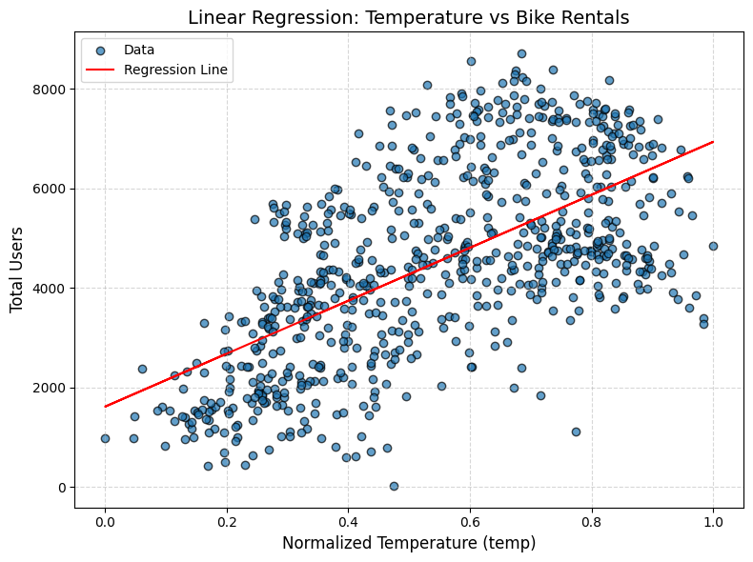

Figure 6 Linear Regression: Temperature vs Bike Rentals

Key metrics:

* **R² Score**: Indicates a strong linear relationship between temperature and rentals.
* **Mean Squared Error (MSE)**: Measures the error of predictions.

**Future Prediction**

The regression model was extended to predict bike rentals for hypothetical future temperature values.

Figure 7 Future Predictions: Temperature vs Bike Rentals

**Key insights:**

* Predictions show a linear increase in bike rentals as temperature rises, validating the model’s reliability for future estimates.

**Conclusion**

This report highlights key findings:

1. Seasonality and weather strongly influence bike rental patterns.
2. Temperature positively impacts rental counts, as evidenced by regression analysis.
3. Clustering provided meaningful segmentation for understanding user behavior.
4. Predictive analytics can aid in forecasting future rental demands, offering actionable insights for resource planning.

**GitHub Repository**

The full codebase, along with reproducible Python scripts and notebooks, is available at: Click Here