DTMF ENCODER & DECODER

Ali Hamza Malik | Ali Aqdas | Ali Ashraf | Muneeb Elahi Malik

# **Abstract**

Our aim is to develop a DTMF ENCODER & DECODER in MATLAB which will generate corresponding tone frequencies for keys pressed 0-9, “*” or “#”. This generated signal is then feed back into a decoder function which returns the key presses present in the signal.

# **Block Diagram**

## DTMF Encoder

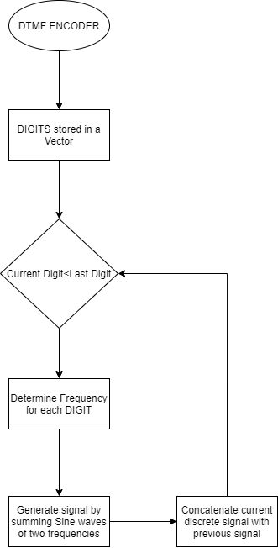

## DTMF Decoder

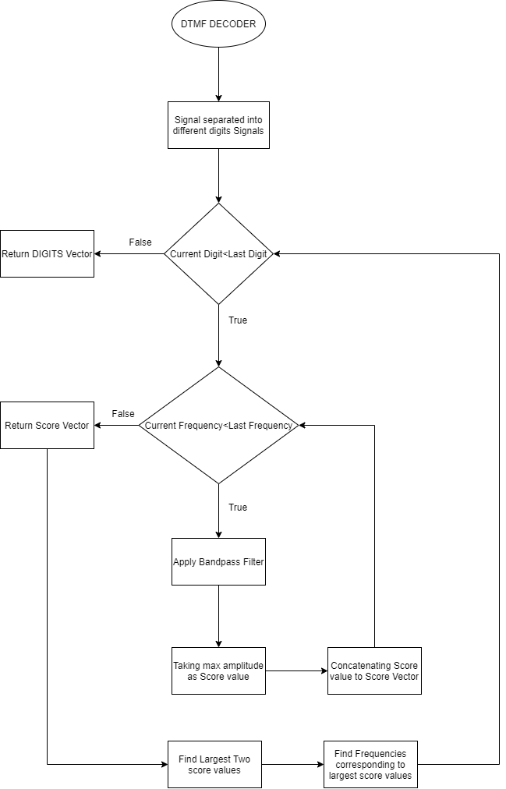

# **Work Distribution**

## Ali Hamza Malik

The function to separate signal into digit signal segments and determine frequency tones present in the signal segments by applying BDF for each frequency on the signal segments and storing the score for each BDF which is the max amplitude of the filtered signal segment from which largest two scores are used to determine the corresponding frequencies.

## Ali Aqdas

The BDF filters taking a Center Frequency, Filter Length L and Sampling Frequency fs as inputs and returning an impulse response which is used to determine which frequencies are present in the Signal. Also, the code to plot frequency responses of the BDF for a center frequency for a certain value of filter length L and try to determine which L is optimal.

## Ali Ashraf

The function to take the frequencies as input and determine whether a combination of frequencies present in the signal segment are the combination for the tone frequencies for the keys pressed 0-9, “*” or “#” and returns “E” for an incorrect combination.

## Muneeb Elahi Malik

The DTMF Encoder which take a vector of key presses and converts them into a DTMF signal with silent zones between the signal sample for each of the digits with optional variation of digit signal time and silent time.

# **Problems Faced and Solutions**

Separating the signal into digit signal segments which was a challenge as the signal could vary and contain noise present in dead zones which could cause problems in a frame-by-frame analysis which was solved by converting the entire signal into a square wave by taking a moving average of the signal with a width equal to expected silent time sample size and then convert it into a logical vector where values above a certain value and zero for below it. Then the vector is passed through $diff()$ function which takes difference of adjacent terms leaving a vector which stores 1 in areas of transition from silent time zone to signal time zone for which the indices are found using the $find(signal\sim =0)$ expression and the indices gaps which are less than $expected silent time sample$*10 are removed as these have very small sample size to be a digit signal segments.

# **Results**

A DTMF Encoder Function which can generate a signal for key presses stored in a vector with optional variable signal segment time and silent segment time at a sampling frequency passed to the function.

A DTMF Decoder Function which can take the output of the DTMF Encoder or a recorded DTMF sample with noise and return the digits present in the signal.