

ProGile Assesment



Project submitted in the context of the course   
Info3302 Server Side Web Development

Prepared by   
Ali Rahal 86023 & Reem Atwi 87622

Lebanese University

Faculty of Sciences I

Department of computer Sciences

2018 - 2019

# Acknowledgements

We would like to express our most sincere gratitude and appreciation to our project guide Dr. Abed Safadi, who went out of his way to help make this project possible.

# Abstract

Zomatix helps provide customers an easy to use interface to order food in an elegant way, which accompanies customers by each minute an update is done on their order via the manager side of the application. The manager side allows employees/managers to accept/refuse/update orders corresponding to their restaurants and print bills. With the addition of the employee dashboard that provides real time updates to the customer about the order status.

# Table of Contents

Acknowledgements 2

Abstract 3

Table of Contents 4

Table of Figures 5

Chapter I - Preliminary Study 6

I.1. Introduction 6

I.2. Project Objectives 6

I.3. Similar apps 6

I.4. Features 6

I.5 Design 7

Chapter II - Database 10

II.1. Introduction 10

II.2. Tables 10

Chapter III - Implementation 11

III.1. Introduction 11

# Table of Figures

Figure 1 - Admin Panel 7

Figure 2 - Answering Questions 8

Figure 3 - Create Project 8

Figure 4 - Conditions 8

Figure 5 - Create Questionnaire 9

Figure 6 - Manage Teams 9

1. Preliminary Study
   1. Introduction

The world of programming is growing everyday, and with it, projects are getting bigger. But with bigger projects, staying up to date with what the team is doing is necessary. So our website will help do this in clean and simple way.

* 1. Project Objectives

Our objective is to provide an easy way for project managers to communicate with team members and get feedback depending on what they need

* 1. Similar apps

There are no exactly similar apps, but Trello has a similar objective

* 1. Features
* Create Project
* Create Team
* Create Questionnaire
* Add coach to your team
* …

## I.5 Design

Below are some screenshots of our website

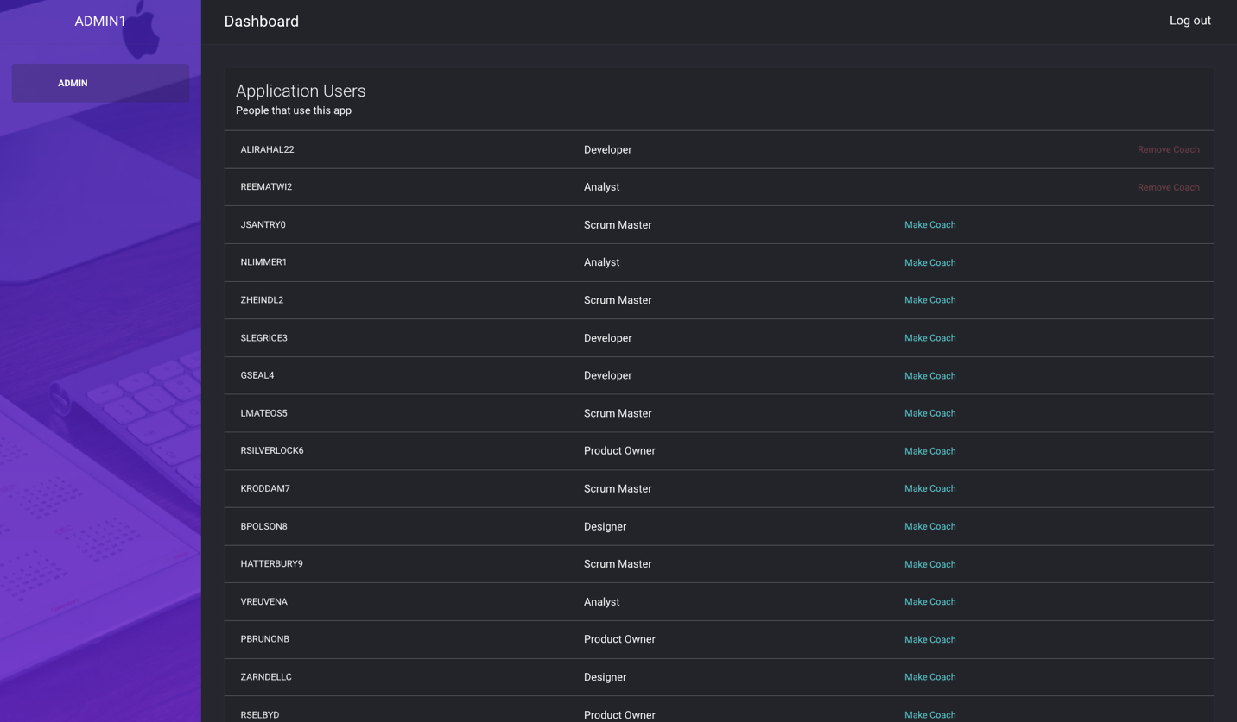

Figure - Admin Panel

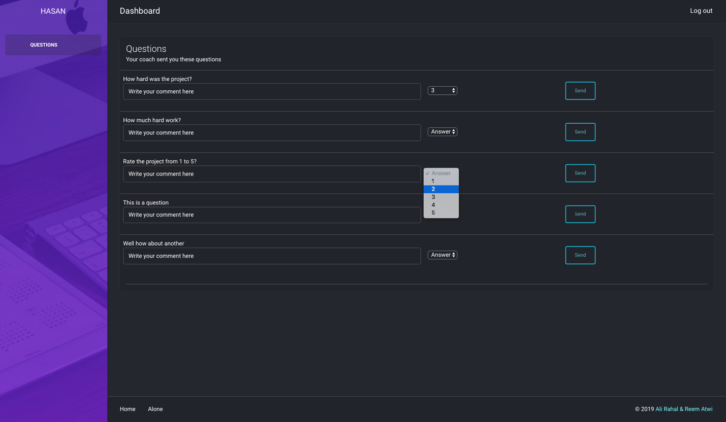

Figure - Answering Questions

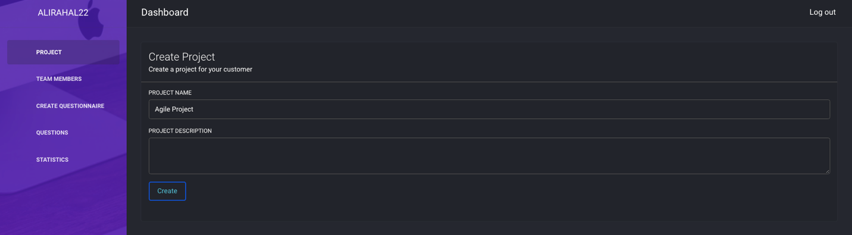

Figure - Create Project

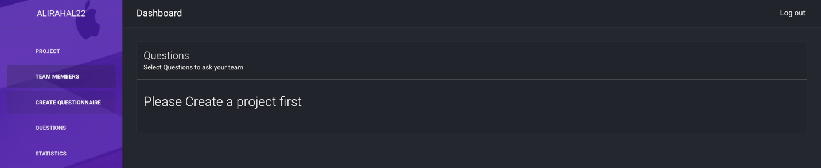

Figure - Conditions

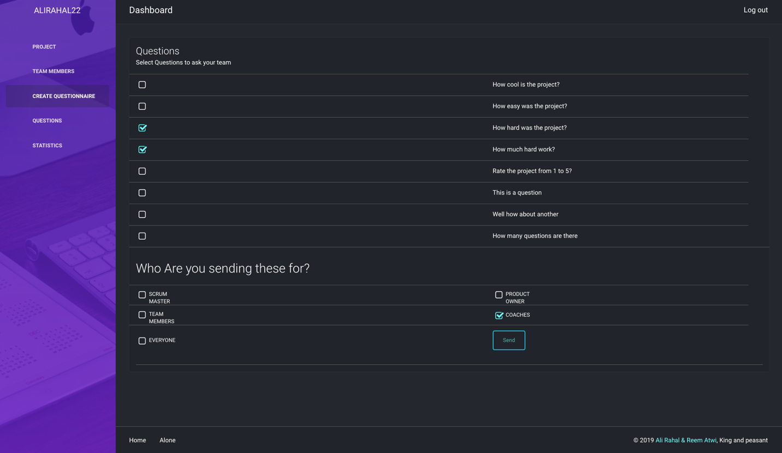

Figure - Create Questionnaire

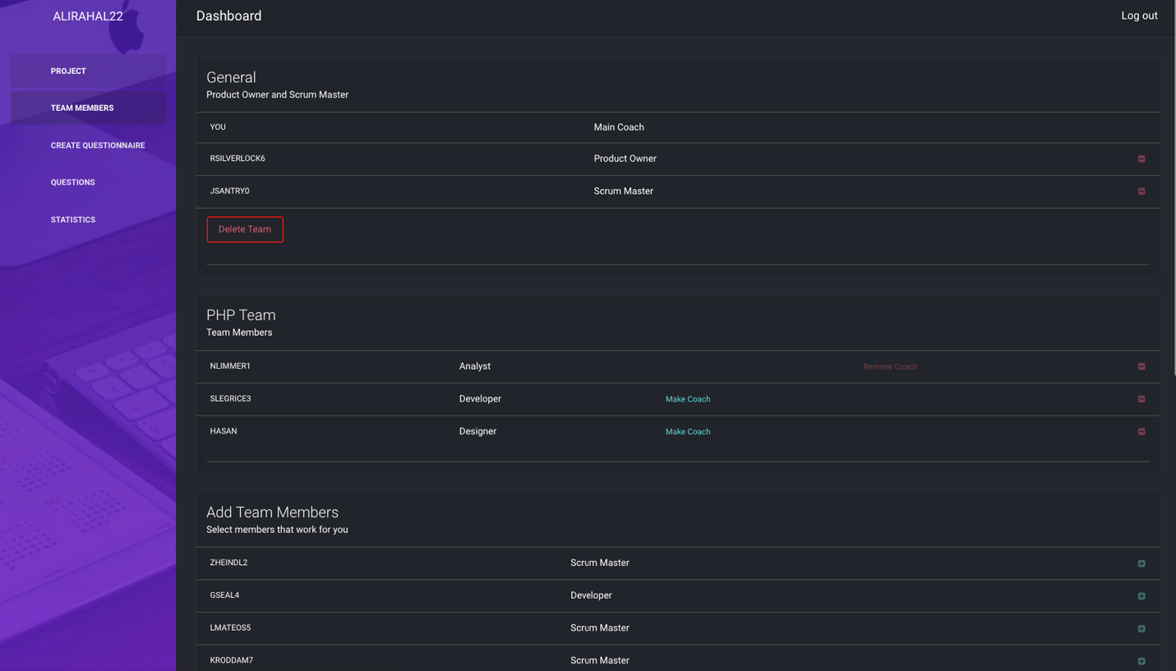

Figure - Manage Teams

1. Database
   1. Introduction

We used mySQL as our database management system

* 1. Tables

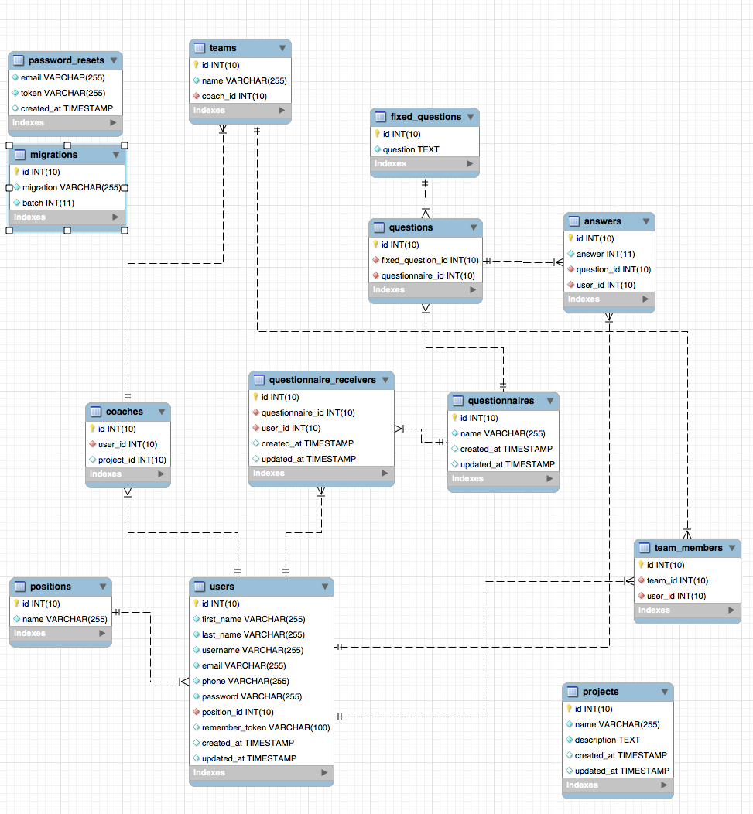

1. Implementation
   1. Introduction

As we all know, there are many ways to build websites, and many thoughts we decided to use Laravel Framework, simply because it makes everything easier.

* 1. Constraints
* Only admins can create Head Coaches
* Coaches can create a team after creating of getting a project
* Removing a coach from a team will remove all his subordinates from the project