**Product Specification:**

**Style**: All custom sizes and styles available  
**Size (LxWxH)**: Fully customizable to your specifications  
**Quantities**: 100 – 500,000  
**Paper Stock**: 10pt to 28pt (60lb to 400lb) including Eco-Friendly Kraft, E-flute Corrugated, Bux Board, and Cardstock  
**Printing**: Plain, CMYK, PMS (Pantone Matching System), Spot Colors  
**Finishing**: Gloss Lamination, Matte Lamination, Gloss AQ, Gloss UV, Matte UV, Spot UV, Embossing, Foiling  
**Included Options**: Die Cutting, Gluing, Perforation  
**Additional Options**: Embossing, Window Patching, Foiling, Hot Stamping  
**Proof**: Flat View, 3D Mock-up, Physical Sampling (upon request)  
**Turnaround**: 8-12 business days after the press-ready file is approved by the client  
**Shipping**: Ships flat, packed in boxes, with delivery options via UPS, FedEx, or DHL

**Ordering Process**

**Our Process Is Quick And Easy**

At City Packaging, we prioritize a seamless ordering experience. Whether you need custom Cardboard, Mailer, or Kraft Boxes, our dedicated team ensures timely delivery. Here's a glimpse of our streamlined process:

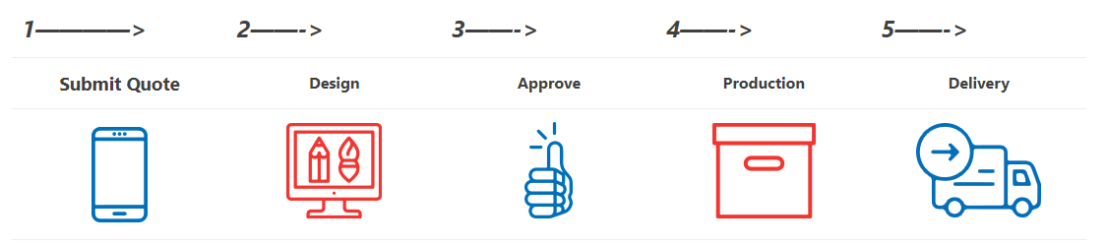

**Artwork Preparation Guide**

Ensure your artwork is ready for submission by following our Artwork Guidelines along with the details provided below. Need assistance? We're here to help! At City Packaging, we offer 100% free design support and mock-ups to guarantee that the final product aligns perfectly with your vision. Simply reach out to our packaging experts—whether it's a call or a click, we’re always ready to assist!

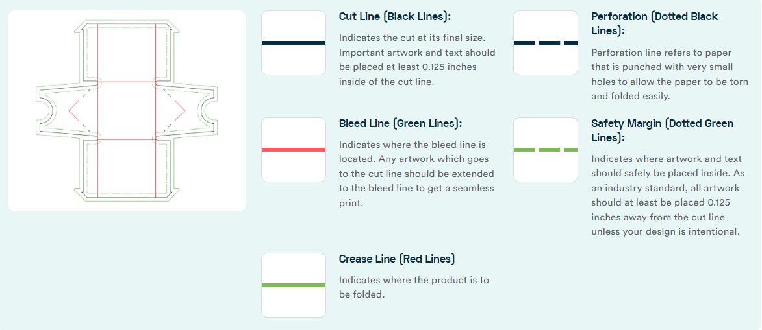

**Stock Type & Thickness**

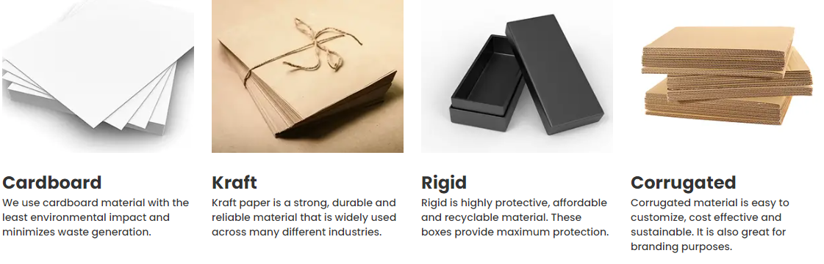

**Special Finishes**