Universal Asynchronous Receiver/Transmitter (UART) is a hardware protocol for asynchronous serial communication. It transmits data between devices without a shared clock, using start/stop bits for synchronization. Key features include simplicity, low hardware overhead, and full-duplex communication (separate TX/RX lines).

UART was one of the earliest serial protocols. The once ubiquitous serial ports are almost always UART-based, and devices using RS-232 interfaces, external modems, etc. are common examples of where UART is used.

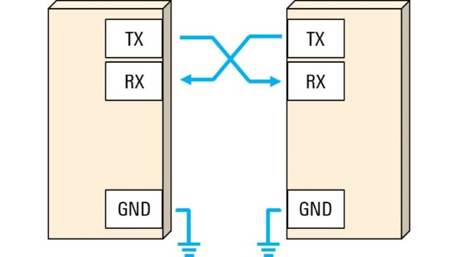In recent years, the popularity of UART has decreased. However, UART is still used for lower-speed and lower-throughput applications, because it is very simple, low-cost and easy to implement.

**KEY FEATURES:**

1. **Asynchronous Communication:**

* No shared clock; devices use predefined baud rate for timing.
* Data framed with start bit (1 low pulse), 5–9 data bits, optional parity bit, and stop bit(s) (1–2 high pulses).

1. **Signal Lines:**

* TX: Transmitter output.
* RX: Receiver input.
* GND: Common reference voltage.

**UART FRAME FORMAT:**

* Start Bit (1-bit): Always logic 0 (LOW), signals beginning of data.
* Data Bits (5-9 bits): Actual data payload.
* Parity Bit (Optional): Used for simple error detection.
* 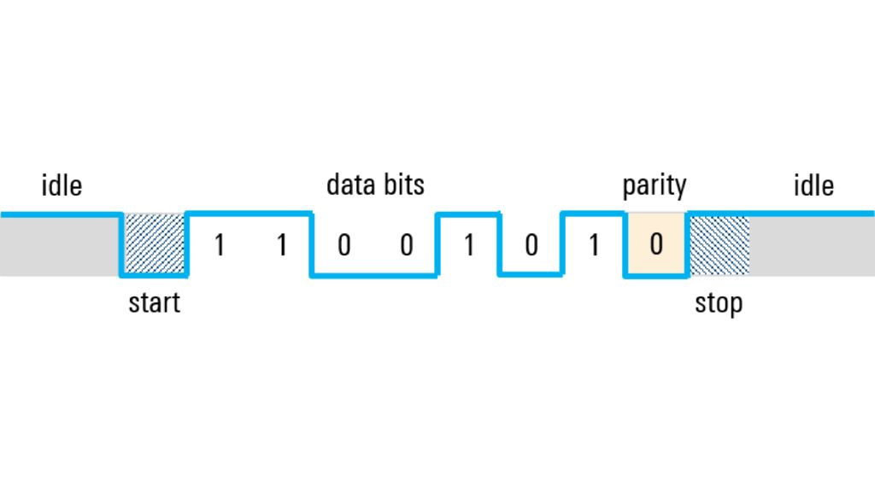Stop Bit(s) (1 or 2 bits): Always logic 1 (HIGH), signals end of frame.

**BAUD RATE:**

Baud rate is the number of signal changes (symbols) transmitted per second in a communication channel. In UART, 1 baud = 1 bit per second, assuming one bit per symbol (which is typical for UART).

For example:

* A baud rate of 9600 means 9600 bits are transmitted per second.

Since UART is **asynchronous** (no shared clock), both the transmitter and receiver must agree on how fast the bits are being sent — this is where baud rate comes in.

The receiver samples each bit at the expected time. If baud rates mismatch, data will be corrupted. It defines how fast data is sent. Higher baud = faster communication, but it increases the risk of errors if signal quality is poor.